STRATEGIC MANAGEMENT

NAME: MOHIT BHATT
STUDENT ID: 2132840
COURSE: MASTER OF BUSINESS ADMINISTRATION
MODULE: LCMB7003
LECTURER: CHARLES OHAM
SUBMISSION DATE: 30/12/2022

Executive summary
Netflix is a popular SVOD platform which is struggling in with the operations in India. Therefore the main porpoise of the report was to analyze the problems of the faced by the Netflix India. Additionally, the strategies implemented in for improving the situations are analyses under a critical analysis. All the strategies are discuses with the strategies like fishbone diagrams. Additionally the factor like market analyses are considers in the report. The various strategies have been discussed in the report along with market framework like and components. Along with the recommendation have been discussed based on the implementing modern technology in the process can improve sales and decision-making for the business.

Table of Contents
Introduction 5
Central issues faced by the company 5
Dealing of the central issues of the company 9
Root Cause Analysis 10
Fishbone Diagram 10
Use of theories to understand the strategy deployed to solve the issues 12
Overview 12
Components 14
Framework 15
Achieving competitive advantage by choice of strategic management 19
Drawbacks and Benefits of the Strategic Management Decisions Taken 23
Recommendation for addressing the drawbacks of the challenges 25
Recommendation 1: Employer local people in the management and another important process of Netflix Company can be helpful 26
Recommendation 2: Implementing modern technology in the process can improve sales and decision-making for the business 26
Recommendation 3: Collaborating with local creators and other platforms can be beneficial for Netflix to gain popularity in the Indiana market. 27
Conclusion 27
References 28

Lists of Figures
Figure 1: Fishbone model 10
Figure 2: Steps of Strategic marketing 13
Figure 3: Strategic management model 14
Figure 4: Competitive Advantages 16
Figure 5: Portfolio Theory 17
Figure 6: Experience Curve 18
Figure 7: GE McKinney matrix framework 20
Figure 8: Porter’s Five Forces 22

Lists of Tables
Table 1: SWOT Analysis 5
Table 2: Ansoff Model 7

Introduction
Strategic management is playing a crucial role in making proper goals, objectives, and procedures for making up an effective company. It is mainly looking forward to the proper staff deploying and the resources for achieving the goals. There are mainly five-step for strategic management those are included goal setting, strategy evaluation, strategy formulation, strategy evaluation, and strategy formulation. The three major steps for strategic management are included transformational strategy, business strategy, and operations strategy.

Central issues faced by the company
STRENGTH | WEAKNESS
- Original content  - Adaptively  - Top rate shows  - Global presences  - Available in most Asian countries | - Revenue model copies  - Bad customer service representation  - Higher price membership  - Rivals  - copyright
OPPORTUNITIES | THREATS
- Powerful images  - Better services to the platform  - Improving new ideas for the OTT channels  - Strategic partnerships along with local marketplaces  - Growing demand for the OTT services | - Covid 19  - Media privacy  - Low client base  - Government policies  - Hacked Netflix accounts

Table 1: SWOT Analysis
(Sources: Influenced by Bogers et al. 2019)
Table 1 is representing the SWOT analysis for the Netflix Company, the strengths, weaknesses, threats, and opportunities have been discussed regarding Netflix Company. As stated by Bogers et al. (2019), the strengths are mainly discussing the development aspects of the Netflix Company which is the main part of the SWOT analysis. The strengths have been mainly discussed by the availability of Netflix among Asian countries mainly in south Asia which is creating a major impact on the global presence. It is providing a better opportunity for the changing and strategic market. Along with this, the Netflix Company is very adaptive; it is generally developing its services for responding to the customer's preferences. As commented by Banabakova et al. (2018), it is the main reason for becoming more special to audiences over time. The program and the films are providing plenty for the development of the filmmakers and the audiences are appreciating their unique concepts. Netflix is creating a better bond by replacing top-rated shows and developing their productivity at a higher rate.
Those strengths include global presence, providing the top rate shows, real content, and adaptability. Along with this, the opportunities are based on the strengths of the Netflix Company. Those opportunities are helping to develop the overall demand of the market and they're over-the-top (OTT) services for the productivity of the Netflix Company. As commented by Leiblein et al. (2020), Netflix Company has a proper image in the industry which is developing the growth and success of the company. It is able to create a better service for the Netflix Company regarding comedy, gaming, and comics for entertainment to the audiences and the organization has modern ideas for providing the offers to the OTT channels.
Netflix is rejecting the traditional past ads model those are based on the economy and allowing audiences to focus on the customer's support. With the help of a higher amount of audience, they are able to make a large number of subscribers for the local market prices for catching up with the strategic marketplaces. The Netflix threats are based on the victim in the time of media piracy. Many audiences need the unauthorized version of the main show which is making the organization at risk. Along with this, the number of hacked users of Netflix is creating issues for the services. In the time of the covid 19, movies and original shows have been hampered. As mentioned by Ketchen Jr et al. (2020), the threats are based on the low client base, media piracy, covid 19, government policies, and hacked Netflix accounts.
The weakness of the Netflix Company is based on copyrighting which is restricted for the company and they have not proper customer service and create less customer satisfaction. The weakness is based on the revenue of the copied model, bad customer services, and restricted copyright and costly membership. The SWOT analysis determines the problems of the company, and along with this, they are able to determine opportunities and the strengths of the company. From the SWOT analysis, it acne be concluded that Netflix company needs to prevent copyright issues.
 | Existing products | New market
Existing Markets | Market Penetration  - Constant innovation in UI design  - New subscribers | Product Development  - Modern content category  - Production of content  - Netflix development for the films and shows  - Merchandising
New Markets | Market Development  - International expansion  - Content Ownership  - Focus on the emerging markets | Diversification

Table 2: Ansoff Model
(Sources: Influenced by Drnevich et al. 2020)
Table 2 is representing the Ansoff model for examining the growth strategy of the Netflix Company for strategic marketing. As stated by Rabetino et al. (2021), the Netflix Company is looking forward to the development of the subscription, and the games are mainly based on the Netflix franchise for the improvement of the show quality. The existing products and the new products are the main key components of the Ansoff model for the Netflix Company. The existing products are based on market penetrations these include constant innovation for the UI design and the new subscribers. Along with this, the new products are based on the developed not-for products which determine the merchanding, content of the products, and the development of Netflix for their own films and shows. As stated by Drnevich et al. (2020), the Ansoff model is based on four major stages those are diversification, market development, product development, and market penetrations which are mainly based on internal and external factors. The Ansoff matrix is helping to develop strategic marketing tools for the guidance and growth of the business.
The external factor is based on the economy for a proper region, and the political stability along with this, the internal factors are based on the resources capabilities and talent management. As stated by Mehta et al. (2020), the purpose of this model is the development of the international growth of the Netflix Company. The market penetration is able to develop the production capacity which is allowing Netflix Company to become more effective in the strategic market. Along with this, it is developing efficiency and maintaining the cost and attractiveness for the highest market penetrations. As mentioned by Sullivan et al. (2018), the Netflix market redevelops the investment and the activities of the ad for the development of market penetrations. The Netflix Company is developing the design engagement for the different groups of the market and the development of the investment activities and the communication ns are able to develop the overall market share. Netflix is creating a better bond by replacing top-rated shows and developing their productivity at a higher rate
Henceforth, it is helping to reduce operational costs, competitive pricing, and develop distributions. Netflix is able to determine the advantages of modern and new products, and develop joint ventures and partnerships. As stated by Abdullah et al. (2020), the market development is able to develop and reach the market, able to detect the international market expansion, modern customer segment, customer education, and brand awareness. Product development is based on the launching of new products, identification of recent products, strategic partnerships, and the quality of the products. The diversification is based on horizontal diversification, vertical diversification, and diversification for the new business regarding acquisition, and mergers.

Dealing of the central issues of the company
The Netflix Company mainly provides social media services and creates examination for mitigating the issues that have been created by the Netflix Company. As stated by Hughes et al. (2020), regarding the case, there are various issues that have been faced by the Netflix Company those are including freedom and responsibility, not following the rules and regulations, and looking for effective proper, and extraordinary candidates. They are facing problems in the time of the leftover of subscribers, difficulties in international growth, and determining the media companies. The Netflix Company is facing problems for the higher competitors where the HBO and Disney Company are trying to develop their subscribers and spending a huge amount of money for developing.
Along with this, they have faced problems in international growth, competitive advantages, and tentative solutions for the Netflix Company. As stated by Milovanović et al. (2019), the Netflix Company is facing problems with the freedom and responsibilities of the employees. This company is not able to take proper decisions and in beginning, the Netflix community is expanding its market for the overall country. As commented by Teece et al. (2019), the major issues those are faced by Netflix management are an excessive amount of titles, mobile data deals, and international expansion. Along with this, the Netflix Company is losing market share and customers. Netflix share is reducing its share of the video market sharing. They are not following the rules and regulations that are needed for the development of the Netflix Company. This company is avoiding the rule of creating modern challenges in the strategic marketplaces. There are various challenges that are facing by Netflix Company. As stated by Deliu et al. (2019), the five major key challenges for Netflix Company is internet speeds, no download options, competition with the other company, and the catalog. The bargaining power is higher and the suppliers are not providing the proper videos for the company and creating problems. They are facing problems with the black screen with no sounds, the speed of the internet connection and stops responding and are stuck in loading.

Root Cause Analysis
The root causes analysis is a technique for determining the root causes for determining the solutions. The five major stages for the root cause analysis are based on the factor analysis, implementing the solutions, gathering data and determining the casual factors. In this structure, the method is based on process, measurement is based on the inspections, materials are based on the raw materials, and manpower is based on the physical works.

Fishbone Diagram
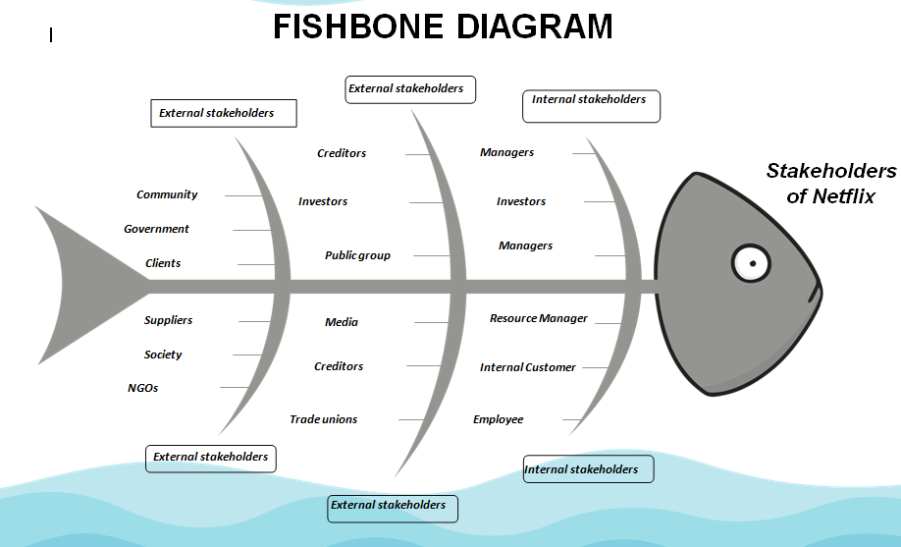

Figure 1: Fishbone model
(Source: Influenced by Veselovsky et al. 2019)
The figure 1 is representing the fishbone diagram for the visual representation of the effects and the causes of their work. As commented by Veselovsky et al. (2019), the seven major key components of the fishbone diagram are based on the machine, measurements, environment, man, material, and methods. The fishbone diagram has mainly discussed the stakeholder of Netflix which is based on the internal stakeholders and external stakeholders. The importance of internal stakeholders is based on the shareholders, leadership team, and employees.
The key factor for the leadership team is based on the CEO, founder, chief content officers, and chief officers. The vice president is providing various functions for playing a major role in the Netflix Company. As stated by Phornlaphatrachakorn et al. (2019), Netflix Company mainly has 9400 full-time workers those are working in teams including content, marketing, products, and corporate functions. The company's success is mainly based on the development and the research h for preventing the problems. The shareholders are playing a major role in the Netflix Company and create a financial impact for the Netflix Company. The external stakeholders are based on the competitors; pressure globally, regulators, and customers. As stated by Ritter et al. (2018), Netflix company have 200 million subscribers which is determining the Netflix company and creating better satisfaction for the revenue of the company. Netflix Company is mainly focused on the original aspect of the company and helping the company to gain a high level of satisfaction for the customers. The competitors for Netflix company are based on HBO max, Hulu, Paramount, Amazon prime video, Disney+, and Apple TV.
They have been needed to maintain their overall activities for determining the resources and the content for competitive advantages. As stated by Meyer et al. (2018), for Netflix Company the internal and external stakeholders are based on various aspects. For the Netflix Company, the internal stakeholders are based on the employee and the owners. Along with this, the external stakeholders are based on the communities, government agencies, customers, investors, trade unions, creditors, and communications. Cultural benchmarketing is creating an impact on Netflix's values for the employees who are included honest, self-awareness, and developing the productivity of the company. As commented by Agrawal et al. (2021), this company is mainly following four major types those are included market culture, clan culture, and hierarchy culture. The seven major factors for cultural development those are included religion, language, government forms, economic systems, and social organizations.

Use of theories to understand the strategy deployed to solve the issues

Overview
Strategic management is playing an important role in determining the goals of the business and able to determine the vision and objectives of the organization. Strategic management is helping the organization to determine the process for determining the goals and creating a better impact for the performance of the key factors. As commented by Shibani et al. (2018), the three-level of the strategy is based on functional strategy, corporate-level strategy, and business level. They are facing problems in a strategic development which include low levels of goal, inappropriate tracking, measurement, and the lack of alignment. The Netflix Company is creating the 3C's model for strategic actions those are included customers, company, and competition. It is helping to develop the vision and the goals for determining the goals.
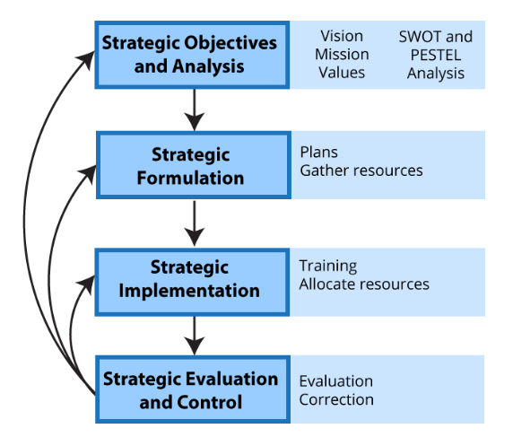

Figure 2: Steps of Strategic marketing
(Sources: Shibani et al. 2018)
The figure 2 is representing strategic management those are helping to create a mission, vision, and value for the organization and it is mainly done in four major steps. As commented by Afolayan et al. (2020), those steps include strategic objective analysis, strategic formulation, implementation, and strategic control and evaluations. Among those, the strategic implementation step is playing a major role in business marketing. The four major perceptive for strategic management are based on innovation intrapreneurs, visionary strategies, and functional experts.
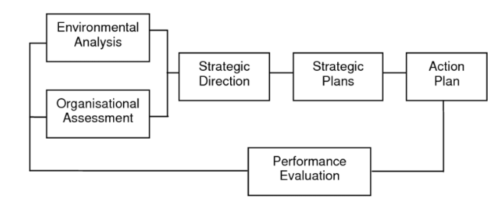

Figure 3: Strategic management model
(Sources: Afolayan et al. 2020)
The figure is representing the strategic management model those are included environmental analysis, organizational assessment, strategic decisions, strategic plans, action plans, and performance evaluations. The major skills for the strategic techniques are based on prioritization, forward-thinking, international actions, and communications. there are various advantages to strategic management those are including helping to achieve goals, allowing the strategy for future decisions, providing competitive advantages, and developing the strategy and workforce.

Components
The major components of strategic management are based on determining the internal and external factors for the weakness and strengths. It is able to formulate the plans and determine the actions ad develop the actional plans for making proper marketplaces. As stated by Höse et al. (2022), there are various kinds of strategic management those are including expressive, adaptive, linear, transcendent, and interpretive which determine the strategic representation for the development of the Netflix market. The major components of strategic marketing are based on the implementation and formulations. The formulations are mainly based on the assessment of the environment which is helping to operate and creating the new strategy for the development of the budgeting techniques. Along with this, the implementation is based on the development of the resources for meeting the objectives.

Framework
1. Competitive Advantage
The framework is based on competitive advantages; the Netflix Company is able to determine the overall cost of production to create better advantages for the products. As commented by Meyer et al. (2018), it is applying for a crucial role in the development of the market position of the Netflix brand and developing competitive advantages over the competitors. The competitive advantages are creating the factors for allowing the Netflix Company to create the factors for the production of the company. The five competitive advantages are based on product attribution, human capital, price discrimination, and bundle prices. The four major competitive strategies are based on the cost focus strategy, cost leadership strategy, differentiation strategy, and leadership theory.
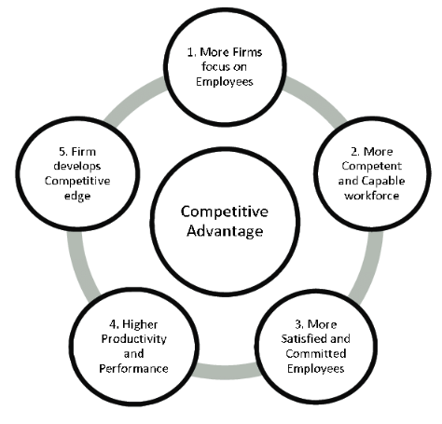

Figure 4: Competitive Advantages
(Sources: Dalisov et al. 2020)
The figure 4 is representing the four major types those are includes cost focus, differentiation focus, differentiation, and cost leadership. As stated by Dalisov et al. (2020), the competitive advantages are based on customer satisfaction, variety, quality, reputation, and informational technology. The competitive advantages are based on the five major aspects which include more forms those are focusing on the employees, capable workforces, committed employees, and high production rates and performances. Along with this, firm improvement is playing a major role in the development of the edge.
2. Corporate strategy and portfolio Theory
The recent portfolio theory is able to provide a better assessment for mitigating the risk. This theory is allowing the organization to create a cost-benefit for the organization and development of the resources for the loyalty of the company. As stated by Aydın et al. (2020), the main purpose of this theory is the development of the growth rate and market share for the Netflix Company. The growth rate is helping the measurement of the industry and is able to develop the competitive position for the peers. Portfolio management is a technique for the use of resources for organizations and meeting their strategic objectives for the organizations. The three primary corporate strategies are based on the growth strategy, stability strategy, and retrenchment strategy.
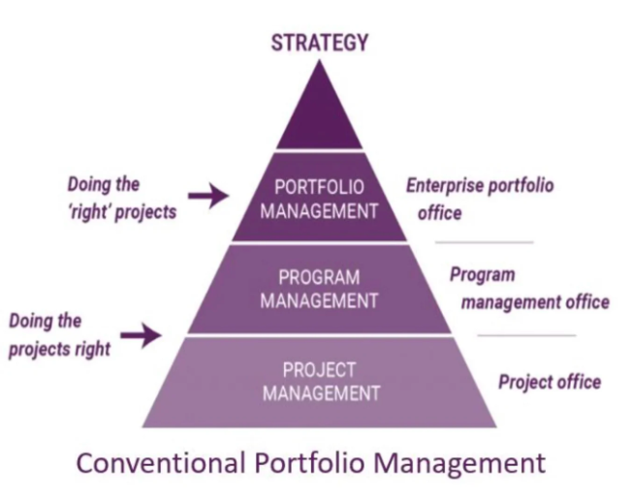

Figure 5: Portfolio Theory
(Sources: Destino et al. 2022)
The figure 5 is representing portfolio management for the three major stages those are included portfolio management, project management, and program management. As stated by Sestino et al. (2022), the strategy portfolio management techniques are mainly based on alignment, inventory, management, and align. The main reason for the portfolio analysis those are includes analysis, determining the growth strategy, and making decisions regarding the retention of the products. The five corporate strategies are mainly based on quality, distribution, cost, technology, and intellectual property. The corporate strategy is playing a major role in determining the business destinations.
3. Experience Curve
The experience curve mainly determines the proposition of the overall process of the company and is able to determine the brand value for the company. As commented by Basias et al. (2018) the importance of the experience curve is able to grow the overall production cost and it is helping to create a large market share for the business. It is mainly controlling the market position and the development of the profit of the organizations.
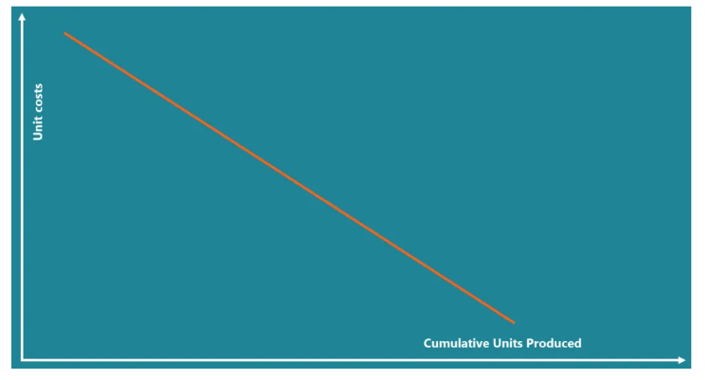

Figure 6: Experience Curve

(Sources: Basias et al. 2018)
It is developing the skills of the employee, developing the CV, knowledge regarding the finding details, and developing workplace and communication skills. As commented by Shad et al. (2019), the cost curves are mainly able to determine the profit rate for the proper decision-making for the organizations. It is helping to create a better firm value and able to gain the efficiency of the Netflix company.

Achieving competitive advantage by choice of strategic management
In order to achieve competitive advantages in the market a business needs to implement a business strategy according to available resources. As commented by Havard et al. (2021), business strategy helps in scaling up the business to its full potential. In addition, with the help of strategic planning businesses archives a competitive edge in the market. Netflix is having seen a decline in the market over time. At the end of the quarter on September 30, 2022, was 1.3989 billion dollars or it 3.51% decline over the past years (Bbc.com, 2022). In addition, Netflix is facing an overall decline of 0.14% when compared to the past years of the company (Bbc.com, 2022). Similarly, Netflix was facing difficulties in capturing other market which are proven to be a beneficial for other streaming services.
After capturing market and other platforms Netflix gave a splash in India in 1018 with a vision of capturing 100 million subscribers for India (Bbc.com, 2022). All though three years later senior management of the California-based content stemming service has achieved lot less than their target. Indians stemming market is around 2 billion dollars and become one of the favorite marketplaces for other streaming services like Hot star and Amazon Prime (Bbc.com, 2022). Therefore, Netflix has a huge amount of competition in the Indiana market. Hence to achieve a competitive edge Netflix can implement following business strategy in order to get a commutative edge in the market.
1) GE McKinney matrix
At the time of conducting the Netflix case study, it haze been seen that there is a major problem in the employee management system of the company. As commented by Xiao et al. (2018), employs of a company are one of the basic factors which are related to the success of the business. Additionally, employs of a bison helped to build a process which is works for the benefit of the company. There is a problem in the employee haring system of the company. It has been found that the business mainly has 50% of the employee according to their hard skills (Bbc.com, 2022). Although Netflix’s business is related to technology and needs to upgrade according to order time and employee with hard skills make it difficult to change their skill for the benefit of the business. Similarly GE McKinney matrix helps to analyses product and process according to their flaws.
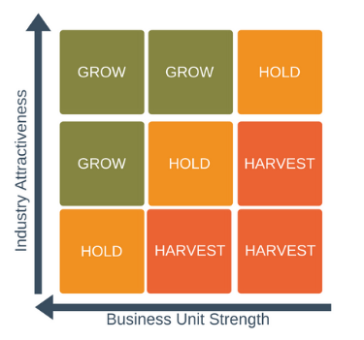

Figure 7: GE McKinney matrix framework
(Source: Xiao et al. 2018)
Therefore, with the help of the framework of objective and key results Netflix can set objectives for their employee. At the same time hiring employee with skills which can be changed according to the objective of the business is helpful. GE McKinney matrix framework is related to the managing performance of the employee through which a business can improve its business model according to the market demand. GE McKinney matrix framework is based on the objective of the business. In addition objectives of a business are the targets that a business needs to achieve for a competitive edge in the market. GE McKinney matrix framework helps to set objectives which are time bounded and measurable. Therefore it is possible to achieve those targets with a cooperative effort of the employee. Similarly completing the objectives with cooperative efforts reduces the pressure on the employees and the management. GE McKinney matrix helps to analyze strategies to develop the corporate management. Not only in the employee has management had GE McKinney matrix helped to improve the product line for the business. Additionally, it improves the commutative strengths of the business.
2. BCG matrix
Leaking of sociable info emanation is as issue which Netflix was facing from a long time. In addition it is related with the management of the employee. As opined by Claudi et al. (2019), sociable info mutation of a business reduced the impact of business strategy and made the business vulnerable to the market. Therefore management of the business objectives and assigning related goals to the management can help to fix the issue. Problem of sensitive information leakage is an issue which is largely related to employee loyalty, therefore, Netflix needs to maintain their employee and work objective in a better way. Therefore BCG matrix framework can be beneficial in such scenarios where product of the company need to be improved.
With the help of the BCG matrix better management of the information can be done as it allows business leaders for collaborating with business leaders and discuss the objective of the business. Similarly, with the help of BCG matrix, transparency can be managed in the organization. Collaboration with the management team and the HR team allows making understand employee and the objective, further with that understanding they Ana divide the objective accordingly. Hence, by dividing the objective accordingly sensitive information can be managed further, a better working process can be achieve. Additionally with changes like objective division Netflix can a chive a competitive edge to the market.
3. Porter’s Five Forces
In order to achieve a quality market share in the Indiana market Netflix needs to understand the competition in the subcontinent. In order to understand and analyze the competitor, porter’s five forces provide a wider perspective of the market (Fagerjord et al. 2019). Similarly, market sustainability can be achieved by understanding threats to their market. Additionally, profitability levels can be improved with the help of the framework. In India, there are competitors like Disney Hot star and Amazon Prime and they offer similar services in the local language. Therefore, there is huge competition for Netflix. Hence, an understanding of the competition and market is going to help a comparative edge for Netflix.
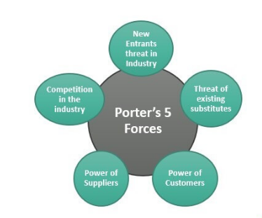

Figure 8: Porter’s Five Forces
(Sources: Machado et al.2022)
According to the above image, there are mainly five market forces which help to determine a market and the competitive rivalry for Netflix. Potters five forces have market competition in the centre and there are four different factors which define competitive rivalry for the business.
One of the factors is the suppliers' power in the market. The monopoly of the suppliers largely determines the pricing and quality of the goods. For Netflix, the suppliers on the market are technical supplies and production houses that make shows and movies. Therefore Netflix has a high dependency on the quality of its product.
The second force of the market is the buyers' Power which helps to determine the power of the customer. Netflix is related to the subscribers of the Indiana subcontinent. It can be seen that Netflix has lowered the prices for Indians at the same time they released a series in the local language in 2018. Therefore, such wikis are made for the subscribers of Netflix hence they can be identified as the power buyers.
The third force of the market can be identified as a form of the threat of new entrants into the market. The Indian market is a big and versatile market which offers opportunities for new platforms. Additionally, in Indian Subcontinent, there are platforms like Hulu and Hitstare are some of the major competitors that serve local language content. Additionally, it has been seen that almost 2% of Netflix subscribers left Netflix subscriptions (Machado et al. 2022). Therefore, Immerging new platforms can be a threat to achieving market sustainability in India.
Similarly, there is a high threat of duplicated product and product that offers similar values in the market. Emerging competition in the Indian continent and there is a major market problem faced by Netflix. Additionally, Pirated videos are a huge threat to Netflix in the Indian Market. Therefore lot the above-mentioned factor defines the competitive rivalry in India. Similarly, the competitive edge in the market is largely determined to by the forces of the market.

Drawbacks and Benefits of the Strategic Management Decisions Taken
In order to achieve the quality market share there are a huge change made in the planning management of the Netflix. SVOD platforms of are relatively new for the Indiana audience, therefore there was a huge opportunity for Netflix. The initial idea was too related with achieving subscriber for m the well-educated background who will watch English web series. India is a huge and diverse market that offers opportunities to the new business. Therefore With opportunity Netflix faced competition in a huge level. As commented by Havas et al. (2021), with market competition there a business makes changes and growth in the market, In addition competition promoted innovative thinking for the business. Therefore the session of producing show in local language was an importance change the management made. In 2018 they come up with the TV series name "Sacred games" which was in Hindi. In addition there are a series of other shows which gain popularity in India.
The Drawback of the strategy is related can be identified with the budget and other are associated with that. At the same time, Netflix didn't do something about the issue of pirated series. Hence the series was available in many platforms that have no charges. Although, Series which are were released in the local gained popularity, Netflix generated poor revenue from them.
There were some theoretical benefits that Netflix could have achieved from this session of serving content in the local language there was no actual benefits of the decision. However, it helped to gain popularity for the brand. Although there were several other factors which played a decisive part in the popularity of the platform.
In order to improve the work culture Netflix implemented the work N culture benchmarking which helped to determine the work culture for the company. The benchmarking tools usually helps to understand the current culture of the business at the same time employee management can be done with more efficiency (Vlassis et al.2021). Cultural benchmarking largely impacts the values of employers and helps to implement loyal work culture. At the same time with the help of benchmarking employee growth can be tracked which can be beneficial for the employee and the business.
Drawback of the N culture benchmarking is there transparency is created by the benchmarking. Furthermore, with the bench marking the dependency on the employee and other companies is increased. Although tit depend on the coalmines background and the process of implementing the system.
Benefit of the same is related to Brand Image. With the help of N culture benchmarking have achieved reputation in the market place at the same time the popularity is increased. Generally implementing such factors helps to improve the work culture in the company.
Furthermore, Netflix implemented N Cash flow model in order to improve the cash flow of the business. In India the rate of customers leaving Netflix subscription was about 2% (Joo et al.2020). In addition there are different market players who entered the market with similar products hence the sustainability of Netflix was in Question. Additionally, there is making an Indian subscriber base was a huge challenge for Netflix. The implementation of the cash flow model in the business helped Netflix in increasing the resources they invested in building regional shows.
The benefit of the cash flow model can be counted as it improved the resource building for the company. In addition, the cash flow model has an indirect effect on making a healthy work environment for the company. The drawback can be associated with the volatility of the model (Vlassis et al. 2021). The cash flow model allows in a granting change I the resources. At the same time, resource allocation is affected by cash flow. Therefore cash flow model makes it hard to achieve actual data of the profit and the loss.
On the other hand net fix introduced International streaming video players on the Indian continent. In India, English web series were ageing popularity. At the same time, the demand for some international hits was in the rise in the region. Therefore analyzing those in the platform helped Netflix to achieve sustainability in the Indian continent. There are no such disadvantaged of the strategy, and playing international hits in their platform helped Netflix to achieve a huge subscriber base.
Releasing the Netflix original was an impressive de that the management took in order to improve the subscriber base in the region. Netflix collaborated with different local creators who made some original content to be released on the Netflix platform. In addition, all the shows were created regional language. There are many other platforms that presented huge competition to the brand. For instance, Jio TV, Hotstar, and Hulu are some of the competitors who released shown in the local language. As commented by Putri et al.(2019) market competition is a major factor for innovation and implementation of new business models. Therefore, Netflix's original series helped to fight such market contains and achieve subscribers. In addition, there are releasing original content that helped to achieve some subscribers to the platform. The disadvantages were related to the distribution and privacy of the series which was responsible for financial loss.

Recommendation for addressing the drawbacks of the challenges
At the time of consulting the case study, there were some gaps and problems which created problems in achieving subscribers for Netflix. India is larger that has a huge opportunity for Netflix therefore Netflix management needs to implement strategies which are going to help improve its market share. As opined by Wayn et al. (2019), changing according to the market demand is a nature of a successful business model. At the same change allows a business model to implement innovation and get a sustainable market share. During the analysis, there is some points found that need to be fixed for a better-performing business. Hence following recommendations are made according to the findings. Proper implementation of the following recommendation can help to improve the market capture for Netflix

Recommendation 1: Employer local people in the management and another important process of Netflix Company can be helpful
In order to get a better hold in the market Netflix needs to hire local management who can make decision but understanding the situation. Additionally, the main purpose of hiring local people is to get ratable information about the market. In order to make profit in market, a business needs to have knowledge about the market. Similarly hiring management from India is going be beneficial as they have the knowledge about the market and how to get profitable in the market. At the same time local management have the capability to face adverse situation for which will arrive in the market.

Recommendation 2: Implementing modern technology in the process can improve sales and decision-making for the business
Businesses in the modern era are implementing and using technology which is beneficial in order to achieve their business objectives. As commented by Rahe et al.(2021), implementation of modern technology solves different business problems which presents complication in the process of business. Technologies like data science and machine learning are some of the technology that helps in cession making and product recommendation. Additionally Implementation of the technology helps to make a batter work culture for the business. Therefore, Netflix need to implement modern technology in the process of their business which is going to solve the problems in the market. At the same time decision making is one of feature which can be backed by data and advance technology. Therefore Implementing, technology can help to improve the market share of Netflix.

Recommendation 3: Collaborating with local creators and other platforms can be beneficial for Netflix to gain popularity in the Indiana market.
In order to busied a quality subscriber base in the Indiana continent Netflix need to collaborate and with other local creators and production houses. As stated by Cunningham et al. (2020), collaboration between different processes increases the chance of knowledge sharing between companies. In addition, the exchange of knowledge allows businesses to grow and have a competitive edge in the market. Similarly, collaborating with other local creators is going to help them the knowledge of regional movies.
Local movies in Netflix can help to improve the subscriber base at the same time regional movies can improve demand in the market and Netflix can supply according. As stated by Penner et al. (2020), collaboration with other creators is going to present different opportunities for the business and all the processes. On the other hand the collaboration with Netflix can revive local artist and there rare work. Therefore noncommercial rare content can help to maintain rarity for the business model of Netflix. Additionally rarity in the content can improve the demand and therefore can b beneficial for Netflix in order to capture local market

Conclusion
The study of Netflix in the Indian market has opened a lot of opportunities for the business. Although Netflix is a popular brand in the US, it struggled to sustain in the Indian market. Therefore a brief understanding is presented in the analysis. In order to discuss the central ices faced by Netflix all the problems are discussed in the study at the same time theoretical understanding of the issues is developed. At the same time threes are presented to get a theoretical advantaged are presented in the process. Additionally, target analyzing the issues recommendation are presented in the process in order to resolve the issues of Netflix India. Implementation the recommendation can help to achieve busies objectives for Netflix India and can improve their business model.

References
Abdullah, N.H.N., 2020. Assessing strategic management accounting practices in public interest companies in Malaysia. Indonesian Journal of Economics, Social, and Humanities, 2(1), pp.13-25.
Afolayan, A.O. and de la Harpe, A.C., 2020. The role of evaluation in SMMEs’ strategic decision-making on new technology adoption. Technology Analysis & Strategic Management, 32(6), pp.697-710.
Agrawal, A. and Hockerts, K., 2019. Impact investing strategy: Managing conflicts between impact investor and investee social enterprise. Sustainability, 11(15), p.4117.
Aydın, G., Nyadera, I.N. and Önder, M., 2020. Strategic management in Turkey’s public sector: Reforms and application issues. Public Organization Review, 20(4), pp.719-734.
Banabakova, V. and Georgiev, M., 2018. The role of the Balanced Scorecard as a tool of strategic management and control. IJASOS-International E-journal of Advances in Social Sciences, 4(10).
Basias, N. and Pollalis, Y., 2018. Quantitative and qualitative research in business & technology: Justifying a suitable research methodology. Review of Integrative Business and Economics Research, 7, pp.91-105.
Bbc.com, 2022, Netflix: Why the world's biggest streaming service is frustrated with India Available at: https://www.bbc.com/news/world-asia-india-60108294 [Accessed on: 17/12/2022]
Bogers, M., Chesbrough, H., Heaton, S. and Teece, D.J., 2019. Strategic management of open innovation: A dynamic capabilities perspective. California Management Review, 62(1), pp.77-94.
Claudia, O., 2019. SOME INSIGHTS ON THE WORLD'S MOST INNOVATIVE COMPANIES AND THEIR DEFINING CHARACTERISTICS. Studies in Business & Economics, 14(2).
Cunningham, S. and Scarlata, A., 2020. <? covid19?> New forms of internationalisation? The impact of Netflix in Australia. Media International Australia, 177(1), pp.149-164.
Dalisova, N.A., Sharopatova, A.V. and Karaseva, M.V., 2020, August. Value and role of the strategic management in the development of agricultural enterprises. In IOP Conference Series: Earth and Environmental Science (Vol. 548, No. 2, p. 022102). IOP Publishing.
Deliu, D., 2019. Empathetic leadership–Key element for inspiring strategic management and a visionary effective corporate governance. Journal of Emerging Trends in Marketing and Management, 1(1), pp.280-292.
Drnevich, P.L., Mahoney, J.T. and Schendel, D., 2020. Has strategic management research lost its way?. Strategic Management Review, 1(1), pp.35-73.
Fagerjord, A. and Kueng, L., 2019. Mapping the core actors and flows in streaming video services: What Netflix can tell us about these new media networks. Journal of Media Business Studies, 16(3), pp.166-181.
Havard, C.T., 2021. Disney, Netflix, and Amazon oh my! An analysis of streaming brand competition and the impact on the future of consumer entertainment. Findings in Sport, Hospitality, Entertainment, and Event Management, 1, pp.38-45.
Havas, J. and Horeck, T., 2021. Netflix feminism: binge-watching rape culture in ‘Unbreakable Kimmy Schmidt’and ‘Unbelievable’. In Binge-Watching and Contemporary Television Studies, pp.250-273.
Höse, K., Süß, A. and Götze, U., 2022. Sustainability-Related Strategic Evaluation of Business Models. Sustainability, 14(12), p.7285.
Hughes, P. and Hodgkinson, I., 2020. Knowledge management activities and strategic planning capability development. European business review, 33(2), pp.238-254.
Joo, J.S., 2020. Disney's Acquisition of Fox and the Changing Media Environment in the US. Journal of Convergence for Information Technology, 10(1), pp.28-34.
Ketchen Jr, D.J. and Craighead, C.W., 2020. Research at the intersection of entrepreneurship, supply chain management, and strategic management: Opportunities highlighted by COVID-19. Journal of Management, 46(8), pp.1330-1341.
Leiblein, M.J. and Reuer, J.J., 2020. Foundations and futures of strategic management. Strategic Management Review, 1(1), pp.1-33.
Machado, I.A., Costa, C. and Santos, M.Y., 2022. Data mesh: concepts and principles of a paradigm shift in data architectures. Procedia Computer Science, 196, pp.263-271.
Mehta, A.M., Ali, F.H., Farooq, S. and Tariq, M., 2020. Dynamic managerial capabilities, competitive advantage and business performance: an integrative model, literature review and research propositions. Academy of Strategic Management Journal, 19(4), pp.1-12.
Meyer, K.E. and Xin, K.R., 2018. Managing talent in emerging economy multinationals: Integrating strategic management and human resource management. The International Journal of Human Resource Management, 29(11), pp.1827-1855.
Meyer, K.E. and Xin, K.R., 2018. Managing talent in emerging economy multinationals: Integrating strategic management and human resource management. The International Journal of Human Resource Management, 29(11), pp.1827-1855.
Milovanović, V. and Janošević, S., 2019. Total quality management in the function of value creation: View from the strategic management perspective. Ekonomika preduzeća, 67(5-6), pp.319-333.
Penner, T.A. and Straubhaar, J., 2020. Netflix originals and exclusively licensed titles in Brazilian catalog: a mapping producing countries. Matrizes, 14(1), pp.125-149.
Phornlaphatrachakorn, K., 2019. Effects of transformational leadership, organisational learning and technological innovation on strategic management accounting in thailand’s financial institutions. Asian Journal of Business and Accounting, 12(1), pp.165-188.
Putri, D.E., 2019. Application of Online Dispute Resolution (ODR) in International and Indonesia Domain Names Disputes. Lampung Journal of International Law, 1(1), pp.19-26.
Rabetino, R., Kohtamäki, M. and Federico, J.S., 2021. A (re) view of the philosophical foundations of strategic management. International Journal of Management Reviews, 23(2), pp.151-190.
Rahe, V., Buschow, C. and Schlütz, D., 2021. How users approach novel media products: Brand perception of Netflix and Amazon Prime video as signposts within the German subscription-based video-on-demand market. Journal of Media Business Studies, 18(1), pp.45-58.
Ritter, T. and Lettl, C., 2018. The wider implications of business-model research. Long range planning, 51(1), pp.1-8.
Sestino, A. and De Mauro, A., 2022. Leveraging artificial intelligence in business: Implications, applications and methods. Technology Analysis & Strategic Management, 34(1), pp.16-29.
Shad, M.K., Lai, F.W., Fatt, C.L., Klemeš, J.J. and Bokhari, A., 2019. Integrating sustainability reporting into enterprise risk management and its relationship with business performance: A conceptual framework. Journal of Cleaner production, 208, pp.415-425.
Shibani, A. and Gherbal, N., 2018. Using the balanced scorecard as a strategic management system in the Libyan construction industry. Management studies, 6(1), pp.1-19.
Sullivan, K., Thomas, S. and Rosano, M., 2018. Using industrial ecology and strategic management concepts to pursue the Sustainable Development Goals. journal of cleaner production, 174, pp.237-246.
Teece, D.J., 2019. A capability theory of the firm: an economics and (strategic) management perspective. New Zealand Economic Papers, 53(1), pp.1-43.
Veselovsky, M.Y., Izmailova, M.A., Lobacheva, E.N., Pilipenko, P.P. and Rybina, G.A., 2019. Strategic management of innovation development: Insights into a role of economic policy. Entrepreneurship and Sustainability Issues, 7(2), p.1296.
Vlassis, A., 2021. European Union and online platforms in global audiovisual politics and economy: Once Upon a Time in America?. International Communication Gazette, 83(6), pp.593-615.
Vlassis, A., 2021. Global online platforms, COVID-19, and culture: The global pandemic, an accelerator towards which direction?. Media, Culture & Society, 43(5), pp.957-969.
Wayne, M.L. and Castro, D., 2021. SVOD global expansion in cross-national comparative perspective: Netflix in Israel and Spain. Television & New Media, 22(8), pp.896-913.
Xiao, M., Zhu, J., Ma, L., Jin, Z., Ge, J., Deng, X., Hou, Y., He, Q., Li, J., Jia, Q. and Mukerjee, S., 2018. Microporous framework induced synthesis of single-atom dispersed Fe-NC acidic ORR catalyst and its in situ reduced Fe-N4 active site identification revealed by X-ray absorption spectroscopy. Acs Catalysis, 8(4), pp.2824-2832.

