19/12/2024
UNIVERSITY OF WALES TRINITY SAINT DAVID
LONDON CAMPUS
Assignment 2
Learning in the Digital Era
Video Link: LDE-Assessment 2-PPt Presenation.pptx

Module Name: Learning in the Digital Era
Module Code: ACCA 4025

Student Name: Abiodun Paul
Student ID:2532525
Group: 3

Lecturer’s Name: Anees Baqir

Table of Contents
Introduction 2
Main Body 2
Conclusion 9
References 9

Introduction
This report comprises of three main areas of my studies in the digital era as a module towards attaining skills and knowledge required for competent computer use at workplace. The three areas include my self-evaluation specifically my strengths and weaknesses analysis, a professional development plan with SMART goals and a summary of a topic Learning to Learn which is very vital to improve my skills and knowledge for career growth.

Slide 1 COVER PAGE
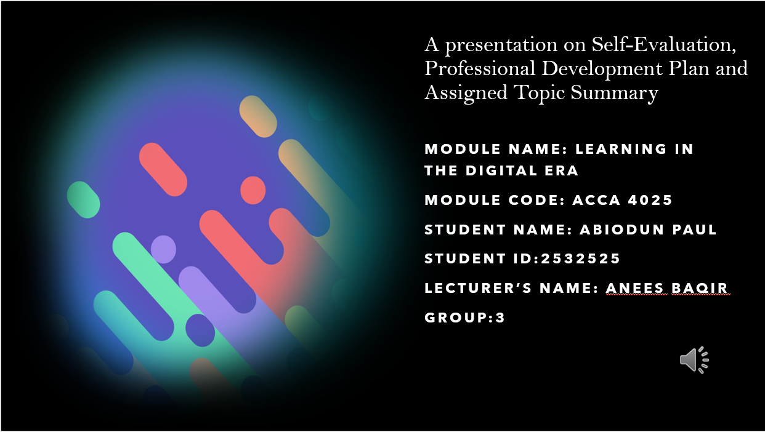
Slide 2 CONTENTS
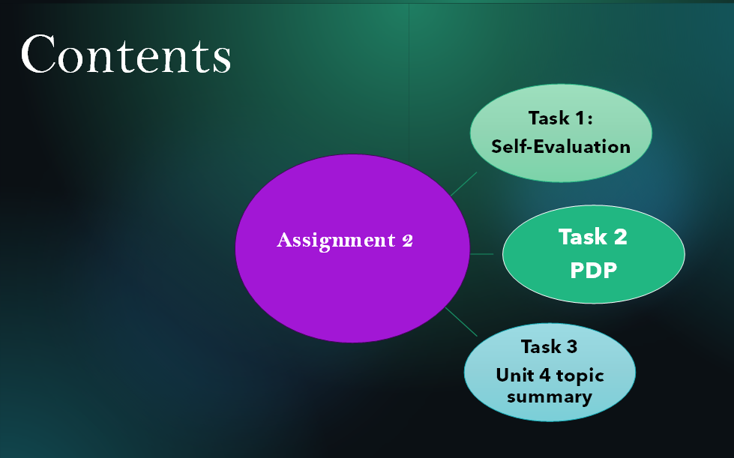
The content of this report includes the following three main tasks; Task 1; Self-evaluation, task 2; Professional Development Plan and task 3; summary of unit 4 topic; Learning to Learn.
Slide 3 GIBB’s REFLECTIVE MODEL
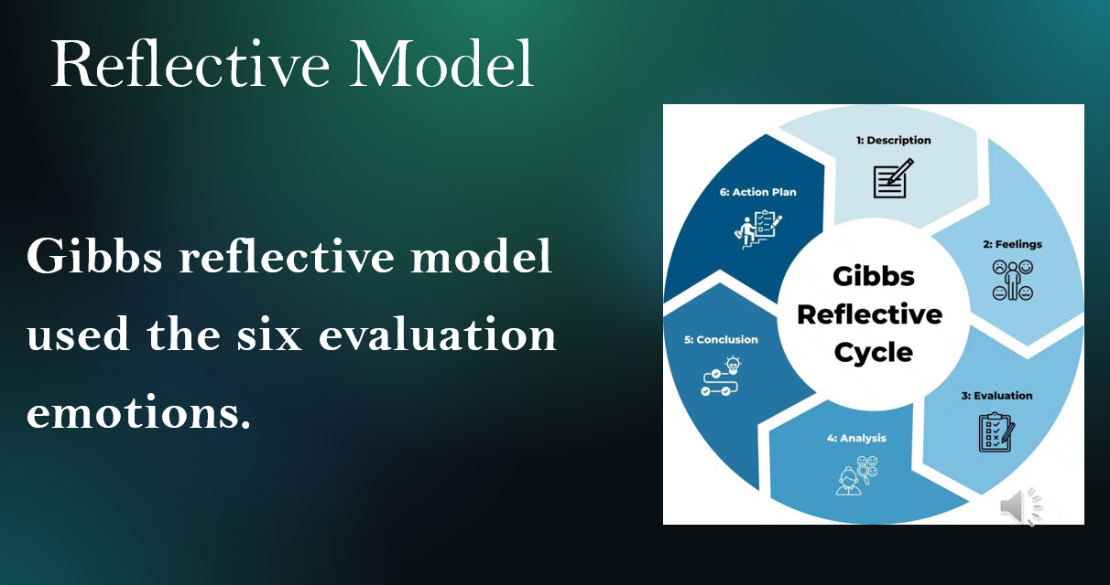
The diagram above shows Gibbs reflective model developed by Graham Gibbs in 1988. It is considered as a model for in depth self-reflection [1]. I will use this model for my own self-evaluation for my SWOT analysis.
Slide 4 TASK 1: SELF EVALUATION
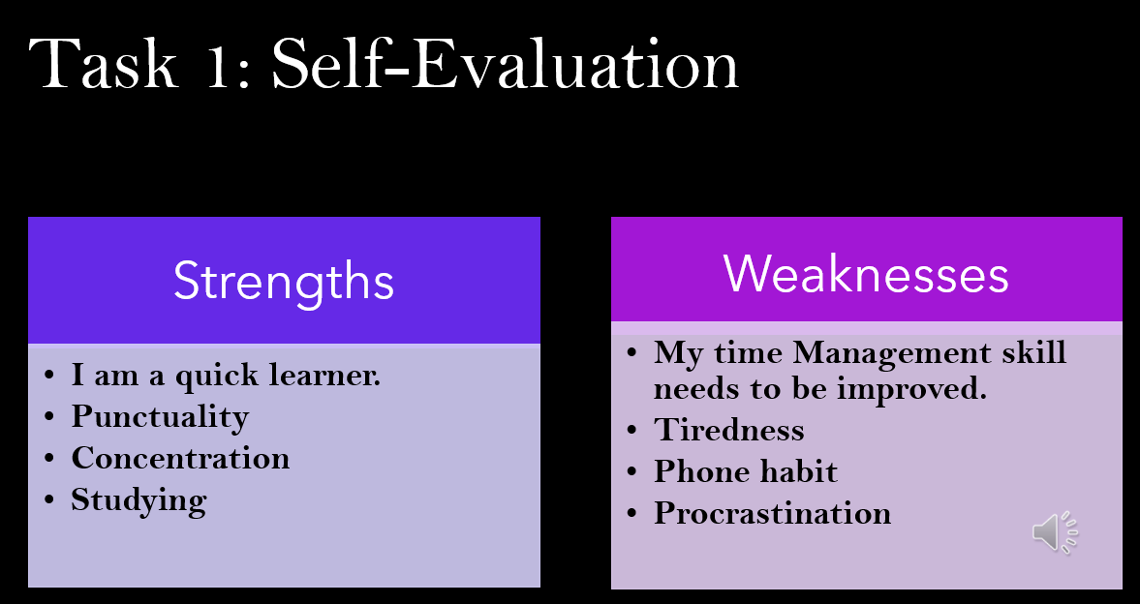
According to my individual SWOT analysis and having used Gibbs Reflective model for my self-evaluation, my key strengths include being able to learn in a fast environment, good timer manager, always concentrate on task and willingness to study. My weaknesses are lack of good time management skills for multitasking, get exhausted faster, phone addicted and always unnecessarily postponing task ahead of time.
Slide 5 TRAITS GAINED FROM THE SELF EVALUATION
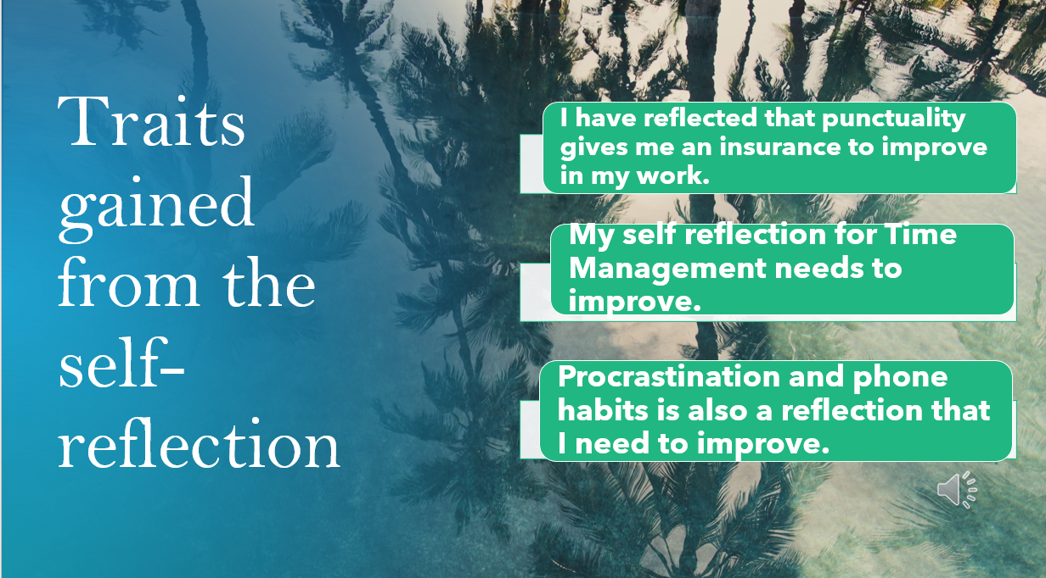
By using the Gibbs model for my self-evaluation, I was able to understand that punctuality gives me an insurance to improve in my work, my time management needs to improve and avoid procrastination and bad phone habits.

Slide 6 PROFESSIONAL DEVELOPMENT PLAN
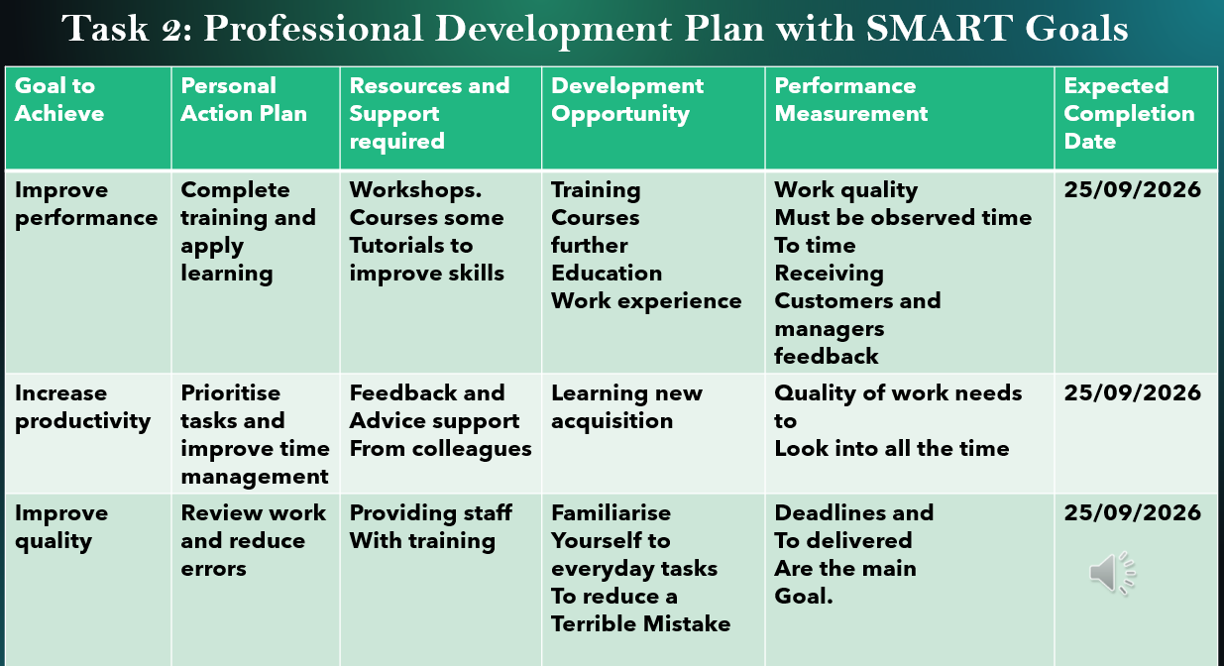
My professional development plan clearly shows my SMART goals of being a reliable manager in terms of improved performance, increased productivity and quality with clear personal action plans, resources and support I need to be successful, the opportunities available, how to measure my performance and also know the expected completion period.
Slide 7 UNIT 4 TOPIC SUMMARY
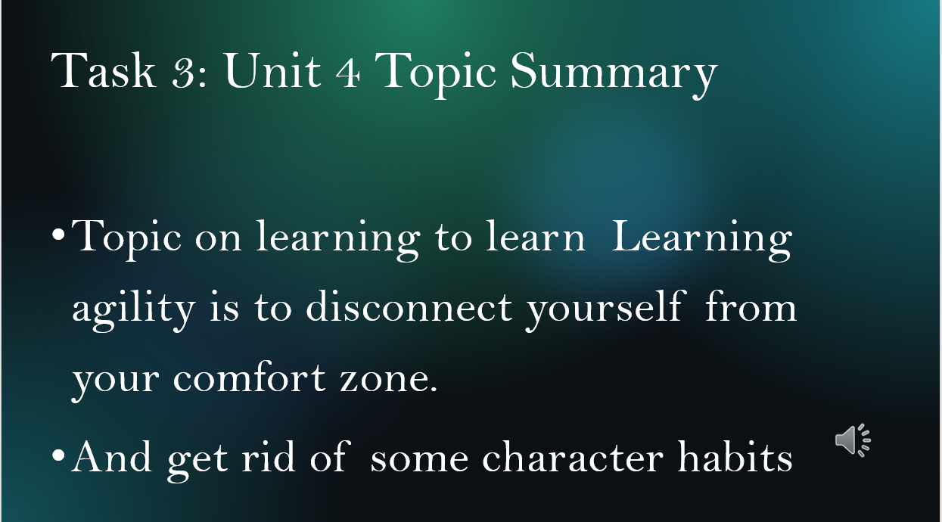
Unit 4 topic of becoming a lifelong learner, subtitled Learning to Learn taught that learning agility required stepping out of my comfort zone for a continuous learning and at the same time getting rid of unwanted habits that hinders learning.
Slide 8 CONCLUSION
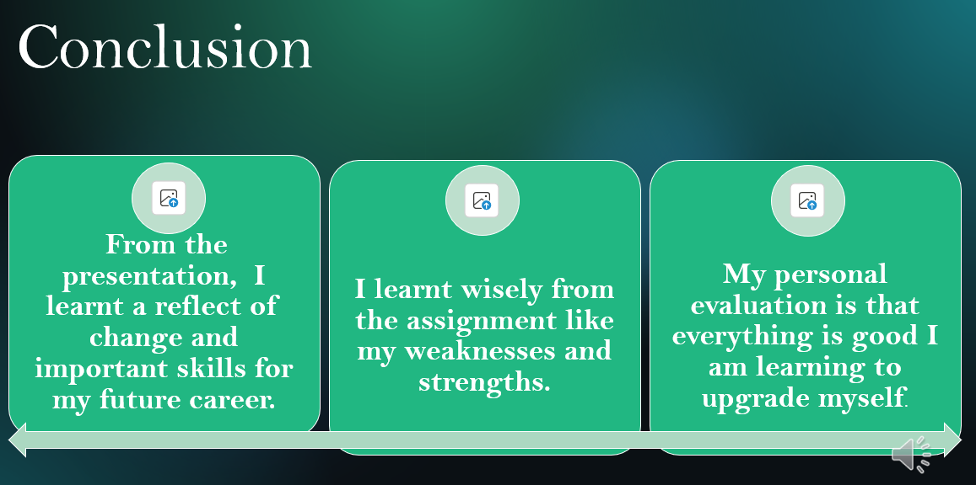
The presentation highlighted keys changes and important skills I need for my future career development. The assignment through self-evaluation I was able to identify my strengths and weaknesses and learnt to appreciate all the learning processes I am taking on currently to achieve my dream career.
Conclusion
In conclusion, the self-evaluation using the Gibbs reflective model clearly identified my strengths and weaknesses and the opportunities to turn my weaknesses into learnings to enhance my experience. The self-evaluation offered a great opportunity to learn important traits such as time keeping improving my performance k and productivity, always completing task as scheduled-no procrastination and avoiding unbecoming habits.
The professional development plan brought out my SMART goals for achieving my dream career in a specific time frame and lastly, learning agility composed myself for continuous learning for my future progress.

Slide 9 References


