  LOCATION Swansea | LLEOLIAD abertawe
LEVEL 6 | LEFEL 6
EXAMINATION PERIOD | CYFNOD ARHOLIADAU
May 2019 | Mai 2019

MODULE CODE: M3X8529
Embedded Microcontrollers
TIME: 2 Hours
answer all four questions

Equipment or materials required – None
The Candidates are not permitted to bring calculators, dictionaries; text books/case studies or any other reference materials into the exam room.

ANSWER ALL FOUR QUESTIONS – Questions are NOT equally weighted.

QUESTION ONE (30 marks total)

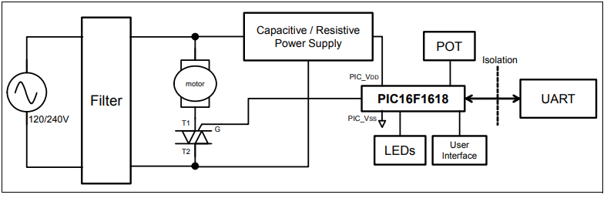

The diagram above depicts an AC motor control system based on an embedded PIC microcontroller.

- Give a general overview on the principles of how a system such as this operates, ensuring you describe the basic function and purpose of each component/block in the diagram (10 marks)
- The PIC16F1618 above contains a ZCD (Zero Cross Detection) module. With the aid of diagrams, explain what ZCD is, and what is its purpose in designs such as this is. (5 marks)
- Using diagram(s) to assist your answer, explain the principles behind phase angle control in situations such as the motor controller above. (10 marks)
- Explain why is it prudent to include the Isolation barrier? Also give one example of how you might actually implement it. (5 marks)

QUESTION TWO (20 marks total)

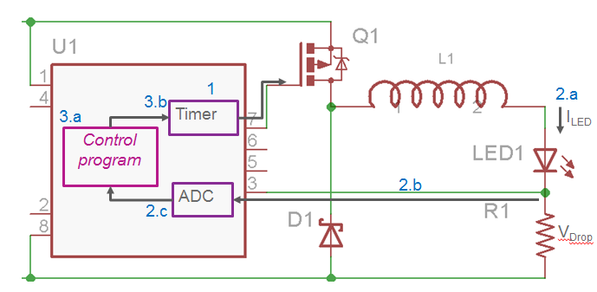

The diagram above depicts an embedded microcontroller (U1) that is being used to control a high power LED in a flashlight.
- What is the purpose of R1? (5 marks)
- Explain what type of signal/waveform you would expect to see coming out of Pin7 to drive Q1. Use diagrams to augment your answer. (5 marks)
- What is the purpose of L1 and why is D1 needed? (5 marks)
- What advantages does using an embedded system as shown give over a dumb/passive implementation where an LED is simply driven via a current limiting resistor? (5 marks)

QUESTION THREE (20 marks total)

- Explain the general principles of what the Boundary Scan method is and why it was originally developed (10 marks)
- JTAG has subsequently been expanded to allow additional functionality over Boundary scanning alone. Give two additional situations where JTAG is now used. (5 marks)
- Briefly explain what is meant when an RTOS (Real Time Operating System) is said to be ‘deterministic’. (5 marks)

QUESTION FOUR (30 marks total)

Often, embedded systems require significant computing power and a PC type architecture is the most suitable solution.

- Write a brief report explaining the principles behind the PC104 standard(s), and what benefits the system gives to embedded systems designers. (10 marks)
- The original PC104 bus is derived from the IBM PC’s ISA bus specification. This allows fairly easy interfacing of custom circuitry directly to the CPU system busses. Sketch a block diagram that outlines the basic bus signals and include typical interface chips/methods that could be used to achieve this interfacing. (10 marks)
- Newer PC104 implementations can have PCI express links that use LVDS signalling. Explain the principles behind LVDS and give two advantages of using this method of data transfer over a conventional parallel bus. (10 marks)

