BSc Health and Social Care
Changemakers: Building Your Personal Brand for Sustainable Employment
BMHP: 5015
Component 2
Olufemi Oluranti
Word Count: 2000

Table of Contents
Introduction 3
Employability skills 4
Evaluate your own skills 5
Action plan and Timeline 6
Personal development planning 7
Building your personal brand 9
Promoting your Professional identity 10
Conclusion 10
Reference 11

Introduction
This assignment evaluates the essential employability skills required for effective practice in health and social care and directly aligns with my goal of becoming a healthcare manager. Strengthening abilities such as communication, leadership, and reflective practice is vital for building professional confidence and demonstrating readiness for managerial roles. Developing these skills not only enhances daily performance but also increases motivation, as feeling competent and appreciated fosters sustained engagement in career advancement. By emphasising how focused skill development contributes to effective management, this assignment outlines a clear pathway for growth within the healthcare sector and preparation for future leadership opportunities.

Job Advertisement

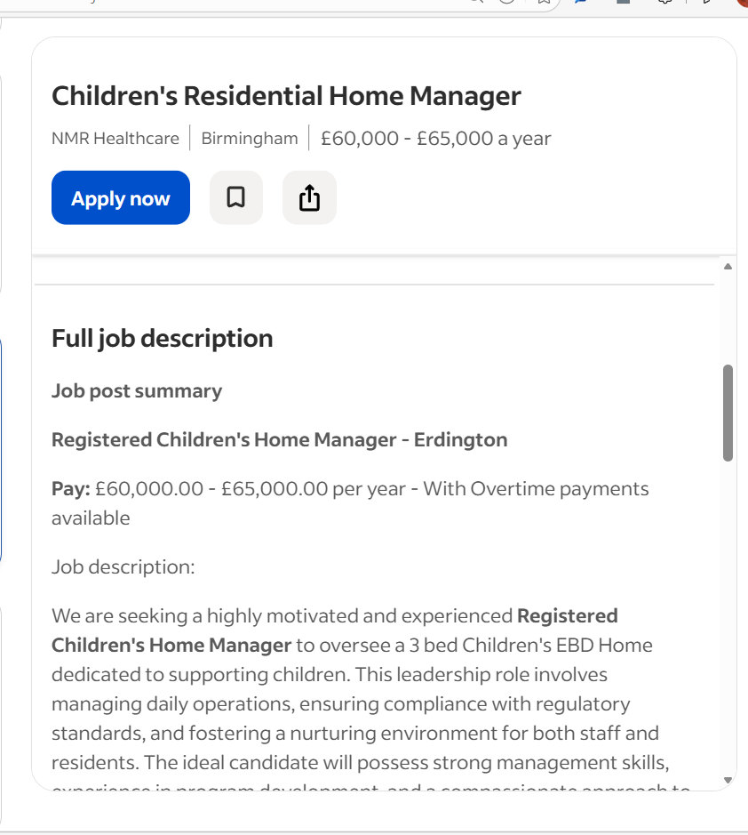

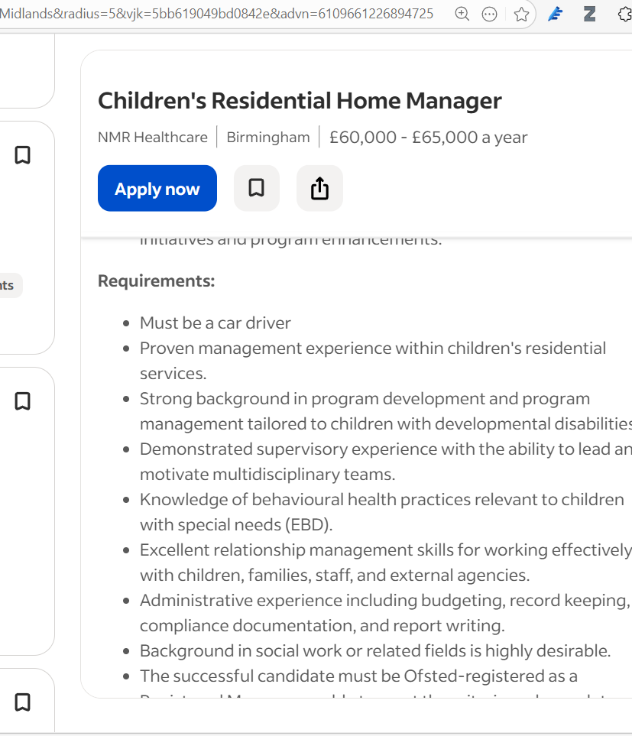

Employability skills
Effective health-care managers must combine clinical understanding with organisational and business expertise to lead safe and efficient services. Contemporary literature emphasises the importance of communication, leadership, analytical decision-making, teamwork, and adaptability (Rudnick, 2022). The national health services and their allied social care partners are experiencing a significant shift towards integrated, person-centred models of care, which reflect national policy priorities for coordinated service delivery (Department of Health and Social Care, 2022). In this evolving landscape, managers at all organisational levels are expected to drive transformational change while simultaneously maintaining service quality, ensuring patient safety, and upholding financial accountability.
Effective healthcare managers need a combination of interpersonal, analytical, and organisational skills to lead patient-centred services that are safe and efficient. Clear communication is vital, as managers must effectively convey priorities, policies, and clinical information across multidisciplinary teams. This ensures a shared understanding and minimises the risk of errors. Strong leadership is equally essential, as managers are tasked with motivating staff, cultivating a positive organisational culture, and guiding teams through ongoing changes. Effective leadership is consistently recognised as a critical driver of successful organisational transformation (Hussain et al., 2018).

In addition, analytical decision-making empowers managers to interpret data, assess risks, and allocate resources wisely, supporting evidence-based practices and financial accountability in a resource-limited environment. Teamwork is of great importance in health and social care settings, where cohesive, collaborative efforts ensure continuity of care and enhance service quality. Managers must nurture positive team dynamics to strengthen staff cohesion and improve patient outcomes. Furthermore, adaptability is crucial, as managers operate in a rapidly changing sector shaped by policy reforms, technological advancements, and fluctuating service demands.

These competencies resonate with the core values and skills deemed necessary for effective healthcare leadership (Dye, 2019). Together, they equip managers to navigate complex organisational landscapes and deliver high-quality, safe, and efficient care.

Evaluate your own skills
Reflecting on personal skills enables a practitioner to critically evaluate their capabilities and identify the steps required for ongoing professional development. Engagement in a level 5 qualification in health and social care, alongside a prior level 4 qualification in healthcare management, has provided a strong theoretical foundation in leadership approaches, reflective practice, and organisational behaviour. These programmes have enhanced understanding of how effective learning environments, reflective practice, and organisational behaviour support professional growth within dynamic health care settings (Griffiths et al., 2024). Specific leadership skills targeted include strategic decision-making, conflict resolution, and stakeholder engagement. Such knowledge strengthens readiness for future roles and aligns with the values and behaviours expected across the sector, including the 6Cs of care, compassion, competence, communication, courage, and commitment (NHS England, 2025).

One identified strength is an authoritarian leadership style, which can promote clarity and structure within organisations; however, it may also reduce staff autonomy and satisfaction if not balanced with collaborative approaches. Key professional assets include strong problem-solving skills abilities, effective time management skills, and clear communication. Areas requiring further development include public speaking and presentation skills, as evidenced by group activities in which articulating ideas confidently proved challenging. As teamwork is essential within health and social care, strengthening public speaking abilities will enhance contributions to collaborative decision-making and support effective team functioning. To address this, enrolment in targeted short courses focused on public speaking is planned to build confidence, improve delivery and enhance overall professional competence.

Action plan and Timeline
Effective communication and continuous personal development are essential for advancing towards specific healthcare management roles. This assignment outlines a three-part action plan: a short course in public speaking, a short course in presentation skills, and participation in a personal development plan cycle. It draws on contemporary research emphasising transferable skills, reflective learning, and strategic self-management. Riley et al. (2019) highlight the transfer of skills in adapting competencies across professional contexts, while Bilardi et al. (2024) demonstrate the effectiveness of blended learning in developing communication skills. Reflective practice, as noted by Bornman and Louw (2023), allows individuals to evaluate their performance and identify areas for improvement. Bryson (2011) also emphasises strategic planning to set goals and align development with specific healthcare leadership aspirations, ensuring the plan directly supports readiness for healthcare leadership roles.

- Public Speaking Short Course
Phase | Action | Rationale | Timeline
Preparation | Create a 10-questionnaire to identify gaps in confidence. | Consistent with the suggestion by Riley et al. (2019), diagnostics that focus on the learner enhance skill adoption. | 1 week
Delivery | Sign up for a 4-week blended course that includes 2 hours of live webinars and 2 hours of self-paced video each week. | Bilardi et al. (2024) demonstrate that blended learning formats enhance retention for adult learners. | 4 weeks
Practice | Engage in weekly "micro-speech" groups (5-minute intervals) where peers provide feedback based on a set rubric. | Provides spaced rehearsal, a proven accelerator of speaking fluency (Riley et al.,2019) | 2-5 weeks
Assessment | Produce a 5-minute persuasive presentation: submit it for expert assessment and earn a competency badge. | Official evaluations confirm the transfer of knowledge and encourage individuals to finish their tasks (Bryson, 2011). | 6 weeks
Reflection | Complete a reflective entry using the Gibbs Cycle, focusing on coping strategies. | Bornman and Louw (2023) emphasise the role of reflection in promoting behavioural changes | - weeks

- Presentation-skills short course
Phase | Action | Rationale | Timeline
Kick-off | Use a self-audit checklist to assess visual design skills. | Sets the standard for focused learning (Riley et al., 2019). | 1 week
Instruction | Participate in a 3-week immersive workshop (3 hours) focused on slide design, narrative techniques, and audience assessment. | Bilardi et al. (2024) show that intensive workshops enhance design-thinking skills. | 3 weeks
Peer-review | Swap presentations with a partner: utilise a jointly created evaluation matrix (clarity, visual attractiveness, engagement). | Peer assessment deepens metacognitive awareness (Bornman and Louw,2023). | 5 weeks
Certification | Send the completed presentation to the course moderators for certification of "Advanced Presentation Skills." | Official certification enhances motivation. | 6-8 weeks

Personal development planning
Goal-setting week 1: The PDP process begins by identifying specific developmental priorities using SMART criteria. Two immediate goals are identified: boosting confidence in public speaking and improving presentation delivery skills. In addition to these, one long-term career goal is to pursue a leadership position that requires advanced communication skills. Establishing goals in this organised way offers clear direction, fosters accountability, and ensures that development efforts align with broader professional objectives.

Action- Mapping
The next stage involves creating a systematic action plan for the selected short courses, ensuring live sessions don’t overlap, and learning is organised for maximum skill development. Additionally, three hours weekly are set aside for reflective writing and journal assessments. This promotes ongoing assessment of progress. Borman and Louw (2023) highlight that systematic reflection boosts self-awareness, metacognitive skills, and ongoing growth. The PDP cycle provides a structured framework for developing communication skills crucial for future careers.

Monitoring and review (7-8 weeks)
Progress is assessed using Bryson’s (2011) “Plan-do-check-act” cycle, which offers an organised framework for ongoing improvement.
Plan: Verify that all course milestones and learning activities have been finished in accordance with the schedule.
Do: Present a 15-minute integrated presentation to a diverse audience of peers and faculty to showcase the use of newly acquired communication skills.
Check: Evaluate audience feedback and performance ratings, comparing them to the initial self-assessment to pinpoint measurable advancements and persistent skill gaps.
Act: Revise the PDP to include newly identified development needs, such as enhancing negotiation and influencing skills, to ensure the learning path remains aligned with long-term professional aspirations.

Future roadmap 6-12months
To reinforce and expand the skills gained from the short courses and the DPD cycle, a mentorship session with an experienced communication specialist has been arranged. This supports the findings of Riley et al. (2019), who highlight the significance of expert support in facilitating the application of newly learned skills in real-world workplace environments. Through mentorship, reflective discussions, and focused practice, communication skills can be more thoroughly integrated into professional conduct, enhancing preparedness for prospective leadership roles.

Building your personal brand
A strong personal brand conveys credibility, compassion, and professional expertise, which are vital in health and social practice. It's crucial to define a clear value proposition that showcases clinical competence and ethical values (Du et al., 2025). Clear communication of unique contributions enhances service delivery and aligns with sector expectations. Consistent messaging across digital platforms and professional interactions builds authenticity and trust. This coherence helps recruiters and colleagues recognise a reliable, values-driven profile. By focusing on compassion, accountability, and quality practice, practitioners boost their visibility, reputation, and long-term career progression in the evolving healthcare landscape.
LinkedIn: Develop a concise, professional headline that integrates role identity and specialist focus (e.g.,” Registered Nurse Community-Based). The “about” section should highlight measurable achievements and professional service credibility.
Personal website: Create a digital portfolio showcasing case studies, accredited training, and a downloadable CV. Incorporating SEO-optimised healthcare terminology enhances visibility and supports engagement from employers and professional networks.
Professional Networking Events: deliver brief, well-structured elevator pitches to introduce expertise and career interest. Collect contact details and follow up with personalised LinkedIn invitations that reference shared discussions to reinforce professional rapport.
Social media: Share succinct insights, policy developments, or short reflective videos to demonstrate sector awareness. Using targeted hashtags such as #Socialcareinnovation enables participation in wider professional conversations and increases reach within the health and social care community.
Content strategy: Publishing concise blog posts or peer-reviewed pieces helps establish a credible professional voice by analysing real-world scenarios and showcasing evidence-based interventions (Andraus Quintero et al., 2025). Including anonymised, well-structured case studies further demonstrates critical thinking, problem-solving ability, and a commitment to ongoing learning (Jena, 2017). Together, these outputs strengthen professional identity and highlight reflective, practice-informed expertise.

Promoting your Professional identity
Customizing the CV and cover letter for each job is essential to demonstrate suitability for the role. Highlighting relevant skills, quantifying achievements, and using job-specific keywords align with employer expectations and applicant-tracking systems (Gorbatov, Khapova & Lysova, 2019). A brief professional summary at the CV's start showcases the applicant's value, while the cover letter connects past accomplishments to job requirements. This targeted approach enhances professional positioning and employability.

Online presence
Establishing a robust online presence is crucial for enhancing professional visibility. A polished LinkedIn profile ought to feature a current headline that reflects the desired position, a thorough experience section, and endorsements that validate essential skills. Engaging in personal projects, obtaining certifications, and collecting testimonials provide recruiters with a more holistic view of professional abilities. Regular participation in industry groups and sharing insightful content can boost credibility and aid in expanding one’s network.

Building a network for successful employment
Networking is vital in the health and social care sector, linking knowledge, opportunities, and influence. It grants access to crucial information on policy changes, funding, and best practices that is often unavailable through formal channels. Networking boosts professional credibility, as referrals from respected leaders act as endorsements and aid career mobility, with many senior roles filled through informal connections. Engaging in webinars and peer-review groups promotes continuous learning in clinical governance and digital innovation while also offering emotional support for managing stress and maintaining performance.

Conclusion
Effective communication is essential in healthcare management, enabling leaders to convey complex information clearly to clinicians, commissioners, and the public. Strong presentation skills, logical organisation, effective visuals, and controlled delivery are vital for engaging stakeholders and ensuring performance data is understood across teams. Public speaking further extends influence, with confident delivery building trust. These skills can be developed through training, peer feedback, and regular practice. Additionally, continuous reflection contributes to improvement. Coupled with strategic networking, polished communication abilities enhance employability and empower managers to shape the future of health and social care.

Reference
Andraus Quintero, C.E., Vega Mendoza, D.L., Esquivel Garcia, R., Mendoza Véliz, D.K., Espinel Zambrano, P.M. and Arteaga Biones, L.A. (2025). The Impact of Social Media on Healthcare Professionals’ Branding. Salud, Ciencia Y Tecnología, 5, p.1539. doi:https://doi.org/10.56294/saludcyt20251539. (Accessed 20 March 2026)
Bilardi, D., Rapa, E., Shah, K., Zeeshan, S., Baker, B.L. and Lang, T. (2024). Professional development scheme: a tool to measure health research competencies in healthcare professionals. BMJ Leader, [online] 9, p.leader-2024-001036. doi:https://doi.org/10.1136/leader-2024-001036.(Accessed 20 March 2026)
Bornman, J. and Louw, B. (2023). Leadership Development Strategies in Interprofessional Healthcare collaboration: a Rapid Review. Journal of Healthcare Leadership, [online] 15(15), pp.175–192. doi:https://doi.org/10.2147/JHL.S405983.(Accessed 20 March 2026)
Bryson, D. (2011). The Personal Development Planning Cycle. Journal of Visual Communication in Medicine, [online] 34(4), pp.177–182. doi:https://doi.org/10.3109/17453054.2011.635290.(Accessed 20 March 2026)
Department of Health and Social Care (2022). Leadership for a Collaborative and Inclusive Future. [online] GOV.UK. Available at: https://www.gov.uk/government/publications/health-and-social-care-review-leadership-for-a-collaborative-and-inclusive-future/leadership-for-a-collaborative-and-inclusive-future.(Accessed 20 March 2026)
Du, W., Yang, Y., Guo, X. and Vogel, D. (2025). Building Physicians’ Personal Brand and Boosting Online Return: The Role of Social Media Engagement. International Journal of Electronic Commerce, 29(2), pp.272–303. doi:https://doi.org/10.1080/10864415.2025.2471674.(Accessed 20 March 2026)
F. Dye, C. (2019). Leadership in Healthcare Essential Values and Skills. [online] Google.co.uk. Available at: https://www.google.co.uk/books/edition/Leadership_in_Healthcare_Essential_Value/9L5TEQAAQBAJ?hl=en&gbpv=1 [Accessed 18 Mar. 2026].
Gorbatov, S., Khapova, S.N. and Lysova, E.I. (2019). Get Noticed to Get Ahead: the Impact of Personal Branding on Career Success. Frontiers in Psychology, [online] 10(2662). Available at: https://www.frontiersin.org/articles/10.3389/fpsyg.2019.02662/full.(Accessed 25 March 2026)
Griffiths, M., Monaghan, K., Monaghan, M. and Tompkins, V. (2024). Developing New Healthcare Practice Learning Environments through a third-space Reflective Practice approach: a Case Study. Health Education. doi:https://doi.org/10.1108/he-03-2024-0042.(Accessed 25 March 2026)

Hussain, S.T., Lei, S., Akram, T., Haider, M.J., Hussain, S.H. and Ali, M. (2018). Kurt Lewin’s Change model: a Critical Review of the Role of Leadership and Employee Involvement in Organizational Change. Journal of Innovation & Knowledge, 3(3), pp.123–127.(Accessed 25 March 2026)

Jena, B.N. (2017). Effective Marketing Tool for the Marketing Professionals in Healthcare organization: the 4 ‘S’ Model. International Journal of Healthcare Management, 13(3), pp.1–6. doi:https://doi.org/10.1080/20479700.2017.1402423..(Accessed 25 March 2026)
Kongsri, N. and Jaroenwanit, P. (2024). Key Aspects of Personal Brand Identity in Social Media commerce: Impact on Successful Personal Branding. International Journal of Data and Network Science, [online] 8(4), pp.2663–2676. doi:https://doi.org/10.5267/j.ijdns.2024.4.012.(Accessed 25 March 2026)
NHS England (2025). The 6 Cs of Care. [online] NHS Professionals. Available at: https://www.nhsprofessionals.nhs.uk/nhs-staffing-pool-hub/working-in-healthcare/the-6-cs-of-care.(Accessed 25 March 2026)
Riley, M., Robinson, K., Prasad, N., Gleeson, B., Barker, E., Wollersheim, D. and Price, J. (2019). Workforce survey of Australian graduate health information managers: Employability, employment, and knowledge and skills used in the workplace. Health Information Management Journal, 49, p.183335831983929. doi:https://doi.org/10.1177/1833358319839296.(Accessed 25 March 2026)
Rudnick, A. (2022). The Importance of Skills Training for Service Users in Health Care: a Comparative Analysis. Healthcare, 10(8), p.1554. doi:https://doi.org/10.3390/healthcare10081554.(Accessed 25 March 2026)

