Student name: Lowri Morris
Programmes: BA (Hons) Leisure, Events, Tourism & International Travel & Tourism Management
Module: Niche Marketing & Social Media
Module Code: BMTH4014
Lecturer: Chris Wilkin
Assignment Title: Marketing Report
Word Count: 1500 Words (+/-10%)
Submission Deadline: 12th December 2025

Ai Acknowledgment Statement
I confirm that I have not used Ai tools in the research and creation of the assignment. I confirm that I have not presented any Ai generated materials as my own work. I confrim I have copies of my draft, notes, and other resources I used, which I may be asked to provide as evidence.

Introduction
In this report, I will be focusing on promoting a marketing plan for the Swansea Areana House Party. The purpose of my marketing plan is to raise awareness about the event and to increase a larger audience, this would also lead to making a bigger profit for future events which would be a beneficial impact. Furthermore, the Swansea Areana House Party is aimed at an audience who enjoys a variety of music genres therefore the target audience is towards young adults, elderly people and families.
I will be structuring my marketing plan by using different frameworks. Such as SOSTAC (Smith, P.R. (2011) The SOSTAC Guide to Writing Your Perfect Digital Marketing Plan. Great Britain: PR Smith.), using SOSTAC will provide the overall planning structure, which will keep it organised. Another framework is the 4’Ps, this gives a guidance especially when it comes to developing the marketing plan, along with the use of Ansoff's Matrix it can be used to recognise useful strategies to help with the development. Moreover, referring to in – class topics using strategic marketing, market segmentation and niche planning could be a useful way to structure my marketing plan. Strategic marketing helps with the direction, marketing segmentation identifies the target, and niche planning helps with the response of an audience. (Kotler, P. and Keller, K., 2016. Marketing Management. 15th ed. Harlow: Pearson.)

Situation Analysis
Strengths | Weaknesses
- Modern venue (arena), large space, high quality facilities and amenities.  - Popular venue for live music and nightlife events.  - The venue has the ability of attracting popular DJ's or performers as of its reputation.  - The Swansea arena is central, easy for people to access on foot.  - Swansea arena has good social media presence, developing recognition outside of Swansea. | - High operating prices such as equipment, staff and security.  - Limited parking spaces, public transport can be an issue for customers that don't live locally.  - Complaints from residents due to traffic or noise from the arena.  - Dependant on weather especially for queuing outdoors.  - High ticket prices for some events, may be an issue for students or a young audience.

Opportunities | Threats
- A venue that can attract tourists outside of Swansea.  - A wide variety of options to have partnerships.  - Nightlife and the interest in music is growing among people.  - Opportunities to collaborate with Welsh artists to increase visibility.  - Swansea Arena has the equipment to expand into themed nights or house parties, making it a bigger attraction. | - Rising costs in transportation  - Issues with economics as there’s a downfall in disposable income for entertainment.  - Competition with local bars, clubs and events.  - Unexpected cancellations, transportation issues or poor weather.  - Customers having safety concerns, the cost of everything and event regulations
This is a SWOT analysis table.
Gurel, E. and Tat, M., 2017 SWOT Analysis: A Theoretical Review.

Company – Referring to what I disclosed, the Swansea arena would obtain a variety of strengths. The location of the arena is central which is convenient for locals or tourists visiting and there are many accessibilities provided to help anyone with problems. On the other hand, the weaknesses may create an issue of attendance to the event as there are limited parking spaces and public transportation which can have issues like cancellations. But the opportunities that are given to the area means they are equipped to expand and decrease those issues from developing as it has become a big attraction. However, the threats that the event could face is costs rising, weather issues or customers having safety concerns, using the 5’s will give structure. (Chernev, A., 2020. Strategic Marketing Management: Theory and Practice).
Customers - The customer sector for Swansea arena illustrates three customer profiles, using psychographics, demographics, geographic and behavioural. From looking at my appendix B, I made three customer profiles (Similar Web), the profiles are different examples of what kind of customers that may attend the event and the difference in what they need provided.
Competitors - From the perceptual map, appendix A, it portrays where the Swansea Arena has been placed between high- and low-quality experience, high and low price. I placed the Swansea arena there as the venue would have competition from other venues such as Depot, Tramshed, Wind Street clubs and so on. Also, the Swansea arena has a rise in popularity and provides decent prices for events. Meanwhile, the venue Friction would not be as much of a threat because of the low pricing and not having as a high-quality venue compared to the Swansea Arena.
Collaborators – Having collaborations can positively benefit the event as it would improve attendance and marketing. For example, having collaborations with apps like Skiddle or Ticket master would help target the right audience as all information about the event will be on the app for people to investigate. Furthermore, having partnerships with social media marketers or performers will increase the chances of people being more interested as more knowledge will be provided.
Climate – Referring to the PESTLE framework, the Swansea Arena House Party illustrate factors of macro – environment which shapes the event. Such as economic pressures, advancing technologies, social trends, safety requirements, and political, environmental issues which can affect the attendance and marketing effectiveness. (Johnson, G., Whittington, R., Scholes, K., Angwin, D. and Regner, P. 2020. Exploring Strategy. 12th ed. Harlow Pearson).

Objectives
SMART objective – To increase overall attendance to the event by 15% in 12 weeks by aiming at local and popular music, performers. It aligns with my marketing goals as performers like live experiences, this will strengthen ticket sales, visibility and interest.
MindTools, 2025. SMART Goals: How to make your goals achievable. https://members.mindtools.com/a4wo118/smart-goals (2025)

Strategy
The Ansoff Matrix is a strategy to use when planning, especially when focusing on developing products and marketing. ‘it’s a strategic planning tool that links an organisation's marketing strategy with its general strategic direction’, (p. 144., Ana Patricia Pereira Ferraz Soares Ferreira, and Maria Beatriz, 2024). Reflecting on Ansoff Matrix my overall market strategy for the Swansea arena house party event focuses on developing attendance for the event.
The marketing mix can include ticket packaging that would make attendees experiences cheaper and the Swansea arena would earn reasonable profit. Ticketing packages usually include admission, family packages and group bundles, pricing usually increases if attendees want a VIP ticket which promote early sales. Tickets tend to have easy accessibility online therefore using the app Ticketmaster would be beneficial. (Kotler, P., & Keller, K. L (2016). Marketing Management).
“Customer Relationship Management software helps companies measure and get control of their lead generation and sales pipelines far beyond traditional spreadsheets” (What is Customer Relationship Management, CRM? IBM, 2021). The Swansea arena uses CRM as it helps manage big crowds, marketing and ticket sales. Venues like Swansea arena tend to use a CRM to understand their customers and to track progress, using apps like Audience View can show the company what their customers are interested in, how to make the event better, and the budget. It is also beneficial for Swansea Arena to use CRM to develop their digital marketing and performance metrics to make customer experiences better.

Tactics
The Swansea Arena is known for using the RACE framework, ‘RACE consists of four steps or online marketing activities designed to help brands engage their customers throughout the customer lifecycle’, (Dr Dave Chaffey, digital insights, 2023.) (Reach, Act, Convert, Engage.) Focusing on the Swansea arena house party event, the RACE framework and the communication mix come into role because the target market is to reach locals and students through creating social advertisement and to engage with competitors and influences for content which is act. Converting tickets through online apps like Ticketmaster and remaining loyal to customers through emails and offers is another form of engagement that would benefit the Swansea Arena.
Furthermore, referring to the situational analysis, the Swansea Arena house party event use communicational tactics to address the issues such as targeting social media to attract a new or specific audience to the event, using TikTok or Facebook which is a positive benefit as social media is now used by most people. If customer engagement with the event is low, using CRM can strengthen and ensure that communication equals to the audience preferences and issues. This links to examples of different customer profiles as the customers have different needs and expectations from the event therefore using RACE and the communication mix is a good idea to ensure satisfaction from customers. ‘The communications mix in marketing comprises of the various ways that a company can communicate with its customers’, Marketing91, Hitesh Bhasin, 2025.
By looking into the Swansea arena’s current social media situation, it seems that there is a lack of communication and engagement between the company and customers, especially on Twitter. Looking at the Swansea Arena website, (https://www.swansea-arena.co.uk/visitors ) it portrays that they keep in contact with customers through email or advertisement which could lead to a negative review as it links to inactivity. Consistent content and follow ups on events seems to be what the Swansea Arena is lacking in the most therefore I would improve this by creating offers such as discounts and interactive posts for customers to engage with, this would also help with getting feedback from events and what the arena can do better with.

Action
My action plan contains my marketing channels, (Batra, R. & Keller, K.L., 2020. Integrating marketing communications and directions: New developments and Directions). As we live in a modern world with new technology developments, I have decided to prioritise social media as my marketing strategy because using popular social media platforms such as TikTok, twitter, Facebook or Instagram can attract many people to the Swansea Arena Event and it is an effective way to gain marketing knowledge especially knowing how to target the right audience.

Control
I would manage the success of my marketing plan by using key performance indicators, for example, new attendees indicate development in visibility, and it shows if the progress of the events marketing is good and developing. (Chaffey, D., & Smith, P, R., 2022. Digital Marketing Excellence: Planning, Optimising, and Integrating Online Marketing). Using social media would also show progress as you can view if there's any new followers and comments. Furthermore, tracking web searches or website traffic can help marketers to see whether their marketing is gaining interest and for extra information about the house party event. Managing profit is also beneficial because comparing ticket prices or sales against marketing costs will help progress and gain success. Developing digital engagement with customers, raising awareness about the event and having a financial strategy, these key performance indicators provide a visual of progress and success.

Conclusion
To conclude, my marketing plan for the Swansea arena house party event aims on attracting an audience such as locals, students or an auidence beyond Swansea through targeting advertisement, interactive engagement on social media and developing new measures for customer experiences. The challenges that may be faced is low social media activity due to the Swansea Arena’s current status and customers not being happy with ticket sales as some think it is overpriced or the lack of marketing for some events. To overcome these challenges, I recommend future campaigns to focus on stronger partnerships with influencers, locals and companies to ensure that Swansea Arena will have a good outcome and a clear structure for the organisation.
Furthermore, my marketing plan includes the use of the 5 C’s which is company, customers, competitors, collaborators, and climate, the 5 Cs has also helped with identifying challenges that the Swansea Arena can face. By creating customer profile examples in my appendix, it gave me a perspective on the different needs that customers have therefore marketing is crucial. I would make sure that the marketing for events is directly aimed for the right audience and to look into discounts for students as many struggle with income.

References
- Batra, R. & Keller, K.L., 2020. Integrating marketing communications and directions: New developments and Directions)
- Chernev, A., 2020. Strategic Marketing Management: Theory and Practice
- Chaffey, D., & Smith, P, R., 2022. Digital Marketing Excellence: Planning, Optimising, and Integrating Online Marketing
- Dr Dave Chaffey, digital insights, 2023
- Gurel, E. and Tat, M., 2017 SWOT Analysis: A Theoretical Review.
- Marketing91, Hitesh Bhasin, 2025.
- What is Customer Relationship Management, CRM? IBM, 2021
- Johnson, G., Whittington, R., Scholes, K., Angwin, D. and Regner, P. 2020. Exploring Strategy. 12th ed. Harlow Pearson
- Kotler, P., & Keller, K. L (2016). Marketing Management
- Kotler, P. and Keller, K., 2016. Marketing Management. 15th ed. Harlow: Pearson
- MindTools, 2025. SMART Goals: How to make your goals achievable.
- p. 144., Ana Patricia Pereira Ferraz Soares Ferreira, and Maria Beatriz, 2024
- mith, P.R. (2011) The SOSTAC Guide to Writing Your Perfect Digital Marketing Plan. Great Britain: PR Smith
- https://www.swansea-arena.co.uk/visitors
- Similar Web

Appendices
Appendix A – Competitor Analysis
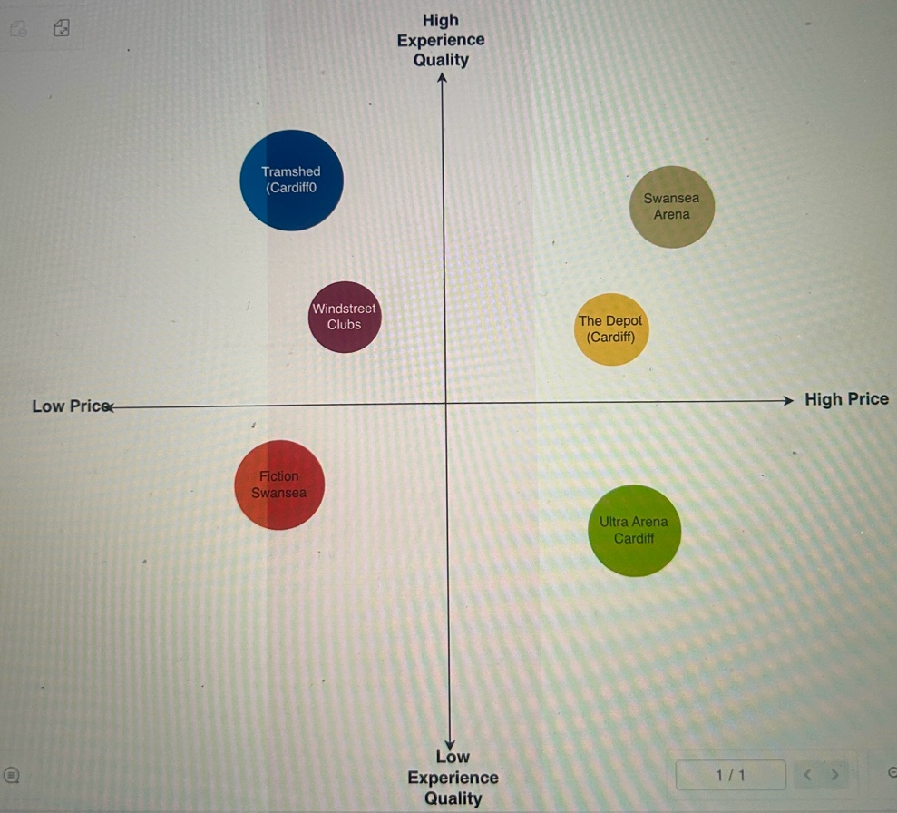

Appendix B – Customer Profile
Customer profile 1 – Student | Customer profile 2 – Introverted person | Customer profile 3 -  Tourist
Geographic  - Lives in Swansea, in a student accommodation or house.  - Travels mainly by walking or bus.  - Enjoys the nightlife and has knowledge on local nightlife spots.  Demographic  - Age 18 – 25  - Full time university student.  - Budgets money  Psychographic  - Likes new experiences, enjoys socialising and having fun.  - -Enjoys music, trending events.  - Attends affordable events with offers.  Behavioural  - Books last minute tickets.  - Frequently going out and with friends.  - Loves to share experiences on social media and tends to leave feedback. | Geographic  - Lives nearby Swansea, Uplands in their own home.  - Travels by walking or car.  - Likes their alone time and has a small friend circle.  Demographic  - Age 20 – 25  - Has a full-time job in hospitality.  - Has a good income.  Psychographic  - Wants to try new experiences.  - Enjoys reading and performances.  - Attends social events with friends.  Behavioural  - On social media a lot, keeps up with trends.  - Has a balanced life between work and socialising.  - Sometimes browsers for things to do with friends. | Geographic  - Lives in London.  - Travels by train, car, bus.  - Loves seeking for new experiences whilst balancing work life.  Demographic  - Age 25 – 30  - Young adult with a secure income.  - Full time j0ob in journalism.  Psychographic  - Always wanting a memorable night.  - Always ready to adventure the world and try new things.  - Influenced by tourism websites, reviews and friends.  Behavioural  - Often travels for work and ends up on a night out.  - Shares experiences and writes about them.  - Always online finding feedback about events.

