

LEVEL 4

SEMESTER 1

MODULE CODE: CLCS4007
ATHENS AND ROME: LIFE AND CULTURE IN CLASSICAL ANTIQUITY

aSSESSMENT TYPE: GOBBET, component 1

COMPONENT WEIGHTING: 50%

WORD COUNT: 1,000 words

MODULE TUTOR: Dr Matthew Cobb

Pick one of the following passages or images and write an essay of 1,000 words (this is worth 50% of your mark). For the passages comment upon the context, content, and any relevant parallels that can be drawn from other historical sources; for the images comment upon their nature, imagery and political, social or economic significance.

1) “Hearing that the boy was at my house, he came there at night in a drunken state, broke down the doors, and entered the women's rooms: within were my sister and my nieces, whose lives have been so well-ordered that they are ashamed to be seen even by their kinsmen” – Lysias Against Simon 3.6 – trans. by W. R. M. Lamb (1930).

2) “Soon afterwards one of his own slaves murdered the city-prefect, Pedanius Secundus, either because he had been refused his freedom, for which he had made a bargain, or in the jealousy of a love in which he could not tolerate his master's rivalry. Ancient custom required that the whole slave-establishment which had dwelt under the same roof should be dragged to execution, when a sudden gathering of the populace, which was for saving so many innocent lives, brought matters to actual insurrection… Still, the party which voted for their execution prevailed.” – Tacitus Annals 14.42 – trans. by J. Jackson (1937).

3) “But on the contrary, in the days of our ancestors, it was these that were to be seen in their halls, and not statues made by foreign artists, or works in bronze or marble: portraits modelled in wax were arranged, each in its separate niche, to be always in readiness to accompany the funeral processions of the family; occasions on which every member of the family that had ever existed was always present. The pedigree, too, of the individual was traced in lines upon each of these coloured portraits. Their muniment-rooms, too, were filled with archives and memoirs, stating what each had done when holding the magistracy.” – Pliny NH 35.2.4-6 – trans. by J. Bostock and H. T. Riley (1855).

4)
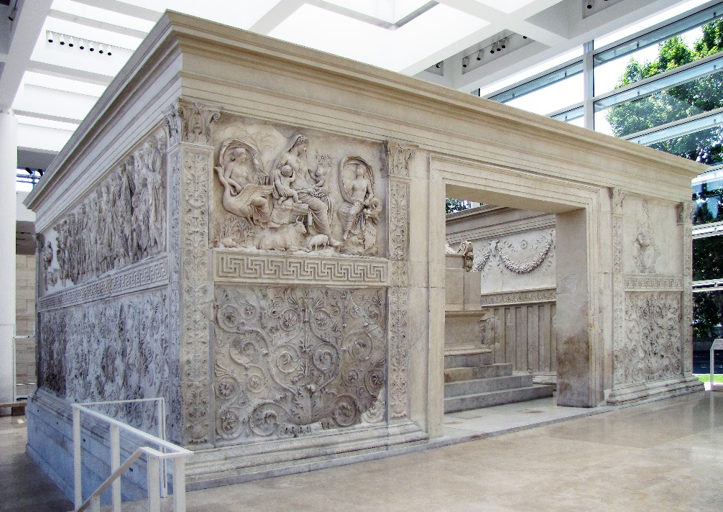
Ara Pacis

5)
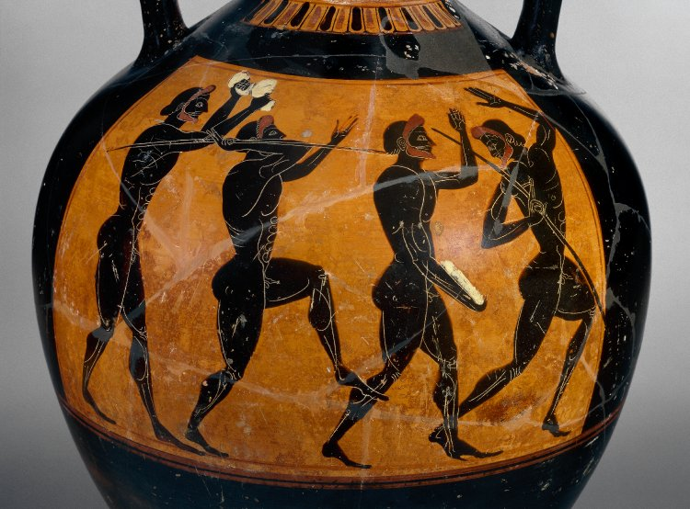
Panathenaic amphora – c. 530-520 BC

SUBMISSION DETAILS: A turn-it-in link will be set up on the module’s Moodle page through which students should submit their work. Students must submit before the specified deadline.

LEfEL 4

SEMESTER 1

Cod Y modIwl: CLCS4007
ATHENS AND ROME: LIFE AND CULTURE IN CLASSICAL ANTIQUITY

mATH O ASESU: Gobbet, COMPONENT 1

PWYSAU’R CYDRAN: 50%

NIFER Y GEIRIAU: 1,000 words

TIWTOR Y MODIWL: Dr Matthew Cobb

Pick one of the following passages or images and write an essay of 1,000 words (this is worth 50% of your mark). For the passages comment upon the context, content, and any relevant parallels that can be drawn from other historical sources; for the images comment upon their nature, imagery and political, social or economic significance.

1) “Now, since it is thought that he proceeded thus against the Samians to gratify Aspasia, this may be a fitting place to raise the query what great art or power this woman had, that she managed as she pleased the foremost men of the state, and afforded the philosophers occasion to discuss her in exalted terms and at great length. That she was a Milesian by birth, daughter of one Axiochus, is generally agreed… and so Aspasia, as some say, was held in high favour by Pericles because of her rare political wisdom. Socrates sometimes came to see her with his disciples, and his intimate friends brought their wives to her to hear her discourse, although she presided over a business that was anything but honest or even reputable, since she kept a house of young courtesans… However, the affection which Pericles had for Aspasia seems to have been rather of an amatory sort. For his own wife was near of kin to him, and had been wedded first to Hipponicus, to whom she bore Callias, surnamed the Rich; she bore also, as the wife of Pericles, Xanthippus and Paralus. After, since their married life was not agreeable, he legally bestowed her upon another man, with her own consent, and himself took Aspasia, and loved her exceedingly.” - Plutarch Life of Pericles 24.1-3, 5 – trans. by Bernadotte Perrin (1916).

2) “I have lodgings right over a bathing establishment. So picture to yourself the assortment of sounds, which are strong enough to make me hate my very powers of hearing! When your strenuous gentleman, for example, is exercising himself by flourishing leaden weights; when he is working hard, or else pretends to be working hard, I can hear him grunt; and whenever he releases his imprisoned breath, I can hear him panting in wheezy and high-pitched tones. Or perhaps I notice some lazy fellow, content with a cheap rubdown, and hear the crack of the pummeling hand on his shoulder, varying in sound according as the hand is laid on flat or hollow. Then, perhaps, a professional comes along, shouting out the score; that is the finishing touch. Add to this the arresting of an occasional reveller or pickpocket, the racket of the man who always likes to hear his own voice in the bathroom or the enthusiast who plunges into the swimming-tank with unconscionable noise and splashing.” – Seneca Letters 56 – trans. by Richard M. Gummere (1917).

3) “Appalling too was the rapidity with which men caught the infection; dying like sheep if they attended on one another; and this was the principal cause of mortality. When they were afraid to visit one another, the sufferers died in their solitude, so that many houses were empty because there had been no one left to take care of the sick; or if they ventured they perished, especially those who aspired to heroism. For they went to see their friends without thought of themselves and were ashamed to leave them, at a time when the very relations of the dying…” – Thucydides 2.51 – trans. by Benjamin Jowett (1900).

4)
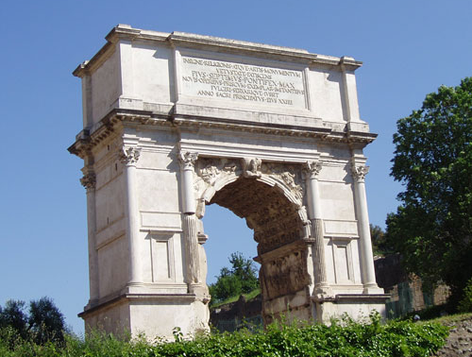
Arch of Titus

5)
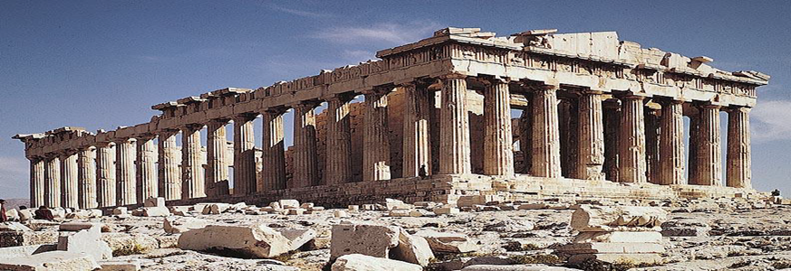
The Parthenon

MANYLION CYFLWYNO: A turn-it-in link will be set up on the module’s Moodle page through which students should submit their work. Students must submit before the specified deadline.

