Managing Projects in the Organisation (BMSW5104_BIRM)

Category: Birmingham Learning Centre

By Wesley Regis 1713352
Lecturer: Paul Ranson

Contents
- Executive summary
- Overview of the Vinters antiques organisation commissioning the project
- Critical risk assessment for the Vinters organisations project
- Management techniques and tools applied to Vinters antiques project
- Implementation of plans for project stakeholders
- Personal recommendations for Vinters antique organisation
- References

- Executive summary

In this report I will be conducting a Critically assessment of a project to be carried out on behalf of the Vinters organisation, demonstrating the practical purpose of project management tools and techniques. Using these tools and techniques I will be developing a suitable plan to deal with the intricacies for their project to be performed by their organisation, and producing a Critical evaluation suggesting recommendation that I myself could use to make the project much better.

- Overview of the Vinters antiques organisation commissioning the project

Vinters antiques organisation is a small family run business, with 5 members of staff.
The Vinters antique organisation has been established for over 30 years now, selling antiques out of their shop in Shirley Birmingham.

Recently, the Vinters family were approached by Tesco's to buy their location in Shirley to expand their Tesco express store.

the Vinters family are happy about the news of this money coming in, as the business has not been going well for some years.

because of this opportunity, the Vincent family have decided to invest the money from the sale of the store to take the business in another direction.

Inspired by a TV programme called storage hunters that they watch, the idea for the vintage family is to replicate the exact idea of within the show.

in this TV show it's about an antiques expert travelling the roads of Britain looking for rare and precious antiques in both good I'm broken conditions that they will later go onto repair and advertise the refurbished antique on the online store.

They have a warehouse that they used for storage in spark hill Birmingham that they would like to use but is in serious disrepair.
.
the Vinters family idea is to upgrade their business by transforming this warehouse to replicate the usage shown in the TV show.

The 5 members of staff are as follows: -

Doreen Vinters
Accountant and manager for the family business
Dennis Vinters
Antiques specialist / delivery driver
Suha Madani
Customer services /
Omar King
Operations and restorations specialist

- Critical risk assessment for the Vinters organisations project

Pro and con of Vinters siblings’ risk to project

Observing that Vinter antiques is a family Business, led and run by brother and sister, has been successful for years,” personal issues by members of staff may cause problems that put the success of the project at risk” (Integrated control mechanism toward project management success, 2017)

Pros

Doreen Vinter has two senior roles within the Vinters antique organization, in, she is both head of finance and the manager, being in control of these departments for years has gained Doreen valuable experience and expertise that has helped the family business survive, making key financial and business decisions daily for the store, making her a major stakeholder in the project, likewise with her brother Dennis, who is also an expert in antique, and focuses his attention on his decisions for products the business depends on.

Cons

Because of the idea of replicating The TV show is centred around the antiques expert, solely may cause conflicting situations between brother and sister when it comes to decision making, for who knows best and why.

Pros and cons of Vinters experts

Plus, there are 3 staff members who are experts in their positions within the Vinters organisation, and “maybe difficult to manage as they have their own methods to how they get things done, that may cause conflict to adhering to the plan of the project and throw it commercially off track (Artto and Kahkonen, 2013)”.

This can create situations if the task at hand is dependant on the task previously, it can cause communication issues that can harm the smooth transitions from task and result in negative outcomes that can impact the cost or extend the time of the project or both.

But on the positive side, is that these “experts (specialist) have the know how to get things done by themselves which can be beneficial to time and cost for completing the project” (It's time to get things done, 2017), by keeping them commercially on track.

Suha from customer services is vitally essential to the interests of the project, although she is not an expert her tangible knowledge of customers is of importance, as she knows the customers (users) needs, wants and desires.

Because her position in the Vinters organisation is not senior, her opinion / information may not be equally received, which can be detrimental components missed for the success of the critical path of the project.

- Management techniques and tools applied to Vinters antiques project

- Before the 1st meeting with Vinters stake holders, their roles will have to be defined. “Defining of roles will be needed to eliminate any conflicting issues between stakeholders” (Pamungkas, Warto and Mugijatna, 2019), of who is responsible for what. And to give a clear chain of command essential to the critical path’s success for the project.
- “Defining roles is proclaiming a chain of command and ensuring everyone knows and stays in their role” (Pride, 2017).

- Creating “user stories”, to highlight problems that each stakeholder views” (Estaswara, 2020), that may block the project from completion and to give each stakeholder an equal chance to have input into the project. To create user stories each stakeholder of the project lists their problems on post it notes or digital cards answering 3 question, who they are, what they want and why they need it.
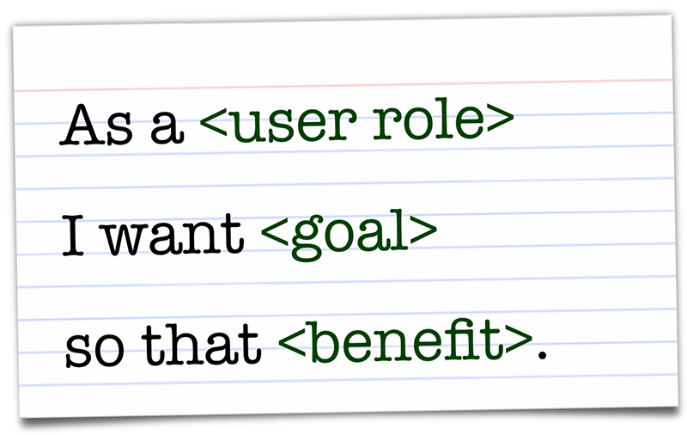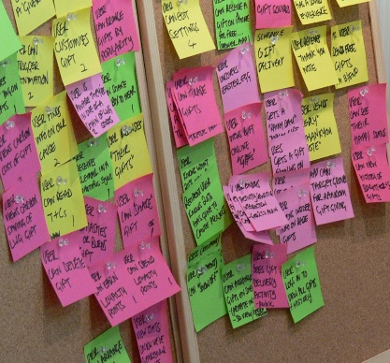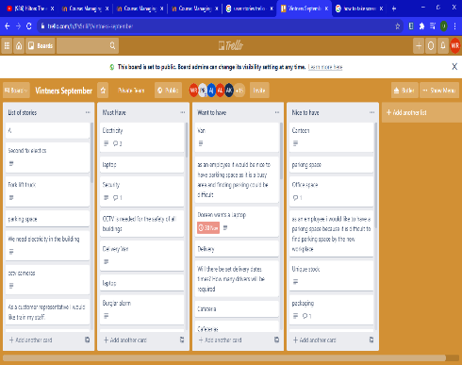

- Use the chevron technique to prioritise tasks. “The chevron techniques require the (vintner’s stakeholders to have a meeting) to organise the task based upon importance and relevance” (Azarovа, 2018). if the tasks are dependant in function on each other meaning, one task cannot start until another finishes, or independent that they do not require another task to be completed for it to start. The task of the user stories is divided into 3 sections of priority / importance.
- MUST HAVE .... HIGH PRIORITY /IMPORTANCE
- WANT TO HAVE…. MODERATE PRIORITY / IMPORTANCE
- NICE TO HAVE…. LOW PRIORITY / IMPORTANCE
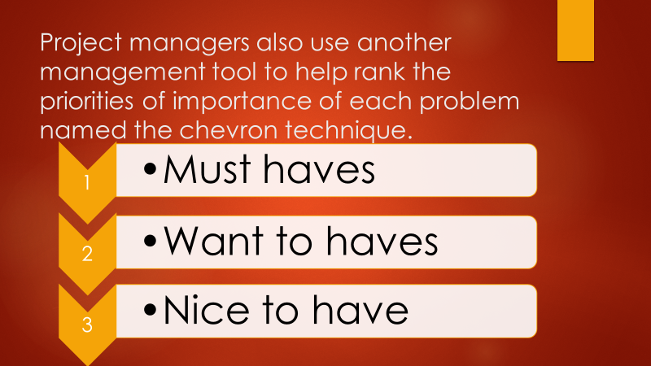

- Each stakeholder will have a chance to place their user stories where they feel they are relevant on the chevron. Then all the must have’s user stories task, after a consensus are gathered for estimated times of delivery for the and order to be delivered allocated for them.

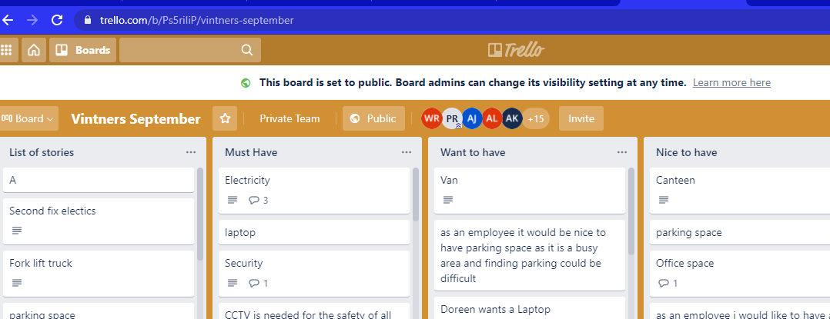

- Once prioritising the tasks has been agreed by Vinters stakeholders, times for completion of each task will have to be estimated.
- Using “the Roberts product project technique “(Roberts, 2013), to estimate the time by splitting the task into 2 dimensions, (a) complexity and (b) size, a matrix with predetermined times is used to work out how long (in days) it will take to complete the task of delivering the Vinters antiques project to completion the technique is used for each task.
Complexity | Low | Medium | High
Size
 | 1 | 3 | 5
Small
 | 4 | 8 | 11
medium
 | 7 | 12 | 19
Large
- The number shown in above diagram represents, the number of estimated days needed to be allocated for the task, pending on the viewpoints of the collective stakeholder expertise and general experience arriving at a consensus for the estimated times for each task.
- And “the wisdom of the crowd technique” (Surowiecki .J 2004). A theory that says the collective’s opinion is more accurate and fit for purpose. The technique requires the stakeholders together to guess / estimate how long each task will take, coming to a consensus, and allocating the times to each task.


- Once this task has been completed, to gain a visual understanding of how the project will be delivered, a schedule of the tasks will be produced using Microsoft project planner to create a Gantt chart for Vinters stakeholders and the project manager to monitor that each task is completed for the projects plan.

- “Gantt charts display all the tasks that need to be completed by each stakeholder responsible for the successful delivery of the project” (Genua, Giuffrida and Rinaudo, 2006).
- Gantt charts shows the start, duration, and deadline dates for both independent and dependant tasks.

- It also displays task that are dependant on each other in an descending order (known as waterfall) with the start and deadlines back to back to give clear indications for when one task can start and when it should end for another task to begin, to ensure that the critical path has an order to sort out all problems that may stand in the way of the success of the Vinters project.

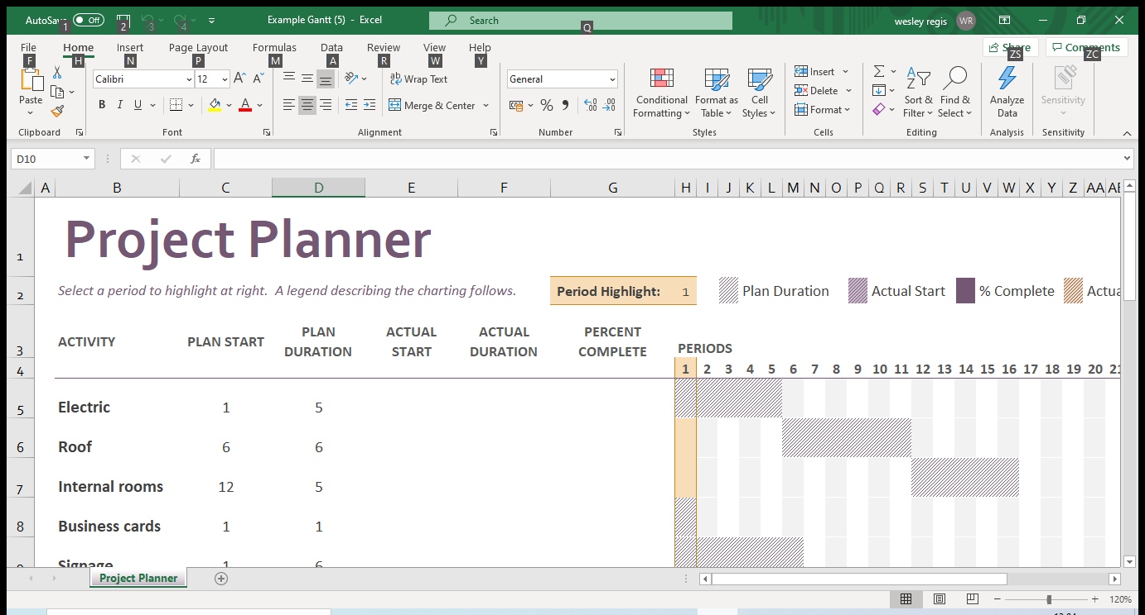

- Implementation of plans for project stakeholders

“To ensure the critical path is adhered to by all stakeholders involved, the project life cycle, a management tool used to communicate and monitor the progress of (the Vinters) project” (Badau, 2019), and stakeholder. during the lifetime of the project till completion, will be used to communicate the project to the Vinters stakeholders committee.

Project life cycle

- A meeting will be held, to deliver the project plan developed in the initial planning stage of the project for the Vinters stakeholders.
- A Presentation of the Gantt chart will have to be demonstrated to show how the project will flow to completion.
- Each of the “must have task” Identified on the Gantt chart to start the project will be delegated to the relevant stakeholder for completion according to the schedule of the chart.
- Vinters stakeholder will have to attend regular meetings with the project manager to update them on the progressions of their task according to the schedule created on the Gantt chart of the project, to ensure that the critical path of the project is maintained
- The project manager will produce a report based off the findings of the meeting with the relevant Vinters stakeholder’s progress to present to the Vinters organisation stakeholders committee.
- From the report of the project manager it is down to the committees control to evaluate if the findings are good or not, if a new problems that may occur requires the project plan to be re adjusted the project manager will become responsible to rework the plan to ensure it meets the requirements or quality level needed to complete the project.
- Regardless if a new problem comes to be or not the project cycle along with the communication will be continuous until the project end.

- Personal recommendations for Vinters antique organisation

Upon reflection of this project for the Vinters antiques organisation, when looking at the task they want done to move their business into a new direction and conducting a project on a scale that I would consider large and beyond the expertise of most of the members of the organisation. Highlighted the cause to have more external expert assistance to ensure that this project was delivered on level of quality that replicates the level by the production team of the tv show, I realised that I would have to develop my personal skills for leadership as managing experts can be a difficult thing. I would have to further my knowledge in understanding how to effectively used the managing by exception technique, as it will require it to be used broadly from my opinion in both the setup and future if I was recommissioned for future project for the Vinters organisation.

- Additionally, to the current project of the Vinters I recommend a Health and safety risk assessment of the Vinters spark hill warehouse, and advise they bring in an expert contractor to give an evaluation of the cost of repair.

- And to find a television show production consultant to help provides information on the requirements needed to make their show a reality

- external expert advice will be needed as although Omar King has restoration of antiques skills, he does not possess the essential knowledge to assure safety of the premises for purpose.

- References

- Issues in Information Systems, 2017. INTEGRATED CONTROL MECHANISMS TOWARD PROJECT MANAGEMENT SUCCESS.
- Artto, K. and Kahkonen, K., 2013. Managing Risks in Projects. Hoboken: Taylor and Francis.
- British Dental Journal, 2017. it is time to get things done
- Pamungkas, B., Warto, W. and Mugijatna, M., 2019. NEGOTIATION BETWEEN STAKEHOLDERS OF COMMODIFICATION: Roles and Impacts as Stakeholders in Tebing Breksi Prambanan. Jurnal Antropologi: Isu-Isu Sosial Budaya
- Pride, W., 2017. Foundations of Business. New York: Cengage learning.
- Estaswara, H., 2020. Defining Communication Problems in Stakeholder Relations Based on Stakeholder Theory. Jurnal ASPIKOM,
- Azarovа, I., 2018. Identification of project stakeholders based on system analysis. Transport development,
- Roberts, P., 2013. Guide to Project Management. New York: Wiley.
- Surowiecki. J, 2004.The Wisdom of Crowds: Why the Many Are Smarter Than the Few and How Collective Wisdom Shapes Business, Economies, Societies and Nations,
- Genua, C., Giuffrida, S. and Rinaudo, S., 2006. “GANTT CHARTS FOR PRODUCTION FLOW” FRAMEWORK.
- Badau, K., 2019. Application of Project Cycle Management Tool on the Management of Higher Education Projects in Universities of North Eastern Nigeria. SSRN Electronic Journal,

