

Digital Technology in Health and Social Care (BMD57006)
03/03/2023
Student ID: 2218887
Word count:

Contents
Sections | Title | Page
1 | Introduction
2 | Method
3
4
5 | Search strategy
6 | Literature review ???
7 | Results
8 | Discussion
9 | Conclusion
10 | References


Introduction
This assignment will discuss and evaluate the Welsh Nursing Care Record (WNCR) using the Fitt framework analysis.
WNCR is a digital nursing application that aims to standardise and digitalise the nursing documentation within every Health Board in Wales.
The safety case and readiness report produced by Digital Health Care Wales (2020) clearly outlined the project context, objective and benefits of the introduction of a digital nursing care record within every health board in Wales.
Objective
The project's goal was to employ a digital application to supply standardised, agreed-upon nursing documentation used in adult secondary care settings throughout Wales. The project's initial proposal of digitised papers included the following documents:
- Inpatient assessment form
- Core risk assessments:
- Falls
- Skin and repositioning
- Continence
- Nutrition
- Manual handling
Context
The NHS Wales nursing and midwifery leadership has determined that there is currently little standardisation of nursing documentation throughout Wales. The introduction of electronic nursing records in secondary care has been mandated by nursing leadership in order to eliminate variations and respond to audit reports and findings on health and care standards. (Reference) The goal was to establish uniform information standards in Wales across all adult inpatient healthcare facilities, with the exclusion of mental health and maternity.
Wales did not have a standardised system for nursing documentation. The Welsh Assembly Government's Fundamentals of Care (2003) Unified assessment (2002) or the Activities of Daily Living approach by Roper et al. (1980) are three approaches that certain Health Boards have previously accepted as the framework for a nurse evaluation. There are also copious amounts of risk assessment forms available, some of which were not evidence-based, and there is no option to guide best practise within the paper assessments to help guide best practice in the prevention of risk or harm to patients.

Expected Benefits
- Improved communication between clinicians, nurses and wider members of the team
- Duplication and time reduction in completing documents, hence releasing more time to care.
- A digital enabler for nurses and the multi-disciplinary team.
- Improved audit capability
- Cost reduction with the reduction in the use of paper and printing
- Improved quality of nursing documentation.
- Decreased transcribing errors.

WNCR Vision
“Nurses, midwives and multi-professional team members are confident and competent when using the WNCR. They utilise the data from WNCR to drive improvements and learning across organisations in Health and Care in Wales, improving patient outcomes and experiences. Patients receive seamless care and patients and staff can move across services in Wales using the single WNCR system”
Digital and Health Care Wales (2020)

As a result of a successful pilot in 2020, the WNCR digital nursing application was subsequently rolled out across the eight Health Boards in Wales with the first “go live” commenced in 2021 and expected full rollout by 2023. The rollout has resulted in some documentation being completed digitally, while some remain on paper until digitalised. The application is linked to the patient Administration system, allowing patient demographics to be pulled across during the admission process.
The WNCR application is used in acute and community hospitals to admit patients to hospitals, perform nursing assessments, and document ongoing patient care. Access to the application is available to all healthcare professionals via the Welsh clinical portal using their Nadex ID. Temporary staff (agency, bank and student nurses). can also access the system by the ability to create a temporary ID valid for up to thirty days.

The NMC Standards of Professional Practice and Conduct for Nurses and Midwives (2022) clearly outline the responsibilities of nurses. Standard 10 states that nurses should keep clear and accurate records relevant to their practice. The Code requires that accurate records be made at the time of care or as soon as possible after the event and that all records be kept securely.

METHOD
When introducing information technology into the workplace, it is important to consider the socio-organisational factors that may influence the success of the implementation that could affect the deployment and success of what you are trying to achieve.
The literature has extensively covered the driving forces behind the successful adoption of IT inside every organisation. (REFS). There are frameworks to facilitate the evaluation of introducing technology while taking a variety of elements into account.

Fit between task, individual and technology framework (Fitt framework)
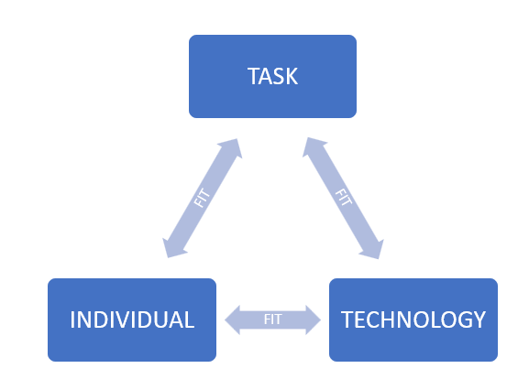
The fit framework is the fit between individual, task and technology. It is the relationship that each part plays to ensure the success of the intended deployment of the application in question.
In comparison, other frameworks (such as TAM or ITAM) leave out an important aspect: the interaction between the user and the task.
The technology acceptance analysis model (TAM) focuses exclusively on why users adopt or reject a system. It would predict attitudes toward using the system as well as the ease of use and usefulness of a system. Since both of these factors relate to the functions of the application, it does not consider user acceptance or the tasks required of the application.
The Information technology adoption model (ITAM) concentrates on the fit of the technical infrastructure with the information technology knowledge of the user.
Within health care, the examples of each component of the Fitt model would be the fit between individuals (the change process, lack of IT skills or motivation) Task (ability to document what is required and the complexity of the requirements) and technology (reliability, functionality ease of use).
Evaluation
The sources of information used for the evaluation of WNCR were gained from a Health Board report following the introduction of WNCR in Neath Port Talbot Hospital, a qualitative study with the use of staff questionnaires and the evaluators’ personal experience following the implementation process in clinical practice.

Fit between task and individual.
- Can staff can evidence the care provision in accordance with their professional code of practice?
- Were the contents of the digital platform different from the current paper documentation?
- Would staff accept the change from paper to digital documentation?
- Were there training implications?

Fit between individual and technology.
- The fit between individual and technology evaluation sought to determine the product's dependability, usability, and staff-friendliness.
- Were staff able to access the system when they needed to?
- Did they have any issues accessing devices to use?
- Were there connection issues?
- Did the staff have the necessary IT skills to use the system?
- What if the devices were not charged and nurses were unable to document?

Fit between technology and task.
- The fit between technology and task evaluation looked at if the system was able to function in the way nurses required it to do so
- was the digital version of the adult in-patient admission process and risk assessments sufficient to collect the information required to inform the patients’ plan of care?
- Would the digital version take more time than writing on paper?

Results
Evaluators personal experience
WNCR was implemented in a 32 bedded medical ward in Neath Port Talbot Hospital. The implementation phase took 2 weeks with the support of the Clinical nursing informatics officer and the digital clinical nurse specialist.
Prior to the rollout of WNCR, the health board’s monthly metrics assurance audits uncovered documentation errors that included issues with not signing, failing to date and time entries, illegible writing, leaving parts blank or vacant, and utilising abbreviations that did not adhere to the NMC code of professional practice.
Following the implementation of WNCR, the date is automatically populated, and there is no requirement to sign following an entry as the system automatically captures the user and the overall completion of nursing documentation is improved. Daily compliance reports were produced that indicated an improvement in the overall documentation.

Table 1: Example of WNCR compliance report following implementation.
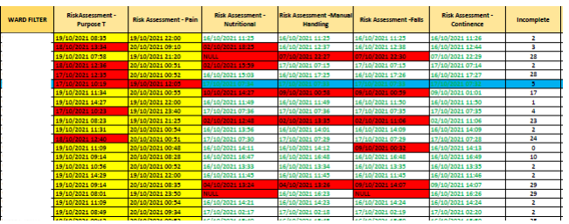
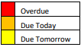
The fit between technology and the individual was initially seen as a barrier to the implementation of WNCR. While the younger set of nurses found it easy to adopt technology and were able to pick up the concept easily, the older group of nurses were hesitant to document every day on a digital platform because they lacked IT abilities. With good leadership and the implementation of teaching sessions and support the barrier was overcome. The business change team and the implementation team “floor walked” during the initial phase of the rollout.
Nurses felt the creation of a temporary user account was time-consuming if another user was requesting an account the system took longer to respond.
The first day of rollout proved to be a challenge as all existing patients’ documentation on the ward was paper-based and required transcribing to ensure consistency across the ward. The experience changed practice as the rollout developed across the Hospital and decisions were made to digitalise only new patients and keep existing patients’ notes on paper until discharged with all new patients admitted digitally.
The inconsistency of some documents being paper and others being digital presented a difficulty to nurses. In order to preserve patient safety and lower the possibility of incomplete mandated risk assessments, this was overcome by making explicit instructions available to staff to demonstrate what was digital and what was paper.
Nurses were initially concerned that if the system crashed, patient data may be lost. A business continuity strategy was in place, and a specific computer was assigned to retrieve all patient data every five minutes with the option to print all supporting documents if necessary. Additionally, the nurses had a designated file with a limited amount of nursing documentation they could refer to if necessary.
Initially, nurses' feedback indicated that they spent more time using digital documentation than they did writing on paper. However, perceptions changed once users were comfortable with the application to "I now spend less time to document since I can find what I am searching for" and "we never lose a document like we used to".
Swansea Bay University Health Board report evaluation
A project evaluation was conducted by Swansea Bay University Health Board following the implementation of WNCR (2021)
WNCR was implemented in six wards within Neath Port Talbot Hospital in April 2021. A pre and post-implementation audit was conducted with the following results:

Table 2: WNCR time comparison of completing paper versus digital assessments.
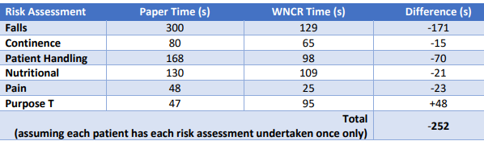

The data in table 2 show that, with the exception of purpose T, nurses now take less time to perform digital risk assessments. A modification in the process is what has caused the extended time. When using the paper format of the purpose T (a skin assessment), the nurse would tick a box for the daily review if nothing changed and finish the comprehensive risk assessment once a week. The full purpose T must be completed every day by the nurse because the computerised system lacks a daily review. The total amount of time spent decreased by 4 minutes and 12 seconds.
The report suggested that the documentation's quality had increased. According to the data gathered, the number of sections completed in the adult initial assessment upon admission to the hospital increased by 36%. The justification offered was that WNCR has necessary fields that must be filled out before a user can label a section as complete, improving compliance with completion. The functionality of the system alerts the nurse when an assessment is due as opposed to the nurse looking through paper files to check.

Table 3: Risk assessment completion 2 weeks post WNCR implementation
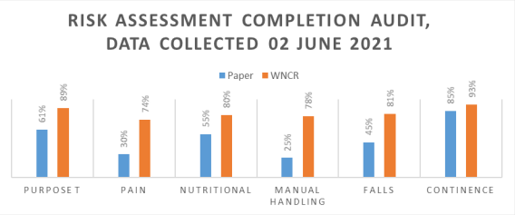
In the Introduction, describe the service context and the purpose of the software product. In the Methods, describe the FITT framework and how you have applied it or varied from it. Also in this section, describe how you collected data (literature, observation, interviews with users, your personal experience or something else). In the Results section, give a summary of what data you collected and report any quantitative ratings or qualitative themes that emerged. In the Discussion, reflect on the key findings and relate them to other relevant domain knowledge from the literature. You may also wish to discuss the limitations of the FITT framework and describe alternative approaches that could have been used. Make sure that you discuss the value (and limitations) of the given software product on the provision of “seamless care”.

Describe the FITT framework and how I applied or varied from it
Describe how you collected your data (lit RV/ Observation/ interviews/personal experience)
RESULTS
Summary of data collected and report any quantitative ratings or qualitative themes that emerged.

DISCUSSION
The evaluation of the WNCR system employing the FITT framework revealed etc
Reflect on the key findings and relate them to other relevant domain knowledge (compare other digital nursing records with WNCR)
Discuss the value (and limitations) of WNCR on the provision of seamless care
CONCLUSION
Recommendations for future practice
REFERENCES
Akhu‐Zaheya, L., Al‐Maaitah, R. and Bany Hani, S. (2018) ‘Quality of nursing documentation: Paper‐based health records versus electronic‐based health records’, Journal of clinical nursing, 27(3-4), pp. e578–e589. Available at: https://doi.org/10.1111/jocn.14097.

Chan, K.G. et al. (2020) ‘Simulated electronic health documentation: A cross-sectional exploration of factors influencing nursing students’ intention to use’, Nurse education in practice, 48, pp. 102864–102864. Available at: https://doi.org/10.1016/j.nepr.2020.102864.
Chan, Kim Geok ; Pawi, Saloma ; Ong, Mei Fong ; Kowitlawakul, Yanika ; Goy, Siew Ching
Scotland: Elsevier Ltd

Chan, Kim Geok ; Pawi, Saloma ; Ong, Mei Fong ; Kowitlawakul, Yanika ; Goy, Siew Ching
Scotland: Elsevier Ltd

Digital Health and Care Wales (2020) vision statement. (Not shared in the public domain)

Digital Health and Care Wales (2020) Safety Case and readiness report. (Not shared in the public domain)

Zaman, N. et al. (2021) ‘The Relationship between Nurses’ Training and Perceptions of Electronic Documentation Systems’, Nursing reports (Pavia, Italy), 11(1), pp. 12–27. Available at: https://doi.org/10.3390/nursrep11010002.
Zaman, Nohel ; Goldberg, David M ; Kelly, Stephanie ; Russell, Roberta S ; Drye, Sherrie L
Switzerland: MDPI AG

Nguyen, L. et al. (2017) ‘Exploring nurses’ reactions to electronic nursing documentation at the point of care’, Information technology & people (West Linn, Or.), 30(4), pp. 809–831. Available at: https://doi.org/10.1108/ITP-10-2015-0269.
Nguyen, Lemai ; Wickramasinghe, Nilmini ; Redley, Bernice ; Haddad, Peter ; Muhammad, Imran ; Botti, Mari
West Linn: Emerald Publishing Limited

Nursing and Midwifery Council. (2022) The Code. Professional standards of practice and behaviour for nurses, midwives and nursing associates. Available at: https://www.nmc.org.uk/globalassests/sitedocuments/nmc-publications/nmc-code,pdf

Roper N. Logan. W, Teirney A (1996) The elements of nursing. 3rd ed. Churchill Livingstone. Edinburgh

Swansea Bay University Health Board (2021) Project Evaluation: Welsh Nursing Care Record. Neath Port Talbot Hospital (not shared in the public domain)

Yu, P. et al. (2013) ‘Unintended adverse consequences of introducing electronic health records in residential aged care homes’, International journal of medical informatics (Shannon, Ireland), 82(9), pp. 772–788. Available at: https://doi.org/10.1016/j.ijmedinf.2013.05.008.
Yu, Ping ; Zhang, Yiting ; Gong, Yang ; Zhang, Jiajie

Meißner, A. and Schnepp, W. (2014) ‘Staff experiences within the implementation of computer-based nursing records in residential aged care facilities: a systematic review and synthesis of qualitative research’, BMC medical informatics and decision making, 14(1), pp. 54–54. Available at: https://doi.org/10.1186/1472-6947-14-54.
Dowding, D. (2013) ‘Are nurses expected to have information technology skills?’, Nursing management (Harrow, London, England), 20(5), pp. 31–37. Available at: https://doi.org/10.7748/nm2013.09.20.5.31.e1112.

