Marking Key
ANSWER ALL THE QUESTIONS

Question 1 [25 Marks]
- For the circuit shown in fig1, Calculate the following
- Total resistance in the circuit [4 Marks]
- Total current in the circuit. [2 Marks]
- Current across each resistor [8 Marks]
- The voltage across $R_{7}$ resistor [2 Marks]
- Power delivered by the battery [2 Marks]
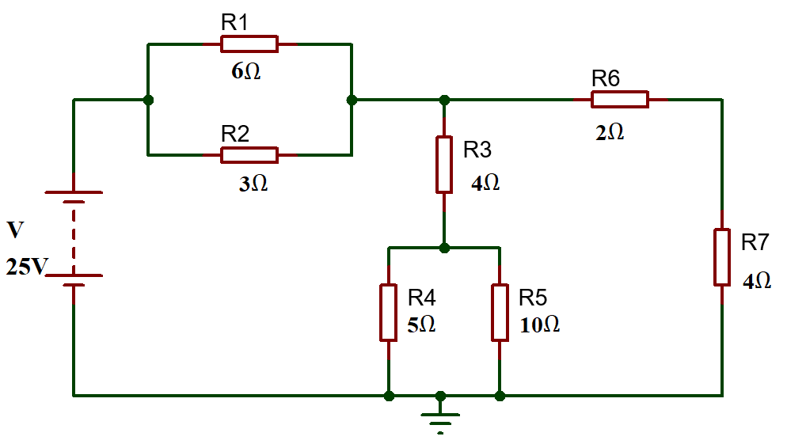
Fig: 1
Answers:
- Total Resistance in the circuit
$R_{1} and R_{2}$ are in parallel
$R_{eq1}=\frac{1}{\frac{1}{R_{1}}+\frac{1}{R_{2}}}=\frac{1}{\frac{1}{6}+\frac{1}{3}}=\frac{1}{0.5}=2Ω$ [1 Mark]
$R_{4} and R_{5}$ are in parallel
$R_{eq2}=\frac{1}{\frac{1}{R_{4}}+\frac{1}{R_{5}}}=\frac{1}{\frac{1}{5}+\frac{1}{10}}=\frac{1}{0.3}=3.33Ω$ [1 Mark]
$R_{eq2} and R_{3}$ are in series
$R_{eq3}=R_{eq2}+R_{3}=4+3.33=7.33Ω$ [1 Mark]
$\left(R_{6}+R_{7}\right)$ in parallel with $R_{eq3}$
$R_{eq4}=\frac{{(R}_{6}+R_{7})×R_{eq3}}{R_{6}+R_{7}+R_{eq3}}=\frac{\left(2+4\right)×7.33}{2+4+7.33}=3.3Ω$
$R_{eq4} and R_{eq1}$ are in series
$R_{t}=R_{eq4}+R_{eq1}=3.3+2=5.3Ω$ [1 Mark]
- Total current in the circuit
$I=\frac{V}{R_{t}}=\frac{25}{5.3}$ [1 Mark]
$I=4.71A$ [1 Mark]
- Current across each resistor
Current across $R_{1}$
$I_{1}=\frac{IR_{2}}{R_{1}{+R}_{2}}= \frac{4.7×3}{6+3}=1.57A$ [1 Mark]
Current across $R_{2}$
$I_{2}=\frac{IR_{1}}{R_{1}{+R}_{2}}= \frac{4.7×6}{6+3}=3.14A$ [1 Mark]
Current across $R_{3}$
$I_{3}=\frac{I(R_{6}+R_{7})}{R_{6}+R_{7}+R_{eq3}}= \frac{4.7×(2+4)}{2+4+7.33}=2.1A$ [1 Mark]
Current across $R_{4}$
$I_{4}=\frac{I_{3}R_{5}}{R_{4}+R_{5}}= \frac{2.1×10}{5+10}=1.4A$ [1 Mark]
Current across $R_{5}$
$I_{5}=\frac{I_{3}R_{4}}{R_{4}+R_{5}}= \frac{2.1×5}{5+10}=0.7A$ [2 /Marks]
Current across $R_{6}$ and $R_{7}$
$I_{6}=\frac{IR_{eq3}}{R_{6}+R_{7}+R_{eq3}}= \frac{4.7×7.33}{2+4+7.33}=2.55A$ [2 Marks]
- Calculate the Voltage across $R_{7}$ Resistor
$V_{7}=I_{6}R_{7}=2.44×4=10.2V$ [2 Marks]
- Power delivered by the battery
$P=VI=25×4.71=$117.75W [2 Marks]
- A solar yard light has a solar collector that can provide 1.0W of power for charging the 3.0V batteries. What is the maximum charging current the solar collector could supply to the fully discharged 3.0V batteries? [2 Marks]
Answers:
$I=\frac{P}{V}=\frac{1}{3}$ [2 Marks]
$I=0.33A$ [1 Mark]
- Calculate the current flowing when a charge of 60C flows past a point over a period of 2 minutes. [2 Marks]
Answers:
$I=\frac{Q}{t}$ [1 Mark]
$I=\frac{60}{120}=0.5A$ [1 Mark]

- What length of German silver wire, diameter 0.050 cm, is needed to make a 28 resistor, if the resistivity of German silver is $2.2×{10}^{-7}$ m? [3 Marks]
Answers:
$A=π{ r}^{2}$
$r=2.50×{10}^{-4}m$
$A=π{×( 2.50×{10}^{-4})}^{2}=1.96×{10}^{-7}m^{2}$ [1 Mark]
$L=\frac{RA}{ρ}$ [1 Mark]
$L=\frac{28×1.96×{10}^{-7}}{2.2×{10}^{-7}}=24.95m$ [1 Mark]
Question 2 [25 Marks]
- Calculate the current flowing when a charge of 60C flows past a point over a period of 2 minutes. [2 Marks]
Answers:
$I=\frac{Q}{t}$ [1 Mark]
$I=\frac{60}{120}=0.5A$ [1 Mark]
- Determine the current across each resistor in the circuit shown in fig.2, using mesh analysis (Kirchhoff’s Voltage Law) [13 Marks]
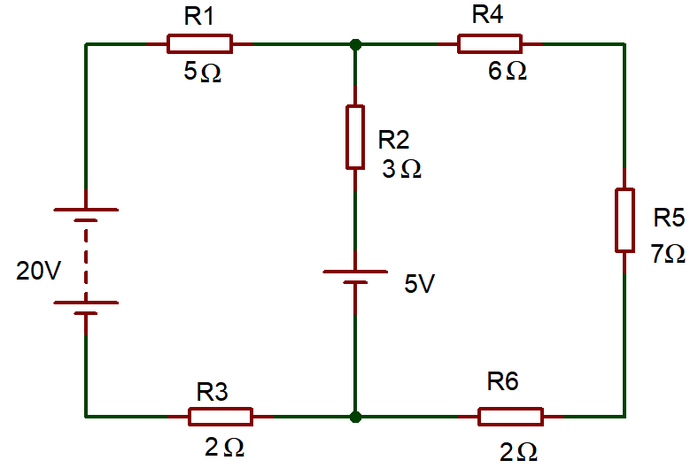
Fig.2
Answers:

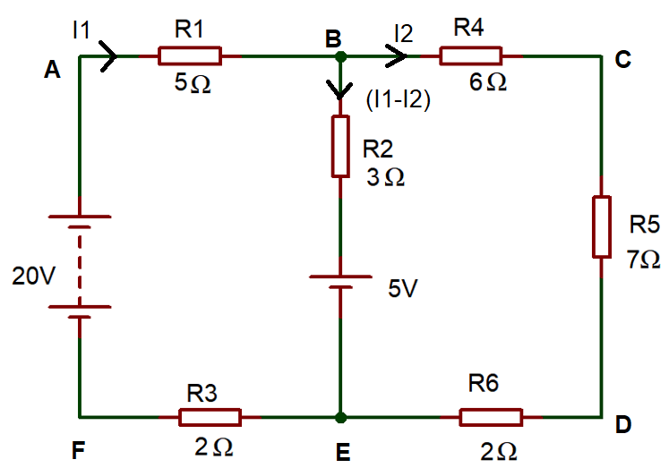

Apply KVL in ABEFA
$-5I_{1}-3\left(I_{1}-I_{2}\right)-5-2I_{1}+20=0$ [2 Marks]
$-10I_{1}+3I_{2}=-15$ …………(1) [2 Marks]
Apply KVL in BCDEB
$-6I_{2}-7I_{2}-2I_{2}+5+3\left(I_{1}-I_{2}\right)=0$ [2 Marks]
$-3I_{1}-18I_{2}=-5$ …………(2) [2 Marks]
Simplifying Equation (1) and (2)
$I_{1}=1.67A$ [2 Marks]
Substitute, $I_{1}$ in equation (1)
$-10 \left(1.67\right)+3I_{2}=-15$
$-16.7+3I_{2}=-15$
$3I_{2}=-15+16.7$
$I_{2}=\frac{1.7}{3}$=0.567A [2 Marks]
Current across branch BE
$I_{1}-I_{2}=1.67-0.567=1.1A$ [1 Mark]
Current Across $R_{1}and R_{3}=I_{1}=1.67A$
Current Across $R_{2}=I_{1}-I_{2}=1.1A$
Current Across $R_{4} R_{5} and R_{6}=I_{2}=0.567A$
- Differentiate Step- up Transformer and Step-Down Transformer (minimum of two differences) [4 Marks]
Answers:
Sl. No | Step-up Transformer | Step-down Transformer
1 | Input voltage is lower than the output voltage | Input voltage is higher than the output voltage
2 | Number of Secondary winding is higher than the primary winding | Number of Secondary winding is less than the primary winding
3 | 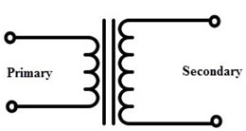 | 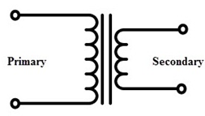
[Each difference two marks, Maximum of 4 marks]
- Explain the following terms:
- Resistance [2 Marks]
- Reactance [2 Marks]
- Impedance [2 Marks]
Answers:
- Resistance
Opposition to flow of current. Unit is Ohm - DC circuit property [2 Marks]
- Reactance
Opposition to change of flow of current. Unit is Ohm - AC circuit property [2 Marks]
- Impedance
Opposition to change of flow of current. Unit is Ohm- AC circuit property [2 Marks]

Question 3 [25 Marks]
- The alternating current is given by $i=40 sin314t A$. Determine the following
- Peak Value of current [1 Mark]
- RMS Value of Current [2 Marks]
- Frequency [2 Marks]
- Time period [1 Mark]
Answers:
- Peak Value of current
From the given equation, $I_{m}=40A$ [1 Mark]
- RMS Value of Current
$I_{RMS}=\frac{I_{m}}{\sqrt{2}}=\frac{40}{\sqrt{2}}$ [1 Mark]
$I_{RMS}=28.28A$ [1 Mark]
- Frequency
From the equation, $ω=314$
We know that, $ω=2πf$
$314=2πf$ [1 Mark]
$f=\frac{314}{2π}$=50Hz [1 Mark]
- Time
$T=\frac{1}{f}=\frac{1}{50}=0.02sec$ [1 Mark]
- An oscilloscope display shows the below voltage waveform. The oscilloscope settings are shown in the box next to the waveform.
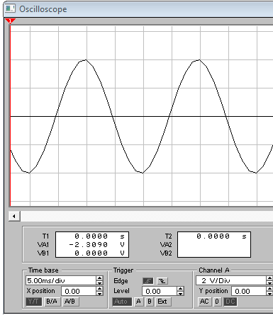
Oscilloscope settings:
2V/div
10ms/div

Fig:3
- Estimate the period of the waveform. [1 mark]
- From the estimated period, determine its frequency. [2 marks]
- Determine its peak-peak amplitude [2 marks]
- Determine the r.m.s. value of the waveform. [2 marks]
Answers:.
- Estimate the period of the waveform.
$Period=4 div ×10 ms=40 ms$ [1 mark]
- From the estimated period, determine its frequency.
$f=\frac{1}{t}$
$f= \frac{1}{40 ms}=25 Hz$ [2 marks]
- Determine its peak-peak amplitude
$V_{pk-pk}=4 div ×2 V=8 V$ [2 marks]
- Determine the r.m.s. value of the waveform.
$V_{RMS}=\frac{V_{pk}}{\sqrt{2}}=\frac{4}{\sqrt{2}}=2.828 V$ [2 marks]

- An RLC circuit is shown in figure 4 below. Calculate the following
- The total circuit impedance [4 Marks]
- Total current flowing in the circuit. [2 Marks]
- Determine the voltage drop across each component in the circuits. [6 Marks]
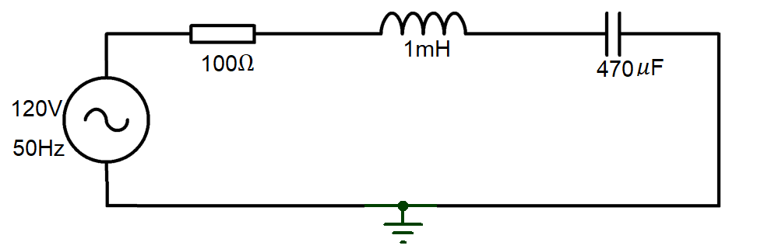
Fig: 4
Answers:
- Total impedance
$X_{L}=2πfL=2×π×50×1 mH=0.3142 Ω$ [1 Mark] $X_{C}=\frac{1}{2πfC}=\frac{1}{2×π×50×470 μF}=6.773 Ω$ [1 Mark]
$\left|Z\right|=\sqrt{R^{2}+{\left(X_{L}-X_{C}\right)}^{2}}=\sqrt{{100}^{2}+{\left(0.3142-6.773\right)}^{2}}=100.208 Ω$ [2 Marks]

- Circuit Current
$I=\frac{V}{Z}=\frac{120}{100.208}=1.198 A$ [2 Marks]
- Determine the voltage drop across each component in the circuits.
$V_{R}=I×R=1.198×100=119.8 V$ [2 Marks]
$V_{L}=I×X_{L}=1.198×0.3142=0.376 V$ [2 Marks]
$V_{C}=I×X_{C}=1.198×6.773=8.114 V$ [2 Marks]
Question 4 [25 Marks]
- State Maximum power transfer theorem. [2 Marks]
Answers:
Maximum power is transferred from a source to a load when the load resistance​ is equal to the internal resistance of the source network as seen from the load terminals. [3 Marks]
- A transformer has 300 turns in its secondary coil and is used to step up a 12v AC voltage to 200V.
  - How many turns would there be in the primary coil. [3 Marks]
  - Under full load conditions, the current demand in the secondary circuit is 2.5A. Determine the Power output rating of this transformer. [2 Marks]
  - Determine the maximum load resistance that this transformer could supply. [2 Marks]
  - we assume that the transformer is 97.5% efficient, estimate the current flow in the primary circuit for the conditions present in part b). [2 Marks]
Answers:
- $\frac{N_{S}}{V_{S}}=\frac{N_{P}}{V_{P}}$ [1 Mark]
$N_{S}=\frac{20}{5}×110=440 turns$ [1 Mark]

Therefore, turns ratio = 20:440 = 1:22 [1 Mark]

- Power Rating = $V_{S}× I_{S}$ [1 Mark]
Power Rating= 110 x 3 = 330W [1 Mark]
- $R_{L max}= \frac{V_{S}}{I_{S}}$ [1 Mark]
$R_{L max}$ = $\frac{110}{3}$ = 37Ω [1 Mark]

- $P_{S}$=$P_{P}×0.93$
$P_{P}=\frac{P_{S}}{0.93}$ = $\frac{330}{0.93}$ = 355W [1 Mark]
$I_{P \left(full load\right)}=\frac{P_{P}}{V_{P}}$
$I_{P \left(full load\right)}=\frac{355}{5}=71A$ [1 Mark]
- Describe the functions of the following components used in DC machines
- Field System [2 Marks]
- Armature [2 Marks]
Answers:
  - Field System
It consists of number of poles bolted inside the circular frame. It provide uniform magnetic field. [1 Mark]
The mmf (magnetomotive force) produced by the field windings provides a magnetic flux that passes through the pole pieces, the air gap, the armature and the frame. [2 Marks]
  - Armature
The armature consists of coils of wire wound around a metal core. When the armature rotates within the magnetic field created by the stationary field magnets, an electromagnetic force (EMF) is induced in the armature coils due to electromagnetic induction. [3 Marks]
- In the transient circuit, a Capacitor of Value $1μF$ and a resistor of 5.45M$Ω$ are connected in series across a $220V$ power supply through a switch. Calculate the time by which the capacitor will be charged to $60$percentage of the supply voltage. [10 Marks]
Answers:
When the Capacitor is charging
$V_{C}=V(1-e^{-\frac{t}{τ}})$ [1 mark]
$V_{C}=V(1-e^{-\frac{t}{RC}})$
$V_{C}=V(1-e^{-\frac{t}{5.45×{10}^{6}×1×{10}^{-9}}})$ [1 mark]
As the capacitor will be discharging to 60% of the Voltage
$\frac{220}{100}×60=220(1-e^{-\frac{t}{5.45}})$ [1 mark]
$132=220(1-e^{-\frac{t}{5.45}})$
$\frac{132}{220}=(1-e^{-\frac{t}{5.45}})$ [1 mark]
$0.6=(1-e^{-\frac{t}{5.45}})$
$e^{-\frac{t}{5.45}}=1-0.6$
$e^{-\frac{t}{5.45}}=0.4$ [1 mark]
Taking Log on both the side
$-\frac{t}{5.45}=\ln\left(0.4\right)$ [1 mark]
$-\frac{t}{5.45}=-0.916$ [2 marks]
$t=0.398×5.45$
$t=4.99 Sec$ [2 marks]
The Time taken by the capacitor to charge to 60% of the supply voltage is 2.17Sec.

