

Bettina Silsby
1905229

Managing Enterprise
In the 21st Century

University of Wales
Trinity Saint Davis
27/06/2020

Table of Contents
Mission statement.……………………………………………………………………………………………………………………………3
Introduction 4
Product and service………………………………..…………………………………………………………………………………………4
Marketing Activities……………………………..…………………………………………………………………………………………..5
Physical resources………………………………..…….…………………………………………………………………………………….5
Financial resources…………………………………………………………………………………………………………………………..6
Human resources…………………………………………………………………………………………………………………………..….7
Swot 8
Appendinces 9
References 10
UPDATE TABLE FREQUENTLY – CHECK IT HAS BEEN UPDATED PRIOR TO SUBMISSION

Type of the business: Sol trader

Owned by Bettina Silsby

Mission Statement:
I believe, it is important that, the children in my care are guaranteed a happy and secure environment. I will enable them to enjoy learning through play to develop to their fullest potential.

Aim and Object of Business:

As a registered childminder I aim to provide a childminding service that allows boys and girls to learn and develop in a safe, secure, home-based environment. I believe the best way to develop your child is in a home caring environment. Play will be at the centre of the child’s learning and development, and a wide range of activities and experiences appropriate to the age and stage of development of each child will be offered.

Introduction

I have chosen to become a childminder after the birth of my daughter. I have always been closely involved with the care and welfare of the children within in my family. My house is located opposite the local school and I had plenty of knowledge for the needs of additional childcare.
As a fresh new mother, I took my daughter out to local mother and baby groups, and it soon became very clear to me that there was not enough childcare options in the village where I live.
I have studied level 4 childcare to become a CIW registered childminder.
I believe the best place for babies and toddlers is in the home caring environment. (need a quote)
A unique selling proposition (USP, also seen as unique selling point) is a factor that differentiates a product from its competitors, such as the lowest cost, the highest quality, or the first-ever product of its kind. (Rouse, 2013) My childcare offers a warm welcoming home, with a wide range of activities, giving opportunities to the children developing new skills in only a few steps away from the local Meithrin and School. My business is offering care from birth to age 12, so I can offer the parent the opportunity for each child to stay in my care until they attend senior school.

Product/Service

I am registered with the Care Inspectorate Wales to care for up to 9 children from birth to 12 years of age.
My service is available from Monday to Friday 7:30 am to 6;30pm, and occasionally on a Saturday and a Sunday. My setting is open to all children and families. The language used at my setting is primarily English and I will provide basic Welsh learning through activities and rhymes. I am offering a drop off and pick up service from local schools and pre-schools. I can also offer out of school care for children. I provide a range of activities including cooking, baking, art and craft, storytelling, singing and musical instruments, role play, construction toys and jigsaws.
I will take children to the local park, playgroups, shops, and library on a regular basis.
Breakfast, lunch, dinner and snacks will be provided according to my meal and daily routine schedule. This will be discussed ensuring each child’s dietary needs are met.
My service is available for every child from birth to age 12. The parents have an opportunity to choose from 4 types of service:
- All day childcare
- Half day childcare
- Before school and school drop off
- After school pick up, with 3 hours childcare and a home cooked nutritious dinner.
I will organise various outgoing programs in the school holiday periods, such as visiting museums, national parks, play areas and historic places.

Marketing Activities

Market segmentation can help you to define and have a better understanding of your target audiences and ideal customers. (unknown,2019) In my business the ideal customer will be local or live in nearby cities-villages to me and they are working families who have the need for childcare.
A target market is the specific group of people you want to reach with your marketing message. They are the people who are most likely to buy your products or services, and they are united by some common characteristics, like demographics and behaviours. (Newberry, 2018) My ideally target market will be local families with children aged between 0-12 and who live in the Swansea and Llanelli area. I could target a wide range of customers and not just local people in my village as my house is only a 2 minute drive from the M4 motorway junction. This is providing easy access to working parents, who travel to work from the local villages to Swansea or Carmarthen. It is important for every business to position them self on the right market and to become aware all the competitors. Market position usually parallels competitive position. Competitive position measures the company against competitors customers values. Market position measures the result of the market. (Christopher 2007 I have observed a few other childcare providers in my area, which has assisted me to find out how I can become more successful with my marketing strategy and offer a better service than my competitors. In my business I have various advantages as my house is located next to the local school, the parents do not need to travel further miles to collect the children, this saves time and travel for the parents. The local park is only a 5 minute walk from my house, therefore I can take the children out on a regular bases and this provides an opportunity for the children to meet and play with friends. I always offer nutritious home cooked meals.

Strength  - Location of my house,  - Offering hour rate charge  - Offering good hourly rate, | Weakness  - Only speak basic Wales  - I do not know a great deal of people as I am not from the village
Opportunities  - I have a daughter and she attends the local Cylch Meithrin, and I can meet with the parents at pick up and drop off time | Threats  - Other childminder been longer in the market, and well known.  - New childminders setting up within my area
To become a success business, I must convert my weaknesses to strength. I am willing to take on a basic Welsh language course. I will make sure I regularly take the babies to baby and toddler playgroups, and the parents can become familiar with me and they will find I am easily approachable if they have a need for childcare. The marketing is a tool for considering the different elements that go into promoting a brand and its product. (Eanest-Jones, 2019) I will wear a t-shirt with my logo on the front and the business name and phone number printed on the back. I will make sure the children wear a Hi-Vi vest every time that we go out and about, for example in the local park or playgroups, play areas and wherever we go. The Hi-Vi vest will have my business name printed on it.
I am advertising my business on the local Facebook website and the local newspaper. I have created a website and I have designed a poster and this has been put up in the local pharmacy, post office, grocery shops and in my house window. My house is located on the main road and opposite the school so potential customers can easily see it when they are walking the children to school or passing my house. I will design stickers on my car with my business name and phone number.

I have become a member of the childcare.co.uk, which is the most well-known childcare searching web site in the United Kingdom. All these steps are part of my 4P -Promotion.
Place At my home address 103 Iscoed Road Hendy SA4 0UW
Price: I will be charging £4.50 per hour, which includes, food, drinks, snacks, and playgroup fees. When a new customer signs the contract, I will request a £100 deposit which will secure the child’s place until the start date. The deposit is non-refundable if they later decide not to use my services. Otherwise the £100 deposit will be taken off the last month fees. If for any circumstances I am not able to offer the place as we agreed, then the deposit will be returned. I have a fixed price for the after-school care, it is £15, and includes a home cooked dinner.
In my online questionnaire I have asked people how much they are willing to pay for childcare services, 80% of the people said £5 and 20% of the people said £4. I have set my starting fees in the middle, as this can give me an advantage with the starting of my business.
Product/Service: All day Childcare, half day childcare, pre-school and after school.
My online questionnaire was very useful as it gave me great ideas to use for my business and to set my target market. According to my questionnaire, it will be in my best interest to target local people within a 5mile area of my home, and families who have children aged under 3 or school age children. Most people are not eligible for any of the government schemes that assist families with childcare. This means my potential customers will have to pay out fully from their own income, in this instance a big part of my market segmentation will be from the higher income background.
The questionnaire also showed that I have a wide market for my childminding business, and I can charge higher than the minimum rate. It also helped me to identify where I need to put my strengths, and what I actually thought will be a strong weakness (my Welsh language), is not going to have a major impact on the business. The people, who filled out the questionnaire 100% said do not speak Welsh at home, and 100% said they children do not attend in Welsh school. This is showing great opportunity, as I can quickly convert this to a strong strength by attending a Welsh language course. The responses from the questionnaire have also given me great ideas in how I can maximise my profits.
I can confidently say my business will be a success according to this questionnaire.
Physical Resource:

My childminding business is a brick type of business.
As a childminder I will be working from home. It is a perfect location as my house is opposite the local school.
I am currently renting my property, and it does not cost me any extra to use the property for business purposes. 25% of my rent is allocated to business expenses.
My address is 103 Iscoed Road Hendy, Swansea SA4 0UW. My house on is the main road and there is street parking outside. I will provide care on the ground floor and outside play on the patio area at the back of the house. I have an open plan living room and dining area at the front of the house with the kitchen and bathroom to the rear. The patio area is accessed through two patio doors from the dining area. Younger children will be able to rest or sleep in a bedroom provided on the first floor and I have a suitable bed and cot available for this. I have a downstairs toilet with hand washing facilities. Space for homework will be available.
I must meet all health and safety measures and all the CIW regulations. To do this I have prepared a starting expenses report.
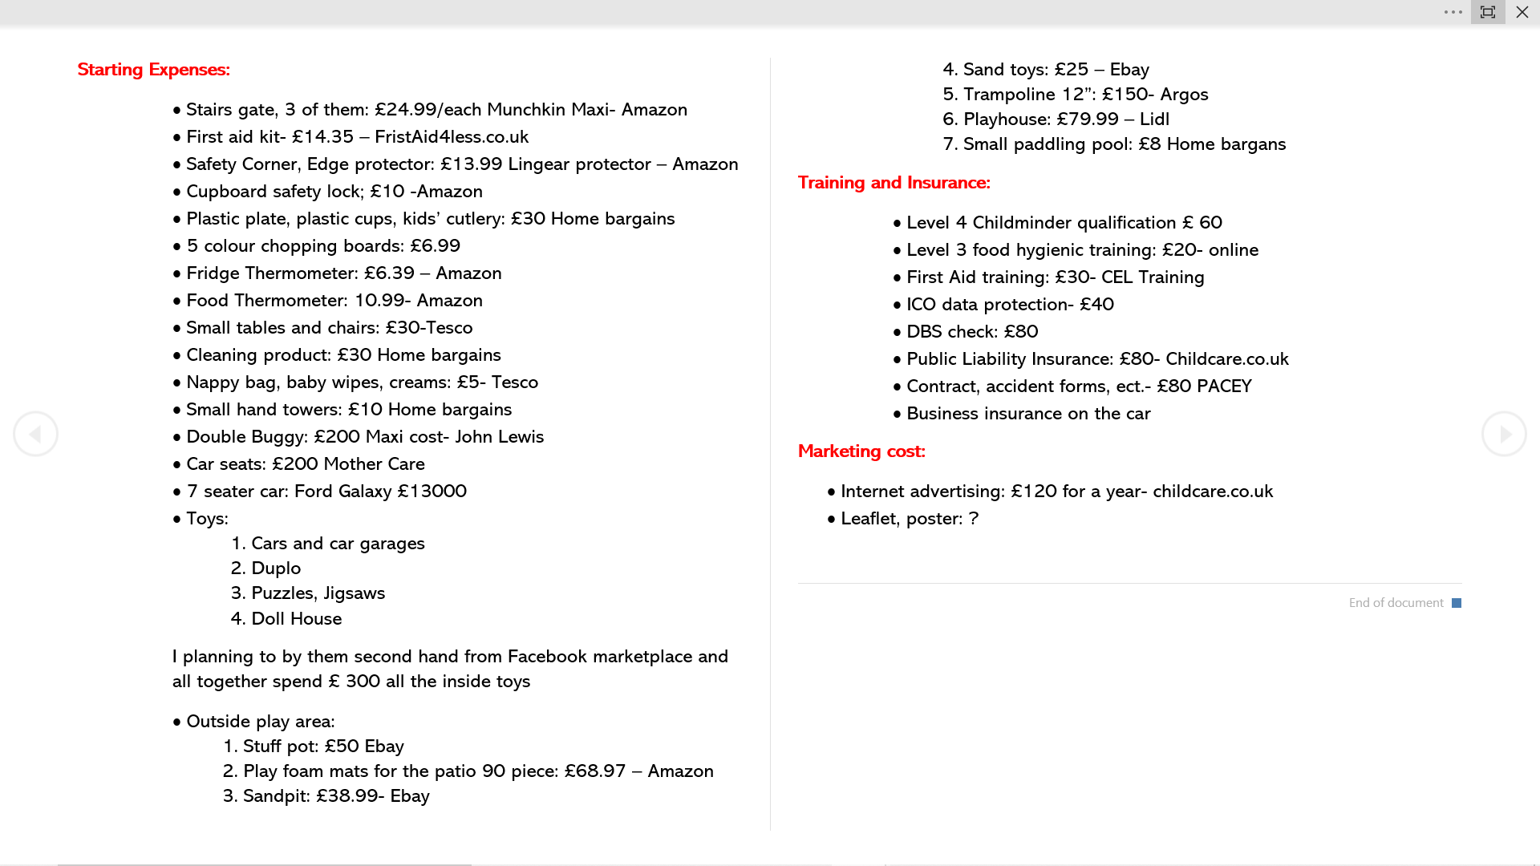

Financial Resources
Every single business needs a stable finance background to start up. I have set aside £4000, from my personal savings but this will not cover all my start-up costs, as can be seen in the previous page. As my business is only small, I have ruled out investors or angels. A business angel or angel investor is a wealthy individual who invests personal capital in start-up companies. They invest in return for an equity stake. In other words, when they invest, they obtain a percentage ownership of the start-up business. (Marketbusinessnews.com, 2020)
To help with the starting up costs and to get useful tips about setting up a new business I have registered with www.businesswales.co.uk
Unfortunately, I am not eligible for any start up grants, but they can offer me a start up loan. This is a government fund loan with the 6.19% APR and 6% of interest rate per annual rate. To be eligible for this loan I will have to pass a credit check and fill out an application form giving all my business details, marketing plans, attach a SWOT analysis and a year business plan.
The advantage of this loan is that it provides a business adviser for free over a year period.
My major start-up expense is to purchase a 7-seater car, instead of using car finance which have high interest rates I can use the start-up loan to pay for this. The start-up loan has better interest rates which are much fairer than any other car finance can offer.
Each child’s payment is paid a month in advance, I have set this to be on the 28th of each month. This ensures that I am paid for my work and there is less chance of not receiving payment or for any of my customers falling behind with the payment. My business will not have debtors. A debtor is a company or individual who owes money. If the debt is in the form of a loan from a financial institution, the debtor is referred to as a borrower, and if the debt is in the form of securities – such as bonds – the debtor is referred to as an issuer.(Chen, 2019)

Human Resources

My business is a sole trader. According to Korchak “As a sole trader, you have absolute control over your business, its assets and profits after tax. Alongside this control, this business model offers comparative simplicity, versatility and a number of other advantages.” Being a sole trader, my biggest advantage is I do not need to answer to anyone else, I can make decisions quicker and easier. Unfortunately, there is a negative side as well, it means I can work longer working hours, and maybe I will have to work on the weekends as well as the weekdays. I think the biggest disadvantage comes with unlimited liability. Unlimited liability refers to the full legal responsibility that business owners and partners assume for all business debts. This liability is not capped, and obligations can be paid through the seizure and sale of owners’ personal assets, which is different than the popular limited liability business structure. (Traver, 2019) I must be careful with my future decisions as I am solely responsible with my personal savings and all goods for my business. If my business does not succeed, I can easily lose my personal goods and money.
As a qualified Childminder I will be taken on the Childminder role. I have completed level 4 Certificate in Higher Education: Skills for the Workplace in the Swansea University. I will take on the Human Resource role and all the administrative, marketing and financially jobs. I can grow the number of children attendance in the same day and time, if I taken on a Childminder assistant. This position would be ideal for someone, who like to have some practise next to childcare study, or anyone who like to voluntary.

Childminder - Job description

Childminders are responsible for planning and preparing a programme of play-based activities and in the completion of all relevant record keeping, paperwork and administration. All Childminders have a responsibility to set promote and demonstrate a high level of professionalism when carrying out their work. The childminder must prepare a home cooked nutritious meal. The childminder must hold a food hygiene certificate to be made available and to meet with the regulations. The childminder must also hold a DBS check and have attended Paediatric First Aid training. A Level 4 Childminder qualification is required.

Childminder assistant responsibilities are to work closely with the childminder. The assistant is to help plan the daily activities, programs and to help with all the food preparation. The main duties are to play with the children and to help with the collection of children from school. They do not require any training, but they must have a DBS check.

Appendices

References
- Christopher, F. W. (2007) Holistic Management -Managing what matter for Company Success. New Jersey: John Willey & Sons INC

- Earnest-Jones, S. (2019) What is marketing mix and how can you use it? [www.globalwebindex.com] Available at: https://blog.globalwebindex.com/marketing/marketing-mix/ (Accessed: 17/05/2020)

- Newberry, C. (2018) How to defined target market, [www.blog.hotsuite.com] Available at: https://blog.hootsuite.com/target-market/ (accessed: 13/05/2020)

- Lotamate.com (2017) What is marketing segmentation? [www.lotame.com] Available at: https://www.lotame.com/what-is-market-segmentation/ (Accessed: 13/05/2020)

- Rouse, M. (2013) Unique selling point (USP) [www.whatis.techtarget. com] Available at: https://whatis.techtarget.com/definition/unique-selling-point-USP (accessed: 08/06/2020)

- Marketbusinessnews, (2020) Business angels definition and meanings [www.marketnews.com] Available at: https://marketbusinessnews.com/financial-glossary/business-angel/ (accessed: 15/06/2020)

- Korchak, J. (2020) What is solo trader? [www.informdirect.co.uk] Available at: https://www.informdirect.co.uk/business-management/what-is-a-sole-trader/ (accessed: 15/06/2020)

- Traver, E. (2019) Unlimited Liability [www.investopedia.com] Available at: https://www.investopedia.com/terms/u/unlimited-liability.asp (Accessed 15/06/2020)

- Chen, J. (2019) Comparative finance and accounting- What is debtor? [www.investopedia.com] Available at: https://www.investopedia.com/terms/d/debtor.asp (Accessed: 15/06/2020)

