

Master of Business Administration

International Marketing: Principles and Practices – LCMB7026

Student Name -Harshkumar Manojkumar Patel

Student ID – 2503790

Lecturer Name – Dr. Tushara Balendran

Company – ZARA

Country – UK & USA

Word Count – 5351

Table of Contents
Section 1: Report 3
1. Introduction 3
2. Background of the Company 3
3. Comparative Analysis of the Market 4
3.1 Critical Macro-Environmental Evaluation through PESTEL 4
3.2 Socio-Cultural and Consumer Behaviour Synthesis 8
4. Comparative Analysis of STP 9
5. Application of 7Ps strategy 12
6. Directional Development Strategy: Ansoff Matrix 18
7. Ethical Issues: Greenwashing, Sustainability, and the Circular Economy 19
8. Recommendations 20
8.1 For the UK Market 20
8.2 For the USA Market 20
Section 2: Reflection 22
Conclusion 25
Reference List 26
Appendices 33
Appendix 1: Comparative Analysis of STP 33

- Section 1: Report
- 1. Introduction
International marketing in global organisations has become one of the major requirements to survive the extreme competition of the market. Brands like Zara nowadays must maintain a balance between standardisation and localisation to operate in diverse regions by understanding the similarities and differences of the different markets. Noor, Till and Hafeez, (2025, p.184) have further mentioned that consumer value differentiation occurs due to the culturally, economically and institutionally differentiation in the market.
The report critically compares the international marketing strategy of Zara across two significant markets, the US and the UK, while evaluating the macro environment with the help of the PESTLE framework and the application of cultural dimensions from the perspective of consumer behaviour theory. The application of segmentation, targeting, and positioning strategy for their help in understanding the marketing mix. The study will also include a reflective account based on the learning and the experience gained throughout this project.
- 2. Background of the Company
In increasing sustainability, concern and digital environment upgradation, along with the geopolitical uncertainty within the fast fashion industry, have further intensified the situation of competitiveness and digital expansion. Specifically, regions like the UK or the USA are highly essential due to their variations in retail and macro-environmental pressure, which directly impact the purchasing habits of their consumers, as mentioned by Johnsson and Kramer (2023, p.13). The continued investment in sustainability and technology, along with consumer experience, has helped for maintaining strong prisons in the international market, despite having competition from other brands like H&M or other digital-first retailers like Shein.

Figure 1: Featuring the Logo of the Company
(Source: INDITEX, 2026)
- 3. Comparative Analysis of the Market

3.1 Critical Macro-Environmental Evaluation through PESTEL
Political Environment: From the perspective of political stability, the UK is heavily dependent on the Parliamentary system, having a constitution and party dominance in the ruling system, while the USA have a centralised presidential system with a separate branch of government and federalism. Johnson and Zhu (2023, p.12) further highlighted that the Parliamentary and democracy constitutional system in the United Kingdom represent ahead of state as an elected representation, who is the head of government with the Prime Minister. However, the government intervention is having differentiation that directly influence the operation of global organisations. Rashid, (2025) highlights that the UK fashion industry is highly based on Trade agreement, protection, sentiment, and has recent vulnerability in the tariff environment making the environment less favourable compared to the USA. The fashion industry in the USA is highly dependent on domestic shifts and international trade policies, imposing higher effective tariff rates, as represented by Joy, (2026, p.13), specifically on footwear and apparel compared to other imports which makes the business challenging. However, with effective management of Zara can easily address these regulatory requirements.
Economic Environment: The economic stability of any nation is the navigating factor for the management of the business venture. The fashion resilience among younger consumers. Purwanti, Judijanto and Thalib, (2023, p.49) have mentioned that the higher growth economy of the United Kingdom is driven by Tech and consumer spending largely making this region more favourable for the growth of the fashion businesses. The USA market, however, features a high centralisation and service-based market which requires challenges for the conduction of the new business. This further makes challenges for the fashion businesses in the long run. The economic environment of both the UK and the USA is shaped by the differentiation of the fashion industry through trade policy and sustainability demands for the convenience of digital shopping in both regions (Bibi et al., 2024, p.1496454). The pricing strategy of Zara can be highly affected by the economic environment in both these regions.
Social Environment: The social factors can highly contribute towards the influential international market for global organisations like Zara. This can directly impact the business decisions of the fashion brands (Baena, 2024, p.4319). The social environment of the US is characterised by individualism and outward expression, with a high focus on the success of the career creating more opportunity for the Fashion brands like Zara to invent new apparel products. The social environment of the UK is based on privacy, politeness and stronger collectiveness through public services which demands sophistication and elegance creating new favourable approach for the business expansion.
Technological Environment: The technical infrastructure is the primary way out for the retail strategy for featuring a digital-ready environment and having a better retail ecosystem for long-term delivery as mentioned by Barker, (2024, p.85). The talent pool within the UK creates created a strong environment for venture capital and giant tech corporations with a favourable market development. The advanced retail market in both the USA and the UK has a greater emphasis on artificial intelligence and both markets are effective for the development of the business expansion for the fashion brands like Zara. AI-driven demand forecasting can help Zara make consumer analytics and optimisation of the inventory for operational improvement across the diverse market (Kumar, 2024, p.1933). Advanced digital payment system technologies also have better opportunities for integration with mobile applications and omnichannel transfer for the enhancement of customer journeys and maintaining better technical capabilities. However, the primary differentiation among these regions is the focus on immediate omnichannel convenience among UK consumers through leveraging technology, whereas in the US, Zara focuses on vast logistics management and personalised digital engagement. The events like Brexit in this aspect can have a direct impact on the business management for the long run development for the business expansion in the UK.
Environmental Factors: In recent times, environmental sustainability has become one of the essential aspects within the global fashion retail industry. Providing specific attention towards textile waste, carbon emissions and circular economic initiatives is essential to address with increasing consumer demand for responsible consumption (Arora and Mishra, 2023, p.5). The government initiatives within the UK further encourage sustainable consumption, which can place additional pressure on Zara to represent measurable environmental performance that makes the business chapelling due to additional cost rather than any commitments through symbolic measurements only. The federal environment policies in the US, however, have fluctuation and demand for sustainable practices is currently fragmented within this region, as mentioned by Ukpoju et al., (2024, p.389). Currently, Zara is facing intense scrutiny over the environment and the challenge of fast fashion operations. Emphasis on the global standardisation of join life sustainability initiative. The organisation has a step right to establish an example of a better clothing program and develop targets to mitigate environmental impact.
Legal Environment: The legal environment at UK and the USA has a strong influence on the business creating more favourable business environment. The legal compliances shape in marketing and operational decisions of Zara, as they can maintain compliance with consumer protection legislation, with a focus on product safety, advertising standards, and employment rights, along with data privacy and data protection through rules like GDPR (Celestin, 2024, p.12).
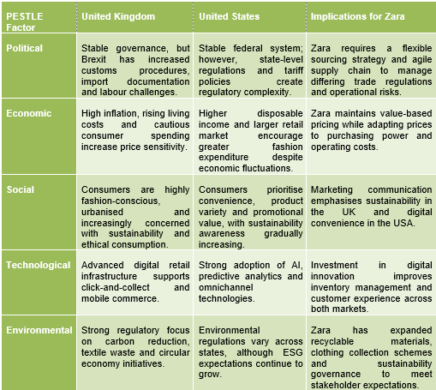
Figure 2: Comparative Evaluation of UK and USA
(Source: Idea taken from INDITEX, 2026 and PESTLE analysis)

3.2 Socio-Cultural and Consumer Behaviour Synthesis
The comparison through the application of Hofstede Insights (2026, p.1) as represented in the image below between the UK and the USA features exceptionally high individualism among both countries, representing appreciate towards personal self-expression through fashion and personal identity with unique styling. The framework is effective in describing the cultural differences among the people and helps in the navigation of the marketing communication of the fashion brands like Zara. However, the operationalisation of these business environments has differentiation. The British people are represented to be more individualistic and view fashion through the perspective of achieving success and uniqueness. Sindhuja, (2025) has mentioned that Americans have a preference towards changing urban high-street trends, along with the ethics of their purchase being eco-friendly.
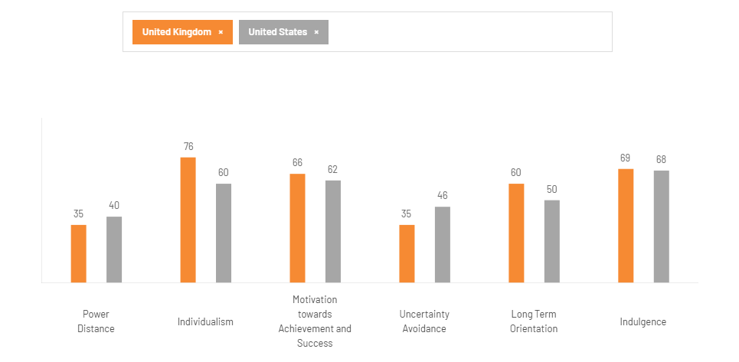
Figure 3: Cultural Variation Comparison among the UK and USA
(Source: Hofstede Insights, 2026)
The evaluation of the power distance among these countries represents subtle but effective variations, representing the high comfort level of consumers in having advances styling and challenging the traditional norms of styling. However, comparatively low scores in both countries suggest that consumers prefer informal relations within stores through personalised and customer-centric services from sellers (Noor, Till and Hafeez, 2025, p.184). As a result of this kind of preference, Zara focuses on accessibility of its own stores rather than offering only luxury products.
Fashion purchases in Britain have the nature of frequent shopping, urban convenience, and fast online delivery. In case of America, the citizens are geographically scattered and dependent on the mall experience, along with a preference towards digital shopping and promotional events.
However, the primary disadvantage of this framework is that it does not focus on the complexity of the human experience and the business operational issue having lesser capability of understanding the cultural aspects from the perspective of the business environment. Despite these limitations, the Hofstede's Cultural analysis can provide effective comparison among the national cultures which further helps the brands like Zara to understand the preferences of the consumers and maintain both the local responsiveness and globalisation at the same time.
- 4. Comparative Analysis of STP
Segmentation: The global fashion brand Zara primarily adopt standardised global segmentation strategy while selectively adapting towards localised offerings to address country-specific demographic requirements and differentiation in purchase behaviour. Bhat et al., (2025, p. 1566) have mentioned that international market segmentation is highly dependent on demographic, psychographic, and behavioural variables which is effective for both the UK and USA in a similar manner. The demographic segmentation by age specifically targets individuals who are between 18 and 40 years of age and have moderate income, focusing on people who are seeking the latest and stylist clothing options (Refer to Appendix 1). This hybrid segmentation helps the brand to mitigate global identity and respond to the local market conditions. In both the UK and US markets, the primary targeted consumers, Generation Z and millennials, have high fashion concepts and digital engagement, which makes it easier to target them through digital platforms (Wandhe, 2024, p.89). The highly compressed geographic segmentation within the UK model focuses on the Metropolitan area and high-street zone, whereas in the US, the brand is looking forward to having a vast continental segmentation of the market within the tier one centres. However, the USA offers a broad demographic due to its larger population and ethnic diversity, which influences Zara to provide differentiation in size, Product style and different regional merchandise. Purba et al., (2025, p, 159) also mentioned that Zara targets consumers who have a value for fashionable design and quality while also focusing on affordability. However, the primary differentiation of these two markets is the behavioural choices in the fashion product the helps the brand to maintain consistency based on the different expectations of the shoppers and attract rapid turnover of the product, having limited edition collections to create an exclusive environment. The critical segmentation of Zara is highly based on standardisation, regardless of demographic and psychographic differentiation, as the global trend of consumer profile is relatively uniform.
Targeting: The primary targeted market of Zara is fashion involved generation Z and millennials, as this group include young professionals who prefer the latest fashion trends and have the potential to make purchases with a basic income level (Wandhe, 2024, p.22). The differentiated targeting strategy of Zara is concentrated on consumer segments preferring similar fashion areas, but different purchasing behaviour across different international markets. Young professionals value rapid adoption and digital convenience. These people are appropriate for approaching with a frequent product renewal and making them receptive towards the fast fashion business model of the organisation. However, the primary similarity of the both the UK and US market is in the preferences of the young professionals who value purchasing decisions with quality, affordability and professional appearance influenced by social media platforms like TikTok, as mentioned by Sibulan and Limos-Galay, (2024, p.48). In the UK, increasing sustainability awareness is encouraging Zara to make an environmentally conscious product line demanding high differentiation and the circular initiatives. On the other hand, the US market is having more preferences towards digital connectivity as consumers are prioritising convenience and differentiation in shopping availability. Within this region, the brand actively targets suburban demographics through prominent regional Mall placement. Purba et al., (2025, p.160) have mentioned that the targeting strategy of Zara is highly effective as it can directly address each requirement of the consumers with an increasing level of fashion involvement.
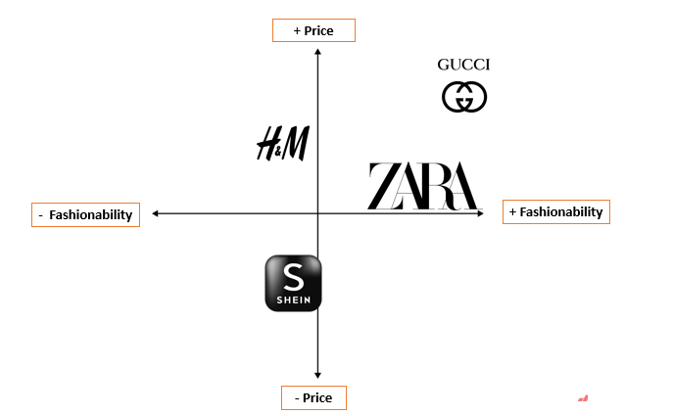
Figure 4: Positioning Map of Zara and Competitors
(Source: Self-generated)
Positioning: The brand Zara has occupied a unique and highly profitable business space within the international fashion industry, including markets like UK and USA which operates at the convergence of fast fashion and affordable luxury rather than purely competitor on price or being a low-cost retail organisation, as represented in the image above. Islami, Rahyuni and Rukayyah, (2024, p.110) have mentioned that positioning is one of the necessary aspects for the business of Zara providing similar opportunity for the market development and acquisition while focusing on quality trends only, responsiveness or shopping experience.
A detailed analysis of STP strategy developed by Zara is represented in the Appendix 1. This further includes comparing and contrasting the similarities and differences of its application in the UK and US markets.
- 5. Application of 7Ps strategy
Product Strategy: The international strategy of product development at Zara is based on standardisation while also including localisation within the business environment. UK products are more focused on seasonal clothing while the USA offers broader size ranges. Ukpoju et al., (2024, p.389) have mentioned that the physical product at Zara has continuous local adoption to match the regional needs of the consumers, as the brand offers globally standardised collections through minimalist European aesthetics and rapid turnover with limited production volume. The clothing collection in the UK has a frequent reflection of seasonal transitions with cold weather, which results in a greater focus on neat wear or outer wear and layering products (Singh, Midha and Sikka, 2026, p.16).
On the other hand, the USA demands differentiation in size range and assortment depth, having regional differentiation in demand for product allocation. The vertical integration of the supply chain further helps Zara to have a real time sales information and maintain responsiveness while minimising the excessive inventory management requirement for developing a sustainable environment of value chain activities, as represented in the image below.
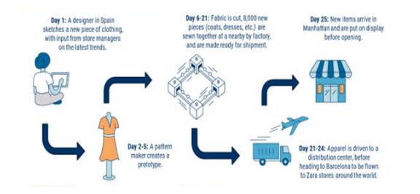
Figure 5: V Fast-Fashion Supply Chain Depth of Zara
(Source: Ahmad, 2024, p.4)
Price Strategy: The price strategy of Zara is preferring value-based pricing, which helps in maintaining the retail business with a value-based pricing strategy. Rashid, (2025, p.16) has highlighted that rather than only focusing on the discount process. UK consumers place greater emphasis on product quality, and the consumer of the Usa is having more influence through the fashion trends, product variety and promotional communication. have also mentioned that consumers in the UK have a general awareness and scepticism towards the fast fashion industry. Within the region of the UK, the business operations are being influenced by the standard of living of the people, as also mentioned by Abdi, Li and Càmara‐Turull, (2022, p.1259). As the people of the UK are having more focus on the value of the product over advertising, the products can directly impact the perception of the people, creating a negative effect on the image of a premium brand within the UK, as mentioned by Guerreiro et al., (2023, p.39).
On the other hand, the USA market is having preference towards the sizing requirements and prefers having information from the fashion magazine. The demographic variability within the region of the USA is represented in differences in shopping approaches. Therefore, Zara needs to make sure that they opt for omni channel strategy for the retention of consumers.
Place Strategy: The strategic combination of a highly agile and vertical supply chain at the same time can have a direct impact on the physical footprint in different locations of the brands, as mentioned by Ye, Lau and Teo, (2023, p.1567). The smaller business size of the UK provides Zara with an opportunity to establish effective logistic operations and a swift delivery system through the click-and-collect options for delivery and returning orders. The flagship stores of Zara are in London, Manchester and Birmingham, but there is also a unique brand experience to help the brand in the digitalisation (Gaudó, 2025, p. 78).
On the other hand, the USA market has represented a significant increase in logistics considering the size of the country. The brand in this case concentrates on the flagship stores in metropolitan areas, while also maintaining digital commerce to reach consumers and clients from different parts of the USA.
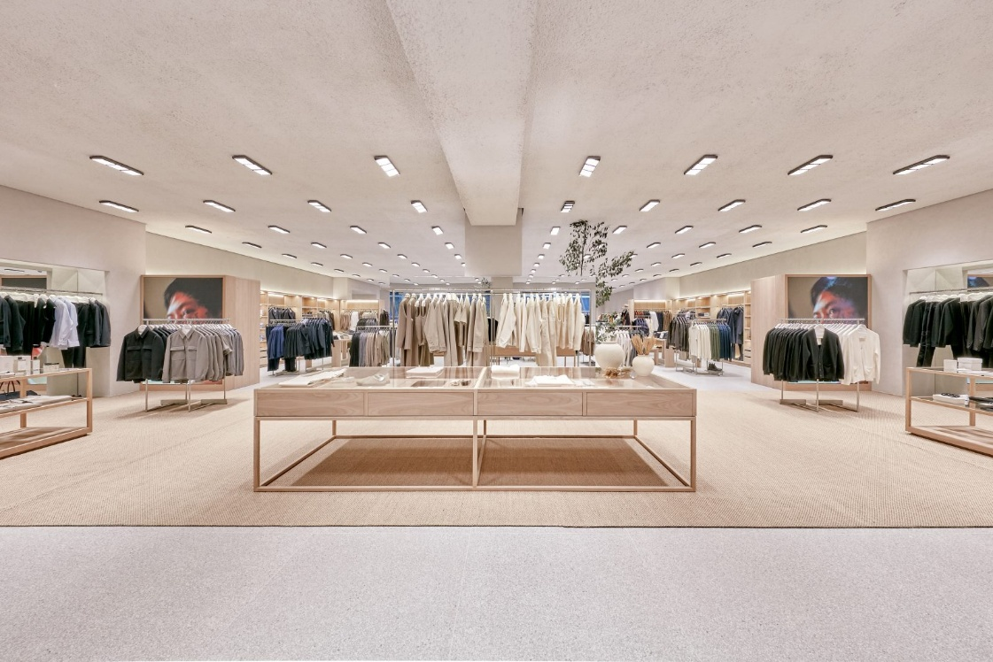
Figure 6: New Biggest store of Zara in the UK
(Source: Fish, 2026)
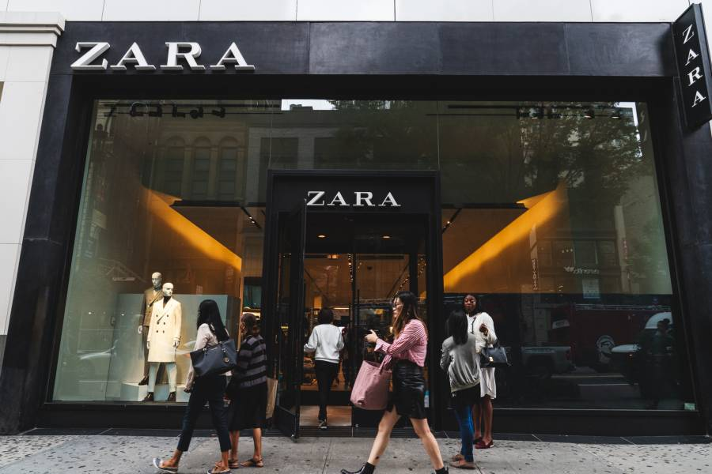
Figure 7: Zara store in New York City, USA
(Source: 34th Street, 2026)
Promotion Strategy: Zara employs a distinct and unconventional international promotion strategy based on minimal traditional advertising, where the brand completely avoids expensive television or any billboard campaign (Nguyen, 2023, p.29). Additionally, British consumers are having a tenancy for accepting changes in the fashion trends more easily than Americans. Jasrotia, Darda and Pandey, (2023) have mentioned that in recent times the British consumers have become more interested in responsible purchases and authentic consumption along with styling. The UK consumers respond effectively to the sustainable messaging.
The people from the USA prefer to find reliable information in reviews and advertisements and having high influence like reviews, advertisements and influencer content. Despite some variations in terms of masculinity, Americans also focus more on achievements and status, which influences the marketing strategy of Zara to remain affordable but stylish. Both cultures show relatively high levels of Indulgence, highlighting instant gratification preferences. To drive engagement, the plan further depends on digital marketing and organic visits through social media platforms, leveraging the micro and micro influencer partnership. Overall, the promotional strategy can reinforce the perception of exclusivity and reduce marketing expenditure.
People: The marketing mix evaluation of people analysis extends beyond the fraud line employee for evaluating the capabilities of the organisation that can shape the perspective and experience of consumers (Azizi and Naeli, 2024, p.156). Focuses on knowledgeable staff and efficient consumer service, with continuous employee training to maintain a premium, accessible shopping environment. However, the implementation is represented in the local market conditions where stores in the UK prioritise personalisation,
The store within the USA demands workforce flexibility. The younger consumers of the UK are having environmental credentials along with the quality of the product and price. American consumers, on the other hand, is having fashion-oriented mindset based on the availability and convenience of promotional value. These consumers have more preference for product variability and ethical considerations alone (Baena, 2024, p.4315). The total number of employees in the UK is 3,137, whereas in USA the company have employed around 7000 employees around the 103 stores.
Process: The operational process at Zara is created for mitigating the friction and providing a seamless consumer journey in the USA market as well as management of the inventory system (Nguyen, 2023, p.52).
The digital checkout process in the UK have standardisation through the global framework integration, offering navigation through localised payment methods and automation with return labels.
Physical Evidence: With the help of the cohesive and luxury-inspired brand identity, the physical evidence is standardised for delivering better services in the UK, having features of minimalist architecture aesthetics. UK stores maintain a consistent European-inspired fashion for the consumers
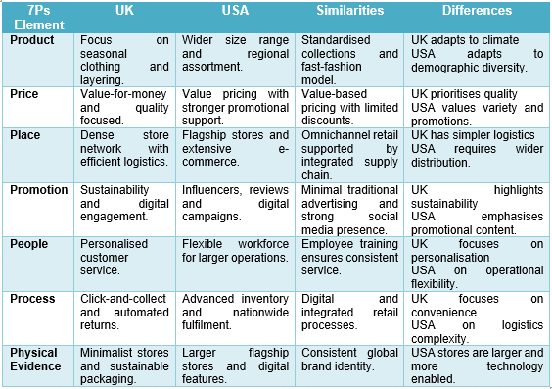
Figure 8: Comparative Analysis of the UK and USA in terms of Similarities and Differences
(Source: Ye, Lau and Teo, 2023, p.1567; Nguyen, 2023, p.29)
The advanced Packaging ID in the USA further reflects the contemporary brand identity with the increasing use of recyclable materials to achieve the target of Net zero emission by reaching at least 90% of its carbon footprint by 2040, as represented in the image below.
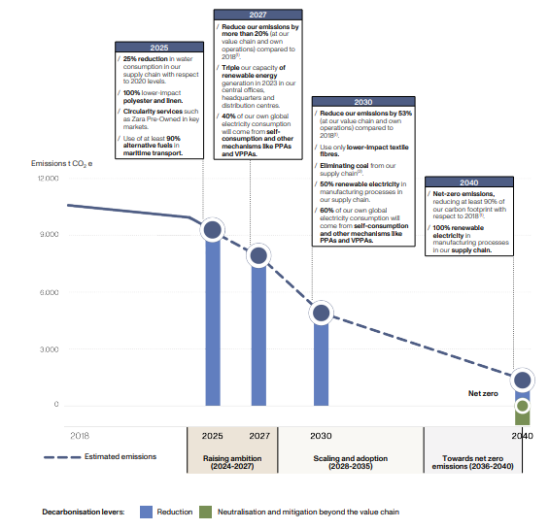
Figure 9: Net Zero Target by 2040
(Source: INDITEX, 2026)
- 6. Directional Development Strategy: Ansoff Matrix
Among the international business environment of Zara, the United States provides one of the most feasible contexts for the directional development of the company. The long-term growth opportunities of Inditex can have more opportunities within the USA, as this market has variability in the nature and preferences of consumers, as mentioned by Benavides, (2024, p.79). Zara primarily adopts a dual strategy in the region with market penetration and market development, despite having a significant presence. The market penetration is further executed through digital integrated flagship store in the secondary retail hub within the US for simultaneous out-of-stock with existing locations for omnichannel. Keep capabilities like automated pick-up points or RFID-based sales. Despite having the capability to determine the business environment with the help of the macro environment, cultural variations and values can have a direct impact on the business environment of fashion brands like Zara, while influencing consumer behaviour directly and defining the efficacy of international marketing, as mentioned by Gasamáns Gesto (2023). The application of Hofstede's Cultural Dimensions to the adaptation capacity of the Zara adaptation strategy can provide an effective evaluation of the cultural differentiation between the cultures of the UK and the USA while highlighting the reason behind the gradual adaptation in the marketing strategy from the organisation to retain the global identity. The market penetration is further executed through a digitally integrated flagship store in the secondary retail hub within the US for the simultaneous out Gracian with existing locations for omnichannel. Keep capabilities like automated pick-up points or RFID-based self-check-in. Zara also drives market development with the digital print expansion through corporate investment and having sub brand launching with high end collections. The report from INDITEX, (2026) further supported the strategic direction through the evaluation of investment in Digital transformation and sustainability governance for maintaining the key abilities and operational roles. At the same time, the strategy of Zara in America is characterised by Deep penetration within the existing market and supported by the selective development of different product categories.
- 7. Ethical Issues: Greenwashing, Sustainability, and the Circular Economy
The primary challenge for fashion brands nowadays is the global scrutiny regarding their commitment to environmental stewardship and the actual outcomes of the brands (Jamil, 2024, p.32). Established in 1975, Zara has become one of the leading fashion retail organisations with the help of vertical integration of the business model and product development cycle as represented in INDITEX (2026). From the perspective of the 7Ps marketing mix, the organisation Zara represents both ethical and unethical marketing practices. The production within this region has a high tendency to address the requirements of the people with sensitivity towards value though the approach like Zara promotes its Join Life clothing collection from the product in the USA. Again, the process strategy it offers digital receipts and click-and-collect services for the paper use minimisation.
However, unethical marketing has alos been noticed. From the of Promotion perspective, Greenwashing challenges in recent times has developed as one of the major issues at fashion organisations like Zara due to the requirement of concrete operational accountability and influencing the demand for measurable development towards the circular economy for maintaining sustainability from the Promotional aspect of the 7Ps marketing environment. Shibly and Hoque (2025, p.12) have also mentioned that the ethical challenge in the USA is having heavy dependency on supply chain transparency due to the increasing textile waste generation. Additionally, under the Product element, the fast manufacture with the short-life fashion collections have led towards the overconsumption and created textile waste influencing the environmental sustainability challenge. From the geographic perspective, this business is having a more concern to address the social status of the people. Papasolomou, Melanthiou and Tsamouridis, (2023, p.193). The global supply-chain transparency in the USA is also having high preference towards labour standards and responsible sourcing facilities, influencing the requirement of supply-chain accountability.
- 8. Recommendations
To understand the potential of any market, it is essential to understand the external factors affecting the business environment (Purwanti, Judijanto and Thalib, 2023, p.46). The following recommendations can be helpful for further development. The recommendations below highlight the critical macro environmental component and approaches that can be essential in both the UK and USA aspects for providing necessary information regarding marketing expansion.

8.1 For the UK Market
To strengthen the international market is having effectiveness across the UK market that demand initiatives for scaling circular economy systems. Gaudó, (2025, p.88) have also mentioned that differentiation within the market and communicating the same can have a direct impact on the expectations of the consumers. A strong consumer data protection is necessary for operating in the UK through having a more decentralised system of legal obligations, including employment regulation, taxation, or environmental requirements. Effective legal adaptation, therefore, supports management while reinforcing consumer protection across different markets. Zara also needs to improve transparency within its supply chain with comprehensive disclosure to improve accountability and better sustainability communication through its annual reporting

8.2 For the USA Market
Inditex, the parent company of Zara, can have a direct influence on its business due to the differentiation of the regional environment. Strengthen the circular ecosystem for fashion products with recycling infrastructure by taking the used products back in exchange for reward points, as represented in the business operations of H&M (2026) can be effective for the USA market. Enhancing AI-driven personalisation, focusing on the US market, should enhance investment in predictive analytics and a better recommendation system for Product relevance enhancement. Focusing on the differentiation of the products based on the basic requirement of the local market can also help in the greater market acquisition.
- Section 2: Reflection
Description: The completion of the report have demanded systematic procedure of research that have aimed to evaluate the marketing strategy of the Zara and the evaluation have highlighted that for the development of an international marketing strategy within the US, business management, environmental-related demand balancing, global standardisation, and hyper-localisation are required to maintain regional diversity and strict state-by-state compliance due to the variance in consumer purchasing power and strict competition within the domestic market was also mentioned by Barker, (2024, p.85). Again, the UK market has an in-depth preference for trend management with a high fashion, environmentally friendly requirement for business management, which is mainly influenced by European trade policies and a recent alteration after the Brexit incident. The application of different frameworks like PESTEL, Hofstede's Cultural Dimensions, STP analysis, along with the extended 7Ps marketing mix, has been effective for the marketing strategy evaluation.
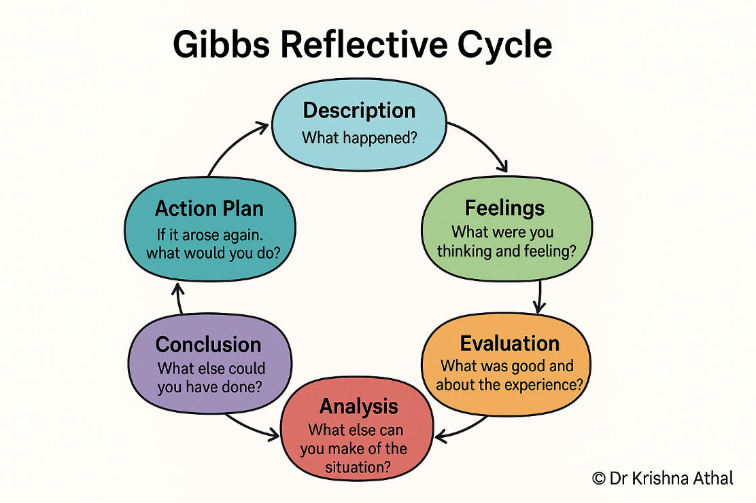
Figure 10: Gibbs Reflective Cycle
(Source: Athal & Athal, 2026)
Feelings: During the initial phase, the report structuring and construction have been the most challenging part, which required multiple observations of the assignment brief for understanding the requirement of the theoretical framework and critical comparison between the two different international markets. Moving towards the strategic evaluation, I have evaluated the order of international marketing and analysed how product differentiation or value-based pricing helps in promotional activity and implementation of variations. During the writing process, I found initial difficulty to avoid reputation as several frameworks, specifically PESTLE and the marketing mix, have addressed connected aspects of business strategy. However, with careful planning, it was effective to distinguish between the external environment and strategic response at the same time while completing this report and discovering the necessary insights regarding the transforming of marketing strategy to have more integration within the USA market.
Evaluation: This has also helped Zara to actively re-engage its global positioning while emphasising environmental responsibility, revealing how the brand separates itself from the standard first fashion organisations and focuses on a High Street brand, maintaining balance between accessible pricing and effective design relevance.
One of the primary strengths of this research is in the successful integration of marketing theory concepts from the perspective of the real company perspective like Inditex, which is the parent company of Zara. Rather than focusing on a single framework like PESTLE or 7Ps in isolation, I have connected the theories with the real-life realities of Zara while focusing on the bi-weekly air shipments and value-based price matrices. Additionally, the RFID self-checkouts are also integrated for inventory tracking and management. The fundamental positioning of the brand is consistent across both the UK and USA. However, there are minute differentiations in the localisation practices of the marketing strategy.
Despite having multiple achievements of the organisation, there are several difficulties connected with the writing process. This was one of the most challenging aspects of the task while also maintaining the word count requirement. Apart from that, I also have to deal with problems in finding unbiased sources regarding the problems of Zara in terms of logistics and greenwashing.
Analysis: The successful completion of this report has enhanced my understanding towards internationalisation of any brand through Masiive combining strategic management and sustainability of consumer behaviour in the global business environment. My initial approach was to focus more on collecting information regarding marketing activities. However, academic literature provides me with the necessary information that postgraduate assessment demands and the strategies that are adopted and their implementation are influenced by the micro and macro environmental concerns. For example, the application of cultural dimensions has shown that small cultural differences among UK and the USA can produce meaningful variations in consumer expectations and purchasing behaviour. The clothes alignment between both markets, I suggested a standardisation in the marketing approach and helped me to realise that aligning with consumer value required differentiation in Product communication. These further highlight that global brands cannot depend on absolute standardisation but also require adapting place, price and logistics as per local requirements.
Conclusion: Overall, working through this individual report has evolved my understanding of international marketing strategy for global brands. The assignment has also demonstrated that successful international marketing requires addressing alterations in consumer expectations and making technical developments to reinforce critical thinking and evidence-based waste analysis.
Development requirement as I need to develop more confidence in applying marketing frameworks and prepare for future work of stronger quality retrieve analysis using market statistics. From the research perspective, I have also realised that the mission approach is heavily dependent on descriptive writing, which needs to be altered in critical academic evaluation through integrating analytical insights and using a framework for explaining the success of the strategies. The experience has overall enhanced the capacity for the gradual development in the future area.
Action Plan: Based on these experiences gathered from his individual report, I further aim to improve my professional and academic performances in future projects through the implementation of a structured plan of action. I will attempt future extensive reports through the creation of highly strict online constraints and prepare drafts for each of the sections. This needs to be applied immediately for the next academic module, and it will prevent overwriting and ensure a better balance between critical analysis and descriptive writing. Apart from that, building a balanced critical matrix and enhancing the practical knowledge of data-driven prediction, maintenance is also essential, where I need to be self-directed, professionally independent from the critical literature during the initial phase of research. I will also focus on a professional training module focusing on the application of AI in the predictive model of the supply chain. This approach requires ongoing evaluation, and it can provide strong analytical depth and practicality in science, formulating any actionable strategy or Recommendations for the global organisation. The future direction also needs to focus on the capability development for the academic writing and managing proper citation.
- Conclusion
Evaluate the international marketing strategy of Sara across the UK and USA, the macro environmental situation of both regions, along with their cultural differentiation. The application of the STP framework and international marketing may have been effective for highlighting the significant difference in economic condition and culture expectation, along with consumer behaviour and the regulatory environment. Moving forward, continued market leadership is highly dependent on its ability of navigating operation, cost and complex logistics through targeted intervention for the growth strategy. Overall, the individual report and the reflection have highlighted that a successful marketing strategy demands, continuous balance maintenance between the globalisation and local strategy adaptation.

- Reference List
Abdi, Y., Li, X. and Càmara‐Turull, X., (2022). How financial performance influences investment in sustainable development initiatives in the airline industry: The moderation role of state‐ownership. Sustainable Development, 30(5), pp.1252-1267. https://onlinelibrary.wiley.com/doi/pdf/10.1002%2Fsd.2314
Ahmad, H., (2024). Zara, the Global Fast Fashion Pioneer from Spain. Journal of Global Awareness, 5(1), p.7. https://scholar.stjohns.edu/cgi/viewcontent.cgi?article=1114&context=jga
Arora, N.K. and Mishra, I., (2023). Responsible consumption and production: a roadmap to sustainable development. Environmental Sustainability, 6(1), pp.1-6. https://link.springer.com/content/pdf/10.1007/s42398-023-00266-9.pdf
Azizi, S. and Naeli, M., (2024). Internal Marketing Mix Operationalization: A Review of the Literature. Internal Marketing: Issues and Perspectives for Internal Customer-Centric Management: Internal Marketing, pp.155-185. https://www.researchgate.net/profile/Ali-Mirakzadeh/publication/384235510_Internal_Marketing_Models/links/6747028b790d154bf9aed9ed/Internal-Marketing-Models.pdf#page=154
Baena, V., (2024). The shift from fast fashion to socially and sustainable fast fashion: The pivotal role of ethical consideration of consumer intentions to purchase Zara. Corporate Social Responsibility and Environmental Management, 31(5), pp.4315-4328. https://onlinelibrary.wiley.com/doi/pdf/10.1002/csr.2803
Barker, J., (2024). Touching the Void: Wealth creation through regional supplier hyper-localisation. Management and Innovation, p.85. https://figshare.cardiffmet.ac.uk/articles/conference_contribution/Advances_in_Management_and_Innovation_Conference_Proceedings_2024/25860580/1/files/46439878.pdf#page=86
Benavides, G.F., (2024). Evolution of INDITEX group’s internationalization strategy in Latin America. Cuadernos de Administración (Universidad del Valle), 40(79). http://www.scielo.org.co/scielo.php?pid=S0120-46452024000200008&script=sci_arttext&tlng=en
Bhat, S., Jarad, R., Bhavsar, D., Yadav, M., Suryavanshi, P. and Moholkar, D., (2025). The Role of Psychographic Segmentation in Advertising. International Journal of Research Publication and Reviews. https://doi. org/10.55248/gengpi, 6, p.1566. https://www.researchgate.net/profile/Mahendra-Yadav-27/publication/391435304_The_Role_of_Psychographic_Segmentation_in_Advertising/links/684bd87f72548d4a032c65c3/The-Role-of-Psychographic-Segmentation-in-Advertising.pdf
Bibi, S., Khan, A., Fubing, X., Jianfeng, H., Hussain, S. and Khan, A.N., (2024). Impact of environmental policies, regulations, technologies, and renewable energy on environmental sustainability in China’s textile and fashion industry. Frontiers in Environmental Science, 12, p.1496454. https://www.frontiersin.org/journals/environmental-science/articles/10.3389/fenvs.2024.1496454/pdf
Celestin, P., (2024). How Emerging Data Protection Laws Are Reshaping Digital Marketing and Consumer Privacy Policies. https://papers.ssrn.com/sol3/Delivery.cfm?abstractid=5188091
Gasamáns Gesto, L., 2023. A change beyond fast fashion: An analysis of Zara’s positioning and communication. https://ruc.udc.es/bitstreams/04fa47fc-e148-402b-9d08-002f7cf0ab7a/download
Gaudó, M.L., (2025). The ROLE of DIGITAL COMMUNICATION in GLOBAL FASHION BUSINESS: ZARA’S BRANDING STRATEGY. https://zaguan.unizar.es/record/166389/files/TAZ-TFG-2025-4600.pdf?version=1
Guerreiro, J., Loureiro, S.M.C., Nascimento, J. and Duarte, M., (2023). How to earn a premium price: the effect of green marketing and brand coolness. Journal of Communication Management, 27(1), pp.35-63. https://www.researchgate.net/profile/Jorge-Nascimento-9/publication/366849261_How_to_earn_a_premium_price_the_effect_of_green_marketing_and_brand_coolness/links/63b549bc097c7832ca8d3350/How-to-earn-a-premium-price-the-effect-of-green-marketing-and-brand-coolness.pdf?origin=journalDetail&_tp=eyJwYWdlIjoiam91cm5hbERldGFpbCJ9
H&M. (2026). Garment collecting & recycling. Available at: https://www2.hm.com/en_in/customer-service/product-and-quality/garment-collecting-reycling.html
Athal, K., & Athal, K. (2026, August 3). Gibbs Reflective Cycle explained: A Framework for Structured Self-Reflection | Dr Krishna Athal. Dr Krishna Athal. Available at: https://drkrishnaathal.com/blog/gibbs-reflective-cycle-explained-a-framework-for-structured-self-reflection/ [Accessed 08 August 2026]
Fish, I. (2022, October 13). Inditex’s UK MD on the UK’s biggest Zara store. Drapers. Available at: https://www.drapersonline.com/news/inditexs-uk-md-on-the-uks-biggest-zara-store [Accessed 08 August 2026]
34th Street. (2026). Zara The best in fashion. Available at: https://34thstreet.org/shop-eat/zara [Accessed 08 August 2026]
Hofstede Insights (2026). Country comparison tool. Available at: https://www.theculturefactor.com/country-comparison-tool?countries=united+kingdom%2Cunited+states. [Accessed 16 June 2026]
INDITEX (2026). INDITEX | Reports & Regulations. Available at: https://www.inditex.com/itxcomweb/es/en/investors/corporate-governance/reports-and-regulations. [Accessed 16 June 2026]
Islami, M.M., Rahyuni, S. and Rukayyah, A., (2024). Strategic branding: Building market positioning and business growth through integrated management practices. Advances in Business & Industrial Marketing Research, 2(2), pp.110-122. https://advancesinresearch.id/index.php/ABIM/article/download/293/133
Jamil, M., (2024). Comparative analysis of Finnish fashion brands in terms of, sustainable initiative and Transpar ency of their sustainability action. https://www.theseus.fi/bitstream/handle/10024/861880/Jamil_Muhammad.pdf?sequence=2
Jasrotia, S.S., Darda, P. and Pandey, S., (2023). Changing values of millennials and centennials towards responsible consumption and sustainable society. Society and Business Review, 18(2), pp.244-263. https://www.researchgate.net/profile/Pooja-Darda/publication/361857791_Changing_values_of_millennials_and_centennials_towards_responsible_consumption_and_sustainable_society/links/62cd0dce00d0b451104bc49c/Changing-values-of-millennials-and-centennials-towards-responsible-consumption-and-sustainable-society.pdf?_sg%5B0%5D=started_experiment_milestone&origin=journalDetail
Johnson, R. and Zhu, Y.Y., (2023). Introduction: The Case for the Political Constitution. Sceptical Perspectives on the Changing Constitution of the United Kingdom. https://qmro.qmul.ac.uk/xmlui/bitstream/handle/123456789/103179/Johnson%20Introduction%20The%20Case%202023%20Accepted.pdf?sequence=5
Johnsson, F. and Kramer, R., (2023). How macro factors influence decision-making in the fashion industry value chain. https://gupea.ub.gu.se/bitstreams/40cd6764-3b60-49b1-b7dc-9caf3e165163/download
Joy, E. (2026). 'Fashion is more political than meets the eye,' Slow Fashion Saturday, 31 January. Available at:https://consciousstyle.substack.com/p/yes-fashion-is-political. [Accessed 16 June 2026]
Kumar, P., Choubey, D., Amosu, O.R. and Ogunsuji, Y.M., (2024). AI-enhanced inventory and demand forecasting: Using AI to optimize inventory management and predict customer demand. World J. Adv. Res. Rev, 23(1), pp.1931-1944. https://www.researchgate.net/profile/Praveen-Kumar-611/publication/386381884_AI-enhanced_inventory_and_demand_forecasting_Using_AI_to_optimize_inventory_management_and_predict_customer_demand/links/674fa8a4a7fbc259f1aafffe/AI-enhanced-inventory-and-demand-forecasting-Using-AI-to-optimize-inventory-management-and-predict-customer-demand.pdf
Nguyen, T., (2023). Zara’s organization apparatus: what is the key behind Zara's fast fashion success? https://www.theseus.fi/bitstream/handle/10024/797609/Nguyen_Truc.pdf?sequence=2
Noor, N.A.M., Till, B. and Hafeez, K., (2025). Differentiation Strategies in Competitive Markets. Copyright© 2025 Eurasian Research Institute, 184. https://www.gbppublications.com/_files/ugd/5e526c_d512b35bd3f04b9eac3a95ed47ef78ea.pdf#page=197
Papasolomou, I., Melanthiou, Y. and Tsamouridis, A., (2023). The fast fashion vs environment debate: Consumers’ level of awareness, feelings, and behaviour towards sustainability within the fast-fashion sector. Journal of marketing communications, 29(2), pp.191-209. https://www.researchgate.net/profile/Yioula-Melanthiou/publication/366336610_The_fast_fashion_vs_environment_debate_Consumers%27_level_of_awareness_feelings_and_behaviour_towards_sustainability_within_the_fast-fashion_sector/links/66b1d0f4299c327096b3a843/The-fast-fashion-vs-environment-debate-Consumers-level-of-awareness-feelings-and-behaviour-towards-sustainability-within-the-fast-fashion-sector.pdf
Purba, E., Manik, L., Khan, Z.T. and Sembiring, P.S., (2025). The Influence of Price and Product Quality on Consumer Decisions in Purchasing Zara Brand Clothing in Medan 2024. Maroon Journal De Management, 2(3), pp.158-168. https://gensain.com/index.php/mjdm/article/download/178/155
Purwanti, A., Judijanto, L. and Thalib, N., (2023). The influence of the external environment on business strategy planning and implementation. West Science Journal Economic and Entrepreneurship, 1(02), pp.42-49. https://www.academia.edu/download/122648944/315.pdf
Rashid, A., (2025). The Impact of Global Economic Policies on Business Development: A comprehensive study on how global trade agreements and economic policies influence business development decisions. https://osuva.uwasa.fi/bitstreams/dae5c3eb-cc66-4f87-ad0e-24ee69ce75b8/download
Shibly, M.A.H. and Hoque, M.M.U., (2025). Sustainability challenges of the textile industry. In Textile Industry and the Environment-Challenges, Recent Development and Future. IntechOpen. https://www.intechopen.com/online-first/1199271
Sibulan, F.C.T. and Limos-Galay, J.A., 2024. TikTok affiliate marketing: Factors influencing purchase intention of young professional consumers in Santa Cruz, Occidental Mindoro. International Journal of Research, 12(3), pp.47-66. https://www.researchgate.net/profile/Jenny-Galay-Limos/publication/382495982_TikTok_affiliate_marketing_Factors_influencing_purchase_intention_of_young_professional_consumers_in_Santa_Cruz_Occidental_Mindoro/links/66a0bf955919b66c9f6840c6/TikTok-affiliate-marketing-Factors-influencing-purchase-intention-of-young-professional-consumers-in-Santa-Cruz-Occidental-Mindoro.pdf
Sindhuja, P., Kotni, V.D.P., Misron, A., Hakimi, H. and Udandrao, S.D., (2025). Exploring slow fashion consumer buying behavior in the context of sustainability: a systematic literature review using TCCM approach. Cogent Business & Management, 12(1), p.2519966. https://www.tandfonline.com/doi/pdf/10.1080/23311975.2025.2519966
Singh, S., Midha, V. and Sikka, M., (2026). Thermophysiological comfort in multilayered clothing for cold weather: a scientific overview. Journal of Thermal Analysis and Calorimetry, pp.1-21. https://www.researchgate.net/profile/Sakshi-Singh-99/publication/400034230_Thermophysiological_comfort_in_multilayered_clothing_for_cold_weather_a_scientific_overview/links/699410297247bc6473e13470/Thermophysiological-comfort-in-multilayered-clothing-for-cold-weather-a-scientific-overview.pdf
Ukpoju, E.A., Adefemi, A., Adegbite, A.O., Balogun, O.D., Obaedo, B.O. and Abatan, A., (2024). A review of sustainable environmental practices and their impact on US economic sustainability. World Journal of Advanced Research and Reviews, 21(1), pp.384-392. https://www.researchgate.net/profile/Emmanuel-Adikwu/publication/377806991_A_review_of_sustainable_environmental_practices_and_their_impact_on_U_S_economic_sustainability/links/6973265258b9985baa8a668d/A-review-of-sustainable-environmental-practices-and-their-impact-on-U-S-economic-sustainability.pdf
Wandhe, D.P., (2024). The new generation: Understanding millennials and Gen Z. Available at SSRN 4716585. https://papers.ssrn.com/sol3/Delivery.cfm?abstractid=4716585
Ye, Y., Lau, K.H. and Teo, L., (2023). Alignment of green supply chain strategies and operations from a product perspective. The International Journal of Logistics Management, 34(6), pp.1566-1600. https://www.researchgate.net/profile/Ying-Ye-6/publication/370602234_Alignment_of_green_supply_chain_strategies_and_operations_from_a_product_perspective/links/6459304e809a535021597443/Alignment-of-green-supply-chain-strategies-and-operations-from-a-product-perspective.pdf

- Appendices
- Appendix 1: Comparative Analysis of STP


