

Name – Jake Howells

Student Number – 2407082

Course – HND Quantity Surveying

Module – Digital surveying and highway design

Table of Contents
Contents Page…………………………………………………………………………………2
Introduction…………………………………………………………………………………………………….3
About the Dylan Thomas Centre…………………………………………………………………………3
Part 1 The Survey Plan………………………………………………………………………………………4
Purpose of the survey………………………………………………………………………………………4
Survey Area……………………………………………………………………………………………………4
Site assessment……………………………………………………………………………………………4
Scan Positions……………………………………………………………………………………………….4
Lighting Conditions…………………………………………………………………………………………5
Environmental Considerations…………………………………………………………………………5
Safety Considerations………………………………………………………………………………………5
Risk Assessment…………………………………………………………………………………………….6
Part 2………………………………………………………………………………………………………………7
What went well and what had to be changed?.............................................................7
Real world issues that I encountered……………………………………………………………………7
Part 3 Drawings……………………………………………………………………………………………8-10
Laser scan vs Traditional measurement………………………………………………………………11
Time and efficiency………………………………………………………………………………………11
Accuracy………………………………………………………………………………………………………12
Accuracy of the Data………………………………………………………………………………………12
Health and Safety………………………………………………………………………………………12-13
Conclusion…………………………………………………………………………………………………….13
References…………………………………………………………………………………………………14-16

Introduction
This project focuses on the use of digital surveying technologies to help capture accurate spatial information form the Dylan Thomas Centre in Swansea. By using 3D laser scanning methods the work follows the complete workflow og a professional building survey, from the initial planning through to the on site data collection and the final measurement analyses
Part 1 focuses on planning the survey including defying the areas to be scanned and assessing access, logistics and safety within the historic building. Part 2 covers the practical in person work and documenting the scanning process and any adjustments that were made. And Part 3 involves analysing the processed point cloud data to extract the key measurements and comparing accuracy and efficiency of the laser scanner with traditional manual methods.

  - About The Dylan Thomas Centre
The Dylan Thomas centre is a cultural and literacy centre that is located in Swansea that is housed in a restored historic building. The centre is dedicated to the Welsh poet Dylan Thoma and is exhibition that showcases his writing and his legacy. On top of the exhibitions the building has event rooms, meeting rooms and public facilities and it is also used for talks, education and cultural events.(DylanThomas.com, n.d.) (Visitwales.com, 2025)
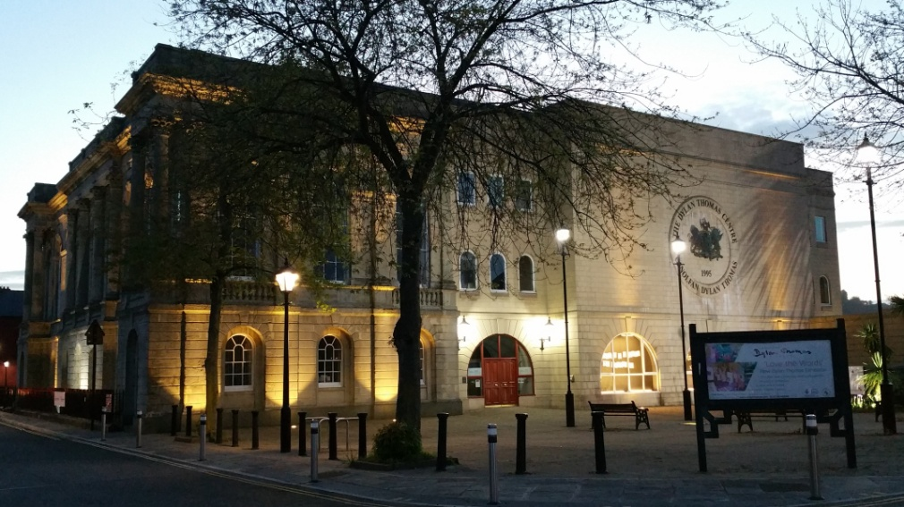

(Swansea Wales, 2023)
3

Part 1 The Survey Plan

  - Purpose of the survey
The aim of this project is to complete a detailed 3D laser scan survey of the specified floor (the surrounding hallway near the theatre room) at the Dylan Thomas Centre. The main purpose is to capture accurate spatial information such as the corridor layouts with the doors, windows etc. The information gathered from this exercise will later be used to extract measurements and compare digital surveying with traditional manual methods. (Howells, J. 2025) (Met Consultancy Group, n.d.)

  - Survey area
The area that is being surveyed is the 4 corridors that loop back to each other next to the theatre. The level of detail required will be as follows, extracting found measurements on to the processed laser scanned paper it will include the overall room dimensions, the ceiling height and the door and window dimensions. (Howells, J. 2025)

  - Site assessment
Access to the Dylan Thomas centre was gained through the main public entrance of the building where we were then met by our tutors and guided to the second floor. Ou group assembled in the theatre space where there was a briefing that outlined the survey objectives, the use of the equipment and any health and safety considerations. After this we were guided up the stairs on the side f the theatre where we then entered the corridors where the surveys were carried out. (Howells, J. 2025)

  - Scan positions
The scanner was positioned in the four corners of the corridors as well as the hallway spaces in between, by doing this we were able to capture full coverage of the hallways and corridors and that all of the key feature were captured accurately, for example, the lift area, the stair, floor openings, window positions and the pillars that were in the walls. There were some occasions where the first scan did not fully capture all areas, we knew this by looking at the iPad. Therefore, we did an additional scan to ensure that everything was captured. (Howells, J. 2025) (Laserscanning-europe.com, 2025)
4
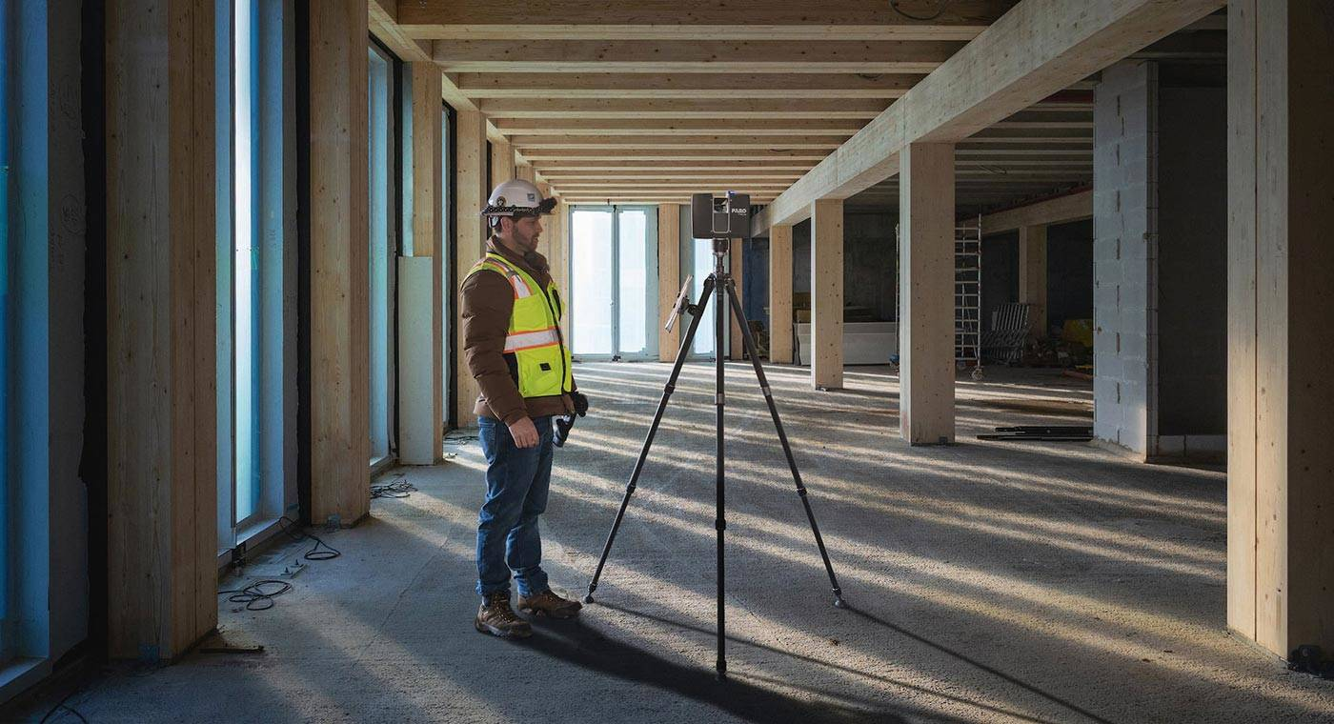
(Faro.com, 2022)
  - Lighting Conditions
The Dylan Thomas Centre was well lit, there was plenty of artificial lighting and many windows, when carrying out the scan it was explained that due to the amount of windows there was some issues with the light and the scanner, when the scan was transferred on to the software there were areas which were not beneficial to the project therefore they were removed when transferring to the software. Where necessary we also completed some additional scans to compensate for this. (Howells, J. 2025) (Photoneo Focused on 3D, 2024)

  - Environmental considerations
It was expected that there would be high foot traffic especially as we were measuring the hallways, therefore there were some cases where there was individuals who needed to walk past and we had to stop the scan and re do it to ensure that there was no obstructions and movement in the scan making sure that the final scan was as accurate and as clear as possible. (Howells, J. 2025) (callidussurveys.co.uk, 2024)
  - Safety considerations
There were not many safety considerations while at the Dylan Thomas Centre as the hallways were mostly clear, the main ones that I had identified were the trip hazards on the scanners tripod legs especially when we were moving its location, ensuring the stability if the scanner, we would then monitor the scanner to try and prevent any interference and we also did our best to avoid any obstructions of the corridors. Whilst doing this we were also advised not to look at eh laser to prevent any damage to our eyes. (Howells, J. 2025) (www.hse.gov.uk, n.d.)
5
  - Risk assessment
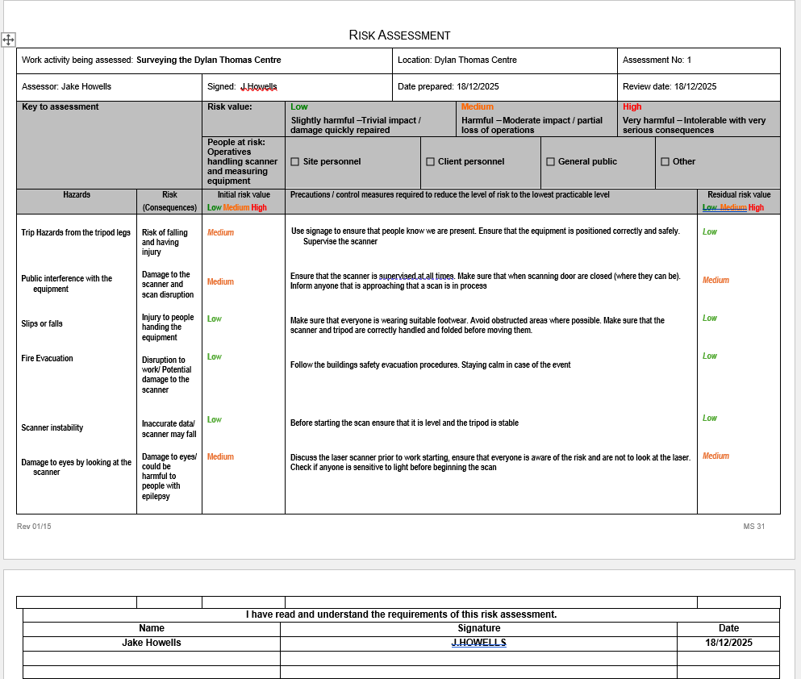
(Howells, J. 2025)

6

Part 2

  - What went well and what had to be changed ?
During my time at the Dylan Thomas centre I was Tasked with measuring form the back right and working anti clockwise, this ensured that I would not be measuring the same place as my classmates at the same time which really helped me get the most accurate measurements. I was able to gather most of the measurements as accurately as I could with the equipment provided, a laser measurement tape, a normal tape, a pend and notepad and a ruler. I initially drew my plans not in sections which I quickly had change as my drawings were becoming very confusing, as soon as I changed my drawing in to sections it made it much more clear to understand for when I transported the measurements on to the scanned piece of paper. Unfortunately I did not take any photos and looking back this would really ave helped me when it came to transporting the measurements, (Howells, J. 2025)

  - Real world issues that I encountered
Whilst I was on site at the Dylan Thomas centre there was a few issues that I was faced with. The first issue I had encountered was obstacles in the was for examples bins and objects these made it slightly more difficult to measure around especially with the laser scanner. Another issue was due to there being many classrooms there was a lot of people walking back and forth which made it more difficult for me while measuring especially the doorways. It also was an issue with the laser scanner because if there was someone in that scan we had to re- do the scan to make sure it was accurate. (Howells, J. 2025)

7

Part 3 Drawings
Please see the below drawings
Whilst on site I noticed that the ceiling height was the same throughout at a height of 2.4 Meters
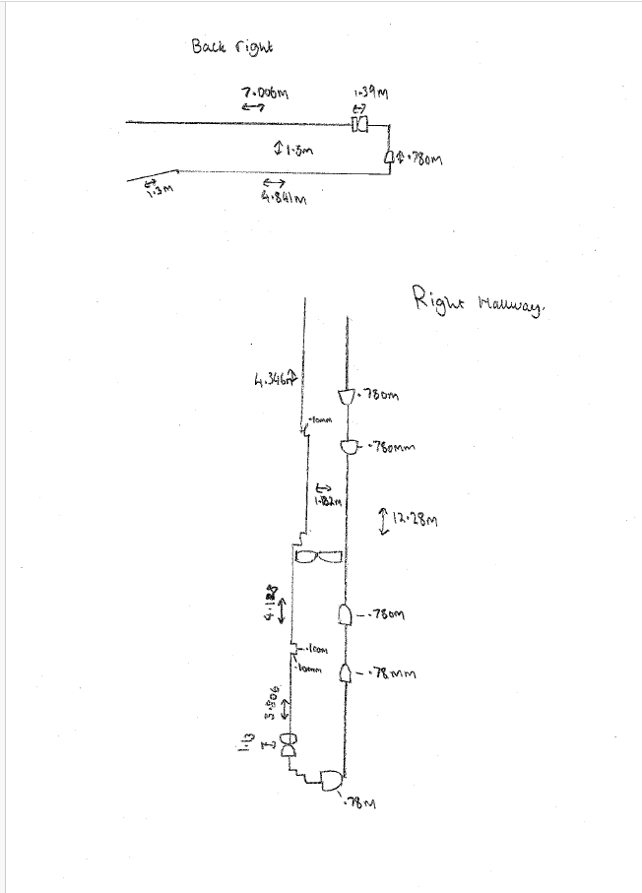

(Howells, J. 2025)
8

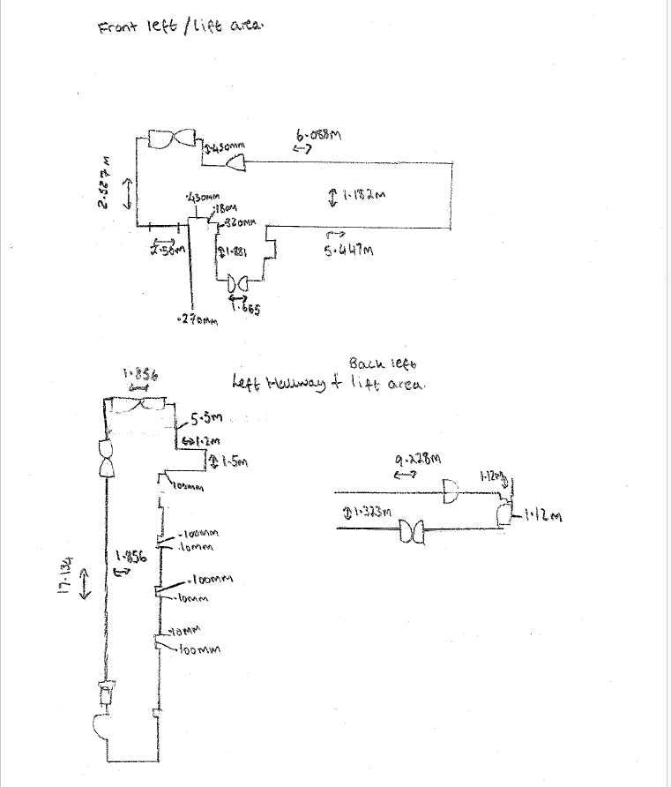
(Howells, J. 2025)

9

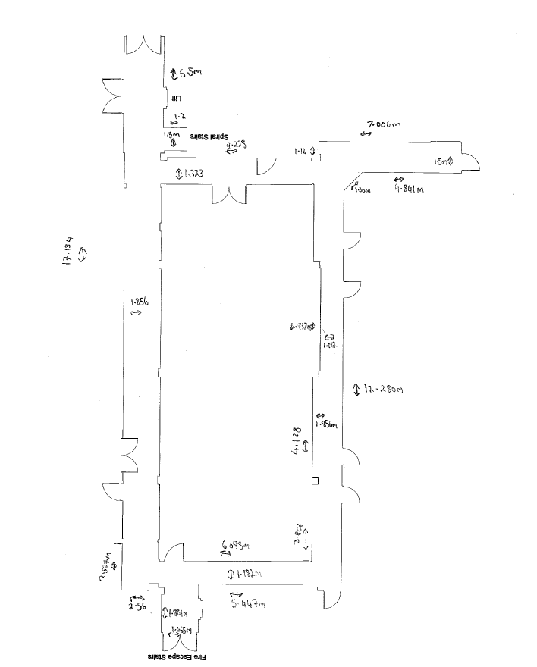
(Howells, J. 2025)

10

Laser Scan vs Traditional measurement
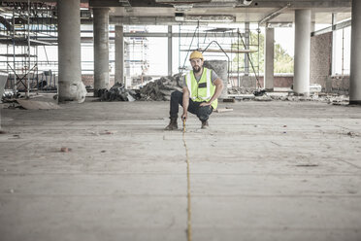
Traditional measurement method in construction involves the use of tape measures, laser measurement tapes, and hand drawn sketches. These techniques have been used for many years and still remain suitable for some small scale projects or a simple building layout. They are a much lower cost compared to modern measurements, very minimal equipment is required and in some cases it can be more effective where the access space is not very good. However when it comes to more complex, larger and historic buildings this method can present limitations in terms of accuracy, the efficiency and the overall completeness of the data that is recorded. (Olofsson, Holmgren and Persson, 2024)

(zerocreatives, 2016)

  - Time and efficiency
One of the main disadvantages of traditional measurement is the time efficiency the manual surveys requires the surveyors to physically measure each dimension on site and record it accurately, which can be slow and labour intensive. If any measurements are missed or any additional information is required at a later stage which means that more site visits may be needed. In the busy or operational buildings this method can disrupt the construction work or the occupants in the building. And then on the other hand the 3D laser scanner captures millions spatial data points within minutes therefore it reduces the time on site significantly whilst still capturing a high level of detail therefore making it more suitable for complex or occupied buildings.
(Mileseey tools, 2025) (3D Laser Scanning for Heritage Advice and Guidance on the Use of Laser Scanning in Archaeology and Architecture, n.d.)
11

  - Accuracy
Accuracy is another key difference between the two different approaches. Traditional measurements are more common to human error such as incorrect readings, having to make multiple different readings and manually having to make the calculations, when combining these factors on a larger more complex building these errors will be costly. The laser scanner uses advanced sensors to capture precise spatial data where it often archives millimetre level accuracy, therefore this creates a reliable digital representation of the building then the accurate dimensions such as the room sizes, floor to ceiling heights and the structural features can be extracted. (Multivista, n.d.)
(Olofsson, Holmgren and Persson, 2024) (Mileseey tools, 2025)

  - Accuracy of the Data
When It comes to data collection the traditional surveys only capture the measurements that are identified as necessary at the time of the survey, if the design changes or further information is required more surveys may be needed therefore another site visit will be needed. However, with the laser scanner is will produce a comprehensive digital record of the entire visible environment, this allows for measurements to be taken later from the point cloud without the need of revisiting site which improves efficiency and reducing disruption, this is especially beneficial in construction projects that involves refurbishment, retro fit or in heritage buildings.
(Mileseey tools, 2025) (Olofsson, Holmgren and Persson, 2024) (Existingconditions.com, 2025)

  - Health and Safety
From a health and safety point of view, traditional measurement could require the surveyor to work at height, enter small spaces, exposed to loud noises, airborne dust slips trips and falls or even measure in active construction areas. The laser scanner reduces the need for physical access to access hazardous areas, or areas with uneven terrain, as the measurements can be taken remotely, therefore the team operating can plan a safe route and reduce the risks to surveyors and machinery whilst also maintaining a high quality of measurements. (Shepherd, 2023) (Tejjy Inc., 2025)

12
Although the laser scanner has many advantages it does have some disadvantages such as the cost of the equipment and the specialist software is considerably higher than manual measurement. The laser scanner requires skilled and trained personnel to operate it and to process the point cloud data, furthermore any reflective surfaces, site movement or obstructions can affect the quality of the scan. (Fibrox3d.com, 2024)

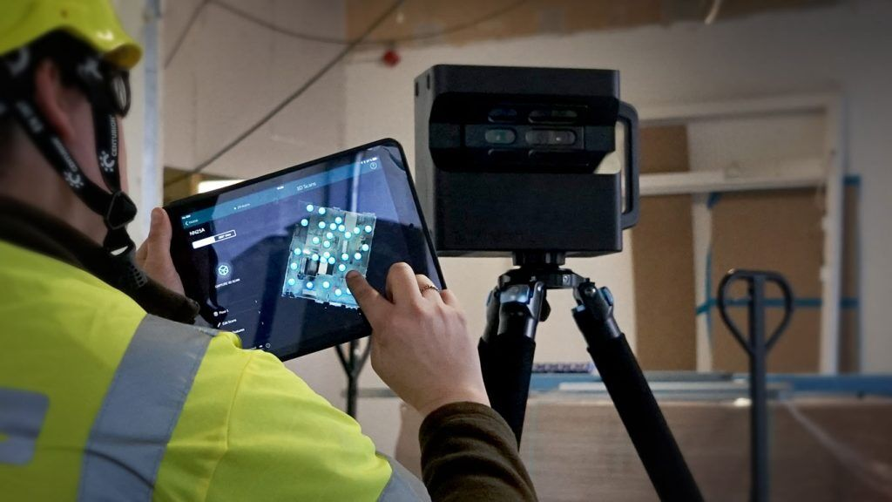
(Tejjy Inc., 2022)

Conclusion
In conclusion, traditional measurements methods remain appropriate for straight forward construction projects, while the laser scanner offers more clear advantages when it comes to safety, accuracy and the completeness of the data. Therefore for the modern construction projects especially the ones that involve complex geometry, refurbishment or existing buildings the laser scanner is a more reliable and future proof solution

13

References
3D Laser Scanning for Heritage Advice and Guidance on the Use of Laser Scanning in Archaeology and Architecture. (n.d.). Available at: https://historicengland.org.uk/images-books/publications/3d-laser-scanning-heritage/heag155-3d-laser-scanning/.

callidussurveys.co.uk. (2024). Common Challenges in Laser Surveying and How to Overcome Them. [online] Available at: https://callidussurveys.co.uk/common-challenges-in-laser-surveying-and-how-to-overcome-them/.

DylanThomas.com. (n.d.). History of the Dylan Thomas Centre. [online] Available at: http://www.dylanthomas.com/dylan-thomas-centre/history-dylan-thomas-centre/.

Existingconditions.com. (2025). How Do We Collect 3D Laser Scanning Field Data? | Existing Conditions. [online] Available at: https://www.existingconditions.com/knowledge-center-articles/how-we-collect-field-data [Accessed 12 Dec. 2025].

Faro.com. (2022). Speed, Accuracy, Sustainability: The Benefits of 3D Laser Scanning for Mass Timber Construction. [online] Available at: https://www.faro.com/en/Resource-Library/Article/3D-Scanning-for-Mass-Timber-Construction [Accessed 14 Dec. 2025].

Fibrox3d.com. (2024). Advantages and Disadvantages of 3D Laser Scanners. [online] Available at: https://fibrox3d.com/advantages-vs-disadvantages-of-3d-laser-scanner.

Howells,J. (2025)

hse.gov.uk. (n.d.). The Safety of laser lighting displays. [online] Available at: https://www.hse.gov.uk/pubns/indg224.htm.

14
Laserscanning-europe.com. (2025). Correctly positioning a laser scanner | Laserscanning Europe GmbH. [online] Available at: https://www.laserscanning-europe.com/en/case-study/correctly-positioning-laser-scanner.

Met Consultancy Group. (n.d.). What is Laser Scanning? [online] Available at: https://www.metconsultancygroup.com/met_blog/what-is-laser-scanning.

Mileseey tools (2025). Why are Traditional Measuring Devices Not Reliable? [online] Mileseey Tools. Available at: https://mileseeytools.com/blogs/precise-measurement/why-are-traditional-measuring-devices-not-reliable?srsltid=AfmBOoqIXT0C68fzTO4enEf8oIBChlM16iqKVI52pEPSR16XYbe39ngZ [Accessed 16 Dec. 2025].

Multivista. (n.d.). Top 5 Benefits of 3D Laser Scanning in Construction. [online] Available at: https://www.multivista.com/blog/top-5-benefits-of-3d-laser-scanning-in-construction/.

Olofsson, M., Holmgren, H. and Persson, K. (2024). Comparative analysis of traditional and modern measured survey methods. ~ 14 ~ International Journal of Surveying and Structural Engineering, [online] 5(1), pp.14–19. Available at: https://www.civilengineeringjournals.com/ijsse/article/14/5-2-6-461.pdf.

Photoneo Focused on 3D. (2024). Impact of Lighting Conditions in Machine VIsion and 3D Scanning. [online] Available at: https://www.photoneo.com/lighting-conditions-machine-vision/.

Shepherd, A. (2023). Common Health and Safety Risks in Construction. [online] NPH Group. Available at: https://nph-group.co.uk/health-and-safety-risks-in-construction/.

Swansea Wales. (2023). The Dylan Thomas Centre Swansea. [online] Available at: https://swanseawales.co.uk/the-dylan-thomas-centre-swansea/ [Accessed 17 Dec. 2025].
15
Tejjy Inc. (2022). 3D Laser Scanning in Construction [Complete Guide]. [online] Available at: https://www.tejjy.com/3d-laser-scanning-in-construction-complete-guide/.

Tejjy Inc. (2025). Improve Site Safety With 3D LiDAR Scanning Tech. [online] Available at: https://www.tejjy.com/3d-lidar-scanning-construction-site-safety/ [Accessed 18 Dec. 2025].

Visitwales.com. (2025). The Dylan Thomas Centre | VisitWales. [online] Available at: https://www.visitwales.com/attraction/museum/dylan-thomas-centre-564161.

Westend61 (2016). Construction worker using tape measure in construction site. [online] Westend61. Available at: https://www.westend61.de/en/photo/ZEF007866/construction-worker-using-tape-measure-in-construction-site [Accessed 18 Dec. 2025].

16

