7/27/2025
University of Wales Trinity Saint David
London campus
E-Portfolio Link: https://2539235.wixsite.com/samuel-ojoks-e-port
Home | Samuel Ojok E Port
Module Name: Learning In the Digital Era
Module Code: ACCA 4025

Student Name: Samuel Ojok
Student ID:2539235
Group: 3

Lecturer’s Name: Anees Baqir

LDE Assignment 1
E-Portfolio
Contents
Introduction. 3
Main Body. 3
Task 1: Essential Academic and Employment Skills for the future career Path. 3
Task 1 (a): Report on Essential Academic and Employment Skills. 3
Task 1 (b): Evaluation of Task 1 (a) based on Similarity report. 4
Task 2: Collaborative Mind Map and Individual Poster. 5
Mindmeister.com (Collaborative). 5
Professional Academic poster. 7
Task 3: Virtual Collaboration and RefWorks. 7
Report on Virtual Collaboration. 7
Step-by-step process of using RefWorks with visuals. 8
Task 4: E-Portfolio Creation and Evaluation 12
Task 4 (a): E-Portfolio Creation 12
Task 4 (b): Illustrative Review of E-Portfolio tool Selection. 16
Conclusion. 16
Task 1 References: 17

Introduction.
In this era, there is rapidly changing digital and professional environment, academic, technical and employability skills which are essential for successful career development. This coursework focuses on the development of key academic and employment skills required for a future career.
The assignment is divided into four main tasks: Task 1 examines the essential academic and employment skills required for future career and evaluates the quality of the work using a similarity report. Task 2 focuses on collaborative working through the development of a group mind map and an individual poster, highlighting the importance of communication, leadership, planning, organisation, collaboration and team dynamics. Task 3 explores virtual collaboration, particularly the norming stage of Tuckman’s team development model and provides a practical step-by-step guide to using RefWorks for managing academic references. Task 4 focuses on the creation and evaluation of an e-portfolio, considering how digital portfolios can support learning, reflection and future employability.
Overall, this coursework demonstrates how academic knowledge, digital literacy, teamwork, communication and reflective learning can contribute to professional development and prepare an individual for a successful career.

Main Body.

Task 1: Essential Academic and Employment Skills for the future career Path.

Task 1 (a): Report on Essential Academic and Employment Skills.
Geographic Information Systems (GIS) Specialist: Essential Skills for Study and Employment.
Recently Geographic Information Systems (GIS) gained high demand in most the employment sectors. It links geography, information technology and data analysis to provide solutions to real-world spatial problems. To be successful in GIS studies and employment, GIS software, data analysis and programming, problem-solving and critical thinking, and communication and teamwork are essential.
Technical understanding of GIS skills are essential in the career and requires competence in GIS software such as ArcGIS and QGIS as widely used for mapping, spatial analysis and data management [1]. Additionally, knowledge of remote sensing, GPS technologies and spatial databases will enhance the ability to collect, process and analysis of geographic information effectively.
Data analysis and programming are valuable skills for the career and employability in the field of GIS as it involves working with large datasets hence proficiency in programming languages such as python and structured query language (SQL) are important when automating tasks and analysing spatial information efficiently [[2].
Problem-solving and critical thinking skills work better in combination and very essential as the use of spatial data requires these skillsets to aid decision-making in areas of urban planning, environmental management, disaster response and transportation [3]
Communication and teamwork skills are vital for regular cooperation with other professionals such as planners, engineers, environmental scientists, and policymakers. This makes it possible to present maps and spatial results clearly through reports and visualisations [4].
Progressive learning and adaptability are essential to the pathway due to advancement in technologies which include web GIS, cloud processing and artificial intelligence applications in spatial analysis [5]. Therefore, possessing these skillsets shall makes it successful in the GIS field.
Figure 1: GIS applications to solve real-world spatial challenges through combination of geography, technology and data analysis for technical, analytical and information insemination.
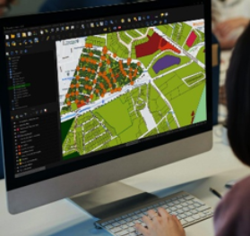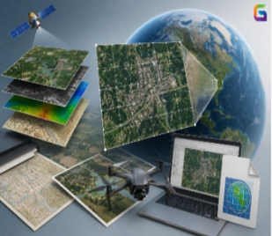

Task 1 (b): Evaluation of Task 1 (a) based on Similarity report.
In conclusion, the similarity score was 16% and the awarded mark is 68%. To ensure better grade, I will improve on understanding the subject matter further, paraphrase literatures appropriately.

Task 2: Collaborative Mind Map and Individual Poster.

Mindmeister.com (Collaborative).Effective Teamwork
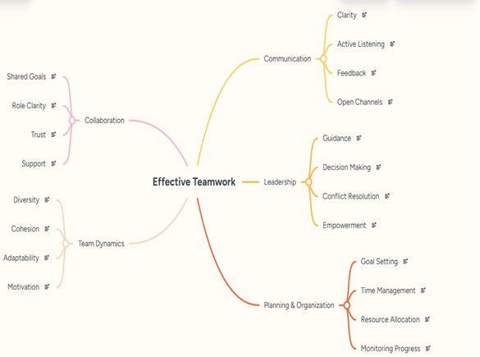

Team members.

Penelope Flores.
Communication: Good communication helps team members understand their roles, share ideas and work together efficiently. Clarity ensures that instructions and expectations are easy to understand, reducing mistakes and confusion. Active listening allows people to understand different perspectives and respond appropriately. Constructive feedback helps individual improvement their performance and encourages continuous learning. Open communication channels create an environment where employees feel comfortable asking questions, sharing concerns, and suggesting new ideas.
Leadership: is equally important in creating and effective workplace. Good leaders provide guidance by setting clear goals and supporting their teams. They make informed decisions that help the organization achieve its objectives. Effective leaders also resolve conflicts fairly, maintaining positive relationships among team members. By empowering employees through trust, responsibility, and encourage, leaders build confidence and motivation. Together, effective communication and strong leadership improve teamwork, increase productivity, and create a positive work environment where individuals and organizations can succeed.

Victoria Owen.
Planning and organization are essential for effective teamwork because they help teams work efficiently toward shared goals. Planning sets clear objectives, establishes priorities, and creates timelines, ensuring everyone understands what needs to be achieved. Organization assigns roles and responsibilities according to each member's skills, reducing confusion and preventing duplication of work. Together, they improve communication by providing clear reporting structures and regular updates, helping team members stay informed and collaborate effectively. They also support better time management and efficient use of resources, enabling tasks to be completed on schedule and within budget. By defining expectations and responsibilities, planning and organization reduce misunderstandings and conflicts while increasing accountability. They also help teams anticipate potential challenges and develop solutions in advance, improving problem-solving. As team members achieve milestones and see progress, motivation, trust, and morale increase. Overall, effective planning and organization create a productive, coordinated, and supportive working environment that leads to higher-quality outcomes and successful achievement of team objectives.
Samuel Ojok
Collaboration supports effective teamwork by keeping all members on shared goals allowing all members to work towards same objectives. Clear roles shared among members reduce chances of confusion and give better accountability. Trust permits open communication, sharing ideas, build confidence, reinforce cooperation and solving problems amongst members. These elements create positive work environment where members contribute effectively, resolve issues and achieve better results. Strong collaboration therefore foster productivity, strengthen relationship and permit teams to contribute efficiently while meeting all objectives.
Team dynamic positively influences effective teamwork through diversity, cohesion, adaptability and motivation. Diversity allows members to contribute different ideas, knowledge and skills which greatly improve creativity and decision-making. Cohesion builds relationship and promotes cooperation amongst members. Adaptability permits teams to respond efficiently to changing environment and challenges whilst motivation strengthens individual commitment and outcomes. Collectively these elements effectively build communication, collaboration, and problem solving while enabling teams to successfully achieve shared goals.

Professional Academic poster. Team Sport
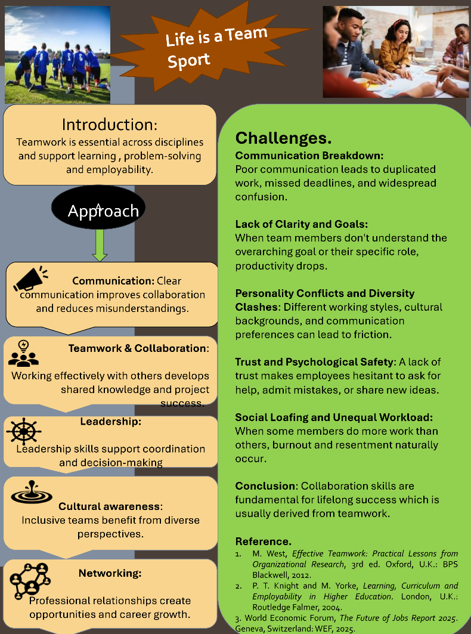

Task 3: Virtual Collaboration and RefWorks.

Report on Virtual Collaboration.

Norming – T he Third Stage of Tuckman's Team Development Model.
The norming stage is the third stage of Tuckman's model of team development and occurs when team members begin to work together more effectively after the challenges of the storming stage [1]. During this stage, individuals start to resolve their differences, develop mutual respect, and gain a clearer understanding of leadership and each member's role within the team. Although cooperation and harmony increase, this may still be temporary as the team continues to adjust to different situations [2].
According to Mullins, several characteristics become evident during the norming stage [2]. Team members begin to avoid unnecessary conflict, show a willingness to conform to agreed ways of working, trust one another, and recognise the needs of the rest of the team. As trust develops, communication improves, allowing members to collaborate more effectively and work towards shared objectives [2].
Commitment and accountability are also important during the norming stage. Lencioni identifies lack of commitment and avoidance of accountability as the third and fourth dysfunctions that reduce team effectiveness [3]. These dysfunctions can result in low responsibility, poor decision-making and reduced team performance. Lencioni explains that successful teams first establish trust, engage in healthy conflict, commit to decisions and then hold one another accountable, creating a stronger and more effective team [3].
The concept of Radical Candor, developed by Kim Scott, also supports effective collaboration [4]. Scott argues that successful communication requires team members to care personally while challenging directly. She describes four communication styles: Obnoxious Aggression, Manipulative Insincerity, Ruinous Empathy and Radical Candor, with Radical Candor being the most effective because it combines empathy with honest, constructive feedback [4]. This approach encourages people to feel heard while also improving individual and team performance.
A networking activity such as sharing an individual SWOT analysis and receiving constructive feedback further supports the norming stage. It enables team members to learn from one another, strengthen relationships and feel valued within the team. Overall, the norming stage is essential because it builds trust, commitment, accountability and open communication, helping teams progress towards the performing stage [1]– [4].

Step-by-step process of using RefWorks with visuals.

Step 1: Login to RefWorks with your account, it could be Gmail or the university email address.
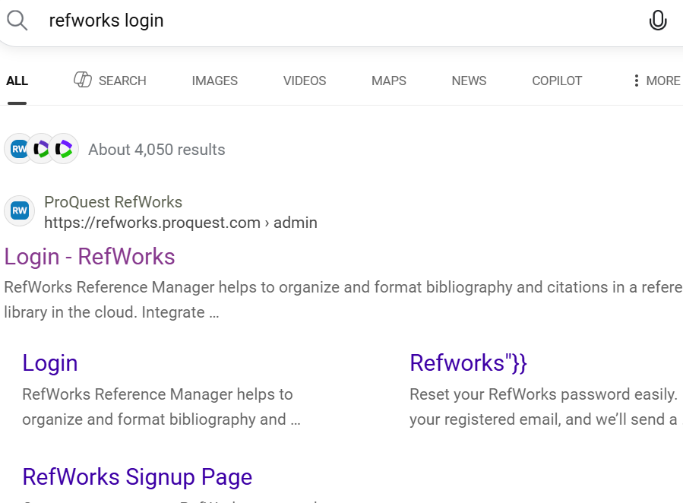
Step 2: Open Google Scholar and search for the articles, books, papers etc using key words to be used as citation and reference in your work.
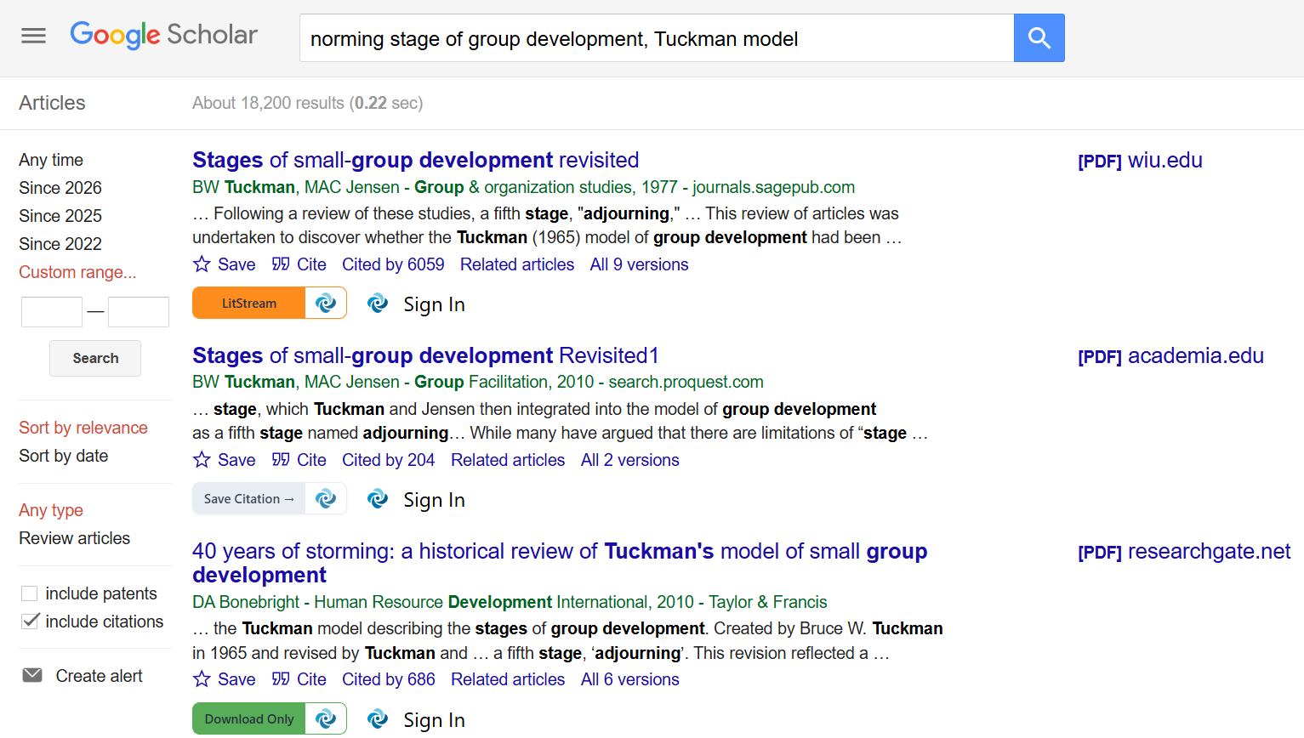
Step 3: Click on “Cite” at the bottom of your chosen search result to import to RefWorks. A Cite table will appear on the screen with several options at the bottom, click on RefWorks.
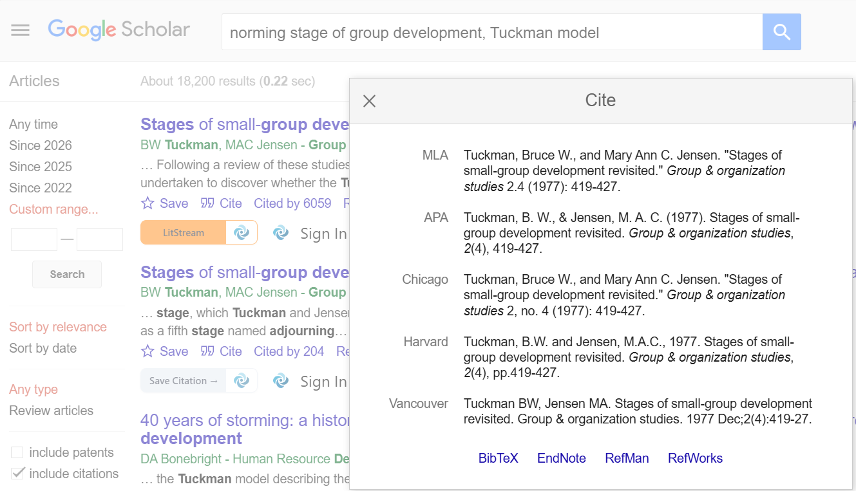

Step 4: RefWorks page will appear on the screen with functional layouts on the right-hand side. Click on "Import" to transfer the reference to RefWorks.
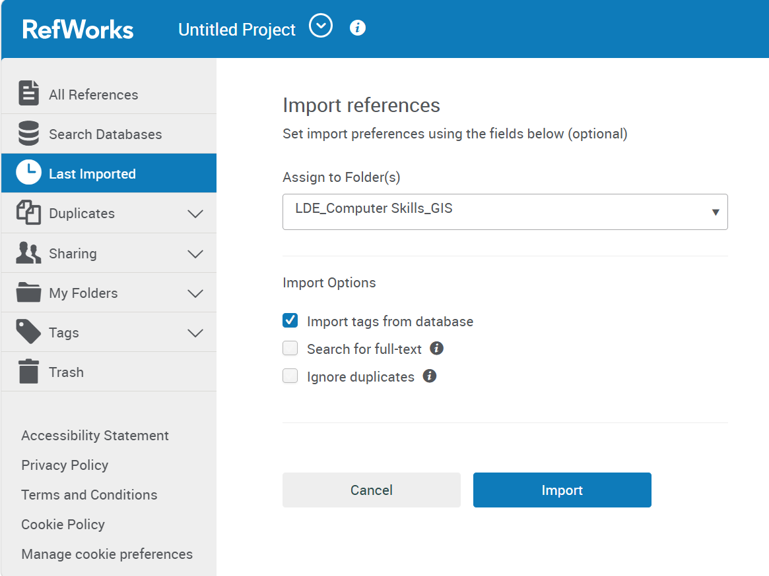
Step 5: To confirm a successful import of the citation/reference, a pop screen shown below should appear on your screen with a message " Import Process Complete".
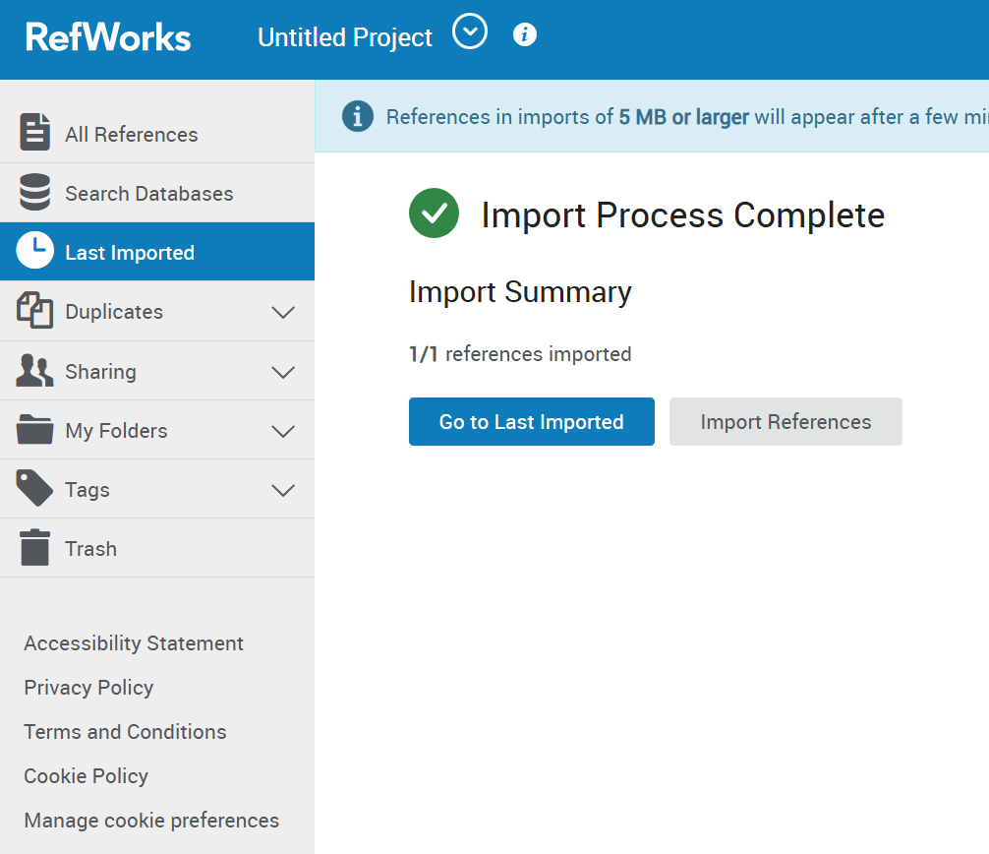

Click "Last Imported" for most recent imported citation/reference or "All References" for all what have been imported to RefWorks.
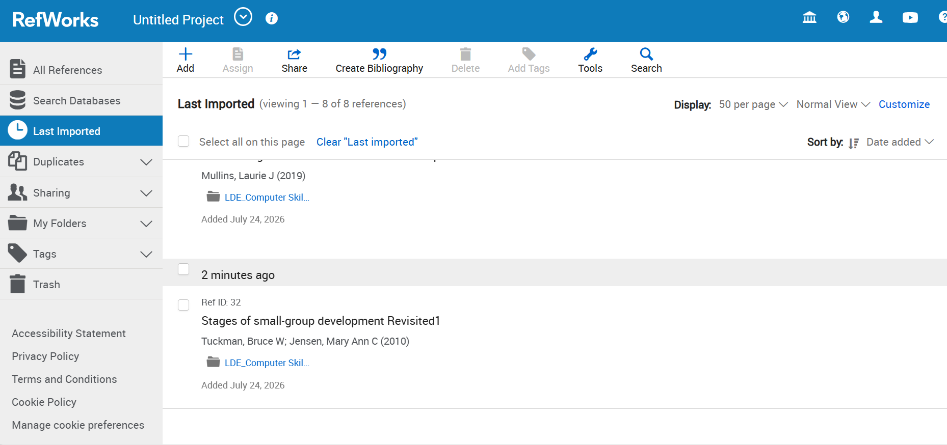
Step 6: To apply the citation to your work and automatic reference, use the recommended style by the instructor/institution, for instance IEEE. Ensure both “Citation and Bibliography” are marked "On" as shown below.
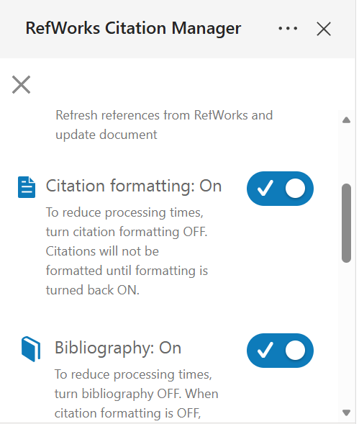

Step 7: To insert the citation to your work on a word document, under "My References" select the citation place cursor before the full stop (.) on where the citation should appear and insert. This will appear on the work with a figure for instance [1] for IEEE style and reference page will be generated automatically down the bottom of your work.
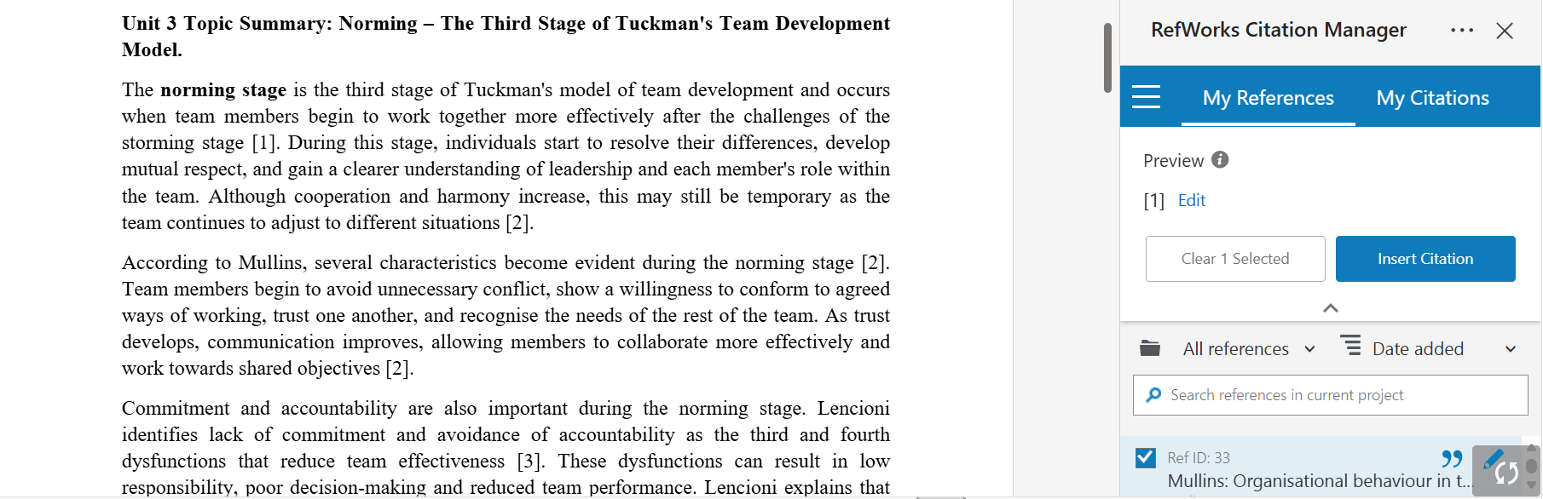

Task 4: E-Portfolio Creation and Evaluation

Task 4 (a): E-Portfolio Creation
I created an online e-portfolio using Wix.com The purpose of the e-portfolio is to provide an organised online platform where my coursework activities, academic development and evidence of skills can be presented clearly. The portfolio has been structured to include a welcome page followed by separate sections for each task for easy navigation of the work.
I selected Wix because it provides a user-friendly website building platform that does not require advanced coding skills. Wix provides drag and drop editing tools, customisable templates and features that allow users to add text, images, videos and other forms of content to their websites [1]. These features were useful for my coursework because the assignment requires different types of evidence, including written work, screenshots, a collaborative mind map, a poster and evidence of using RefWorks.
The e-portfolio has been organised into the following sections:
Welcome/Home Page – introduces the purpose of the e-portfolio and provides navigation to the different tasks.
Task 1 – presents the essential academic and employment skills required for my future career as a GIS Specialist.
Task 2 – presents the professional academic poster.
Task 3 – presents the report on virtual collaboration and the step-by-step process of using RefWorks.
Task 4 – provides an explanation and evaluation of the Wix platform selected to create the e-portfolio.
Screenshots.
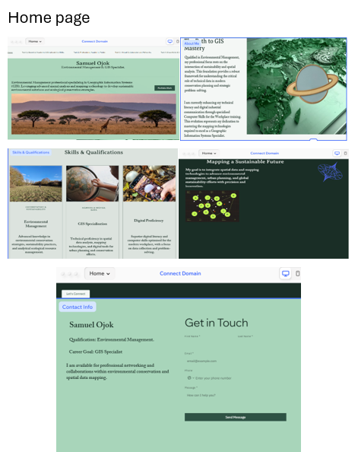

Task 1: Essential academic and employability Skills.
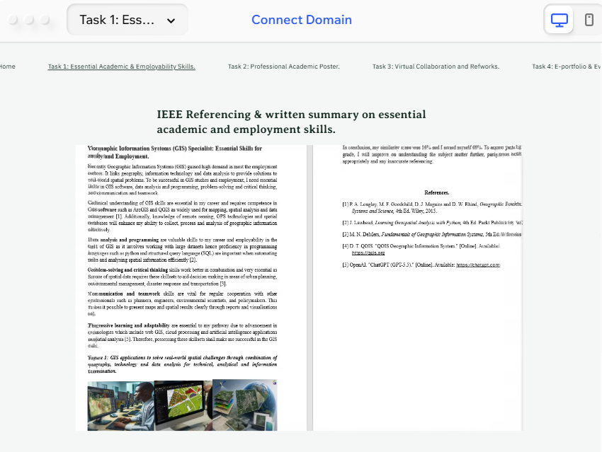
Task 2: Professional Academic Poster.
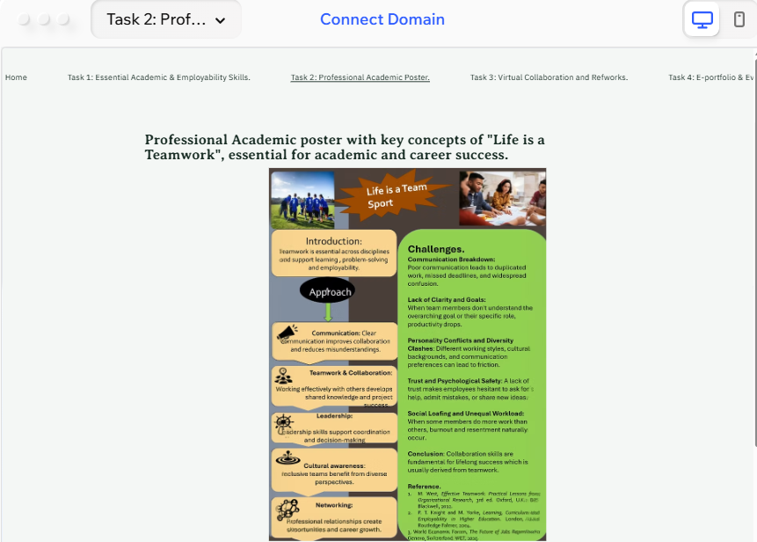

Task 3: Virtual Collaboration and RefWorks.
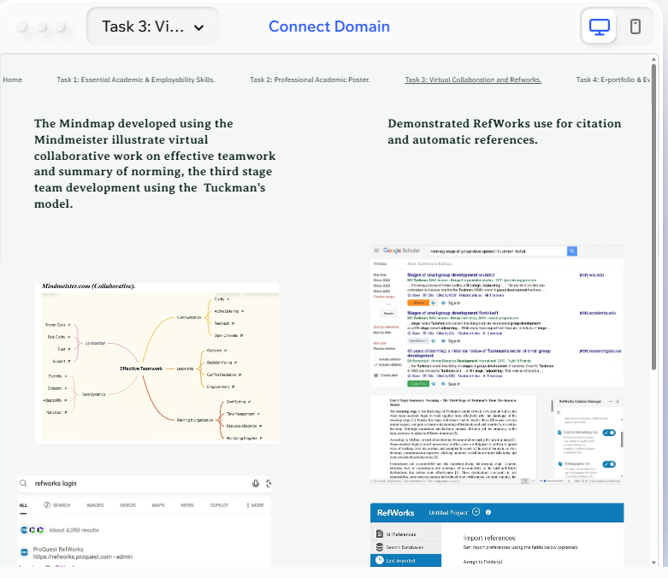
Task 4: E-Portfolio Creation and Evaluation.
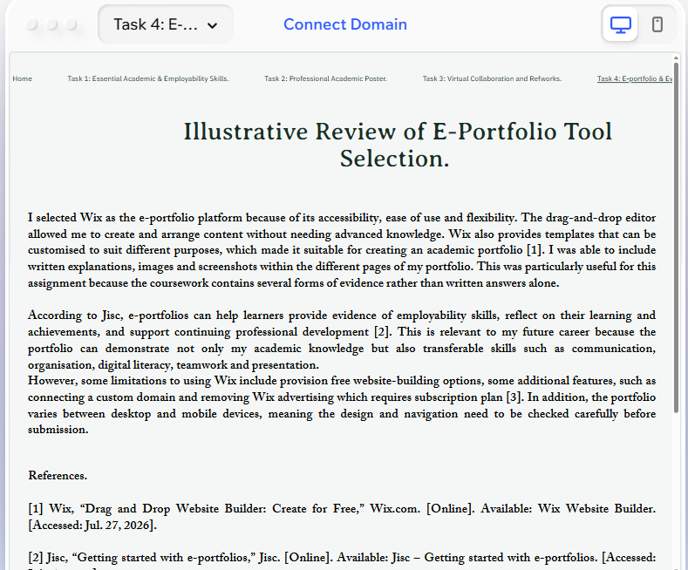

Task 4 (b): Illustrative Review of E-Portfolio tool Selection.
I selected Wix as the e-portfolio platform because of its accessibility, ease of use and flexibility. The drag-and-drop editor allowed me to create and arrange content without needing advanced knowledge. Wix also provides templates that can be customised to suit different purposes, which made it suitable for creating an academic portfolio [1]. I was able to include written explanations, images and screenshots within the different pages of my portfolio. This was particularly useful for this assignment because the coursework contains several forms of evidence rather than written answers alone.
According to Jisc, e-portfolios can help learners provide evidence of employability skills, reflect on their learning and achievements, and support continuing professional development [2]. This is relevant to my future career because the portfolio can demonstrate not only my academic knowledge but also transferable skills such as communication, organisation, digital literacy, teamwork and presentation.
However, some limitations to using Wix include provision free website-building options, some additional features, such as connecting a custom domain and removing Wix advertising which requires subscription plan [3]. In addition, the portfolio varies between desktop and mobile devices, meaning the design and navigation need to be checked carefully before submission.

Conclusion.
In conclusion, this coursework has demonstrated the importance of developing a combination of academic, technical and employability skills for a successful future career. The assignment has highlighted that technical knowledge of GIS software, data analysis, programming, problem-solving and critical thinking are essential for working effectively with spatial information. At the same time, communication, teamwork, leadership, planning and organisation are equally important for working successfully with professionals from different disciplines.
The collaborative activities demonstrated the value of effective teamwork and highlighted how communication, trust, accountability and shared responsibilities can contribute to achieving common goals. The discussion of Tuckman’s team development model, particularly the norming stage, showed how teams can develop stronger relationships and improve their performance through cooperation and constructive feedback. The use of RefWorks also demonstrated the importance of digital academic skills in organising references and maintaining appropriate academic standards.
Furthermore, the development and evaluation of an e-portfolio emphasised the importance of digital tools in recording learning, reflecting on personal development and presenting skills to potential employers. An e-portfolio can provide evidence of academic achievements, technical abilities and transferable skills, making it a useful resource for future employability.

References.
Task 1 References.
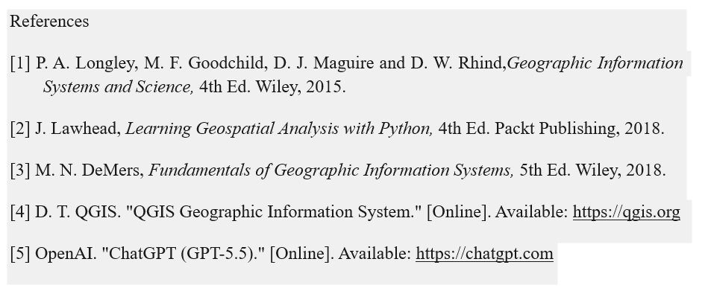
Task 3 References.
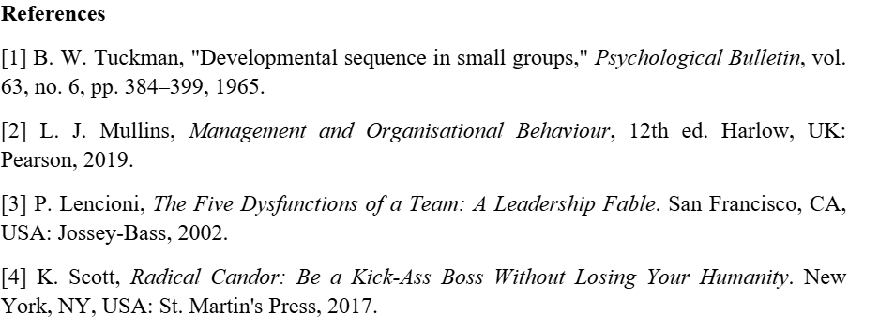
Task 4 References.


