Operational Policing Practice 3 – BMPP6002D
1000 words – Understanding the role of a Constable / Maintaining Professional Standards.
The expectations of a Police Officer is to maintain professional behaviour not only during working hours but also in their personal life. Officers are expected to maintain a standard of behaviour with every decision made. In 2014 the College of Policing introduced a Code of Ethics for policing (College of Policing, 2014a) introduced Code of Ethics to professionalise the standard of behaviour for all staff and officers within the force.
Although within the day-to-day duties of a police officer it is an expectation that officers detect crime and take appropriate action. However, there are occasions where the attending officers have the freedom to use their discretion and own judgement (Newburn and Neyroud, 2008). An example of this would to when attending a mental health call where a low-level crime has been committed such as a Public Order offence. It may be more appropriate to get the individual more support for not only safeguarding but decrease further demands on the police in future.
Support is not only promoted by police forces for members of the public but also from within the force with its staff and officers. Every force is encouraged to recruit and retain their staff within the force. For example, forces are underrepresented by women in various departments within the police. Due to this, forces actively monitor statistics and try to look for different ways of increasing these numbers whether that be with officers being encouraged to go into departments such as Firearms etc.
The Metropolitan police, for example, are said to have just under 30% of police officers being women. Although this statistic is quite high in comparison to other forces across the UK the Metropolitan strives to increase this number (The Metropolitan Police, 2021).
With regards to encouraging Diversity and Equality within the police service, each force actively promotes individuals from every background. South Wales Police, for example, have a team who work as part of the Representative Workforce to try and encourage individuals from every background to apply for all roles within the police service. In 2010 the Equality Act was introduced to policing – this outlined specific legislation which needed to be evidenced and outlined what information needed to be published to meet its requirements and standards (Bedfordshire Police, 2021).
The Equality Act 2010 has outlined protected characteristics. These are:
- Age
- Disability
- Gender reassignment
- Marriage / Civil partnership
- Race / Ethnicity
- Gender
- Sexual Orientation
- Pregnancy / Maternity
Every employee within a police force completed various training packages during their initial training. One aspect of the training is with Equality, Inclusion and Diversity. This not only outlines the expectations of the force but also outlines that every individual has a personal responsibility to include everyone. Any employee who has highlighted any of the protected characteristics would be considered for things such as reasonable adjustments in the workplace.
Another framework which can be applied to policing is the Code of Ethics. This was introduced in 1996 by a number of stakeholders such as Chief Constables etc under Section 1 of the Police Act 1996 (College of Policing, 2014b). The Code of Ethics has published a set of principles of behaviour and standards of professional behaviour, which applies nationally.
The Policing Principles include:
- Accountability
- Fairness
- Honesty
- Integrity
- Leadership
- Objectivity
- Openness
- Respect
- Selflessness
Standards of Professional Behaviour include:
- Honesty and Integrity
- Authority, Respect and Courtesy
- Equality and Diversity
- Use of Force
- Orders and Instructions
- Duties and Responsibilities
- Confidentiality
- Fitness for Work
- Conduct
- Challenging and Reporting Improper Behaviour
The College of Policing recognised that every individual’s values would differ. Introducing set guidelines of what is expected as an employee makes it easier with misconduct hearings or disciplinaries as the expectations have been identified prior to carrying out the role in which that individual has applied for.
After a police officer has completed their initial six months training, they will then go on to the next phase of their training. This would be a 20-week tutorship. During this time the student officer is paired with an independent police officer who has completed the tutor’s course. During the tutorship the student will be accessed daily by their tutor both holistically and practically. Usually, an officer will carry out a debrief after incidents to say what went well and what could have been done better. During this phase of the officer’s training the tutor will also touch on the National Decision Model (NDM) and Code of Ethics to prepare the student for when they are signed off on independent patrol. A tutor will also make sure that the student is aware of how to report an improper behaviour and aware of the different pathways and contacts available.
An example of how tutors are able to analyse reflect on incidents as stated above is with the Experimental Learning Cycle (ELC). This cycle was introduced following studies around how individuals reflect on own experiences (McLeod, 2017). The cycle is as follows:

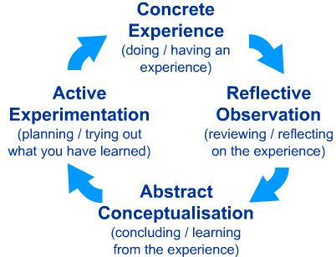

To summarise, the concept of professionalising the police does have a positive outcome to the police service as a whole. Police forces are constantly regulating their policies and procedures and looking for new ways to keep up to date with new legislations brought into policing. Although the Code of Ethics was introduced a number of years ago now, this is kept up to date also and officers regularly undergo training to kept in the know of what is expected of them. This keeps all officer’s knowledge and understanding current.
Changes are often applied to the way in which every force polices. Regularly, ways in which we police are often changed following police failings, complaints or even inquiries which are carried out following a critical incident. A prime example of this, which also applies to protected characteristics is with the Macpherson report. Failings by the Metropolitan Police were outlined following this inquiry following the death of Stephen Lawrence and further training was introduced as a result of the way that the investigation was dealt with (Macpherson, 1999).
The Police and Criminal Evidence Act (PACE) 1984 has also played a large part in professionalising the police force. Prior to PACE (College of Policing, 2021f) officers were able to make more decisions individually as the force was not regulated as closely. Introducing PACE not only structured a set of clear guidelines to officers when dealing with a suspect but also improved the way that suspects were dealt with whilst in custody. Overall, this has improved the public’s perception of the police.
Word Count - 1100

1000 words – Critically evaluate the role of the police in Counter Terrorism Policing (Structure / Risks / Insider threat).
Within policing Counter Terrorism there are various job roles. Due to the nature of the role itself with the security risk with it anyone who is employed within this sector undergoes a higher security vetting that response officers. Policing Counter Terrorism not only involves operational policing but also office-based roles. A lot of Counter Terrorism roles are intelligence led policing and relies heavily on intelligence received from the public, police etc.
Counter Terrorism not only involves the police but also other agencies. This type of policing is a multi-agency approach of a higher security vetting. Majority of information and intelligence relating to Terrorism is not available to the public. It is only in certain circumstances where information will be shared such as media appeals for identifying suspects etc using still images from CCTV.
As previously stated, with Counter Terrorism there are a number of agencies involved with it due to the severity of the risk involved. Agencies such as the Centre for the Protection of National Infrastructure (CPNI) has been set up to regulate the risk within organisations. The CPNI helps to facilitate the review of the structuring of security (CPNI, 2021). The main role of the CPNI is to protect the UK’s National Security by identifying any vulnerabilities within organisations which could be exploited. By identifying these risks it would prevent threats of things such as terrorism, espionage and sabotage. The CPNI work with the government, police and other industries of national infrastructure.
Any vulnerabilities or risks identified which may result in terrorism may be passed to MI5. MI5 deal with anything of National Security. The role of MI5 is defined as (MI5, 2021):
“The protection of National Security and in particular its protection against threats such as terrorism, espionage and sabotage, the activities of agents of foreign powers, and from actions intended to overthrow or undermine parliamentary democracy by political, industrial or violent means”.
Other agencies which also actively identify risk and prevent acts of terrorism is the National Counter Terrorism Security Office (NaCTSO). This is a police unit that works to protect and prepare the government from acts of Counter Terrorism strategy. The NaCTSO works with the Home Office (Home Office, 2021).
These types of agencies involved are of a higher level. Operational policing also plays a significant role in detecting and responding to these type of incidents. Also every force has a Counter Terrorism department within their force. Every police officer undergoes initial training on how to respond to these type of incidents. A police officer will not only be used to respond but also used to gather any intelligence of persons or places of note that the necessary departments need to be aware of.
Prior to the 9/11 attacks on the Twin Towers in New York in 2001 the way in which terrorist attacks were dealt with by police differed. Due to the severity of this attack it has been reviewed how attacks are dealt with. Changes to the Terrorism Act 2000 were also reviewed to change some powers and policies to enable police officers to respond to terrorism related incidents (GOV.UKa).
Officers regularly have briefings of any recent incidents or intelligence that they need to be aware of whilst on patrol. Daily the threat assessment of the level of threat the UK is at of an attack will be incorporated into the officers briefing.
Threat assessment of the likelihood of a Terrorist attack taking place in the UK is set by the Joint Terrorism Analysis Centre and Security Service (MI5). The level of an attack taking place is at five stages (GOV.UK, 2021):
- Low – an attack is highly unlikely.
- Moderate – an attack is possible but not likely.
- Substantial – an attack is likely.
- Severe – an attack is highly likely.
- Critical – an attack is highly likely in near future.
When a terrorist attack is declared a major incident must be declared by the officer/officers who suspect or have been made of an attack. Officers are expected to pass the following information over their police radio. This not only informs over emergency services of what is happening but also informs Gold and Silver Commanders of what is happening for monitoring and resourcing reasons (College of Policing, 2021c):
- Major incident declared.
- Exact location.
- Time of Incident.
- Hazards.
- Access to location.
- Number of Casualties.
- Emergency Services required.
Police forces are continuously looking at different ways to police terrorist attacks and evaluate how works well and what needs to change in order to respond to these types of incidents more effectively. An example of this would be with the London Bridge Terrorist Attack which happened in 2017. Following this attack studies have been carried out to evaluate how police and other emergency services responded to this incident (College of Policing, 2021h).
A critical role with policing terrorism for a police force is not only with the initial response to an incident but also for prevention of an attack. This may be with visible patrols but also with the safeguarding of individuals who may be subject to radicalisation. It is essential for both police officers and staff to identify the vulnerable within the communities in which we police and educate these. Every force have prevention officers within the force to assist with this (NPCC, 2021). If an officer has reason to believe that a person may be involved with anything terrorism related then due to the risk it would be expected for the officer to submit an intelligence report but also inform the relevant departments immediately.
To summarise, there are a number of different roles within a police force which play a significant role in the identification, response and prevention of terrorist attacks. It is not only important for an officer to be aware of the current threat assessment of a terrorist attack but also be up to date with training on current issues, groups or individuals who may be involved with terrorism offences. Maintaining good relationships with the community also plays a large part in preventing this type of incident from taking place. The public often are the source of a lot of terrorism related intelligence gathered by the police. Police forces continuously look at different ways to prevent any further attacks from happening and assess the threat daily to be able to act on any information received.
Word Count – 1060
1000 words – Information and Intelligence / Communication skills.
Police receive information from various sources on a daily basis. Whether this is from briefings, people they speak to whilst at calls or when out within the communities that we police.
All information received is confidential and only passed to the appropriate policing units that need to know the information. In some cases, information may be passed to external partnership agencies pending that it is necessary.
When joining the police both police officers and other staff members undergo training such as the Management of Police Information (MoPI) which involves the correct way to manage information. Due to prior failings with the management of information following a murder in Soham a statutory code of practice was introduced in 2006. This set up a guidance of how the police should collect, record, share and retain any information relevant to their day-to-day policing (Bichard, 2004). Following this inquiry due to police failings, the Police National Database (PND) was introduced to policing in 2011 for the sharing of information and intelligence between police forces. The PND contains ‘POLE’ data which stores information about people, objects, locations and events.
The difference between information and intelligence is that information is something received by a source, whereas intelligence is information that has been received and has been sanitised. It is important as a police officer to be able to distinguish between the two to know when it is suitable to submit intelligence reports.
Information and intelligence not only is passed to officers by the public but this can also be done via police systems. South Wales Police use the Police National Computer (PNC) to pass majority of their information and intelligence via the radio handset and also Samsung mobile device. Examples of the type of information that can be gathered via this would be any recent intelligence on an individual such as drugs, vehicles used, associates etc. PNC is also used to know any previous convictions of an individual.
When officers undergo their initial basic training, they will have full training on how to use these systems and will have to sign a declaration that should they share any data unlawfully then they will be liable for prosecution under the Data Protection Act. A past example of where a data protection breach has occurred was with checking a daughter’s new boyfriend’s details on PNC (Wadham, 2004).
On a day-to-day basis when gathering information it is essential to refer a source to become a Covert Human Intelligence Source (CHIS) handler if they regularly pass intelligence to police. This is to safeguard the source and allow them to be managed a CHIS handler who will be in regular contact with that CHIS and be able to evaluate the accuracy of the intelligence that is being passed by the informant. The definition of a CHIS is (Blackstone’s, 2015):
“Under Section 26(8) of RIPA a person is a source if he/she establishes or maintains a personal or other relationship with a person for the covert purposes of:
- Obtaining information and providing access to information to another person; or
- Disclosing information obtained by the use of such a relationship, or as the consequence of the existence of such a relationship”.
Due to the risk and authority needed when handling a CHIS it would not be appropriate for a response officer to manage a source. CHIS handlers undergo further training in order to carry out this role.
Although informants can be a useful way of gathering information and intelligence this is not the only way that is can be gathered. Police forces have intelligence departments which is made up of staff and police constables which are involved with the managing of data. The police also used surveillance officers to gather information of intelligence. Surveillance officers are usually in plain clothes so they blend in with the public and observe individuals, locations, vehicles etc. These officers can take action whilst out on patrol but usually are used for covert surveillance. Covert surveillance can only be carried out if it is in a manner that is to ensure that the subject is unaware that it is, or may be taking place (Blackstone’s, 2015).
Police Community Support Officers (PCSO’s) and Police Officers are both expected to submit intelligence reports on a regular basis. This not only keeps other departments up to date with recent intelligence but also is required when applying for warrant. An example of this would be with drugs warrants, recent intelligence would be required for the recent three-month period prior to submitting a warrant application.
The current intelligence model used by police forces across the UK is the 3x5x2 model. This is used to assess the piece of intelligence before it is passed to an intelligence officer for analysing This model is broken down into source evaluation, information and intelligence assessment and handling codes. It is displayed as shown below on the intelligence report (College of Policing, 2019i):
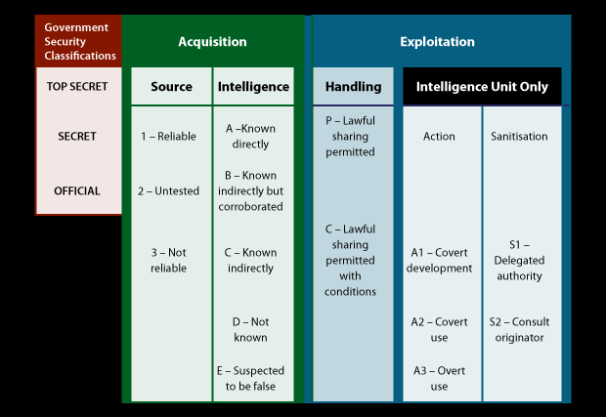
The important of intelligence submissions is that it not only is good for information sharing with other operational staff and officers for their awareness but can also be used for crime analysis. Intelligence is often used to look for crime patterns, patterns in offending behaviours etc. It can also be used for data such as associations, vehicles used, sightings, descriptions of clothing etc.
In recent years police forces have focused on the importance of intelligence submission and also outlined the importance of it for proactive policing. This not only assists the police in areas of note where they police but also made officers aware of persons of note in the area also and kept them up to date with warning markers such as weapons etc. Intelligence can not only be accessed via their mobile handset but also passed over their police radio handsets which is beneficial with response policing.
Word Count - 966
1000 words – Public Protection.
Police officers identify various vulnerabilities in everyday policing and are victim led when dealing with crimes. This gives the victim an input into what action they want the police to take. However, in some instances, the police may still go for a victimless prosecution if the victim does not support a prosecution.
The police encounter not only victims but also other people who require support that are vulnerable – for example people with mental health issues. Due to the high demand on the NHS, police officers are increasingly attending mental health calls, to safeguard an individual using a multi-agency approach. Due to the increased number of these type of calls, policies and guidelines have been implemented by ACPO in 2010 to structure how officers deal with people with Mental Health issues and disabilities (NPIA, 2010). There are a number of legislations could be applied to this such as the Mental Capacity Act 2005 and Mental Health Act 1983.
Vulnerabilities refers to a wide variety of people such as elderly, children, disabilities, personal situation etc. A large demand on police is with calls involving children. This is not only from identifying concerns for children when attending their home addresses after reports of domestics, assaults etc. But also, for concerns of neglect. The Children Act 1989 was introduced regarding the welfare and safeguarding of children. This was introduced after the death of Victoria Climbie` whereby failings by the police and other agencies such as social services were identified (BBC, 2003). Since this act was put in place information sharing between agencies has improved and better training is given to staff to ensure that this does not happen again in the UK. This piece of legislation can also be applied when dealing with any report of child abuse.
When applying police protection powers to policing when dealing with children there are circumstances where a Public Protection Notice (PPN) may be submitted for any concerns which may need to be addressed by social services or policing departments where there is not an immediate risk of harm. However, there are some instances where immediate action is needed to be taken to safeguard the children before. Police Officers have the power under the Children Act 1989. This will be implemented if the officer believes that if no action is taken then the child may be subject to harm.
Every contact count when dealing with vulnerable people and their support network. When providing victims and witnesses during an investigation it is important to identify any needs or concerns early into the investigation. This will result in better evidence during any prosecution should they be required to attend court. The police are able to request for further support for them such as Special Measures which includes screening, video links etc, making them feel more confident in attending court. Witness support also assist with keeping victims and witnesses updated throughout the investigation.
Establishing a good relationship with a victim of crime also benefits an investigation as it makes them more likely to assist with investigations and encourage them to contact the police in future. This usually applies to people who have been made to think that the police will not help, have a negative perception of police etc.
Individually everyone will have different needs depending on what type of incident they have been involved with. For example, teenagers and children will require social services to be involved in order to safeguard that person from any further harm, risk of Child Sexual Exploitation (CSE) etc. There are different types of CSE that can occur (College of Policing, 2021d). These include:
- Inappropriate relationships.
- Boyfriend Model.
- Peer-on-peer exploitation.
- Gang associated CSE.
- Organised/networked sexual exploitation or trafficking.
Often children involved with CSE are often reported as missing by family or guardians. It is important as a police officer to not only investigate these types of a incidents as an isolated incident but to also look at the bigger picture. Children who encounter police due to truanting, staying out overnight without any explanation or any changes in in their behaviour is concerning as they are all signs of CSE.
If it is believed that a child may be involved with CSE it is essential to try and safeguard these children immediately. This not only would be dealt with by police but also social services, charities such as Barnados, Lighthouse etc. Children who are subject to CSE are befriended and then brainwashed into believing that they are the only person who cares for them. This makes it difficult for the police to engage with the child. Children who are at risk of CSE are not only at risk of being victim to Sexual Offences but also from being coerced in being involved with other crimes and further down the line being involved with Organised Crime Groups (OCG’s).
In recent years there has been an increase in the amount of children that are involved with County Lines. In 2018, the Home Office Serious Crime Strategy created the following definition of a County Line (NSPCC, 2021a):
“A term used to describe gangs and organised criminal networks involved in exporting illegal gangs and organised criminal networks involved in exporting illegal drugs into one or more importing areas within the UK, using dedicated mobile phone lines or other forms of ‘deal line’. They are likely to exploit children and vulnerable adults to move and store the drugs and money and they will often use coercion, intimidation, violence (including sexual violence) and weapons”.
I think this is a good definition to summarise exploitation. It highlights that there is not one type of vulnerable person that can be a victim of this type of crime. It highlights that children and also vulnerable adults are coerced into it. This shows the severity of how the suspects can manipulate members of the public into being involved with crime but also be victims. This outlines the importance of educating the public and also identifying any members of the public who could or may be involved in order to intervene preferably before the risk increases. If the police are shown to safeguard victims and make them feel like the police are investigating the crime thoroughly this will safeguard the individuals involved but also the wider community. This will then identify further suspects and identify other people who need safeguarding and also increase public perception of the police and the community, also preventing other crimes from taking place, such as drugs, which will safeguard other victims of crime.
Word Count – 1086

1000 words – Evidence Based Policing / Criminology and Crime Prevention / Criminal Justice.
Over the years a number of theories and studies have been applied to policing following police failings and investigations which have worked well etc. Although studies and statistics shows evidentially what works well and areas of improvement it has been suggested that proactive patrols are the best way to show results (Sherman, L., 1998).
Police forces nationally are continuously looking for ways to improve the way that their force deals with different crimes, depending on operational demand, they also gather evidence based on statistical analysis of data on reduction of the type of crime over a period of time. This will not only show if the method is working but also highlight other issues. Police forces also used public satisfaction surveys for their input also.
A well-known theory which can be applied on the public’s perception is the ‘Broken Window Theory’. This study was introduced in 1982 highlighting that areas with issues such as vandalism or broken windows will generate more serious crimes occurring in the vicinity due to the public’s perception of it being a rundown area (Kelling et al, 1982).
Other studies have supported that prioritising policing strategies around disorder would have a positive outcome with the public (Braga, Welsh and Schnell, 2015) however, other studies have suggested that it is very difficult to prove that the ‘Broken Window Theory’ can be difficult to evaluate for a number of reasons (Braga et al., 1999).
Also academic and theories can be used to support your findings it is important to also use evidential evidence in the form of crime statistics, public satisfaction surveys and things such as comparisons on what the public perceives to be an issue in comparison to the crime statistics. This will show if the type of issue being analysed is actually an issue which needs to be reviewed.
Prior to analysing results, it is important to carry out research into the issue being reviewed prior to gathering evidence. This is usually done in different phases. A prime example of where this can be applied to be policing is with crime reduction. This is looked at yearly to see what the forces priorities are to be able to manage demand and look for different ways of dealing with various crimes. The College of Policing have introduced a crime reduction template (College of Policing, 2021g). This outlines where information and evidence come from:
- Professional experience and judgement.
- Data, facts and figures.
- Scientific and academic research.
- Stakeholder values and concepts.
In recent years police forces have become more victim focused in their approach to policing after studies showed that the relationship between the police and the public had deteriorated. Due to this in 2002 Police Community Support Officers (PCSO’s) were introduced under the Police Reform Act 2002 (Legislation.gov.uk, 2021). The main role of the PCSO was to help build the relationship between the public and the police. They are expected to be visible within the community in which they police and be a point of contact for the public.
A Neighbourhood Policing review (College of Policing, 2021g) was carried out in the UK. During this review the OSARA problem solving model was introduced, mainly utilised by Neighbourhood Teams. The OSARA model is a model used to gather information and evidence prior to acting on the ongoing problem, then evaluate it (Spelman et al, 1987):
- Scanning (Identifying and prioritising the selected problems).
- Analysis (Analysing the cause of the problem, including any repeat victims etc).
- Response (Identifying the best response to the issue and good crime prevention).
- Assessment (Assessing and evaluating the response and seeing what went well and what you would do differently).
The OSARA model has enabled Neighbourhood Policing to formalise what they were doing before. The OSARA models are publishes on the internal policing page in order for other staff to view it should they wish. This shows if what is being done to resolve an ongoing issue in the area is working. By reviewing actions taken over a period of time shows if it is working or not.
In recent years, things such as PACT meetings were organised within the community. This allowed the local police officers and PCSO’s to attend once a month and speak to members of the community regarding any ongoing issues. However, over the past couple of years a lot of reporting is now done online. Police forces also used social media platforms such as Twitter, which is now used a lot for the reporting of crime.
Often officers will attend locations to carry out house to house enquiries after the report of a crime in the vicinity. This informs the public that an incident has taken place but also gives the police the opportunity to gather any information and intelligence regarding that crime or anything else that is happening in the area. By doing this it also allows the police to give crime prevention advice to members of the public. By going door to door this also enables the police to speak to members of the public who may not be on social media such as the elderly etc.
Although frequently new crime prevention ideas are applied to policing a lot of information and feedback still comes from the public. With the recent Neighbourhood Policing Review this has allowed Neighbourhood Policing Teams to focus more on community policing which will increase the amount of intelligence and information gathered by police. This will also make police aware of any incidents which may have gone unreported. This allows officers to prioritise their proactive patrols to not only deter crimes but also increase the public’s perception in police. This will in turn then encourage the public to report more incidents to police.
This type of approach along with managing offenders has had a positive effect of crimes in England and Wales. Within the police there are offender managers, Youth Offending Team who all primarily work with an offender to support and safeguard them but also prevent further offending.
This appears to be working as studies have shown that between 2005-2012 there has been a decrease in offending as shown in Peterborough and Doncaster below, this pilot was implemented across England and Wales (Ministry of Justice, 2013):
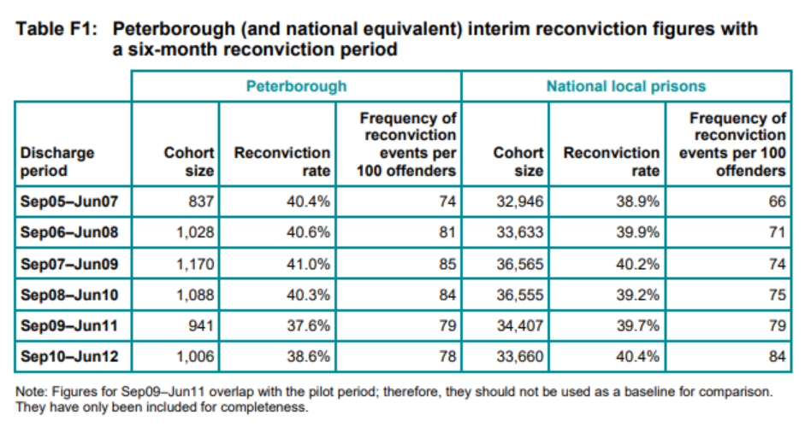
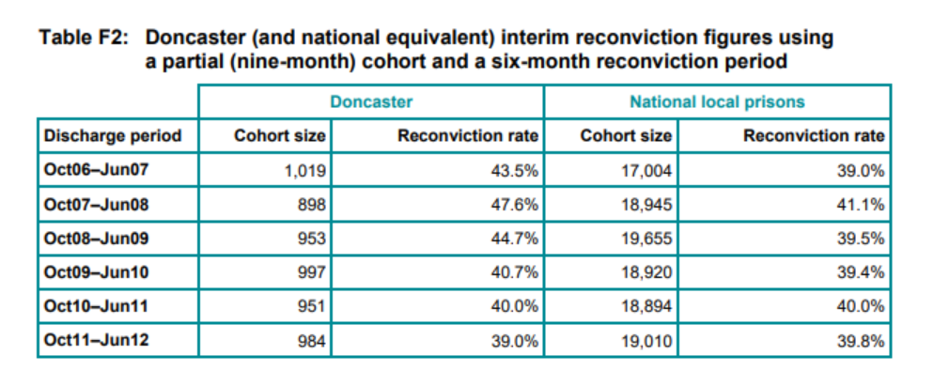
This shows that using a multi-agency approach and trying different methods to prevent crime and prevent reoffending has a positive outcome on crimes. This will not only reassure the community but also decrease the demand on the police, enabling them to be more visible within the community.
Word Count – 1087

Bibliography
BBC (2003) Timeline: Victoria Climbie. Available at BBC NEWS | UK | Timeline: Victoria Climbie (Accessed 16th November 2021).
Bedfordshire Police (2021) Ethics, Equality and Inclusion. Available at https://www.bedfordshire.police.uk/information-and-services/About-us/How-we-work/Ethics-equality-and-inclusion#b1035f0a (Accessed 22nd November 2021).
Berk, R., & MacDonald, J. (2010). Policing the homeless: An evaluation of efforts to reduce homeless-related crime. Criminology and Public Policy, 9 (4), 813-840.
Bichard, Sir M. (2004) Return to an address of the Honourable the House of Commons dates 22nd June 2004 for the Bichard inquiry, Report HC 653 (London: The Stationary Office).
Blackstone’s (2015) Covert Human Intelligence Sources. Blackstone’s Handbook for Policing Students, P.488.
Blackstone’s (2015) Covert Surveillance. Blackstone’s Handbook for Policing Students, P.492.
Braga, A. A., Weisburd, D. L., Waring, E. J., Mazerolle, L. G., Spelman, W., & Gajewski, F. (1999). Problem‐oriented policing in violent crime places: a randomized controlled experiment*. Criminology, 37(3), 541-580.
Braga, A. A., & Bond, B. J. (2008). Policing crime and disorder hot spots: A randomized controlled trial. Criminology, 46 (3), 577-607.
College of Policing (2013) Pre-Join to Policing Programmes. Available at http://www.college.police.uk/en/11621.htm (Accessed 17th September 2021).
College of Policing (2014a) Professional Entry to Policing. Available at http://www.college.police.uk/en/docs/Professionl_Entry_To_Policing_Strategy.pdf (Accessed 17th September 2021).
College of Policing (2014b) The Code of Ethics – Summary July 2014. Available at https://assets.college.police.uk/s3fs-public/2021-02/code_of_ethics_summary.pdf (Accessed 22nd November 2021).
College of Policing (2019e) Evidence Based Policing. Available at PowerPoint Presentation (birmingham.ac.uk) (Accessed 17th November 2021).
College of Policing (2019i) Intelligence Management. Available at https://www.app.college.police.uk/app-content/intelligence-management/intelligence-report/ (Accessed 2nd October 2021).
College of Policing (2021c) Civil Contingencies. Available https://www.app.college.police.uk/app-content/civil-emergencies/civil-contingencies/ (Accessed 20th October 2021).
College of Policing (2021d) Ethics. Available at https://www.college.police.uk/ethics (Accessed 22nd November 2021).
College of Policing (2021g) Neighbourhood Policing Evidence Review. Available at Neighbourhood policing evidence review | College of Policing (Accessed 17th November 2021).
College of Policing (2021h) ‘On the scene and dealing’ – An exploratory study into the cognitive processing of the London Bridge 2017 terror attack on first responders. Available at https://whatworks.college.police.uk/Research/Research-Map/Pages/ResearchProject.aspx?projectid=835 (Accessed 1st October 2021).
College of Policing (2021f) Search powers and obtaining and executing search warrants. Available at https://www.app.college.police.uk/app-content/investigations/investigative-strategies/search-powers-and-obtaining-and-executing-search-warrants/ (Accessed 1st November 2021).
CPNI (2021) Insider Risk Mitigation Framework. Available at Insider Risk Mitigation Framework | CPNI (Accessed 12th November 2021).
GOV.UK (2021) Terrorism and National Emergencies. Available at https://www.gov.uk/terrorism-national-emergency (Accessed 1st November 2021).
GOV.UK (2021a) Operation of Police Powers under Terrorism Act 2000 and subsequent legislation: Arrests, outcomes, and stop and search Great Britain, year ending December 2020. Available at https://www.gov.uk/government/statistics/operation-of-police-powers-under-the-terrorism-act-2000-quarterly-update-to-december-2020/operation-of-police-powers-under-the-terrorism-act-2000-and-subsequent-legislation-arrests-outcomes-and-stop-and-search-great-britain-year-ending (Accessed 2nd October 2021).
Home Office (2021) National Counter Terrorism Security Office. Available at National Counter Terrorism Security Office - GOV.UK (www.gov.uk) (Accessed 12th November 2021).
Kelling, G, L. and Wilson, J, Q. (1982) Broken Windows. Available at Broken Windows - The Atlantic (Accessed 17th November 2021).
Legislation.gov.uk (2021) Police Reform Act 2002. Available at Police Reform Act 2002 (legislation.gov.uk) (Accessed 17th November 2021).
Macpherson, W. (1999) The Stephen Lawrence Inquiry. Available at https://assets.publishing.service.gov.uk/government/uploads/system/uploads/attachment_data/file/277111/4262.pdf (Accessed 10th November 2021).
McLeod, M. (2017) Kolb’s Learning Styles and Experimental Learning Cycle. Available at https://www.simplypsychology.org/learning-kolb.html (Accessed 19th November 2021).
Ministry of Justice (2013) Transforming Rehabilitation: A summary of evidence on reducing reoffending. Available at https://assets.publishing.service.gov.uk/government/uploads/system/uploads/attachment_data/file/243718/evidence-reduce-reoffending.pdf (Accessed 1st October 2021).
MI5 (2021) MI5 Protects the UK against Threats to National Security. Available at What We Do | MI5 - The Security Service (Accessed 12th November 2021).
Newburn, T. (1999) Understanding and Preventing Police Corruption: Lessons from the literature, Police Research Series Paper 110 (London: Home Office).
Newburn, T and Neyroud, P (2008) Dictionary of Policing (Cullompton: Willan).
Newburn, T. (2011) Review of Police Leadership and Training: Volume One (London: Home Office). Available at http://www.homeoffice.gov.uk/publications/consultaions/rev-police-leadership-training/report?view=Binary (Accessed 17th September 2021).
NCA (2021) NPCC Definition of a County Line. Available at County Lines - National Crime Agency (Accessed 17th November 2021).
Novak, K., Hartman, J. L., Holsinger, A. M., & Turner, M. G. (1999). The effects of aggressive policing of disorder on serious crime. Policing: An International Journal of Police Strategies and Management, 22, 171-190.
NPIA (2010) Guidance on Responding to People with Mental Ill Health or Learning Disabilities. Available at http://www.acpo.police.uk/documents/edhr/2010/201004EDHRMIH01.pdf> (Accessed 16th November 2021).
NSPCC (2021a) NSPCC definition of a County Line. Available at County Lines - National Crime Agency (Accessed 16th November 2021).
NSPCC (2021b) Child Sexual Exploitation. Available at Child Sexual Exploitation & How to Keep Your Child Safe | NSPCC (Accessed 16th November 2021).
NSPCC (2021c) Terrorism in the UK. Available at https://www.npcc.police.uk/CounterTerrorism/HomePage.aspx (Accessed 1st October 2021).
Pace, S. A. (2010). “Assessing the impact of police order maintenance units on crime: An application of the Broken Windows Hypothesis”. Unpublished M.A. Thesis, University of Nevada, Las Vegas.
Pate, A. M., Skogan, W., Wycoff, M.A. & Sherman, L.W. (1985). Reducing the ‘Signs of Crime’: The Newark Experience. Washington, DC: Police Foundation.
Sherman, L., (1998) Evidence Based Policing. Available at Ideas-Sherman (policefoundation.org) (Accessed 17th November 2021).
Spelman, W. and Eck, J. (1987) Problem Solving: Problem-Orientated Policing in Newport News. Washington, DC: Police Executive Research Forum. Available at » Refresher: SARA Model and Problem-Oriented Policing (evidence-basedpolicing.org) (Accessed 17th November 2021).
The Metropolitan Police (2021) Metropolitan Police Service. Available at https://www.met.police.uk/SysSiteAssets/foi-media/metropolitan-police/policies/inclusion-strategy-2017-2021.pdf (Accessed 22nd November 2021).
Wadham, J. (2004) ‘Conference on data protection and information sharing’, 15 July (London)

