

BMHP5015
Changemakers: Building your Personal Brand for Sustainable Employment

Component 1

Student Name ALISA CIURE
Student ID 2409582
Table of Contents
Task 1 – Personal Brand 3
Task 2 – Network Map and Rationale 4
Task 3 – Blog 6
Task 4 – NHS Equality, Diversity and Inclusion (EDI) Quiz 7
Task 5 – A Letter to Yourself 9
Task 6 – Gantt Chart 10
Task 7 – Making Changes Report: Introducing Digital Care Planning in a Care Home 12
References 14

Task 1 – Personal Brand
A personal brand is the image, values and skills a person presents to the people they work with or the people around them (employers/colleagues). The branding of personal brand is also increasing in the aspect of a positive employability that is represented through the demonstration of competence, credibility and professionalism (Gorbatov, Oostrom and Khapova, 2024). I am a brand of dependability, resilience, empathy and professionalism. Being in the UK and pursuing my degree has contributed to my confidence in being able to adapt to new challenges, manage my time effectively and communicate with people from other cultures. Having worked for a number of customer service jobs, I have developed my skills in interpersonal, problem solving and teamwork, all of which are important attributes for any future health or social care professional (Cai et al., 2025). I do understand this will require that I continue to learn about safeguarding, person-centred care, professional ethics and healthcare policies. Finally it will also help develop my professional identity, I can sign up myself for some professional development courses and learn practical skills on placements, keep myself in contact with LinkedIn contacts and attend some continuous professional development opportunities. This will give me confidence and employability. We keep on improving professionally, knowledge and tools and being health professionals will enable us to provide higher quality treatment and that the acknowledgment as part of the healthcare service has become increasingly important not only in the service of the individuals and families of the society, but also now.

Task 2 – Network Map and Rationale
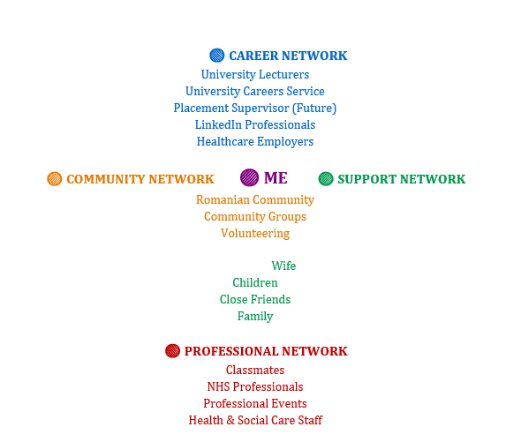

Supporting Rationale

My own career networks and community and professional networks (including personal & career development networks) are for me to participate in. Such a wider variety of professional networks is also essential, as they provide professionals with knowledge for both emotional and professional encouragement, career development and advice on employability (Healy, Hammer and McIlveen, 2022) so it is important to create those networks. My main support system is (partner, children, close friends and family). They motivate me, they give me that positive energy as I face it all — university, getting a job, raising a family. It was their support that powered me through difficult times and propelled me toward my career related dreams. I discuss every bit with my friends in school, University Careers Service, and health care professionals within my own academic group of university lecturers; I give them everything I receive not only for my studies but for job placements as well. And it is these connections which are so valuable, providing me with concrete advice, criticism and insights with which I can base my own professional knowledge. And I will also strive to increase professional LinkedIn networks with a professional LinkedIn profile established and connecting me to professional events and professional development activities. And I've connections locally e.g.: Romanian people, organisations, associations, voluntary work. Community groups allow me to experience others cultures and to understand that communicating with people in a more practical manner is essential, so essential for health and social care. While this is expanding my networks, I realize I lack friendships with high-level healthcare managers & senior professionals. Therefore, there is a need to make more professional contacts around placements, conferences, workshops, and relevant bodies. A wider network would enable me to accumulate and establish know-how, confidence, work-for-work, networking opportunities, establishing a central element of my professional identity, broadly across the health and social care community.

Task 3 – Blog
Tackling Loneliness Among Older Adults in UK Care Homes: Why Social Connection Matters
Target Audience: Care home staff, family members and carers

Loneliness is now a growing concern for older people in care homes in the UK. But sometimes this strategy can undermine the emotional side of health even as it gives good physical care to many of our residents. Indeed, loneliness is one of our many negative health outcomes (i.e., cognitive impairment, depression, anxiety and adverse physical health outcomes that detract from overall health and well-being (National Institute on Ageing, 2024)). So the issue of coping with loneliness should be considered and handled as part of person-centred care, rather than as a second option. A number of elderly people become lonely after losing a spouse, when they leave their homes or when they have little contact with relatives and friends. Care home offers more safety and access to health care but risk loneliness in the absence of great social connections (Victor and Pikhartova, 2020). Loneliness may be more common if there are mobility issues, hearing loss or dementia. Social isolation is likely to be managed at care homes if the provision of facilities to keep residents connected (as can be achieved) is contextualised within the context of residence for whom relevant people are concerned. For example group activities, music therapy and gardening activities, exercise groups and intergenerational programmes from the local schools may participate their socialising as well as psychological development. But loneliness doesn’t melt away during the planning of recurrent functions. Staff need to pause and discover each resident’s unique interests, hobbies and personal life, so that those important to them go into the activities. The focus on an individual’s well-being, this person-centred approach will aid in preserving the residents’ identity, independence and sense of belonging. We should involve families in the planning of care and be responsive to the family’s needs through continuous communication. It’s not just the financial strain on the UK care system or the thousands of people out there providing care services that has posed problems. But relatively simple and effective interventions that focus on developing meaningful relationships with residents in whatever capacity can all be positive for people’s overall mental health. Care workers, family and the public can unite to construct care homes around older people in which their dignity, belonging and support is valued. The issue of counteracting loneliness doesn’t simply appear to rest on the diffusion of positive general emotional welfare. It is now a matter of dignity and autonomy and the quality of life in old age. Only once we acknowledge the role of sociability with respect to other people can care homes be person-centred as well as serving health, physiological and psychosocial purposes.

Task 4 – NHS Equality, Diversity and Inclusion (EDI) Quiz
1. What is the primary goal of the NHS Equality, Diversity, and Inclusion Improvement Plan?
The key purpose of this plan is to create a fair, inclusive, and respectful level setting in the workplace which enables people of all backgrounds, identities and characteristics to achieve the same success.
2. How does the NHS EDI Improvement Plan propose to tackle the gender pay gap?
The approach encourages pay transparency in order to address the gender pay gap, encourage flexible working, and promote fair access to promotion and talent without compromising leadership, promotion, and career opportunities.
3. What is meant by the term ‘intersectionality’ as used in the NHS EDI Improvement Plan?
Intersectionality recognizes that individuals can be disadvantaged by multiple discrimination on the basis of the combined impact of their identities including but not limited to ethnicity, gender, disability, sexual orientation, and/or age.
4. Why is it important for the NHS to create a psychologically safe work environment?
If all staff are able to share about concerns, report mistakes and share ideas in an environment that is psychologically safe, as this ensures staff are able to speak things up without fear of bullying, discrimination or blame, the wellbeing of staff will be better, which will translate into safer patient care.
5. How does the NHS EDI Improvement Plan suggest improving the experience of internationally recruited staff?
It recommends holistic induction efforts, career development, mentoring and support to ensure people on the move feel welcomed, included and valued.
6. What role does leadership play in advancing EDI objectives according to the NHS Improvement Plan?
Leadership, in this way, has a share in promoting inclusive behaviours, opposing discrimination, supporting initiatives of equality, and embedding EDI principles in organisational culture and decision making.
7. Identify one way the NHS EDI Improvement Plan aims to reduce health inequalities within the workforce.
One approach is to increase access to education, training and career advancement opportunities to ensure fairness across the workforce (for underrepresented groups).
8. Why does the NHS EDI Improvement Plan emphasise the importance of collecting and analysing data on protected characteristics?
Collecting and analysing workforce data gives the NHS information to be used to detect inequalities, track progress, and build on evidence for improvement in equality, diversity and inclusion.
9. Explain how flexible working policies can contribute to equality and inclusion in the NHS workforce.
Flexible working arrangements support employees’ ability to manage work hours alongside personal and caring roles, health and other obligations, making employment more accessible and inclusive for the diverse workforce.
10. What is one strategy mentioned in the NHS EDI Improvement Plan to combat bullying and harassment in the workplace?
One is strengthening reporting procedures, dealing with incidents in a timely and appropriate manner and instilling within a workplace a culture of dignity, respect and accountability.

Task 5 – A Letter to Yourself
Dear Younger Me,
Sitting in your chair, I want to point out to you just now that you are not beating yourself up today. Dreams about wanting to create a future for your family sometimes need you to step out of your comfort zone, and then it can feel pretty scary. You are in the new country, you are new to different cultures, you are working long hours, you are trying to balance having family life with education, so you think you need to become a bigger person. And I want you to know you are. That emotional intelligence translates to equally strong resolve. I have the belief you will sometimes think or do something because of some stress, frustration or self-doubt. And instead of trying to fix your problems by yourself, discover a way to confront how you feel and share feelings openly with your loved ones. And that is not a failing to reach out for support — it is a sign of strength and maturity. Another thing that I have learned over the years is that resilience does not mean fleeing from everything, resilience is getting along and getting on. And there will be disappointments, setbacks and times when your dreams seem lightyears away. In later years, the plus will be patience and confidence with perseverance. You are going to the challenge and you can be better prepared and wiser for the challenge. My journey is unique. It is unlike anyone else's. We are stepping out like this, but success and victory does not come from how fast you reach next level but from your unwillingness to stop. If that’s the case, party on whatever you accomplish—big or small—for every triumph you achieve will propel you one step nearer your goal of becoming the person you want to be. More importantly, never strip yourself of the humanity — or belief, at least — you as a human being seek and this is for other people. Slowly, over time, you will realize with great pride, that all these sacrifices went on to this day with huge pride to yourself for being that tender, confident, tough adult type that you are today.
Yours sincerely,
Your Future Self

Task 6 – Gantt Chart
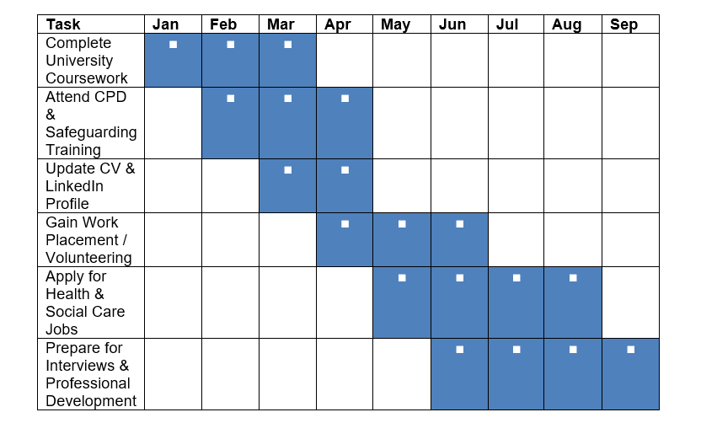
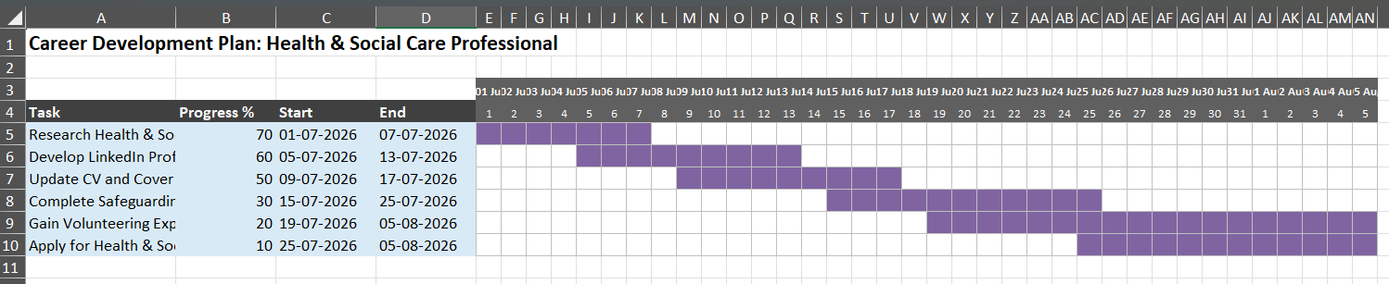

Explanation
These tasks in the coming 9 months would need to be completed by using a Gantt chart to prepare me for long-term career objectives I set for myself through a career in health and social care. It was detailed in six stages that aim for academic achievement, career promotion and career readiness. As a job, I would first like to do university courses so that I would get everything I need for my college work before becoming employed because it’s a good period to stay on the current knowledge grid and a profession for which I can work as well as one that I could get good credentials for. After my studies I would like to undertake safeguarding and continuing professional development (CPD) training to enhance my knowledge of person-centred care, professional practice and current healthcare legislation. First of all, I update my CV and LinkedIn profile so employers can see my professional profile. I will also be working or volunteering so I can apply what I learnt to practice, using my knowledge in health care and learning communication, teamwork and problem solving. I will then apply for jobs in health and social care and prepare for interviews by looking into potential employers, honing interviewing techniques and reflecting on my experience. I believe this plan will give me the knowledge needed to be prepared in order to be a competent and compassionate health and social care professional whilst enhancing my long term employability as well as providing me the right confidence in being a successful healthcare professional.

Task 7 – Bringing AI-assisted Falls Prevention into a Care Home

Introduction

Falls represent a direct cause of injury, hospitalizations and the loss of independence in aged care residents. As a senior manager in a care home I’d initiate an AI-supported falls prevention strategy, complete with wearable tech and a smart monitoring system to identify those residents at greater risk of falling. The initiative focuses on enhancing resident safety, reducing the threat of harm and offering staff the chance to provide person-centred care without compromising the independence of those they care for.

Planning the Change

I would apply Kotter’s Eight-Step Change Model to make this a success. The first one is that the staff are first notified, by demonstrating the future potential benefits of AI in falls prevention that AI will offer to staff. They would be followed by a smaller pilot programme introduced by a subsample of residents before the system became generalised to cover the care home. Staff training on the use of technology, reading of alerts, interpretation and responding to alerts, among other information would be provided on site. There would also be staff meetings at every stage to share feedback, raise concerns and revise. Recognizing early achievements - decreased rates, reduced time to respond - would maintain staff engagement and encourage more uptake (Kotter 2012).

Skills Required

Effective implementation will need strong leaders and strong leadership, and effective communication and sound judgment. As a manager, I’d have to communicate a digestible message for change, empower staff to embrace new tech and offer immediate resources as the change unfolded. Skills such as problem-solving, teamwork and digital leadership to deliver an answer to technical or operational challenges as they arise.

Barriers and Solutions
Another resistance of staff to technology's usurper of human care can be barriers. This can be achieved by involving staff in decisions that concern them in this process so that they can go along with them and learn by doing – and by reinforcing that the AI is not replacing an expert opinion but augmenting it. There is still a problem with the price of a new tech initiative. Then there is external funding and small steps toward implementation to ease financial burden. Still, with the implementation there are certain technical challenges that must be overcome, but there are also opportunities for IT support to help with deployment and updates (constant and ongoing). Privacy of the residents is also paramount and should not be a secondary concern in handling – anything that is gathered from any data, needs to be handled according to UK data privacy law – as well as by the institution it is within.
Conclusion.
Implementing an AI for falls prevention program can increase residents’ safety, reduce preventable injuries, and contribute to the provision of quality care. While there could be staff resistance, implementation costs and technology concerns, the good leadership mechanism, communication structure and sufficient training will help this innovative mode of care be adopted in the care home.

References
Beyari, H. (2023) 'The relationship between social media and the increase in mental health problems', International Journal of Environmental Research and Public Health, 20(3), p. 2383.
Cai, W., El Baroudi, S., Gorbatov, S., Khapova, S.N. and Fan, X. (2025) 'How proactively building personal brand equity can help employees' marketability', The International Journal of Human Resource Management. Available at: https://doi.org/10.1080/09585192.2025.2458521.
Healy, M., Hammer, S. and McIlveen, P. (2022) 'Mapping graduate employability and career development in higher education research: A citation network analysis', Studies in Higher Education, 47(4), pp. 799–811.
Igbokwe, I.C., Egboka, P.N., Thompson, C.C., Etele, A.V., Anyanwu, A.N., Okeke-James, N.J. and Uzoekwe, H.E. (2023) 'Emotional intelligence: Practices to manage and develop it', European Journal of Theoretical and Applied Sciences, 1(4), pp. 42–48.
Kotter, J.P. (2012) Leading Change. Boston, MA: Harvard Business Review Press.
Lydahl, D., Britten, N., Wolf, A., Naldemirci, Ö., Lloyd, H. and Heckemann, B. (2022) 'Exploring documentation in person-centred care: A content analysis of care plans', International Journal of Older People Nursing, 17(5), e12461.
NHS England (2023) NHS Equality, Diversity and Inclusion Improvement Plan. London: NHS England. Available at: https://www.england.nhs.uk/long-read/nhs-equality-diversity-and-inclusion-improvement-plan/ (Accessed: 5 July 2026).
Portes, A. (2024) 'Social capital: Its origins and applications in modern sociology', in New Critical Writings in Political Sociology. Abingdon: Routledge, pp. 53–76.
Rantz, M.J., Alexander, G., Galambos, C., Vogelsmeier, A., Hicks, L., Scott-Cawiezell, J. and Greenwald, L. (2023) 'Technology-supported approaches to improve safety and reduce falls in long-term care: A review', Journal of Nursing Care Quality, 38(2), pp. 120–127.
Tuominen, M., Kilpi-Jakonen, E., García Velázquez, R., Castaneda, A. and Kuusio, H. (2023) 'Building social capital in a new home country: A closer look into the predictors of bonding and bridging relationships of migrant populations at different education levels', Migration Studies, 11(4), pp. 598–630.
Victor, C.R. and Pikhartova, J. (2020) 'Loneliness and social isolation in residential care settings: A systematic review', Health and Social Care in the Community, 28(4), pp. 1233–1245.
World Health Organization (2021) Step Safely: Strategies for Preventing and Managing Falls Across the Life-course. Geneva: World Health Organization.
Zamir, S., Hennessy, C.H., Taylor, A.H. and Jones, R.B. (2020) 'Intergroup "Skype" quiz sessions in care homes to reduce loneliness and social isolation in older people', Geriatrics, 5(4), p. 90.

