Kemi

1. Introduction 2
2. Application Development Concepts 2
2.1.1. Consistency 2
2.1.2. Feedback 2
2.1.3. Shortcuts 2
2.1.4. Links 2
2.1.5. Page layout 2
3. Requirements 3
4. A brief introduction to your website 3
4.1. Describe its purpose 3
4.2. Subject matter 3
4.3. The target audience and its relevance 3
4.4. Phone 3
4.5. Tablet 3
4.6. Desktop 3
5. Design 4
6. Implementation 5
7. Evaluation 7
8. Bibliography 7

Introduction
The main purpose of this report is to create a website that is responsive and is well designed using the usability guidelines as a base for the design and to also explain the code and how the website works and why it was created.

Application Development Concepts

Consistency
The website should be created so that a user does not get lost in the design such as if they click a cross on the page that means they are closing a part of the website where as if the website was not consistent with the cross, they would create it so the cross makes the user link to a new page. [1]

Feedback
Feedback is an important area that helps make improvements to the website with suggestions from users that can be submitted users that send an e-mail as feedback or on a forum that will let the moderator update the website using some of the suggestions submitted. [1]

Shortcuts
This is a useful function that will allow users to use their keyboard
f-keys (f1-12) that they have set to allow them to do a multitude of different functions such as take a screenshot of the screen they are browsing, there is also the f-key to allow a user to save a site as a favourite or allow a user to go back a page or forward a page there is also Key combos such as control+c for copying and alt-f to close windows etc. [1]

Links
Links are used to move users from one page on the website to another as the website may have multiple pages that will be used some may be simple words which link you to the page others may link from pictures or arrows that will lead to a specific page unlike word links which are set to their own page links. [2]

Page layout
A websites page is what a user will be sent to after they have selected the link so it’s best to create a simple page that will not confuse new users by not having loads of text or just cluttering the screen with multimedia (images, videos) that will only confuse the user it is best to have a mix of both of these on the web page. [2]

Requirements
The requirements that will be implemented in the creation of this website are that of user-friendly system as the website is a game-based information Hub that will allow for information to be accessed fast and simply by many users as quickly as possible.

A brief introduction to your website

Describe its purpose

This website has been created for users to check out new games that will be released and how long till the game is released on the website there will also be game reviews for users to check out whether the game is of interest to them before they buy the game, the website will also show users different gaming events (Blizzcon, E3, Comicon) around the world and will send them to a website to where they can buy tickets for the event to attend.

Subject matter

As the website that is being created is a videogame based site it will attract a range of people that will use the website most will be gamers and will be dedicated to the games that are playing this will draw people to check the new releases of games and the events some will look at the reviews and comment their own opinions this may lead to a forum being created later on down the line.

The target audience and its relevance

The target audience is made up mostly of teenagers that are gamers and have an interest in a game brand and in reviews that will draw more users to the website as each review will and more tags that users may find the website off making it easier for users to search for the website.

Phone
A phone screen size (320x480) is slowly increasing allowing for more information to be shown on the screen where as it was once only used for messaging and phoning people now it can be used to check the weather read the news and update Facebook statuses on the go. As well as making the text smaller the images will also become smaller then if the image was on a tablet or a desktop.

Tablet
A tablets screen size (768x1024) can have an impact on the way the web page is displayed such as it can make the display on screen become cropped to fit the screen or it will only show a list of items such as images, reports or writing.

Desktop
The desktop (1024x800) is usually the original place for the most information to be displayed and where most developers will create a webpage for, as this will show the user the most information in the quickest amount of time.
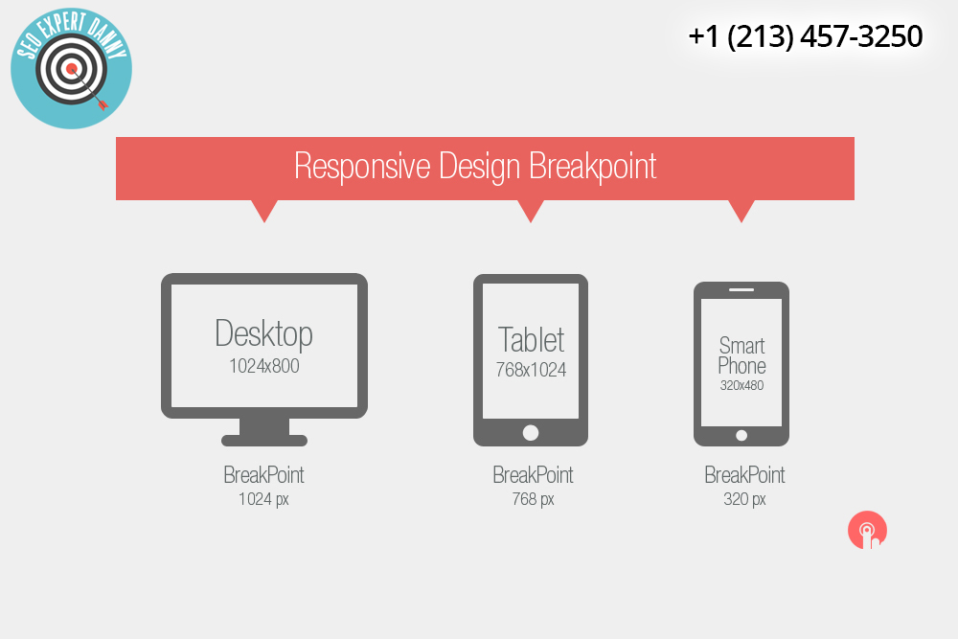
https://seoexpertdanny.com/breakpoints-responsive-web-design/

Design
The website that is going to be created will involve a lot of video game imagery that will appeal to more users that have visited or use the site by creating specific pages for the users to visit such as reviews for the gamers who want to read up about the news released games there will also be a page on gaming new that will include all of the information that is happening around the gaming community the third page will be events where users can come and find out when an event is happening and be sent to a site such as Ticket-master to purchase tickets for the event the last page will be games that are being released soo
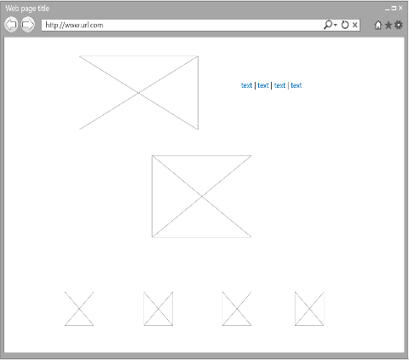

Implementation
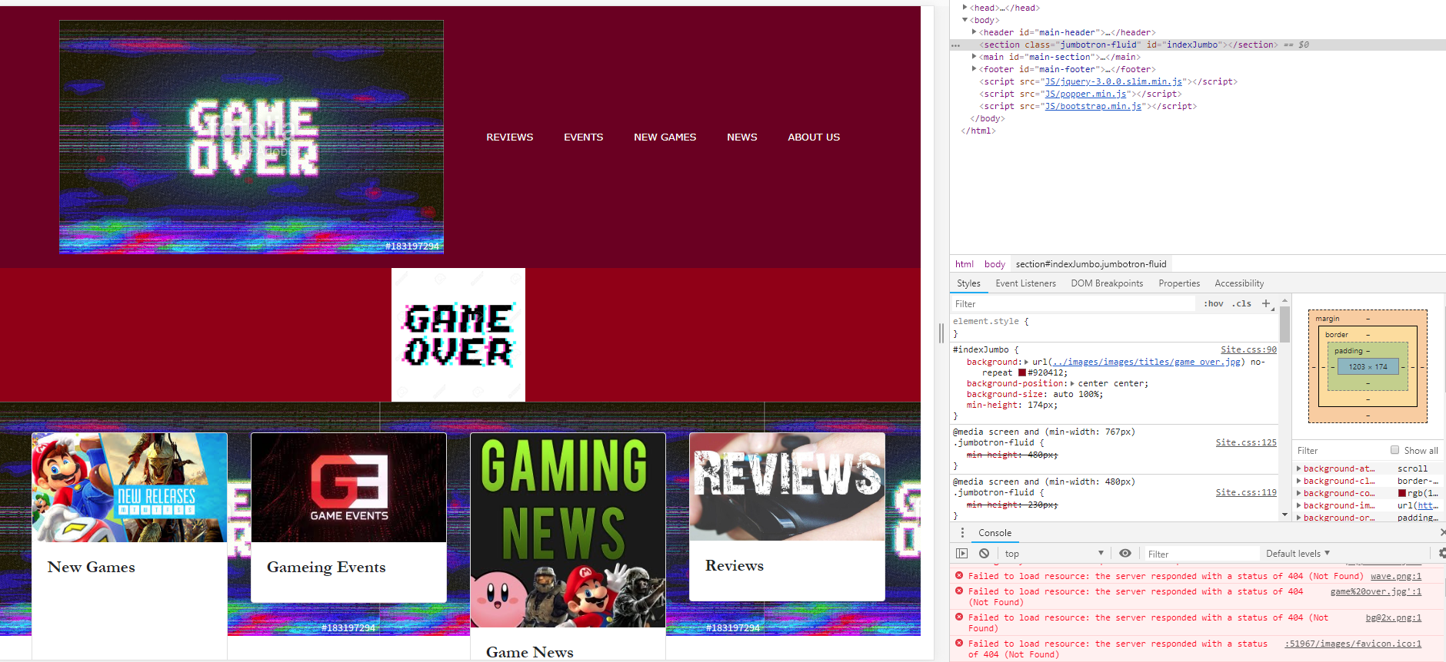

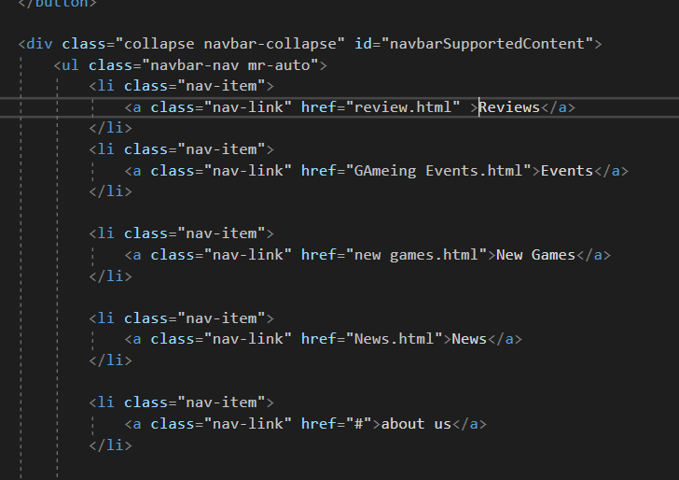

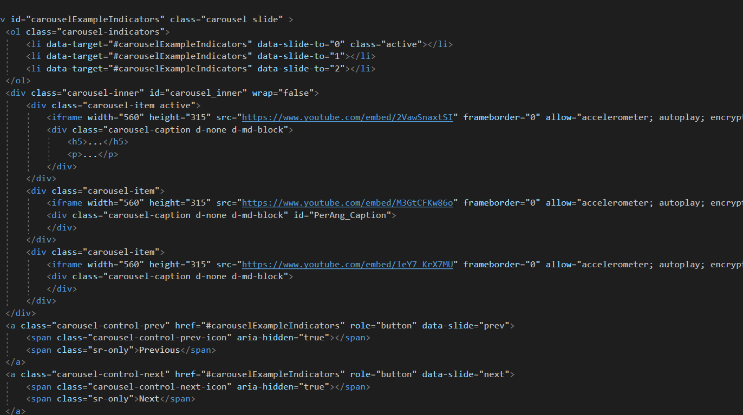







Evaluation
The overall website that is built has been created has a good range of information regarding the overall design of the website and how the website reacts to connecting with each page within the website the code that created the website and the pages took some time to create but after it was in place it all worked out more smoothly the only problems where having very limited knowledge of the subject mater and the time in which to create the website with the time remaining.

Bibliography

[1] | J. Nielsen, Designing web Usability, 1999.
[2] | G. Bigby, “18 usability guidelines and website design standards,” Dyno mapper, 3 2 2018. [Online]. Available: https://dynomapper.com/blog/19-ux/464-usability-guidelines. [Accessed 17 12 2018].
[3] | E. Wong, “Shneiderman’s Eight Golden Rules Will Help You Design Better Interfaces,” Interaction Design foundation, 17 11 2018. [Online]. Available: https://www.interaction-design.org/literature/article/shneiderman-s-eight-golden-rules-will-help-you-design-better-interfaces. [Accessed 17 12 2018].
[4] | P. A. s. &. A. Dix, “Usability – Not as we know it!,” Volume 2 Proceedings of the 21st BCS HCI Group conference , vol. 2, no. 21, 2007.

marking criteria and Student FEEDBACK

This section details the extent to which the assessment criteria are demonstrated by you, which in turn determines your mark. The marks available for each category of skill are shown. Lecturers will use the space provided to comment on the achievement of the task(s), including those areas in which you have performed well and areas that would benefit from development/improvement.

Common Assessment Criteria Applied (Assignment 1) | Marks available | Marks  awarded
1. Engagement with Literature Skills

Satisfactory evidence of a number of reference sources consulted. For additional improvements, expand the range of reference sources consulted. (Grade mark: 40.00%) | 5 | 2
2. Knowledge and Understanding Skills

Discussion of application development concepts is brief and does not really demonstrate a sound and critical understanding or in-depth research of the concepts. (Grade mark: 36.00%) | 25 | 9
3. Cognitive and Intellectual Skills

A basic evaluation of the website has been provided. (Grade mark: 22.50%) | 20 | 4.5
4. Practical Application Skills

A basic attempt featuring a simple website. The implemented solution does not really demonstrate an understanding of RWD and the content is rather limited and basic and also does not really support the requirement for the website to be responsive. Also aim to improve your understanding of JavaScript to add functionality and interactivity as none of this has been implemented. See additional comments in your report. (Grade mark: 35.56%) | 45 | 16
5. Transferable Skills for Life and Professional Practice

The report is of average standard. (Grade mark: 50.00%) | 5 | 2.5

Assignment Mark (Assessment marks are subject to ratification at the Exam Board. These comments and marks are to give feedback on module work and are for guidance only until they are confirmed. ) | Late Submission Penalties (tick if appropriate) |  | 34%
 | Up to 1 week late (40% Max) |  | 34%
 | Over 1 week late (0%) |  | 34%

