Name: Tyler Johns
Student Number: 1901704

Human Evolution and the Origins of Modern Human Behaviour

Practical exercise 2021

Please indicate your response clearly

Looking at faces 1
Look at the following images and then compare them to the list below. Indicate clearly (circle or highlight) the name of the early hominin skull you believe this to be.
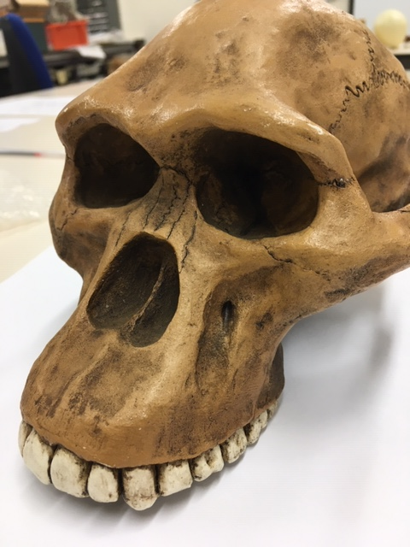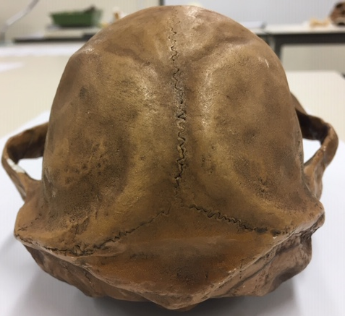

Chimpanzee

Australopithecus afarensis

Australopithecusafricanus

Australopithecus robustus

Homo habilis
Looking at faces 2
Look at the following images and then compare them to the list below. Indicate clearly (circle or highlight) the name of the early hominin skull you believe this to be.
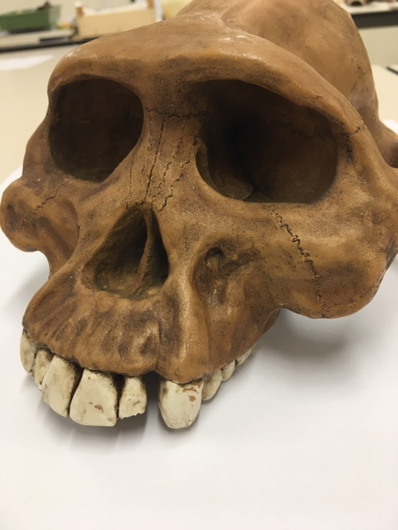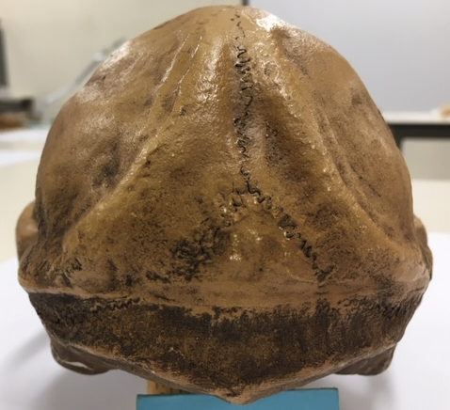

Chimpanzee

Australopithecus afarensis

Australopithecusafricanus

Australopithecus robustus

Homo habilis

Looking at faces 3
Look at the following images and then compare them to the list below. Indicate clearly (circle or highlight) the name of the early hominin skull you believe this to be.
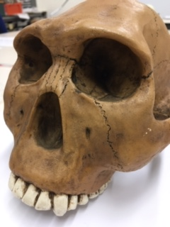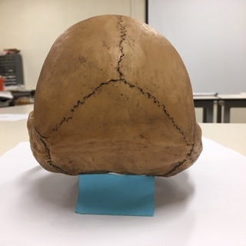

Chimpanzee

Australopithecus afarensis

Australopithecusafricanus

Australopithecus robustus

Homo habilis
Maxilla (upper jaw): Identify the species these belong to
A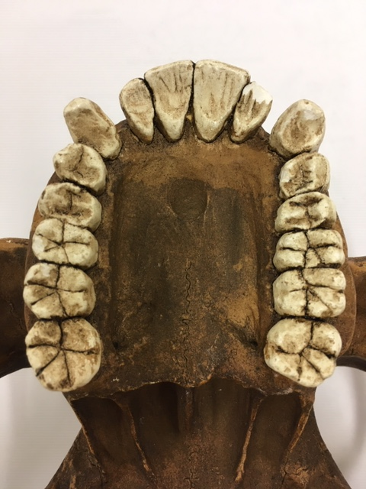B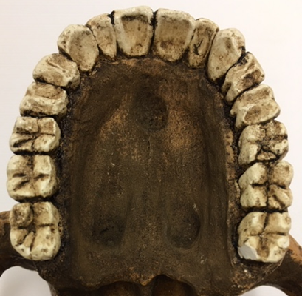
A: Australopithecus Afarensis B: Australopithecus Africanus
Top row left Chimpanzee, Middle Australopithecus afarensis, Right modern human
Lower row Left Australopithecus africanus, Right Australopithecus robustus
Indentify the skull to genus and species level
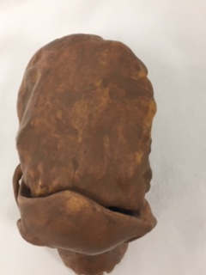
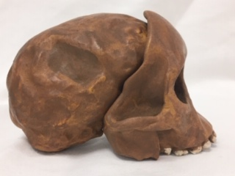
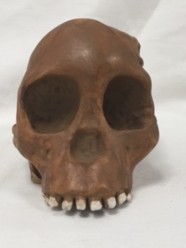
Answer: Australopithecus Africanus (Taung Child)
Indentify the skull to genus and species level
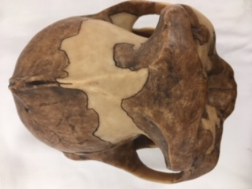
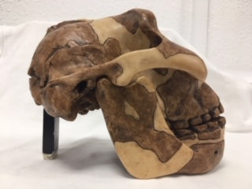
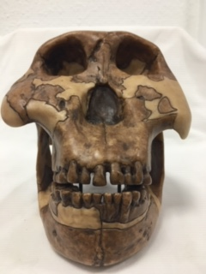
Answer: Australopithecus Bosei
Identify the hominin skull to genus and species level
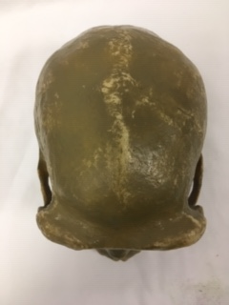

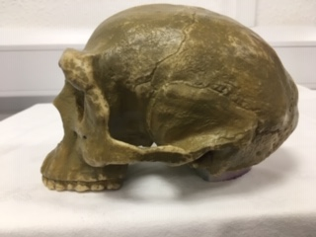

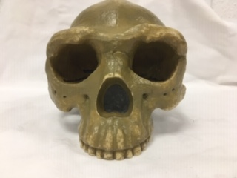
Answer: Sinanthropus Pekinensis (Peking Man)
Indentify the skull to genus and species level
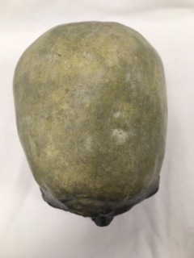
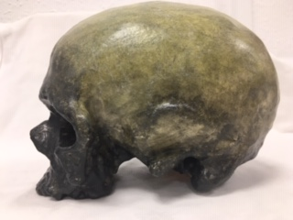
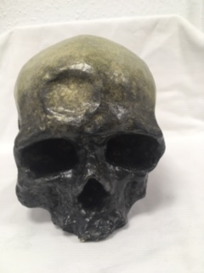
Answer: Cro-Magnon (Homo-Sapien?)
Identify, compare and contrast these two mandibles. Use the illustration below to help if you need to.
Homo-Heidelbergensis
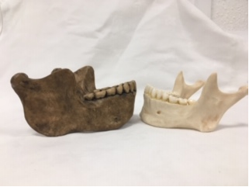
Homo-Sapien
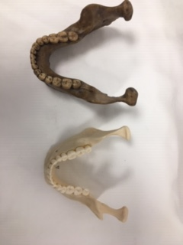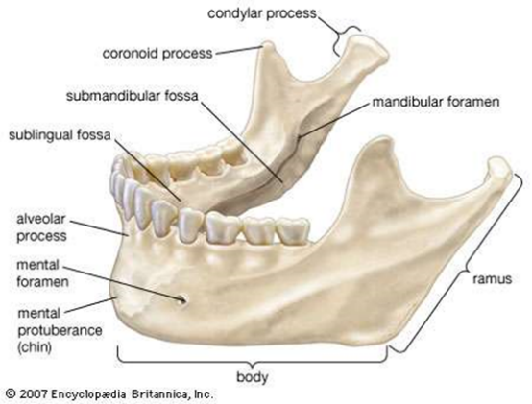

Answer: As Identitfed in the above text boxes the Homo-Heidelbergenesis mandible is the larger specimen between the two and with that possess signficantly robust features such as the body and ramus in contrast to the smaller human body and ramus of their mandibles. Another feature that contrasts betweens the two mandibles would be the condylar process and cornoid process which in the H. Heidelbergensis is signficantly less concave in comparision to the Human’s concave condylar process and cornoid process. Another feature worth mentioning with be the alveolar process and the mental protuberance which in the H. Heidelbergensis is more robust with the alveolar process to support the larger teeth whilst, the mental protuberance is sloped inwards towards the neck

Stone tools and tool technology: How to tell a stone is worked.
What suggests this has been worked?
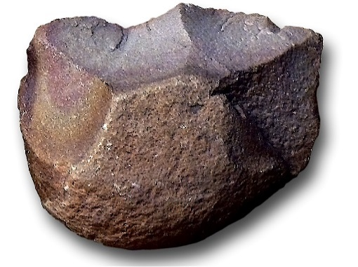
Answer: The stone has sevaral flake scars and large flake scar ridges which indicates that it has been knapped. Also the strone stone has the defining features as what is known as a lithic Chopper.

Features of stone tool flaking: identify features 1-5
Dorsal Surface
Profile
Ventral Surface
1. Striking Platform
2. Bulb of Percussion
3. Flake scars and Flake scar ridges from knapping.
4. Errailure
5. Ripples along the ventral surface

Stone tools and tool technology: Stone tools not to scale
Below left: Oldowan Below Right: Acheulean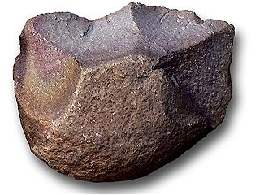 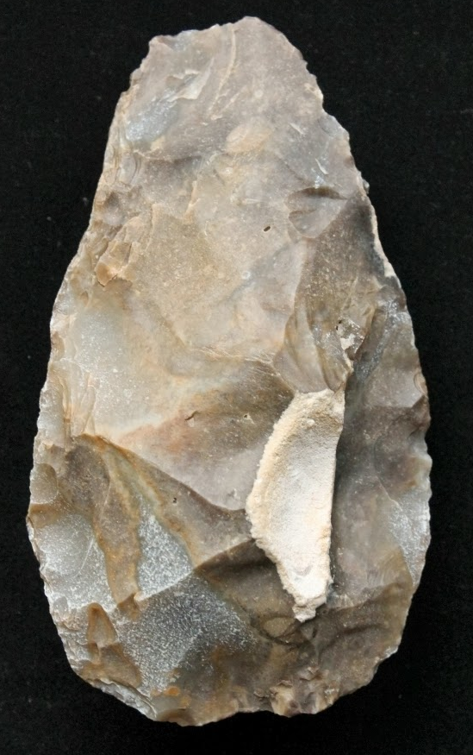
Images taken from https://images.search.yahoo.com

Task: Compare and contrast these two stone tools
The first and most obvious comparison to make between theses two stone tools would be the type of mineral that they were manipulated from. The Oldowan Chopper which seems to be a type of sedimentary rock such as flint or chert, another feature of the Oldowan Chopper is that it has what looks to be a smoothed out handles from repeated use.
Whilst the Acheulean stone tool seems to be flake from a core and was thus used as an awl or chisel, the material of the Acheulean flake looks to be flint and it seems to have been knapped extensively and from this process have left an large amount of flake scar ridges, which the Oldowan Chopper only shows several.

