BA Business Management
Data Handling & Business Intelligence – LCBB5000
Lecturer: Xavier Matieni
ASSIGNMENT 2
Boris Vladimirov – 2124687



Data Handling & Business Intelligence
Assignment 2

Table of Contents
1. Introduction 3
PART 1: Analysis of Hotel Reservation Data Using Microsoft Excel 3
1. Data Pre-processing 3
1.1. Remove Null Values 3
1.2. Remove Duplicate Values 4
2. Data Analysis and Visualisation 4
2.1. Descriptive Statistics 4
2.2. Line Chart: Average Price per Year 5
2.3. Pie Chart: Average Price by Market Type 6
2.4. Line Chart: Average Price by Room Type (filtered using Adult Type) 7
2.5. Average Price by Meal Type and Status 8
3. Discussion 9
PART 2: Analysis of Survey Data on School Students 10
1.1. Gender Distribution: 10
1.2. Lunch Qualification Distribution: 10
1.3. Mean and Median of Students' Scores by Lunch Qualification: 11
1.4. Mean and Median Differences of Pre-test and Post-test Scores: 12
1.5. Clustering Analysis (K-Means Clustering): 13
1.6. Examples of Data and Text Mining Methods 14
1.7. Advantages and Disadvantages of SPSS and Excel 15
2. Conclusion 17
References 18

1. Introduction
In this article, two distinct studies of datasets are presented: the first one examines hotel reservation data using Microsoft Excel, while the second one examines survey data on students using SPSS data mining software. The study of hotel reservations focuses mostly on tracking changes in average reservation fees over time and assessing Microsoft Excel's usability for data analysis. The study of the student survey, on the other hand, intends to look into the connections between gender, pre- and post-test results, and lunch eligibility. The document digs into data pretreatment, analysis, and visualisation to offer insightful information to educational institutions and hotel management.

PART 1: Analysis of Hotel Reservation Data Using Microsoft Excel

1. Data Pre-processing
In each data analysis effort, data pre-processing is an essential step. In order to assure precision and dependability in later studies, it requires cleaning and processing the data (Chu, et al., 2016). Two crucial steps of pre-processing were carried out for this dataset.

1.1. Remove Null Values
The dataset has been validated for null values to verify data completeness. It's a good thing that no null values were discovered because that means the dataset was complete and didn't need any imputation. Null values are undesirable for accurate analysis because they can produce skewed results and insufficient insights.
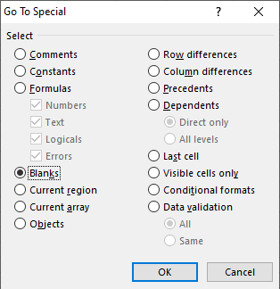
Figure 1: Removing null values.

1.2. Remove Duplicate Values
It has been examined for duplicate values in the dataset to prevent duplication bias and assure data integrity. Fortunately, no duplicate records were found, guaranteeing that each record was distinct and lacking in redundant information. Duplicate entries can distort analytical results, producing false conclusions and possibly erroneous decision-making.
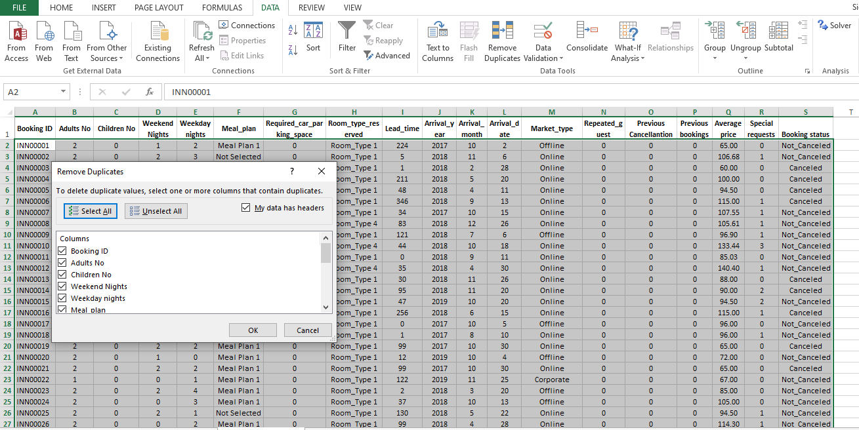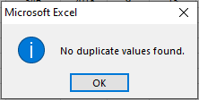
Figure 2: Removing duplicates.

2. Data Analysis and Visualisation

2.1. Descriptive Statistics
Descriptive statistics summarise the key features of the data (Mishra, et al., 2019). Here are some key statistics for the selected columns:
Table 1: Descriptive statistics
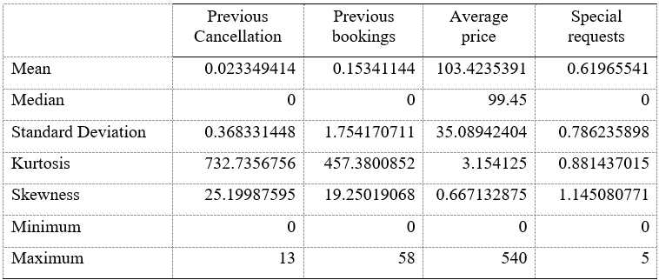
The primary aspects of the dataset are outlined by descriptive statistics. We can learn a lot about the distribution and central tendency of the data by computing metrics like the mean, median, standard deviation, kurtosis, skewness, minimum, and maximum (Buhalis, et al., 2018).
For instance, it was discovered that the median price was slightly lower at £99.45, and the mean average price was almost £103.42. This shows that certain higher-priced outliers may be driving the mean upwards, causing the distribution of average prices to be slightly right-skewed. The standard deviation of room reservation costs is around £35.09, which reflects the variety of accommodation types, seasons, and other pricing-influencing factors.
Analysed each variable's kurtosis and skewness values as well. Kurtosis and skewness both gauge a distribution's degree of flatness or peakiness, respectively. High kurtosis values for "Previous Bookings" and "Previous Cancellations" imply heavy tails in their distributions, while "Average Price" and "Special Requests" distributions with skewness values greater than 1 show positively skewed distributions.

2.2. Line Chart: Average Price per Year
Using the AVERAGEIF function in Microsoft Excel, the average prices for each year (2017–2021) were calculated in order to examine the trend of average prices through time. Then a line chart was made to show the price changes over time. According to the line graph, there was an increase from 2017 to 2018, and then there was a minor fall in 2019. After that, prices rose once more in 2020 before falling in 2021.
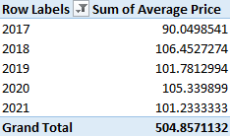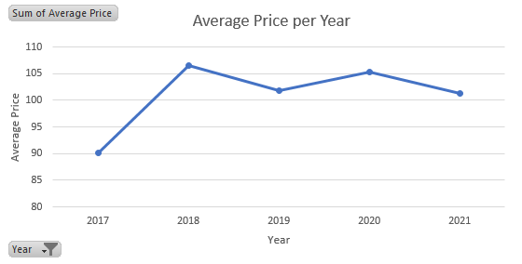
Figure 3: Average Price per Year
The average price fluctuates with time, as seen in the line graph. In 2019, there is a minor dip after a rise from 2017 to 2018. But in 2020, prices rise once again, and in 2021, they start to decline. For hotel management, it is crucial information that average costs have fluctuated over time (Wu, et al., 2020). Recognising these trends can assist in locating seasonal patterns, economic effects, and other variables that affect pricing strategies. For instance, the rise in pricing between 2017 and 2018 may be a sign of rising demand or the success of marketing initiatives. On the other hand, the reduction in 2019 can be the result of outside forces like economic downturns or increasing competition.

2.3. Pie Chart: Average Price by Market Type
The distribution of average prices based on market categories was depicted using a pie chart. The graph showed that most reservations were made online, which also accounted for the highest average price count. Due to their accessibility and convenience, online bookings have grown in popularity (Toh, et al., 2011). They enable customers to make reservations at any time and from any location by comparing costs and reading reviews. The second-highest count was for the corporate market category, highlighting the importance of corporate reservations for hotel income.
However, the number of typical prices was lowest for the Aviation market type. This result raises the possibility that the hotel's revenue may not be considerably impacted by reservations from the aviation industry. Nevertheless, it is crucial to take into account the entire value that these visitors provide, such as return business, group bookings, or conference events (Swarbrooke, et al., 2012).
Hotel management may successfully organise resources and marketing efforts with the help of the insights provided by this pie chart. They can modify their marketing strategy to draw and keep the most valuable consumer segments by studying the predominant market types.
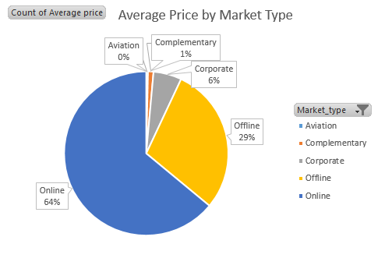
Figure 4: Average price by market type

2.4. Line Chart: Average Price by Room Type (filtered using Adult Type)
The average costs for various accommodation kinds are represented on a line graph and filtered by the number of adults.
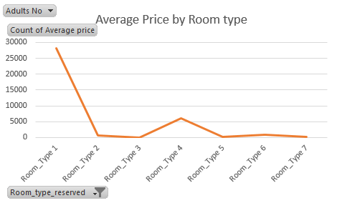
Figure 5: Average price by room type
Decisions on revenue management and marketing must take into account preferences for different room types. The popularity of Room_Type 1 may indicate that it is the most popular choice among visitors because of its price or amenities. On the other hand, the lower counts for Room_Type 3 and Room_Type 7 would suggest that visitors do not favor these room kinds as much. To stimulate demand for less well-liked room types in response, hotel managers may think about targeted promotions, package deals, or room improvements.
Moreover, capacity planning can be influenced by the insights from this research. Hotel management can arrange resources and personnel in accordance with the strong demand for particular room types to ensure customer happiness and effective operations.

2.5. Average Price by Meal Type and Status
The average cost for several meal plans is displayed in a table along with the status of the plans (Canceled or Not_Canceled).
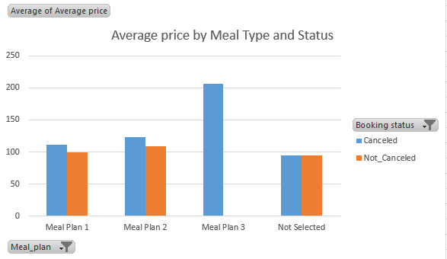
Figure 6 Average price by meal type and status
We developed a table showing the average pricing for various meal plans based on their state (Canceled or Not_Canceled), in order to better evaluate the effect of meal plans on reservation outcomes. Analysis showed that Meal Plan 3 had no successful reservations and only cancellations, pointing to potential problems with the plan's availability or pricing.
On the other hand, Meal Plan 2 had the highest average cost for both canceled and confirmed reservations. This implies that Meal Plan 2 might provide upscale or upscale dining options, luring in customers prepared to pay more for an improved culinary experience. Contrarily, Meal Plan 1 and the "Not Selected" option had comparable average costs, indicating that visitors might not consider certain meal plans to be very valuable.
This discovery may lead hotel management to reexamine the features and costs of Meal Plan 3. Understanding the reasons why people are rescheduling their reservations with this meal plan could point up areas that need work or provide potential incentives to boost booking success. To enhance Meal Plan 2's adoption rate, it may also be advantageous to highlight its appealing qualities.

3. Discussion
The analysis of the Hotel Reservation dataset offers insightful information on average pricing trends and how they are distributed across various categories. Here are some significant findings:
- Average Price Trends: The average price each year is represented as a line chart, which demonstrates changes over time. Prices rose from 2017 to 2018, dropped in 2019 and then rose once more in 2020 and 2021. Various elements, such as seasonal demand, economic conditions, or marketing tactics, may have an impact on these swings.
- Market Type Distribution: Online booking platforms are important in the hotel industry, as evidenced by the fact that the majority of reservations are made there. Additionally, a sizeable portion comes from corporate reservations, with the aviation market type contributing the least.
- Room Type Preference: Customers most frequently select Room_Type 1, which might be the typical room type. Other room kinds have a much lower percentage, indicating that they can be more specialised or expensive possibilities.
- Meal Plans: Only cancellations are displayed for Meal Plan 3, which may point to a problem with the meal plan's availability or cost. Meal Plan 2 has the highest average price for cancelled and uncancelled bookings, suggesting that it may be a well-liked and more expensive alternative.

PART 2: Analysis of Survey Data on School Students

1.1. Gender Distribution:
The first variable we looked at was the gender distribution of the students. While 1077 male students make up 50.5% of the sample, 1056 female students make up 49.5% of it. The gender distribution reveals that there are almost equally as many male and female students in the school. Table 1: Gender Distribution Table
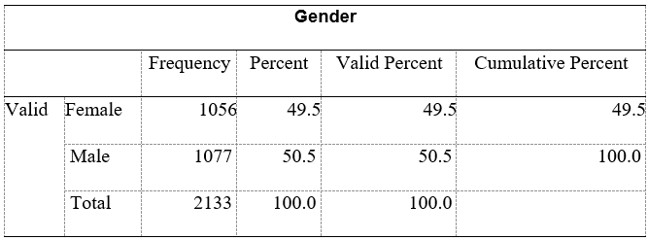

1.2. Lunch Qualification Distribution:
Table 2: Lunch qualification distribution
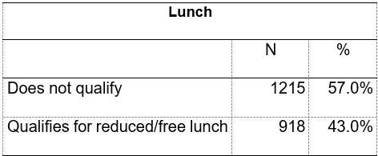
The next analysis focused on the distribution of kids according to their eligibility for lunch. According to the results, 918 students (43%) are eligible for free or reduced-priced lunches and 1215 children (57%) does not qualify. This indicates that a substantial percentage of students qualify for the lunch program, which raises the possibility of socioeconomic differences among the kids.
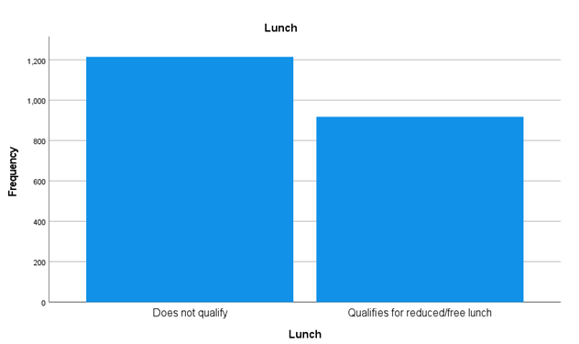
Figure 1: Lunch frequency distribution

1.3. Mean and Median of Students' Scores by Lunch Qualification:
We were able to understand the relationship between students' academic performance and their eligibility for reduced/free lunch by comparing the pre-test and post-test results of children who qualified and do not qualify for lunch.
- For Students Who Are Not Eligible for Reduced or Free Lunch:
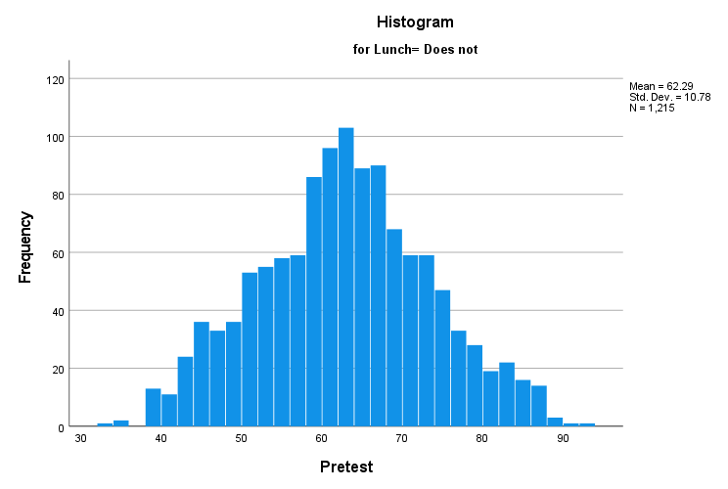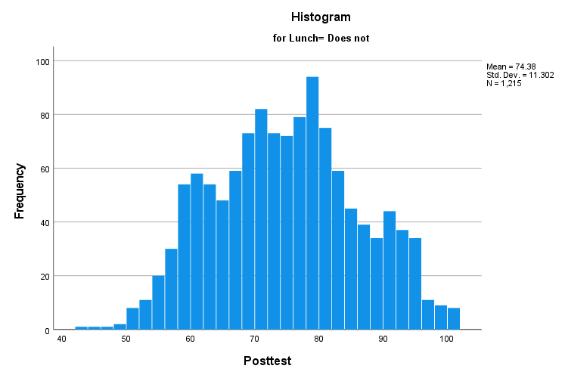
Figure 2: Students Who Are Not Eligible for Reduced or Free Lunch
The findings showed that pre-test mean scores 62.29 and pre-test median scores 62.00 were higher for children who were not eligible for free or reduced-price meals. Their post-test median score was 74.00, and their post-test mean score was 74.38.
- For Students Who Qualify for Reduced/Free Lunch:
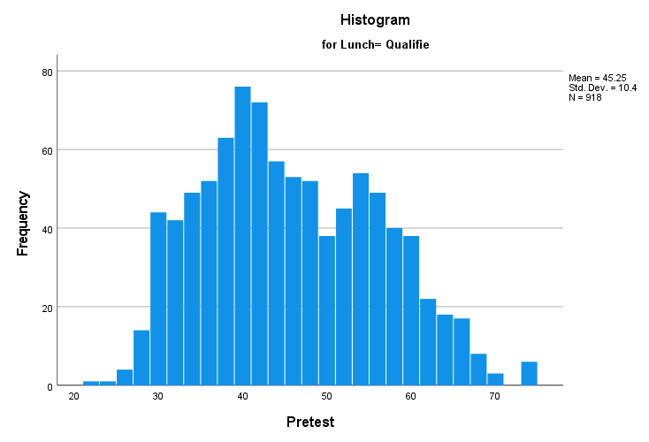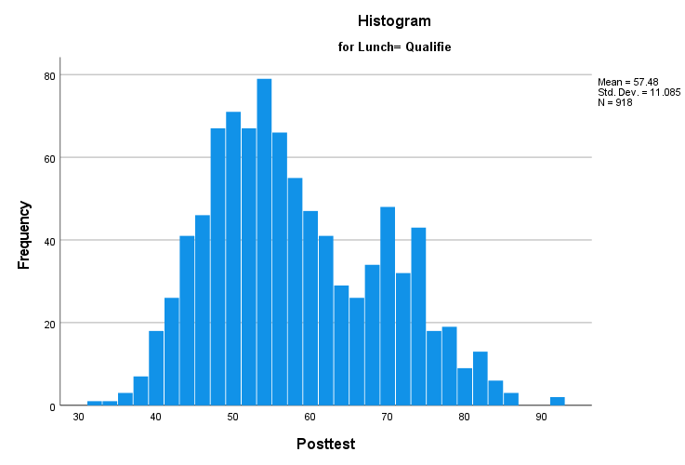
Figure 3: Students Who Qualify for Reduced/Free Lunch
However, those students who were eligible for free or reduced-priced lunch showed less improvement in their academic standing. The pre-test mean and median scores were 45.25 and 44.00 respectively. Additionally, their post-test median score was 55, and their post-test mean score was 57.48.

1.4. Mean and Median Differences of Pre-test and Post-test Scores:
Calculated the mean difference to get a general idea of how students' scores changed overall between the pre- and post-test.
Table 3: Paired sample test
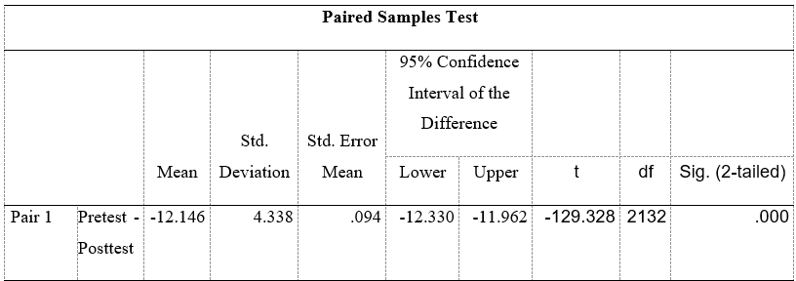
Mean difference for all students: -12.146
According to the negative mean difference, pupils' post-test scores on average fell below those from their pre-test. This disparity may be explained by a number of variables, including the tests' degree of difficulty, students' learning progress, or other circumstances beyond of the students' control that have an ongoing effect on their performance.

1.5. Clustering Analysis (K-Means Clustering):
We performed a clustering analysis using K-Means clustering with four clusters to investigate the grouping of students based on their pre-test and post-test results.
Table 4: Final Cluster Centres
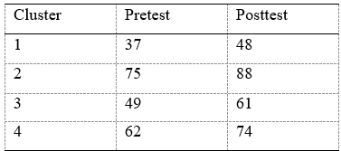
Based on their pre-test and post-test results, the clustering analysis found four different groups of students. According to their academic performance, each cluster of pupils represents a different group. The ANOVA findings show substantial disparities between these clusters, indicating that the classification is meaningful and reflects differences in academic achievement among the students.
Table 5: Number of Cases in Each Cluster
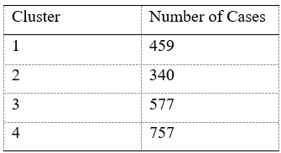
According to the distribution of cases throughout the clusters, Cluster 4 has the highest mean scores for both the pre-test and the post-test, and this is where most students are located. After Clusters 3 and 1, Cluster 2 gets the second-highest scores.

1.6. Examples of Data and Text Mining Methods
Businesses must use data mining and text mining techniques to get the most out of their unstructured text data and huge datasets. Here are five prevalent data mining and text mining techniques, along with examples of real-world uses for each.
Data Mining Methods:
- Classification: This method of supervised learning classifies data into predetermined groups or categories. It is utilised for sentiment analysis, fraud detection, and client segmentation (Kohavi, et al., 2002). An e-commerce business, for instance, can utilise classification to interpret input from customers' perspectives and adjust the quality of its goods and services as necessary.
- Clustering: Clustering is a method of unsupervised learning that assembles comparable data points based on similarities. Market segmentation, anomaly detection, and recommendation systems all use it (Hossain, et al., 2019). For instance, a retailer can utilise clustering to categorise customers based on their purchasing patterns, enabling more precise marketing plans.
- Association Rule Mining: This technique reveals intriguing connections between variables in sizable datasets. In the retail industry, it is used for market basket analysis to identify frequently occurring items in shoppers' shopping baskets. By grouping baby wipes and diapers on shelves, for instance, a supermarket store can employ association rule mining to promote cross-selling (Telikani, et al., 2020).
- Regression Analysis: By establishing links between variables, regression analysis forecasts numerical results. Demand estimate, pricing optimisation, and sales forecasting are three business applications. For instance, a hotel chain can forecast room occupancy rates based on room rates, seasonal changes, and nearby events, optimising room pricing to maximize income.
- Time Series Analysis: Understanding patterns and trends in data gathered over time is the main goal of this technique. For predicting sales, stock prices, and product demand, it is frequently used in business (Zhao, et al., 2020). To properly distribute resources and guarantee customer satisfaction, a telecoms business, for instance, can forecast call volumes at various times of the day.
Text Mining Methods:
- Sentiment Analysis: Utilised to ascertain the sentiments represented in text data, such as customer evaluations or social network posts. Analysis of consumer reviews, reputation management, and brand monitoring all use it (Chintalapudi, et al., 2021). For instance, a restaurant can utilise sentiment analysis to determine the thoughts of its patrons regarding its cuisine and service, responding to any unfavourable comments and preserving its good reputation.
- Named Entity Recognition (NER): Recognises and categorises named entities—people, places, and organisations—in unstructured text data. Document classification, entity linkage, and information extraction all depend on NER (Gao, et al., 2020). As an illustration, a financial institution can utilise NER to extract pertinent data from financial news stories to help with well-informed investment decisions.
- Topic Modeling: Finds subjects or themes in a big quantity of text data automatically. Market research, trend analysis, and content recommendation are among the uses for businesses (Hu, et al., 2019). The topic modeling technique, for instance, can be used by an online news platform to categorise articles for user convenience.
- Text Classification: Applied to text data, and akin to data mining's classification. Text documents must be categorised into predetermined classes. Businesses employ text categorisation for sentiment analysis, spam email filtering, and ticket routing for customer service. As an illustration, a customer service center can employ text classification to direct client inquiries to the right division, guaranteeing prompt and accurate responses.
- Text Summarisation: Reduces lengthy text blocks into shorter versions while preserving the most important details. Extensively employed for producing executive summaries, news summaries, and document summaries. For instance, a company that conducts market research can employ text summarisation to swiftly deliver crucial insights by condensing extensive market reports.

1.7. Advantages and Disadvantages of SPSS and Excel
The two most popular software programs for data analysis are SPSS (Statistical Package for the Social Sciences) and Excel, each of which has advantages and disadvantages of its own. A brief comparison follows:
SPSS Advantages:
- Statistical Power: Perfect for intricate statistical methods and extensive data processing.
- User-Friendly Interface: Usable by non-technical individuals who are not familiar with programming.
- Broad Range of Analysis: Offers a range of statistical tests and data mining methods for use in academic and research contexts.
SPSS Disadvantages:
- Price: Expensive licensing for home users or microbusinesses.
- Learning Curve: Needs instruction and knowledge of statistical principles, which could take a lot of time for beginners.
- Requires a lot of resources: When working with big datasets and intricate studies, this problem can be resource-intensive.
Excel Advantages:
- Common and Familiar: Widely used and known by users for quick and easy data analysis.
- Data Visualisation: Provides easy-to-use tools for data visualisation that are yet effective for making charts and graphs.
- Ease of Data Manipulation: Great for manipulating, cleaning, and performing basic computations on data.
- Affordability: Easily accessible and more affordable because it is a component of the Microsoft Office suite.
Excel Disadvantages:
- Basic statistical operations are limited compared to SPSS, which restricts the types of analyses that may be performed.
- Data Size Restrictions: With large datasets, performance problems or data truncation may occur.
- Limited Ability to Perform Advanced Analysis: Limited ability to perform advanced statistical and data mining operations.
- Version Compatibility Issues: Particularly with advanced capabilities, exchanging files between versions may lead to compatibility issues.
Practical Examples:
- Benefits of SPSS: A medical research team uses SPSS to analyse patient data to examine the efficacy of new medications. Advanced statistical tests in SPSS and data mining provide precise predictions and correlations.
- A small business owner who is analysing sales data finds SPSS to be cost-prohibitive and prefers Excel for jobs that are easier to complete.
- Excel's benefits: Using the simple Excel interface, a marketing team can quickly construct a bar chart to compare sales performance across areas.
- Drawbacks of Excel: When performing time series analysis on a large dataset, an analyst must get around Excel's statistical function and data size restrictions by using specialised software like SPSS.

2. Conclusion
In conclusion, both studies provide important light on the analysed datasets. Microsoft Excel was used to analyse hotel reservation data in order to show how average room reservation fees changed over time and to highlight Excel's capabilities for preprocessing, analysing, and visualising data. The analysis of survey data on school pupils using SPSS uncovers intriguing trends in relation to the academic achievement of students, gender distribution, and lunch eligibility. Both analyses stress the importance of data mining techniques and how they may enable organisations, including educational institutions, to make defensible judgments based on patterns and trends in data.

References
Buhalis, D. and Leung, R., 2018. Smart hospitality—Interconnectivity and interoperability towards an ecosystem. International Journal of Hospitality Management, 71, pp.41-50.
Chintalapudi, N., Battineni, G., Di Canio, M., Sagaro, G.G. and Amenta, F., 2021. Text mining with sentiment analysis on seafarers’ medical documents. International Journal of Information Management Data Insights, 1(1), p.100005.
Chu, X., Ilyas, I.F., Krishnan, S. and Wang, J., 2016, June. Data cleaning: Overview and emerging challenges. In Proceedings of the 2016 international conference on management of data (pp. 2201-2206).
Gao, X., Tan, R. and Li, G., 2020, March. Research on text mining of material science based on natural language processing. In IOP conference series: materials science and engineering (Vol. 768, No. 7, p. 072094). IOP Publishing.
Hossain, M.Z., Akhtar, M.N., Ahmad, R.B. and Rahman, M., 2019. A dynamic K-means clustering for data mining. Indonesian Journal of Electrical engineering and computer science, 13(2), pp.521-526.
Hu, N., Zhang, T., Gao, B. and Bose, I., 2019. What do hotel customers complain about? Text analysis using structural topic model. Tourism Management, 72, pp.417-426.
Kohavi, R. and Quinlan, J.R., 2002. Data mining tasks and methods: Classification: decision-tree discovery. In Handbook of data mining and knowledge discovery (pp. 267-276).
Mishra, P., Pandey, C.M., Singh, U., Gupta, A., Sahu, C. and Keshri, A., 2019. Descriptive statistics and normality tests for statistical data. Annals of cardiac anaesthesia, 22(1), p.67.
Swarbrooke, J. and Horner, S., 2012. Business travel and tourism. Routledge.
Telikani, A., Gandomi, A.H. and Shahbahrami, A., 2020. A survey of evolutionary computation for association rule mining. Information Sciences, 524, pp.318-352.
Toh, R.S., DeKay, C.F. and Raven, P., 2011. Travel planning: searching for and booking hotels on the internet. Cornell Hospitality Quarterly, 52(4), pp.388-398.
Wu, F., Zhang, Q., Law, R. and Zheng, T., 2020. Fluctuations in Hong Kong hotel industry room rates under the 2019 Novel Coronavirus (COVID-19) outbreak: Evidence from big data on OTA channels. Sustainability, 12(18), p.7709.
Zhao, H., Wang, Y., Duan, J., Huang, C., Cao, D., Tong, Y., Xu, B., Bai, J., Tong, J. and Zhang, Q., 2020, November. Multivariate time-series anomaly detection via graph attention network. In 2020 IEEE International Conference on Data Mining (ICDM) (pp. 841-850). IEEE.

