Introduction to Web and Database Concepts – 1910716

Oliver Bird
Second Year Applied Software Engineer
1910716@student.uwtsd.ac.uk
01/04/2021
Abstract
Table of Contents:
- Introduction
- Requirements
  - Mission statement
  - Target audience
  - Relevance
- Implementation
- Validation
  - HTML
  - CSS
- Evaluation
  - Usefulness
  - Search Engine Optimisation (SEO)
  - Accessibility

- Introduction

This report will cover in detail the contents and design of a new, modern and responsive website built with bootstrap v5.0. Its functionality and potential user base will be considered more generally with regards to basic web design and usage first.
The site will then be evaluated against current web standards evaluating:
- Its usefulness
- Optimisation for search engine indexing and crawling
- Accessibility

- Requirements

The site represents the thoughts and opinions of a local cheese enthusiast group known as the Cardiff Cheese Co. It is to be used as a platform for the group to interact with and spread the word with both new and old-time lovers of the food, while both providing useful and interesting information to the user base. The site contains basic information about various cheese types (breeds), production methods, guides and videos and local hotspots, along with points of contact for the group.

As above, the target audience for this site is firstly:

- Anybody with an interest in cheese in any capacity.
- Activists
- Funding or government bodies
In the modern day, the prevalence of mass produced and cheaper options in our food is higher than ever. Costs are cut at every corner to appeal to the masses for profit. The second primary focus of this site is to provide an alternative view point and potentially encourage and provide the foundations for users to think more deeply about their purchases, and drive the market away from the mass production of cheeses, and certainly many other food groups.
The site has been deliberately designed to be friendly and easy to read with little suggestive or manipulative content which could arguably be more effective to achieve this goal, however this site is not purely to enact change, but to also educate and advise for those interested in heightening their culinary expertise!
- Implementation

Screenshots have been taken for various devices only for the homepage to demonstrate the dynamic formatting provided by bootstrap.

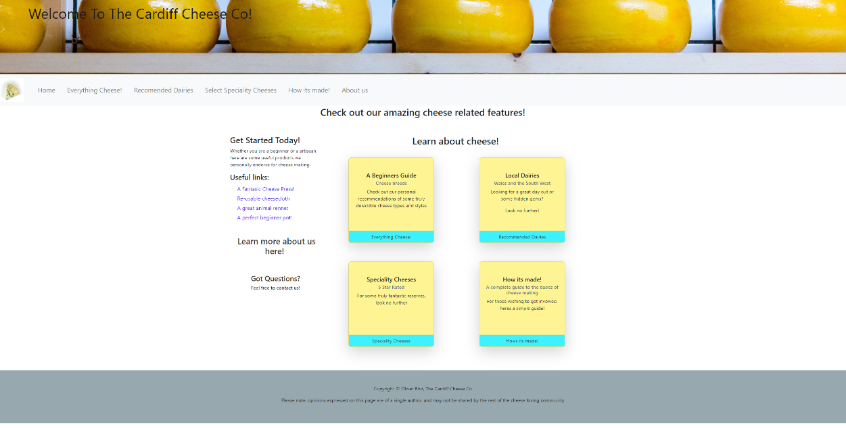
  - Homepage – Fullscreen Large

  - Homepage – Tablet

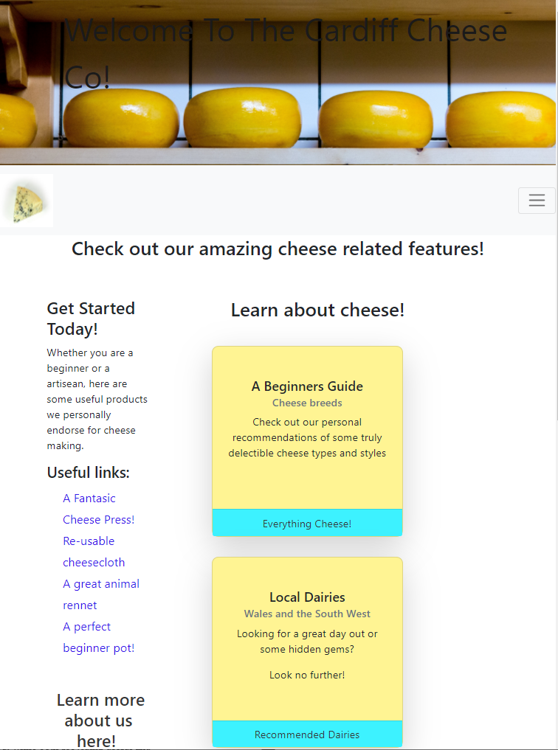

  - Homepage – Mobile

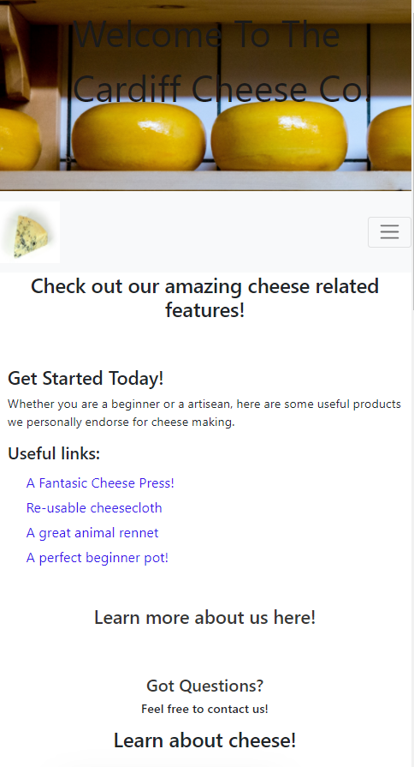
  - Everything Cheese

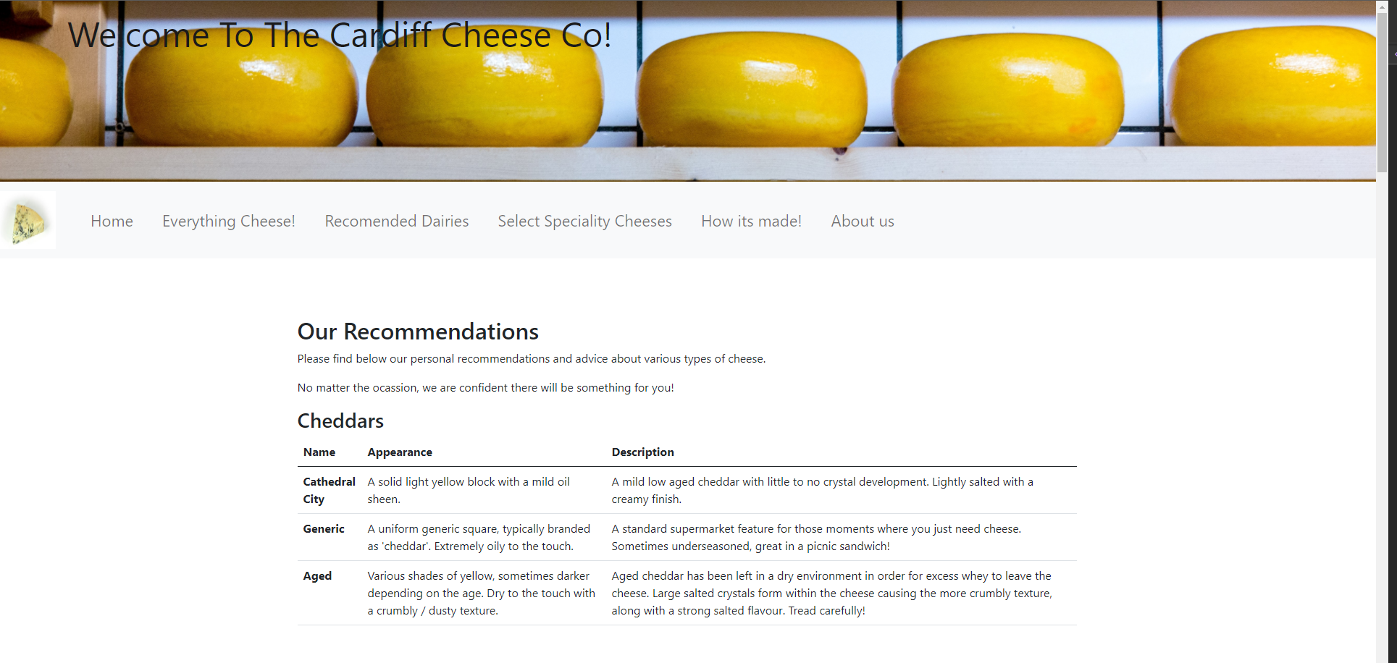
This page contains a large number of tables and data, it is not required to show screenshots of the whole page.

  - Recommended Dairies

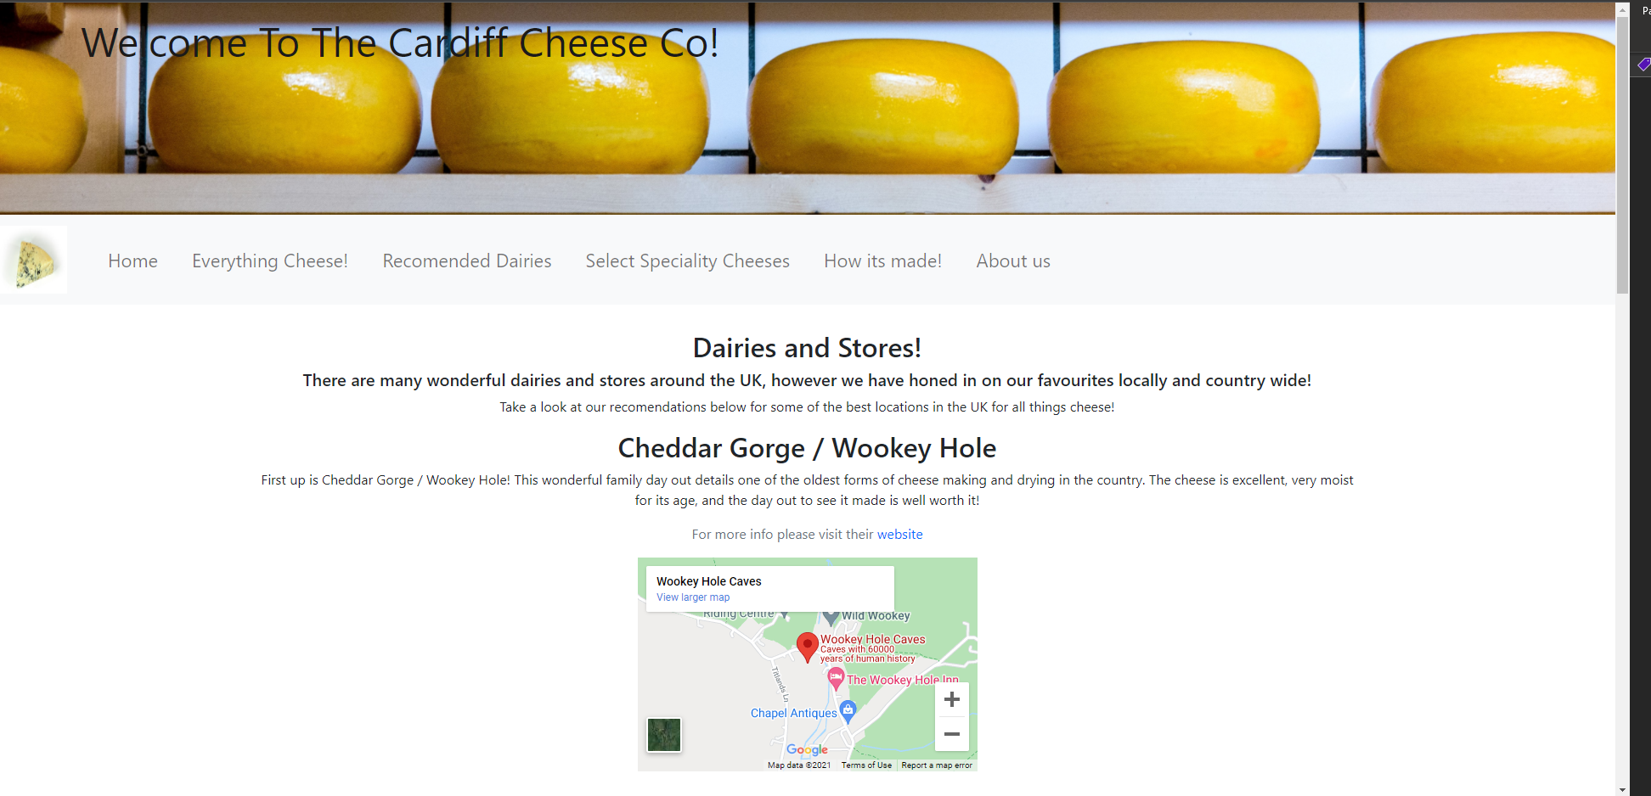

  - Select Speciality Cheese

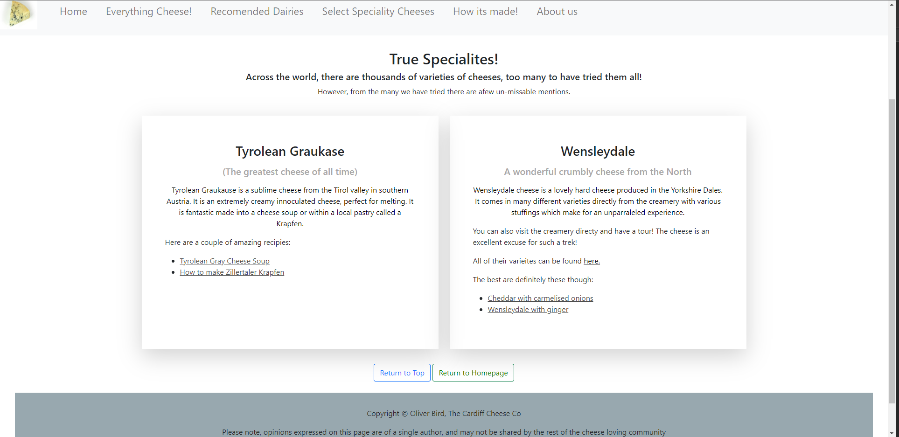

  - How it’s made!

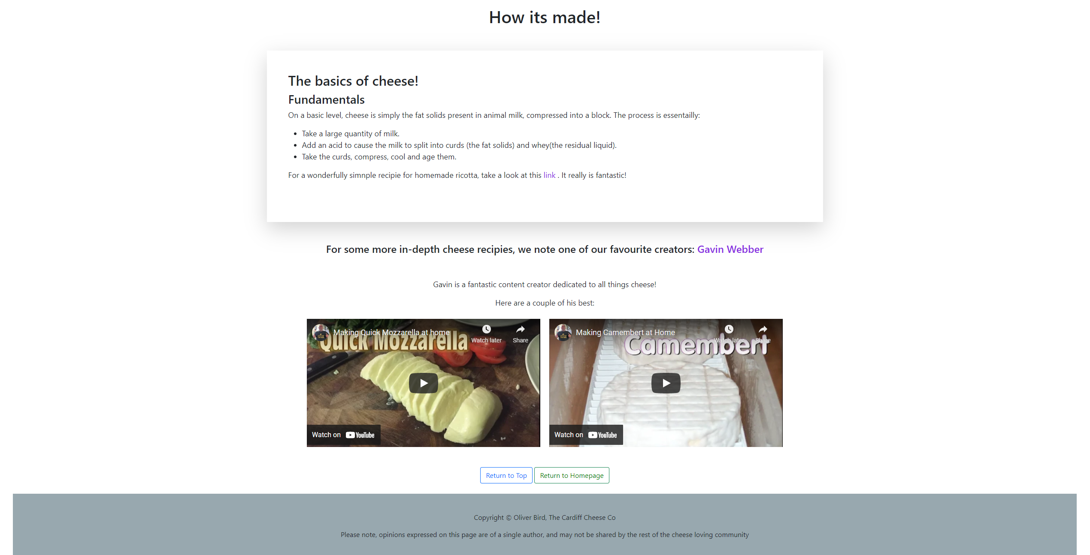

  - About Us

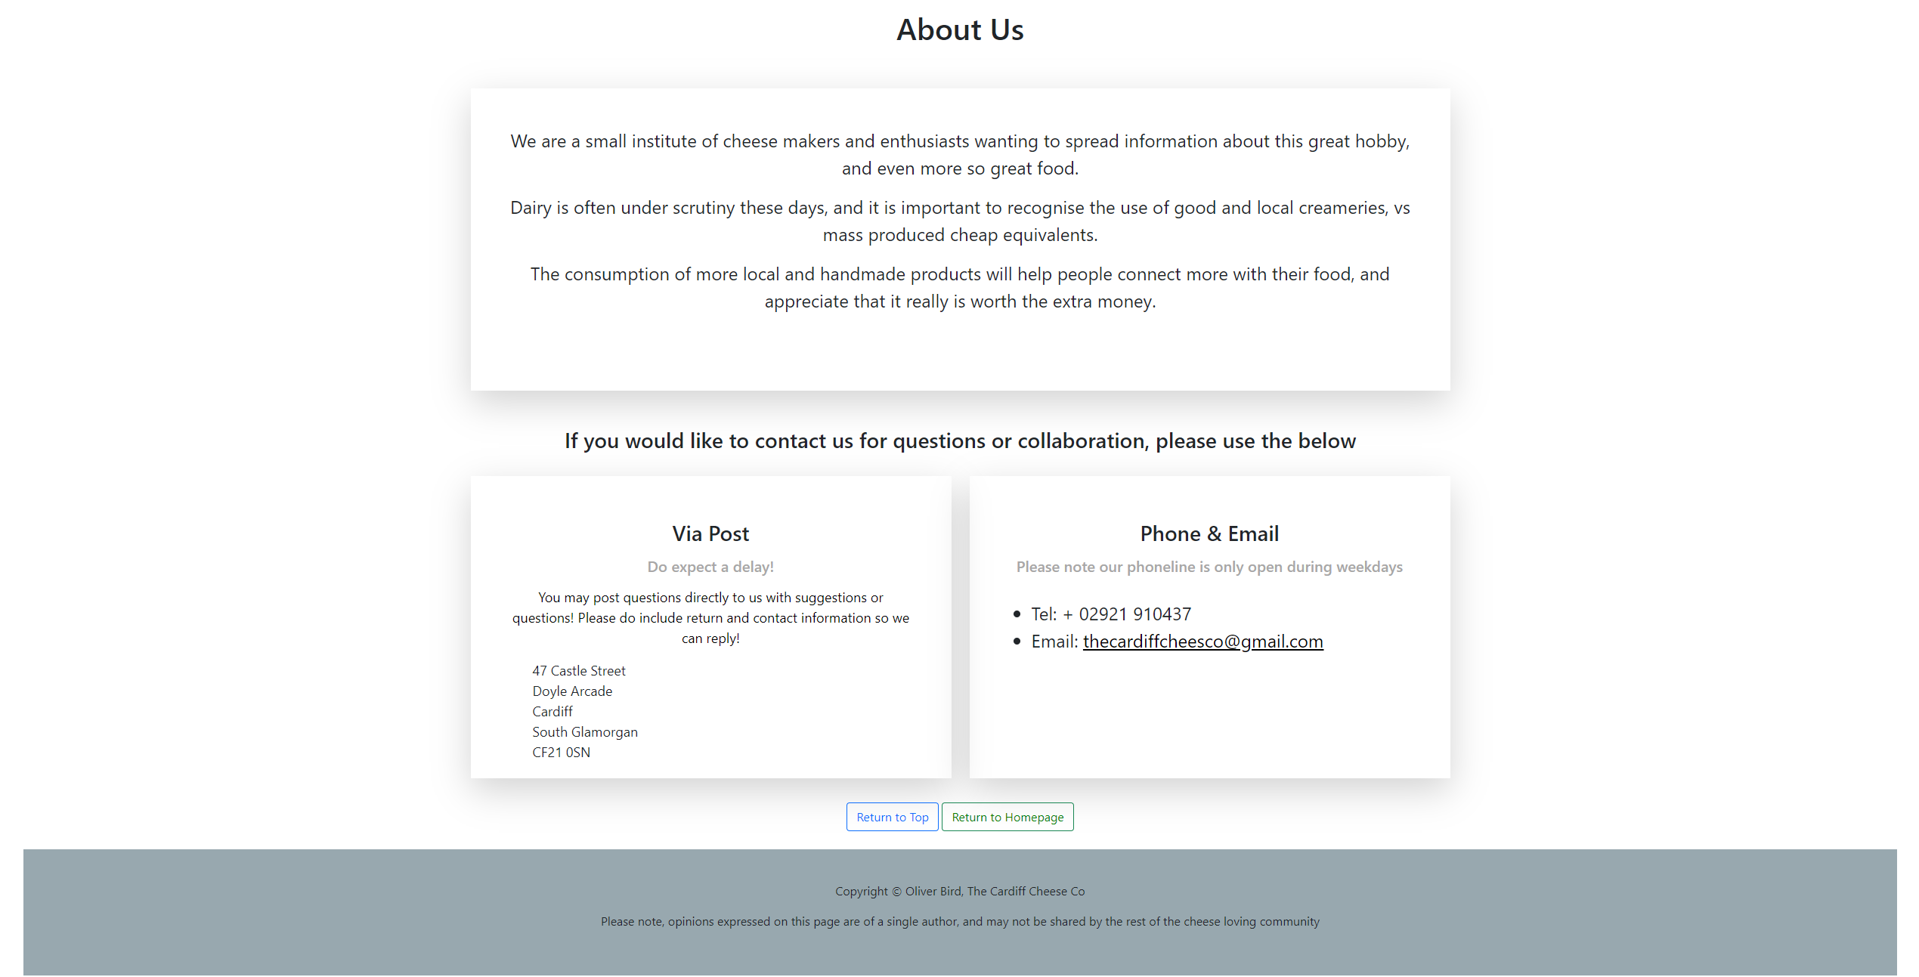

- Validation

All pages have been validated using https://validator.w3.org/nu/#textarea

All pages using the return to homepage button experience the same error:

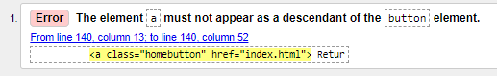

It is suspected that this is caused by the hyperlink insert should be called as a JS function, as opposed to directly in the HTML. The functionality works as expected however.

  - Homepage

The homepage was found to have no errors present in the html.

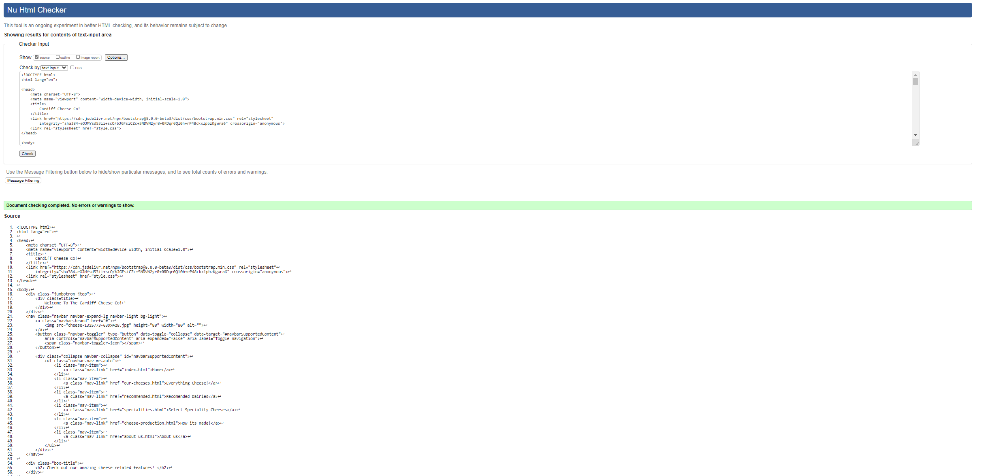

  - About Us

Only the above home button error is found on this page.

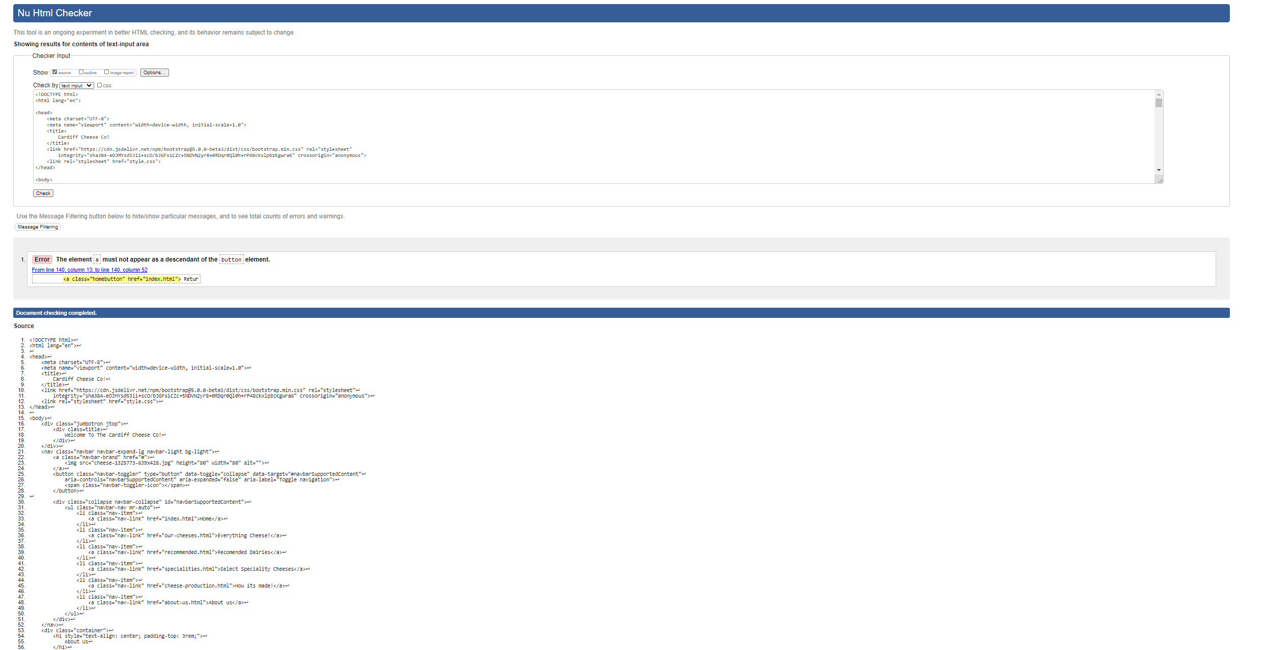
  - Cheese Production

Only the above home button error is found on this page.

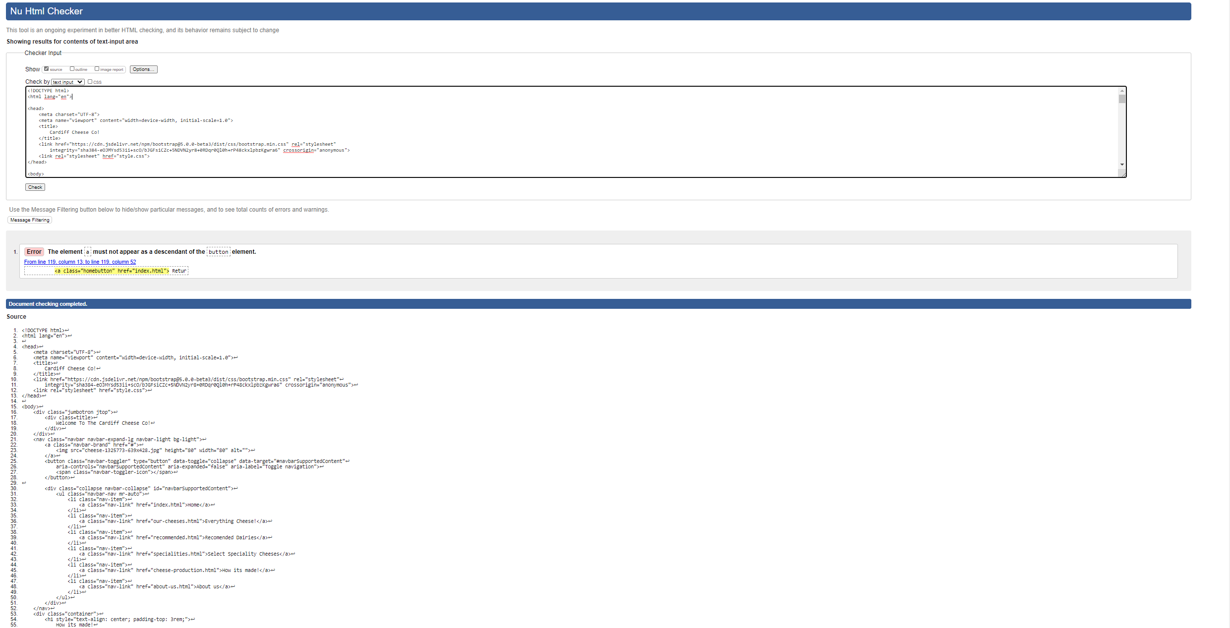

  - Everything Cheese

Only the above home button error is found on this page.

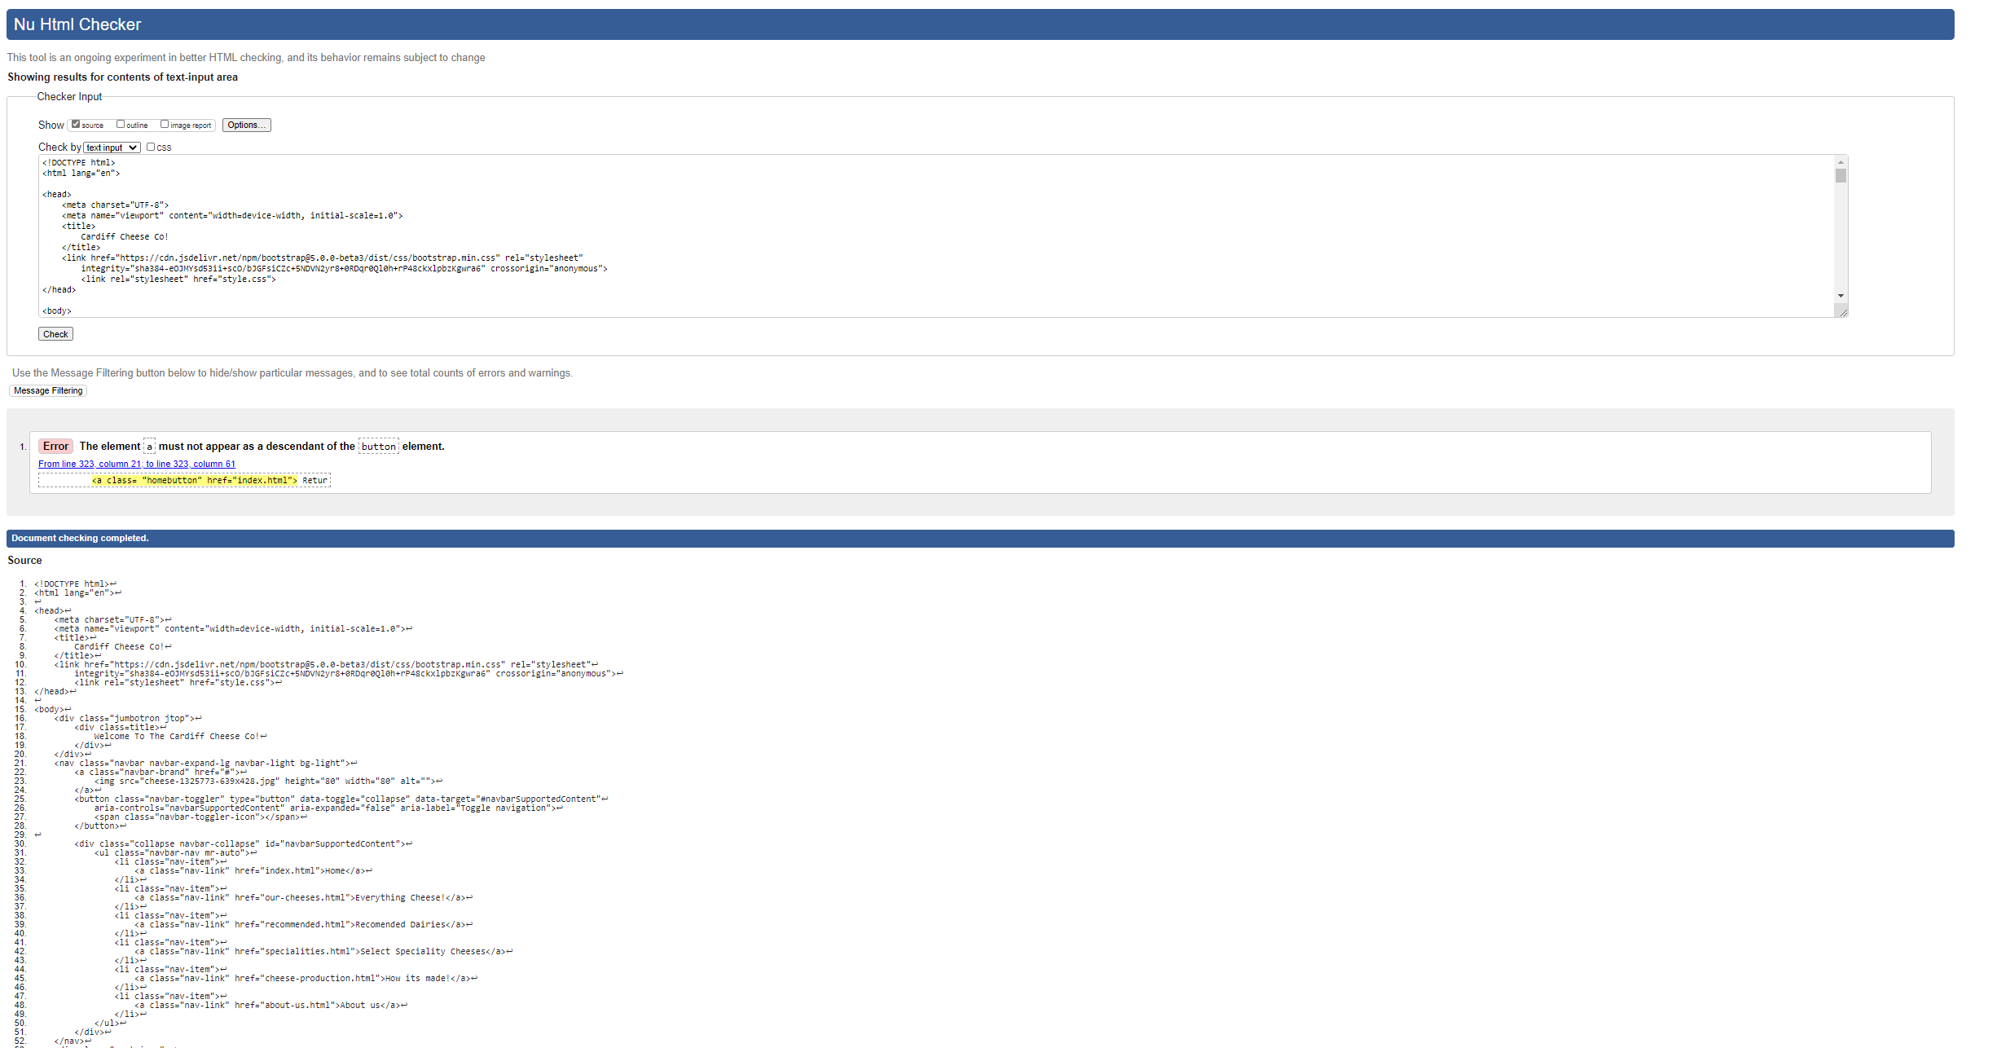

  - Recommended Dairies

Only the above home button error is found on this page.

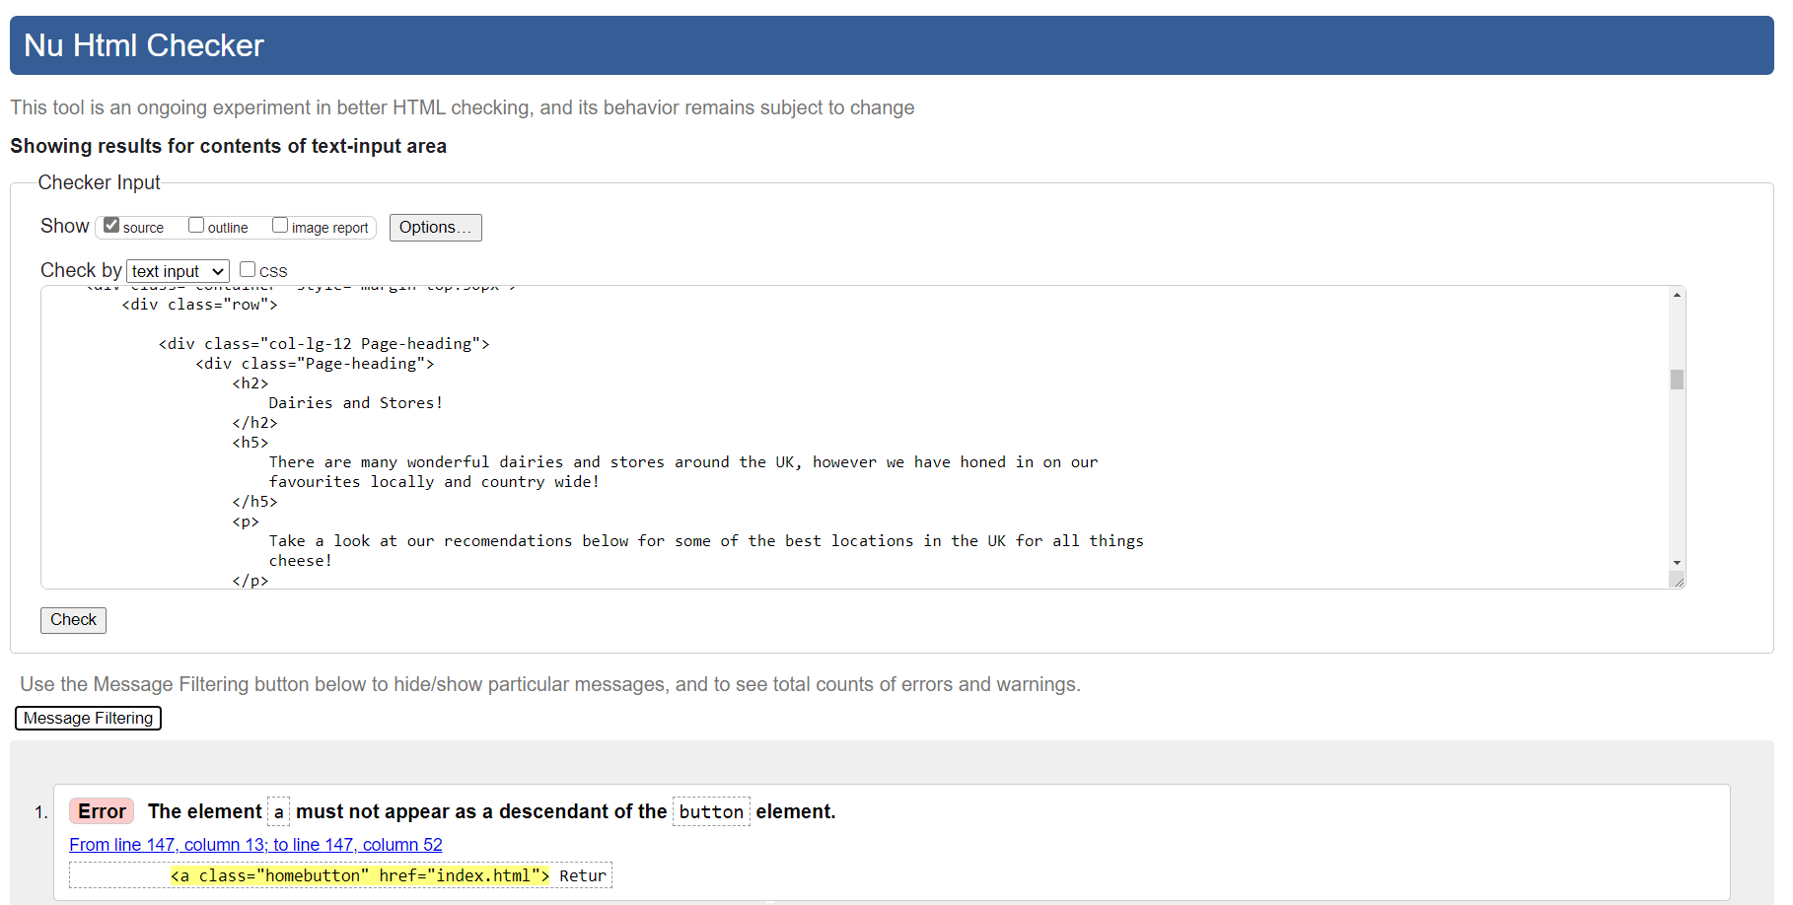

  - Select Speciality Cheeses

Only the above home button error is found on this page.

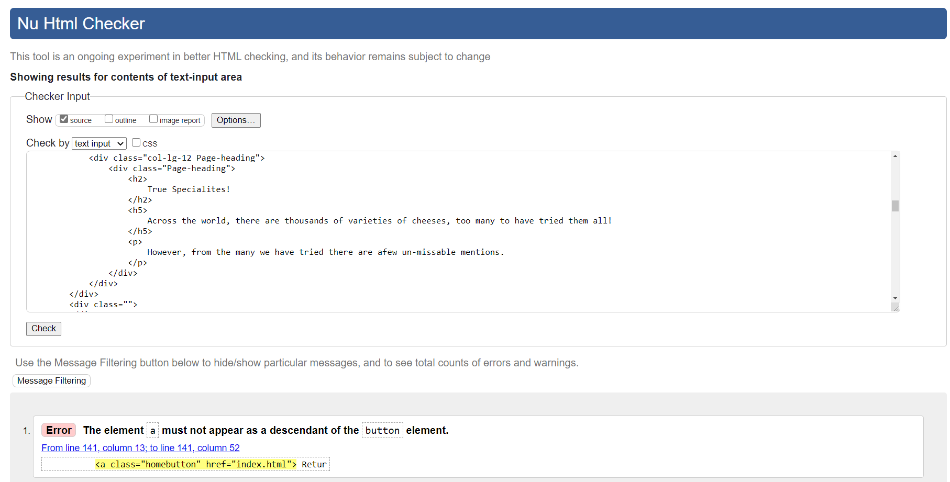

  - Main CSS

The CSS has been evaluated using The W3C CSS Validation Service

No CSS errors were found via this validation tool.

- Evaluation
  - Usefulness
    - Functionality (Utility)

A websites functionality is defined as to how well a user can achieve their expected goal. Part of this is site effectiveness [A]. In the case of the provided site, both of the listed goals shall be evaluated as to their functionality:

- Cheese education

In the case of the user wishing to learn about the basics of cheese and its making, the site is extremely functional. There are multiple different avenues for education in these fields via a number of methods.
The site contains many text based education fields via a dictionary table, external hyperlinks to credible sources and also allows the user to query directly to the group for questions and further info.
Beginner level video guides have been used in the case of a more visual aid for users which act as a gateway into further content and learning.

- Purchasing consideration

The site has been completely designed with the undertone of users questioning their current cheese purchasing options. The site contains many descriptions of how more adventurous purchasing options can not only benefit them, but also support smaller businesses outside of mainstream supply. No links to large chain stores have been added or encouraged.

This kind of information is extremely easy to access in all cases, either directly presented to the user or implied in the cases where it is appropriate.

    - Usability

The usability [B] and ease of use of this website have been prioritised in its design. Principles of user centred design [1]. [2] poses that usability of sites has a large positive impact on user satisfaction.

The site has been thoroughly tested to ensure that each contained element acts as is expected. No dead links or failing button functionality is present.

All images and elements have been properly formatted to be responsive and to minimise load times by cropping and fixed relative sizing styling.

The site has been designed using the bootstrap 5 CSS framework [3] which allows for many scalable and responsive elements throughout the website. All sections of the site have been tested with both large scale (4k resolution), medium scale (1080p resolution) and mobile screen sizes to allow for various device types. All 3 of these sizes were found to be working as expected and the full functionality of the site was experienced by all 3.

The overall UI design of the site has been minimalistic with the vast majority of information both easy to access and even more easy to read. The fonts and colours used are not harsh on the eyes and allow for very casual browsing. There are little distractions or useless elements on each page to distract the user from their current interests.
Sidebars are only present where necessary, and the excess space is used as both eye relief, and potential advertisement space for later.

The pages are all linked by a uniform header and navbar at the top of the page, allowing consistency across the entire site no matter where the user may be viewing from. This simple element grounds the users in their current page and allows for easy browsing across all of the sites features, with minimal clutter.

The longer pages contain both ‘Return Home’ and ‘Return to Top’ buttons to allow for easy access around the site if the user has reached the end of their current page. The ‘Return to Top’ function has been made using the provided code from W3 Schools [4].

There are a number of helpful pointers around the site to direct the user to where they may want to visit. All of the headers and page names have been deliberately named to give a good indication of what each page is about, without forcing the user to explore them. This minimises user frustration with misleading headers.

    - Content

All of the content supplied by the website has been done so either with the permission of the providers or under correct copyright law.

All images used are provided free of charge with no royalty or expectation of acknowledgement.

Hyperlinks and embeds are used freely as they are not claimed under their terms of service [4], [5] and cannot be subject to lawsuit for infringement of copyright as all used are free from such regulations.

The content of the site has been presented in the most short-form manner it could be but allows for external research and investigation through suggested links and encouragement to learn.

All links and external content have been vetted to match the friendly and fun manner of which the site is presented, also to follow the theme and match the learnability of the site.

    - Improvements

To improve the site going forward, a number of additions should be added:

- A forum style page for the user base / community to interact and evolve the site from the voice of the Cardiff Cheese Co to the whole group.
- A company blog which the group could post and update to with new and additional information, not worthy of addition to the larger pages. This would improve on the human element of the site and broaden the sense of real human interaction.
- An order page, in which a user could be redirected to the various sites physically selling goods. The page would the collate that information into one page allowing users to keep track of their purchases.
- Further addition to each page should be incorporated, more information and recommendations.
- Additional embedded pages should be created for each. This would leave the original pages as more headers. In the case of users wanting further information, they could delve deeper into more fleshed-out pages with additional detail. This would keep the simplistic feel of the initial site, without compromise of the complete information set.
- Adding additional web crawler functionality such as a Robots.txt instructional file.
- Improve HTML tagging to improve SEO.
- Add additional social media pages.

  - Search Engine Optimization (SEO)

Search engine optimization is the process in which a website is designed with search engines in mind. Certain elements of the website should be written to increase uptake within the crawling algorithms run by search engines to index all of the internet. [7] poses that using SEO as a valuable marketing tool in modern business is essential and can have many lasting benefits across multiple marketing variables. The study encompassed KPIs [C] such as brand loyalty, brand recognition, user reviews, with the most beneficially effected being market share, arguably the most important.

Different search engines have different priorities when indexing and analysing websites. In general, a website is scanned, and each element of the site is ranked against various factors. The crawlers scanning the site will look for keywords, tags, colours, JavaScript and many other pieces which make up the website and check their relevance and compliance. Keywords and enticing sentences are ranked highly, alongside a positive voice for the specific words (no harsh or abusive content) and a positive user experience all increase the ranking of the website. Different search engines use different algorithms to determine these rankings, with their requirements listed below.

The site has been designed with many features to increase SEO.
Principles outlined by two major search engines have been followed:

    - Google Webmaster

Googles webmaster principles [6] have been followed closely to improve SEO. The site has been created entirely for a user experience. There is little to no available input via automated functionality such as an API or interactive forms.

There is no deception in any of the content produced, no external influence from any competitor or provider. The function and mission statement of the site is followed to the letter, as there is really no need for anything else.

The design of the website is purely UI based with minor JavaScript. No circumventing or manipulation has been done to the page to cheat the search engine into prioritising it higher. The quality of the content is the only benefit to this.

All of the content has been created manually, no automatic generation of pages has been undertaken.

Any linked or affiliated content directed at this site would be attributed to other users word of mouth.

No spamming of tags or keywords has been done in the html as hidden to increase search engine uptake, and certainly no malicious or plagiarised content has been included for this purpose.

No automated or API driven calls have been created via the website, as above it is purely a UI with a small amount of additional JavaScript.

    - Bing Webmaster

Recommendations made by Bing are far more technical in the underlying website markup code. Their webmaster guidelines [8] have been considered where appropriate. HTML tagging and semantic element usage have been implemented site wide, most notably in the navbar. Allowing the CSS to be directly accessed via crawlers with the appropriate tags allows for better indexing across elements. Tagging paragraphs, tittles and tables as such as is required for correct identification. Titles and headers on the index page gave been named appropriately for the gateway page of the website, allowing for a higher Relevance ranking within Bing’s indexing algorithm.

Embeds have been used correctly and adequately marked, with none hidden inside JavaScript or requiring a flash element.

The friendly voice of the website encourages a positive experience from the user, which promotes uptake via the indexing process.

A low number of clicks is required in order to navigate and operate the website and all of its features. This increases user engagement as it is indicative of good functionality when the site is passed to the Bing web crawlers.

The load time for the page is extremely fast as stated above. This can be a large gain in optimisation as the system determines how functional the site is. The fast page loading is not a negative experience in this case, as all elements are loaded quickly enough, with text always taking precedence and in most cases is not noticeable.

  - Accessibility – Web Content Accessibility Guidelines WCAG 2.1

The four pillars outlined in WCAG 2.1 [9] are as follows:
- Perceivability
- Operability
- Understandableness
- Robustness
These will be evaluated below.

    - Perceivability

Content and information have been presented in multiple forms to allow for various learning types. Usage of both text, video and hyperlinking to other avenues allows for this. All multimedia embeds are tagged acceptably at their source for screen reading and additional identification and description. Some video content is provided externally to allow for audio as well as sight-based content.

Colour has been used sparingly and has been checked against [10] to ensure compliance. For the majority of the site, black / darker grey text is used an extremely light background made for easy reading.

    - Operability

The website can be operated using a keyboard. The navbar and page can be accessed solely via this medium. Users are not pressed to click content within a certain time frame, as no elements have this kind of functionality. The design is such that easy browsing and reading is encouraged, and it should be a relaxed and simple page.

There are no flashing are harsh contrast images which could trigger any light sensitive conditions from a user.

All headings and hyperlinks are descriptive in their naming and detailing to allow users to easily find the appropriate content on the site. In depth content has not been added specifically to keep the simple flow and idea behind the site.

    - Understandableness

All text has been written in easy, colloquial English and should not be difficult to understand. External sites have been chosen deliberately with this in mind to mimic the same user experience.

There are no complex animations or confusing functionality within the sites design which could potentially lead to a negative browsing experience and would certainly introduce further bugs when developing the site further.

    - Robustness

To comply with future developments and tools, the source code for the site has been made deliberately robust and is in accordance directly with WCAG 2.1 [11]. All HTML has been validated and is ordered correctly. All elements of the site are available programmatically for both developers and assistive technologies for both testing and reality.

Status messages have not been included in this build as there is little to no background JavaScript bringing web functionality.

Appendix
- Effectiveness
The accuracy and completeness with which specified users can achieve specified goals in particular environments. [3]

- Usability
The design and usage of an item with respect to its location.

References

[1] | Interaction Design, "User Centered Design," Interaction Design, Ongoing. [Online]. Available: https://www.interaction-design.org/literature/topics/user-centered-design. [Accessed 18 04 2021].
[2] | R. K. A. N. S. Urvashi Tandon, "Customer satisfaction using website functionality, perceived usability and perceived usefulness towards online shopping in India," Information Development, vol. 32, no. 5, 2016.
[3] | Bootstrap, "Build fast, responsive sites with Bootstrap," MIT, 2020 June 2020. [Online]. Available: https://getbootstrap.com/. [Accessed 19 04 2021].
[4] | W3 schools, "How TO - Scroll Back To Top Button," [Online]. Available: https://www.w3schools.com/howto/howto_js_scroll_to_top.asp. [Accessed 20 04 2021].
[5] | Youtube Inc, "Terms of Service," 17 March 2021. [Online]. Available: https://www.youtube.com/static?gl=CA&template=terms. [Accessed 19 04 2021].
[6] | Google, "Google Maps Terms of Service," 06 May 2020. [Online]. Available: https://cloud.google.com/maps-platform/terms. [Accessed 19 04 2021].
[7] | Google, "Webmaster Guidelines," 05 03 2021. [Online]. Available: https://developers.google.com/search/docs/advanced/guidelines/webmaster-guidelines. [Accessed 19 04 2021].
[8] | Bing, "Bing Webmaster Guidelines," [Online]. Available: https://www.bing.com/webmasters/help/webmasters-guidelines-30fba23a. [Accessed 21 04 2021].
[9] | W3C, "Web Content Accessibility Guidelines (WCAG) 2.1," 05 June 2018. [Online]. Available: https://www.w3.org/TR/WCAG21/.
[10] | Courtesy of Acart Commications, "Contrast Checker," 2017. [Online]. Available: https://contrastchecker.com/. [Accessed 19 04 2021].
[11] | w3, "Guideline 4.1 - Compatible," 04 Oct 2019. [Online]. Available: https://www.w3.org/WAI/WCAG21/quickref/#compatible. [Accessed 20 04 2021].
[12] | N. Bevan, "International standards for HCI and usability," International Journal of Human-Computer Studies, vol. 55, no. 4, pp. 533-552, Oct 2001.

Appendix:

    - The accuracy and completeness with which specified users can achieve specified goals in particular environments. [3]
    - The design and usage of an item with respect to its location
    - Index.html source code

<!DOCTYPE html>
<html lang="en">

<head>
<meta charset="UTF-8">
<meta name="viewport" content="width=device-width, initial-scale=1.0">
<title>
Cardiff Cheese Co!
</title>
<link href="https://cdn.jsdelivr.net/npm/bootstrap@5.0.0-beta3/dist/css/bootstrap.min.css" rel="stylesheet"
integrity="sha384-eOJMYsd53ii+scO/bJGFsiCZc+5NDVN2yr8+0RDqr0Ql0h+rP48ckxlpbzKgwra6" crossorigin="anonymous">
<link rel="stylesheet" href="style.css">
</head>

<body>
<div class="jumbotron jtop">
<div class=title>
Welcome To The Cardiff Cheese Co!
</div>
</div>
<nav class="navbar navbar-expand-lg navbar-light bg-light">
<a class="navbar-brand" href="#">
<img src="cheese-1325773-639x428.jpg" height="80" width="80" alt="A picture of blue cheese">
</a>
<button class="navbar-toggler" type="button" data-toggle="collapse" data-target="#navbarSupportedContent"
aria-controls="navbarSupportedContent" aria-expanded="false" aria-label="Toggle navigation">
<span class="navbar-toggler-icon"></span>
</button>

<div class="collapse navbar-collapse" id="navbarSupportedContent">
<ul class="navbar-nav mr-auto">
<li class="nav-item">
<a class="nav-link" href="index.html">Home</a>
</li>
<li class="nav-item">
<a class="nav-link" href="our-cheeses.html">Everything Cheese!</a>
</li>
<li class="nav-item">
<a class="nav-link" href="recommended.html">Recomended Dairies</a>
</li>
<li class="nav-item">
<a class="nav-link" href="specialities.html">Select Speciality Cheeses</a>
</li>
<li class="nav-item">
<a class="nav-link" href="cheese-production.html">How its made!</a>
</li>
<li class="nav-item">
<a class="nav-link" href="about-us.html">About us</a>
</li>
</ul>
</div>
</nav>

<div class="box-title">
<h2> Check out our amazing cheese related features! </h2>
</div>

<div class="container" style="margin-top:50px">
<div class="row text-left">
<div class="col-sm-3 good-links">
<h3>
Get Started Today!
</h3>
<p>
Whether you are a beginner or a artisean, here are some useful products we personally endorse for
cheese making.
</p>
<h4> Useful links:</h4>
<ul class="nav nav-pills flex-column">
<li class="nav-item">
<a class="nav-link-sidebar"
href="https://www.amazon.co.uk/Drainer-Removing-Machine-Presser-Dehydrator/dp/B07YVB8YNL/ref=sr_1_5?dchild=1"
target="_blank">
A Fantasic Cheese Press! </a>
</li>
<li class="nav-item">
<a class="nav-link-sidebar"
href="https://www.amazon.co.uk/Cheesecloth-Reusable-Straining-Unbleached-Strainer/dp/B088F3VVSD/ref=sr_1_5?dchild=1"
target="_blank">
Re-usable cheesecloth</a>
</li>
<li class="nav-item">
<a class="nav-link-sidebar"
href="https://www.amazon.co.uk/Animal-Liquid-Rennet-100ml-Cheesemaking/dp/B0747P329Q/ref=sr_1_6"
target="_blank">
A great animal rennet</a>
</li>
<li class="nav-item">
<a class="nav-link-sidebar"
href="https://www.amazon.co.uk/MasterClass-Induction-Safe-Stainless-Steel-Stock/dp/B000YJF03Y/ref=sr_1_3"
target="_blank">
A perfect beginner pot!</a>
</li>
</ul>
<div class="about-us-link">
<h3>
<a class="about-us-link " href="about-us.html"> Learn more about us here!</a>
</h3>
</div>

<div class="contact-us-link">
<h4>
<a class="contact-us-link " href="about-us.html"> Got Questions?</a>
</h4>
</div>
<div class="contact-us-statement" style="padding-top: 0.05rem; font-size: medium; text-align: center;">
<h6> Feel free to contact us!</h6>
</div>

</div>
<div class="col-sm-8 page-panels text-center">
<h2>
Learn about cheese!
</h2>

<div class="row panels">
<div class="col-lg-6 column-1">
<div class="card shadow-lg">
<div class="card-body">
<h5 class="card-title">A Beginners Guide</h5>
<h6 class="card-subtitle mb-2 text-muted">Cheese breeds</h6>
<p class="card-text">Check out our personal recommendations of some truly delectible
cheese types and styles</p>
</div>
<div class="card-footer text-muted footerCard">
<a href="our-cheeses.html" class="card-link"
style="text-decoration: none; color: rgb(54, 54, 54);">Everything Cheese!</a>
</div>
</div>
</div>
<div class="col-lg-6 column-2">
<div class="card shadow-lg">
<div class="card-body">
<h5 class="card-title">Local Dairies</h5>
<h6 class="card-subtitle mb-2 text-muted">Wales and the South West</h6>
<p class="card-text">Looking for a great day out or some hidden gems? </p>
<p class="card-text">Look no further!</p>
</div>
<div class="card-footer footerCard text-muted">
<a href="recommended.html" class="card-link"
style="text-decoration: none; color: rgb(54, 54, 54);">Recommended Dairies</a>
</div>
</div>
</div>
</div>
<div class="row panels">
<div class="col-lg-6 column-1">
<div class="card shadow-lg">
<div class="card-body">
<h5 class="card-title">Speciality Cheeses</h5>
<h6 class="card-subtitle mb-2 text-muted">5 Star Rated</h6>
<p class="card-text">For some truly fantastic reserves, look no further</p>
</div>
<div class="card-footer footerCard text-muted">
<a href="specialities.html" class="card-link"
style="text-decoration: none; color: rgb(54, 54, 54);">Speciality Cheeses</a>
</div>
</div>
</div>
<div class="col-lg-6 column-2">
<div class="card shadow-lg">
<div class="card-body">
<h5 class="card-title">How its made!</h5>
<h6 class="card-subtitle mb-2 text-muted">A complete guide to the basics of cheese
making</h6>
<p class="card-text">For those wishing to get involved, heres a simple guide!</p>
</div>
<div class="card-footer footerCard text-muted">
<a href="cheese-production.html" class="card-link"
style="text-decoration: none; color: rgb(54, 54, 54);">Hows its made!</a>
</div>
</div>
</div>
</div>
</div>
</div>
</div>

<br><br>
<div class="jumbotron jbottom" style="margin-bottom:0; ">
<div class="footer">
<p> Copyright &copy; Oliver Bird, The Cardiff Cheese Co</p>
<p>Please note, opinions expressed on this page are of a single author, and may not be shared by the
rest of
the cheese loving community</p>
</div>
</div>
<script src="https://cdn.jsdelivr.net/npm/@popperjs/core@2.9.1/dist/umd/popper.min.js"
integrity="sha384-SR1sx49pcuLnqZUnnPwx6FCym0wLsk5JZuNx2bPPENzswTNFaQU1RDvt3wT4gWFG"
crossorigin="anonymous"></script>
<script src="https://cdn.jsdelivr.net/npm/bootstrap@5.0.0-beta3/dist/js/bootstrap.min.js"
integrity="sha384-j0CNLUeiqtyaRmlzUHCPZ+Gy5fQu0dQ6eZ/xAww941Ai1SxSY+0EQqNXNE6DZiVc"
crossorigin="anonymous"></script>
</body>

</html>

D. About Us source code
<!DOCTYPE html>
<html lang="en">

<head>
<meta charset="UTF-8">
<meta name="viewport" content="width=device-width, initial-scale=1.0">
<title>
Cardiff Cheese Co!
</title>
<link href="https://cdn.jsdelivr.net/npm/bootstrap@5.0.0-beta3/dist/css/bootstrap.min.css" rel="stylesheet"
integrity="sha384-eOJMYsd53ii+scO/bJGFsiCZc+5NDVN2yr8+0RDqr0Ql0h+rP48ckxlpbzKgwra6" crossorigin="anonymous">
<link rel="stylesheet" href="style.css">
</head>

<body>
<div class="jumbotron jtop">
<div class=title>
Welcome To The Cardiff Cheese Co!
</div>
</div>
<nav class="navbar navbar-expand-lg navbar-light bg-light">
<a class="navbar-brand" href="#">
<img src="cheese-1325773-639x428.jpg" height="80" width="80" alt="A picture of blue cheese">
</a>
<button class="navbar-toggler" type="button" data-toggle="collapse" data-target="#navbarSupportedContent"
aria-controls="navbarSupportedContent" aria-expanded="false" aria-label="Toggle navigation">
<span class="navbar-toggler-icon"></span>
</button>

<div class="collapse navbar-collapse" id="navbarSupportedContent">
<ul class="navbar-nav mr-auto">
<li class="nav-item">
<a class="nav-link" href="index.html">Home</a>
</li>
<li class="nav-item">
<a class="nav-link" href="our-cheeses.html">Everything Cheese!</a>
</li>
<li class="nav-item">
<a class="nav-link" href="recommended.html">Recomended Dairies</a>
</li>
<li class="nav-item">
<a class="nav-link" href="specialities.html">Select Speciality Cheeses</a>
</li>
<li class="nav-item">
<a class="nav-link" href="cheese-production.html">How its made!</a>
</li>
<li class="nav-item">
<a class="nav-link" href="about-us.html">About us</a>
</li>
</ul>
</div>
</nav>
<div class="container">
<h1 style="text-align: center; padding-top: 3rem;">
About Us
</h1>
<div class="row"></div>
<div class="col-lg-12 Page-heading " style="padding-top: 3rem;text-align: left;">
<div class="content shadow-lg " style="height: 400px;">
<div class="text-readible-large">
<p>
We are a small institute of cheese makers and enthusiasts wanting to spread information about
this great hobby, and even more so great food.
</p>
<p>
Dairy is often under scrutiny these days, and it is important to recognise the use of good and
local creameries, vs mass produced cheap equivalents.
</p>
<p>
The consumption of more local and handmade products will help people connect more with their
food, and appreciate that it really is worth the extra money.
</p>
</div>
</div>
</div>
</div>
<div class="Page-heading" style="padding-top: 3rem;">
<h3>
If you would like to contact us for questions or collaboration, please use the below
</h3>
</div>

<div class="container">
<div class="row">
<div class="col-sm-6 mt-4">
<div class="content shadow-lg" style="font-size: large; height: 400px;">
<h3 class="title-box">Via Post</h3>
<h5 class="text-box"> Do expect a delay! </h5>
<p class="text-box" style="color: black;">
You may post questions directly to us with suggestions or questions! Please do include return
and contact information so we can reply!
</p>
<ul style="list-style-type: none;">
<li>
47 Castle Street
</li>
<li>
Doyle Arcade
</li>
<li>
Cardiff
</li>
<li>
South Glamorgan
</li>
<li>
CF21 0SN
</li>
</ul>

</div>
</div>
<div class="col-sm-6 mt-4">
<div class="content shadow-lg" style=" height: 400px; font-size: x-large;">
<h3 class="title-box">Phone & Email</h3>
<h5 class="text-box"> Please note our phoneline is only open during weekdays </h5>
<p class="text-box" style="color: black;"> </p>
<ul>
<li>
Tel: + 02921 910437
</li>
<li>
Email:
<a href="thecardiffcheeseco@gmail.com" style="color: black;">thecardiffcheesco@gmail.com</a>
</li>
</ul>

</div>
</div>

</div>

</div>

<div class="bottom-buttons">
<button type="button" onclick="topFunction()" class="btn btn-outline-primary btn-md"
style="align-items: center;">Return to Top</button>
<button type="button" class="btn btn-outline-success btn-md homebutton" style="align-items: center;">
<a class="homebutton" href="index.html"> Return to Homepage</a>
</button>
<br><br>
<div class="jumbotron jbottom" style="margin-bottom:0; ">
<div class="footer">
<p> Copyright &copy; Oliver Bird, The Cardiff Cheese Co</p>
<p>Please note, opinions expressed on this page are of a single author, and may not be shared by the
rest of
the cheese loving community</p>
</div>
</div>
<script src="https://cdn.jsdelivr.net/npm/@popperjs/core@2.9.1/dist/umd/popper.min.js"
integrity="sha384-SR1sx49pcuLnqZUnnPwx6FCym0wLsk5JZuNx2bPPENzswTNFaQU1RDvt3wT4gWFG"
crossorigin="anonymous"></script>
<script src="https://cdn.jsdelivr.net/npm/bootstrap@5.0.0-beta3/dist/js/bootstrap.min.js"
integrity="sha384-j0CNLUeiqtyaRmlzUHCPZ+Gy5fQu0dQ6eZ/xAww941Ai1SxSY+0EQqNXNE6DZiVc"
crossorigin="anonymous"></script>
</div>
<script>
//Get the button:
mybutton = document.getElementById("scrollTop");

// modifies function to activate once doc has passed 300 px moved
window.onscroll = function () { scrollFunction() };

function scrollFunction() {
if (document.body.scrollTop > 300 || document.documentElement.scrollTop > 300) {
mybutton.style.display = "block";
} else {
mybutton.style.display = "none";
}
}

// When the user clicks on the button, scroll to the top of the document
function topFunction() {
document.body.scrollTop = 0; // For Safari
document.documentElement.scrollTop = 0; // For Chrome, Firefox, IE and Opera
}
</script>

</body>

</html>

E. Cheese-production.html
<!DOCTYPE html>
<html lang="en">

<head>
<meta charset="UTF-8">
<meta name="viewport" content="width=device-width, initial-scale=1.0">
<title>
Cardiff Cheese Co!
</title>
<link href="https://cdn.jsdelivr.net/npm/bootstrap@5.0.0-beta3/dist/css/bootstrap.min.css" rel="stylesheet"
integrity="sha384-eOJMYsd53ii+scO/bJGFsiCZc+5NDVN2yr8+0RDqr0Ql0h+rP48ckxlpbzKgwra6" crossorigin="anonymous">
<link rel="stylesheet" href="style.css">
</head>

<body>
<div class="jumbotron jtop">
<div class=title>
Welcome To The Cardiff Cheese Co!
</div>
</div>
<nav class="navbar navbar-expand-lg navbar-light bg-light">
<a class="navbar-brand" href="#">
<img src="cheese-1325773-639x428.jpg" height="80" width="80" alt="A picture of blue cheese">
</a>
<button class="navbar-toggler" type="button" data-toggle="collapse" data-target="#navbarSupportedContent"
aria-controls="navbarSupportedContent" aria-expanded="false" aria-label="Toggle navigation">
<span class="navbar-toggler-icon"></span>
</button>

<div class="collapse navbar-collapse" id="navbarSupportedContent">
<ul class="navbar-nav mr-auto">
<li class="nav-item">
<a class="nav-link" href="index.html">Home</a>
</li>
<li class="nav-item">
<a class="nav-link" href="our-cheeses.html">Everything Cheese!</a>
</li>
<li class="nav-item">
<a class="nav-link" href="recommended.html">Recomended Dairies</a>
</li>
<li class="nav-item">
<a class="nav-link" href="specialities.html">Select Speciality Cheeses</a>
</li>
<li class="nav-item">
<a class="nav-link" href="cheese-production.html">How its made!</a>
</li>
<li class="nav-item">
<a class="nav-link" href="about-us.html">About us</a>
</li>
</ul>
</div>
</nav>
<div class="container">
<h1 style="text-align: center; padding-top: 3rem;">
How its made!
</h1>
<div class="row"></div>
<div class="col-lg-12 Page-heading " style="padding-top: 3rem;text-align: left;">
<div class="content shadow-lg " style="height: 400px;">
<h2>
The basics of cheese!
</h2>
<h3>
Fundamentals
</h3>
<div class="text-readible">
<p>
On a basic level, cheese is simply the fat solids present in animal milk, compressed into a
block. The process is essentailly:
</p>
<ul>
<li>
Take a large quantity of milk.
</li>
<li>
Add an acid to cause the milk to split into curds (the fat solids) and whey(the residual
liquid).
</li>
<li>
Take the curds, compress, cool and age them.
</li>
</ul>
<p>
For a wonderfully simnple recipie for homemade ricotta, take a look at this
<a href="https://www.thekitchn.com/how-to-make-homemade-ricotta-cheese-cooking-lessons-from-the-kitchn-23326"
style="text-decoration: none; color: blueviolet;">link</a>
. It really is fantastic!
</p>
</div>
</div>

<h4 style="padding-top: 3rem;text-align: center;">
For some more in-depth cheese recipies, we note one of our favourite creators:
<a href="https://www.youtube.com/channel/UCE31MqUy6nIMJ_f8y4R3_AA"
style="text-decoration: none; color: blueviolet;">Gavin Webber</a>
</h4>
<div class="text-readible" style="padding-top: 3rem;text-align: center;">
<p>
Gavin is a fantastic content creator dedicated to all things cheese!
</p>
<p>
Here are a couple of his best:
</p>
<iframe style="padding: 0.5rem;" width="560" height="315"
src="https://www.youtube.com/embed/4VbuBcNCgAc" title="YouTube video player"
allow="accelerometer; autoplay; clipboard-write; encrypted-media; gyroscope; picture-in-picture"
allowfullscreen></iframe>
<iframe style="padding: 0.5rem;" width="560" height="315"
src="https://www.youtube.com/embed/Qk03ja6vS58?start=1" title="YouTube video player"
allow="accelerometer; autoplay; clipboard-write; encrypted-media; gyroscope; picture-in-picture"
allowfullscreen></iframe>
</div>
</div>
</div>
<div class="bottom-buttons">
<button type="button" onclick="topFunction()" class="btn btn-outline-primary btn-md"
style="align-items: center;">Return to Top</button>
<button type="button" class="btn btn-outline-success btn-md" style="align-items: center;">
<a class="homebutton" href="index.html"> Return to Homepage</a>
</button>
<br><br>
<div class="jumbotron jbottom" style="margin-bottom:0; ">
<div class="footer">
<p> Copyright &copy; Oliver Bird, The Cardiff Cheese Co</p>
<p>Please note, opinions expressed on this page are of a single author, and may not be shared by the
rest of
the cheese loving community</p>
</div>
</div>
</div>
<script src="https://cdn.jsdelivr.net/npm/@popperjs/core@2.9.1/dist/umd/popper.min.js"
integrity="sha384-SR1sx49pcuLnqZUnnPwx6FCym0wLsk5JZuNx2bPPENzswTNFaQU1RDvt3wT4gWFG"
crossorigin="anonymous"></script>
<script src="https://cdn.jsdelivr.net/npm/bootstrap@5.0.0-beta3/dist/js/bootstrap.min.js"
integrity="sha384-j0CNLUeiqtyaRmlzUHCPZ+Gy5fQu0dQ6eZ/xAww941Ai1SxSY+0EQqNXNE6DZiVc"
crossorigin="anonymous"></script>
<script>
//Get the button:
mybutton = document.getElementById("scrollTop");

// modifies function to activate once doc has passed 300 px moved
window.onscroll = function () { scrollFunction() };

function scrollFunction() {
if (document.body.scrollTop > 300 || document.documentElement.scrollTop > 300) {
mybutton.style.display = "block";
} else {
mybutton.style.display = "none";
}
}

// When the user clicks on the button, scroll to the top of the document
function topFunction() {
document.body.scrollTop = 0; // For Safari
document.documentElement.scrollTop = 0; // For Chrome, Firefox, IE and Opera
}
</script>
</body>

</html>

F. Our-cheeses.html
<!DOCTYPE html>
<html lang="en">

<head>
<meta charset="UTF-8">
<meta name="viewport" content="width=device-width, initial-scale=1.0">
<title>
Cardiff Cheese Co!
</title>
<link href="https://cdn.jsdelivr.net/npm/bootstrap@5.0.0-beta3/dist/css/bootstrap.min.css" rel="stylesheet"
integrity="sha384-eOJMYsd53ii+scO/bJGFsiCZc+5NDVN2yr8+0RDqr0Ql0h+rP48ckxlpbzKgwra6" crossorigin="anonymous">
<link rel="stylesheet" href="style.css">
</head>

<body>
<div class="jumbotron jtop">
<div class=title>
Welcome To The Cardiff Cheese Co!
</div>
</div>
<nav class="navbar navbar-expand-lg navbar-light bg-light">
<a class="navbar-brand" href="#">
<img src="cheese-1325773-639x428.jpg" height="80" width="80" alt="A picture of blue cheese">
</a>
<button class="navbar-toggler" type="button" data-toggle="collapse" data-target="#navbarSupportedContent"
aria-controls="navbarSupportedContent" aria-expanded="false" aria-label="Toggle navigation">
<span class="navbar-toggler-icon"></span>
</button>

<div class="collapse navbar-collapse" id="navbarSupportedContent">
<ul class="navbar-nav mr-auto">
<li class="nav-item">
<a class="nav-link" href="index.html">Home</a>
</li>
<li class="nav-item">
<a class="nav-link" href="our-cheeses.html">Everything Cheese!</a>
</li>
<li class="nav-item">
<a class="nav-link" href="recommended.html">Recomended Dairies</a>
</li>
<li class="nav-item">
<a class="nav-link" href="specialities.html">Select Speciality Cheeses</a>
</li>
<li class="nav-item">
<a class="nav-link" href="cheese-production.html">How its made!</a>
</li>
<li class="nav-item">
<a class="nav-link" href="about-us.html">About us</a>
</li>
</ul>
</div>
</nav>
<div class="container">
<div class="row">
<div class="col">
</div>
<div class="col-10">
<div>
<h2 class="page-title">
Our Recommendations
</h2>
</div>
<div>
<p>
Please find below our personal recommendations and advice about various types of cheese.
</p>
<p>
No matter the ocassion, we are confident there will be something for you!
</p>
</div>
<h3>
Cheddars
</h3>
<table class="table cheese-table-cheddar">
<thead>
<tr>
<th scope="col">Name</th>
<th scope="col">Appearance</th>
<th scope="col">Description</th>

</tr>
</thead>
<tbody>
<tr>
<th scope="row">Cathedral City</th>
<td>A solid light yellow block with a mild oil sheen.</td>
<td>A mild low aged cheddar with little to no crystal development. Lightly salted with a
creamy finish.</td>

</tr>
<tr>
<th scope="row">Generic</th>
<td>A uniform generic square, typically branded as 'cheddar'. Extremely oily to the touch.
</td>
<td>A standard supermarket feature for those moments where you just need cheese. Sometimes
underseasoned, great in a picnic sandwich!</td>

</tr>
<tr>
<th scope="row">Aged</th>
<td>Various shades of yellow, sometimes darker depending on the age. Dry to the touch with a
crumbly / dusty texture.</td>
<td>Aged cheddar has been left in a dry environment in order for excess whey to leave the
cheese. Large salted crystals form within the cheese causing the more crumbly texture,
along with a strong salted flavour. Tread carefully!</td>

</tr>
</tbody>
</table>
<br><br>
<h3>
Blue / Innoculated
</h3>
<p>
These cheeses have been deliberately allowed to mould, either natually or had a mould inserted /
coated onto them.
</p>
<table class="table cheese-table-Blue">
<thead>
<tr>
<th scope="col">Name</th>
<th scope="col">Appearance</th>
<th scope="col">Description</th>

</tr>
</thead>
<tbody>
<tr>
<th scope="row">Stilton</th>
<td>Pale to dark beige with a large percentage of blue / brown mould streaks.</td>
<td>A strong and salty cheese with a croumbly texture due to the heavy moulding within the
crystal structure. Can be overpowering to some.</td>
</tr>
<tr>
<th scope="row">Roquefort</th>
<td>White curd structure with heavier blue mould streaks towards the centre.</td>
<td>A less intense brother to stilton with a milder creamier curd flavour. The mould streaks
however can be extremnely intense with a sharp tang.</td>

</tr>
<tr>
<th scope="row">Gorgonzola</th>
<td>A dark off white colour with blue moulding. A creamy and soft surface texture with a
slight dampness.</td>
<td>A personal favourite for us, this fantastic blue cheese is a touch milder than both
stilton and roquefort, with excellent melting properties and an extremely creamy
texture!</td>

</tr>
<tr>
<th scope="row">Brie</th>
<td>A white disc with a beige centre. The surface can be unifrom or bumpy.</td>
<td>This cheese can be found either coated in bacteria from a spray system, or naturally in
the air. It creates a thin 'skin' to protect the inner cheese leaving a firmer outside
with a gooey middle.
A wonderfully creamy cheese paired great with anything sweet.</td>

</tr>
<tr>
<th scope="row">Camembert</th>
<td>A white disc with a beige centre. The surface can be unifrom or bumpy.</td>
<td>This cheese is extremely similar to brie, however the gooey centre has a stronger, more
earthy flavour due to the milk used to produce it. Wonderful melted in the oven in a
dish to dip items item it.</td>
</tr>
</tbody>
</table>
<br><br>
<h3>
Goudas
</h3>
<p>
These are mild milky cheeses with nutty undertones. Fantastic for melting, cheeseboards or an
accompanyment when mixed with other cheeses. You will find them normally as whole wheels (big cheese tyres) or slices of them!
</p>
<table class="table cheese-table-Gouda">
<thead>
<tr>
<th scope="col">Name</th>
<th scope="col">Appearance</th>
<th scope="col">Description</th>
</tr>
</thead>
<tbody>
<tr>
<th scope="row">Generic</th>
<td>A uniform light yellow with a smooth curd. Can come with holes!</td>
<td>There are far too many types of gouda to mention, however most are slightly sweet with
heavy nutty flavours</td>
</tr>
<tr>
<th scope="row">Swiss/ Edam</th>
<td>A uniform light yellow full of air pockets!</td>
<td>A very mild gouda. Wonderful grilled or in a sandwich!</td>
</tr>
<tr>
<th scope="row">Old Amsterdam</th>
<td>A pale orange sheen with a very slight oily texture.</td>
<td>A strong gouda with a unique earthy flavour. Be warned, in some cases whey is trapped
within hidden air pockets in the cheese, which can be unpleasent if unexpected!</td>
</tr>
</tbody>
</table>
<br><br>
<h3>
Non Aged white curd
</h3>
<p>
These are extremely milky cheeses formed purely from compressed curds. They are not usually aged and should be treated such as cream or milk. I.e once open, use them within a reasonable timeframe!
</p>
<table class="table cheese-table-Curd">
<thead>
<tr>
<th scope="col">Name</th>
<th scope="col">Appearance</th>
<th scope="col">Description</th>
</tr>
</thead>
<tbody>
<tr>
<th scope="row">Mozzeralla</th>
<td>A white ball formed of layers of set curd.</td>
<td>A truly wonderful cheese. Creamy with a tang of whey split into layers. Ranges from mild and creamy from cows milk, to strong and tangy with buffalo milk.</td>
</tr>
<tr>
<th scope="row">Burrata</th>
<td>A white ball with a set skin and creamy filling.</td>
<td>The king of creamy cheeses, burrata is a ball of rich cream which has been encapsulated in a mozzerella coating to protect it. Absolutely sublime.</td>
</tr>
<tr>
<th scope="row">Riccota / Cottage</th>
<td>A white paste resembling yogurt.</td>
<td>This cheese is simply the curd of cows milk which has been drained of most of its whey, without heavy compression. Salt is mixed in with the curd. A creamy and mild flavour perfect for pastas and sauces.</td>
</tr>
<tr>
<th scope="row">Mascarpone</th>
<td>A white ball with a set skin and creamy filling.</td>
<td>Very similar to riccota, however with a sweeter flavour with very little curd texture. Wonderful in deserts!</td>
</tr>
<tr>
<th scope="row">Cream Cheese</th>
<td>A white yogurt like paste.</td>
<td>Again very similar to riccota, however this cheese is sometimes whipped with milk and any curd structure is destroyed creating a perfectly uniform texture.</td>
</tr>
<tr>
<th scope="row">Feta</th>
<td>A clean white block with a fuzzy outer texture</td>
<td>A more heavily salted form of recotta which has been heavily formed into blocks. More of the whey is left in the cheese allowing for a heavy salty tang! Great on salads or in an adventurous cheese toastie!</td>
</tr>
<tr>
<th scope="row">halloumi</th>
<td>A rubbery white block submerged in a salty liquid.</td>
<td>An interesting cheese with a 'rubbery' texture. Formed like feta however most whey is compressed out of it, leaving a dry and sometimes crumbly interior. Not normally consumed raw due to the texture, however it will crips beautifully on a barbecue
making it one of the most delicious cheeses on this list.
</td>
</tr>
</tbody>
</table>
<br><br>
<h3>
Red Cheeses
</h3>
<p>
These are very similar to cheddar, however the milk and bacteria used cause the cheeses to turn a darker orange colour.
</p>
<table class="table cheese-table-Red">
<thead>
<tr>
<th scope="col">Name</th>
<th scope="col">Appearance</th>
<th scope="col">Description</th>
</tr>
</thead>
<tbody>
<tr>
<th scope="row"> Double Gloucester</th>
<td>A light orange colour with an almost shiny outer edge</td>
<td>A wonderful mild cheddar with a distinct creamy flavour. The perfect snacking cheese of the author, and even better if melted over something else.</td>
</tr>
<tr>
<th scope="row">Red Leicester</th>
<td>A darker orange block with a crumbly texture.</td>
<td>Very similar to the above, but with a stronger flavour and a different texture.</td>
</tr>
</tbody>
</table>
<br><br>
<h3>
Hard Cheeses
</h3>
<p>
These are long aged dry cheeses with a brittle a crumbly texture. Very umami! Normally formed in large wheels and sealed in a thick wax or cork.
</p>
<table class="table cheese-table-Hard">
<thead>
<tr>
<th scope="col">Name</th>
<th scope="col">Appearance</th>
<th scope="col">Description</th>
</tr>
</thead>
<tbody>
<tr>
<th scope="row">Parmesan / Parmigiano-Reggiano </th>
<td>A pale yellow crumbly cheese with a dry / dusty texture</td>
<td>Parmesan is an umbrella term which covers many specific types of dry aged cheeses. Parmigiano-Reggiano is a specifc type of this cheese which struct production regulations. It is dry and salty with a slight nutty undertone.</td>
</tr>
<tr>
<th scope="row">Grana Padano</th>
<td>A pale yellow crumbly cheese with a dry / dusty texture</td>
<td>Very similar to Parmigiano-Reggiano, however it has much less strict regulations, therefore a cheaper alternative which closely matches is cousin.</td>
</tr>
<tr>
<th scope="row">Pecorino Romano</th>
<td>A white to pale yellow cheese with a crumbly texture.</td>
<td>This is the equivalent of parmesan however it is made with sheems milk. It is salty and nutty with a tangy finish!</td>
</tr>
</tbody>
</table>
<div class="bottom-buttons">
<button type="button" onclick="topFunction()" class ="btn btn-outline-primary btn-md" style="align-items: center;">Return to Top</button>
<button type="button" class="btn btn-outline-success btn-md" style="align-items: center;">
<a class= "homebutton" href="index.html"> Return to Homepage</a>
</button>
</div>
</div>
<div class="col">
</div>
</div>
</div>

<br><br>
<div class="jumbotron jbottom" style="margin-bottom:0; ">
<div class="footer">
<p> Copyright &copy; Oliver Bird, The Cardiff Cheese Co</p>
<p>Please note, opinions expressed on this page are of a single author, and may not be shared by the rest of
the cheese loving community</p>
</div>
</div>
<script src="https://cdn.jsdelivr.net/npm/@popperjs/core@2.9.1/dist/umd/popper.min.js"
integrity="sha384-SR1sx49pcuLnqZUnnPwx6FCym0wLsk5JZuNx2bPPENzswTNFaQU1RDvt3wT4gWFG"
crossorigin="anonymous"></script>
<script src="https://cdn.jsdelivr.net/npm/bootstrap@5.0.0-beta3/dist/js/bootstrap.min.js"
integrity="sha384-j0CNLUeiqtyaRmlzUHCPZ+Gy5fQu0dQ6eZ/xAww941Ai1SxSY+0EQqNXNE6DZiVc"
crossorigin="anonymous"></script>
<script>
//Get the button:
mybutton = document.getElementById("scrollTop");

// modifies function to activate once doc has passed 300 px moved
window.onscroll = function() {scrollFunction()};

function scrollFunction() {
if (document.body.scrollTop > 300 || document.documentElement.scrollTop > 300) {
mybutton.style.display = "block";
} else {
mybutton.style.display = "none";
}
}

// When the user clicks on the button, scroll to the top of the document
function topFunction() {
document.body.scrollTop = 0; // For Safari
document.documentElement.scrollTop = 0; // For Chrome, Firefox, IE and Opera
}
</script>

</body>

</html>

G. Recommended.html
<!DOCTYPE html>
<html lang="en">

<head>
<meta charset="UTF-8">
<meta name="viewport" content="width=device-width, initial-scale=1.0">
<title>
Cardiff Cheese Co!
</title>
<link href="https://cdn.jsdelivr.net/npm/bootstrap@5.0.0-beta3/dist/css/bootstrap.min.css" rel="stylesheet"
integrity="sha384-eOJMYsd53ii+scO/bJGFsiCZc+5NDVN2yr8+0RDqr0Ql0h+rP48ckxlpbzKgwra6" crossorigin="anonymous">
<link rel="stylesheet" href="style.css">
</head>

<body>
<div class="jumbotron jtop">
<div class=title>
Welcome To The Cardiff Cheese Co!
</div>
</div>
<nav class="navbar navbar-expand-lg navbar-light bg-light">
<a class="navbar-brand" href="#">
<img src="cheese-1325773-639x428.jpg" height="80" width="80" alt="A picture of blue cheese">
</a>
<button class="navbar-toggler" type="button" data-toggle="collapse" data-target="#navbarSupportedContent"
aria-controls="navbarSupportedContent" aria-expanded="false" aria-label="Toggle navigation">
<span class="navbar-toggler-icon"></span>
</button>

<div class="collapse navbar-collapse" id="navbarSupportedContent">
<ul class="navbar-nav mr-auto">
<li class="nav-item">
<a class="nav-link" href="index.html">Home</a>
</li>
<li class="nav-item">
<a class="nav-link" href="our-cheeses.html">Everything Cheese!</a>
</li>
<li class="nav-item">
<a class="nav-link" href="recommended.html">Recomended Dairies</a>
</li>
<li class="nav-item">
<a class="nav-link" href="specialities.html">Select Speciality Cheeses</a>
</li>
<li class="nav-item">
<a class="nav-link" href="cheese-production.html">How its made!</a>
</li>
<li class="nav-item">
<a class="nav-link" href="about-us.html">About us</a>
</li>
</ul>
</div>
</nav>
<div class="container" style="margin-top:30px">
<div class="row">

<div class="col-lg-12 Page-heading">
<div class="Page-heading">
<h2>
Dairies and Stores!
</h2>
<h5>
There are many wonderful dairies and stores around the UK, however we have honed in on our
favourites locally and country wide!
</h5>
<p>
Take a look at our recomendations below for some of the best locations in the UK for all things
cheese!
</p>
</div>

<h2> Cheddar Gorge / Wookey Hole</h2>
<p>
First up is Cheddar Gorge / Wookey Hole! This wonderful family day out details one of the oldest
forms of cheese making and drying in the country.
The cheese is excellent, very moist for its age, and the day out to see it made is well worth it!
</p>
<div class="text-muted wookey-hole-link">
<p>
For more info please visit their
<a href="http://www.caveagedcheddar.co.uk/" style="text-decoration: none;">website</a>
</p>
</div>
<iframe style="padding-bottom: 3rem; border:0;"
src="https://www.google.com/maps/embed?pb=!1m18!1m12!1m3!1d2498.618745141067!2d-2.674842483691136!3d51.22609863905168!2m3!1f0!2f0!3f0!3m2!1i1024!2i768!4f13.1!3m3!1m2!1s0x487222074de6a21d%3A0xd69effc46e3fbeb!2sWookey%20Hole%20Caves!5e0!3m2!1sen!2suk!4v1619089747771!5m2!1sen!2suk"
width="400" height="300" allowfullscreen="" loading="lazy"></iframe>

<h2>
The Welsh Cheese Company
</h2>
<p>
A wonderful small store local to South Wales with some of the most fantastic cheese from around the
country. Truly a brilliant selection for any level of experience. Some great deals also!
</p>
<div class="text-muted welsh-cheese">
<p>
For more info and to place orders, please visit their
<a href="https://www.welshcheesecompany.co.uk/" style="text-decoration: none;">website</a>
</p>
</div>
<iframe style="padding-bottom: 3rem; border:0;"
src="https://www.google.com/maps/embed?pb=!1m18!1m12!1m3!1d2481.257445475476!2d-3.268275984073928!3d51.54517811576093!2m3!1f0!2f0!3f0!3m2!1i1024!2i768!4f13.1!3m3!1m2!1s0x486e1a25125d713f%3A0x82c0fa62f36c460d!2sThe%20Welsh%20Cheese%20Company!5e0!3m2!1sen!2suk!4v1619090220720!5m2!1sen!2suk"
width="400" height="300" allowfullscreen="" loading="lazy"></iframe>

<h2>
Madame Fromage
</h2>
<p>
For any local Cardiff resident, Madame Fromage is a iconic cafe and cheeseshop location in the heart
of arcades. For a delightful lunch, and cracking cheese selection, its the perfect lunchtime meal!
</p>
<div class="text-muted madame-from">
<p>
For more info on the cafe, and to book a table, please visit their
<a href="http://www.madamefromage.co.uk/" style="text-decoration: none;">website</a>
, or give them a call on 029 2064 4888
</p>
</div>
<iframe style="padding-bottom: 3rem; border:0;"
src="https://www.google.com/maps/embed?pb=!1m18!1m12!1m3!1d738.7320427543503!2d-3.1815345029055546!3d51.48039627433174!2m3!1f0!2f0!3f0!3m2!1i1024!2i768!4f13.1!3m3!1m2!1s0x486e1cb03a1a88eb%3A0xed1bec846fe0a7fc!2sMadame%20Fromage!5e0!3m2!1sen!2suk!4v1619090572891!5m2!1sen!2suk"
width="400" height="300" allowfullscreen="" loading="lazy"></iframe>

<h2>
Neals Yard Dairy
</h2>
<p>
Finally on this list is a store much less close to home, however it is WELL worth the visit if you
are in London. The store is chocked full of fantastic cheeses, along with a large online selection
in which you can order your favourites for any ocassion!
</p>
<div class="text-muted madame-from">
<p>
For more info on the shop, or their cheese selection, please visit their
<a href="https://www.nealsyarddairy.co.uk/" style="text-decoration: none;">website</a>
</p>
</div>
<iframe style="padding-bottom: 5rem; border:0;"
src="https://www.google.com/maps/embed?pb=!1m18!1m12!1m3!1d1241.8928138791205!2d-0.07434006892465654!3d51.49880129139257!2m3!1f0!2f0!3f0!3m2!1i1024!2i768!4f13.1!3m3!1m2!1s0x0%3A0xaf4c57849acd9d64!2sNeals%20Yard%20Dairy!5e0!3m2!1sen!2suk!4v1619091232428!5m2!1sen!2suk"
width="400" height="300" allowfullscreen="" loading="lazy"></iframe>
</div>
</div>
</div>

<div class="bottom-buttons">
<button type="button" onclick="topFunction()" class="btn btn-outline-primary btn-md"
style="align-items: center;">Return to Top</button>
<button type="button" class="btn btn-outline-success btn-md" style="align-items: center;">
<a class="homebutton" href="index.html"> Return to Homepage</a>
</button>
<br><br>
<div class="jumbotron jbottom" style="margin-bottom:0; ">
<div class="footer">
<p> Copyright &copy; Oliver Bird, The Cardiff Cheese Co</p>
<p>Please note, opinions expressed on this page are of a single author, and may not be shared by the
rest of
the cheese loving community</p>
</div>
</div>
</div>

<script src="https://cdn.jsdelivr.net/npm/@popperjs/core@2.9.1/dist/umd/popper.min.js"
integrity="sha384-SR1sx49pcuLnqZUnnPwx6FCym0wLsk5JZuNx2bPPENzswTNFaQU1RDvt3wT4gWFG"
crossorigin="anonymous"></script>
<script src="https://cdn.jsdelivr.net/npm/bootstrap@5.0.0-beta3/dist/js/bootstrap.min.js"
integrity="sha384-j0CNLUeiqtyaRmlzUHCPZ+Gy5fQu0dQ6eZ/xAww941Ai1SxSY+0EQqNXNE6DZiVc"
crossorigin="anonymous"></script>
<script>
//Get the button:
mybutton = document.getElementById("scrollTop");

// modifies function to activate once doc has passed 300 px moved
window.onscroll = function () { scrollFunction() };

function scrollFunction() {
if (document.body.scrollTop > 300 || document.documentElement.scrollTop > 300) {
mybutton.style.display = "block";
} else {
mybutton.style.display = "none";
}
}

// When the user clicks on the button, scroll to the top of the document
function topFunction() {
document.body.scrollTop = 0; // For Safari
document.documentElement.scrollTop = 0; // For Chrome, Firefox, IE and Opera
}
</script>
</body>
</html>
H. Specialities.html
<!DOCTYPE html>
<html lang="en">

<head>
<meta charset="UTF-8">
<meta name="viewport" content="width=device-width, initial-scale=1.0">
<title>
Cardiff Cheese Co!
</title>
<link href="https://cdn.jsdelivr.net/npm/bootstrap@5.0.0-beta3/dist/css/bootstrap.min.css" rel="stylesheet"
integrity="sha384-eOJMYsd53ii+scO/bJGFsiCZc+5NDVN2yr8+0RDqr0Ql0h+rP48ckxlpbzKgwra6" crossorigin="anonymous">
<link rel="stylesheet" href="style.css">
</head>

<body>
<div class="jumbotron jtop">
<div class=title>
Welcome To The Cardiff Cheese Co!
</div>
</div>
<nav class="navbar navbar-expand-lg navbar-light bg-light">
<a class="navbar-brand" href="#">
<img src="cheese-1325773-639x428.jpg" height="80" width="80" alt="A picture of blue cheese">
</a>
<button class="navbar-toggler" type="button" data-toggle="collapse" data-target="#navbarSupportedContent"
aria-controls="navbarSupportedContent" aria-expanded="false" aria-label="Toggle navigation">
<span class="navbar-toggler-icon"></span>
</button>

<div class="collapse navbar-collapse" id="navbarSupportedContent">
<ul class="navbar-nav mr-auto">
<li class="nav-item">
<a class="nav-link" href="index.html">Home </a>
</li>
<li class="nav-item">
<a class="nav-link" href="our-cheeses.html">Everything Cheese!</a>
</li>
<li class="nav-item">
<a class="nav-link" href="recommended.html">Recomended Dairies</a>
</li>
<li class="nav-item">
<a class="nav-link" href="specialities.html">Select Speciality Cheeses</a>
</li>
<li class="nav-item">
<a class="nav-link" href="cheese-production.html">How its made!</a>
</li>
<li class="nav-item">
<a class="nav-link" href="about-us.html">About us</a>
</li>
</ul>
</div>
</nav>
<div class="container" style="margin-top:30px">
<div class="row">

<div class="col-lg-12 Page-heading">
<div class="Page-heading">
<h2>
True Specialites!
</h2>
<h5>
Across the world, there are thousands of varieties of cheeses, too many to have tried them all!
</h5>
<p>
However, from the many we have tried there are afew un-missable mentions.
</p>
</div>
</div>
</div>
<div class="">
</div>
</div>

<div class="container">
<div class="row">
<div class="col-sm-6 mt-4">
<div class="content shadow-lg">
<h3 class="title-box">Tyrolean Graukase</h3>
<h5 class="text-box">(The greatest cheese of all time) </h5>
<p class="text-box" style="color: black;">
Tyrolean Graukause is a sublime cheese from the Tirol valley in southern Austria. It is an
extremely creamy innoculated cheese, perfect for melting. It is fantastic made into a cheese
soup or within a local pastry called a Krapfen.
</p>
<p>
Here are a couple of amazing recipies:
</p>
<ul>
<li>
<a href="https://www.kulturtirol.at/rezept-tiroler-graukasesuppe"
style=" color: rgb(71, 71, 71);">Tyrolean Gray Cheese Soup</a>
</li>
<li>
<a href="https://www.tyrol.com/blog/b-food-drink/how-to-make-zillertaler-krapfen"
style=" color: rgb(71, 71, 71);">How to make Zillertaler Krapfen</a>
</li>
</ul>
</div>
</div>
<div class="col-sm-6 mt-4">
<div class="content shadow-lg">
<h3 class="title-box">Wensleydale</h3>
<h5 class="text-box"> A wonderful crumbly cheese from the North </h5>
<p class="text-box" style="color: black;">
Wensleydale cheese is a lovely hard cheese produced in the Yorkshire Dales. It comes in many
different varieties directly from the creamery with various stuffings which make for an
unparraleled experience.
</p>
<p>
You can also visit the creamery directy and have a tour! The cheese is an excellent excuse for
such a trek!
</p>
<p>
All of their varieites can be found
<a href="https://www.wensleydale.co.uk/shop/fruity-and-savoury-varieties/"
style="color: black;">here.</a>
</p>

<p>
The best are definitely these though:
</p>
<ul>
<li>
<a href="https://www.wensleydale.co.uk/product/fountains-gold-cheddar-with-caramelised-onions-200g/"
style=" color: rgb(71, 71, 71);">Cheddar with carmelised onions</a>
</li>
<li>
<a href="https://www.wensleydale.co.uk/product/yorkshire-wensleydale-ginger-200g/"
style=" color: rgb(71, 71, 71);">Wensleydale with ginger</a>
</li>
</ul>
</div>
</div>
</div>
</div>
<div class="bottom-buttons">
<button type="button" onclick="topFunction()" class="btn btn-outline-primary btn-md"
style="align-items: center;">Return to Top</button>
<button type="button" class="btn btn-outline-success btn-md" style="align-items: center;">
<a class="homebutton" href="index.html"> Return to Homepage</a>
</button>
<br><br>
<div class="jumbotron jbottom" style="margin-bottom:0;">
<div class="footer">
<p> Copyright &copy; Oliver Bird, The Cardiff Cheese Co</p>
<p>Please note, opinions expressed on this page are of a single author, and may not be shared by the
rest of
the cheese loving community</p>
</div>
</div>
</div>
<script src="https://cdn.jsdelivr.net/npm/@popperjs/core@2.9.1/dist/umd/popper.min.js"
integrity="sha384-SR1sx49pcuLnqZUnnPwx6FCym0wLsk5JZuNx2bPPENzswTNFaQU1RDvt3wT4gWFG"
crossorigin="anonymous"></script>
<script src="https://cdn.jsdelivr.net/npm/bootstrap@5.0.0-beta3/dist/js/bootstrap.min.js"
integrity="sha384-j0CNLUeiqtyaRmlzUHCPZ+Gy5fQu0dQ6eZ/xAww941Ai1SxSY+0EQqNXNE6DZiVc"
crossorigin="anonymous"></script>
<script>
//Get the button:
mybutton = document.getElementById("scrollTop");

// modifies function to activate once doc has passed 300 px moved
window.onscroll = function () { scrollFunction() };

function scrollFunction() {
if (document.body.scrollTop > 300 || document.documentElement.scrollTop > 300) {
mybutton.style.display = "block";
} else {
mybutton.style.display = "none";
}
}

// When the user clicks on the button, scroll to the top of the document
function topFunction() {
document.body.scrollTop = 0; // For Safari
document.documentElement.scrollTop = 0; // For Chrome, Firefox, IE and Opera
}
</script>

</body>

</html>
I. Style.CSS
.jtop {
margin-bottom: 0;
background-image: url(cropped-katrin-leinfellner-v9deD75EaRw-unsplash.jpg);
height: 250px;
background-size: cover;
background-position-y: bottom;

}

.title {
text-align: left;
font-size: 3rem;
color: rgb(27, 26, 26);
padding-left: 6rem;
padding-top: 0.5rem;
}

.nav-item {
font-size: 22px;
color: rgb(255, 255, 10);
padding-left: 1.5rem;
}

.jbottom {
height: 3.5%;
background-color: rgb(152, 168, 175);
}

.footer {
text-align: center;
padding: 1.75%;
}

.box-title {
text-align: center;
padding: 0.05%;
font-size: x-large;
}

.nav-link-sidebar {
font-size: 18px;
padding-top: 0px;
padding-right: 0px;
padding-left: 0px;
padding-bottom: 0px;
text-decoration: none;
color: rgba(55,24,234,1.00);
}

.card {
background-color: rgb(255, 244, 147);
border-radius: 10px;
height: 18rem;
width: 18rem;
padding-top: 2rem;
}

.column-1 {
padding-left: 5rem;
margin-top: 30px !important;
}

.column-2 {
padding-left: 5rem;
margin-top: 30px !important;
}

.footerCard {
background-color: #3df2ff;
text-decoration: none;
}

.panels {
padding-bottom: 2rem;
}

.about-us-link {
padding: 0.4rem;
text-decoration: none;
color: rgb(54, 54, 54);
padding-top: 3rem;
text-align: center;
}

.contact-us-link {
padding: 0.4rem;
text-decoration: none;
color: rgb(54, 54, 54);
padding-top: 3rem;
text-align: center;
}

.Page-heading{
text-align: center;
}

.bottom-buttons{
padding: 2rem;
text-align: center;
}

.homebutton{
text-decoration: none;
color:green;
}

.page-title {
padding-top: 5rem;
}

.content {
border: 2px rgb(121, 121, 121);
width: 100%;
height: 500px;
padding: 50px;
}
.title-box{
text-align: center;
padding-top: 0.5rem;
}
.text-box{
text-align: center;
padding-top: 0.5rem;
color: rgb(168, 167, 167);
}
.Page-heading1{
text-align: center;
}
.text-readible{
font-size: large;
}

.text-readible-large{
font-size: x-large;
text-align: center;
}

