

Doing business in South Africa: Challenges and Sensitivities in Business Communication

7 January 2022
Name:Li Yaodong
ID:2108265

At present, the process of global economic integration is accelerating, national economies are interpenetrating and interdependent featured with cross-border trades, as well as flows of talents (Baraldi, 2006). Culturally diverse employees can lead to more comprehensive and complementary skillsets and more unique perspectives in innovation, therefore resulting in enhanced productivity and performance (Sorrells, 2011; Guo, 2019). Smooth intercultural communication is widely perceived as a fundamental requirement to navigate a diverse team in an effective manner. Although cultural distances have been shrinking in the context of increasing globalization and technological advances, but cross-cultural business communication still remain to be demonstrably polymorphous. People from different cultural backgrounds differ greatly in terms of language, knowledge, beliefs, laws, customs and values, modes of thinking and ethics (Bennett, 1988). For any domestic businesses wants to expand their businesses internationally, it is a perquisite that they do a thorough research towards the potential challenges and sensitivities they may encounter in the potential host countries they intend to operate. The present essay investigates the challenges and sensitivities may be confronted by British businesses when operating in South Arica.
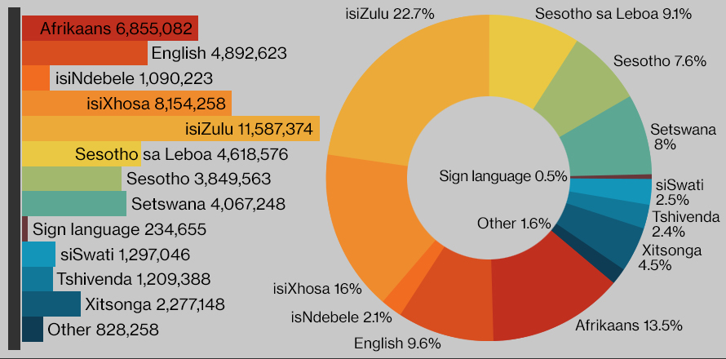
Figure 1. Official languages spoken by South Africans.
Source: (South Africa Gateway, 2018)
Verbal communication, as well as the accompanying non-verbal communication, has been the most prominent way in intercultural communication. The official language used by British companies will, of course, be English. However, South Africa has been famous for its language diversity, as it has 11 official languages that may emerge in the workplace (South Africa Gateway, 2018). Specifically, IsiZulu and isiXhosa are the most two commonly used languages, and English is spoken by only one in ten people (World Atlas, 2018). Although English is an urban language of public life, widely used in the businesses and governments in cities such as Johannesburg, Durban, etc.(Nortjé and Albertyn, 2015) However, the insistencies on using English when operating in South Africa may result in extra complexities when communicating to local employees, or operating in less developed cities where English is not commonly used. The evident gap here posed by language barriers here is an absolute challenge for British businesses. Languages are not the only factors we should consider in communication. Words and texts can be perceived in a very different way due to contextual cues. South Africa has experienced a unique evolution brought about by immigration from Europe, which results in low ethnic homogeneity. Like most European countries, South Africa has a low context culture judging by the criteria by Hall (1989) in classifying cultures according to their specific communication style, which is in the same category as Britain. In general, that means they both communicate in an explicit and straightforward manner with relatively high reliance on verbal and written information to information exchange, and with specific communication contexts less important (Thompson, 2014). However, the complex culture of South Africa still indicates some differences in communication styles across communities. For instance, the black South Africans have a relative higher context culture, as they prefer to convey information both verbally and non-verbally and pretty talkative (Berg, 2012). Also, the black majority have a strong tribal identity, and interacting with them tends to be noisy, folksy, and do not strictly adhere to agendas. Meanwhile, white South Africans of European origins are typically prouder of their cultural heritage and communicate in an elegant, relaxed, and reserved way (Hadfield, 2016). The diversity of the official languages and the diversity of tribal cultures present an obvious challenge for British people. It is important for them to figure out the specific communities their employees are from, and adopt an appropriate way of communication according to the specific communication styles. The solution for British businesses is to design and implement some basic communication training to both British and South African employees. The contents of training should involve language skills and communication styles. Choosing one official language, such as English to be used in the workplace communication is highly necessary to remove any language barriers, but the understanding on other languages and communication styles with different South African communities can help with developing a more cohesive and transparent working environment.
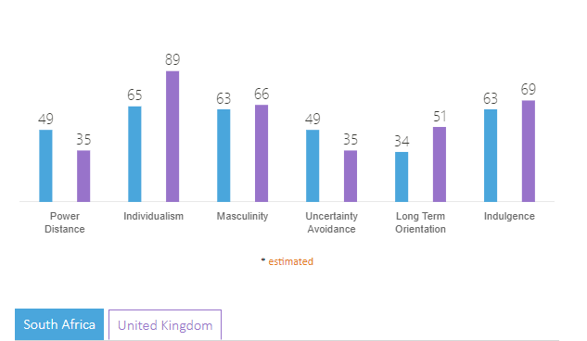
Figure 2. Country comparison: South Africa and United Kingdom
Source: (Hofstede Insight, no date)
However, international business communication concerns more than verbal and non-verbal communication mentioned above. More awareness and sensitivity should also be placed in the other underlying influential factors. In a multicultural workplace, employees from both parties are influenced by their own culture and the culture of the organization to form a code of conduct and value evaluation standards, when they are exposed to the new culture brought by foreign employees, there might be barriers in communication (Yue and Le, 2012). The six cultural dimensions promoted by Hofstede (2011) affords us a great practical framework to compare South African culture towards the British culture and figure out specific details British people should pay attention to. In terms of power distance, South African employees, despite belove than the average level, still accept a more hierarchical order than British employees, indicating everybody prefers a specific job position that needs further justification (Zoogah, Peng and Woldu, 2015). The senior leaderships make the final decision, after or even without consensus with subordinates. The main topics of conversation are usually carried out by the top, and the bottom is more of a feedback source (Castro and Martins, 2010). However, attention should be paid here is that black community are so different as they have an inertial prejudice from the apartheid period and will perceive hierarchy, power and authority in the organization as a manifestation of inherited inequalities, especially when they work with white people (Berg, 2012). The organizational structure in Britain tends to be flatter with emphasis on two way communication between subordinates and superiors and the respect of employee voices (Berg, 2012). In terms of individualism, South Africa is less individualistic compared to Britain, and it has a higher preference for a more tightly-knit social framework, but both of them are individualistic societies (Tindall and Holtzhausen, 2011). The contract between the employer and employee in the British workplace is based on mutual society, and any human resource decisions will be made with reference to individual performance (Kiazad, Seibert and Kraimer, 2014). British employees are influenced by a culture of individualism, and when faced with a communication objective, British employees make use of the facts and figures they have gathered to communicate, so that most of their thinking is based on their own perceptions and analysis of reality, rather than on the thinking of others (Dunkerley and Robinson, 2002). While, South African employees may place a bit more attention on the psychological contract with employers, desiring for more sense of caring and belongingness (Berg, 2012). The exception can be found in the black community, as they perceive the tribe as everything and have a strong tribal affiliation. The increasingly developed education systems in South Africa and other socio-cultural changes enabled by modernization are eroding the tribal bonds gradually (Thompson, 2014). In terms of masculinity, South Africa and Britain have similar scores, and both of them are masculine societies where people are oriented by work, equity, competition and achievements. In terms of uncertainty avoidance, South African people show a tendency to avoid uncertainties through maintaining some rigid codes of conduct and beliefs and appreciate values directness for the sake of clarity and mutual understanding. For instance, they will be well prepared with a plan and schedule of how they want a company event (such as a meeting) to go (Berg, 2012). For British employees who naturally embrace uncertainties through behaving out of the ordinary, South African employees may be intolerant and uncomfortable. The uncertainty avoidance is especially true on the while majority in South Africa, but less obvious in the black Africans. In terms of long-term orientation, South African culture is much more normative than pragmatic in their thinking with great respect exhibited for traditions. South African employees prefer quick results and responses in business decisions, while black South Africans tends to have a longer-term orientation than the general (Berg, 2012). British employees are influenced by a long-term oriented culture, which is reflected in their mastery of the concept of time, i.e. because of their perception of the dynamics of things, the topics on communication usually do not cut straight to the chase, but spend time in understanding the background of the person they are communicating with and only start talking about serious matters after the relationship between the two parties has been expanded (Nixon and Bull, 2006). Regarding the indulgence dimension, the scores are quite similar between South Africa and Britain. Both of them are clearly concerned with their basic human drives related to work-life balance and natural desires, and people are more inclined towards consumption due to the rapid modernization process in Africa. Besides, the prosperous economy in South Africa affords people with higher living standard and greater consumption desires (Economics and 2013, no date). The higher indulgence level not only manifests in the private workplaces but also within bureaucratic institutions where behaviors of public employees would be significantly influenced by bribery, interpersonal connection and personal desire to maintain social status, given the fact that South Africa has a less effective legal system (Salahuddin et al., 2020). These differences in cultures may influence business endeavors such as decision making, problem solving, team development, meeting scheduling, negotiation, etc. Considering the peculiarities of British and South African cultures discussed above, it is necessary for British businesses operating in South Africa to be culturally aware, sensitive and competent. Especially, the challenges and sensitivities can arise from specific sub-cultural groups within South Africa. The innumerable differences between British culture and South African culture, maybe even within the different South African cultures, bring with them a high potential for conflicts, misunderstandings, discriminations, disregard, frictions or even clashes.
Other common challenges in communication are interpersonal issues and gift-giving issues. Within the workplace, gift-giving can be seen as part of the milieu of the social working environment, which are legitimate relationship building. Nevertheless, the gift-giving to other cultures can be seen as bribery and kickbacks. However, it seems that both South African and Britain has taken the same common ground regarding gift-giving in businesses. South African Anti-Corruption Laws, Code of Conducts under the Public Service, and The Executive Ethics Code have been among the worlds’ most stringent (Yeboah-Assiamah et al., 2016; Bornman, 2017). The essence of the Law indicates where the gift exchange courtesies may constitute an inducement to obtain an improper advantage over another, it is not advisable (Global Compliance News, 2020). The British workplace emphasises independence and objectivity, which is enabled by general regulation such as Anti-Bribery Law and firm-specific guidelines (Global Legal Insights, 2019). A similar stance against gift-giving culture does not mean British businesses should not perceive it as a potential communication challenge. As the culture of gift-giving and the framework that governs gift-giving varies from country to country, there should be a delicate balance between whether a gift-giving should be interpreted as acceptable. Especially, despite being quite stringent, the current regulation against corruption in South African is highly fragmented, too, with some inconsistencies and multiple ambiguities, making it hard for British businesses to define the boundary between gifts and corrupt practices (Salahuddin et al., 2020). Therefore, a thorough investigation of South-African local regulation and preferences in terms of gift-giving is required to facilitate the establishment of clear and comprehensive firm-specific guidelines. Most South African people are like British people, as they trust the explicit rules and regulations as the basis to develop trust against each other and against the organization (Berg, 2012). That is to say, they rely on normative formal networks to establish mutual trust. However, the black majority in South Africa tend to resort to informal networking, say interpersonal relationships, for developing trust (Ntuli, 2012). That indicates different attitudes and behaviours should be taken by British businesses when interacting with different sub-communities in South Africa.
The above discussion indicates South Africa as a multicultural society with many discrepancies compared to Britain and across strata. To cope with above mentioned challenges and sensitivities in business communication when operating in South Africa, some recommendations are given here. On the basis of a full understanding of cultural differences, UK companies should develop coping strategies based on the communication barriers caused by cultural differences. The deep-seated causes of cross-cultural communication problems should be analysed on the basis of their causes. However, it is important to note that cultural factors that influence communication do not occur in isolation but are more often the result of several cultural factors simultaneously. Then, strategies should be developed for different communication problems. After analysing the causes of communication barriers, resources are promptly mobilised to help employees cope with the solutions. On the basis of not changing the organisational culture, and according to the main needs of different business activities and in combination with the existing main culture, a suitable and flexible intercultural communication strategy is developed for the company in order to facilitate adjustments in the values, thinking styles, communication styles, time perceptions and personal habits of employees. This is of great importance given to the complexity and diversity of the South Africa culture. The flexibility in the communication strategies will ensure maximized communication effectiveness when interacting with different communities (Steyn and Reygan, 2017). Also, Bennett (1988) indicated that intercultural sensitivity can be enhanced through training that posits a continuum of increasing sophistication in coping with differences, resulting in gradual movement from ethnocentrism to ethnorelativism with greater awareness and acceptance of difference. Especially, the training contents should cover major themes covered above, including basic language training, business technique training, communication skill training, etc. The training designed for South African employees and Britain employees should be specifically targeted, and different training formats, such as lectures, mentorship, orientation, sharing, activities, can be intertwined to improve intercultural competencies.
Without effective business communication, work progress would become an uphill task for British businesses operating in South Africa. The multicultural workforce requires attention being paid to challenges and sensitivities to communication. Through comparing typical cultural aspects between Britain and South Africa, the present essay highlights some challenges and sensitivities in the workplace in South Africa. Major challenges presented here include the language barriers, the communication styles, the values and beliefs, the gift-giving culture, etc. Especially, as South Africa is a nation with high cultural diversity, the challenges and sensitivities may vary from one community to another. The above discussion indicates the black majority has been an exception exhibiting a distinct feature in communication. A deep dive into each sub-culture is necessary to enhance the flexibility and effectiveness of communication.

References
Baraldi, C. (2006) ‘New forms of intercultural communication in a globalized world’, International Communication Gazette, pp. 53–69. doi: 10.1177/1748048506060115.
Bennett, M. J. (1988) Basic Concepts of Intercultural Communication: Selected Readings. Intercultural Press Yarmouth, ME.
Berg, A. (2012) Connecting with South Africa: Cultural communication and understanding. Texas University Press.
Bornman, E. (2017) ‘Intercultural Communication Study in South Africa’, in The International Encyclopedia of Intercultural Communication. Wiley, pp. 1–10. doi: 10.1002/9781118783665.ieicc0094.
Castro, M. L. and Martins, N. (2010) ‘The relationship between organisational climate and employee satisfaction in a South African information and technology organisation’, Journal of Industrial Psychology, 36(1). doi: 10.4102/sajip.v36i1.800.
Dunkerley, K. J. and Robinson, W. P. (2002) ‘Similarities and differences in perceptions and evaluations of the communication styles of American and British mangers’, Journal of Language and Social Psychology, pp. 393–409. doi: 10.1177/026192702237956.
Economics, W. K.-J. of D. and 2013, undefined (no date) ‘Conspicuous consumption and “race”: Evidence from South Africa’, Elsevier. Available at: https://www.sciencedirect.com/science/article/pii/S0304387812000648?casa_token=OuF6lA9xsaIAAAAA:z50o-EP4h6DjfU-pc14X0mUNeLixrvcOejaO1aWgCxZWOOePFh3_gzDYRvlkpjRofVX32hs84A (Accessed: 4 January 2022).
Global Compliance News (2020) Anti-Corruption in South Africa . Available at: https://www.globalcompliancenews.com/anti-corruption/anti-corruption-in-south-africa-2/ (Accessed: 4 January 2022).
Global Legal Insights (2019) ‘Bribery & Corruption Laws and Regulations | United Kingdom | GLI’. Available at: https://www.globallegalinsights.com/practice-areas/bribery-and-corruption-laws-and-regulations/united-kingdom (Accessed: 4 January 2022).
Guo, Q. (2019) ‘Competency in globalization and intercultural communication’, in The Wiley Handbook of Global Workplace Learning. wiley, pp. 277–299. doi: 10.1002/9781119227793.ch16.
Hadfield, L. A. (2016) Liberation and development: Black consciousness community programs in South Africa. MSU Press.
Hall, E. T. (1989) Beyond culture. Anchor.
Hofstede, G. (2011) ‘Dimensionalizing cultures: The Hofstede model in context.’, Online readings in psychology and culture, 2(1), pp. 2307–0919.
Hofstede Insight (no date) Country Comparison - Hofstede Insights. Available at: https://www.hofstede-insights.com/country-comparison/south-africa,the-uk/ (Accessed: 4 January 2022).
Kiazad, K., Seibert, S. E. and Kraimer, M. L. (2014) ‘Psychological contract breach and employee innovation: A conservation of resources perspective’, Journal of Occupational and Organizational Psychology, 87(3), pp. 535–556. doi: 10.1111/joop.12062.
Nixon, Y. and Bull, P. (2006) ‘Cultural communication styles and accuracy in cross-cultural perception: A British and Japanese study’, Journal of Intercultural Communication, (12). Available at: http://search.ebscohost.com/login.aspx?direct=true&profile=ehost&scope=site&authtype=crawler&jrnl=14041634&AN=22917033&h=NWoe%2B3eyebiixRTgQ1gdqASkRzXG8uzlExZ%2Fmrel%2BAqwTcnND8MSz0crEngZhmSU8VbaP7K0I%2Fei9o8DvYEMOQ%3D%3D&crl=c&casa_token=uqGGGRkl7mUAAAAA (Accessed: 4 January 2022).
Nortjé, N. and Albertyn, R. (2015) ‘The cultural language of pain: A South African study’, South African Family Practice, 57(1), pp. 24–27. doi: 10.1080/20786190.2014.977034.
Ntuli, C. D. (2012) ‘Intercultural misunderstanding in South Africa: An analysis of nonverbal communication behaviour in context’, Intercultural Communication Studies, 21(2), pp. 20–31. Available at: https://web.uri.edu/iaics/files/02CynthiaDanisileNtuli.pdf (Accessed: 4 January 2022).
Salahuddin, M. et al. (2020) ‘Globalisation, poverty and corruption: Retarding progress in South Africa’, Development Southern Africa, 37(4), pp. 617–643. doi: 10.1080/0376835X.2019.1678460.
Sorrells, K. (2011) ‘Re-Imagining Intercultural Communication in the Context of Globalization’, in The Handbook of Critical Intercultural Communication, pp. 171–189. doi: 10.1002/9781444390681.ch11.
South Africa Gateway (2018) The 11 languages of South Africa. Available at: https://southafrica-info.com/arts-culture/11-languages-south-africa/ (Accessed: 4 January 2022).
Steyn, M. and Reygan, F. (2017) ‘New competencies for intercultural communication: Power, privilege, and the decolonisation of higher education in South Africa’, in Intercultural Competence in Higher Education: International Approaches, Assessment and Application, pp. 83–94. doi: 10.4324/9781315529257.
Thompson, L. (2014) A history of South Africa. Yale University Press.
Tindall, N. T. J. and Holtzhausen, D. R. (2011) ‘Toward a roles theory for strategic communication: The case of South Africa’, International Journal of Strategic Communication, 5(2), pp. 74–94. doi: 10.1080/1553118X.2011.561075.
World Atlas (2018) Languages Of South Africa. Available at: https://www.worldatlas.com/articles/languages-of-south-africa.html (Accessed: 4 January 2022).
Yeboah-Assiamah, E. et al. (2016) ‘A socio-cultural approach to public sector corruption in Africa: key pointers for reflection’, Journal of Public Affairs, 16(3), pp. 279–293. doi: 10.1002/pa.1587.
Yue, Y. and Le, Q. (2012) ‘From “ Cultural Shock ” to “ ABC Framework ”: Development of Intercultural Contact Theory’, International Journal of Innovative Interdisciplinary Research, 2(2), pp. 133–141. Available at: https://www.auamii.com/jiir/Vol-01/issue-02/10yue.pdf (Accessed: 4 January 2022).
Zoogah, D. B., Peng, M. W. and Woldu, H. (2015) ‘Institutions, resources, and organizational effectiveness in Africa’, in Academy of Management Perspectives. Academy of Management, pp. 7–31. doi: 10.5465/amp.2012.0033.

