

LOCATION: Swansea | LLEOLIAD: abertawe
LEVEL 5 | LEFEL 5
EXAMINATION PERIOD | CYFNOD ARHOLIADAU
May 2021 | Mai 2021

MODULE CODE: ACCA5024
COD Y MODWL: ACCA5024
ADVANCED NETWORKING
TIME: 2 HOURS

Name :

Student ID :

Date & Time :

This is an individual practical test, held under examination conditions. You will be assigned three Switches and three Routers; you should configure these devices based on the given specifications. Handwritten notes are allowed

This paper is marked out of 100.

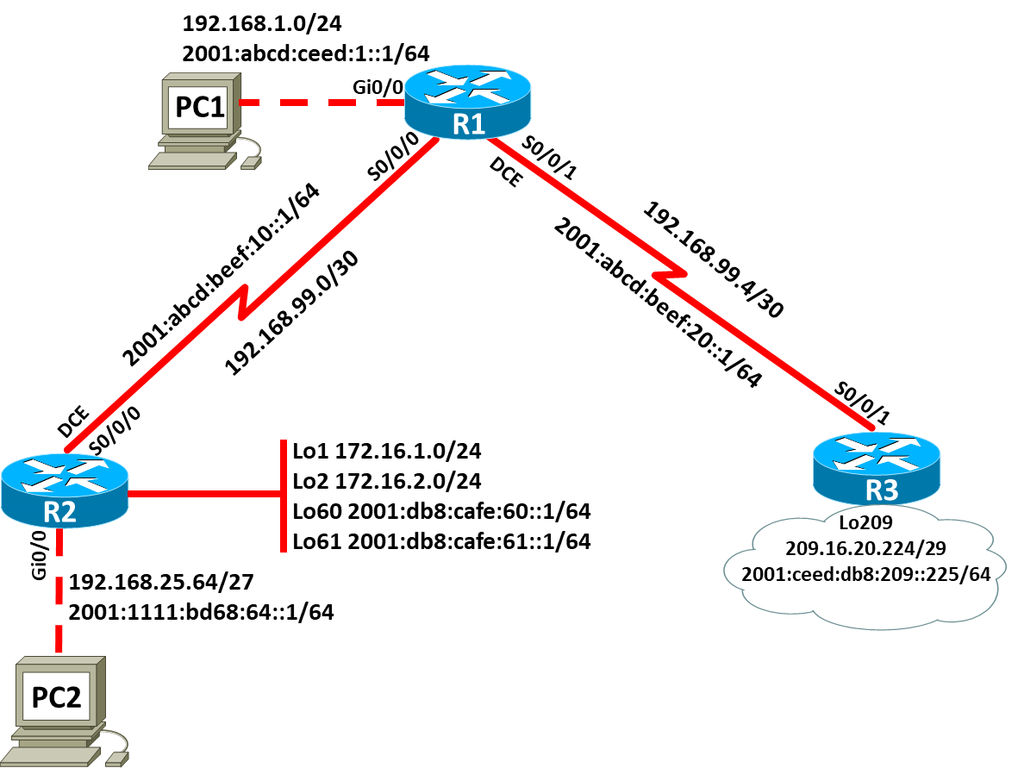
Topology

Addressing Table: IPv4 (5 marks)
Device | Interface | IP Address | Subnet Mask | Default Gateway
R1 | Gi0/0 | 192.168.1.0 | 255.255.255.255 | N/A
 | S0/0/0 | 192.168.99.0 | 255.255.255.0 | N/A
 | S0/0/1 | 192.168.99.4 | 255.255.0.0 | N/A
R2 | S0/0/0 | 192.168.99.0 | 255.255.255.0 | N/A
 | Gi0/0 | 192.168.25.64 | 255.255.255.255 | N/A
 | Lo1 | 172.16.1.0 | 255.255.255.255 | N/A
 | Lo2 | 172.16.2.0 | 255.255.255.255 | N/A
R3 | S0/0/1 | 192.168.99.4 | 255.255.0.0 | N/A
 | Lo209 | 209.16.20.224 | 255.255.255.255 | N/A
PC1 | Gi0/0 | 192.168.25.64 | 255.255.255.0
PC2 | Gi0/0 | 192.168.1.0 | 255.255.0.0

Addressing Table: IPv6 (5 marks)
Device | Interface | IPv6 Address | Link-local | Gateway
R1 | Gi0/0 | 2001:abcd:ceed:1::1 |  | N/A
 | S0/0/0 | 2001:abcd:beef:10::1 |  | N/A
 | S0/0/1 | 2001:abcd:beef:20::1 |  | N/A
R2 | S0/0/0 | 2001:abcd:beef:10::1 |  | N/A
 | Gi0/0 | 2001:1111:bd68:64::1 |  | N/A
 | Lo60 | 2001:db8:cafe:60::1 |  | N/A
 | Lo61 | 2001:db8:cafe:61::1 |  | N/A
R3 | S0/0/1 | 2001:abcd:beef:20::1 |  | N/A
 | Lo209 | 2001:ceed:db8:209::225 |  | N/A
PC1 | Gi0/0 | 2001:abcd:ceed:1::1
PC2 | Gi0/0 | 2001:1111:bd68:64::1

Task 1: - Topology Creation (5 marks)
Using Packet Tracer software create the topology shown above and complete all tasks below.

Task 2: - Device Configuration (75 marks)

- On all devices,
  - Configure hostname on all devices
  - Set privilege EXEC password
  - Configure line console password
  - Set logging synchronous
  - Configure line VTY password
  - Disable DNS lookup
  - Set password encryption
  - Set banner “Authorized Users Only!”

- On all devices, configure interfaces with IPv4 and v6 addresses as shown in the topology

- On R1, configure IPv4 static route to R2 and R3 networks, excluding Lo209 network.

- On R2, configure IPv4 static route to R1 and R3 networks, excluding Lo209 network.

- On R3, configure IPv4 static router to R1 and R2 networks.

- Configure default static route to reach Lo209 network using next-hop ip address.

- Set the bandwidth on serial links to 512kbps.

- Set the clock rate on DCE to be 64000

- On R1, configure IPv6 static route to R2 and R3 networks, excluding Lo209 network.

- On R2, configure IPv6 static route to R1 and R3 networks, excluding Lo209 network.

- On R3, configure IPv6 static router to R1 and R2 networks.

- Configure IPv6 default static route to reach Lo209 network using next-hop ip address.

- Using 1024 bit RSA keys configure SSH access on R1. Use domain soac.com, username: admin and password: Sw@ns3a.

Task3: Network connectivity (10 marks)

Using ping command, verify end-to-end connectivity for both IPv4 and v6 networks:
From PC1, ping PC2. Is it successful? ___yes_____
From PC1, ping Lo209. Is it successful? ___yes____
From PC2, ping Lo209. Is it successful? ___yes_____

Verify SSH connectivity:
From PC1, establish telnet connection to R1. Is it successful? __no____(this should fail)
From PC1, establish SSH connection to R1. Is it successful? ___yes____
Submission Requirement
The packet tracer file should be saved as “studentname_id” and uploaded onto Moodle. In addition to packet tracer file, you must also submit

- the output of show running-configuration command in a text file for all devices configured.
- This document with Task 3 completed

All documentation for your solution should be submitted electronically on Moodle.
It is your responsibility that you submit all the outputs and files correctly.

