Vikran Sanghera 2204036

History and Theory Essay 2
An Exemplar of Modern Architecture

The Robie House, designed by Frank Lloyd Wright and completed in 1910, is widely regarded as one of the most important works of American architecture (Smith, 2005). This residential building, located in the Hyde Park neighbourhood of Chicago, was commissioned by the businessman Frederick C. Robie, who made his fortune in the lumber industry (Twombly, 2004). The house's significance lies not only in its stunning design but also in its representation of Wright's architectural vision and philosophy.
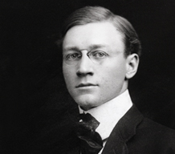 (Anon., n.d.)(Image of Frederick C. Robie)
This essay analyses the Robie House from various perspectives, including its historical background, plan and section, materials and light, and the ideas and theories underpinning its design. By examining these aspects, we can better understand the building's success in achieving Wright's aims and objectives.

Historical Background
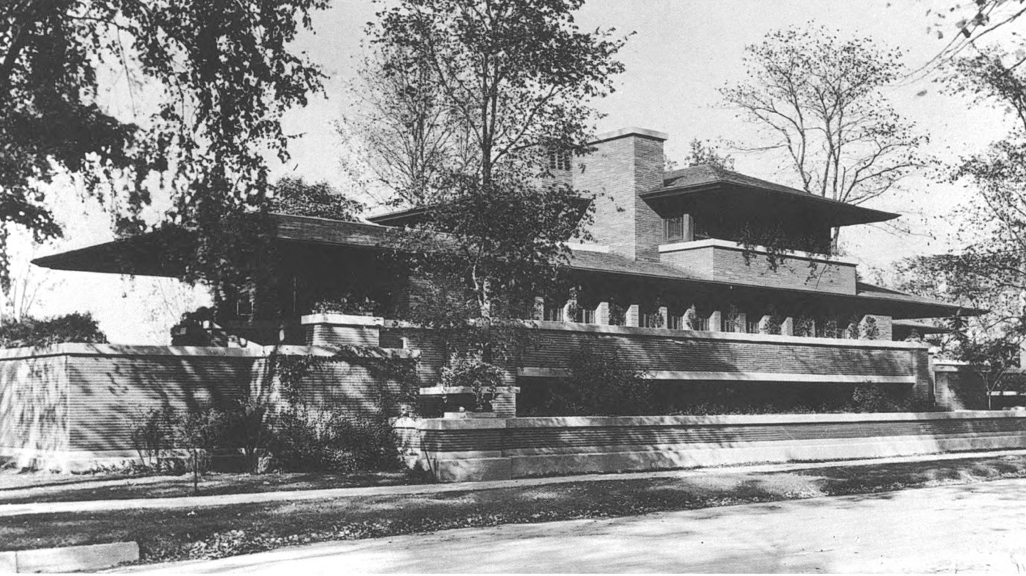(Rocheleau, n.d.)
The Robie House is in the Hyde Park neighbourhood of Chicago, Illinois. Designed in 1908 and constructed in 1910, The building's purpose was to serve as a family home for Robie and showcase his taste and wealth. Frank Lloyd Wright, a prolific architect of the modern era, was commissioned to design the house. The house was designed to reflect Robie's modernist sensibilities and to be innovative and functional. Its design featured a long, low profile, wide overhanging eaves, bands of art glass windows, and horizontal lines that were a departure from the traditional vertical forms of architecture (The Art Story Foundation, n.d.). The small and irregularly shaped building site presented several challenges that Wright innovatively overcame (Storrer, 2006). The Robie House is considered one of the most important works of American architecture and has influenced generations of architects and designers (Storrer, 2006). It was designated a National Historic Landmark in 1963 and is open to the public. In present day, the Robie House is open to the public and serves as a museum, dedicated to the life and work of Frank Lloyd Wright. It is a popular destination for tourists and architecture enthusiasts, offering guided tours and educational programs that explore the history and significance of the house.
In addition, the Robie House is also used for a variety of events and functions. The spacious interior and beautiful design make it a popular venue for weddings, corporate events, and other special occasions. The house has also been used as a filming location for movies and television shows. Overall, the Robie House continues to be a significant and influential work of American architecture, as well as an important cultural landmark in the city of Chicago (The Frank Lloyd Wright Trust, 2022).

Plan and Section
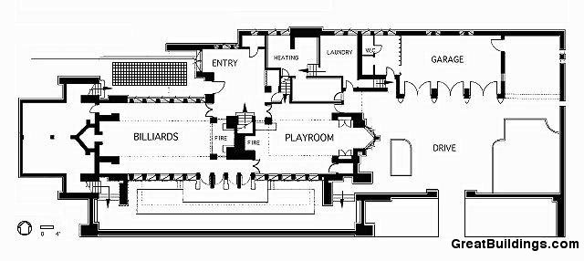 (Perez, 2010)(First Floor Plan) 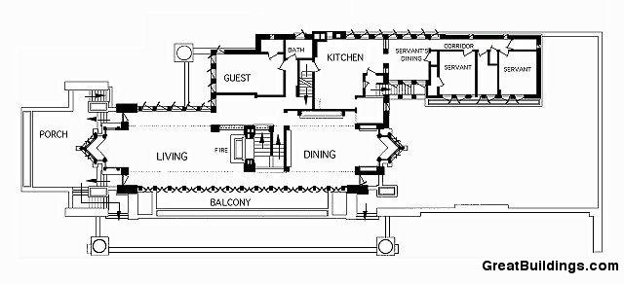 (Perez, 2010)(Second Floor Plan) 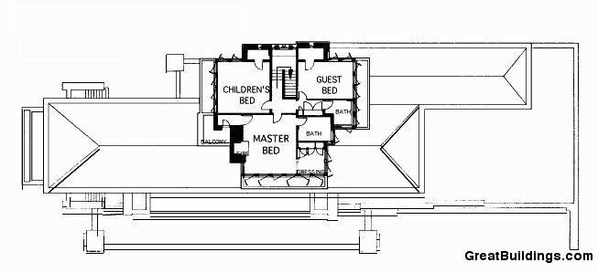 (Perez, 2010)(Third Floor Plan)
The plan of the Robie House is an exemplary model of Frank Lloyd Wright's organic architecture philosophy, which blends the building into their natural surroundings and produce spaces that has a sense of flow and freedom. The open interior plan of the house creates a sense of spaciousness and path between rooms, with the living areas facing towards the street and the private spaces facing towards the back (Smith, 2005).
The house has a long and low profile, with wide overhanging eaves, and has many bands of art glass windows this helps emphasize the horizontal nature of the house.
The fireplace in the centre of the Robie House plan is one of its most notable features by Wright, considered as a focal point for the living spaces and surrounded by built-in seating and storage units. This feature by Wright, serves a functional purpose and creates a warm, welcoming atmosphere (Hildebrand, 2005).

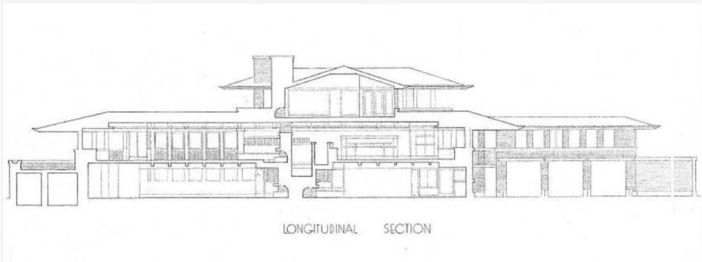 (Hill, 2012)
(Longitudinal Section Looking North)
The Robie House's plan is an open space living environment, which flows between rooms. The section of the Robie House is equally as impressive, as Wright incorporated cantilevered balconies and deep-set windows into his design, it allowed light to penetrate the interior spaces (Hoffmann, 2017). When designing the plan and layout for the Robie House, Wright uses a uniform grid system. Which allowed him to create several large and symmetrical rooms that are interlocked. (McCarter, 2005)
Overall, the plan of the Robie House is an achievement of Frank Lloyd Wright's innovative design approach, creating a balance between functionality and aesthetics and still applying to the principles of organic architecture.

Materials and Light
Frank Lloyd Wright is well known for his innovative use of materials in his designs, and this is well showcased on the Robie House. According to Twombly (2004), Wright's material choices for the house were essential in creating its unique aesthetic qualities. The exterior of the house is clad in Roman brick, the thin and long brick creates a smooth and monolithic look and feel to the exterior of the house. When designing the Robie House Wright pairs the exterior brick, with stained glass, which is one of Wright's signature design elements. The stained glass creates light and shadow throughout the home, creating an atmosphere that changes as you travel around the house (Hoffmann, 2017). Throughout Wright’s work he was praised for emphasising natural light in his designs, and he executes it perfectly on Robie House. Wright has chosen the colours and patterns in the glass to help complement the house's design and to reflect the natural environment outside. With the house’s open plan and deep-set windows, it allows large amount of natural light to flood the interior, this creates a bright and airy atmosphere (Smith, 2005).
Wright believes that natural light is necessary for healthy living, and the Robie house is prime example of his design philosophy.
Overall, the Robie House's use of materials and light is a representation of Wright's vision and ability to create a design that integrates with its natural environment.

Ideas and Theories Underpinning the Design

Frank Lloyd Wright's design for the Robie House was heavily influenced by his philosophy of creating spaces of family intimacy and a sense of security. The prairie house style was the perfect template for Wright's vision, and used low sheltering roof, a central hearth, and a protected front facade to create a welcoming and secure environment for the occupants (McCarter, 2005).
Wright's attention to detail is evident on the second floor living space, which opens to a deck with an unobstructed view of the surrounding environment. This feature, previously seen in the Tomek House, adds an extra layer of protection and privacy for the family, as it places them out of harm's way while still allowing them to enjoy the benefits of relaxing (McCarter, 2005).
Wright's design for the Robie House is heavily emphases the use of traditional craftsmanship and natural materials in his designs (Hoffmann, 2017). This is reflected in the house's Roman brick exterior and stained-glass interior, which blends in with the surrounding environment.
Wright's love for Japanese architecture has also influenced his design for the Robie House. Specifically, the concept of "engawa," an open space between the interior and exterior of a building, it is shown by house's cantilevered balconies and deep-set windows (Twombly, 2004).
The open plan and emphasis on natural light in the design of the Robie House was Wright's belief that architecture should promote healthy living and improve the quality of life for its occupants (Smith, 2005). By allowing natural light to flood the interior and creating an open-plan living space centred around the fireplace, Wright created a welcoming and functional space for the family.
Overall, the Robie House is a representation of Frank Lloyd Wright's innovative design philosophy and his ability to create spaces that integrate with the surrounding environment while creating sense of intimacy and security for their occupants.

Conclusion
The Robie House, located in the Hyde Park neighbourhood of Chicago, is an exemplary model of modern architecture. Designed by Frank Lloyd Wright in 1908, the house was commissioned by Frederick C. Robie. The Robie House's design reflected Robie's modernist sensibilities and his desire for an innovative and functional home. The house's plan is an open living environment that flows between rooms, creating a sense of spaciousness and safety, with the living areas facing towards the street and the private spaces facing towards the back. The fireplace in the centre of the house's plan is one of its most notable features, considered a focal point for the living spaces and surrounded by built-in seating and storage units. The house's exterior is clad in Roman brick, paired with stained glass, which creates a smooth and monolithic look and feel. The stained glass allows natural light to flood the interior, creating a bright, airy atmosphere. The Robie House's design and materials reflect Frank Lloyd Wright's organic architecture philosophy, which blends the building into its natural surroundings and creates spaces with a sense of flow and freedom. The house continues to be a significant and influential work of American architecture and an essential cultural landmark in the city of Chicago.

Bibliography
Anon., n.d. Frank Lloyd Wright Trust. [Online]
Available at: https://flwright.org/researchexplore/robiehouse
[Accessed 14 March 2023].
Foundation, T. A. S., n.d. Frank Lloyd Wright: American Architect. [Online]
Available at: https://www.theartstory.org/artist/wright-frank-lloyd/
[Accessed 14 march 2023].
hildebrand, G., 2005. Frank Lloyd Wright's Robie House: The Illustrated Story of an Architectural Masterpiece.. s.l.:Courier Corporation..
Hill, J., 2012. Must-Know Modern Homes: The Robie House. [Online]
Available at: https://www.houzz.com/magazine/must-know-modern-homes-the-robie-house-stsetivw-vs~5556911
[Accessed 15 march 2023].
Hoffmann, D., 2017. Frank Lloyd Wright's Robie House. Chicago : Chicago Architecture Center.
Hoffmann, D., 2017. The Robie House: Frank Lloyd Wright's Prairie School masterpiece. Chicago: University of Chicago Press.
McCarter, R., 2005. A Primer Of Architectural Principles; On and By Frank Lloyd Wright. London: Phaidon Press Limited.
McCarter, R., 2005. Frank Lloyd Wright: A Primer on Architectural Principles. s.l.:Princeton Architectural Press..
Perez, A., 2010. AD Classics: Frederick C. Robie House / Frank Lloyd Wright. [Online]
Available at: https://www.archdaily.com/60246/ad-classics-frederick-c-robie-house-frank-lloyd-wright
[Accessed 14 march 2023].
Perez, E., 2010. Thoughts on Architecture: Robie House Plans. [Online]
Available at: https://thoughtsonarchitecture.wordpress.com/2010/09/16/robie-house-plans/
[Accessed 14 march 2023].
Rocheleau, P., n.d. Arquitecturaviva. [Online]
Available at: https://arquitecturaviva.com/works/casa-robie-chicago
[Accessed 14 March 2023].
Rocheleau, P., n.d. In Frank Lloyd Wright Trust. [Online]
Available at: https://flwright.org/visit/robiehouse/historicalbackground
[Accessed 15 march 2023].
Smith, R., 2005. The Prairie School and its legacy: The architecture of the Chicago School. Chicago: University of Chicago Press.
Smith, R., 2005. The Robie House: An Exemplar of Modern Architecture.. The Journal of Architecture, 10(1), pp. 61-78.
Storrer, W. A., 2006. The architecture of Frank Lloyd Wright: A complete catalogue. Chicago: University of Chicago Press.
Storrer, W. A., 2006. The Frank Lloyd Wright Campanion: Revised Edition. Chicago: University Of Chicago Press.
Twombly, R., 2004. Frank Lloyd Wright: His life and his architecture. s.l.:s.n.

