

LEVEL 4

SEMESTER 2

MODULE CODE: SHSS4078
Adventure: A Risk worth Taking

aSSESSMENT TYPE: aSSIGNMENT
Assessment/Component: 1 (Part A)
COMPONENT WEIGHTING: 40 %
WORD COUNT: 2000 WORDS
MODULE TUTOR: Denise leonard

Assignment:
Complete a logbook recording every activity session you complete during this module and include these as appendices to your submission.

With reference to a critical incident case study that we have examined, identify one key contributing hazard. Evaluate your own personal logged experiences in different activities, of risk management in relation to this identified hazard. You should include a synopsis of the critical incident case study in your appendices.

SUBMISSION DETAILS:

Deadline:
Date: 4th May 2018
Time: 3.00pm
Portal: Turnitin

School of Sport, Health & Outdoor Education

Assessment Feedback Sheet

Student No./Name:
Module: SHSS4078
Module Code: Adventure: A Risk Worth Taking

Personal Evaluation – to support your academic progress please complete the section below BEFORE submitting your work.
What do you consider to be the best aspects of this work? |  |  | That I tried my best.
Which aspects do you consider could have been improved in this piece of work? |  |  | The layout as I am a bit uncertain on how I was supposed to do it.
What have you found most satisfying whilst undertaking this submission? |  |  | Trying my best.
ASSESSMENT CRITERIA | Learning  Outcomes |  | GRADE
ASSESSMENT CRITERIA |  |  | Poor  0 – 25% | Unsatisfactory  26-39% |  | Satisfactory  40 – 49% | Good  50 – 59% | Very Good  60 – 69% | Excellent  70 – 85% |  | Exceptional  86– 100% | %
Complete logbook for each session | All |  |  |  |  |  |  |  |  |  |  | 15%
Provide a synopsis of a critical incident case study | All |  |  |  |  |  |  |  |  |  |  | 15%
Identify a specific significant hazard and the risk it poses to undertaking adventurous outdoor activities | 1,2,3,5 |  |  |  |  |  |  |  |  |  |  | 30%
Discuss a range of appropriate measures that might effectively control the identified hazard and consequent risks. | 1,2,3,5 |  |  |  |  |  |  |  |  |  |  | 30%
Appropriate references used and correctly formatted | All |  |  |  |  |  |  |  |  |  |  | 10%
It is expected that students will present work that is proof read, correctly referenced and adheres to the Assessment Checklist. Therefore a range of 0 – 10 marks will be deducted for non-completion of any of the points on the checklist below.
TUTOR COMMENTS:

Submission date:  via Turnitin |  | Return date:  (at least within 4 weeks) |  |  | Tutor: Denise Leonard |  |  |  |  | Mark:

Assignment Checklist

- Please complete the Personal Evaluation section of the Assessment Feedback sheet, add your name and details, and paste the whole of this assignment document into the front of your assignment

- Submission is a single word file, clearly labelled with your name and module code
- Font style - Times New Roman, size -12 for text and 14 for headings
- Ink colour – black only
- Line spacing – 1.5 line spacing and 2cm- 2.5cm page margins
- Quotations more than three lines to be indented 1 line spacing
- One line space between paragraphs, paragraphs must be left aligned
- Pagination (your assignment should have page numbers)
- All tables and figures are internally referenced and have a title
- Word count checked and written at end of text (before references and any appendix)
- Assignment is within 10% of the word limit (excluding references and any appendices)
- All references in the text are included in the reference list
- Correct referencing following the Harvard style, as described in the Palgrave study skills book ‘Cite them Right’.
- Correct spelling using UK English
- Correct use of punctuation
- Grammar and syntax correct- double check anything that has a green line under it
- I have read my assignment out loud to myself and it makes sense and is easy to read
- Somebody else has read my work and it makes sense to him or her!
- I have checked and I have not plagiarised
Failure to follow these guidelines will cost you marks!

Log Books

Rock Climbing 27/02/18

The site which we visited was Three Cliffs Bay in the Gower, Swansea.
The conditions during the day according to various metrological websites suggested that it was mostly likely to be overcast, with low temperatures varying between -2 and 3 degrees Celsius. This being said as the wind direction was coming from a NE/E direction this made temperatures feel cooler between -8 and -1 degrees Celsius.
Tides were also a major factor because we had a limited amount of time where we were able to climb. This is because low tide was at 10:09 and high tide at 16:12.
When we were at the site we arrived at eleven and only had until 14:00 before the tide reached the area where we were doing our activity. This was planned based on the rule of the 12ths and it was undoubtedly correct.
Some NGB awards when concerning climbing are the SPA award, single pitch award, climbing wall award and undoubtedly a first aid certificate.
In terms of legislation we need to take in to account the access points followed by the code of conduct. As when accessing the beach, we do not have to enter any private property as there is a public path which takes us to the beach.
Specific skills that are obtained involve rope work followed by belaying and tying different knots.
The equipment was checked before and after the activity therefore making sure that the PPE is in good condition.
As an individual I felt prepared as I had the appropriate equipment to take part in the activity.
Generic Risk Assessment
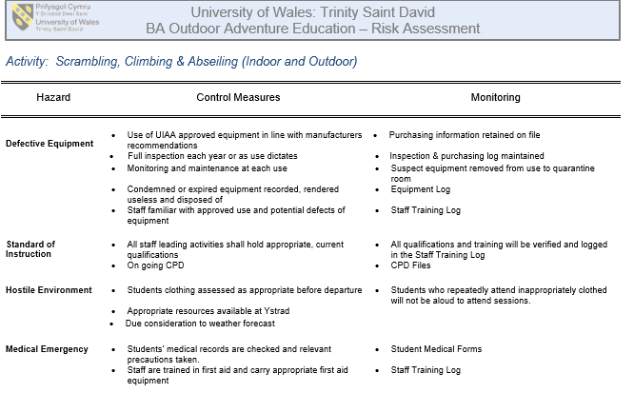

Site Specific Risk Assessment
- Parking: There was no parking, therefore we had to park on the pavement facing the traffic in order to exit the bus safely.
- Appropriate Footwear: When reaching the beach there were many pebbles and rocks where you can easily twist your ankle.
- Falling rock.
- Limited climbing time due to tides.

Gorge Walking 06/02/18

On our first activity we went to the River Sychryd which is located in Dinas Rock, Glynneath.
When arriving at the site due to the direction of the wind which came from a southerly direction with a speed between 5mph-12mph. We did not get much wind due to the location of the gorge. This being said it was still very cold and we did get some precipitation, allowing it to snow. Temperatures were very low between -7 and -2 degrees Celsius. River level were also low restricting us from doing some of the jumps, this was a result from the little amount of precipitation.
We travelled upstream of the river this allowed us to crawl under a waterfall followed by doing two jumps and finally heading back to the bus.
It was also important that we were aware of the legislations such as NRW Concordat: which is an agreement between SWAOPG and FCW concerning site users as this further includes; access, code of conduct and the near misses.
The NGB awards that one may or must have in this sort of activity are a first aid qualification, BCU Star Test, MTLE SPA, white water safety and FSRT.
The site specific skill that could be involved is rope work. However, the potential benefit from this session was dynamically risk assessing a gorge walk. During the activity our PPE was in good condition before the session and during the session we all kept a close eye on the equipment to see if there was any wear and tear done throughout the activity.
As an individual I felt prepared however there was an individual who forgot his gloves. This was a hazard on the day as he could have suffered with a mild case of hypothermia and as a result could have led us to stop the activity.
A key contributing hazard was the hypothermia as temperature levels were very low. The way in which we effectively risk managed the situation was by wearing appropriate clothing along with never staying still. An example was, whilst waiting for the others instead of staying still we would collectively be doing star jumps or burpees to keep the blood flowing and keep us warm.
Risk Assessment
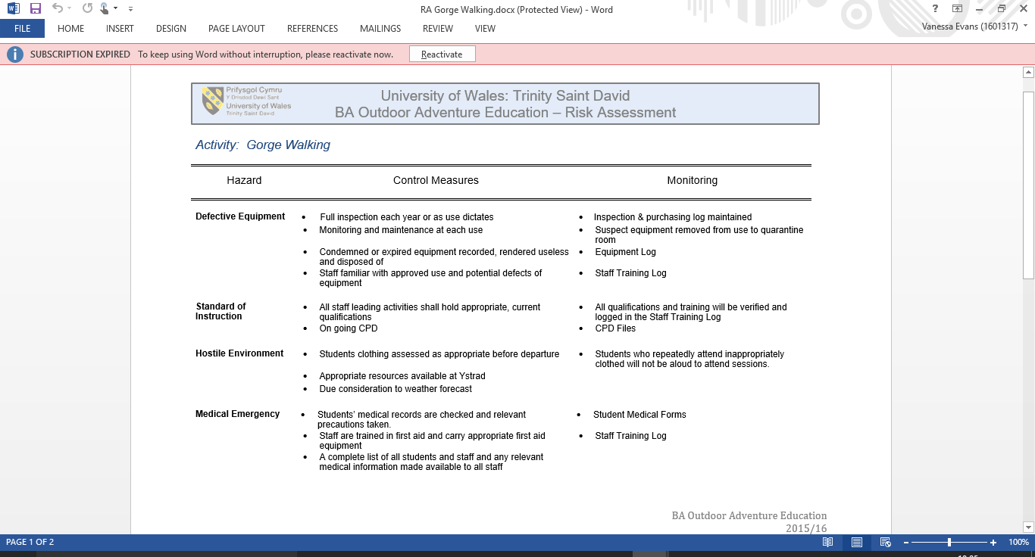

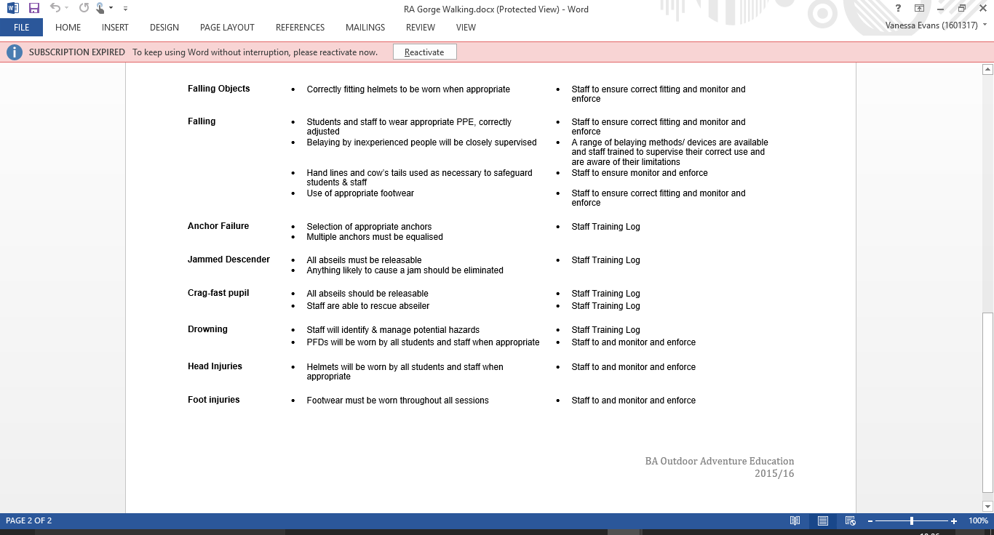

River Kayaking 06/03/18

The site which we visited for our river kayaking session was Llandysul. The weather was relatively nice as the sun was out however it did get to a point where there was some cloud cover which made us think twice as the wind slightly picked up and therefore it got a bit chilly. Luckily, there wasn’t any precipitation. This being said, despite prior looking at river levels and websites saying that river levels were okay.
After visiting the site and personally looking at the level and flow of the river, we could see that there was a higher level than expected and as well from previous times after having visited this location. There was also a peculiar colour to the water. I believe that these aspects of the river have occurred do to the heavy snowfall from the previous week and as a result it has reflected in these aspects of the river as there was also a higher percentage of debris flowing through.
It is essential to have a first aid certificate and there are other NGB awards you can gain such as the British Canoeing Star Award or BCU’s.
The legislation that was important when going river kayaking in Llandysul was access in and out of the river followed by the code of conduct.
The specific skills that would be done when river kayaking are using a throwline, how to river swim and using correct paddling technique. The benefits of this session would be dynamically risk assessing along with learning new paddling techniques and how to behave when doing river based activities.
All our PPE was in good condition before the activity and then was again inspected after in order to make sure that equipment is suitable to be used again. For example, helmet, buoyancy aid, wetsuit etc.
Despite the fact that as a group we were well prepared a hazard was that river levels were higher than expected. Therefore, we then had to alter the session making it a river swim. As a result, we were able to stay much safer.
Hazards when we completed a river swim were again hypothermia and to avoid this we kept moving as much as possible. The river in itself is another hazard. Therefore, it is important when looking at risk management that all individuals know what they have to do on different parts of the river followed by applying the correct techniques. Therefore, if an object is spotted downstream you are able to manage yourself to turn either left or right.

Generic Risk Assessment

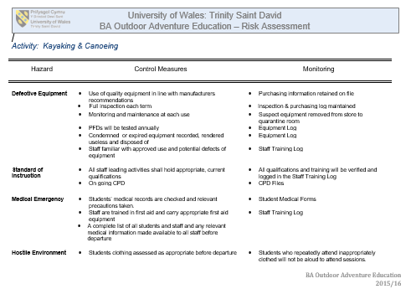
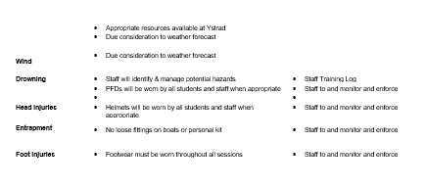

Hill Walking 13/03/18

The site that we visited was Herbert’s Quarry on Black Mountain on the west part of the Brecon Beacons. When re-doing a previous route, we in counted with some beautiful weather. In terms of wind there was not at all an extensive amount as there was a light breeze between 10mph-15mph. When looking at cloud cover, as from midday it cleared but a bit leaving us with blue skies. Giving us good visibility throughout the four and a half hours that we were there.
When looking at NGB’s there are a numerous number of qualifications that you do such as hill skills, mountain skills, lowland leader, hill and moorland leader, mountain leader, winter mountain leader and international mountain leader.
The specific skills that can be learned when hill walking are those such as map reading and working on a team.
Asides dynamically risk assessing further benefits from the session are those such as taking the lead of a group and directing them in the correct manner on the chosen route.
All our PPE was in good condition before the activity and then was inspected after in order to make sure that equipment is suitable to be used again.
The major hazards that you can come across when hill walking in the Brecon Beacons is the weather. It then vital when going out that you take appropriate clothing as weather is very likely to change very quickly and then good risk management is making everyone aware to take spare clothes.

Generic Risk Assessment
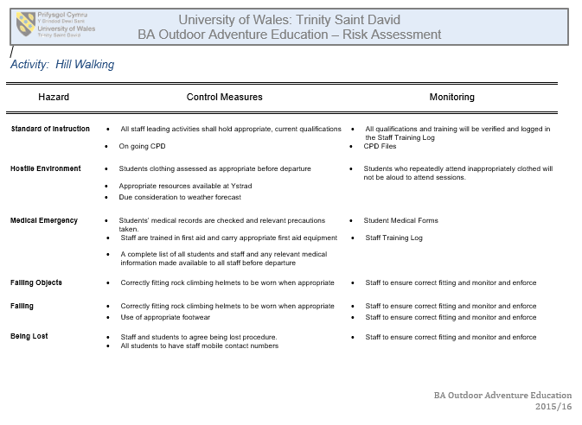

Coasteering 20/03/18

The location which we went to was St. Nons in St David’s. We had nice weather as the sun was out throughout the whole day. There was light north easterly to northerly winds 9-13mph with gusts up to 18mph. Temperatures were low between five and seven degrees Celsius. This being said we had excellent visibility as there was no clouds or fog. When we arrived (roughly around eleven) we did so at mid-tide, as high tide was at 08:30 14:47. They were five meter tides.

When looking at relevant legislations it is again very important that the code of conduct is taken in to account as access points must be usually public and if not and they are private they are to be treated with respect.

As far as NGB’s are concerned it is again vital that a first aid certificate is held along with a lifeguard qualification and a coaster award.

The skills that you may develop when coasteering is understanding what the sea is doing. You also may improve some scrambling skills as well.

Other benefits that you may gain from coasteering are that it will keep you fit as you are physically active.

All equipment such as buoyancy aid, wetsuit, helmet etc. Are all checked before and after going on the activity in order to ensure that they are in the best condition for our safety.

In terms of preparation, I felt that I could have prepared better by having bought gloves as I did suffer a bit from the cold.

Hazards when coasteering are sharp rocks. Again appropriate foot and hand wear. In order not to get any cuts or scratches from the sharp rocks and barnacles. Good risk management in relation to this will be to inform beforehand.

Generic Risk Assessment

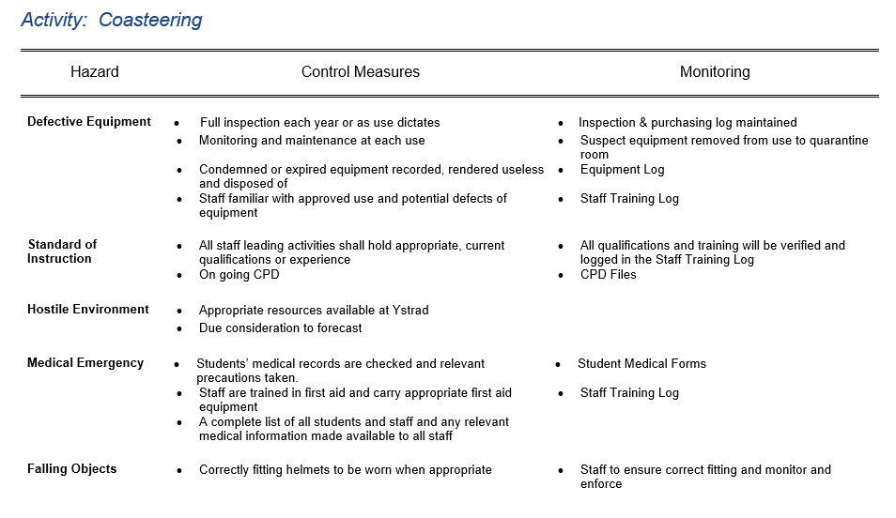

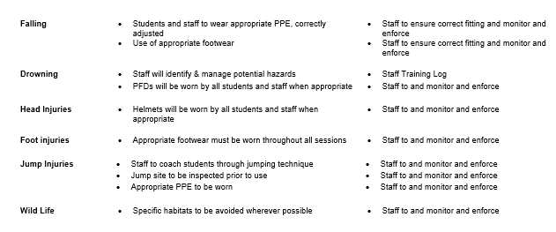

Surf Kayaking 24/04/18

For our surf kayaking we went down to Newgale in Pembrokeshire. The weather was worse than expected as the wind picked up. It was predicted to be between 9 and 13 mph. There was continuous rain throughout the entire day and as a result of cloud cover visibility was moderate. Temperature was between nine and ten degrees Celsius however as a result of the wind temperature felt roughly between six and eight degrees Celsius. This being said, as a result of the wind picking up we had to alternate our plans and instead of going on a journey and then for a surf we decided to make the entire session a surf session due to the fact there was a southern westerly to southerly in the morning moving over to a north westerly over in the evening. As a result of the conditions there was a 1ft- 2ft swell with a six second period but due to the wind it made everything choppy and very messy.

There are NGB awards for surf kayaking such as BC Surf leader or BCU sea coach, first aid. There are international laws and regulations which is known for preventing collision at sea.

There are many skills that may be developed from surf kayaking, as you learn how to read and ride waves. You may benefit from a range of skills and improve your balance.

PPE was all in very good conditions and it is again vital that equipment such as kayaks are kept safely and well as if not it will affect the way in which the kayaks will feel when riding them.

In terms of preparation, I felt prepared throughout the session as I felt comfortable and did not suffer from the cold.

When surf kayaking I again found that the weather played a major hazard as a result of wind direction and currents we were being pushed in a southerly direction going up the beach. A site specific hazard of the location we were in (Newgale), were the rocks when accessing the beach. Good risk management will be wearing appropriate footwear and due to good understanding of the sea it is important that you show two reference points where the group should stay in-between.

Generic Risk Assessment
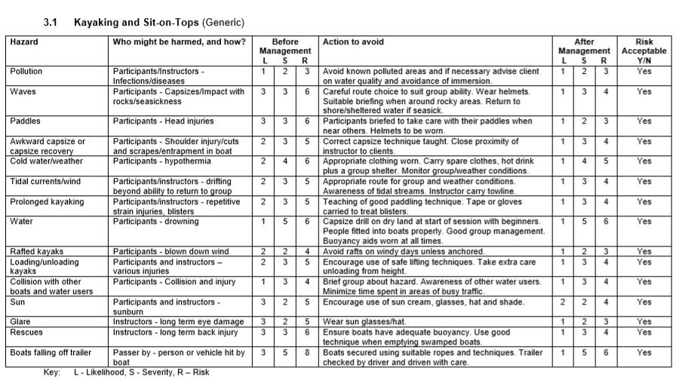

Appendix

Lyme Bay Tragedy 1993

On the 22nd March 1993 the Lyme Bay tragedy occurred on the south coast of England where on a sea kayaking trip four teenagers drowned out of eight. Due to a change in the weather the canoes were pushed out to sea and as a result of inexperienced instructors and teacher.

It all started with the teacher been drifted out to sea first, this therefore led one of the instructors to go and rescue the teacher whilst the other was left with the entire group. As this was happening the canoe continued to drift away where the wave height was starting to increase. As a result, the canoes started to fill up with water leading the individual to end up in the water.

References

BENNETT, P. (2018). The School Canoe Tragedy: Schoolchildren's adventure at sea that. (online) The Independent. Available at: https://www.independent.co.uk/news/uk/the-school-canoe-tragedy-schoolchildrens-adventure-at-sea-that-turned-father-tells-of-survivors-1499565.html (Accessed 1 May 2018).

