PROBLEM ANALYSIS AND DEVELOPMENT OF AN OPTIMISED GROUP MEETING SCHEDULING SOLUTION USING COMPUTATIONAL THINKING



Student Name :Lucia Nieto Gisbert
Student ID :2440002
Course Name :Computer Skills for Workplace Level 4
Module Name: Analysing and Solving Problems
Modulo Code :ACCA4019
Date:06/08/2026
Teaching: Amitave Banik
Group :4

Problem Analysis and Development of an Optimised Group Meeting Scheduling Solution Using Computational Thinking

Introduction
Collaboration is a key component to the success of project-based learning in higher education. The use of group projects is widespread in computing programmes as an effective method for building up students' technical background, but also for the important transferable skills which are acquired, including teamworking, communicative skills, time management and collaborative problem-solving skills. For learners, however, organizing meetings has become more difficult with many being employed and having to balance working jobs with family obligations and other activities. These conflicts of priorities often lead to scheduling conflicts and varying attendance and project advancement. As a result, poorly coordinated meetings can result in an imbalance of workload, less team motivation and delayed turn-in. The problem for this assessment will be structured in such a way that it can include finding appropriate meeting times for the entire group, reduce conflicts in the meeting timetable and make sure that meetings are scheduled prior to weekly project deadlines. In order to avoid designing programs specific to one institution, a generic method of problem solving is used: Computational Thinking (CT) principles, Abstraction and Systems thinking. The solution should be scalable and flexible to be adopted in other educational settings allowing for different class sizes, and flexible institution schedules.

Problem Deconstruction
Problem decomposition is one of the fundamental concepts of computational thinking in which a problem is broken down into modules or components that can be studied separately to create a bigger picture solution . Wing says decomposition helps simplify a problem by systematically breaking it into its constituent parts for examination, followed by building relationships among the parts. When applied to the present situation, the scheduling problem can be seen to be due to a number of inter-related aspects as opposed to an individual scheduling conflict . One way to prioritise the functional requirements is to apply the MoSCoW technique to categorises requirements based on how important they are to successful system operation.
Priority | Requirement
Must Have | Collect each student's available time slots, identify overlapping availability, schedule meetings before weekly deadlines and avoid timetable clashes.
Should Have | Recommend the most suitable meeting time based on maximum attendance, automatically notify members of confirmed meetings and permit schedule updates when availability changes.
Could Have | Suggest alternative meeting slots when conflicts occur, rank meeting options according to convenience and record previous attendance patterns for future scheduling improvements.
Won't Have (Current Scope) | Artificial intelligence prediction of future availability, automatic integration with external calendar services and optimisation across multiple project groups simultaneously.
In addition, there are various operational constraints that have a strong impact on the design of a solution. Academic timetables are always the same for each semester and part time work schedules frequently change weekly. Medical appointments, family commitments and other outside-of-school activities add to the unpredictability of student availability . In addition, each meeting should happen to occur enough ahead of the weekly project deadline so that participants have enough time to complete the tasks. Such limitations necessitate the scheduling process making decisions on the basis of feasible options instead of optimal options, since it may not always be possible for all members to be available.

Proposed Solution (Part A)
A structured scheduling solution has been designed to incorporate the principals of computational thinking, systems thinking and optimisation techniques in order to be able to identify appropriate scheduling times, reduce timetable conflicts, and maintain a consistent timetable outlining the weekly project deadlines . An automated solution around meeting times based on a logical decision-making process that checks students' availability and then proposes a schedule that seems to be the most convenient. The proposed solution does not use manual communication in the form of emails or messaging application.
The first step of the solution is to gather all the necessary scheduling information from each member of the group. Students must provide their weekly academic schedule, hours working part time, and personal commitments/preferred meeting hours . These variables are the main considerations in the scheduling process because they dictate the availability of each person to be scheduled. The information is then added to a structured data-set where each time slot, both available and unavailable, is clearly defined.
Once the data has been collected the scheduling algorithm checks whether there are any overlaps in availability between all members of the project group. This stage is called abstraction because the reasons behind certain commitments are deliberately left out, as unnecessary information. The only analysis that is done is the one of the availability statuses of each time slot. Abstraction allows people to represent and break up problems in their computations by only considering the specific features that should affect the choice they are making.
If overlap in availability is found, each of the possible meeting periods is checked against the weekly deadline of the project. If a time slot comes up after the deadline, it will be automatically rejected since it will not help with completing the task in time . This decision point ensures that there are adequate task allocation, discussion and completion at all scheduled meetings prior to submission deadlines.
If there are more than one overlapping meeting period, an optimisation algorithm is used to select the best one. Each alternative is not simply chosen based on availability of participants, but it must also meet a number of decision criteria, such as: How many participants are available, how close to the deadline is the available time slot, how long do you think the meeting will be, how convenient is the time for the group?
The proposed optimisation process is a weighted allocation process. Priority is given to Meeting Periods which meet all 4 levels of the mandatory requirement as defined in the MoSCoW analysis . For instance, the highest grade is given to persons who attend all classes prior to the weekly attendance deadline as it directly affects the successfulness of the project. Secondary considerations (e.g., convenient times, preferred time) are less important than the primary ones if they are in conflict with each other.
There is also a logical structure of the solution, which includes conflict resolution mechanisms. The algorithm would start by relaxing the lower priority preferences in a gradual manner while keeping the compulsory constraints as is, if there is no common meeting period . For example, meeting time schedules could be altered before trying to shorten meetings or hybrid online meetings are considered. But project timelines and minimum members' participation are never broken.

Proposed Solution (Part B): Flowchart and Solution Explanation

Flowchart for the Proposed Meeting Scheduling Process
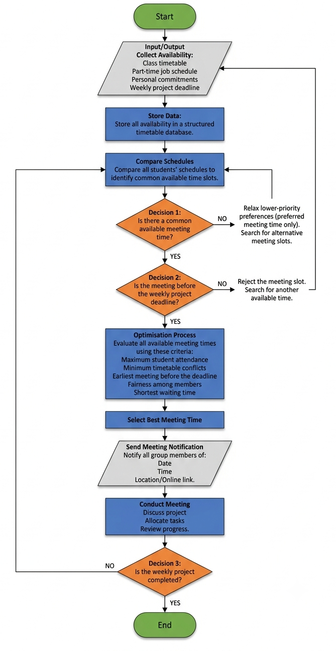
The flowchart proposed here is a decision-making model that is structured and follows the student's availability before scheduling a meeting. Availability is gathered from each group member, which includes lecture timetables and employment schedules and personal commitments. These data are then standardized for consistency when comparing it to others. This is the decomposition part of “computational thinking” since the scheduling problem is broken down into smaller, more manageable tasks.
The next step is to check the availability among all the schedules submitted and identify overlaps. Only the time-slot is considered, not any unnecessary personal information is analysed. This abstraction means that the complexity of the computation is greatly reduced and the scheduling system need only consider those variables that have a direct effect on the end result . If there is no common availability, then the algorithm does not terminate. Rather, the non-crucial aspects of the preferences are modified, such as meeting times, but the still-crucial ones are kept, e.g., project deadlines and minimum attendance criteria. As such, potential solutions are explored, without losing sight of the project's main purposes.
If a set of common meeting periods is detected, each option is analysed according to a set of predefined optimisation criteria. Meeting slots are identified by numbers, this is based on the number of participants, time to the weekly meeting, time expected for the meeting as well as the overall convenience for the group. The top result is then chosen since it meets a larger number of requirements with the least number of scheduling conflicts. This allocation method can help us be fair because it makes it so that students are not always put on the same time to meet.
After the best meeting time is determined, information is disseminated to all project stakeholders regarding project attendance at this meeting. After the meeting, progress on the project is reviewed, outstanding tasks are set and stuff to be done in the next scheduling cycle is prepared . As student availability often varies during the semester, the scheduling occurs again when there are any changes to the student schedule. The iterative approach here is similar to the continual feedback mechanism suggested in systems thinking, where an adjustment in one part of the system calls into question the whole scheduling process.
The proposed solution could be illustrated by an example. Imagine that there is a project group of 5 students with varying lecture hours and part-time works . A common meeting period is determined at first, but none exist during the first few months due to the fact that two members cannot attend on Wednesday afternoons. The algorithm then loosens the requirement on the preferred meeting-time without relaxing the requirement on the required deadline. Thursday morning is therefore being called the best time for a meeting as everyone wants to get in before the week's submitting deadline.
In conclusion, the flowchart proposed here illustrates the potential for incorporating computational thinking, optimisation methods, and logical decision-making into a real-world scheduling system. The solution minimises timetable clashes, facilitates fair play, fairness and efficiency in arranging meeting agendas and allows project groups to set up efficient meetings without risking that the weekly deadlines are not met.

Reflection and Conclusion
Construction of the suggested scheduling solution proved to be the implementation of computational thinking and structured problem-solving solutions to the real-life situation. The meeting organization difficulties of a student project group were solved by applying abstraction, decomposition, systems thinking and optimisation principles. These methods allowed the problem to be analysed in a logical, not intuitive, way, thus creating a solution that was systematic and adaptable. The problem was broken down into sub problems such as data collection, checking availability and conflicts, optimisation of schedules, and confirmation of meetings. This decomposition simplified the design and evaluation process for each individual stage of the decomposition and each stage could be evaluated independently.
Abstract thinking played a significant role in the design of the solution. Only information that directly concerned the scheduling of the work, e.g., availability of the timetable, work commitments and project deadlines, was taken into consideration. The information allowed to be recorded was specific solely to the organising of the meetings, with the personal details left out to ease the decision-making process in order to make the computational process more efficient. This way relates with the principles of computational thinking advocated by Wing who decided that removal of unnecessary complexity would allow to concentrate on important variables. In addition, a systems thinking approach was used to acknowledge that the scheduling process is an interconnected system of activities, as opposed to an independent set of activities. Schedule results are impacted by the availability of any one student, and the many options that need to be considered to ensure an effective schedule.
The MoSCoW prioritisation technique played a very important role in the strength of the proposed solution too. The scheduling algorithm identified mandatory and optional requirements, and always focused on critical objectives, such as common availability and holding meetings before weekly project deadlines. Other preferences were considered to be secondary, such as preferred meeting time, which were given more flexibility to be adjusted as needed. The prioritisation was key to the fairness and the usefulness of the works as it did not affect any essential needs for the project just as it did not allow any of the individual needs to be compromised.
However, the following were identified as limitations. The offered solution is based on the assumption of the student to be reliable with accurate and timely availability data. In reality, unforeseen circumstances, such as sickness, family emergencies, or changes in work practices can diminish the effectiveness of the scheduling process. Likewise, the optimisation model targets mainly finding available meeting times, and not forecasting future availability. This means that there will likely be some recalculation of meeting options if there is a change in the schedule that happens often. One constraint is the solution is essentially a basic structure and hence, would not contain sophisticated features like artificial intelligence, machine learning or direct access to digital calendar solutions. Predictive analytics could be integrated into future developments to anticipate student availability by analysing attendance patterns over time.

References
[1] K. Xiang, X. Hu, M. Yu, and X. Wang, “Exact and heuristic methods for a university course scheduling problem,” Expert Systems with Applications, vol. 248, Art. no. 123383, Aug. 2024.
[2] K. C. Ying, P. Pourhejazy, and X. Y. Huang, “Revisiting the development trajectory of parallel machine scheduling,” Computers & Operations Research, vol. 168, Art. no. 106709, 2024.
[3] N. Mehdiyev, M. Majlatow, and P. Fettke, “Counterfactual explanations in the big picture: An approach for process prediction-driven job-shop scheduling optimization,” Cognitive Computation, vol. 16, no. 5, pp. 2674–2700, 2024.
[4] M. Khatami and A. Salehipour, “The coupled task scheduling problem: An improved mathematical program and a new solution algorithm,” International Transactions in Operational Research, vol. 31, no. 4, pp. 2399–2426, 2024.
[5] T. Czajka, M. Böhm, and M. Karrenbauer, “Efficient multi-processor scheduling in increasingly realistic models,” in Proc. 36th ACM Symposium on Parallelism in Algorithms and Architectures (SPAA), 2024, pp. 301–313.
[6] D. A. Kononov and M. G. Furugyan, “Planning computations in real-time systems: Efficient algorithms for constructing optimal schedules,” Software & Systems, vol. 38, no. 1, pp. 55–64, 2025.
[7] A. Lazarev, D. Lemtyuzhnikova, and I. Kudinov, “Practical applicability of the metric approach for a scheduling problem,” Advances in Systems Science and Applications, vol. 24, no. 2, pp. 94–102, 2024.
[8] M. G. Furugyan, “Scheduling calculations for a multiprocessor system in real time,” Journal of Computer and System Sciences International, vol. 63, no. 1, pp. 122–130, 2024.
[9] S. Malik and M. Abdallah, “Artificial intelligence for university timetable scheduling: A systematic literature review,” Education and Information Technologies, vol. 29, no. 2, pp. 1453–1480, 2024.
[10] P. D. Harpe and J. Ellis, “Optimization methods for educational timetabling: A review,” European Journal of Operational Research, vol. 315, no. 1, pp. 1–18, 2024.
[11] C. Varela, C. Rebollar, O. Garcia, E. Bravo, and J. Bilbao, “Skills in computational thinking of engineering students of the first school year,” Education and Information Technologies, vol. 29, no. 9, pp. 11243–11266, 2024.

K. Xiang, X. Hu, M. Yu, and X. Wang, “Exact and heuristic methods for a university course scheduling problem,” Expert Systems with Applications, vol. 248, Art. no. 123383, Aug. 2024.
K. C. Ying, P. Pourhejazy, and X. Y. Huang, “Revisiting the development trajectory of parallel machine scheduling,” Computers & Operations Research, vol. 168, Art. no. 106709, 2024.
N. Mehdiyev, M. Majlatow, and P. Fettke, “Counterfactual explanations in the big picture: An approach for process prediction-driven job-shop scheduling optimization,” Cognitive Computation, vol. 16, no. 5, pp. 2674–2700, 2024.
M. Khatami and A. Salehipour, “The coupled task scheduling problem: An improved mathematical program and a new solution algorithm,” International Transactions in Operational Research, vol. 31, no. 4, pp. 2399–2426, 2024.
T. Czajka, M. Böhm, and M. Karrenbauer, “Efficient multi-processor scheduling in increasingly realistic models,” in Proc. 36th ACM Symposium on Parallelism in Algorithms and Architectures (SPAA), 2024, pp. 301–313.
D. A. Kononov and M. G. Furugyan, “Planning computations in real-time systems: Efficient algorithms for constructing optimal schedules,” Software & Systems, vol. 38, no. 1, pp. 55–64, 2025.
A. Lazarev, D. Lemtyuzhnikova, and I. Kudinov, “Practical applicability of the metric approach for a scheduling problem,” Advances in Systems Science and Applications, vol. 24, no. 2, pp. 94–102, 2024.
M. G. Furugyan, “Scheduling calculations for a multiprocessor system in real time,” Journal of Computer and System Sciences International, vol. 63, no. 1, pp. 122–130, 2024.
S. Malik and M. Abdallah, “Artificial intelligence for university timetable scheduling: A systematic literature review,” Education and Information Technologies, vol. 29, no. 2, pp. 1453–1480, 2024.
P. D. Harpe and J. Ellis, “Optimization methods for educational timetabling: A review,” European Journal of Operational Research, vol. 315, no. 1, pp. 1–18, 2024.
C. Varela, C. Rebollar, O. Garcia, E. Bravo, and J. Bilbao, “Skills in computational thinking of engineering students of the first school year,” Education and Information Technologies, vol. 29, no. 9, pp. 11243–11266, 2024.

