Managing Engineering Projects

Title: Applying Project Management Techniques

Author: David Whitmore
Email: David.Whitmore@vale.com
Number: 01792 841331
Address:
Vale Europe Limited,
Clydach Refinery,
Clydach,
Swansea,
SA6 5QR

Contents

Executive Summary 2
Introduction 3
Gantt chart 4
Communication Strategy 5
PERT Analysis 8
Project Costs 9
Crash Costing Techniques 10
Resource Management 11
Handover Considerations 12
Conclusion 14
References 15

Executive Summary
Vale Europe (Clydach Nickel Refinery) has a full program of mechanical works for the scheduled summer shutdown in 2020. At the time of writing this is planned for 26th April with a view to complete in the quickest possible time.
During the Vale Europe (Clydach Nickel Refinery) summer site shutdown of 2019 four distinct packages on the Kiln 2 side of the process plant were upgraded/modified. These being:
1. Early Works – Preparation & Works on Roof Elevation
2. Primary Scrubber Vessel replacement
3. Venturi Scrubber/Cooling Column Bypass pipework;
4. Gas Purge Lute Pot and pipework.
Due to operational benefits that have been realised by the Kiln 1 work, it is now Vale’s intention to duplicate the change on Kiln 1 during the 2020 shutdown. The same four distinct work packages above will exist, specifically early works in roof area, the replacement of the existing Primary Scrubber, bypassing the Venturi Scrubber/Cooling Column & installing a new Gas Purge Lute Pot.

Introduction
The purpose of this assignment is to create a Gantt Chart that will detail the activities and timescales required to successfully execute the proposed work in the given timescale. From this Gantt chart a critical path will be identified allowing a PERT analysis to be performed to identify the high-risk activities. The assignment will also address other aspects of the project life cycle, namely, project communication strategy, costing, resource scheduling and project handover.

Gantt Chart
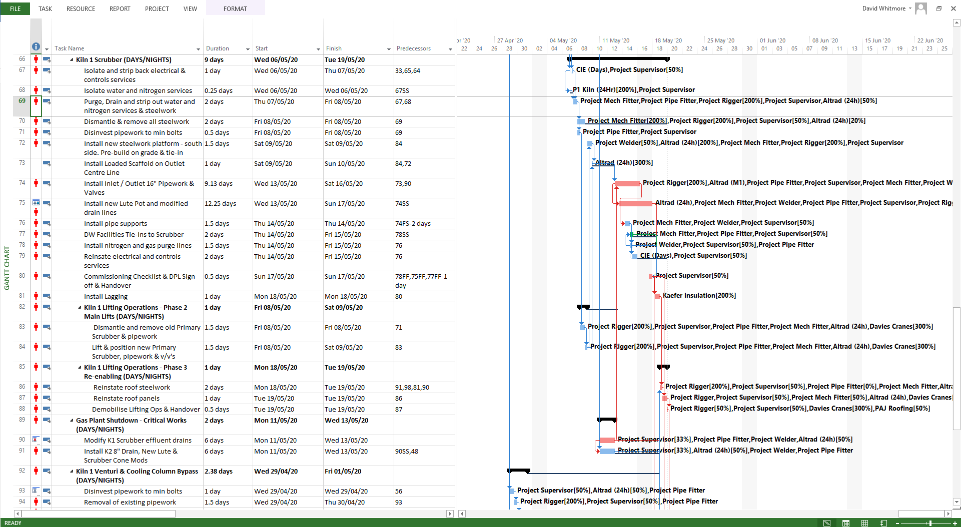

Communication Strategy
A Project Managers success is usually measured on executing the project on time and within budget, however for this this success to be realised the P.M will have to effectively manage the communications and interactions between the numerous interested parties and stakeholders.
As such, communication and the strategy adopted for its implementation is a key factor in successful project management. Many projects have encountered difficulties or ultimately failed due to poor management of communication.
It is the responsibility of the P.M to develop such a strategy at the outset of the project and ensure it is implemented effectively through the project life cycle.
The P.M will act as the central control for project communication ensuring the right information is provided to the right people in the right format at the right time, therefore delivering a clear direction an d progress to all stakeholders. As Campbell (2011) states " To manage a project effectively three types of communication occur: vertical communication, the up and down flow of communication based on hierarchical relationships; horizontal communication, based on communication with peers; and diagonal communication, the upward relationships with managers and diagonal communication with contractors and/or suppliers or team members of other departments"

The communication needs of the project are often misunderstood and underestimated. The process to prepare a communication plan as part of the project execution strategy will assist in developing an understanding of the needs of different groups associated with the project.
Written documents:
- Limit emails to the appropriate persons, ensuring a copy the Project manager and Project Coordinator.
- Always use the project reference number e.g. ‘1234’ at the start of the document reference subject/title.
Verbal communication:
- Always inform by email the Project Manager and the Project Coordinator of any relevant outcome (e.g. actions, important information, etc.) of the verbal communication. The Project Manager and the Project Coordinator will decide if they feel that the information needs to be recorded and distributed to the Project Team members.
- All Project Meetings will be documented, and the minutes distributed to all the Project Team.
Communication with the Project Steering:
- The Project Manager and the Project Coordinator will regularly inform the Project Steering members of the progress of the project.
Use of a common folder
- A Project Folder will be created on Company X server with a copy held by D Whitmore; the 2 will not be linked for safety reasons.
- Any files to be incorporated in the Project Folder will be done by D Whitmore
The Steering Group, Project Team and Project support members will have read access only to avoid discrepancy between information

Risk Management Techniques
Risk is defined as an “uncertain event or set of circumstances that, should it occur, will influence the achievement of one or more of the project’s objectives.” (APM, 2004, p. 17). Project risk has to be assessed throughout the entire project lifecycle. At the initial stage of a project it is important to capture both the risks and opportunities as this will help develop a comprehensive project scope. Using the below identification categories, the information can be recorded and monitored in a risk and opportunity register (see Appendix 1) throughout the project life cycle.
RISK Categories
1 | Low or Acceptable Risk
2 | Some Business Risk or Inefficiency but is plausibly not going to threaten the business/project significantly
3 | Significant Risk that could plausibly impact the project and Refinery operations

OPPORTUNITY Categories
A | Large prize, low resources (financial & manpower) to implement
B | Large prize but either high cost and/or high manpower to implement  OR… Smaller prize but low resources (financial & manpower) to implement
C | Smaller prize, but either high cost and/or high manpower to implement

This approach identifies:
1. The key risks and how to reduce their impact and/or their probability to occur, and;
2. The key opportunities and how to increase their benefit and/or increase their probability to materialize.
PERT Analysis
PERT Analysis allows you to calculate a weighted average time for each activity and is best suited to a project where is little to no previous knowledge or experience in the timings of the projects activities. It also acts a helpful tool for budgeting as it provides estimated durations that will assist Project Managers to identify the numerous resources they require.
The formula used to calculate the estimated time of a task is:
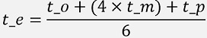
As part of the PERT analysis the likelihood of variance is also calculated, and this is done using the below formula:
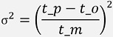
PERT Analysis of the Kiln Scrubber work package of the Project
Project Costs

Crash Costing

Crash costing is “a schedule compression technique in which costs and schedule trade-offs are analysed to determine how to obtain the greatest amount of compression for the least incremental cost.” (PMBOK® Guide). Example techniques include the following:
- Over-time
- Increasing resources to specific critical activities
- Employing additional resources
- Early completion incentives
- Outsourcing internal work / functions
- 24hr working
Crash costing would be utilised in a schedule driven scenario where the proposed project schedule is not acceptable to the client or stakeholder such as a fixed shutdown/maintenance window or specific completion date.
In the case of this assignment Vale Europe are scheduling work for their annual shutdown. As every hour of non-production cost's the company approximately £50,000, reducing this downtime window is a high priority.
The table below shows the crash costing techniques employed by the Project Manager on the critical path activities. This process has resulted in the project schedule being reduced by 15.5 days at an additional cost of £131,388.50.

Resource Management
There are 2 main types of resource optimisation methods available to the Project Manager. Again, the key factor in the method selected is dictated by whether the project is schedule driven, or not.
The two main methods of resource optimisation are:
- Resource smoothing:
This technique is used in a schedule driven project where the project's completion date must remain unchanged. Its aim is to adjust the activities so there are no peaks and troughs of resource usage while ensuring the critical path remains unaffected (Damci & Polat, 2014).
- Resource levelling:
This technique is used when there is a constraint on resource availability. Its aim is to balance the resource over the required activities by adjusting either the start or finish time or both. This method will often result in a change to the critical path (El-Rayes & Jun 2009).

Handover Considerations
A key step in the project life cycle is Project Handover to achieve conclusion for each of the
project milestones. These activities also extend to any temporary organization created for
the project lifetime. Elements associated with these milestones are listed hereafter.
Performance Test:
- Agreed procedure(s) (test allowances/margins for instrument accuracy, correction curves, instrumentation calibration, test code);
- Timeframe without restrictions due to external factors (availability of power or restrictions of export);
- Availability of test engineers;
- Format of report and time for review of agreement;
- Presence of independent monitoring / witnesses;
- Remedies to allow adjustment and retest in the event contractual performances are not met.
Punch list prior to Handover:
- Items to be completed before Take-Over;
- Disputed items: agreement on how to proceed;
- Replacement of operational spares used during commissioning agreed;
- Identification of items that may be deferred, with agreement on deferment.
Insurance, responsibilities identified:
- Resolution of outstanding claims;
- Closing of policies.
Warranty:
- Warranty engineers provision and accommodation;
- Access to operational records;
- Process for management of warranty claims with any warranty extension provisions understood;
- Equipment supplier warranties in place.
Availability or reliability guarantee (if applicable):
- Monitoring, calculation method and reporting agreed;
- Process for access to plant, for repair or verification agreed.
Operation and maintenance staff:
- Participation during the commissioning.
- Trained and signed off.
Documentation:
- O&M Manuals issued, process for updating in accordance with Commissioning experience established;
- As built documentation, scope and program to deliver established with the Sponsor and functions involved;
- Quality documentation from manufacturing, testing and construction delivered;
- Regulatory approvals documentation and certification available to allow operation, e.g. CE certification, pressure vessel certification, insurance or fire authority acceptance;
- Safety work instructions;
- Issue Take-Over certificate (TOC).

Conclusion
Projects can vary in type, size and complexity but the fundamental purpose of project management is to optimise the relationship between the cost, time and quality elements of the project through effective planning. The three variables above are inherently linked and are frequently subject to change. This paper has discussed some of the project management techniques available and applied them to a Vale Europe shutdown project. A Gantt chart has been created detailing the activities, dates and resources required to execute the schedule. The critical path was identified with the high risks identified through a PERT analysis. A crash costing exercise was then performed to explore the feasibility of reducing the project schedule. This resulted in a 15 day reduction to the project timeline at a justifiable cost.

References
Alderman, N., Ivory, C., McLoughlin, I., Thwaites, A., Vaughan, R. (2014). Managing complex projects: Networks, knowledge and integration. New York, NY: Routledge.
Alexander, J. (2015). Understanding why complex projects overrun: Developing a framework for identifying and managing risks (Unpublished PhD thesis). Curtin Business School, Curtin University, Perth, Western Australia.
Association for Project Management. (2004). Project risk analysis and management guide. High Wycombe, UK: APM Publishing Limited.
Biesenthal, C., Clegg, S., Mahalingam, A., Sankaran, S. (2018). Applying institutional theories to managing megaprojects. International Journal of Project Management, 36(1), 43–54.
Bower, D.C. and Finegan, A.D. (2009), “New approaches in project performance evaluation techniques”, Int. J. Managing Projects in Business, Vol. 2 No. 3
British Standards Institute. (2010). Project management: Principles and guidelines for the management of projects. London, UK: BSI.
Cable, D. M., Judge, T. A. (2003). Managers’ upward influence tactic strategies: The role of manager personality and supervisor leadership style. Journal of Organizational Behavior, 24(2), 197–214
Carbonara, N., & Pellegrino, R. (2018). Revenue guarantee in public-private partnerships: A win-win model. Construction Management and Economics, 36(10), 584–598. doi:10.1080/ 01446193.2018.1467028
Cooke-Davies, T. (2002). The “real” success factors on projects. International Journal of Project Management, 20, 185–190.
El-Rayes, K. , & Jun, D. (2009). Optimizing resource leveling in construction projects
Journal of Construction Engineering and Management, 135 (11), 1172–1180 .
Fortune, J., & White, D. (2006). Framing of project critical success factors by a systems model. International Journal of Project Management.
Hodgson, D. (2002). Disciplining the professional: The case of project management. Journal of Management Studies, 39(6), 803–821.
Kerzner, H (1989) Project management.. a systems approach to planning, scheduling, and controlling Van Nostrand Reinhold, New York
Meredith, J. R., Mantel, S. J. (2010). Project management: A managerial approach. Hoboken, NJ: Wiley.
Murphy, A. and Ledwith, A. (2007), “Project management tools and techniques in high-technology SMEs”, Management Research News, Vol. 30 No. 2
Ninan, J., Mahalingam, A., & Clegg, S. (2019). External Stakeholder Management Strategies and Resources in Megaprojects: An Organizational Power Perspective. Project Management Journal, 50(6), 625–640. https://doi-org.ezproxy.uwtsd.ac.uk/10.1177/8756972819847045
Pinto, J. K., & Slevin, D. P. (1988b). Critical success factors across the project life cycle. Project Management Journal, 19(3)
Project Management Institute. (2007). Practice standard for project configuration management. Newtown Square, PA: Project Management Institute.

Project Management Institute. (2008). A guide to the project management body of knowledge (PMBOK® Guide) (4th ed.). Newtown Square, PA: Project Management Institute.
Regan, M., Love, P. E. D., Jim, J. (2015). Public infrastructure procurement: A review of adversarial and non-adversarial contracting methods. Journal of Public Procurement, 15(4), 405–438
Thomas, J., Mullaly, M., 2009. Guest editorial: explorations of value: perspective on the value of Project Management. Project Management Journal 40
Turner, J.R., 2009. The Handbook of Project-based Management, third ed. McGraw-Hill Publishing, Glasgow.
Winch, G. M. (2014). Three domains of project organising. International Journal of Project Management, 32(5), 721–731.

Appendicies
Appendix 1 - Sample Risk and Opportunity Register

