

Submission By: Muhammad Shahid Ashraf
Submission ID: 2526077
CertHE Computing Skills for Workplace
Software Solutions for Business
ACCA4026

Table of Contents
Component 1- Coursework: Portfolio 3
Introduction 3
Task 1: Digital Storefront Platforms for Modern Business 3
1.1 Introduction to Contemporary E-Commerce Website Builders 3
1.2 Shopify as a Specialised E-Commerce Solution 3
1.3 Wix as a Flexible Website and e-Commerce Builder 4
1.4 Comparative Business Relevance 5
Task 2: Strategic Mind Mapping of Contemporary Business Software 5
2.1 Understanding Mind Mapping in Business Contexts 5
2.2 Mind Map of Contemporary Software Applications Used in Daily Operations 6
2.3 Analytical Relevance of Mind Mapping for Organisations 6
Task 3: Office Productivity Applications for Creating, Storing, Presenting, and Analysing Information/Data 7
3.1 Business Importance of Office Productivity Software 7
3.2 Microsoft Word for Professional Documentation 7
3.3 Microsoft PowerPoint for Business Presentations 8
3.4 Microsoft Excel for Analysis and Decision Support 9
3.5 Microsoft Access for Structured Data Storage 10
3.6 Practical Testing of Two Excel Features 11
3.7 Practical Test 1: IF Function 11
3.8 Practical Test 2: Pivot Table 12
3.9 Integrated Workflow Use Across Departments 15
3.10 Expanded Critical Evaluation of Each Application 15
3.11 Extended Reflection on Practical Testing and Business Relevance 16
3.12 Overall Evaluation of Office Applications 16
Task 4: Communication and Collaboration Applications in Modern Business 16
4.1 The Growing Role of Digital Communication and Collaboration Tools 16
4.2 Microsoft Teams as a Contemporary Communication Application 17
4.3 Trello as an Online Collaboration Application 17
4.4 Comparative Analysis of Business Relevance 18
4.5 Practical Testing of One Communication Feature 18
4.6 Practical Testing of One Collaboration Feature 20
Conclusion 21
References 21

Component 1- Coursework: Portfolio

Introduction
Modern business functions rely on efficient software applications that assist with communication, data management, online services, and overall operational efficiency. This paper analyses various software types, including business-focused e-Commerce website builders, mind-mapping software, office apps, and communication and collaboration tools. These software types will be examined theoretically and will include some practical components. The purpose of this report is to gain an understanding of how contemporary software (business-focused e-Commerce website builder, mind-mapping software, office apps, communication and collaboration tools) assist business functions and the impact of contemporary software on productivity, business performance, and digital operations.

Task 1: Digital Storefront Platforms for Modern Business

Introduction to Contemporary E-Commerce Website Builders
Modern e-Commerce site builders allow users to easily make functional websites for businesses without any programming knowledge. These site builders include website construction, along with business necessities, such as a product catalogue, payment processing, order management, shipping, and customer management tools. These site builders are extremely useful for modern businesses, as they help cut development costs, and provide a digital structure that can house businesses of any size. Shopify and Wix are among the most popular. Both offer services that support e-Commerce for modern businesses.

Shopify as a Specialised E-Commerce Solution


Shopify provides all necessary tools for selling goods online. This includes selling/outsourcing analytics, engagement tools, and controls for inventory. Shopify's biggest advantage is its scalable ability; starting a business at Shopify's supported enterprise level is much easier. Growth and complex sales processes are all supported by Shopify's integrated payment and their marketplace which is filled with apps. Shopify's ability to use new tools are AI supported design tools. Shopify focuses their analytics to account more for sales metrics to support higher reporting and operational scalability Webb. Shopify is best suited for mass selling analytical focused enterprises.


Figure 1.1 Shopify Landing Page

Wix as a Flexible Website and e-Commerce Builder


Still in the category of "continue to provide comment on the use of vendor's systems for e-Commerce businesses targeting small mozaicas", as we have discussed above, another versatile tool that offers e-Commerce thematic support for small- and medium-sized companies is Wix. Wix is in fact a close competitor of Shopify that is a website development tool. Unlike Shopify, Wix's primary function is to be a website builder and then add e-Commerce functionality to support. Regardless of this competitors of this type, Wix's unique characteristic is the simple-to-use drag and drop editor which makes interface design very simple for small and medium sized businesses with no technical background to design a website.
Because of this quality, Wix is suited for professional use. Wix's primary purpose is to provide the systems the professional use to sell in e-Commerce means their service provides the professional use systems in a medium and low professional use systems. Wix is also suitable for the type of business which is driven by content. Even though businesses of this type of characteristics seem to be targeting content as the most important element, actually the business fails to target the content and its e-Commerce. Profit margins are not taken under consideration when social e-Commerce capabilities are targeted. [2], [3]
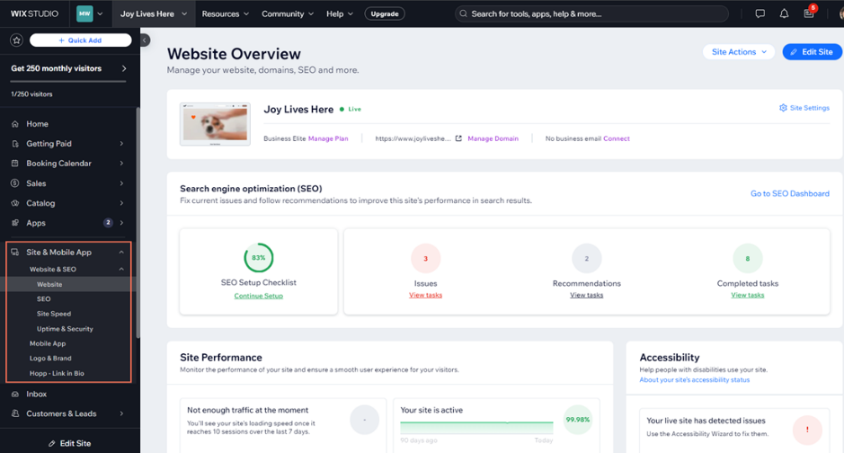
Figure 1.2 Wix Dashboard

1.4 Comparative Business Relevance
When it comes to contemporary e-commerce solutions, Shopify and Wix offer different advantages based on what each organisation is hoping to achieve. Shopify is better suited to businesses that are expecting to grow and develop along with their e-commerce solutions as it provides better commercial depth. Simpler businesses that are looking for a solution that is more easily implemented will find Wix better suited to their design needs. Wix and Shopify are prime examples that display the need for an e-commerce site builder to be chosen based on different factors, such as scale, budget, and customisation needs, along with the company's long-term digital strategy.

Task 2: Strategic Mind Mapping of Contemporary Business Software

2.1 Understanding Mind Mapping in Business Contexts
In its essence, a mind map is an organizational structure used to breakdown and simplify complex problems with multiple approaches. Essentially, mind mapping is used to break down all of the elements of a problem and synthesize an answer and solution with the greatest impact on a business objective. Businesses use mind mapping to work through all of the important details of problems, systems analysis, creative communication, collaborative project management, and to determine the interdependence of systems across multiple organizational areas. mind mapping is a system of organized analysis that presents information visually and improves comprehension, resulting in more effective decision-making [4], [5].
Mind mapping is of significant business value due to its ability to simplify complexity. Businesses use a variety of different communication software systems, office tools, accounting systems, e-Commerce applications, data analytics software, and more. When these tools are visually mapped out, managers and team members can readily identify how software applications overlap in the different operational areas and how digital resources can be organized and focused more efficiently. Rapidly expanding upon the ideas and information of a business goal without the risk of losing sight of that goal contributes to increased creativity, productivity, and innovation. This leads to accelerated planning, reduced information overload, and improved collaboration across different business units [5], [6].

2.2 Mind Map of Contemporary Software Applications Used in Daily Operations
We may visualize the current business software ecosystem as a mind map spanning from the centre Business Operations Software. Branching from this centre, there are four major functional areas where modern organizations operate. Productivity software, which includes both document creation (e.g., MS Office), and analytics and reporting software (MS Excel) are at one end. There is also a database management function (MS Access). At the other end, there are the communication systems. These incorporate both synchronous and asynchronous systems (e.g., MS Teams, Zoom) which facilitate messaging, meetings, and other forms of remote collaboration.
The other areas of enterprise functionality are just as pervasive. There are systems for collaboration and project management (e.g., Trello, Google, Slack) that allow teams to share files, assign tasks, and coordinate workflows in real-time. E-Commerce systems, customer-facing systems (like Shopify and Wix), order management, and customer interaction are also key functional areas. Finally, there are systems that capture the financial and analytics aspects of the enterprise. These include reporting and dashboard tools that are used to monitor performance and support managerial decision-making.
This mind map shows how software applications are not used in isolation. Each category contributes to daily organisational activities. Taken together, they form a cohesive digital ecosystem to support communication, productivity, sales, analysis, and strategic control. The mapping process also helps businesses comprehend the interconnections between software and identifies optimisation opportunities.

2.3 Analytical Relevance of Mind Mapping for Organisations



Aside from the visual aspect of nte-taking, mind maps have a business-centric dimension. At the organizational level, mind maps assist in visualizing digital structures, process awareness, and aligning software investments with business goals. Therefore, it is valuable for managers and analysts, as well as students evaluating contemporary tools and organizational productivity.

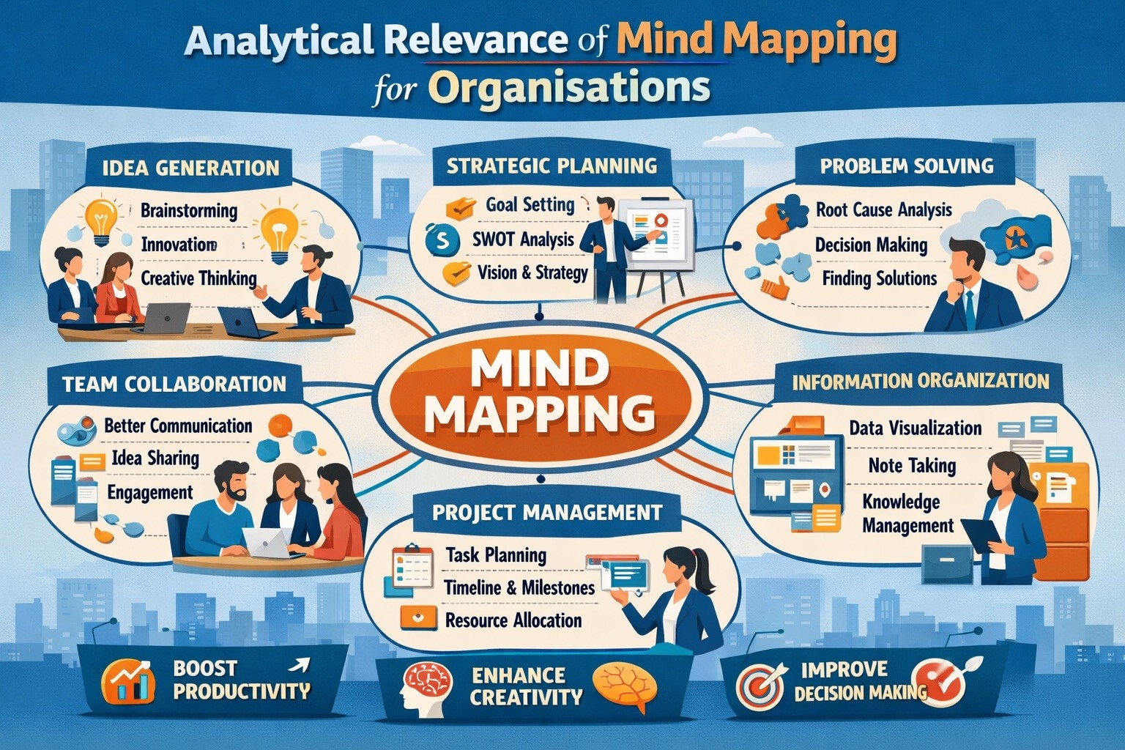

Figure 2.1 Usage of ind Mapping

Task 3: Office Productivity Applications for Creating, Storing, Presenting, and Analysing Information / Data

3.1 Business Importance of Office Productivity Software
The modern business operation cannot be without office productivity applications as they aid in the entire information lifecycle, such as creating documents, storing data, presenting and analysing, and reporting. Microsoft Word, Microsoft PowerPoint, Microsoft Excel, and Microsoft Access are popular in most organisations since they serve a particular functional requirement and are still a part of an interconnected Microsoft platform. They are important in real-world applications because they enhance efficiency, minimise manual labour, standardise communication, and facilitate evidence-based decision-making. All these enable businesses to administer administrative and strategic procedures in a dependable online setting.

3.2 Microsoft Word for Professional Documentation
Microsoft Word is mainly employed in the development of professional business documents i.e., reports, proposals, contracts, invoices, policies, meeting minutes, customer correspondence. Its key characteristics are sophisticated formatting, templates, citation aids, auto table of contents, styles, page structure, spell check, track modify, comments and mail merge. These characteristics render it very useful in the standardisation of official documents in different departments.
Consistency in formal communication is the key advantage of Word. Companies will be able to develop templates of HR letters, legal documents and management reports that can be used again, saving time on formatting and being able to remain professional. Microsoft 365 also enhances real-time collaboration, which enables various employees to read and edit the same file at the same time [7]. One shortcoming of Word is that highly intricate design work might still need to use specialist publishing software.

Figure 3.1 Microsoft Word

3.3 Microsoft PowerPoint for Business Presentations
Microsoft PowerPoint aids business communication by providing visual presentation of ideas, reports and strategies. It is commonly applied in sales pitches, training programs, management meetings, project status reports, and stakeholder reports. Themes, SmartArt, animations, charts, slide transitions, multimedia embedding, presenter mode, and design suggestions are some of the key features.
The key advantage is that it can transform complicated information into a vivid storytelling. As an example, Excel numerical results can be given in the form of charts and summary slides to the executives, which makes it easier and quicker to make decisions. It is especially useful in marketing, project management, and training of employees [8]. It is limited by the fact that the design of the slides or too much text may diminish the effectiveness of communication.
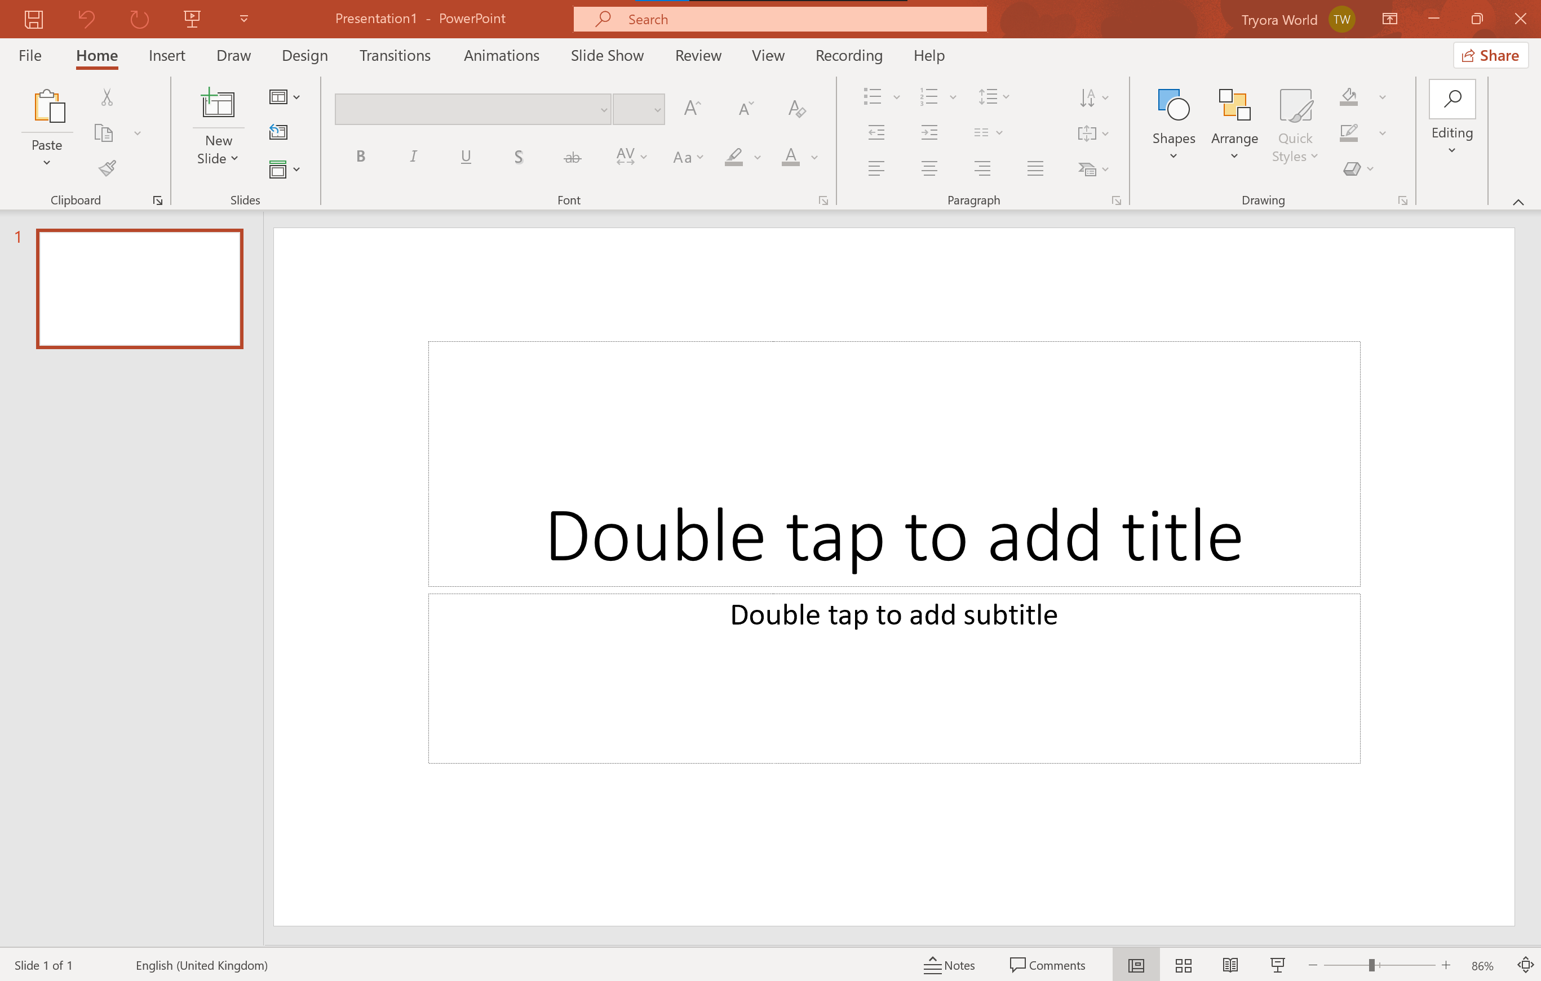
Figure 3.2 Microsoft PowerPoint

3.4 Microsoft Excel for Analysis and Decision Support
One of the most essential business applications in business settings is Microsoft Excel. It is popular in budgeting, payroll, forecasting, inventory management, KPI dashboards, financial modelling and performance reporting. Its significant functions are formulas, functions, PivotTables, IF statements, VLOOKUP, charts, Goal Seek, conditional formatting, sorting, filtering, and data validation.
The most advantageous thing about Excel is analytical flexibility. It assists in simple calculations and the sophisticated analysis of businesses. It enables managers to find out trends, compare sales performance, compute costs and conduct scenario planning. Functions like IF and VLOOKUP are used to automatically apply repetitive logic and PivotTables are used to summarise large datasets into valuable insights [9]. One of the disadvantages is that spreadsheet mistakes are possible when the formulas are not verified.
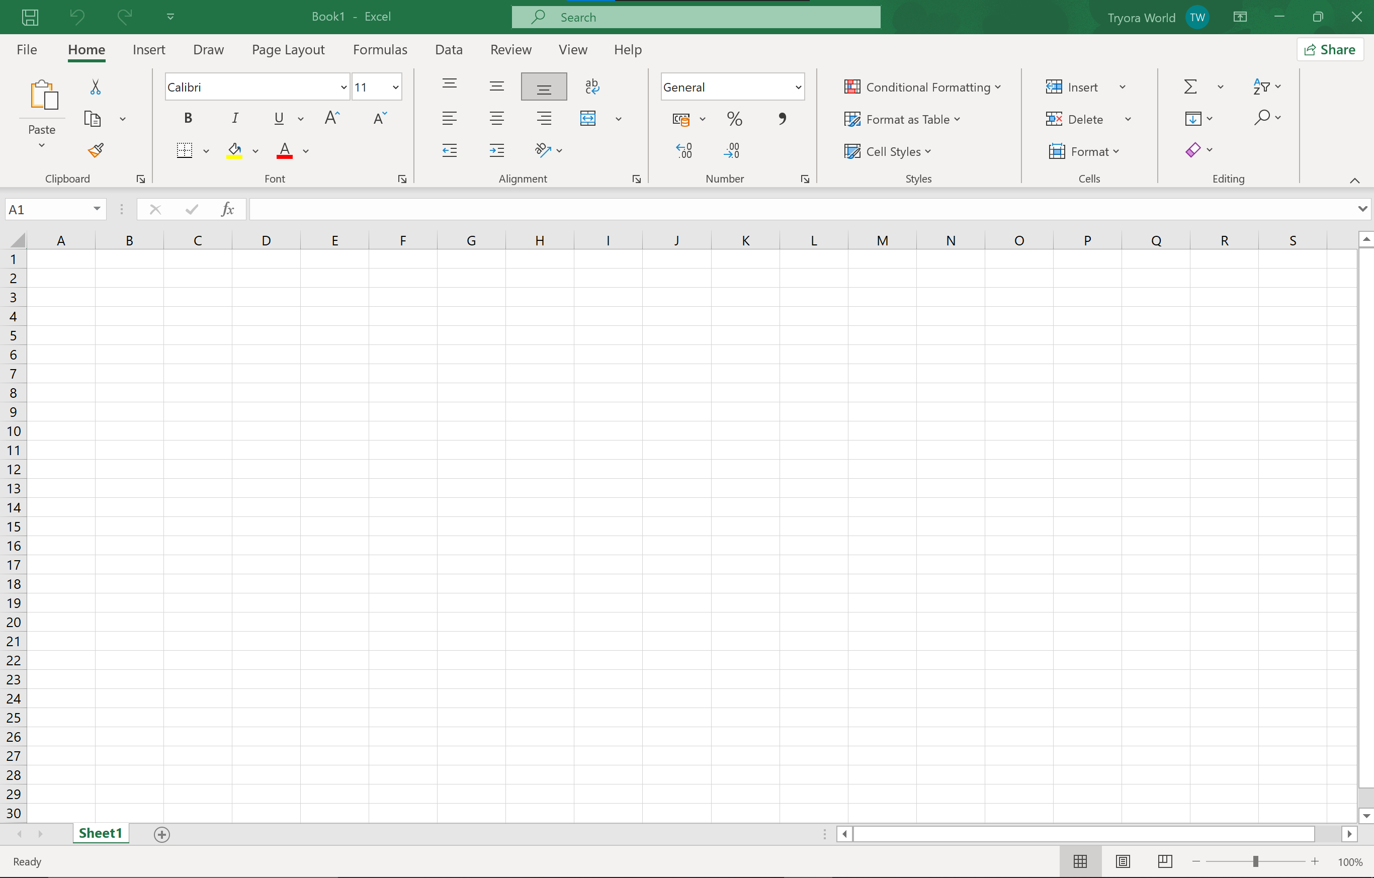
Figure 3.3 Microsoft Excel

3.5 Microsoft Access for Structured Data Storage
Microsoft Access is a relational database program which is utilized to save and access structured data. Uses It can be used in customer databases, employee databases, inventory systems, supplier systems and order books. Tables, queries, forms, reports, relationships and validation rules are the biggest characteristics.
The key advantage of Access is an enhanced data integrity as opposed to spreadsheets. It does not need redundancy through connecting related tables, and allows quick retrieval of information through queries. When dealing with small and medium businesses, it provides inexpensive database functionality as opposed to expensive enterprise database server, which is complex [10]. It is scaled by the fact that very large multi-user systems would be better served by SQL-based systems.

Figure 3.4 Microsoft Access

3.6 Practical Testing of Two Excel Features
In order to illustrate software application in the business processes practically, two functions of Microsoft Excel were tried: the IF Function and the Pivot Table. These features were chosen since they illustrate logical automation as well as data summarisation that are very pertinent in business decision making.

3.7 Practical Test 1: IF Function
A sample employee performance dataset was used to test the IF Function. The worksheet contained the names of the employees, sales figures and a performance outcome column. The formula was dependent on a predefined sales target to evaluate whether the employee met target.
The equation that was typed in was:
=IF(B2>=50000,"Target Achieved","Below Target")
This autofilter was used to test whether the sales in cell B2 was less than or equal to 50,000. In case the condition was true, the result was the Target Achieved; otherwise, it was the Below Target. This applied exercise shows how Excel can be applied to rule-based decision logic within a business context like sales performance analysis, employee appraisal, and bonus eligibility.
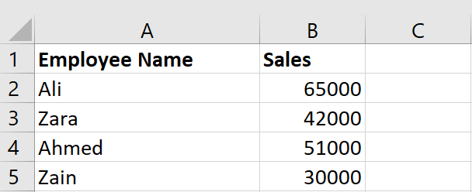
Figure 3.5 Original employee sales dataset before IF Function#
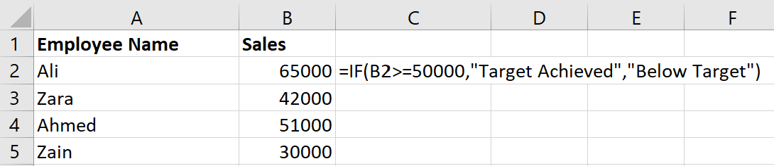
Figure 3.6 IF Function applied in formula bar
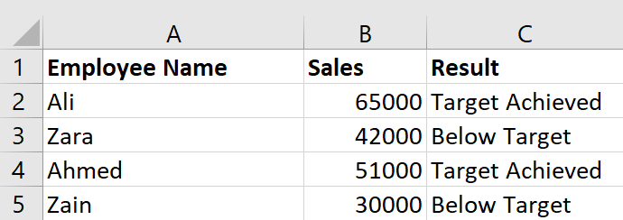
Figure 3.7 Final output of IF Function for employee target evaluation

3.8 Practical Test 2: Pivot Table
The second feature being tested was Pivot Table with a sample monthly sales data with product name, region and sales values. The aim of the test was to condense raw sales data into a report that is easy to understand by the management.
The Pivot Table was built by clicking on the dataset, then clicking on the Insert menu and Pivot Table, and setting the product as a row, Region as a column, and Sales Amount as values. The resultant table automatically created total sales per product and region.
This aspect is most useful in business activities since it converts raw transactional data into summary reports that can assist managers make decisions. An example of this is that a business manager is able to know the region that has brought the greatest revenue or which product is doing well within the month within a short time. Pivot Tables are also much faster and more analytical in time than manual calculations [11].
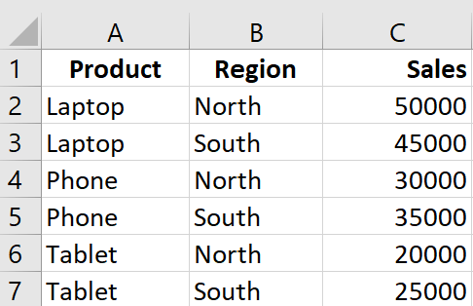
Figure 3.8 Raw sales dataset used for Pivot Table analysis
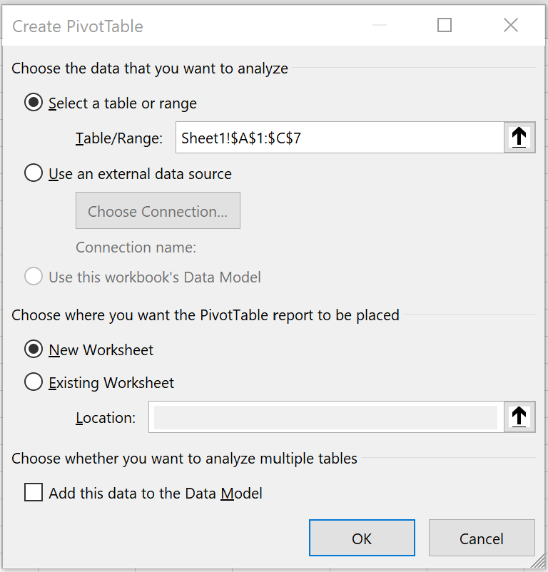
Figure 3.9 PivotTable creation dialog box in Microsoft Excel
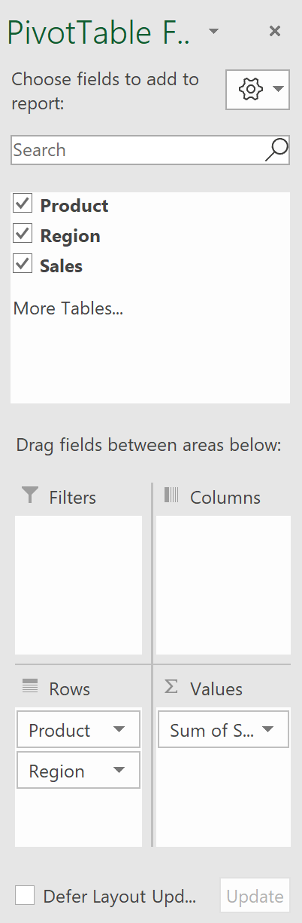
Figure 3.10 PivotTable field selection panel setup
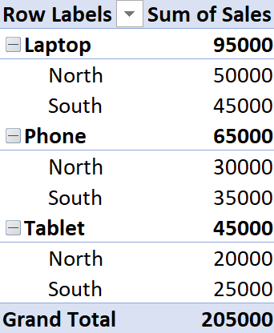
Figure 3.11 Pivot Table summary of regional sales performance

3.9 Integrated Workflow Use Across Departments
The usefulness of these office applications is further enhanced when considered as belonging to an entire organisational process. When dealing with a typical business, customer/sales information can be initially stored within Microsoft Access in a structured database format. This information may be exported to Microsoft Excel to perform financial analysis, trend detection and create KPI dashboards. After the interpretation of the findings, the results are usually written in Microsoft Word in form of a formal management report and converted to Microsoft PowerPoint slides to be presented in executive meetings or to the stakeholders.
This workflow illustrates how the four applications are complementary to each other and not independent of each other. Their interoperability minimizes repetition of work, enhances compatibility, and enhances accuracy of data in various departments. In terms of business efficiency, the integration assists organisations to develop more efficient digital processes and expedited reporting loops.

3.10 Expanded Critical Evaluation of Each Application
Further analysis reveals that every application has a different impact on business performance. Microsoft word finds primary application in formal communication and compliance and also in the centre of legal documentation, policy development and external correspondence. Its value is the greatest in organisations where quality of standardisation and professional documentation matters.
The Microsoft PowerPoint has a greater contribution in strategic communication. Presentation of data in a convincing manner in the course of business activities may determine whether an investment is made, or a client given the nod, or a project extended. As such, it is not only important aesthetically but also in terms of managerial impact and involvement among stakeholders.
The greatest contribution to operational intelligence is that of Microsoft Excel. It aids in making short-term tactical actions, like stock refill and payrolls, and long-term forecasting and budgeting. Due to such versatility, Excel is one of the most business-critical applications in contemporary places of work.
Microsoft Access helps with the organization of data storage and their regulated retrieval. Its relational model enhances consistency and minimized operational risk due to redundant or obsolete records. This has great efficiency advantages in businesses where data on recurring customers, employees or inventory are handled.

3.11 Extended Reflection on Practical Testing and Business Relevance
The illustrative application of the IF Function and Pivot Table also underline the concept of how Office programs can help in the actual business processes. The IF Function is a conditional business logic which is widely used in decision automation. An example of this is attendance decisions within an HR system, credit limits within the financial system or commission eligibility within the sales system are all the same thing.
Similarly, the Pivot Table exercise demonstrates that managers do not need to use sophisticated data science tools to enable them to process enormous amounts of data into strategic summaries. In real world of business this assists in sales analysis, customer segmentation, reviews of budget and monitoring performance. The possibility of cutting thousands of rows into easy to understand reports within a few seconds significantly improves the quickness of reporting and responsiveness amongst managers.
Practical exercises are particularly significant due to being demonstrations not only of theoretical knowledge but also direct skills in software application, which are key transferable skills in the contemporary workplace.

3.12 Overall Evaluation of Office Applications
The four apps in Microsoft Office are all useful in facilitating the key business processes of documentation, visual communication, numerical analysis, and data storage. The applied Excel testing also illustrates the use of such tools in real life scenarios in order to automate logic and summarise operational data. This balance between theoretical explanation and practical evidence demonstrates how the office software directly leads to productivity, the quality of communication, and decision-making based on data in modern organisations.

Task 4: Communication and Collaboration Applications in Modern Business

4.1 The Growing Role of Digital Communication and Collaboration Tools
In modern business environment, communication and collaboration applications have proved to be indispensable towards ensuring productivity, coordination, and teamwork in both physical and remote settings. Such tools are being used by modern organisations to facilitate instant communication, virtual conferences, file sharing, coordination of tasks and execution of cross departmental projects. The growing use of hybrid work has further enhanced the value of digital platforms that enable employees to be in touch with each other at any time and any place. Microsoft Teams is one of the most efficient modern tools as a means of communication, and Trello is a well-known online collaboration tool with workflow and task management.

4.2 Microsoft Teams as a Contemporary Communication Application
Microsoft Teams is a business communication platform that is available as a cloud and is commonly used to conduct messaging, video conferencing, voice calls, file sharing, and discussions in the form of channels [12]. Its key functions are one-on-one chats, group calls, meeting scheduling, screen sharing, captions in real-time, recording of meetings, embedding files into the Microsoft 365 platform, and status updates. These functions enable it to be very appropriate when it comes to internal communication within departments in organisations that already have Word, Excel, PowerPoint and Outlook.
The primary advantage of Microsoft Teams is integrated communication. Businesses can also centralize all the communication activities in one safe platform as opposed to having to use different software to do their messaging, meetings and document sharing. This minimizes the context switching, enhances the response time and provides strong workflow continuity. Teams’ channels are especially effective in communication between departments due to the possibility of organisation of the conversation on the basis of the project, business functions, or operational objectives. It can also be integrated with Microsoft 365, meaning that employees can co-edit Word or Excel files in chats and meetings, which is much more efficient in remote and hybrid work settings.
In terms of business analysis, Teams enhances the speed of decision-making by promoting quicker discussions, live meetings, and real-time collaboration of documents. It is also incredibly useful in communication with clients, in training and onboarding of employees and in coordination between different functions. The recent meeting summaries and chat insights assisted by AI have added to its strategic worth in the contemporary organisations.

4.3 Trello as an Online Collaboration Application
Trello is a popular web-based teamwork and project management system that aids in coordinating a team using a visual board-and-card system [14]. It is particularly useful in task management, workflow management, deadline management and team management. Its key capabilities are boards, lists, cards, due dates, labels, checklists, file attachments, automation rules, integrations, and progress visibility.
Workflow transparency is the best advantage of Trello. Today, in business, there are numerous teams that tend to operate concurrently on marketing campaigns, software development, content planning, customer service, or internal work. Trello enables the representation of each task in the form of cards that can be transferred through workflow phases To Do, In Progress, Review, and Completed. Such a visual system enhances accountability since all team members can easily observe ownership, deadlines and progress.
Cross-functional collaboration is another key business strength. Departments are able to share boards, add files, add members and comment on tasks. This minimises the time delay of communication and makes sure that the information of the project is not decentralised but is concentrated in one place instead of being scattered between emails or chat threads. In the case of small and medium-sized businesses, Trello can be particularly helpful since such collaboration can be provided at a high level, without complex technical configuration.

4.4 Comparative Analysis of Business Relevance
Despite the fact that Microsoft Teams and Trello possess distinct main functions, they are complementary in business activities. Teams emphasises the flow of communication based on messaging and meetings, whereas Trello emphasises the execution of tasks and visibility of the workflow. Practically, they can be combined: Teams to communicate and Trello to monitor the projects [12], [14]. The combination of such usage forms a more powerful operational ecosystem that facilitates information sharing and action management.

4.5 Practical Testing of One Communication Feature
In the case of the practical communication test, the Microsoft Teams screen sharing option is highly suggested due to its simplicity of demonstration and its close association with business applications like meetings, client demonstrations and employee training.

Figure 4.1 Microsoft Teams meeting interface before screen sharing
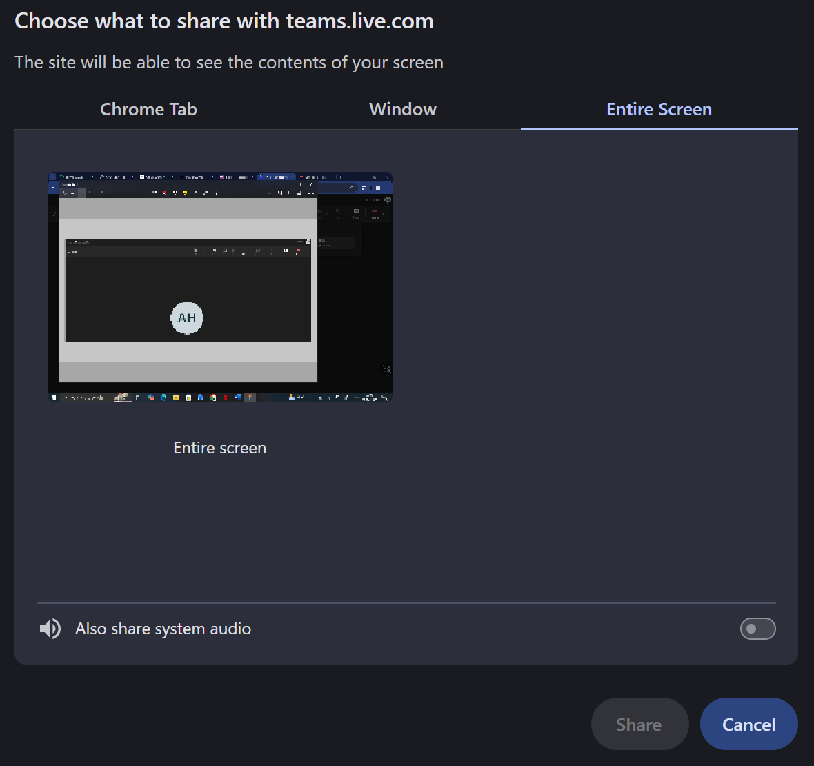
Figure 4.2 Microsoft Teams screen sharing options panel
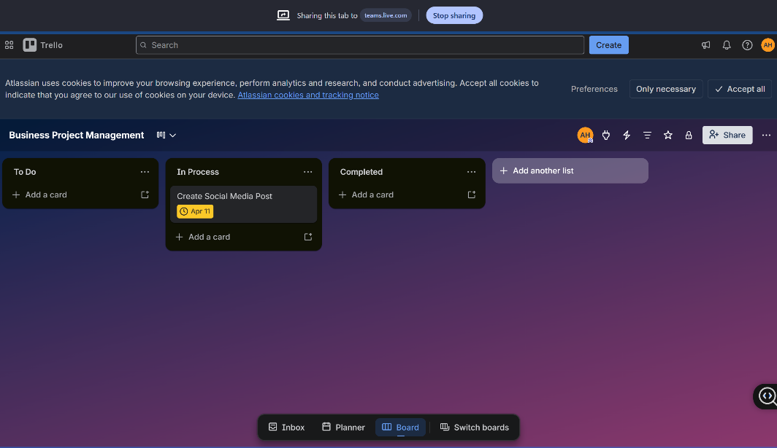
Figure 4.3 Microsoft Teams screen sharing during virtual business meeting
In order to do the activity, in Microsoft Teams, initiate a test meeting, then select the Share button and either Desktop or Window sharing. Bring a Word document, excel spreadsheet, or power point presentation to the meeting.
The description that accompanies it must clarify that this feature helps with real-time communication and demonstrations as well as in collaborative document review, enhancing the speed of decision-making and coordination in remote situations.

4.6 Practical Testing of One Collaboration Feature
In the case of the collaboration test, the most useful aspect of Trello to illustrate is the ability to create task cards and move them through the stages of workflow.
Make a plain Trello board of a business project like in the case of “Marketing Campaign”. Include columns like To Do, In Progress and Completed. Now, make one task card, give it a due date and drop it out of To Do into In Progress.

Figure 4.4 Empty Trello board showing project workflow structure

Figure 4.5 Task card created in Trello under To Do list

Figure 4.6 Due date settings applied to task card in Trello

Figure 4.7 Trello task card movement across project workflow
This real-world evidence shows the relevance of collaboration tools in tracking tasks, accountability and monitoring of progress in contemporary organisations [13], [14].

Conclusion
To sum up, modern business efficiency, communication, data management, and decision-making depends on the use of contemporary software applications. In this assignment, I learnt the manner in which organisational performance can be supported using e-Commerce, mind mapping, office productivity and collaboration tools. Their real-world value was also affirmed in the practical activities, which demonstrated the enhancement of workflow, coordination and business productivity in general with the help of digital solutions.

References
[1] Shopify, “Best eCommerce software for 2026,” 2026.
[2] TechRadar, “Shopify review 2026,” 2026.
[3] TechRadar, “Wix website builder review 2026,” 2026.
[4] MindManager, “What is mind mapping in business,” 2025.
[5] A. Osterwalder and Y. Pigneur, Business Model Generation. Hoboken, NJ, USA: Wiley, 2010.
[6] Lucid Software, “Benefits of mind maps for business planning,” 2025.
[7] Microsoft Support, "What’s new in Word," 2026.
[8] Microsoft 365, "PowerPoint productivity and design features," 2026.
[9] Microsoft Support, "New Excel functions and data analysis features," 2026.
[10] Microsoft Learn, "Fundamentals of Microsoft Access databases," 2025.
[11] Microsoft Support, "Create a PivotTable to analyse worksheet data," 2026.
[12] Microsoft Support, Microsoft Teams help and learning, 2026.
[13] Slack, Best team collaboration tools for productivity in 2026, 2026.
[14] Trello, project collaboration at Atlassian, 2026.

