Appendices

Appendix 1 -Ethics Form

APPLICATION FOR ETHICAL APPROVAL
In order for research to result in benefit and minimise risk of harm, it must be conducted ethically. A researcher may not be covered by the University’s insurance if ethical approval has not been obtained prior to commencement.
The University follows the OECD Frascati manual definition of research activity: “creative work undertaken on a systematic basis in order to increase the stock of knowledge, including knowledge of man, culture and society, and the use of this stock of knowledge to devise new applications”. As such this covers activities undertaken by members of staff, postgraduate research students, and both taught postgraduate and undergraduate students working on dissertations/projects.
The individual undertaking the research activity is known as the “principal researcher”.
Ethical approval is not required for routine audits, performance reviews, quality assurance studies, testing within normal educational requirements, and literary or artistic criticism.
Please read the notes for guidance before completing ALL sections of the form.
This form must be completed and approved prior to undertaking any research activity. Please see Checklist for details of process for different categories of application.
Delete the Guidance Notes at the end of the form BEFORE submitting your application
SECTION A: About You (Principal Researcher)
Full Name: |  | Caitlin Ford
Tick all boxes which apply: |  | Member of staff: | ☐ | Honorary research fellow: | ☐
Undergraduate Student | ☒ | Taught Postgraduate Student | ☐ | Postgraduate Research Student | ☐

Faculty/School/Centre: | Yr Athrofa, UWTSD.
Campus: | Carmarthen
E-mail address: | 1701843@student.uwtsd.ac.uk
Contact Telephone Number: | 07925054444
For students:
Student Number: | 1701843
Programme of Study: | BA Primary Education with QTS
Director of Studies/Supervisor: | Dr Sioned Hughes

SECTION B: Approval for Research Activity
Has the research activity received approval in principle?  (please check the Guidance Notes as to the appropriate approval process for different levels of research by different categories of individual) |  | YES | ☒ | NO | ☐
 |  |  |  | Date
If Yes, please indicate source of approval (and date where known): Approval in principle must be obtained from the relevant source prior to seeking ethical approval | Research Degrees Committee |  | ☐
 | Faculty Research Committee |  | ☐
 | Other – Module Lead |  | ☒ | 06/02/2020

SECTION C: Internal and External Ethical Guidance Materials
Please list the core ethical guidance documents that have been referred to during the completion of this form (including any discipline-specific codes of research ethics, and also any specific ethical guidance relating to the proposed methodology). Please tick to confirm that your research proposal adheres to these codes and guidelines.
UWTSD Research Ethics & Integrity Code of Practice | ☒
UWTSD Research Data Management Policy | ☒
BERA (British Educational Research Association) guidelines – Ethical Guidelines for Educational Research, (2018). | ☒
The research is within the bounds of the normal classroom and in accordance with the ATHROFA guidelines for parental consent as per ATHROFA letter. | ☒
Education Workforce Council (EWC) Research and Ethics Guidelines (2019) | ☒

SECTION D: External Collaborative Research Activity
Does the research activity involve collaborators outside of the University? |  | YES | ☐ | NO | ☒
If Yes, please provide the name of the external organisation and name and contact details for the main contact person and confirmation this person has consented to their personal data being shared.as part of this collaboration.
Institution
Contact person name
Contact person e-mail address

Has this individual consented to sharing their details on this form? |  | YES | ☐ | NO |  |  | ☒
Are you in receipt of a KESS scholarship? |  | YES | ☐ | NO |  |  | ☒
Is your research externally funded |  | YES | ☐ | NO |  |  | ☒
Are you specifically employed to undertake this research in either a paid or voluntary capacity? | Voluntary | YES | ☐ | NO |  | ☒
 | Employed | YES | ☐ | NO |  | ☒
Is the research being undertaken within an existing UWTSD Athrofa Professional Learning Partnership (APLP) | If YES then the permission question below does not need to be answered. | YES | ☒ | NO |  |  | ☐
Permission to undertake the research has been provided by the partner organisation | (If YES attach copy)  If NO the application cannot continue | YES | ☐ | NO |  |  | ☐

Where research activity is carried out in collaboration with an external organisation
Does this organisation have its own ethics approval system? | YES | ☐ | NO | ☒
If Yes, please attach a copy of any final approval (or interim approval) from the organisation

SECTION E: Details of Research Activity
Indicative title: | An investigation into how pupil voice can be used to improve behaviour in schools.
Proposed start date: | 10/02/2020 | Proposed end date: | 01/07/2020
Introduction to the Research (maximum 300 words)
Ensure that you write for a Non-Specialist Audience when outlining your response to the three points below:
- Purpose of Research Activity
- Proposed Research Question
- Aims of Research Activity
- Objectives of Research Activity
Demonstrate, briefly, how Existing Research has informed the proposed activity and explain
- What the research activity will add to the body of knowledge
- How it addresses an area of importance.

Purpose of Research Activity
- To explore how pupil voice can be used in schools and its effect on behaviour.
- To further develop professional knowledge, understanding and future practice.
(this box should expand as you type)
Research Question
How can pupil voice be used to improve behaviour in schools?

(this box should expand as you type)
Aims of Research Activity

- The research aims to explore the views of our current generation of practitioners and pupils in order to contribute to an informed extended essay on the use of pupil voice and behaviour management. Original research from Bruner (1966) emphasises the importance of students autonomy over learning, with the idea that they need to be actively involved. In addition, the use of pupil voice is becoming an increasing important aspect used to improve aspects within education such as behaviour with (Estyn 2016).
- Therefore, the research I wish to undertake will provide a greater insight into if and how it effects children’s behaviour and improve professional practice.

(this box should expand as you type)
Objectives of Research Activity
- To explore the use of pupil voice in schools by interviewing headteacher, head of phases and teachers.
- To observe lessons or talks that involves the use of pupil voice
- To interview/survey children to get their opinions on the use of it.
- To carry out a learning walk around the school.
- To critically reflect on findings and consider how I can use this to improve and transform my professional practice.

(this box should expand as you type)
Proposed methods (maximum 600 words)
Provide a brief summary of all the methods that may be used in the research activity, making it clear what specific techniques may be used. If methods other than those listed in this section are deemed appropriate later, additional ethical approval for those methods will be needed.
Interviews – individuals or a group of children from different classes will be involved in a semi-structured interview where they will be invited to respond to key questions. For example, Do you feel you are listened to within you class? The children will be in an informal natural setting and I will make notes of their responses or with their permission, make audio recordings of the interview. EXIT: The children will not be forced into participating or responding to questions, they will be informed at the start that it is voluntary. All children will be asked if they wish to take part in the interview before starting and informed that they can withdraw at any point. I will check on well-being and ensure ongoing consent through the use of smiley/sad face card. During my write up of research no names will be used, as pseudonyms will be used to assist discussion.
Additionally, I will interview members of staff including the head teacher. I will ensure a pedagogical and professional nature will be posed and well-being is considered. EXIT: Staff participation is also voluntary and this will be expressed at the start of the process, they will also be informed that they can withdraw at any point or not respond.

Observations- I will observe and make notes of a variety of teaching and learning encounters through my research. I will take note of children behaviour and engagement as well as teachers strategies. I may focus on observing whole class or individual children that are of interest to the research. Observations will be made in my personal notebook. EXIT: no names will be included in the notes only pseudonyms if necessary. In some instances I may observe children without their knowledge, however I will also discuss notes with children and teacher to gain further explanations for certain actions displayed.

Questionnaire- Depending on the children and staff responses throughout the research I may create and administer a questionnaire if I believe it will assist me to gather quality data. During creation I will adhere to follow the training provided by university. The questionnaire may contain both qualitative and quantitative data and distributed to both staff and pupils depending on the focus. If they are administered no names will be required but title may be required if administered to both pupils and teachers. A cover letter will accompany the questionnaire which will explain to the participant the reason for and nature of the research questionnaire. Once participants have completed questionnaires, their results will be placed within the response pool for analysis. EXIT: Before participants submit their response they have the right to retain it. However, once I retrieve the responses and it is added to the analysis pool there is no fair way means of identifying their response. This will be explained in the cover letter.

Learning Walk- To support my research I may conduct a learning walk through the school to observe displays and discuss aspects of provisions with member of staff. These walks may be self-directed or facilitated by a learner, group or member of staff. EXIT: I will obtain consent from member of staff prior to the walk and I will ask for permissions from participants who host the walk to use the information given by them.

(this box should expand as you type)

Location of research activity
Identify all locations where research activity will take place.
The proposed study/research activity will be conducted in the assigned elective school within the Athrofa

(this box should expand as you type)
Research activity outside of the UK
If research activity will take place overseas, you are responsible for ensuring that local ethical considerations are complied with and that the relevant permissions are sought. Specify any local guidelines (e.g. from local professional associations/learned societies/universities) that exist and whether these involve any ethical stipulations beyond those usual in the UK (provide details of any licenses or permissions required). Also specify whether there are any specific ethical issues raised by the local context in which the research activity is taking place, for example, particular cultural and/or legal sensitivities or vulnerabilities of participants.
N/A

(this box should expand as you type)

Use of documentation not in the public domain: Are any documents NOT publicly available? | NO | ☒
 | YES | ☐
If Yes, please provide details here of how you will gain access to specific documentation that is not in the public domain and that this is in accordance with prevailing data protection law of the country in question and England and Wales.

(this box should expand as you type)

SECTION F: Scope of Research Activity

Will the research activity include: | YES | NO
Use of a questionnaire or similar research instrument? | ☒ | ☐
Use of interviews? | ☒ | ☐
Use of diaries? | ☐ | ☒
Participant observation with their knowledge? | ☒ | ☐
Participant observation without their knowledge? | ☐ | ☒
Use of video or audio recording? (Interview) | ☒ | ☐
Access to personal or confidential information without the participants’ specific consent? | ☐ | ☒
Administration of any questions, test stimuli, presentation that may be experienced as physically, mentally or emotionally harmful / offensive? | ☐ | ☒
Performance of any acts which may cause embarrassment or affect self-esteem? | ☐ | ☒
Investigation of participants involved in illegal activities? | ☐ | ☒
Use of procedures that involve deception? | ☐ | ☒
Administration of any substance, agent or placebo? | ☐ | ☒
Working with live vertebrate animals? | ☐ | ☒
Other primary data collection methods, please explain in this box  For example, ‘focus groups’. Please indicate the type of data collection method(s) in this box and tick the accompany box. | ☒ | ☐
Details of any other primary data collection method:  Focus Groups  Learning Walk  (this box should expand as you type) | ☒ | ☐
If NO to every question, then the research activity is (ethically) low risk and may be exempt from some of the following sections (please refer to Guidance Notes).

If YES to any question, then no research activity should be undertaken until full ethical approval has been obtained.

SECTION G: Intended Participants
Who are the intended participants: | YES | NO
Students or staff at the University? | ☐ | ☒
Adults (over the age of 18 and competent to give consent)? | ☒ | ☐
Vulnerable adults? | ☐ | ☒
Children and Young People under the age of 8? (Consent from Parent, Carer or Guardian will be required) | ☒ | ☐
Prisoners? | ☐ | ☒
Young offenders? | ☐ | ☒
Those who could be considered to have a particularly dependent relationship with the investigator or a gatekeeper? | ☐ | ☒
People engaged in illegal activities? | ☐ | ☒
Others (please identify specifically any group who may be unable to give consent) please indicate here and tick the appropriate box. | ☐ | ☒
Other – please indicate here:  (this box should expand as you type) | ☐ | ☒

Participant numbers and source
Provide an estimate of the expected number of participants. How will you identify participants and how will they be recruited?
How many participants are expected? | About 50 participants in assigned elective school.  (this box should expand as you type)
Who will the participants be? | Approx. 40 pupils from different year groups in elective school, 1 head teacher and 15 teachers.  (this box should expand as you type)
How will you identify the participants? | Prior to conducting the research, I will discuss and seek advice from the head teacher or senior mentor in the school setting.  (this box should expand as you type)

Information for participants: | YES | NO | N/A
Will you describe the main research procedures to participants in advance, so that they are informed about what to expect? | ☒ | ☐ | ☐
Will you tell participants that their participation is voluntary? | ☒ | ☐ | ☐
Will you obtain written consent for participation? | ☒ | ☐ | ☐
Will you explain to participants that refusal to participate in the research will not affect their treatment or education (if relevant)? | ☒ | ☐ | ☐
If the research is observational, will you ask participants for their consent to being observed? | ☒ | ☐ | ☐
Will you tell participants that they may withdraw from the research at any time and for any reason? | ☒ | ☐ | ☐
With questionnaires, will you give participants the option of omitting questions they do not want to answer? | ☒ | ☐ | ☐
Will you tell participants that their data will be treated with full confidentiality and that, if published, it will not be identifiable as theirs? | ☒ | ☐ | ☐
Will you debrief participants at the end of their participation, in a way appropriate to the type of research undertaken? | ☒ | ☐ | ☐
If NO to any of above questions, please give an explanation
(this box should expand as you type)

Information for participants: | YES | NO | N/A
Will participants be paid? | ☐ | ☒ | ☐
Is specialist electrical or other equipment to be used with participants? | ☐ | ☒ | ☐
Are there any financial or other interests to the investigator or University arising from this study? | ☐ | ☒ | ☐
Will the research activity involve deliberately misleading participants in any way, or the partial or full concealment of the specific study aims? | ☐ | ☒ | ☐
If YES to any question, please provide full details
(this box should expand as you type)

SECTION H: Anticipated Risks

Outline any anticipated risks that may adversely affect any of the participants, the researchers and/or the University, and the steps that will be taken to address them.

If you have completed a full risk assessment (for example as required by a laboratory, or external research collaborator) you may append that to this form.
Full risk assessment completed and appended? |  | Yes | ☐
 |  | No | ☒
Risks to participants
For example: emotional distress, financial disclosure, physical harm, transfer of personal data, sensitive organisational information
Risk to Participant:  - Self-esteem by be affected through not being chosen as a participant in the research.  - Participants may feel under pressure to give the correct answer to questions and worry it may affect their education.  - Safeguarding issues could arising during the research  - Anonymity  (this box should expand as you type) | How will you mitigate the Risk to Participant  - It will be made aware that the pupils and teachers chosen will be selected at random and all potential participants will be given a consent form.  - It will be reinforced that there is not correct answer and simply want honest open answers. They will be made aware that there is no consequence for anything they say and their answers will have no impact on their education or career. There will be no repercussions for actions.  - I will ask who the safeguarding officer is upon arrival and if any issues arise during the research I will inform them immediately.  - Pupil and teachers will be made aware that all data will be anonymised and will remain confidential at all times. No pupil or teacher will be able to be identified from the research.  (this box should expand as you type)
If research activity may include sensitive, embarrassing or upsetting topics (e.g. sexual activity, drug use) or issues likely to disclose information requiring further action (e.g. criminal activity), give details of the procedures to deal with these issues, including any support/advice (e.g. helpline numbers) to be offered to participants. Note that where applicable, consent procedures should make it clear that if something potentially or actually illegal is discovered in the course of a project, it may need to be disclosed to the proper authorities
N/A

(this box should expand as you type)
Risks to investigator
For example: personal safety, physical harm, emotional distress, risk of accusation of harm/impropriety, conflict of interest
Risk to Investigator:  - Possible allegations from pupils whilst completing the research.  - Accusation of fabrication or falsification of data  - Possibly being accused of favouritism by participants who are not chosen to take part.  - Possible power imbalance with myself as a teacher researcher.  (this box should expand as you type) | How will you mitigate the Risk to Investigator:  - I will ensure to carry out research in normal classroom setting as much as possible. If research involves small group or 1-1 interviews I will ensure there is another member of staff in the room.  - During research I will ensure to follow the UWTSD and BERA research and ethical guidelines during my time at the school.  - All participants will be informed that selection is chosen at random and all potential participants will be given a consent form.  - All participants will be make aware that participation is voluntary and they have the right to withdraw at any time without any consequences. Parent/career consent will also be obtained if necessary.  (this box should expand as you type)
University/institutional risks
For example: adverse publicity, financial loss, data protection
Risk to University:  - Researchers not upholding the good name of university due to lack of professionalism.  - Researcher behaving in a way that could impact the partnership between school and university.  - Falsifying data that impact the standards of the university.  (this box should expand as you type) | How will you mitigate the Risk to University:  - I will ensure to follow the UWTSD and BERA ethical guidelines during my research. I will also conduct myself in a professional manner at all times.  (this box should expand as you type)

Disclosure and Barring Service
If the research activity involves children or vulnerable adults, a Disclosure and Barring Service (DBS) certificate must be obtained before any contact with such participants. | YES | NO | N/A
Does your research require you to hold a current DBS Certificate? | ☒ | ☐ | ☐

SECTION I: Feedback, Consent and Confidentiality

Feedback
What de-briefing and feedback will be provided to participants, how will this be done and when?
I will not be providing feedback to participants as it is not relevant. If the participant requests feedback from their response then I will provide a summary of data collected.
I will however provide the school will a summary of my findings and research through a report presentation at the end of electives.

(this box should expand as you type)
Informed consent
Describe the arrangements to inform potential participants, before providing consent, of what is involved in participating. Describe the arrangements for participants to provide full consent before data collection begins. If gaining consent in this way is inappropriate, explain how consent will be obtained and recorded in accordance with prevailing data protection legislation.
Children participation consent-
I will converse with the class teacher and senior mentor informing them of my research aims, providing reason and rationale behind it. I will verbally ask children participants if they are happy to participate and use a system to ensure ongoing consent is given e.g. smiley and sad face cards. If the children show the happy face they are willing if they show the sad face they are not. When interviewed they will be encouraged to respond honestly as there will be no consequences as a result of their answers. Children can also come to me at any time to discuss their contributions.

Teacher participation consent-
I will ask the head teacher to sign a document to agree that the staff in the school agree to take part in the research. If any teachers do not agree to take part then they will not be asked to participate and no information from them will be included in my research. All staff involved will complete a consent form that will have a tick box to tick if they agree with the statements e.g. I confirm I have read and understood the information sheet dated 11/02/2020 for the above study. I understand my participation is voluntary and I am free to withdraw at any time. I understand that any given information given by me may be used in future reports and presentations by the research team. I understand my name will not appear in any and therefore I agree to participate in the above study.

(this box should expand as you type)
Confidentiality / Anonymity
Set out how anonymity of participants and confidentiality will be ensured in any outputs. If anonymity is not being offered, explain why this is the case.
I will ensure that no individual data are made available to school/parents. Only identifiable summary data can be provided in this way.
I will also place a statement on the consent form indicating that, ‘if you decide to remain anonymous maintaining your anonymity will be a priority and every practical precaution will be taken to disguise your identify. There will be no identifying information on audiotapes and transcripts without your prior consent. All materials generated from this research or any interviews/questionnaire will remain confidential.
(this box should expand as you type)

SECTION J: Data Protection and Storage
In completing this section refer to the University’s Research Data Management Policy and the extensive resources on the University’s Research Data Management web pages (http://uwtsd.ac.uk/library/research-data-management/).
Does the research activity involve personal data (as defined by the General Data Protection Regulation 2016 “GDPR” and the Data Protection Act 2018 “DPA”)? | YES | NO
“Personal data” means any information relating to an identified or identifiable natural person (‘data subject’). An identifiable natural person is one who can be identified, directly or indirectly, in particular by reference to an identifier such as a name, an identification number, location data, an online identifier or to one or more factors specific to the physical, physiological, genetic, mental, economic, cultural or social identity of that natural person. | ☐ | ☒
If YES, provide a description of the data and explain why this data needs to be collected:
(this box should expand as you type)
Does it involve special category data (as defined by the GDPR)? | YES | NO
“Special category data” means sensitive personal data consisting of information as to the data subjects’ –  (a) racial or ethnic origin,  (b) political opinions,  (c ) religious beliefs or other beliefs of a similar nature,  (d) membership of a trade union (within the meaning of the Trade Union and Labour Relations (Consolidation) Act 1992),  (e) physical or mental health or condition,  (f) sexual life,  (g) genetics,  (h) biometric data (as used for ID purposes), | ☐ | ☒
If YES, provide a description of the special category data and explain why this data needs to be collected:
(this box should expand as you type)

Will the research activity involve storing personal data and/or special category data on one of the following: | YES | NO
Manual files (i.e. in paper form)? | ☒ | ☐
University computers? | ☐ | ☐

Private company computers? | ☐ | ☐
Home or other personal computers? | ☐ | ☐
Laptop computers/ CDs/ Portable disk-drives/ memory sticks? | ☒ | ☐
“Cloud” storage or websites? | ☒ | ☐
Other – specify: | ☐ | ☐
For all stored data, explain the measures in place to ensure the security of the data collected, data confidentiality, including details of password protection, encryption, anonymisation and pseudonymisation:
(this box should expand as you type)
All Data Storage
Will the research activity involve any of the following activities: | YES | NO
Electronic transfer of data in any form? | ☐ | ☒
Sharing of data with others at the University? | ☒ | ☐
Sharing of data with other organisations? | ☐ | ☒
Export of data outside the European Union or importing of data from outside the UK? | ☐ | ☒
Use of personal addresses, postcodes, faxes, emails or telephone numbers? | ☐ | ☒
Publication of data that might allow identification of individuals? | ☐ | ☒
Use of data management system? | ☐ | ☒
Data archiving? | ☐ | ☒
If YES to any question, please provide full details, explaining how this will be conducted in accordance with the GDPR and DPA (and/or any international equivalent):
Raw data will be available to the university module lead and external examiner, on request. All data will be stored until the relevant research assignment goes through the university exam board. After this point, the data will be destroyed.
All data will be archived on the university one drive and password protected in line with the UWTSD data management guidelines.

(this box should expand as you type)
List all who will have access to the data generated by the research activity:
Researcher- Caitlin Ford, university mentor-Tom Cox and marker.

(this box should expand as you type)
List who will have control of, and act as custodian(s) for, data generated by the research activity:
Researcher- Caitlin Ford

(this box should expand as you type)
Give details of data storage arrangements, including security measures in place to protect the data, where data will be stored, how long for, and in what form. Will data be archived – if so how and if not why not.
Any electronic data will be held on a password protected USB stick. Only I will have access to the USB stick. Any hard copies of work or data will be stored in a locked draw. Only I will have access to the key. All data will be sorted until the relevant research assignment goes through the university exam board. After this point, the data will be destroyed. All data will be archived on the university one drive and password protected in line with the UWTSD data management guidelines

(this box should expand as you type)
Please indicate if your data will be stored in the UWTSD Research Data Repository (see https://researchdata.uwtsd.ac.uk/ ). If so please explain. (Most relevant to academic staff)
N/A

(this box should expand as you type)
Confirm that you have read the UWTSD guidance on data management (see https://www.uwtsd.ac.uk/library/research-data-management/) | YES | ☒
 | NO | ☐
Confirm that you are aware that you need to keep all data until after your research has completed or the end of your funding | YES | ☒
 | NO | ☐

SECTION K: Declaration

The information which I have provided is correct and complete to the best of my knowledge. I have attempted to identify any risks and issues related to the research activity and acknowledge my obligations and the rights of the participants.

In submitting this application I hereby confirm that I undertake to ensure that the above named research activity will meet the University’s Research Ethics and Integrity Code of Practice
Signature of applicant: | 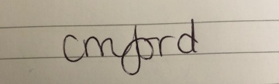 | Date: 06/02/2020

For STUDENT Submissions:
Director of Studies/Supervisor: | Dr Sioned V Hughes | Date:  07.02.20
Signature: | S.V.Hughes | Date:  07.02.20

For STAFF Submissions:
Head of School/Assistant Dean: |  | Date:
Signature: |  | Date:

Checklist: Please complete the checklist below to ensure that you have completed the form according to the guidelines and attached any required documentation:
☒ | I have read the guidance notes supplied before completing the form.
☒ | I have completed ALL RELEVANT sections of the form in full.
☒ | I confirm that the research activity has received approval in principle
☐ | I have attached a copy of final/interim approval from external organisation (where appropriate)
☐ | I have attached a full risk assessment (and have NOT completed Section H of this form) (where appropriate) ONLY TICK IF YOU HAVE ATTACHED A FULL RISK ASSESSMENT
☒ | I understand that it is my responsibility to ensure that the above named research activity will meet the University’s Research Ethics and Integrity Code of Practice.
☒ | I understand that before commencing data collection all documents aimed at respondents (including information sheets, consent forms, questionnaires, interview schedules etc.) must be confirmed by the DoS/Supervisor, module tutor or Head of School.
☒ | I have deleted the guidance notes before submitting the PG2 for consideration

Appendix 2 – School Permission Form

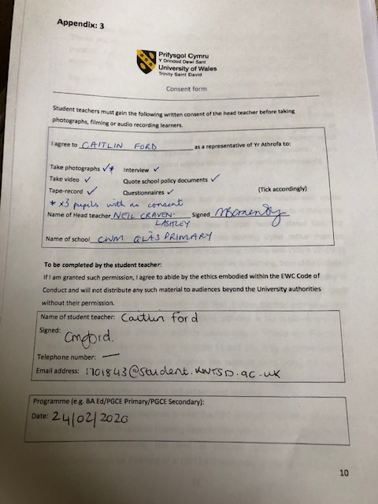
Appendix 3 – Interview Consent Form

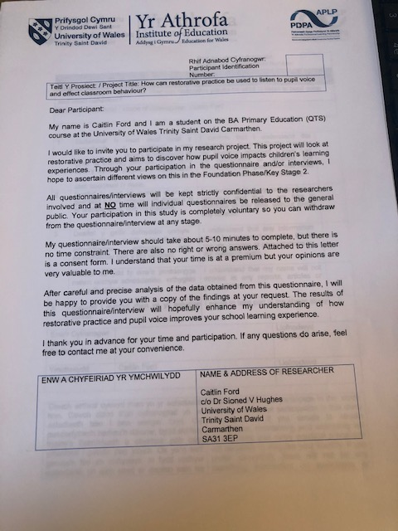

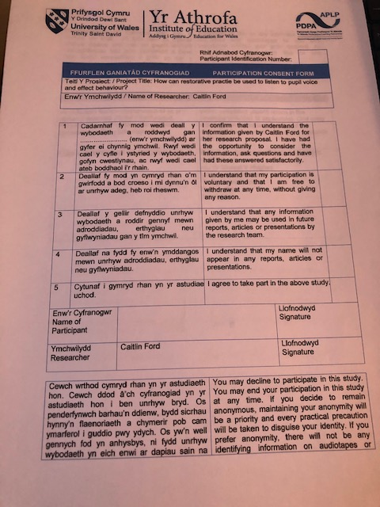

Appendix 4- Emoji Card



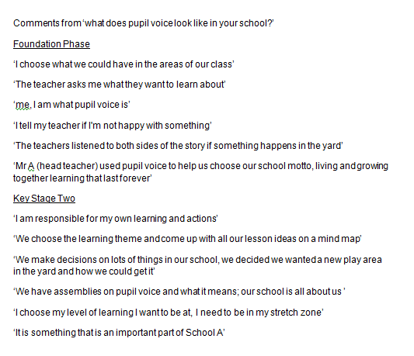
Appendix 5- What does pupil voice look like in your school? Responses
Appendix 6- School Vision

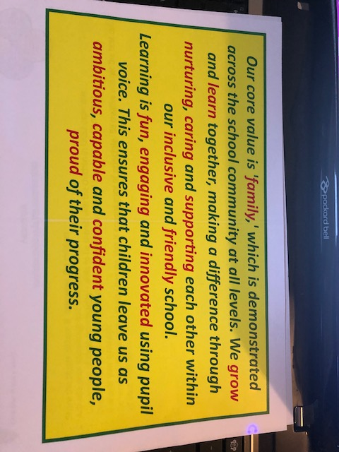

Appendix 7 – Initial Research

What word would you use to describe the ethos of the school?
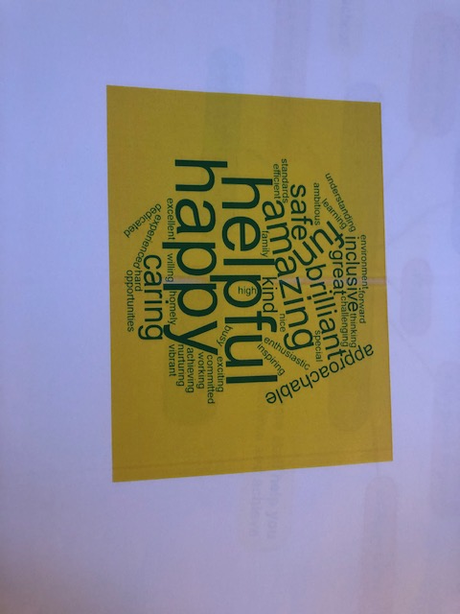

What does school A mean to you?

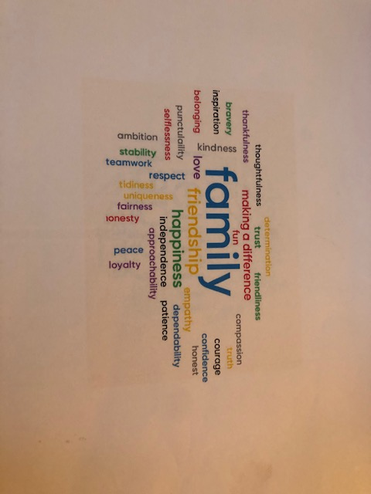

Appendix 8- Observations of Pupil Voice Curriculum and Planning


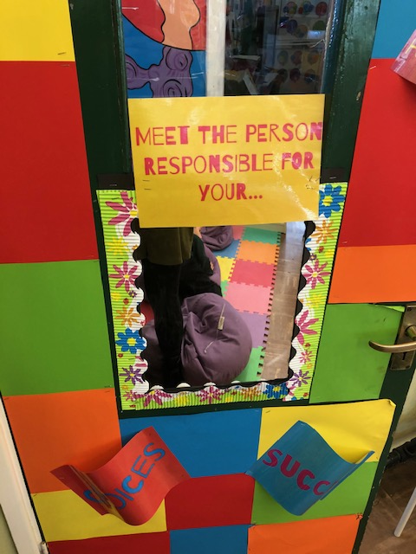

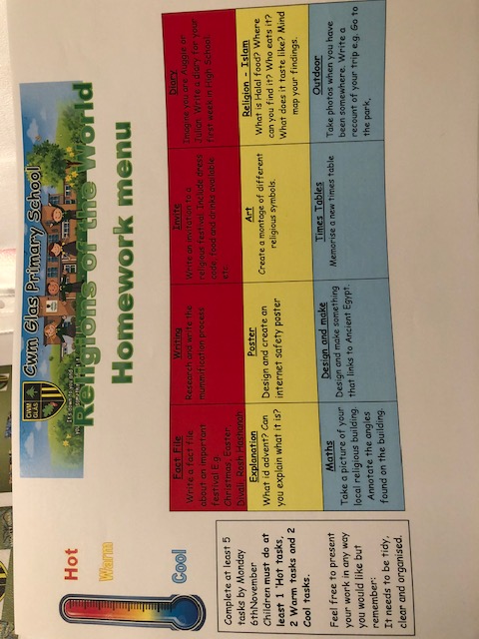
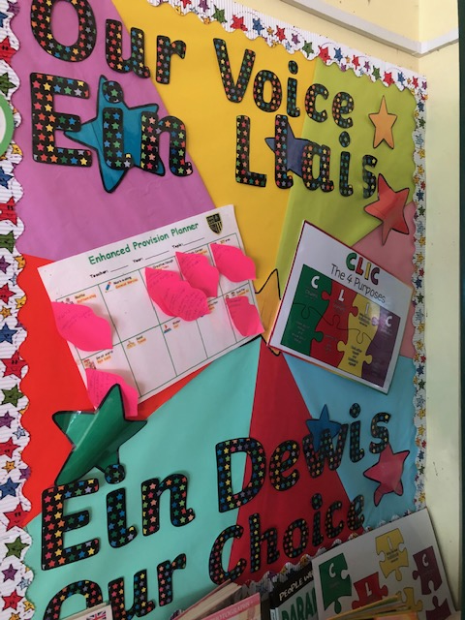

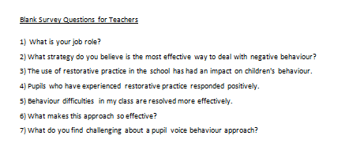
Appendix 9 – Blank Survey Questions for Teachers

Appendix 10- List of Key Words from Response to Question 2)

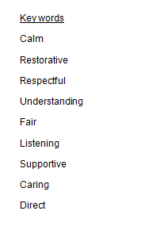

Appendix 11- Behaviour Blueprint



