Module: Community Engagement
Module code: LCBB4011
Lecturer name: Charles Oham
Student name: Mirabela Laura Dobre
Student ID: 2315966
Assignment Title: Coursework - Portfolio

Contents
Introduction 3
Element 1: Community Outreach 3
Element 2: Stakeholder Mapping Exercise 6
Element 3: Community Engagement Plan 9
Element 4: Practical Discussion 12
Recommendations 13
Conclusion 14
Reference 16

Introduction

This report will explore the process of engaging with stockholders in the Southampton community by focusing on how to build strong connections and address community needs. Southampton is a pot city in the Hampshire, England. This city is located approximately 80 miles southwest of London (Southampton.gov.uk, 2024). Through a comprehensive exploration of stakeholder mapping, community engagement strategies and practical applications, the report aims to show the benefits of active participation and the challenges faced in promoting meaningful connections. To enhance the report realisability and authenticity, relevant literature and personal experiences will be combine in this report. A SMART will be developed in this report to resolve the identified challenges in a systematic way.

Element 1: Community Outreach

Description of Outreach Activity

The community outreach activity focused on engaging with local stakeholders within the Southampton community. The aim was to understand the challenges and dynamics of the community by interacting with various groups and individuals, specifically those involved in educational and social services. In Southampton, a city rich in cultural diversity and a multitude of community needs, effective community outreach is crucial to involving stakeholders. In order to establish a connection with stakeholders, outreach initiatives ought to prioritise fostering open communication, addressing problems, and establishing trust. This engagement includes conversations with educators, parents, community leaders and local business owners, for getting a widespread view of the community needs and concerns. Without involving all stakeholders, a comprehensive overview cannot be achieved (Shragge, 2013). The outreach was designed to assess the demographic composition and the social, economic and cultural factors impacting the community.

Demographic Analysis
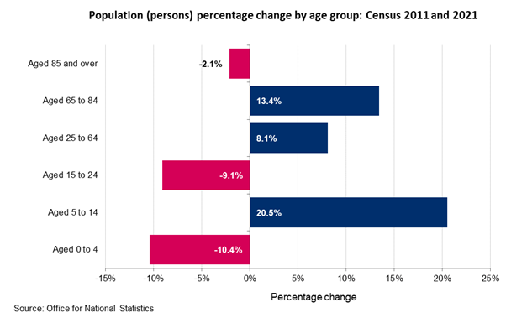
Figure: Population percentage change in Southampton (Ons.gov.uk, 2021)
Southampton's demographic landscape is diverse and changing. According to the data, the city has experienced notable changes in its population structure between 2011 and 2021 (Ons.gov.uk, 2021). The most significant growth has occurred in the age group of 5 to 14 years, which saw a 20.5% increase. This high numbers indicates the growing young population which places increasing demand for the quality education infrastructure and child force community services. The city needs to be very focused for ensuring that this high number of young population get proper education so that in the future they can contribute to the societal development. On the other hand, the population of those aged 0 to 4 years and 15 to 24 years declined by 10.4% and 9.1%, respectively. This trend suggests a potential shift in the needs of early childhood education and youth services.
On the older population segments, specifically those aged 65 to 84 have grown by 13.4% which reflecting a senior population that may require enhanced healthcare services and senior support programs (Ons.gov.uk, 2021). The city needs to ensure that this senior population get their desire heath care facilities. These demographic shifts suggest that Southampton is facing a dual challenge and both senior group and young group have different needs and priorities.

Ethical Considerations
During the outreach, to ensure the respectful and responsible engagement several factors get most importance. Privacy was a primary concern, specifically when interacting with vulnerable populations such as children and the elderly (Bell, 2014). Taking consent before engaging in the discussion is vital to ensure that participants are fully aware about the purpose of the outreach and how their input will be used. It removes the chances of misleading the participants. Ensuring that the outreach did not impose undue burden on participants was also a key ethical consideration, specifically for those involved in multiple community roles or experiencing socioeconomic hardships.

Social, Economic, and Cultural Factors
Southampton is located on the southern coast of England. This city is famous for its rich cultural heritage and a dynamic economy which influenced by a variety of social, economic, and cultural factors.

Social Factors
Southampton is a diverse and vibrant city with a population of approximately 253,000 people. The city is known for its large student population with two major universities, the University of Southampton and Solent University which contributing significantly to the city's demographic makeup (Shapiro, 2023). This high number of the young generation and diverse population enhance the city’s social dynamism and contribute to its vibrant cultural scene. The city also has areas where people face economic difficulties. These economic differences enhance the gaps in getting all the basic needs in the city. The local government is working to help these communities by improving access to services and promoting social inclusion.

Economic Factors
Economically, Southampton is a significant hub for business and industry. In 2020 census, the local economy valued at £7.2 billion. The city is home to around 8,785 businesses and provides approximately 108,000 jobs which making it a vital employment centre in the region (Southampton.gov.uk, 2024). People came to this city from different part of the UK for the professional purpose. Key sectors include health, education, retail and business administration, with transportation and storage seeing substantial growth. The Port of Southampton plays a very crucial role in the local economy. It is one of the largest freight ports in the UK and the country's premier cruise port. The port's activities and the associated marine industries significantly contribute to the city's economic stability and growth. A huge number of people livelihood are involve with the city’s port.

Cultural Factors
Culturally, Southampton is a city with rich history and strong maritime traditions that continue to influence its identity (Shapiro, 2023). The city hosts a variety of cultural events and festivals such as the Southampton Boat Show and the International Film Festival which attract visitors from around the world. The presence of multiple museums, galleries and theatres, including the SeaCity Museum and the Mayflower Theatre further enriches the city's cultural landscape. To visit these places and experience cultural programs, every year lots of tourists visit the city which contributing the local economy. Southampton's cultural diversity is also reflected in its food, music and arts scenes which making it a culturally vibrant and inclusive city.

Element 2: Stakeholder Mapping Exercise

Identification of Stakeholders
Southampton is a diverse community with a wide range of stakeholders. Each community play a very unique role in the city’s development and well-being. To ensure the city’s long term sustainability, active involvement of all stakeholders is very important. The primary stakeholders include local government bodies, such as the Southampton City Council which is responsible for policymaking, urban planning and the provision of public services (Southampton.gov.uk, 2024). Educational institutions including schools, colleges and universities are critical stakeholders. These institutions influence the future workforce and contribute to solidifying connection between the society people.
Healthcare providers such as the National Health Service (NHS) Trusts and private healthcare institutions play a vital role in maintaining the health and well-being of the population (Nhsproviders.org, 2022). When people's mental and physical health are well then their work efficiency is enhanced which is beneficial for the societal rapid growth. Community groups and non-governmental organizations (NGOs), like local charities and advocacy groups also represent key stakeholders. They often serve neglected populations by offering support services, advocacy and community development programs.
Any size businesses are another significant stakeholder group. They contribute to the local economy and employment (Schwab, 2021). Without having suitable business conditions, Southampton economic growth cannot be ensured. In the long run this will cause of unemployment and social economic disparities. So, the city needs to ensure that all the business can operate their operations smoothly. Lastly, residents of Southampton across various age groups, ethnic backgrounds and socio-economic statuses are fundamental stakeholders. Their needs and opinions shape what services are needed and affect local policy and decision-making.
Mapping of Interest Groups and Collaborative Partners
Mapping the interest groups and potential collaborative partners in Southampton requires identifying the key areas of focus for each group and understanding how they intersect with one another (Schwab, 2021). The Southampton City Counsel work as a hub for collaboration between various stakeholders, from businesses to educational institutions. Collaborative partners such as local schools and the University of Southampton are vital in addressing educational challenges. These educational institutions can partner with local NGOs and community groups to provide supplementary education services and support systems for students. When different institutions work together then determine the solution become easier. The progress of the city can be ensure through these partnerships.
Health care providers partnership with the social services and community groups can ensure that the needs of the elderly group and young generation are fulfilled (Evans et al., 2013). This partnership will reduce the health issues and ensure a equitable opportunity for everyone. Businesses, specifically those invested in corporate social responsibility can be powerful allies in community development efforts. They can ensure funding, resources and volunteer support for local initiatives. Interest groups such as cultural organizations and advocacy groups ensure that the city's diversity is reflected in community programs.

Communication Strategies
Effective communication between the stakeholders is very important (Schwab, 2021). Effective communication with the identified stakeholders in Southampton requires a modified approach that respects the diverse needs and preferences of each group. For local government bodies and educational institutions, formal communication methods such as reports, meetings, and policy briefs are appropriate. These stockholders respond well with the data driven discussions and strategic planning session that align with the broader city goals.
For community groups, NGOs and residents, more inclusive and accessible communication methods are essential (Evans et al., 2013). This could involve public forums, community meetings and social media engagement which allow open dialogue and ensure that everyone voices are heard. As different culture and language preferred people live in the Southampton, so ensuring that communication is done by multi language and ensuring culturally sensitive is very important to reach non-native English speakers and marginalized communities effectively.
Businesses, specifically those with a strong online presence may prefer digital communication platforms such as webinars, newsletters and online collaborations (Evans et al., 2013). For example through social media platforms, businesses can respond the quires in the real time which help to establish a customer centric brand image. Engaging with healthcare providers may require a mix of formal and informal communication channels, including professional networks, healthcare conferences and community health workshops.

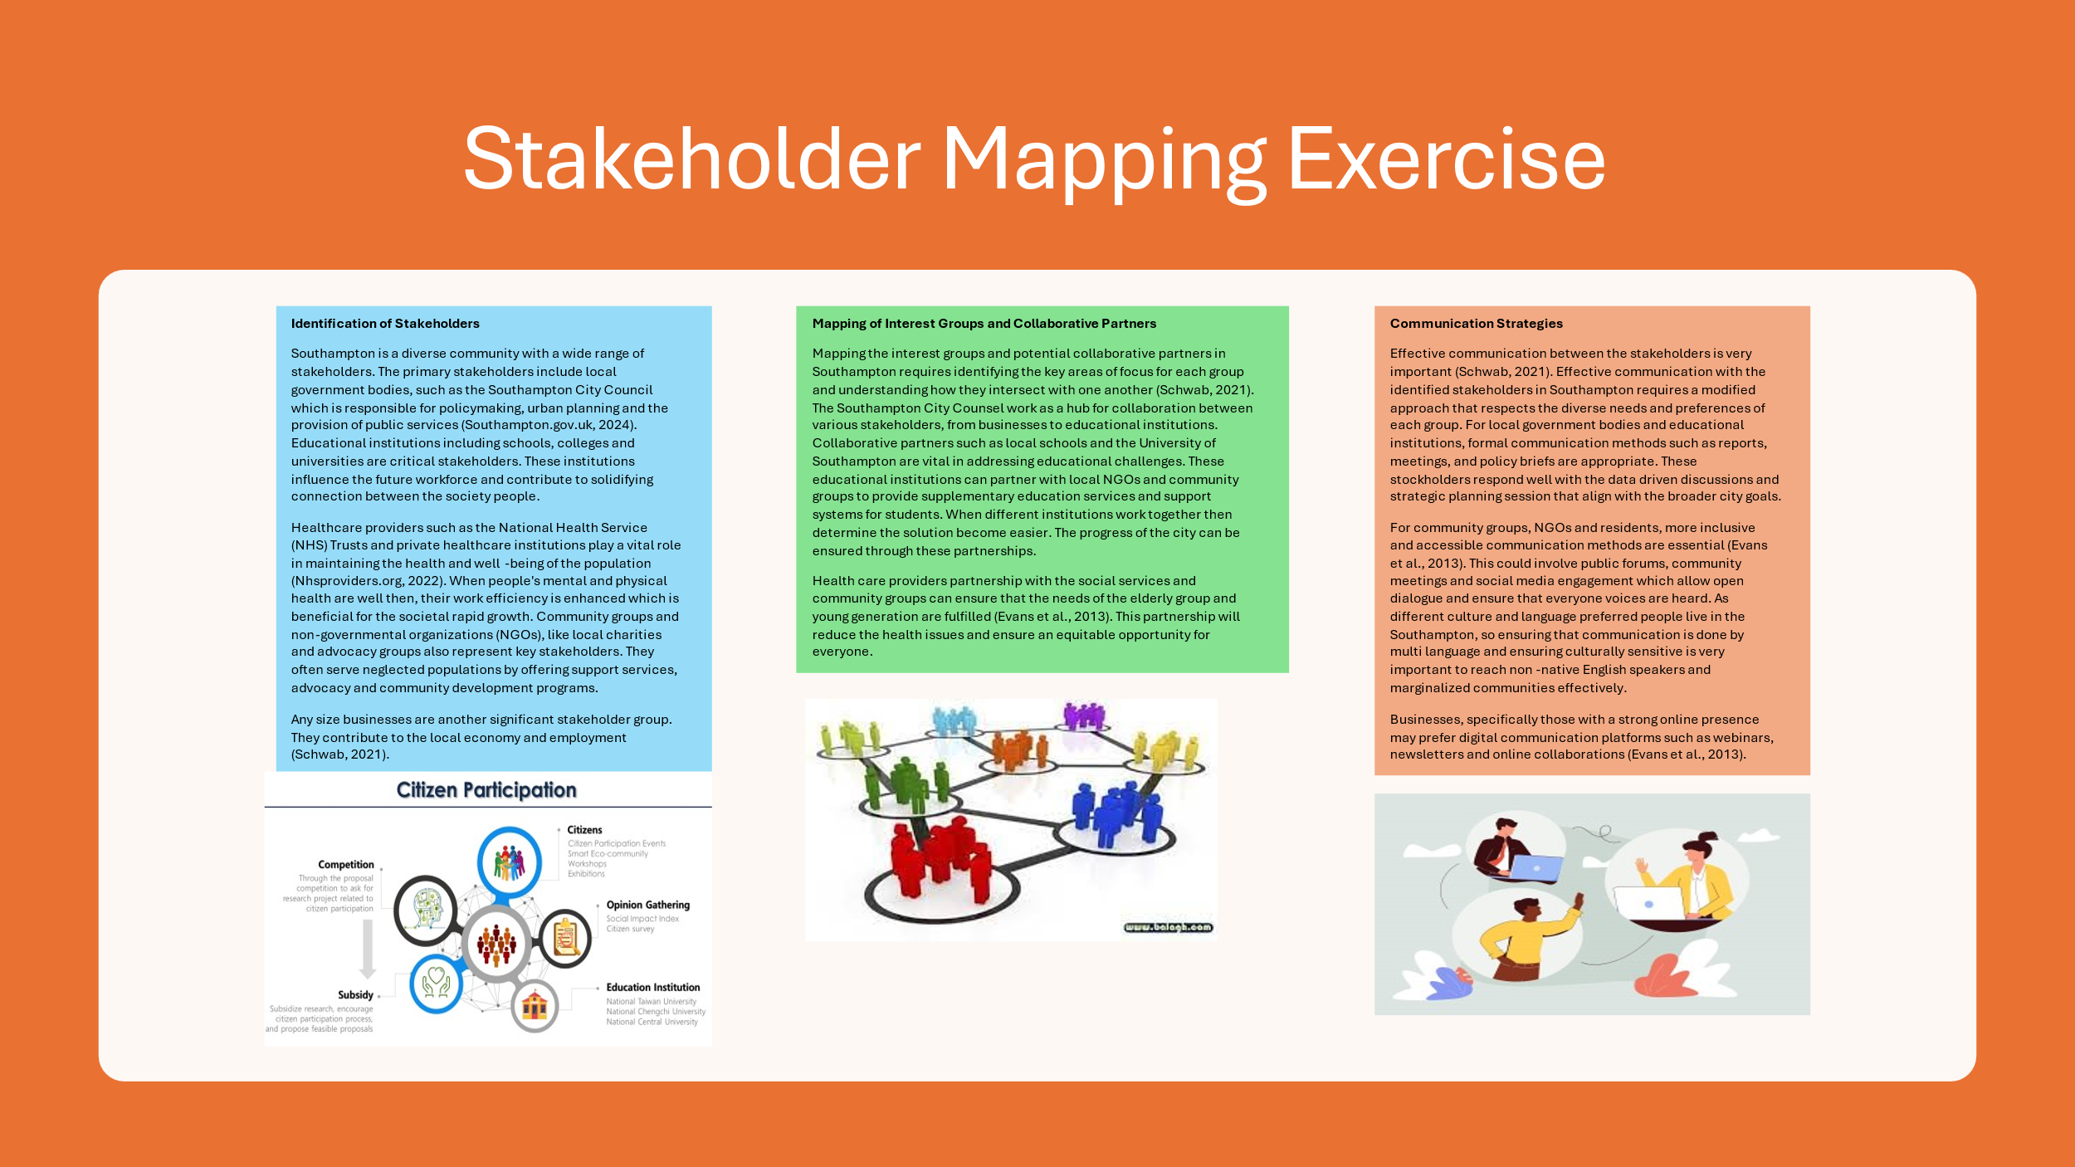Figure: Infographic poster
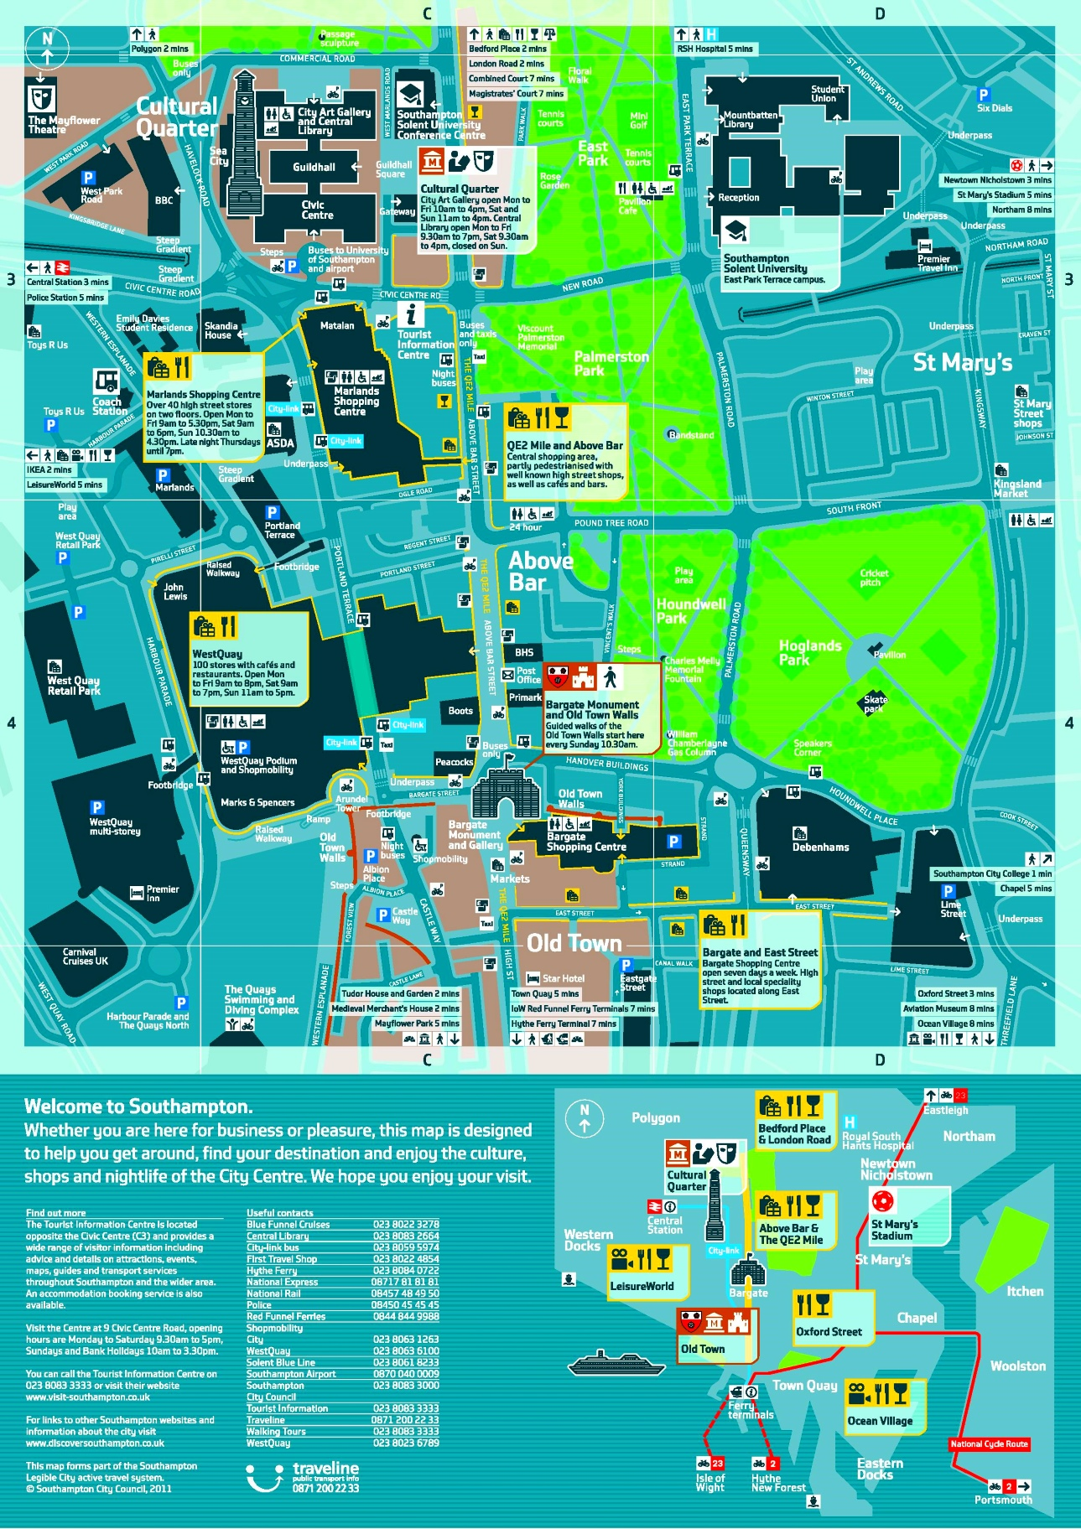
Figure: Map Southampton

Description:
This map illustrates Southampton's accommodations, tourist attractions, and information centers.

Element 3: Community Engagement Plan

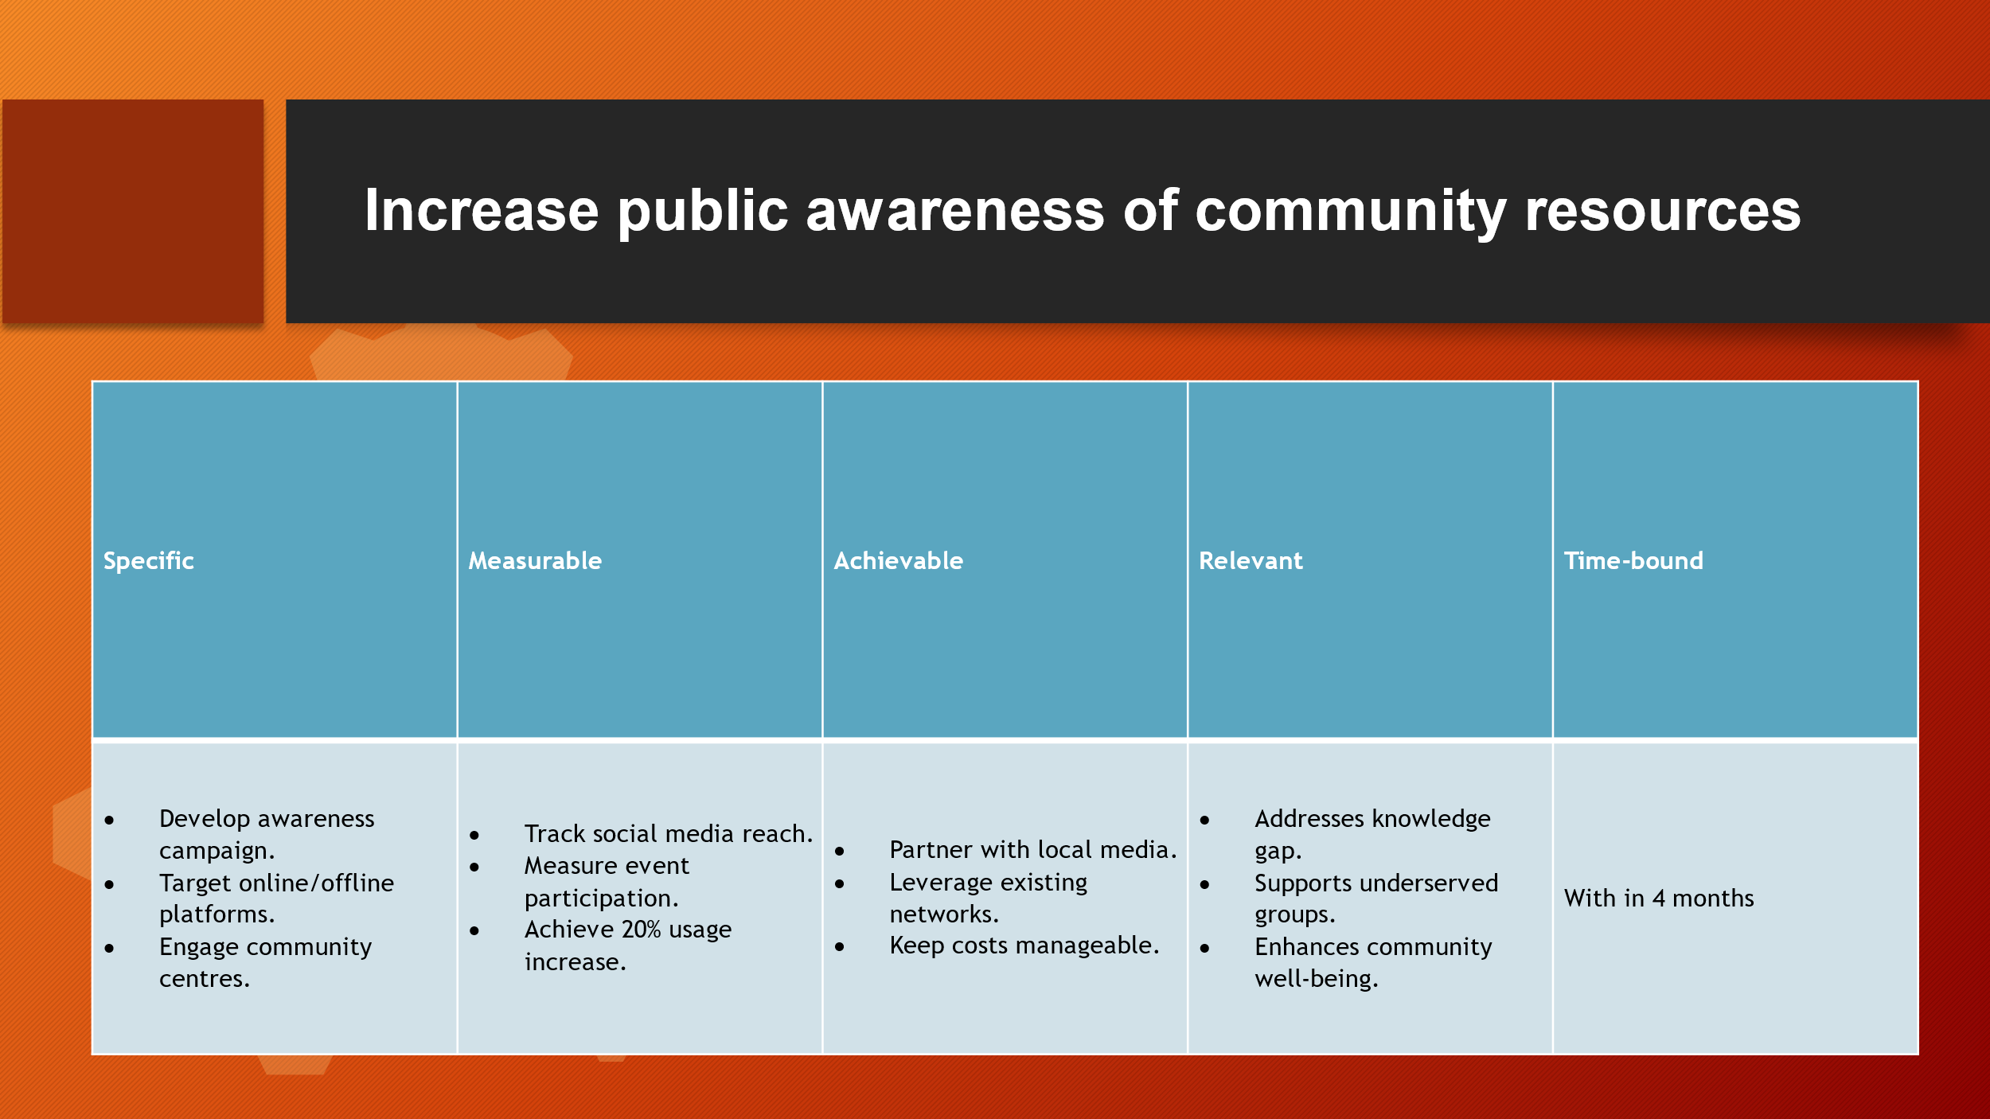

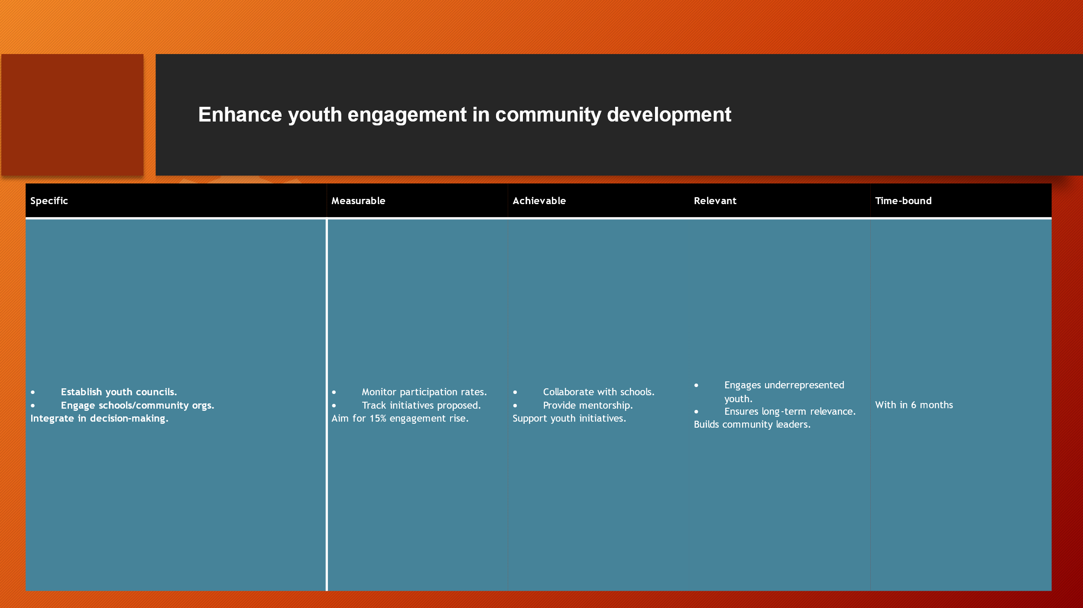

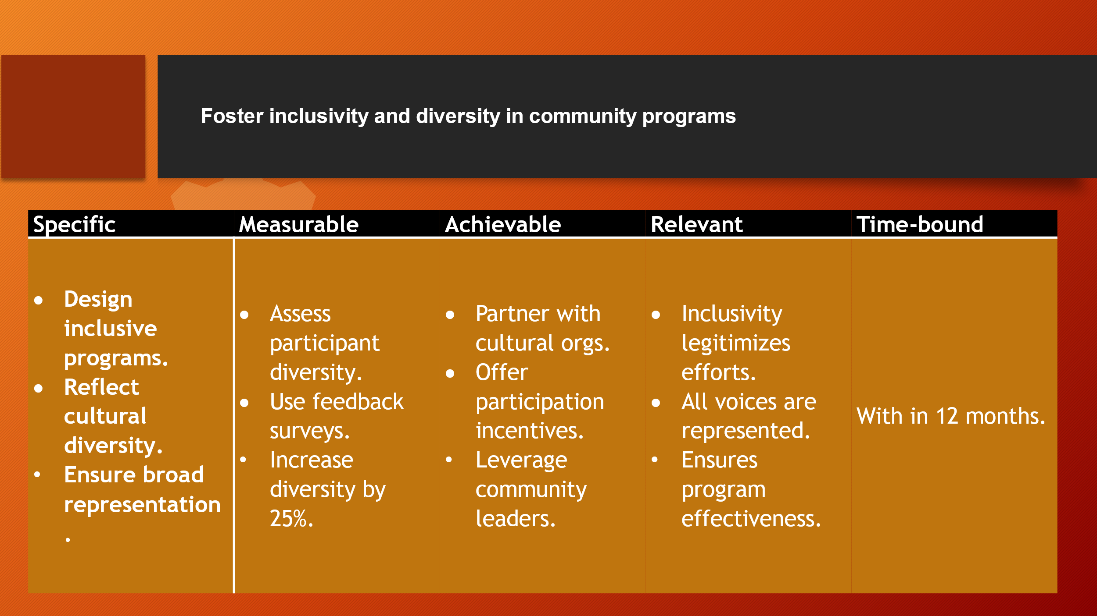

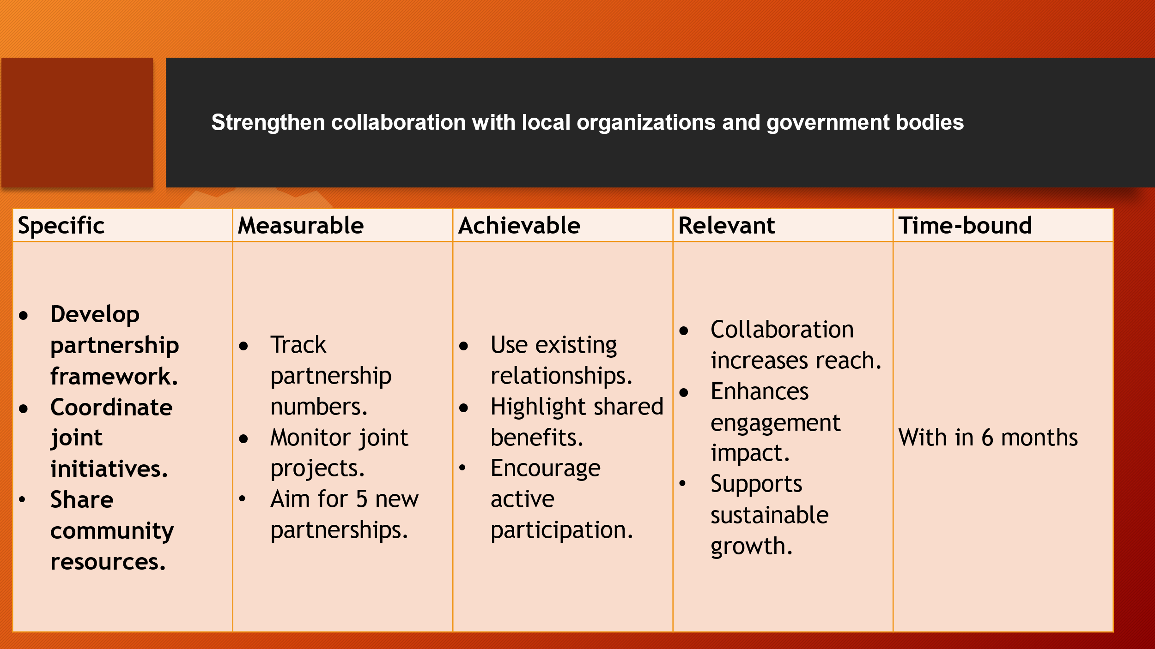

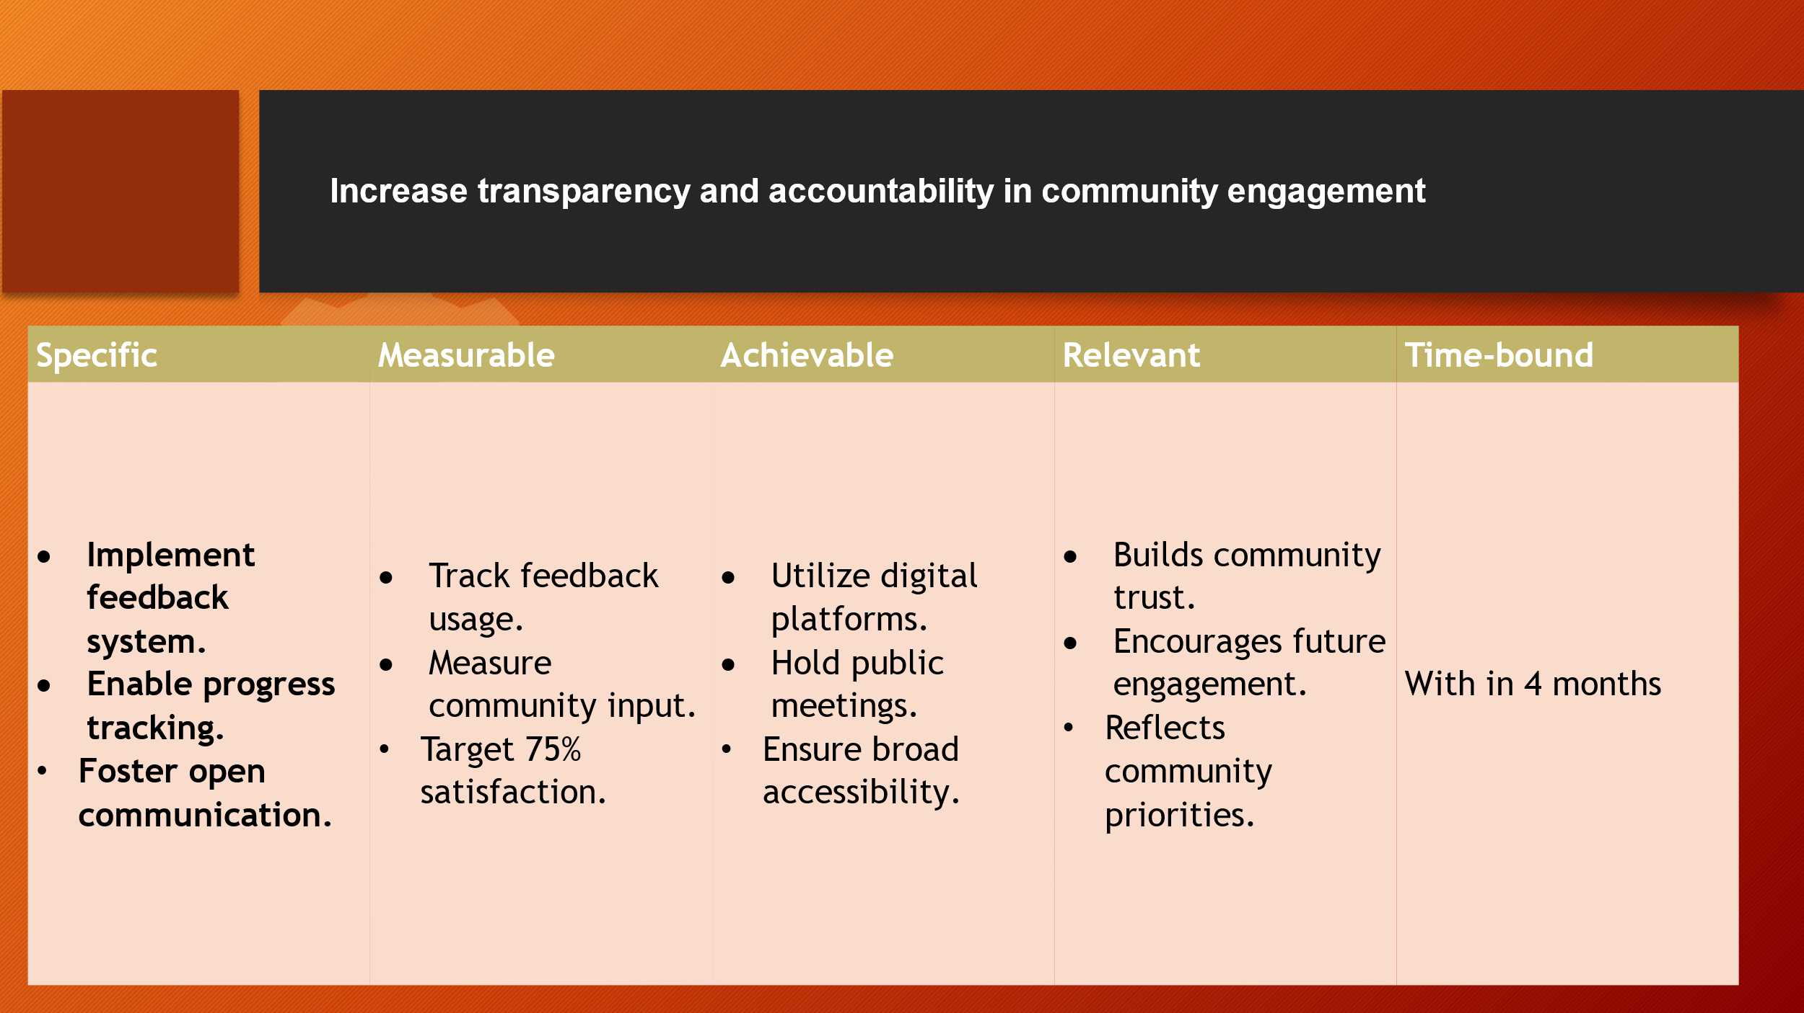

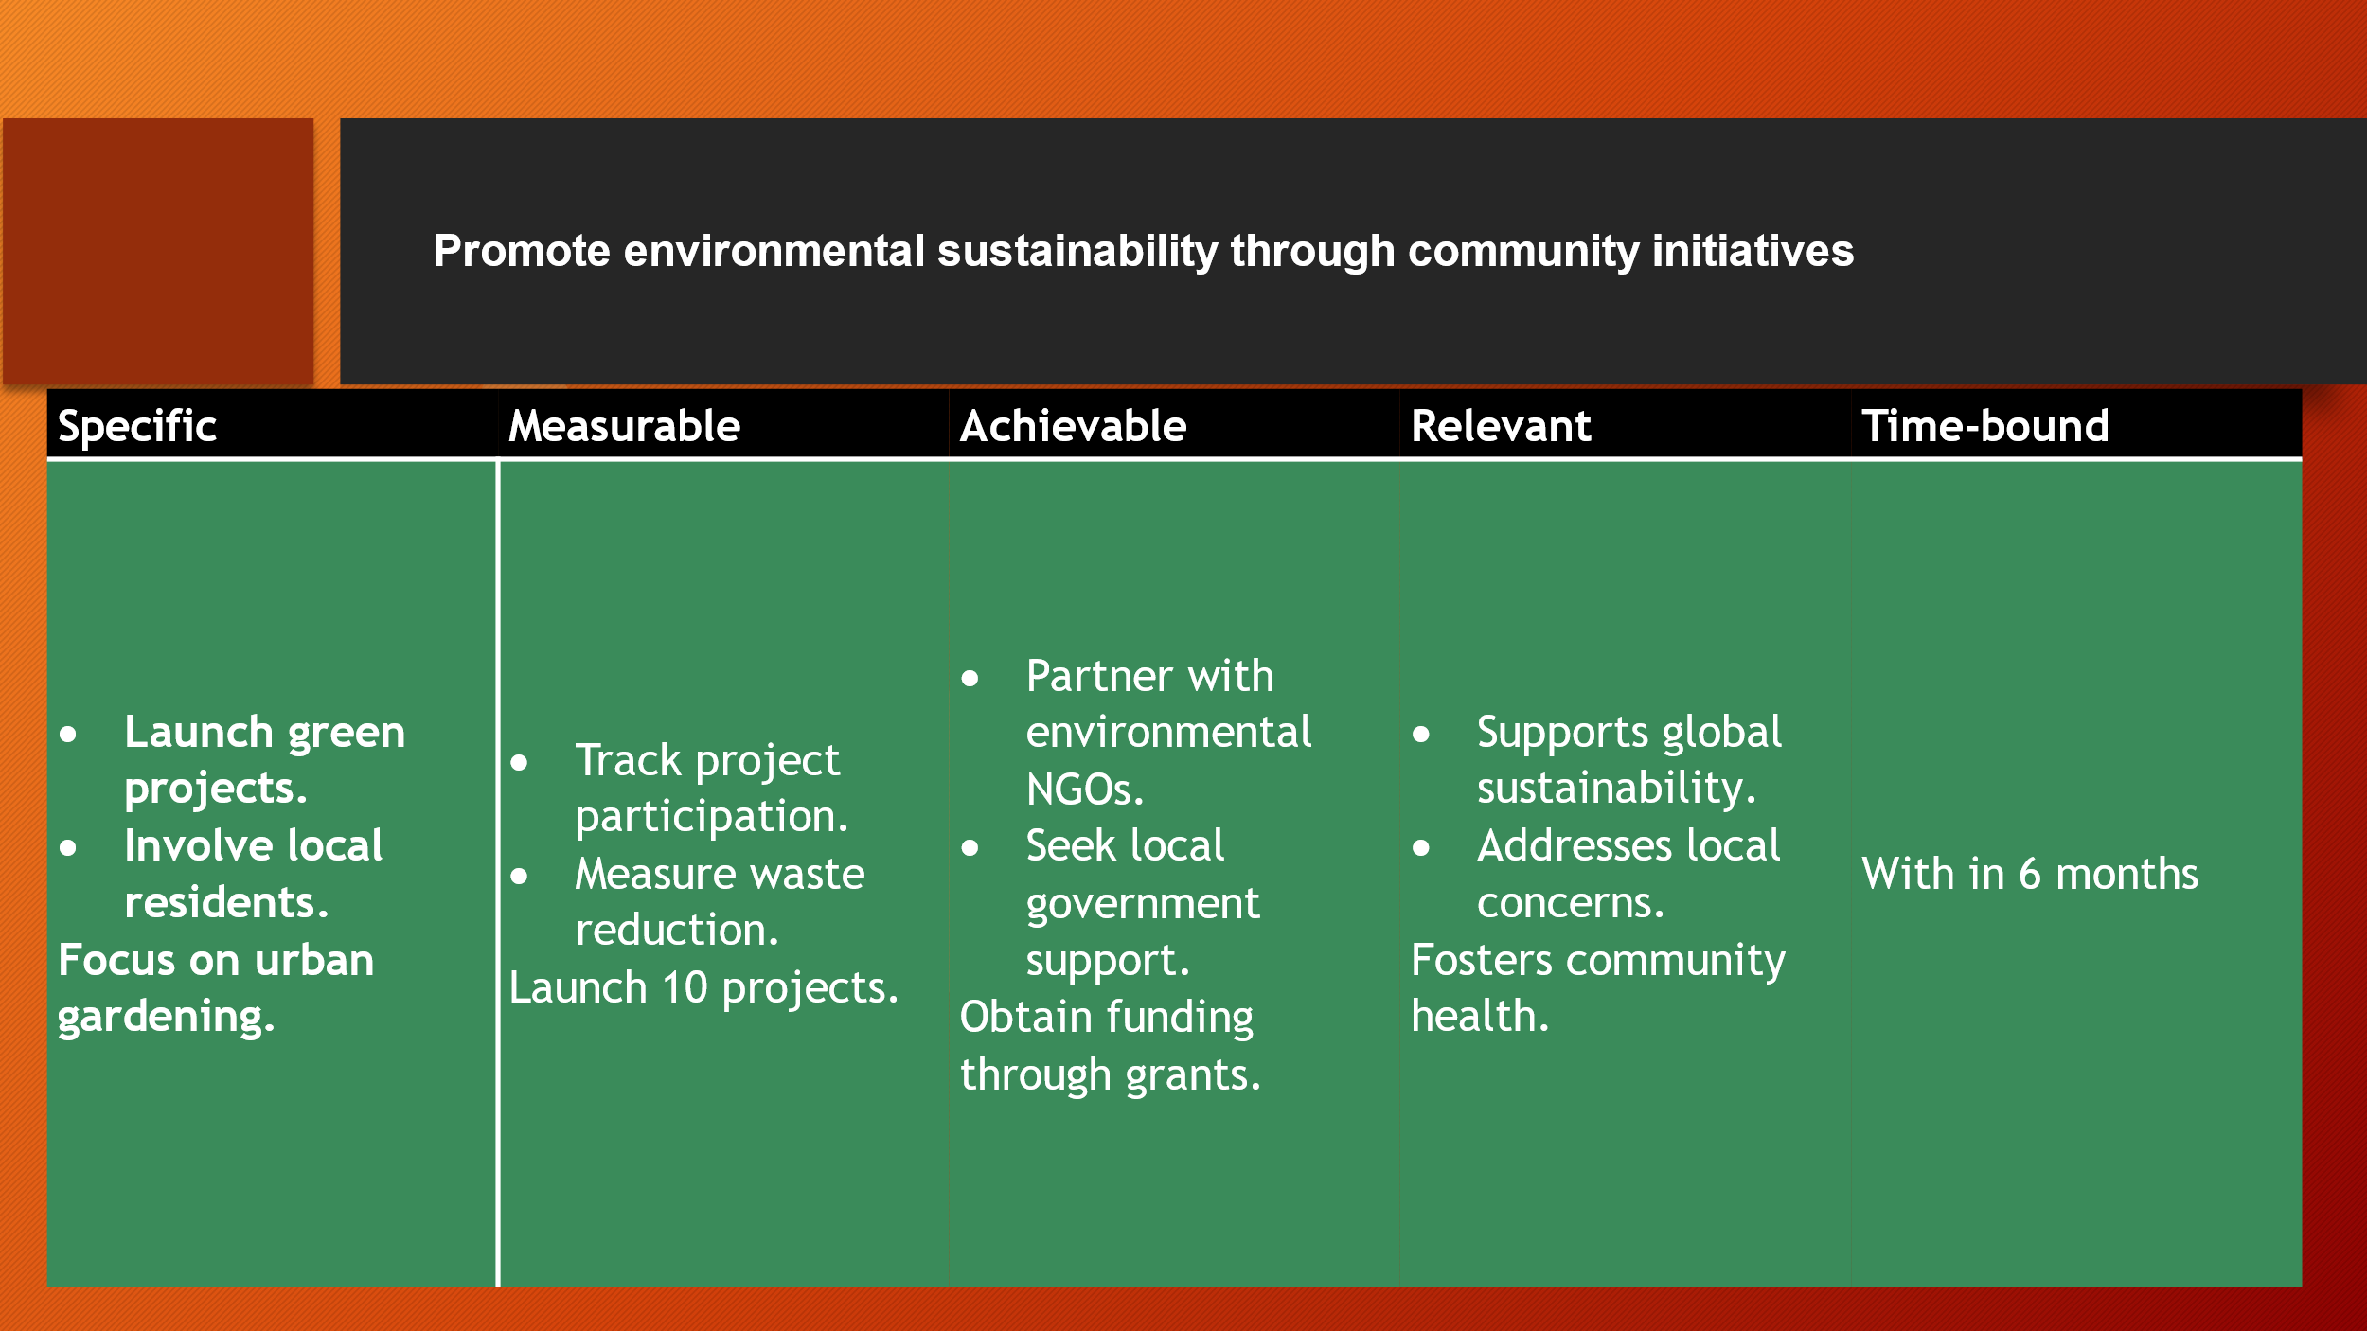

Element 4: Practical Discussion

Key Findings on Stakeholder Engagement
Engaging with the Southampton stakeholders provides several critical information’s into the value and dynamics of active community involvement and collaboration. Firstly, stakeholder engagement proved to be a powerful tool in promoting a sense of ownership and accountability among community members (Bourne, 2016). When stakeholder involvement is ensured in the decision making process then the can contribute positively and sustain their engagement over time. This involvement leads to stronger collaboration between different interest group because they understand the mutual benefits of working together towards common goals. Furthermore, the process highlighted the importance of inclusivity in stakeholder engagement. Engaging a diverse range of voices, ensure that all the people who live in the society are benefits. The chance of exploitation is also reduced through this process.
Another significant finding was the impact of transparency and open communication on stakeholder trust. Effective communication helps to reduce the chances of misunderstanding and ensure that everyone aware about their rights (Bourne, 2016). Transparency helps to promote a culture of trust, which is crucial for long-term community engagement. Additionally, the engagement process highlighted the importance of flexibility and adaptability in stakeholder interactions. As community dynamics are shift, the ability to adjust strategies and approaches to meet emerging needs and challenges becomes essential for sustained engagement.

Personal Experiences and Reflections
As a community member in Southampton, my experiences in engaging with stakeholders have been both educational and rewarding. Participating in various outreach activities allowed me to connect with a wide range of individuals and groups, each bringing unique perspectives and contributions to the work. My communication skills are significantly improved by communication with different individual. This skills will significantly help me in my professional career (Chu et al., 2021). One of the most profound realizations was the depth of passion and commitment that many stakeholders have towards their community. Most of the individual show their commitment for improving the community.

Through these engagements, I also gained a deeper understanding of the complexities involved in community work. The process of engaging with the stakeholder was challenging for me. Balancing differing opinions, managing expectations and ensuring that all voices were heard required careful navigation and a great deal of empathy. The experience of dealing with different people enhance my organizing skills which is another vital skills that required in the professional career (Chu et al., 2021). The gradual building of relationships and trust ultimately laid the foundation for more meaningful and impactful collaborations, although it is time consuming.

Recommendations

To enhance community engagement in Southampton, some recommendations are provided in below:
First, it is important to establish more structured and continuous communication channels between community members and local authorities. Regular community meetings, newsletters and digital platforms can help maintain an ongoing dialogue which ensuring that community members remain informed and engaged (Moulaert, 2013). Social media platforms can be used to share the important information’s in the real time. This will help the enhance the efficiency of the work.
All groups of the people in society needs to include in the decision making (Moulaert, 2013). Addressing this issue is vital for promoting a more inclusive and representative community. When everyone participation can ensured then there will be no chances of exploitation.
Third, there should be a focus on building the capacity of community members to take on leadership roles within their community (Moulaert, 2013). Training programs, mentorship opportunities and leadership development initiatives can empower individuals to lead community projects and sustain engagement efforts over time. Overall, by adopting these initiatives, the long term growth of the Southampton can be ensured.

Conclusion

In conclusion, this report assesses the importance of active stakeholder engagement in promoting a vibrant and inclusive Southampton community. By analysing the city population age census from 2011 to 2021, found that the city young and older population growth rate is higher than others. This indicate that, the city needs to place a strong focus on the education to ensure that the young generation becomes an asset of the city as well as extra care and health facility needs to ensure for the elderly people. Effective communication, inclusivity and flexible strategies are key to meeting the needs of the community and overcoming any challenges. The experiences and information’s shared in this report show the value of involving everyone in the conversation and the need for continuous dialogue to keep the community strong. The recommendations provided aim to help all members of the community feel heard and ensure that Southampton remains a place where everyone is valued. Personally, through this analysis, I enhance several necessary skills which will help me in my academic career as well as professional career.

Reference

Bell, J. (2014). Doing Your Research Project: A guide for first-time researchers. McGraw-hill education (UK).
Bourne, L. (2016). Stakeholder relationship management: a maturity model for organisational implementation. Routledge.
Chu, S.K.W., Reynolds, R.B., Tavares, N.J., Notari, M. and Lee, C.W.Y. (2021). 21st century skills development through inquiry-based learning from theory to practice. Springer International Publishing.
Evans, B., Joas, M., Sundback, S. and Theobald, K. (2013). Governing sustainable cities. Routledge.
Moulaert, F. ed. (2013). The international handbook on social innovation: collective action, social learning and transdisciplinary research. Edward Elgar Publishing.
Nhsproviders.org. (2022). The NHS provider sector - NHS Providers. [online] Available at: https://nhsproviders.org/topics/delivery-and-performance/the-nhs-provider-sector [Accessed 10 Aug. 2024].
Office for National Statistics. (2021). How life has changed in Southampton: Census 2021. [online] Available at: https://www.ons.gov.uk/visualisations/censusareachanges/E06000045/ [Accessed 10 Aug. 2024].
Schwab, K. (2021). Stakeholder capitalism: A global economy that works for progress, people and planet. John Wiley & Sons.
Shapiro, J. (2023). More diverse monuments plan for Southampton. [online] Bbc.com. Available at: https://www.bbc.com/news/uk-england-hampshire-67730313 [Accessed 10 Aug. 2024].
Shragge, E. (2013). Activism and social change: Lessons for community organizing. University of Toronto Press.
Southampton City Council. (2024). About Southampton. [online] Available at: https://www.southampton.gov.uk/jobs/why-work-for-us/about-southampton/#:~:text=Southampton%20is%20a%20green%20city,has%20a%20lively%20student%20scene. [Accessed 10 Aug. 2024].
Southampton City Council. (2024). Homepage. [online] Available at: https://www.southampton.gov.uk/ [Accessed 10 Aug. 2024].
Ontheworldmap. (2023). Southampton sightseeing map. [online] Available at:Southampton sightseeing map - Ontheworldmap.com [Accessed 31 Aug.2024].

