Module number: BMSK5104
Student name: ROMEO MAKIADI
Student number: 1906720
Lecture: Balendran Kandasemy
Managing a project in the organisation

Table of Contents
- Executive summary
- Introduction
- Critical assessment of the usefulness of project management tools and techniques
- Project plant
- Self-reflection
- Conclusion

Executive summary
This is report includes an in-depth analysation of the methodologies used in the Sainsburys expansion project, evaluation of its effectiveness and usefulness in light of the ongoing global pandemic of COVID 19. In addition, the report includes the project plan for the Sainsburys expansion project, which I managed as project lead. The project plan with all aspects, and factors involved, includes schedules, teams, risks, and all stakeholders.
Finally, the last point of the reports covers a self-assessment of myself in being the project manager of the Sainsburys store expansion project. An effective evaluation has been conducted analysing strengths, weaknesses, and future self-development needed to become a better project manager.

Introduction:

In this report, I’ll be examining the theories of project management tools used in the Sainsbury expansion project. Project management is the implementation of methodologies, tools, and systems to ensure the success of a project. Project management is about being effective and efficient with the use of personnel and resources to complete project activities, to ensure deliverables and set objectives are achieved.

Sainsbury's is a UK supermarket retailer, with over 1,400 stores across the UK. The supermarket's main competitive business model is expansion. Rapidly building stores and entering new locations. As a result of the pandemic, coronavirus and social distance measures. Sainsbury's approach to its projects like expanding into new locations has also changed. As a result, we’ll be assessing Sainsbury's development of its new convivence store in Lewisham. Sainsbury’s like many other UK mega supermarkets expands at a fast rate. Therefore, we must investigate the effects of the COVID19 pandemic on the expansion project I managed.

The start date of Lewisham's convivence store development would be the second week of April and would cease in early July, this gives the project a deadline of 12 weeks. The south London area of Lewisham has seen a large surge in new residential and commercial development, as a result, there’s an opportunity for Sainsbury's to open a new store to meet potential demand.

There are many stakeholders involved with the project. A stakeholder would an individual or group would is affected by the achievement of Lewisham store. One of the main stakeholders would be customers/ residents, as they live in the area and most likely to use the store, it’s important to them that the store is completed and successful. Another stakeholder involved in this project is Sainsbury executives. The new store must be a success in earning revenue and benefiting the entire company.

As the residential properties continue to develop, the project must be delivered on time. Failure in completion may lead to losses in potential earnings, as customers would shop elsewhere, whilst waiting for the store to finish. Alternatively, competitors such as Tesco may seize the opportunity to enter the location. Therefore, the store must be developed within its 12-week deadline.

1.0 - Critical assessment of the usefulness of project management tools and techniques

Project management tools are useful for project managers, there are many types of software, techniques, and tools available for managers. In this section of our report, I’ll be critically assessing the usefulness of project management tools and techniques, evaluating their strengths and weakness in the current environment of COVID 19.

Whilst managing this project, there were many tools I used throughout the project lifeline. Firstly, it’s important to understand the purpose of these project management tools. The main purpose of the tool is to provide a framework and guidance for managing a project. The tool should be able to help all types of projects, regardless of the size, scope, budget, or schedule. The systems within the tools will differ, however, the overall objective is the same. ‘complete the project within the constraints of Scope, Cost, and Time while meeting all stated Project Objectives. (Agile vs Waterfall vs Prince2 (Advantages and Disadvantages), 2021)

Agile project management

In the project of developing the new store, in the current global pandemic of COVID 19. As the project manager, I needed to use a methodology and tool, that would provide me with flexibility. This is needed in the case where unforeseen circumstances occur, that would change the direction of the project.

Agile is a project management methodology, that involves a set of principles for managing and completing a project (Highsmith, 2010). These principles focus on allowing projects to divided and characterised into tasks, that are created and adapted to meet the demand of current environments, instead of tasks created from the original plan. Agility is the ability to move at speed with ease. The methodology focuses on bringing agility to projects. The ability helps projects to respond to unforeseen circumstances through a smart task-orientated work process (Aston, 2021).

Agile project management is different from the rest, as its concentrates on the importance of projects having the ability to adapt to unpredictability, such as the COVID 19 global pandemic. As well adaptability the tool also ensures task allows for constant communication amongst team members and key stakeholders of the project. This tool proves to be the most effective in a dynamic environment. Aston, 2021).

Strengths of Agile project management

Flexibility – in light of the pandemic, events beyond control can disturb schedules and plans. As Agile systems are based on tasks, project managers can adjust according to the real scenarios. Whilst still allowing us to complete the project within its timeline. This was an important factor in deciding to use the methodology, COVID 19 has been active for the past 18 months. As history shows, there’s always a possibility of foreseen events occurring, negatively impacting the project. Such as national and regional lockdowns. This is a perfect tool to use, in environments that are dynamic and ever-change.

Weakness of Agile project management too

As well as positive factors relating to the agile project management tool, there are many negatives. In this task, we’ll also be assessing the negative factors attached to the methodologies. The agile project management tool main principle is to break down projects into tasks and sections, many problems can arise from this methodology. The tool relies upon the project having the ability to be broken into sections or increments, this isn’t always the case. Every project is different, in complexity, scope, cost, and time scale. For example, with the Sainsburys project, there are areas where the project is divisible and others which isn’t the case. One of the main tasks involved with the project is recruitment, this can be divided. However, tasks that rely on the completion, of each other, can’t be divided. This shows how limiting the project management tool can be for project managers, who are taking a lot of projects at once.

Finally, the last negative would be the tool is designed to make the assumptions that a project will face unforeseen circumstances, beyond what was originally planned. Therefore, the tool would be a liability to projects that are well planned for diversions and unpredictability. For example, this occurred in the Sainsburys project. The COVID 19 emergency plans have been incorporated into the pre-planned process. Therefore, at times within the project, there wasn’t any need to adopt the agile incremental task processes.

Other project management methodologies

The waterfall approach is considered the traditional and simple approach to project management. The methodology focuses on delivering the project in a series of stages and phases. This approach more suitable is traditional projects like manufacturing and construction, including the Sainsburys project (Clayton, 2020). Such projects are usually very expensive and large in their scope; therefore, they require a systematic methodology with clear-defined objectives and deliverables. These projects would normally occur in a predictable environment; hence the reason waterfall would be the most useful approach.

Although, the Waterfall methodology would be considered as the most useful for the Sainsburys project, as this project would categorize as construction. However, due to the unprecedented time of the global pandemic. The environment we work in has become extremely unpredictable, this means traditional methodologies like Waterfall wouldn’t be able to adapt to unforeseen circumstances, and changes throughout the life span of the project. This is the reason as the project manager I didn’t choose this approach. In comparison to Agile, the methodology is too rigid. Therefore, if an unplanned event was to occur the approach would fail to adapt, affecting the outcome of the project Agile vs Waterfall vs Prince2 (Advantages and Disadvantages), 2021).

2.0 Project:

Building a new Sainsburys convenience store in the area of Lewisham. Expected time for the project from start to finish will be 3 Months [12 weeks]

2.1: Organisational chart

When developing a project plan, it’s important that structure is considered, this includes establishing ‘SMART’ objectives, defining the project, determining resources, and understanding organisational chart.

Lewisham store project 1: developing – organisational chart

Regional Manager: This individual would be indirectly involved with the project. This person's role would be to relay information to and from Sainsbury's Headquarters. Regional managers would oversee multiple store development across their delegated region.

Skills: Management, Communication, Leadership.

Area Manager: This manager would be having a more hands-on approach to this project. They oversee many stores within the near area. He/she shares information from the regional manager over to the project manager.

Skills: Communication, leadership, management

Project manager: managers are in charge of all planning, resources, and organising the direction of the project, ensuring all deliverables and objectives are achieved within the scope of time, budget, and resources. (Miller, 2019)

Skills: project management, organisational skills, risk management, Negotiating, relationship management.

Duty manager: reports directly to the project manager, they would ensure responsibilities are delegated and monitor progression throughout the life of the project.

Skills: Management

Safety officer: This individual is solely in charge of ensuring the safety of the site for all stakeholders using the project, this includes the workers and customers. Other responsibilities include conducting regular safety inspections. Ensuring Compliance with health and safety government covid regulations. Ensuring the working environment is free of health and safety risks.

Planning engineer: This employee would be working on the plans to ensure development follows as planned. They would aside the site manager on site. The engineer would also be responsible for mitigating any problems and providing technical solutions.

Skills: Communication, Risk management, Technical engineer expertise

Site manager: Would responsible for overseeing operations of the whole site on a day-to-day basis. The manager would ensure that all material arrives, overseeing subcontractors and laborers. They would have to work alongside the planning officer and report to the duty project manager.

During the construction of a project, a Site Managers role will be to monitor the progress and report back to key stakeholders.

Skills: Problem-solving, project management, leadership, highly organisation

Health and safety inspector: This individual role would take place in the later stages of the project. Their role is to ensure the stores meet all legislative health and safety regulations before the store is completed. With the unprecedented pandemic, Sainsbury's needs to ensure all employees and customers are protected as much as possible.

Contractors/ suppliers/laborers: These individuals would be outsourced, the role would vary depending on their trade, for example, electricians, plumbers, installers. They would be hired throughout the project and would be reporting to the site manager.

Skills: Communication, teamwork, and tactical trades skills and knowledge

Recruitment:

the project consists of both internal recruitment, Sainsbury's employees, and external outsourced individuals, contracted for work on this project.

Everyone above the 4th line in our organisation project structure, including myself are all employees of Sainsbury. Below, are all outsourced precisely for this project.

Sainsbury's develops new stores at a fast rate each year, in different locations. Additionally, all stores are different in their way, whether its functionality, size, purpose, or location. Therefore, it's best for Sainsbury's to outsource partners and professionals whose skills and experience are tailored to the project.

2.3 Project Stakeholders

This project would involve a high number of interested stakeholders and effect by the success and completion of this project. In recent years it’s been important for those managing and planning projects to understand the importance of stakeholder management (Pirozzi, 2019). Therefore, as a project manager, it’s important that we evaluate and assess each stakeholder's needs and interests, whilst ensuring the overall objective of the project is met.

Sainsbury main project stakeholders -

- Executives – These would be individuals working in Sainsbury headquarters, who are interested in ensuring the store is profitable and beneficial to the entire organisation. This stakeholder represents the interest of Sainsburys shareholders.

- Customers - Are group are using the store, it’s important to them that project is a success and completed within the planned timeframe.

- Residents – As the store is being developed in a residential area, this group would be highly interested in this project. They wish to ensure that the project is beneficial to the local area and doesn’t negatively affect their environment. For example, noise pollutions, litter, anti-social behaviour, etc. Communities are also interested in how the stores impact their safety in regards to the pandemic. ‘Would the stores bring more people to the areas?’ ‘If we enter a lockdown how would the store manage to provide our needs’

- Contractors and labourers – these would the individuals who work on the projects. They're interested in their wages, working environments, safety, and contracts.

- Competitors – Are interested in the project, seeing quick Sainsburys can complete this project, as well as evaluating the possible opportunities to enter the market.

- Government – Their interest would in the safety of the population and users of the store, ensuring all Covid measures are active.

Stakeholder analysis – In managing our project stakeholders

Categorizing stakeholders helps us to develop our stakeholder management strategy related to three areas: Power, influence, and Power. Categorising stakeholders helps project managers top develop stakeholder management strategy, which is needed in determining how we establish our relationship with these individuals and groups. Once developed we’ll be able to understand the following (Roeder, 2013):

- how much time to spend with each stakeholder;
- the most important issues for each stakeholder;
- the level of importance of each stakeholder’s concerns.

Stakeholder types | Key | Primary | Secondary
Executives | Y | Y
Customers |  | Y
Residents |  |  | Y
Competitors |  |  | Y
Contractors and labourers | Y | Y
Government | Y | y

Stakeholder influence matrix

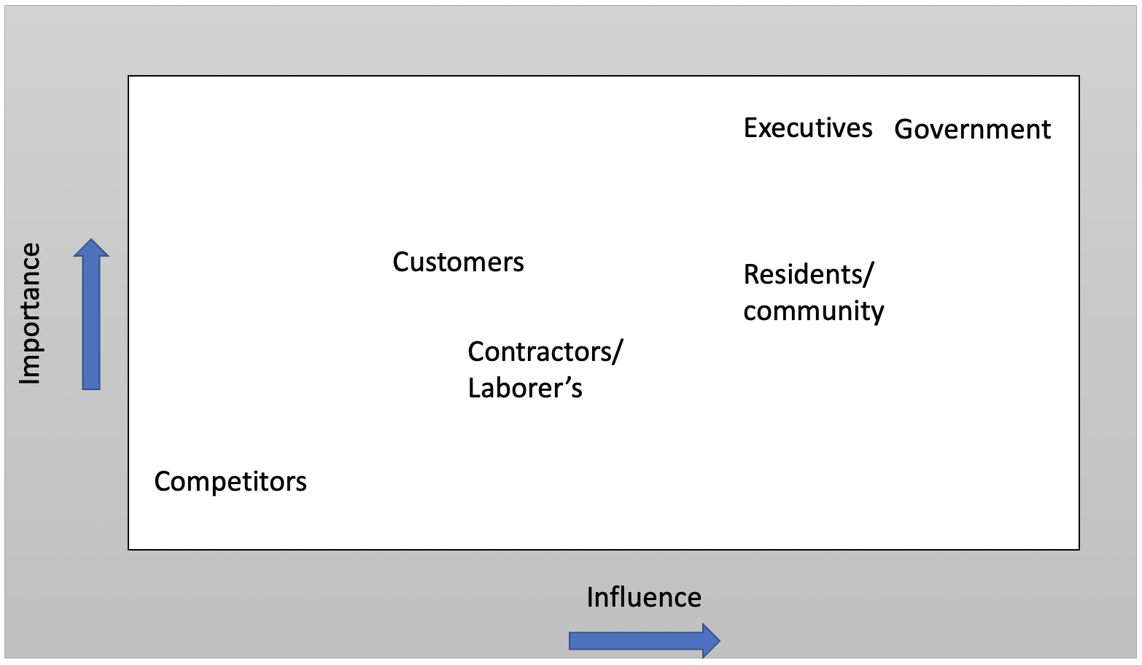

This diagram shows the level of influence to the importance of each project stakeholder, based on this matrix were able to prioritise each stakeholder needs and interests. For example, as we know Executives have the most influence and importance on our project, their interests would be prioritised over competitors and others.

In light of pandemic and the coronavirus disease, other stakeholders would have almost equal or greater importance and influence over Executives/ Shareholders. The government has made it aware to the nation that all businesses regardless of size, must put their customer's health and safety as their highest concern.

This means throughout the completion of the project, we must consider the government's interests as our top priority, this includes ensuring our members on-site are socially distanced and sanitisation stations are available.

2.4 Cost of the project

What are the costs and benefits of the project?

As the store isn’t being built from the foundations upwards, the cost of the operations wouldn’t have a greater cost in comparison to a full construction project.

However, there are areas of adaption and development that need to take place, to ensure the new store meets government and Sainsburys group standards, for functional and safety reasons. This includes adding rooms and removing walls. Large amounts of the cost would be associated with the labour, materials, and equipment used. Outsourced professional tradesmen are expensive, however, they offer a level of quality which meets our stakeholder's needs and interest.

Additionally, in light of the coronavirus global pandemic, the government has required businesses to adapt their stores to meet new COVID measures and protect the customers who use the store. These additional adaptations come at an extra cost to the project. However, in the best interest of our key stakeholders, this must be complete accordingly.

2.5 - Project scope and scheduling

Another important aspect of the project management is understanding the scope and scheduling of the project. As Sainsburys are on a deadline to complete the store, it’s important we develop a schedule that we help us be successful.

When identifying what the key concepts of structuring a good Project, understanding scope
would be fundamental to this process (Khan, 2006)

In developing a project scope, we must indicate three main thresholds:

- Project objectives – This is considered as the closure of a process. These objectives need to ‘SMART' and goal orientated. SMART refers the objectives being specific, measurable, achievable, realistic, and time specific

  - Sourcing all contractors, labourers, and partners by week 4
  - Installing all fittings by week 10
  - Securing planning permission and all legislation requirements by week 3

- Deliverables – What new project will be able to deliver, once completed. As this project will oversee the development of a new Sainsbury store. The main deliverable of the project:

  - New store for residents
  - Covid protected shopping experience for customers
  - Additional retail space for the wider Sainsbury group
  - Fully operational retail store with staff

- Milestones – This is a tool used by project managers to pinpoint various activities, across a timeline. This is also a method of time management in a project timeline.

  - Week 3 – Planning permission secured
  - Week 4 - Development and building should start
  - Week 10 – All fittings and fixtures should arrive to site
  - Week 12 – Final Covid check with the lock authorities

2.6 - Project scheduling

A project schedule usually includes the timeline of the project, from start to finish. Providing project managers vital information including, start and finish date, duration, and resources allocated to each event.

In the Sainsburys project, we need to ensure our effective project schedule is effective in helping deliver a successful project to our stakeholders. Our schedule can be used as a way of communicating with our primary stakeholders regarding our progress throughout the project.

In light of the coronavirus outbreak, project scheduling has become ever more important in project management. Projects and developments across the world have seen delays as a result of the virus.

As a project manager, I must consider possible factors that could affect the project schedule and develop possible contingencies. For example, COVID lockdown conditions

Gantt chart

A Gant Chart is a graphical representation of the project and each task including an estimated framework of time displayed as earliest start dates and ending dates. The method also allows Float/slack to be incorporated into the Gant chart to assist in identifying the finish date.

Project: Lewisham local store Gantt chart

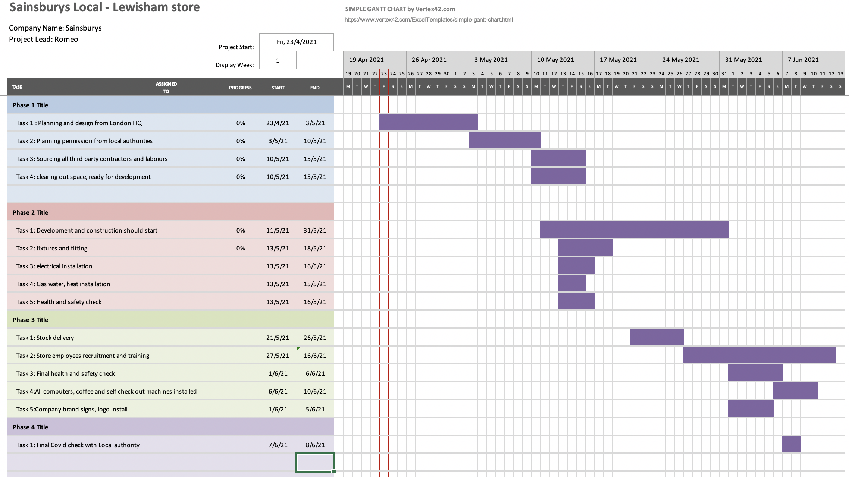

3.0 Self-assessment
Throughout this report, we’ve assessed and evaluated various elements of project management. In this section of the report, I'll be conducting a self-assessment of my ability as a project manager in light of the COVID19 pandemic.

As the project manager, It's important for us to complete self-assessment, to evaluate and identify possible strengths and weaknesses. As part of the self-assessment, I’ll be using the SWOT analysis tool. The tool Is normally used for strategic planning in project management, and competitive strategy in organisations (GÜREL, 2017).

SWOT analysis has two factors of consideration. Internal and external factors. Internal factors are most important when conducting self-assessment, as it confuses on the area of strengths and weaknesses. External factors can be used to identify the risk we pose to companies and future projects, which accounts for potential risk, threats, as well as opportunities. For example, COVID 19 pandemic is considered an external factor threat to projects and the self-development of project managers.

In the context of self-assessment – strength is an attribute that adds value to yourself. Helps you achieve objectives and be successful, regardless of the context. ‘Strength means that something is more advantageous when compared to something else’ (GÜREL, 2017). My strengths add value to projects, I must continue to improve my positive skillsets, as well as acquire new ones.

From completing the project strengths identified:

Organisation skill: Organisation skill is the ability to be organised and resourceful, for example, the ability to meet deadlines and expectations. I can work on large-scale projects and staying organised. In light of the current pandemic, it’s important to stay organised to ensure all government interests are met, and all site workers are safe. Government measures meant that extra precautions and measures had to be met, for the project to commence. Extra administrations work, including covid testing, and instructions signs had to be organised, in the interest of our safety whilst working. This takes a degree of organisation and awareness skills.

Communication: the strong ability to work and effectively communicate with various stakeholders across the timeline of the project. This project required me to work alongside all stakeholders, from executives and regional to site workers. The communication skills help ensure everyone on track and aware of the plan.

Sainsbury's executives in London headquarters need constant communication between myself and them, to ensure that we're aware of our progress as well as, to ensure we constantly following government COVID 19 measures

Adaptability: Due to unprecedented times with the coronavirus, many projects and organisations have changed, which affects the way they normally operate. For example, Social distance measures in place by the UK governments mean construction sites must reduce the number of people on-site, which results in a delay in completion. As a result, projects and organisations need more people with the ability to adapt to change.

Adaptability is the way you can change, learn, and develop new skills and behaviours in correspondence to a new change in circumstance. Whilst working on this project, there were several times, where unplanned events occurred which required me to adapt. For example, delay in materials meant we had to find ways to work around the problem until the material arrived. This is a demonstration of adaptability, as a project manager.

Project managers are leaders, as so we are expected to manage unplanned events, due to usual circumstances, like COVID 19. With the emergence of the virus, more organizations are calling for adaptable leaders and managers, who can solve problems and make decisions.

Weakness

The second internal factor in the SWOT analysis tool is weakness. This refers to having none or lack the ability and competency needed for an objective, in this case, the project. Weakness means that an attribute is considered as disadvantageous in comparison to others. ‘weakness is a characteristic that is negative and unfavourable.’ (GÜREL, 2017, Page 997)

My weakness is considered unfavourable and removes value from the project as a whole, It important to use self-assessment tools like the SWOT to identify weaknesses and failures and address them for the benefit of future projects. ‘it is as important to know its weaknesses as its strengths. The reason is that no strategy can be built upon weaknesses.’ (GÜREL, 2017)
Once identified, we have the opportunity to improve them and turn weaknesses into strengths.

From completing the project strengths identified:

One of the attributes of a good project manager is the ability to motivate and mentor others and team members. Oftentimes, throughout the project as a manager, I rarely offered additional motivation or leadership to my team. The project was on a strict deadline and tasks needed to be completed. However, as the project manager, we must offer additional support, motivation, and mentorship to our team, regardless of their profession or ranking.

As we are completing a project during a global coronavirus pandemic it's important to continue to offer support to the team, to boost morale and overall happiness. High team morale can increase the quality of work as well as time spent on the project, as the team is working in a happy environment. This is an area I failed to evaluate as a project manager.

Improvements

In light of identifying this weakness, has provided the opportunity for me to improve and acquire the skills set. I plan on taking on additional classes, on relationship building and mentorship. I believe future projects are going to require managers who can coach, mentor, and motivate team members. Therefore, I must continue to develop and mature these skills so that I better myself and the future project I’m employed to lead.

To conclude the project offers great opportunity for development as project managers. It’s important we always evaluate our approaches and techniques to projects in light of our environments. Covid 19 has proven that project managers need to have the ability to adapt to ensure the success of the project, and in meeting the interests of all stakeholders. Overall project management is about being a leader, and understanding all factors that contribute to the success.

Bibliography

Linkedin.com. 2021. Agile vs Waterfall vs Prince2 (Advantages and Disadvantages). [online] Available at: <https://www.linkedin.com/pulse/agile-vs-waterfall-prince2-advantages-disadvantages-solus/> [Accessed 2 January 2019].

Highsmith, J., 2010. Agile project management. 1st ed.

Aston, B., 2021. 9 Of The Most Popular Project Management Methodologies Made Simple - The Digital Project Manager. [online] The Digital Project Manager. Available at: <https://thedigitalprojectmanager.com/project-management-methodologies-made-simple/#agile> [Accessed 2 May 2021].

Clayton, M., 2020. What is Waterfall Project Management? | Video. [online] Online PM Courses. Available at: <https://onlinepmcourses.com/what-is-waterfall-project-management-video/> [Accessed
2 May 2021].

Miller, K., 2019. What Does a Project Manager Do?. [online] Northeastern University. Available at: <https://www.northeastern.edu/graduate/blog/project-manager-responsibilities/> [Accessed 2 May 2021].

Pirozzi, M., 2019. The stakeholder perspective. 1st ed. CRC Press.

Roeder, T., 2013. Managing project stakeholders. Toronto: Wiley & Sons Canada.
Khan, A., 2006. Cost Engineering. Project Scope Management, [online] 48(6). Available at: <https://brainmass.com/file/225952/Khan.pdf> [Accessed 2 May 2021].

GÜREL, E., 2017. SWOT ANALYSIS: A THEORETICAL REVIEW.

