Article
Social impact of climate change-the effect of melting glaciers
Austen Morgan-Dennis
ªUniversity of Wales Trinity St David, Waterfront Campus, Swansea
A R T I C L E I N F O |  | A B S T R A C T
Article History:  31/01/2025 |  | Changes in the cryosphere effect human society directly through changes in living conditions, infrastructure and transportation. Glacial melting has meant glaciers are retreating faster than snow can replace them. The Great Aletsch Glacier is expected to lose between 60 and 95 % of its current volume by the end of the century (Huss, 2024). The social impact of this is already being seen in some areas of the world. Downstream and upstream water availability, flooding, water supply stability, food security, energy supply and risks to urban infrastructure are ways this will impact communities. Areas such as Peru, where these impacts are being felt and are having to be dealt with already, will provide valuable modules for solutions on how to minimise the effects of these impacts.
Keywords:
Cryosphere
Hydrological
Glaciers
Hydropower

Introduction :
Why Glaciers are important:
Glaciers store huge amount of the earth’s freshwater and provide multiple ecosystems. Glaciers ice mass move slowly over land under their own weight. Each year the older layers are compressed by the new snow that is added. They have formed over thousands of years. Glaciers are important for the environment for many reasons. Glacial melting provides water to areas due to seasonal melting. Glacial melts fertilise ecosystems and create biodiversity. This has an impact on wildlife and fisheries. They keep solar radiation out of the environment. They can reflect a lot of solar radiation away from the earth. 40 % world’s population live near the coast. Sea level rising will displace this population and destroy the coastal infrastructure that supports this population. Glacier melting in Artic, Antarctic, Himalayan and Alpine regions could produce another metre of sea level rise by around 2200 (www.rgs.org, n.d.).
How climate change is affecting glaciers:
Glaciers permafrost and ice masses are declining in response to global warming and the rise in global temperatures. This means the area and volume of glaciers is declining. Scientists predict that about 50% of the glaciers in high mountains of Asia may disappear by end of 21st Century.
Social impact of melting glaciers:
The impact of melting glaciers on human populations will have sudden and immediate impacts and indirect and not instantly visible impacts. Sudden impact would include damage to housing infrastructure and flooding. Indirect may include energy supply disruption and food shortage. The most impact will be in the water systems of regions. As ice and snow melt the waterflow will increase to a point when ice reserves shrink to a size that means water release will slow down and start to diminish.
Literature Review:
‘The loss of mountain cryosphere due to global warming is already evident in many parts of the world and has direct implications to people living in mountain areas and indirect implications to those who live downstream of glaciated river basins.’ (Rasul and Molden, 2019). The rate of glacial melt is accelerating. The article ‘Unprecedented Rates of Mountain Glacier Melting’ says ‘ Glaciers in Switzerland lost half their volume between 1931 and 2016 and another 12% between 2016 and 2021. (Genevaenvironmentnetwork.org, 2024]. It goes on to say that this gradual disappearance of glaciers will contribute to rising sea level and increased drought in densely populated areas.
The article ‘Changing Policy for a Changing Climate: The social implications of Rapid Glacial Recession in Peru,’ (Peru, 2015) explains that in Peru upstream and downstream water availability depends on glacier meltwater. The population growth of urban areas also need water availability from this source. Peru also uses hydropower which will be affected by changes in river flow volume.
An article ‘The Social Impacts Of Glacial Melts’ says that ‘around 1.9 billion people across the South Asian subcontinent depend upon Himalayan glaciers for drinking water, agriculture and energy. Glacial lake outbursts will wash away people and infrastructure in the mountain slopes with more frequent floods’ (Acharya, 2021). It goes on to say in the future this will lead to more frequent droughts and populations forced to relocate.
The risk to human settlement is also talked about in the ‘Global Social and Economic Consequences of Mountain Cryospheric Change’ article (Rasul and Molden, 2019). The article ‘Glacial change and hydrological implications in the Himalaya and Karakoram’ (Nie et al., 2021) talks about the negative impact the increasing rate of glacial melting will have on downstream populations, infrastructure, hydropower and agricultural irrigation systems. Populations will have water supply, energy and food security problems. This is also shown in the table below.

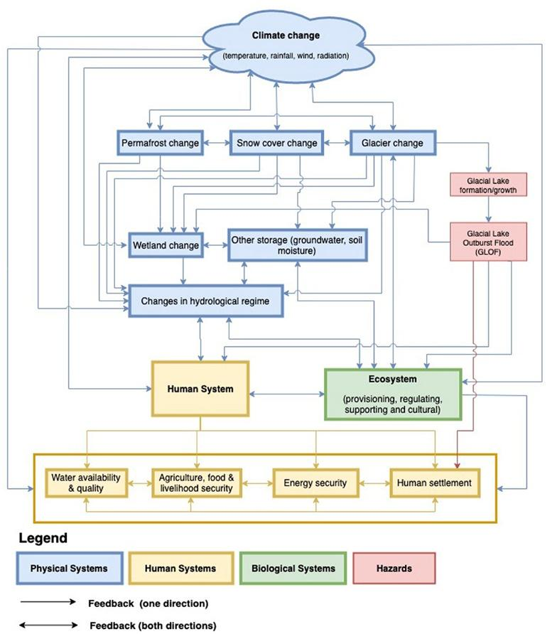
[Rasul and Molden, 2019).
From research and articles written into the impact of glacial melting they highlight the main impacts as water loss to populations, cities and agriculture. They talk of a reduction in water availability across different sectors. Also highlighted are intensified water induced hazards-floods, droughts, avalanches, landslides. This will be due to increased surface water flow in the short term but gradual decrease in glacial-fed rivers and streams over time. Glacial lakes forming due to melt will mean more glacial lake outburst floods. This is turn will lead to damage to infrastructure and potential loss of lives and property. As water supply to large cities and towns originate often from cryosphere, for example the Andes the affect will be huge. Sources of energy will be interrupted. Hydropower supplies about 16% of the world’s electricity. Water for the hydropower reservoirs often comes from glacier and snow melt. The change in waterflow will affect this. Energy output will decrease, and additional investment will be required.
Discussion:
Case Studies showing the demographics primarily affected:
Peru has the majority of the worlds glaciers, and it has huge glacial recession. Of the 71% of the Earths tropical glaciers in Peru 22 % of their combined surface area has been lost. (Peru, 2015). The Hindu Kush-Himalayan region has vast snow and ice, but glaciers are retreating fast. The purifying effect of water being stored as ice will be lost effecting water quality and health. There is a huge economic cost implication to purify the water another way. Accelerated melting speed means pollutants are being released back into the environment. Populations on the low-lying land around a glacial region rely on glacial meltwater for such things as water, hydroelectric power, crop cultivation. In Peru glacial melting in the Andes provides essential water to the surrounding population and ecosystems. With glacial recession the snow melt is moving further and further back. The glaciers here support nearly 1.8 million people in the Rio Santa river basin. They need the glacial runoff to maintain the mountain ecosystem they rely on for food, energy, water. Regions that have a dry season will be more effected as rivers will have less water for the agriculture and power during this time.
Water availability will be impacted in areas that are upstream and downstream. This will affect urban water availability and in turn water quality and Health. Access to clean water is threatened for the population in these regions.
There will be a threat to food security. In high mountain areas there may be drought leading to food shortage. In downstream irrigated areas large irrigation systems may suffer from water shortage and affect productivity. A reduced pasture for animals will threaten food production. There is also a threat to forestry, fisheries, agriculture and tourism in high mountain areas. These communities rely on spring and summer runoff from melting snow. Lowland areas are some of the most densely populated areas in the world. Those living in mountain areas water sources will change for irrigation and drinking and increased threats of floods or drought. The canal waters in the Yanamarey watershed of the Cordillera Blanca in Peru have been dropping over the years, especially during the dry season. This has affected crop productivity. Food sources will be affected for those regions relying on glacial melt as a source of water supply during the growing season. Switzerland Rhone Valley crops are irrigated by channelling meltwater from glaciers to their fields. Ladakh, a desert region, receives little rain so the water comes from snow and glacial melt. 80% of the population relies on farming.
Due to water induced natural hazards increasing mountain regions incur significant economic loss. Risk reduction costs increased to protect infrastructure and relocate communities. For example, the villages of Passu in Pakistan had to move to higher ground. Glacier fed lakes can breach their dams causing flood hazards to those who live downstream
A decrease in tourism will have an economic affect. Ski resorts in Austria are looking at a decreased season. Some have closed due to glacial recession such as Chacaltaya ski resort in Bolivia. The solution glacier-based ski resorts in European alps have been to use geotextiles to help reduce the melt locally (Huss, 2024). These stop snow melt by reflecting solar radiation and blocking warm winds.
Poorer places and people are more vulnerable to the effects of sea level rises because they lack the capacity to change as well. A combination of coastal and low-lying areas with poor areas that are highly populated will be the worst affected, for example areas in Bangladesh and the pacific island of Tuvalu. There is a risk to infrastructure due to costs to replace damage or relocate an area to a safe area.
Amu Darya, a main river in Central Asia, derives part of its water supply from glacier melt. Averaged over the year, that melt accounts for only 8 percent of annual river flow, but it accounts for 27 percent of river flow in late summer, when snow melt provides relatively little water. (National Snow and Ice Data centre, 2024). The alteration to the hydrological system from cryospheric changes will affect society by reducing water availability.
Possible Solutions:
What is being done now to alleviate or rectify the issue:
At Global and National level there should be a risk management plan to minimise the adverse impacts of any climate change. As different areas will be affected there needs to be recognised access to global funding. There should be appropriate adaptive measures to prevent the risk. There needs to be governments that can monitor and enforce regulations. An important element is that local communities are consulted about water storage solutions for the future. As the impact of glacial melting is already being seen in Peru they have started to look at possible solutions that will help for that area. These are being planned and implemented as local and International projects .The Peruvian government has a National Adaption Plan for Climate Change. Peru is looking at tighter water distribution control. They are looking at Joint development ventures with neighbouring countries or areas facing the same problems. These would focus for example to strengthen ecosystem resilience and advocate less water intensive economic activities.
Countries need to have an increased budget for risk reduction measures. For example, digging a canal to lower the glacial lake in Nepal Tsho Rolpa glacier cost USS 3 million in 2002.
What solutions need to be enacted:
Due to the potential loss of water predicted if glaciers continue to melt countries need to look at water storage for the future. Key ecosystems need protective measures put in place such as consideration of the Alpine wetland remediation.
To manage the future water challenges created by glacial melts research suggests solutions need to include sustainable water storage to manage the effect of water flow and how it will change. Water-use efficiency improvement is needed and reduction in waste of water to be managed by having effective government policy incentives. In agricultural areas where water usage is high, improving irrigation methods is needed. Using hydropower turbines to increase energy efficiency and reduce water consumption have been trialled.
Conclusion:
Protecting glaciers requires the world to prevent any additional climate warming they can. However, the threshold has already been passed for some glaciers being completely gone in a lifetime. (Rance, 2023). The article concludes that the future of the Earths glaciers depends on humans working together to limit warming. More research to understand the effects of the cryosphere on socio-economic areas is vital so that clear policies can be put in place and funding available for the changes that will need to be made.
References
Acharya, S. (2021). The social impacts of glacial melts. [online] theecologist.org. Available at: https://theecologist.org/2021/sep/08/social-impacts-glacial-melts.
Genevaenvironmentnetwork.org. (2024). Unprecedented Rates of Mountain Glacier Melting | Glaciers and the Role of Geneva. [online] Available at: https://www.genevaenvironmentnetwork.org/resources/updates/unprecedented-rates-of-mountain-glacier-melting [Accessed 7 Jan. 2025].
Huss, M. (2024). The Alps’ iconic glaciers are melting, but there’s still time to save the biggest. Bulletin of the Atomic Scientists, 80(4), pp.225–229. doi:https://doi.org/10.1080/00963402.2024.2364501.
National Snow and Ice Data center (2024). Why Glaciers Matter. [online] National Snow and Ice Data Center. Available at: https://nsidc.org/learn/parts-cryosphere/glaciers/why-glaciers-matter.
Nie, Y., Pritchard, H.D., Liu, Q., Hennig, T., Wang, W., Wang, X., Liu, S., Nepal, S., Samyn, D., Hewitt, K. and Chen, X. (2021). Glacial change and hydrological implications in the Himalaya and Karakoram. Nature Reviews Earth & Environment. doi:https://doi.org/10.1038/s43017-020-00124-w.
Peru, in (2015). Yale Journal of International Affairs. [online] Yale Journal of International Affairs. Available at: https://www.yalejournal.org/publications/changing-policy-for-a-changing-climate-the-social-implications-of-rapid-glacial-recession-in-peru.
Rance, L. (2023). What Are the Consequences of Glacial Melting? [online] Earth.org. Available at: https://earth.org/glacial-melting.
Rasul, G. and Molden, D. (2019). The Global Social and Economic Consequences of Mountain Cryospheric Change. Frontiers in Environmental Science, 7(91). doi:https://doi.org/10.3389/fenvs.2019.00091.
www.genevaenvironmentnetwork.org. (n.d.). Unprecedented Rates of Mountain Glacier Melting | Glaciers and the Role of Geneva. [online] Available at: https://www.genevaenvironmentnetwork.org/resources/updates/unprecedented-rates-of-mountain-glacier-melting/.
www.rgs.org. (n.d.). How will melting glaciers affect people living in other countries? - RGS. [online] Available at: https://www.rgs.org/schools/resources-for-schools/glacial-environments/how-will-melting-glaciers-affect-people-living-in-other-countries.

