

Student name: Maya Hadzhieva

Student ID: 1818829

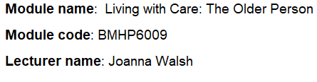

Table of Contents
Introduction 3
Meaning of the elder person in the UK and Bulgaria 4
Meaning of an ageing population 4
Concepts 4
Statistics 5
Theories of ageing 5
Impact of the isolation and loneliness 5
The meaning of the elderly person 6
The UK legislation 6
Bulgarian legislation 7
Bulgarian legislation 7
The comparison between the UK and Bulgarian legislation 7
Critical examination of the current UK legislation 7
The current UK legislation 8
Government’s 2018 loneliness strategy 8
Comparison between the UK and Bulgaria policy 8
Prospective future with the use of AI 9
Future of technology and AI in care homes 9
Benefits and limitations of technology usage 9
Evaluation of technology and AI 10
Recommendations 10
Conclusion 11
References and Bibliography 12
Appendix 15

Introduction
The technology and medicine advances in recent years can support the greater autonomy of elderly people (Inouye, 2021). Their quality of life is improving with the effective treatment and this enhances the chances of their independent wishes. Healthcare services are important for elderly people in situations when they can’t perform their daily routine. They need to enrich their lives with a complete support system to complete everyday tasks such as cooking, working, and housework. A strong relationship between social and healthcare services is required to support elderly people’s independent wishes (Inouye, 2021).
The aim of this report is to deliver a critical evaluation of the influence social isolation on the elderly people. This is a comparative report between the UK and Bulgaria. The objectives of this report are to examine the prospective future of the healthcare of the older person and to include the application of the technology and the use of AI (Artificial Intelligence).
The structure of this study includes discussion, analysis, evaluation, and recommendations. It provides a definition of the term of an elderly person in the UK and Bulgaria. This academic report provides statistics on the ageing population and the changes in recent years. It provides discussions on the relevant theories of ageing and explores the concepts of isolation and loneliness. The legislation of the UK and Bulgaria are an important part of the vital analysis for the policies and protocol for the protection of elderly people. The statistics from both countries are important to raise awareness of the isolation and loneliness of the elderly population. The critical evaluation and comparison between a local, national and global provider of healthcare services for elderly people are examinations of the current policies and initiatives. All the problematic issues are linked together with the preventative measures that are required by healthcare services to support the older population, especially those with the experience of isolation and loneliness.

Meaning of the elder person in the UK and Bulgaria
In the UK, when somebody is over the age of 65 might be considered an older individual (Munson, 2021). The elderly person in the country means “older adults”. In comparison with Bulgaria, the term older person has the same meaning as those over 65. However, the difference is about their independence. Sometimes, in Bulgaria, the meaning of an elder person means an individual without independence. The person is as young as without disabilities (Giddings, 2021).

Meaning of an ageing population
The ageing population in the UK means that the improvement in the quality of healthcare to support the people to live longer and very often with more complex medical conditions. 18.1% of the UK population is aged 65 and over and 1.7 million people are aged 85 and over (ONS, 2021). This means that in the future the population will shrink because of the record low birth rate and people are living longer. By 2041 this number will be over 3 million elderly people. There are 6 million carers in the UK. This supports their independent life choices.
According to the Care Quality Commission (CQC), 1.4 million elderly people are without healthcare and assistance due to the coronavirus pandemic and the rules for social distance. This has a huge impact on the loneliness and isolation of elderly people. The ageing population affects productivity, later retirement, and the costs for personal healthcare. The biggest impacts are on public services, pension, housing, and well-being. The governments are facing additional costs (Spelten, 2021).
The ageing population of Bulgaria means enabling the elderly individuals to remain healthy and implement the government policies related to healthy and productive older ages and take better opportunities for longer lives (Gurler, 2021). The current labour market trend means that the elder force must be integrated with the health and social services for elderly people. Bulgaria is heading for the sharpest decline in the working-ageing employees of any nation-state. The associated issues are a decline in labour supply, a double share of the elderly population, a decline in the national income level, and collapse of the current healthcare sector, pension, and long-term healthcare liabilities (Tcholakova, 2020).

Concepts
In the UK, the concept of loneliness differs from the concept of isolation. People can be isolated but not feel lonely. The opposite is that people can be surrounded by other people and still feel lonely (Rubio, 2021). The concept of loneliness is that this is a subjective feeling between the individual’s favourite level of social interaction and the real level of social contact. The concept of communal isolation is an objective measure of the number of connections that individuals have (Rubio, 2021). They can occur at the same time or one to lead to the other. Social isolation and lowliness are different but related concepts. In Bulgaria, the concepts of loneliness and social isolation are connected to lower levels of empathy, emotional feelings, and high levels of distrust. This is the framework of the risk factors for elderly people (Petrov, 2021).

Statistics
In recent years, the elderly population of the UK and Bulgaria is increasing. The population of both countries is aging at a momentous rate. In 2018, 18.1% of the UK population is aged 65 and over, while for Bulgaria it is 21.3%. In 2019, there is surged to 18.5 % for the UK, while for Bulgaria it is 21.6% (ONS, 2021). In 2020, for the UK is 18.5% and for Bulgaria, it is 20.06%. The current coronavirus pandemic leads to a record death of 700, 000 in the UK. Please see Appendix. For the UK population over 65 is nearly 12 million for 2020. This means a demographic bomb for both counties because the population will shrink in the future. Bulgaria’s population declined sharply from 9 million in 1990 to 6.9 million in 2021. There are fewer employees in 2021 in comparison to 1990 (ONS, 2021).

Theories of ageing
Aging is a progressive, deleterious, universal, and intrinsic process. There are more than 300 theories to understand aging with the high prediction (Kyriazis, 2020). Disengagement Theory shapes that aging is an inescapable, mutual withdrawal, resulting in reduced interaction between the ageing individual and the others from the social system. Activity Theory is opposite of the above theory and is more active and involved the elderly are more to be satisfied with own existing. Reconstruction Theory states that ageing promotes negative psychological functioning (Kyriazis, 2020). These theories have an epistemology for discipline and they have been largely debunked.

Impact of the isolation and loneliness
The current coronavirus pandemic means that many people who live alone can be socially isolated (O'Shea, 2020). The elderly people with no support from family and friends that require a minimum level for good quality can become trapped in their homes. This leads to feeling alone and vulnerable with a serious decline in physical health and wellbeing. The UK government wants to reduce the impact of loneliness and isolation by efforts to reduce social isolation. This will have positive effects on wellbeing and reduce mortality. The government can provide home healthcare with independent choices or living-care rather than hospital healthcare (O'Shea, 2020).
Loneliness and isolation are increasing in Bulgarian society. This development intensifies due to global distance rules in response to the current coronavirus pandemic. Many elderly people in Bulgaria face the reality of living alone (Hristov, 2018). This is the core indicator of social isolation and potential loneliness. It leads to an increase in the risk factors such as poor mental and physical health, low household income, and have little trust in the others in the local area. Many elderly people in Bulgaria face poverty and other economic hardship caused by lockdown restrictions. The measurements are the essential accepting of the ties among social connections and health, and intervention tactics (Kanaan, 2021).
In comparison between the UK and Bulgaria in terms of isolation and loneliness, the UK government takes action to address the problematic issues for elderly people. Bulgaria faces the highest percentage in the EU with elderly people at risk of poverty – 45 % against 18% of the UK’s elderly people. Bulgaria must work much harder than the UK to have a well-functioning labour market and welfare system. Both countries must find more resources to ensure living in dignity (Akram, 2021). However, Bulgaria limits home care for elderly people to those with a disability, limited services for living-in care, and mainly services are in the hospitals. Highlights for both countries are that the UK offers home healthcare services for elderly people, local support, and volunteers. Bulgaria started to create local community centres where vulnerable elderly people can meet together. There are voluntary individuals who buy food for elderly people (Moutafova, 2017).

The meaning to be an elderly person
The structure of modern society is changing with more people living longer. This means that more funds and healthcare services are required. The right knowledge and skills for elderly people are needed. The important role of healthcare staff is vital for them (Garfield, 2021).
Person-centred care is important for the healthcare services in the UK. However, in Bulgaria, this term is almost unknown due to lack of enough funding and lack of interest in jobs in the healthcare industry (Hristov, 2018). Person-centred care for elderly people in the UK highlights the example for future healthcare practices in Bulgaria. This means fulfilment of elderly people’s requirements beyond ailment and disability.

UK legislation
Social Care Act 2014 shapes the responsibilities of local authorities. It focuses on a statutory duty of wellbeing and promoting the wellbeing of adults for decision-making. The local authorities promote the integration of care with healthcare services undertaking their social services function. This act increases the power of the CQC to deal with quality failures (Garfield, 2021). Mental Capacity Act 2005 is planned to empower and protect the individuals who lack the mental capacity to have a decision-making process for their treatment and healthcare. This act supports people to make their own decisions. Policies and protocols for the protection of elderly people in the UK are a framework for integrated care for elderly people. This is the national policy for the implementation of integrated care and includes a range of measures to ensure sustainable change with the development of the workforce through education, training, and strategies to address the work of healthcare professionals with elderly people (Garfield, 2021). The core details from the Care Act are specialised healthcare, personalised social care, and a strong focus on well-being.

Bulgarian legislation
Law of Protection, Rehabilitation, and Social Integration of Disabled 2002 regulate the rights of the disabled and their protection to ensure the obligations for state bodies. It shapes the conditions for social integration of the disabled and their adequate participation in society. This law provides conditions for social rehabilitation, employment, social and legal protection, accessible living, qualification, and the creation of conditions for communication of disabled people (Georgiev, 2019). National Programme “Social Services in a Family Environment” 2009 introduces home-based services such as social helpers, personal assistants, and home assistants.

The comparison between the UK and Bulgaria legislation is that the UK has long-term traditions for elderly people. The beginning of the legislation for elderly people in Bulgaria is several years before becoming part of the EU (Tcholakova, 2020). More training and financial resources and required for this Balkan country to reach the current level of living-with-care in the UK.

Critical examination of the current UK legislation
There is a sharp rise of the elderly people from 12% in 2015 to 18.5% in 2020 (ONS, 2021). Life expectancy will increase and this will lead to more limitations that benefit the national economy because more financial resources are required for them. Welfare spending is increased from £114 billion in 2014/15 to £128 billion in 2019/20 (ONS, 2021). There is a huge impact on NHS and social care costs. The costs for an elder person in a hospital in the UK are three times more than for a young person. This leads to less revenue because the working population is declining. By 2037 for every working-age person there will be one pensioner in the UK.
The Office for Budget Responsibility calculates tax rises, spending cuts, and budget deficits are expected because of the aging population. It is expected welfare payments to be reduced in the UK, and to offer for healthier pensioners to remain in the labour market. The overall result is that UK governments aim to raise awareness of loneliness and isolation in the elderly population.
Age UK is a charity organisation that supports the active life of elderly people. They offer help for carers, arranging care, power of attorney, etc. The UK legislation such as Age Discrimination Act and Equality Act protect elderly people from direct discrimination, indirect discrimination, harassment, and victimisation (Glasby, 2021).

The current UK legislation
It requires local services to have many aspects for older people and to take movements to improve values of care, extend admission to services, ensure reasonable funding of long-term care, and progress services to support independence. At the national level, there is National Service Framework to deliver higher quality services for elderly individuals (Akram, 2021). Limitations are that patients needed to participate in the structures of the NHS, changes are required for the framework since 2001, and extra funds are needed. More nurses, therapists, and consultants are required for working with elderly people. The overall evaluation is that modernisation is required for social services to promote new ways of working (Akram, 2021).

Government’s 2018 loneliness strategy
This strategy is a problematic issue for everyone such as employers, communities, individuals, and healthcare services (Hawkley, 2019). It has three main objectives as to reduce stigma by building a national conversation on loneliness, creating relationships with consideration on policy-making on loneliness, and actions for improvement based on evidence on loneliness. Advantages are improving understanding of loneliness, monitoring loneliness, and capturing the changes that affect it (Hawkley, 2019). The limitations are that lowliness needs indicators across all ages, minimum geographic coverage in England, more activities are required for social connectedness such as sport, culture, art, and volunteering. The strategy has a focus on all ages.

Comparison between the UK and Bulgaria policy
The UK the policy is integrated, reduces the risk of social isolation, promotes dignity, builds a social environment, promotes friendly-based services, and improves the elderly people’s needs (Holt, 2021). Bulgaria receives funding from the EU for the services of elderly people. It needs to improve its healthcare and social services for elderly people (Bogdanova, 2021). This poor Balkan country has a history to underestimate its services. However, new legislation, training, and funding made the essential for the new beginning.

Prospective future with the use of AI
There are many instances where AI can perform better than the healthcare staff, implementation in huge-scale computerisation of healthcare occupations for a significant period (Kalakota, 2019). AI and related technology begin their application within the healthcare industry. The prospective future is to use the powerful combination of AI. The physical robots in healthcare are part of the AI capabilities with a well-operating system (Kalakota, 2019). There are surgical robots in the USA since 2000 with the ability to minimise incisions, stitches wounds and etc. However, the robotic process has a huge potential for the future because of today limited usage mainly in prostate surgery, gynaecologic surgery, and head surgery. The prospective future is robotic process automation. This is a kind of AI with a combination of workflow and the integrated presentation layer. The main focuses of AI in the healthcare system are diagnosis and treatment of disease, clinical workflows, medical record systems, precision medicine, and more algorithmic systems based on machine learning. Future AI prospects for elderly people are for home health monitoring, smart devices for a regular living, and computer-generated companions (Kalakota, 2019). Disadvantages of AI are the high costs of the implementation, it cannot replace humans, and lacks creativity.

Future of technology and AI in care homes
Technology increases its role in healthcare settings nowadays (Tetley, 2019). AI has been introduced into care homes to predict the need for early interventions. This means delivery of 24/7 care and allowing extended ecosystems. New AI-based tools are required for digitalisation of the healthcare industry and for coordination of the local authorities, NHS, and healthcare providers to AI-based solutions. This will play a vital role in the future for the transformation of care homes. It will enhance loneliness, daily key tasks, and workload reduction. This will resolve the problem with the frontline staff (Tetley, 2019). Ethics is a set of values and principles to guide moral conduct. The sensitivity of humanity is a vital issue against AI. However, AI can help people to solve global problems.

Benefits and limitations of technology usage
This includes the solutions for healthcare industry challenges, patient monitoring equipment, diagnostics, better data-driven decisions, to detect the diseases in early stages, assistance in surgery, post-surgical updates, automated human support, mental health support, saves money and energy (Akram, 2021). AI provides big data analytics, an early stage of diagnosis, tracks daily lifestyle habits, and provides reminders for medicine. The biggest advantages of AI are to reduce the side effects, prevent infection, less pain, and minimum blood lack in operations. The limitations are that affect the social life, it is expensive, and it is requires training and education.
Evaluation of technology and AI
Advantages for technology and AI are to foster healthcare availability, clinical decision-making, and streamlining processes (Anand, 2021). AI-driven instruments support expose early illness hazards, AI algorithms can save time and expenses, unparalleled assistance in surgery, and support mental health (Wilde, 2021). The limitations are that a lack of personal involvement will raise unemployment among healthcare employees, the possibility of a malfunctioning diagnosis, and social prejudices. The overall summary is that technology and AI will bring more benefits to the whole healthcare system (Anand, 2021).

Recommendations
The UK Government must provide national guidelines for accountability and to enable consistent care for the elderly people in need (Hewitt, 2016). Identifications of the measurements are required to overcome the core barriers for successful outbreak management. Future guidelines for healthcare managers are required for care facility staff. There is lacking an optimal management strategy for elderly people. For the use of technology and AI is important the feedback loop to ensure responsible technology improvement and implementation (Ho, 2020).
Bulgaria must focus on energy poverty and target heating allowances as the main problem for elderly people (Andonova, 2021). A national regulatory framework is required for quality healthcare services for elderly people and healthcare staff. More funding is required to increase the pensions and to fight poverty. For the use of technology and AI are important the clarification of how elderly people can balance their independence, privacy, and confidentiality. Further development is required for the development for AI health monitoring technologies to deliver unceasing information (Moutafova, 2017).

Conclusion
This academic report provides evidence for the consequences of ageing population. It provides the identification of the elderly people's experience with mental health, poor quality of life, stress, depression, and anxiety. Living-with-care is essential not only for the elderly people but for national economies to cope with ageing population. Essential changes are required in the legislation for many countries. The impact of caring the elderly people on their social relationships, financial wellbeing, and physical health is vital for the quality of services.
This academic work provides recommendations based on real-life situations. It includes the application of technology and AI inside healthcare provision. The evidence-based proof is vital for the realistic, practical, and appropriate demands of the needs of the elderly population in the UK and Bulgaria. This academic study contributes to the national government strategies to gain a clear picture of the interventions and support needed in place and the development of extra financial resources for the quality of practices for elderly people.

References and Bibliography
Age.uk. (2021). Retrieved from Finding and arranging social care. [Online]
Available at: https://www.ageuk.org.uk/information-advice/care/arranging-care/
[Accessed: 21.07.2021]

Akram, A., Kumar, V., Raman, R., and Shareef, M., (2021). "A new health care system enabled by machine intelligence: Elderly people's trust or losing self-control". Technological Forecasting and Social Change, 162(1), p. 15599.
Anand, M., Livingstone, M., Hantrais, L., Allin, P., and Martin, I., (2021). "Covid-19 and the digital revolution". Contemporary Social Science, 16(2), pp. 256-270.
Andonova, A. (2021). "Comitment of the Elderly People in Bulgaria to their Own Health". Open Access Macedonian Journal of Medical Sciences, 9(8), pp. 76-79.
Behrendt, F., Sourbati, M. (2021). "Smart mobility, age and data justice." New media & society, 23(6), pp. 1398-1414.
Bogdanova, B., and Nedev, B., (2021). "Cross-sectional differences in the level of depression for elderly people in Europe". AIP Conference Procedings, 1(1), p. 150011.
Garfield, S. (2021). "Exploring the theory, barriersand anablers for patient and public involvement across health, social care and patient safety: a systematic review of reviews". Health research policy and systems, 19(1), pp. 1-21.
Georgiev, M., Terziev, V., Bogdanova, M., and Kanev, D., (2019). "The social assistance system in Bulgaria". International E-Journal of Advances in Social Sciences, 5(15), pp.1-15.
Giddings, L., and Meurs, M., (2021). "Elder care and paid work: gender differences in the relationship between unpaid work: gender differences in the relationship between unpaid elder work and employment in Bulgaria". Journal of European Social Policy, 31(2), pp. 223-238.
Glasby, J., Yanan, Z., and Parick, H., (2021). "A lost decade? A reneww case for adult social care reform in England.". Journal of Social Policy, 50(2), pp. 406-437.
Gurler, M., and Ozsoy, O., (2021). "Poverty and social exclusion of older people in againg European Union and Turkey". Journal of Public Health, 18(1), pp. 1-5.
Hawkley, L., Cagney, K., and Peek., M., (2019). "Socila isolation, loliness, and violence exposure in urban adults". Health Affairs, 38(10), pp. 1670-1678.
Hewitt, K., White, C., Cassell, J., and Edge, C., (2016). "The management of scabies outbreaks in residential care facilities for the elderly in England: a review of current health protection guidelines". Epidemiology and Infetion, 144(15), pp. 3121-3130.
Ho, A. (2020). "Are we ready for artificial intelligence health monitoring in elder care?". BMC Geriatrics, 20(358), pp. 4-10.
Holt, J. (2021). "Covid-19: are the elderly prepared for virtual healthcare?". BMJ Health & Care Informatics, 28(1), p. 100334.
Hristov, N., Georgieva, L., Pesheva, P., and Dimitrova, D., (2018). "Demographic and social problem of aging in Bulgaria". European Journal of Public Health, 1(28), pp. 214-238.
Inouye, S. (2021). "Creating an anti-agaist healthcare system to improve care for our current and future selves". Nature Aging, 1(2), pp. 150-152.
Kalakota, R., and Davenport, T., (2019). "The potential for artificial intelligence in healthcare". Future Healthcare Journal, 6(2), pp. 94-98.
Kanaan, M., Gilbody, S., and Valtorta, N., (2021). "Loneliness, social isolation and social relationships: what are we measuring? A novel framework for classifying and comparing tools". BMJ Open, 6(4), pp. 1-16.
Kyriazis, M. (2020). "Ageing throuout history: the evolution of human lifespan". Journal of molecular evolution, 88(1), pp. 57-65.
Moutafova, E., Atanasova, E., Domagala, A., Golinowska, A., Pavlova, M., and Groot, W., (2017). "Political will against funds deficiency: Health promotion for older people in Bulgaria". Zeszyty Naukowe Ochrony Zdrowia, Zdrowie Publiczne i Zarzadzanie, 15(1), pp.1-15.
Munson, A., and Altomonte, G., (2021). "Autonomy on the horizon: comparison instituonal approaches to disability and elder care". Theory and Society, 1(29), pp. 1-29.
ONS. (2021). Overview of the UK population. (2021). [Online]
Available at: https://www.ons.gov.uk/peoplepopulationandcommunity /populationandmigration/populationestimates/articles/overviewoftheukpopulation/july2021/
[Accessed: 05 July 2021]

O'Shea, C. (2020). "Isolation". Gender, Work &Organization", 27(5), pp. 717-22.
Petrov, K. (2021). "The Regional Development of the Rural Areas in Bulgaria and the Support of the European Union.". EuropeanCountryside, 13(1), pp. 208-221.
Pilgrim, D. (2021). A Sociology of Mental Health and Illness. London: McGraw-Hill Education.
Rubio, T., Young L., and Hebblethwaite, S., (2021). "Pandemic precarity: Aging and social engagement.". Leisure Sciences, 43(1), pp. 170-176.
Spelten, E., (2021). "Reshaping healthcare delivery for elderly patients: the role of community paramedicin; a systematic revies". BMC Health Services Research, 21(1), pp. 1-15.
Tcholakova, M., (2020). "A vision for integrated social and healthcare services: A experience from Bulgaria". International Social Work, 22(13), p. 0208720336

Tetley, J. (2019). "The education of nurses working in care homes for older people: An Appreciative Inquiry". International Journal of Older People, 14(2), p. 12223.
Wilde, A. (2021). "Ethics and acceptance of smart homes for older adults.". Information for Healthand Social Care, 11(1), pp. 1-28.

Appendix

Table 1

Life Expectancy | UK  (2019) | England  (2019) | London  (2019) | Waltham Forest  (2019) | Bulgaria  (2019)
Males | 79.4 years (+0.12%)  Highest ever | 79.7 years (+0.15%)  Highest ever | 80.92 years (+0.12%) | 79.4 years (+0.06) | 71.2 years (+0.22%)
Females | 83.1 years (+0.15%)  Highest ever | 83.3 years (+0.15%)  Highest ever | 84.69 years  (+0.15%) | 83.8 years (+0.14%) | 78.2 years (+0.25%)
Average  (years) | 81.27 (+0.15%) | 81.3  (+0.15%) | 82.4  (+0.15%) | 81.4  (+0.10%) | 75.11  (+0.17%)

The data for 2020 shows the biggest drop since 1940 due to 70, 000 excess deaths. In comparison with 2019

Table 2

Life Expectancy | UK  (2020) | England  (2020) | London  (2020) | Waltham Forest  (2020) | Bulgaria  (2020)
Males | 78.2 years  (-1.6%)  Biggest drop since 1940 | 78.7 years (-1.5%)  Biggest drop since 1940 | 78.4 years  (-2.6%)  Biggest drop since 1940 | 78.2 years  (-1.4%)  Biggest drop since 1940 | 71.4 years (+0.22%)
Females | 81.1 years  (-1.2%)  Biggest drop since 1940 | 82.7 years  (-0.9%)  Biggest drop since 1940 | 83.1 years  (-1.5%)  Biggest drop since 1940 | 80.2 years (+0.14%)  Biggest drop since 1940 | 78.4 years (+0.20%)
Average  (years) | 80.15  (-1.6%) | 80.1  (-1.5%) | 80.4  (-1.7%) | 80.3  (-1.6%) | 75.23  (+0.17%)

Graph 1
The UK Pension spending % of GDP

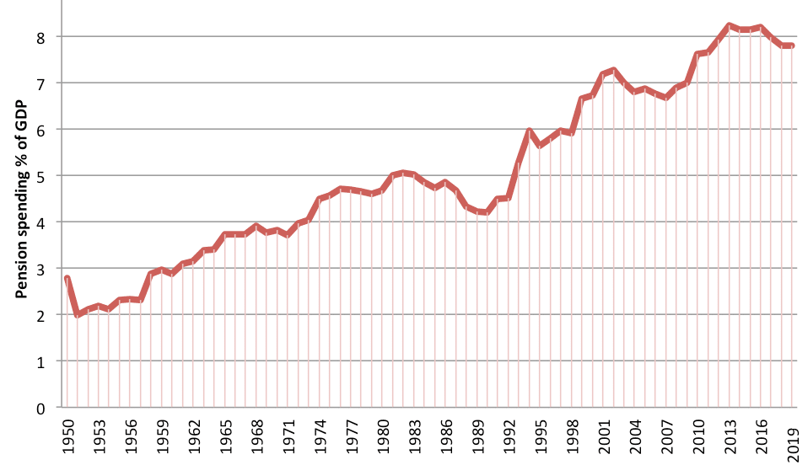
Source: (ONS, 2021)

Graph 2
The projected age structure of the UK population in 2036

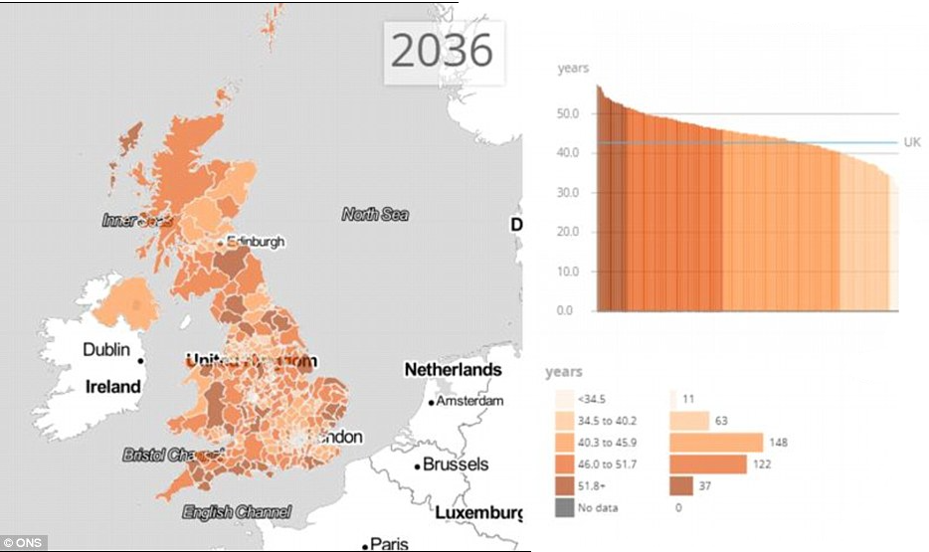
Source: (ONS, 2021)

Graph 3
The Bulgarian Demographic bomb

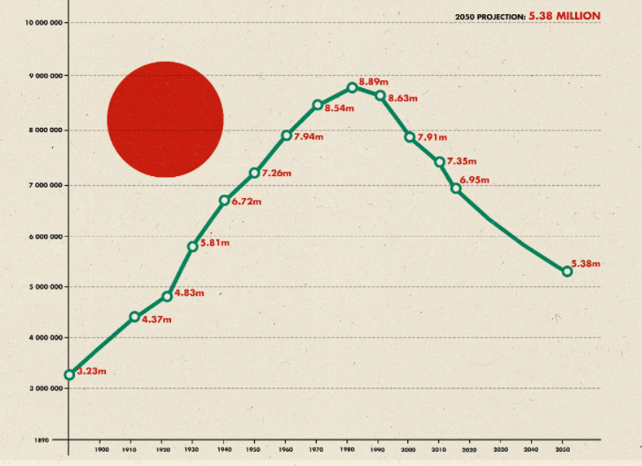

Source: (ONS, 2021)

