Dissertation Proposal
Olivia Hutchings – 1701921
Surface Pattern Design
Module – Research Practices ADAD5001
Tutor – Julia Lockheart

Word Count- 2471

Key words
Design
Problem
Sustainability.

Throughout my second year of University I’ve discovered that there is a lot of hidden problems within the design industry. I discovered that designers face many wicked problems along with the environmental pressures to work sustainably, I didn’t realise that textile waste was such an ongoing big problem in the UK, even in Wales. A recent project I took part in has led me to look into this in more detail. As part of the brief I was only allowed to design and produce a product mainly from a factories waste fabric. By focussing mainly on what design is, the problems involved and sustainability I’d like to look into how we can use all of these together to improve the future. By looking into these problems and the possible solutions to become sustainable it will let me gain more knowledge in order to become a responsible designer in Wales.

Firstly, I’d like to look at design, design is everywhere, you see examples of it every day, from what you write with, to what you wear, to even what you sit on. Although I class myself as a designer, what does the word ‘design’ actually mean? I’m interested in how a change in context can completely change the meaning of it, this is shown in the picture below.

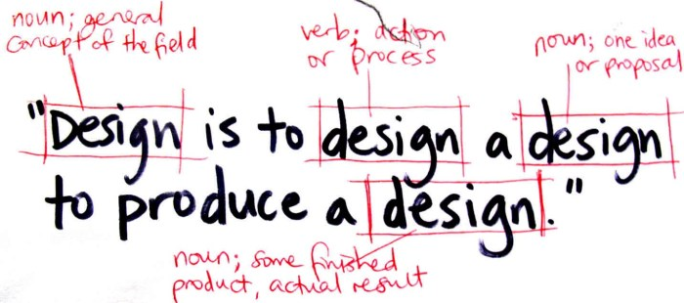
Source 1- (Zuberi, 2019)

Source 1 shows all the possible definitions of design, and quite frankly they all play a part in designing, from the idea, the process to the end result. However, it doesn’t explain that designing can be done in so many different ways by different people, as they are taught to design specifically in their practice and also to suit a certain brief.

Design has different meanings to different of people depending on practice, it usually means the processes that someone goes through in order to make an end product. However, there are many ways in which certain people ‘design’. For example, Bryan Lawson argues that “A fashion designer creating a new collection might be slightly puzzled by the engineer’s use of the word ‘design’. The engineer’s process seems to us to be relatively precise, systematic and even mechanical, whereas fashion design seems more imaginative, unpredictable and spontaneous” (Lawson, 1998, p. 3)
This proves that the word ‘design’ can interpreted in different ways, I believe the engineer doesn’t need to design imaginatively like the fashion designer as his design is a lot more practical and doesn’t tend to look nice, whereas the fashion designers tend to produce ideas that are spontaneous that might not have much practicality to them, just to simply look beautiful. This then shows how engineers and fashion designers are on opposite ends of the design spectrum.

In the middle of the design spectrum are designers that design to make things beautiful but also have practical and functional need. Lawson says that “The three-dimensional and environmental design fields of architecture, interior design, product and industrial design, urban and landscape design all require the designer to produce beautiful and also practically useful and well-functioning end products.” (Lawson, 1998, p. 4) These three-dimensional designers also can’t be as imaginative as the fashion designers as they have to create products that are functionally right instead of spontaneous, although made beautifully it can be seriously dangerous if that products not functional for the consumer. No matter what way the word design is approached in any type of practice the same concept is achieved at the end, to produce an idea/product.

Designing doesn’t just magically come to someone, it takes practice and thought, it’s a skill that I believe is underrated. Lawson says that “Design is a highly complex and sophisticated skill. It is not a mystical ability given only to those with recondite powers but a skill which, for many must be learnt and practiced, rather like the playing of a sport.” (Lawson, 1998 , p. 11). In design school, you are taught processes in which can allow you to design well in your specific practice, just as if someone was taught or shown a physical skill for specific sports. For example, tennis shots, you are taught all possible shots, so you are able to adapt to use the most suitable shot at the right time in order to achieve your end result well. In textiles design it’s the same, you are taught all these different processes that you then adapt and select the right ones suitable to use, depending on client, time and what you’d like to achieve. It takes a lot of thought and doesn’t just come to someone as easy as clicking your fingers.

I believe a design is somewhat of an interpretation, people design things that they might think is complex and beautiful however, someone else would much rather a simple more functional design. There’s no right or wrong way in design, you can push the boundaries as much as you want, its simply up to preferred tastes.

Secondly, I’d like to research the word Problem, Specifically in Design. A problem is “A matter or situation regarded as unwelcome or harmful and needing to be dealt with and overcome.” – (Oxford, 2019) I am interested in looking into the problems that designers face and the methods they use to help overcome them. It is well known that designers are always tackling many problems, and the design thinking methodology by Tim Brown is an approach that many designers in fact use. It involves solving problems in a creative and innovative way, by focusing mainly on human needs.

The first step of the design thinking model is to identify the problem or in some cases identify yourself with customers, trying to gain an understanding of the problem in hand. Once identified and researched it’s time to define what you think your solution is and ideate ideas that are possible. The next step is to make the prototype, this should identify the best possible solution to a problem, which will lead you to the final testing stage. The model is not linear, the research should flow back and forth between each step. By using the methodology of this, it should let you understand the client/consumer better therefore allowing better products to be produced. The diagram bellow shows a model methodology for design thinking.

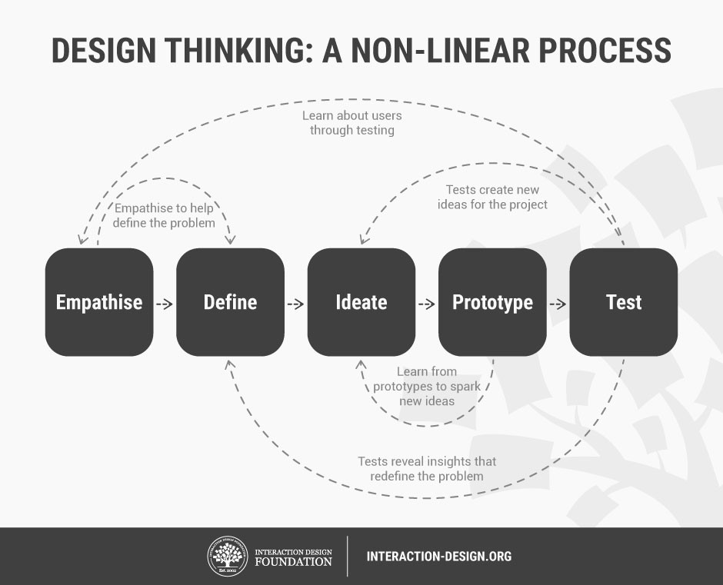
(Knezevic, 2019) – Source 2.

Lawson believes that “designers are traditionally identified not so much by the kinds of problems they tackle as by the kinds of solutions they produce.” (Lawson, 1998, p. 51) This proves that these days there is a lot of pressure on designers for them to overcome problems in order to create a ‘good’ design. I believe this then effects and limits a designer’s creativity, as they can’t think too far outside the box if they have all these problems to consider.

I am Interested in looking into all the problems with designing, as it’s not as easy as just whipping up a design for someone, there is a lot to consider. It can be argued that clients and consumers bring most of the problems for designers to solve. However, there’s not just clients with very specific ideas and taste that cause problems for us, there are also ‘wicked problems in the world. “A wicked problem is a social or cultural issue or concern that is difficult to explain and inherently impossible to solve. Examples of wicked problems in today’s society include things like income disparity, poverty, hunger, health care, obesity and terrorism.” (Hendericks, 2003).

Rittel believes that designers could help with wicked problems in design thinking, as they are highly skilled and experienced people with many different backgrounds that could solve complicated issues, basically thinking outside the box in a more creative approach. Designers are always thinking outside the box, and always thinking what they should do next? So I believe Rittel is right to say that designers could help overcome these impossible problems, they think more creatively and are not afraid to push boundaries, also they do think differently, they think about the problem first by putting the human needs a priority. However, Wicked problems are sometimes too difficult to solve as they often have constant changing requirements that are often difficult to recognize.

Designing for now and for the foreseeable future is difficult for a designer, they have to keep update on current economic, social and cultural problems. Lawson says that “designing in times of rapid change is clearly more difficult than designing for a stable and predictable world” (Lawson, 1998, p. 117 ).This is true as designers are constantly trying to keep up with the world in order to create the best design ideas, however this means they have to design well into the future in order to ahead of time. However, no one is sure what’s going to happen in the future, the best current example for this is in Britain is Brexit. It is an ongoing economic change that is going to impact massively, designers have no idea what could happen to their possible clients, imports, exports if they deal overseas In Europe. This is only one of the many possible problems that designers face, however they have to keep designing in order to achieve a career.

Lastly, I’d like to look at sustainability. As graduation is approaching, I am interested in sustainability, this links in with my two other key words, problems in design. A significantly big problem is waste in design, by looking at this it will allow me to be aware and to become a new responsible graduate designer in Wales.

Sustainable design seeks to reduce the negative impacts on the current environment without harming the future environment. I have looked into Orangebox an office furniture in Wales that are researching how they can become more sustainable. There are many ways you could produce a sustainable design, from the materials it’s made from, how it’s made, to how much of it can be reused at the end of its life.

In our Common Future - The Brundtland Report published 1987 Oxford University press, states “Sustainable development is development that meets the needs of the present without compromising the ability of future generations to meet their own needs.” (Wo, 1990) I believe this quote can be linked to a diagram that explains the circular economy (Diagram Below).

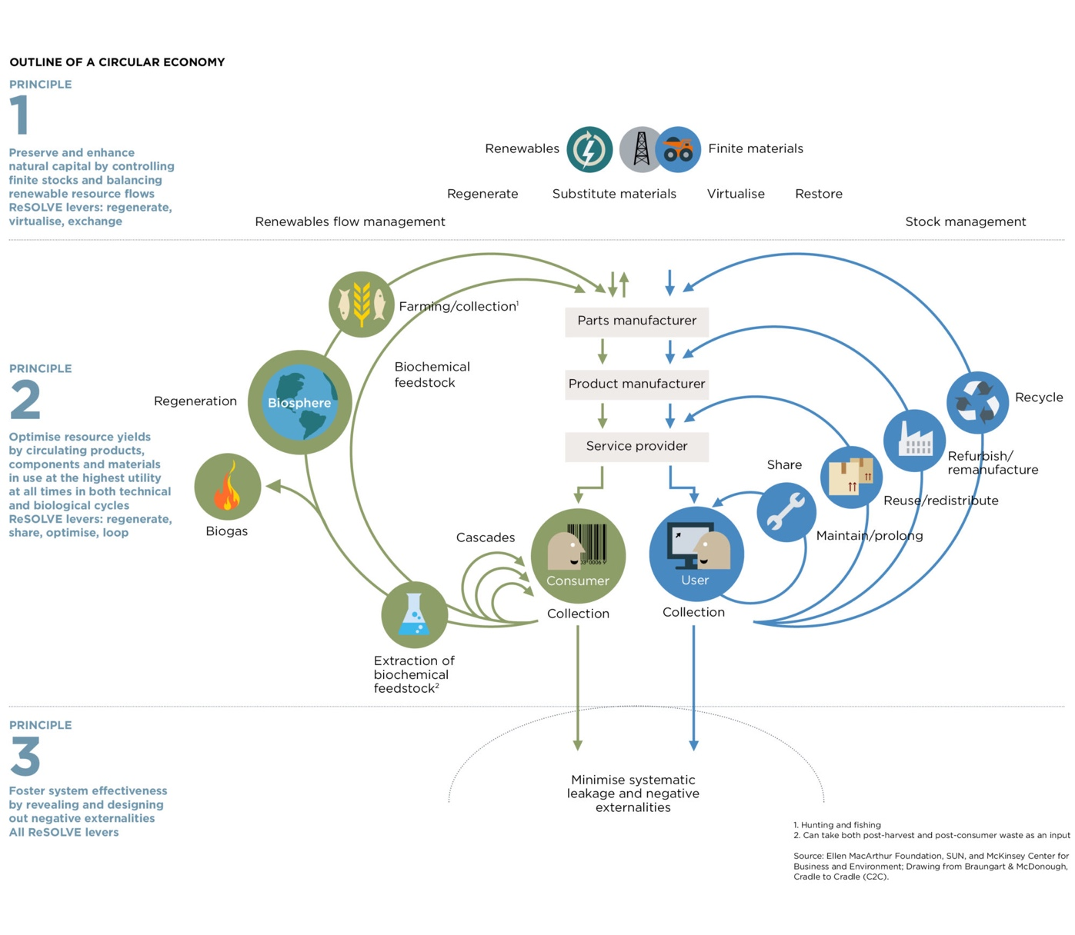
Source 3 Circular Economy Diagram - (Macarthur, 2017 )

“A circular economy is an alternative to a traditional linear economy (make, use, dispose) in which we keep resources in use for as long as possible, extract the maximum value from them whilst in use, then recover and regenerate products and materials at the end of each service life.” (Wrap, 2019) Orangebox are in the process of finding solutions to make their production target a circular economy.

In the book Design Futuring, Fry explains “The very notion of consumption itself, as an economic and socio-cultural practice, is mobilized unproblematically. It is the fact that people do not metabolically consume that is at the heart of the problem. Consumption as an economic category is incommensurate with it as an ecological category. No matter the wat in which products are acquired and used or whether consumption is thought and theorized as an economic activity, the fact is that all durable products at the end of useful life have not been consumed.” (Fry, 2009, p. 192) Here Fry is basically saying consumption is always going to be the main problem, no matter how recyclable a designer has made a product, it is down to the consumer to recycle that product at the end of its life. Orange box ask for their products to be returned after they are no use anymore so they can reuse certain parts e.g. plastic bottoms and legs and reupholster the seat, however, they can’t guarantee they are going to have that product returned to them in order for them to reuse it to follow the model of the circular economy, it is simply down to the consumer.

In the book Cradle to Cradle it talks about how we should not be destroying resources we could pass on to our grandchildren, it talks about possible solutions to help designers become sustainable by making products that once used are able to go back into the biological cycles. However, it explains “Are we too quick to embrace some “solutions”? Britain has planned to build a hundred more waste incinerators – why? Through incineration you lose all the nutrients which should go back into technical or biological cycles”. (McDonough & Braungart , 2009, p. 5) It is obvious that Britain thinks that incinerating waste is a solution that is better than just doing nothing with the waste at all, this links into how they think having ‘more control (being less bad) is not the same as being good.’ (McDonough & Braungart , 2009, p. 4) Britain thinks by just doing something at all to get rid of the problem, it will eventually go away, this is not the case.

I have researched into the use of incineration in my practice, in most cases textile waste is currently disposed of in the general waste stream or incinerated. Although Orangebox are finding solutions to be sustainable they are currently still creating masses of textile waste each day, 50 tonnes a week go into the incinerator. Instead of this happening they have complied with one of the 6 principles of the circular economy, collaboration and given students a chance to reimagine and design from the waste material in order for it to go back into the income stream, instead of being incinerated. If more businesses collaborated to give designers waste to work with, it could have a significant impact on how much waste we are creating.

To conclude, I think my research has led me to topics that I really am passionate about. I think my key words all link together well, as one of the solutions for the problems in design industry is sustainability. I think that being a sustainable designer could somewhat help minor problem within in design, such as the amount of waste. The idea of sustainability is becoming more prominent in the 21st century compared to before and I’m interested to research more into it.

I’d like to research further into specific problems in design, eg. Waste especially in wales, this has led me to come up with this question –

What can you do to become a Sustainable designer specifically in Wales to have an impact on the problem of waste in the design industry?

Sub-questions-
1. Is Waste the biggest problem in the design industry? - Look into waste, research in depth, all around the world.
2. How does Waste effect Wales. – Look specifically in Wales, Figures and case studies.
3. How are designers being sustainable? – look at a range of designers in Wales, fashion, interior and look at the processes they use.

Bibliography
Blanchard, T. (2007). Green is the new black. 1st ed. London: Hodder and Stoughton.

Fry, T., 2009. Design Futuring ; Sustainability, Ethics and New Practice. Oxford : Berg.

Hendericks, 2003. Wicked Problem : Definition & Examples. [Online]
Available at: https://study.com/academy/lesson/wicked-problem-definition-examples.html
[Accessed 22 04 2019].

Knezevic, D., 2019. Design Thinking: Human-Centered Problem Solving. [Online]
Available at: http://blog.awwapp.com/design-thinking-human-centered-problem-solving/
[Accessed 20 04 2019].

Lawson, B., 1998. How Designers Think ; The Design Process Demystified. Oxford : Architectural Press.

Macarthur, E., 2017 . Ellen Macarthur Foundation: Infographic. [Online]
Available at: https://www.ellenmacarthurfoundation.org/circular-economy/infographic/
[Accessed 22 04 2019].

McDonough , W. & Braungart , M., 2009. Cradle to Cradle : Remaking the wat we make things. London: Vintage books.

Oxford, 2019. English Oxford Living Dictionaires. [Online]
Available at: https://en.oxforddictionaries.com/definition/problem
[Accessed 21 04 2019].

Wo, W. C. O. E. a. D., 1990. Our Common Future. US: Oxford University Press.

Wrap, 2019. Wrap and The circular economy. [Online]
Available at: http://www.wrap.org.uk/about-us/about/wrap-and-circular-economy
[Accessed 23 04 2019].

Zuberi, W., 2019. [Online]
Available at: https://waleedzuberi.com/2014/04/07/what-is-design/
[Accessed 22 04 2019]

Sources.

Source 1- Zuberi, W., 2019. [Online]
Available at: https://waleedzuberi.com/2014/04/07/what-is-design/
https://waleedzuberi.com/2014/04/07/what-is-design/

Source 2- Wrap, 2019. Wrap and The circular economy. [Online]
Available at: http://www.wrap.org.uk/about-us/about/wrap-and-circular-economy
[Accessed 23 04 2019].
http://blog.awwapp.com/design-thinking-human-centered-problem-solving/

Source 3- Macarthur, E., 2017 . Ellen Macarthur Foundation: Infographic. [Online]
Available at: https://www.ellenmacarthurfoundation.org/circular-economy/infographic/
[Accessed 22 04 2019].
https://www.ellenmacarthurfoundation.org/circular-economy/infographic/

