

LEVEL 4 ASSESSMENT PORTFOLIO
Software Solutions for Business

Component 1: Coursework Portfolio

Module | Details
Programme | CertHE Computing Skills for Workplace
Module | Software Solutions for Business
Module code | ACCA4026
Lecturer | Kwame Assa-Agei
Submission date | 1 September 2026
Indicative word count | 4000

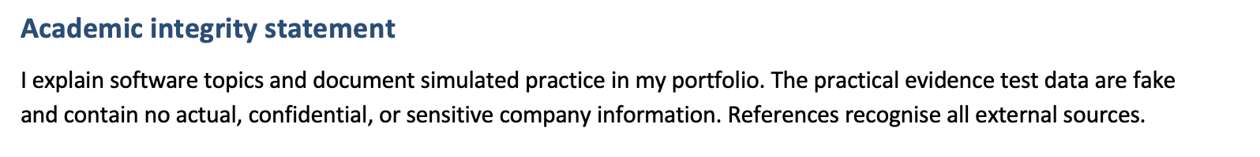
Table of Contents
Component 1: Coursework Portfolio 1
1.1 Shopify 3
1.2 Wix eCommerce 4
2.1 Meaning and business benefits of mind mapping 4
3.1 Microsoft Word 6
3.2 Microsoft PowerPoint 6
3.3 Microsoft Excel 6
3.4 Microsoft Access 7
3.5 Practical Excel evidence: two tested features 8
Test 1: IF function for stock-status control 8
Test 2: VLOOKUP for retrieving a product value 9
4.1 Communication application: Microsoft Teams 10
Practical Teams feature test: channel message and @mention 10
4.2 Online collaboration application: Trello 11
Practical Trello feature test: move a card across workflow lists 11

Introduction
Modern businesses run on connected software, not a single app. An example: a small retailer can build and operate an online shop, log sales and inventory, write customer-facing documentation, evaluate performance, communicate with co-workers and organize operations in one day (Atlassian 2026). Software solutions enhance enterprise capability in circumstances where there is a clear process behind their use and workers are aware of what indicates results or limitations. Grant portfolio to GreenThread Retail, a hypothetical sustainable-clothing microbusiness (Shopify 2026b) It simulates a business environment: humble merchandise sold over the online, a remote team with uncomplicated inventory and task management. In this case, the first scenario enables feature demonstrations without use of customer or work-related employer data (Wix, 2026b).
The Portfolio is organised by four software areas that needed to be prepared. Comparing as e-commerce builders: Shopify vs Wix; the What is business thought mapping; testing Word, PowerPoint, Excel & Access (Microsoft, 2026e) + two Excel tests for features It looks at Microsoft Teams and Trello, giving one practical trial for each (Wix, 2026a). We use current vendor documentation in discussions, as features and availability vary over time. Carefully examine vendor information: it states desired functionality but before a technology can be used, an organization has to determine suitability, accessibility, cost, data protection and any security settings while training their staff (Microsoft 2026c).

TASK 01: e-Commerce website builder or software solutions
1.1 Shopify
Shopify is a host commerce platform for brands to create digital stores without handling your own server infrastructure. The website builder in this category employs themes, visual editing and is based on optional Microsoft (2023d) AI-assisted bespoke design. One. In reference to one administration section that a dealer use lists of products, images, descriptions of the pricing role taxes for payment and fulfilment options — either delivery and assessment cost for the consumer experiences. According to Shopify (2026a), their builder is no-code for simple tasks but enables CSS or Liquid theme updates. This combination is perfect for companies that require quick launches but may soon have a storefront less in need of being special.
GreenThread Retail's functional value is Integration. Link product records with inventory, orders, shipping and sales reporting (Microsoft, 2026a) Integrated workflows eliminate the problem of separately processing orders in one system and reducing stock from another spreadsheet, thereby decreasing data entry as well as transcribing errors. Checkout is not simply taking brochrage page with a payment button (Microsoft, 2026b) or powered by an updated Project Cortex. Fundamental commerce services — themes, order management, inventory, and analytics (Shopify 2026b). In a shared dashboard, owners can compare products, channel, and order patterns which may impact decision-making (Shopify 2026a).
Some restrictions apply. Additional features can lead to a rise in monthly subscription and app fees. In addition, a firm may also rely on platform templates and rules and connectors. To do quality reporting, you would need proper product and order data also technical skills which makes it necessary to include a developer for custom adjustments. For that reason, GreenThread needs to prepare product codes refunds and usage before launch. Rather than looking only at visual design of the tool, everything from browsing to payment to confirmation to packaging and shipping to return should be tested in customer journey (Microsoft, 2026a).
1.2 Wix eCommerce
A WIX IS A E-commerce website TO BUILD It is characterized by a visual drag-and-drop editor, templates and an app store (Microsoft, 2026c). The Wix56 (2026a) platform provides tools for building, managing and marketing a website. Wix Stores (Wix, 2026a) Customer accounts Wish lists Tracking numbers Refunds Email subscriptions at checkout Which makes Wix of interest to small businesses that care about their brand story, editorial content, and page design (Shopify, 2026b) as much as a big catalogue.
GreenThread: Wix MAY publish a colorful story about sustainability with product pages It helps SEO, blogs, forms and promotions. In the page editor, non-technical employees can update simple content fast so that campaign concept gets to publication faster (Wix, 2026b). Its app marketplace is an ecosystem providing not every feature built in-house (Wix, 2026b); Having one person able to update a seasonal landing page, run an email sign-up campaign and publish a new product without the need for a web developer may help streamline workflow (Microsoft, 2026c).
Trade-off: governance. Consequently, this can results in an irregular number of charges by many applications that lead to duplicate information and slower sites (Microsoft, 2026b). Inconsistent designs may occur when staff use the drag and drop layouts not from actual templates. You can access advanced selling and analytics features with three paid plans. A firm should evaluate transaction fees, ownership of the domain used, export opportunities, accessibility and UK data protection (Shopify 2026a) before selecting a service. With operational scale, Shopify is more commerce-oriented while Wix caters for content design and simplicity.

Decision factor | Shopify | Wix | GreenThread implication
Primary orientation | Commerce-first platform | Website/design platform with commerce | Choose Shopify if order operations are central
Ease of editing | Theme editor; advanced customisation available | Highly visual drag-and-drop editor | Use approved templates to protect brand consistency
Operations | Orders, inventory, shipping and analytics | Store functions plus broad business tools/apps | Avoid duplicate apps and duplicate customer data
Main risk | Recurring subscription/app dependence | Feature and app sprawl | Review costs, access and exit options quarterly

Task 2: Mind-map of contemporary software applications

2.1 Meaning and business benefits of mind mapping
2.1 Mind mapping definition and business benefits
Mind maps show related thoughts. It starts with a central theme and branches outwards into categories, subcategories and examples (Microsoft, 2026b). This allows us to see relationships and objects together as opposed to a sequential notes page. In business, they assist with early problem-solving and the planning and preparation of meetings as well as service design. Draw it on paper, software, or collaborative whiteboards (Atlassian 2026). The aim is to simplify something complex so people can visualize the gaps, priorities and dependencies and not embellishment (Shopify, 2026a).
One advantage is faster shared understanding. Managers can talk about "operational software" such as finance, customer database, messaging reportage or cyber security. The mind map removes ambiguity around categories and reduces the amount of discussion happening within a team. That supports divergent thinking when members add alternatives prior to the choices being made by the group. This aids small businesses in the selection of tools as often, the cheapest or most familiar software will not solve entire process problems (Wix, 2026b).
Another benefit is planning. Branches can be utilized to create work breakdown structures, training plans and prerequisite lists (Microsoft, 2026c). Meanwhile, the branches specifically for project-management may funnel into tasks and due dates on Trello, owners of those tasks, etc. And the data—those who breed decision will point to shared spreadsheet or databases. Mind maps are not a replacement for deep analysis. It does not show ROI, security or data ownership. And, hence, a comparison table, a pilot test and an implementation plan should happen next.
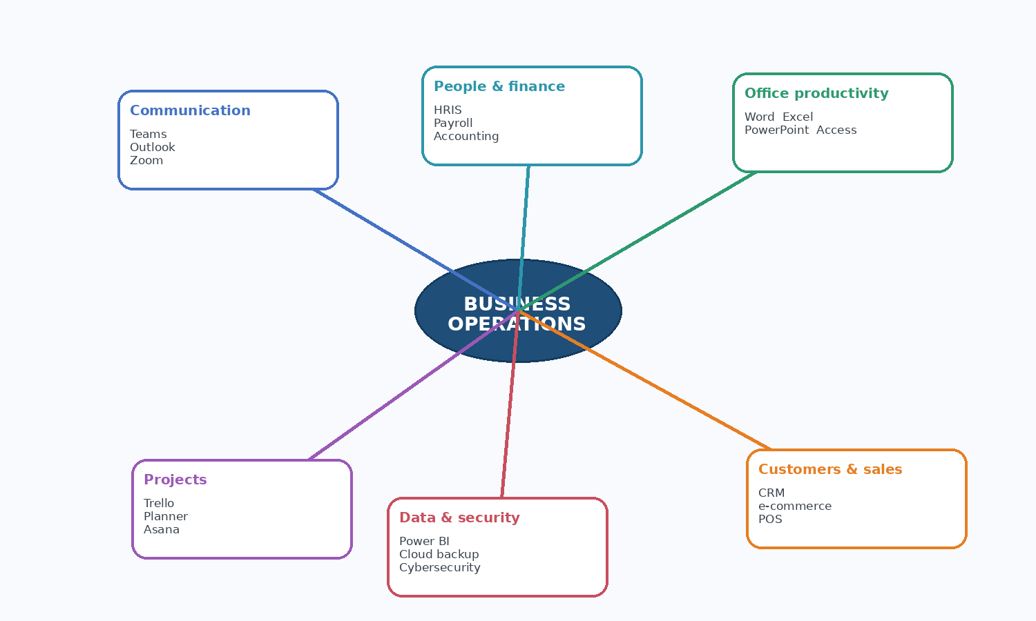
Figure 1. Mind map of contemporary applications supporting day-to-day business operations.
Six related locations are shown in Figure 1. Communication tools coordinate people, office applications create and analyse information, customer and sales tools manage transactions, project tools plan work, data and security controls protect and interpret data, and people/finance systems enable staffing and financial compliance (Microsoft, 2026e). The map is intentionally broad. GreenThread would determine its priority process, assign data owners to each system, and construct a modest integration map of customer, product, and financial data for real deployment.

Task 3: Office applications for creating, storing, presenting and analysing information/data

3.1 Microsoft Word
Figure 1. A mind map of up-to-date software solutions for daily business activities.
Figure 1 shows six locations of interest to the research. While communication tools organise people, office applications create and analyse information, customer and sales tools manage transactions, project tools plan work, data and security controls protect and interpret data (and people/finance systems to enable staffing and financial compliance) (Microsoft 2026e). The map is intentionally broad. GreenThread would decide how to proceed, naming data stewards for each system and creating a small integration map of customer, product and high-level finance data for an actual floor.
Test 3: Office exercise for creating, storing, presenting and analysing information/data
3.1 Microsoft Word
The Microsoft Word is used to generate, change, format, save and share various business documents. Its main features are styles, templates, tables, spelling and grammar tools comments track changes headers page layout mail merge PDF export (Shopify, 2026a). Style-based coverage can utilize the same title, body content and tabular formatting. It also improves readability and reduces the time spent on formatting paragraphs in the office (Shopify, 2026b). Comments and notes on changes are particularly handy when several people have to examine a policy, plan, or contract.
GreenThread Retail possibly uses Word for their staff induction guide, returns process, supplier letter, risk assessment, meeting minutes or monthly performance summary. Employees populate an authorized, branded version and wording with a template (Wix, 2026b). Mail merge personalizes letters and labels from a controlled data set. Documents can be reused, manipulated and assessed, thereby enhancing efficiency (Shopify 2026a). Headings, tables and proofing tools to help readers locate important information make communication easier (Microsoft, 2026c).
Word has limits. You should use it, but don't store live order records in it. Using manual formatting rather than styles typically leads to inconsistencies in long papers, while collaborative editing needs version control. Some of these roles require permission and, furthermore, sensitive data needs a secure store in some cases; another is that an email on the topic will easily create duplicates (Shopify, 2026b). A central location, meaningful file names and templates, and an owner with final sign-off on updates are all traits of sane business practices (Wix 2026a). According to Microsoft (2026a), Word promoting collaboration and review, but only if the team agrees on how to use them.
3.2 Microsoft PowerPoint
Microsoft PowePoint is used to demonstrate ideas in a public. Slides include text, charts, photos, diagrams, material about video and audio playback, speaker notes, and animation (Microsoft 2026d). Its economic value, the most important thing, is that it transposes structured messages into visual narrations (Microsoft, 2026a). Managers may be quick to note sales trends, project decisions and training points (Wix, 2026b). Slide Master allows companies to standardize layouts, fonts, and logos so that company documents can be consistent.
GreenThread could use PowerPoint to kick-off an online campaign, train temporaries on how to pack orders, go over quarterly results or pitch a co-branding opportunity. Charts (Excel and others!) communicate trends more quickly than huge tables. Speaker notes are for the presenter; handouts or PDFs can be distributed after meetings (Microsoft, 2026b). PowerPoint is not just about design, but also about communication and decision-making. Senior colleagues would need to decide based on a clear conclusion, but often only one or two slides.
Oversimplification is the main drawback. PowerPoint slides with pretty pictures but lacking any source, date or scale can hide ambiguity. Excess text, motion or colour distract PowerPoint is not suitable where there is a lot of instruction and the user will have to look up stuff later – you may use a word guide, or knowledge base instead. One main item per slide, adequate contrast, an alternate description for essential diagrams, data labels and source line below charts are best practices (Microsoft, 2026c). Do not read the slide (Atlassian, 2026) but provide an explanation of evidence presented.
3.3 Microsoft Excel
Microsoft Excel, it is a tool to organize, calculate, analyze and visualize structured data. Workbooks include one or more worksheets consisting of rows and columns made of cells containing numeric values, text, logical references (formulas), tables, charts and data-validation criteria (Microsoft 2026c). Top 8 Functions are Numerical computations, IF, lookup filters conditional formatting PivotTable What if analysis Excel earnings: When users work with larger data sets, they are able to deliver a functional model rapidly (where the user knows little or nothing about database development). According to Microsoft (2026b), formulas calculate using cell references, constants, operators and functions.
It's a simple, GreenThread stock-control and order-analysis worksheet in Excel. For example, you could save structured tables for product code, stock level, re-order threshold, unit cost and supplier information (Shopify, 2026b). IF functions signal re-orders and VLOOKUPs pull prices and descriptions from tables (Shopify, 2023a). Filters allow user analysis of categories, PivotTables summarize orders per product by month. Turn tables into decision cues with charts. Thereby, showing exceptions and reducing manual calculations that improve the workflow (Shopify, 2026b).
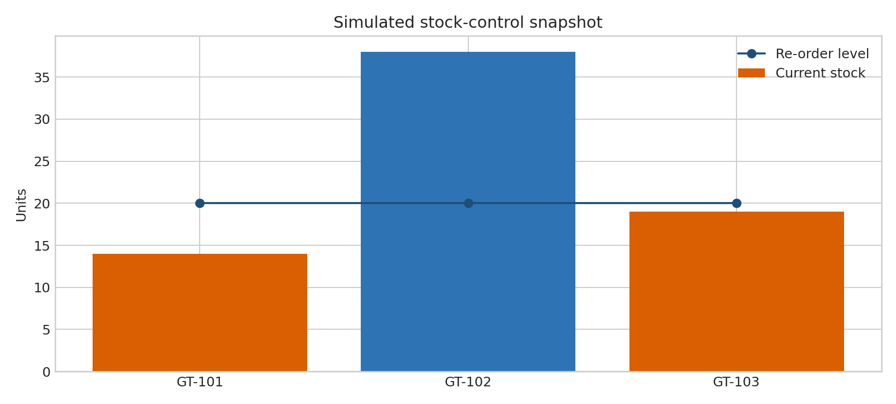
Figure 2. Simulated Excel chart: current stock compared with the re-order level.

Figure 2. A Simulated Excel chart showing the stock that you have today versus your re-order level.
Excel's limits demand management. Hidden rows, pasted values, corrupted formulas or broken links can all go undetected in a spreadsheet (Microsoft, 2026d). VLOOKUP requires the key you want to search to be in the far-left column of whichever table you are searching on, and can error out when ranges are mismanaged (Atlassian, 2026). There is a case of learning and legacy workbooks, where VLOOKUP is helpful, even though XLOOKUP is more versatile. Shared spreadsheets risk simultaneous editing. GreenThread must control these risks by using an Excel Table, locking formula cells, validating product codes, generating a change log and reconciling totals to source records (Microsoft, 2026b). Excel is useful for small-to-medium analysis only and is not good as a large multi-user transaction database.
3.4 Microsoft Access
Relational database software Microsoft Access. It does not use a spreadsheet to store records, rather it organizes related data into separate tables and links them with keys. Standard parts consist of tables, main keys, relationships and queries, forms including reports such as validation rules and macros. This means companies store customers, orders, products and suppliers in discrete tables (Microsoft, 2026d). Order tables will relate to Customer and order-line data on OrderID. Once the customer is in, you only have to type his address one time, it does not reappear in each row of order.
GreenThread might take prototype a miniature working database for Access. For example, A query can list products below the re-order point, a form could allow staff to regularly add new products or suppliers, and report might show pending purchase orders (Atlassian, 2026). For example, ordered that links to a non-existing customer followed would result in an orphan entry. Queries enable businesses to run specific queries such as, "Which product category generated the most sales in value this month? without manually merging sheets.
Access is limited. It needs relationships, data types and normalisation database designing skills. Bad table design is re-creating Excel issues at scale. Desktop databases might not be suitable for large, cloud-first or concurrent (Shopify, 2026a) systems. Access, backup, retention and gdpr continue to be a role based. Start with a simple schema, try it out with fake data, record the data dictionary and move to a more scalable cloud database if you need to grow remotely or integrations (Wix, 2026b). Access should be selected based on its relationship structure and not from an old friend.

Application | Main purpose | Major business benefit | Important limitation/control
Word | Create and review documents | Templates, styles and tracked changes improve consistent communication | Not a transaction database; use version control and permissions
PowerPoint | Present messages and evidence | Slides, charts and notes support briefings and training | Avoid information overload; cite chart data
Excel | Calculate and analyse structured data | Formulas, tables, charts and PivotTables highlight patterns | Formula errors and duplicate versions require checks
Access | Store related records | Tables, keys, forms and queries reduce repeated data | Requires database design and may not suit high-scale cloud use

3.5 Practical Excel evidence: two tested features
The following experiments used fake GreenThread Retail product data. To demonstrate realistic logical testing and table lookup knowledge (Microsoft, 2026b). Customer data is excluded and simplified for clarity (Wix, 2026a). Screenshots mimic workbook data, formulas, and output.

Test 1: IF function for stock-status control
IF returns one result when a logical test is true and another when false. Cells B2 and C2 show stock and reorder levels in this test (Wix, 2026b). The formula in D2 is =IF(B2<=C2,"REORDER","OK"). A less-than-or-equal operator checks if stock is below the re-order level (Microsoft, 2026e). If so, REORDER; else, OK. The Status column received the formula.
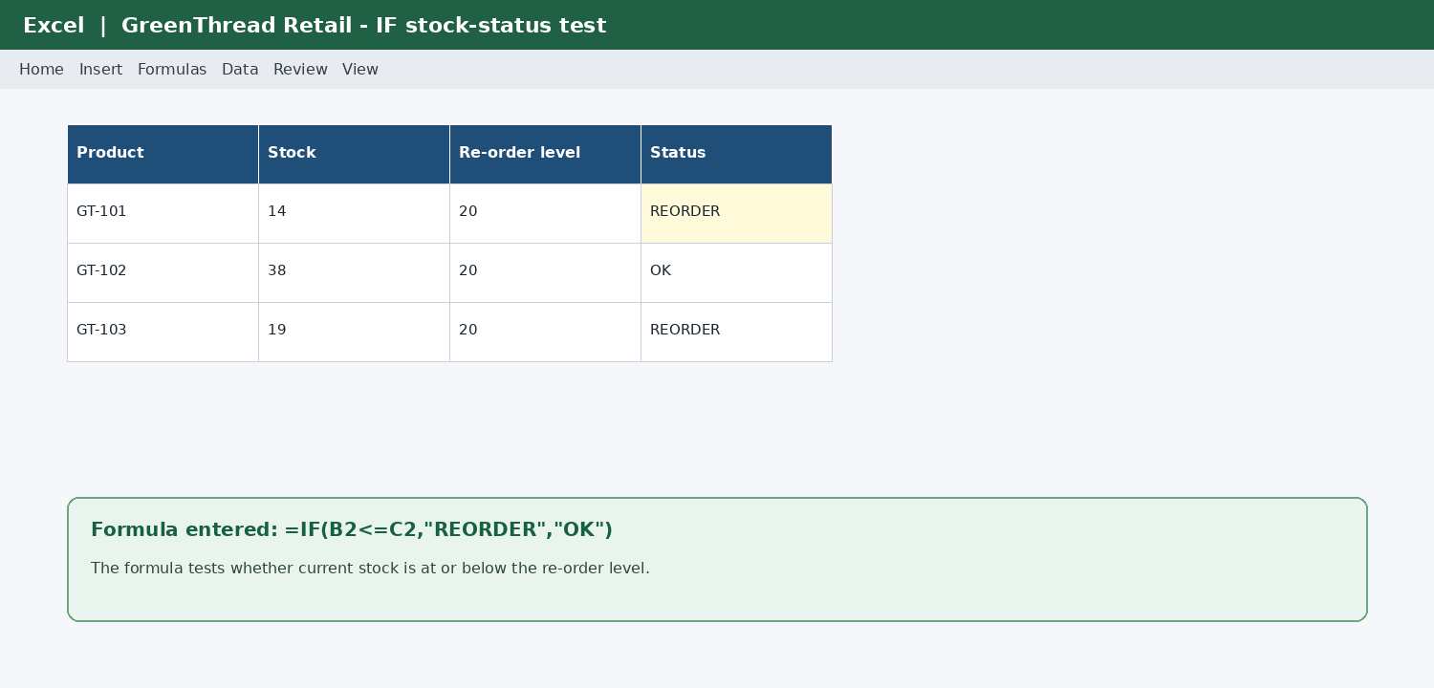
Figure 3. Simulated Excel evidence for the IF function test.
Results suggest GT-101 and GT-103 need maintenance because their stock levels are below 20 units. GT-102 passes since 38 is above the threshold. This helps operations because workers don't have to manually compare statistics. Conditions could turn the REORDER status red to highlight the exception (Wix, 2026a). The formula does not sort automatically. Before buying, a management should check sales estimates, in-transit deliveries, and supplier lead time (Microsoft, 2026d).

Test 2: VLOOKUP for retrieving a product value
VLOOKUP searches the first column of a table for a value and returns information from another column in the same row. The test looks up product codes. Because FALSE is used, the formula =VLOOKUP(B2,$H$2:$J$4,3,FALSE) looks for the code in B2 in the first column of the fixed table range H2:J4 (Microsoft, 2026d). It returns the third column, which is the price, and needs an exact match (Microsoft, 2026a). The lookup table stays put when the formula is copied to later rows using absolute references ($) (Microsoft, 2026a).
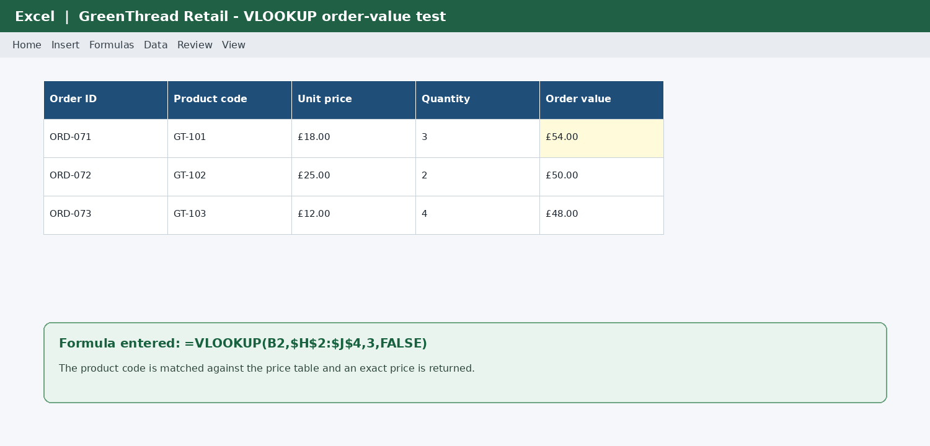
Figure 4. Simulated Excel evidence for the VLOOKUP function test.
After retrieving the unit price, multiply price by quantity to calculate order value. The test shows how a master pricing list reduces manual price entering and improves uniformity. It also reveals a limitation: VLOOKUP requires clean, unique product codes and a left-side lookup field. Staff may get #N/A if they write GT-10I instead of GT-101 (Microsoft, 2026a). Validating data, controlling product codes, and displaying an IFERROR message improve usability. Large companies usually keep the pricing master in an inventory or ERP system, but the exercise shows the logic (Microsoft, 2026a).

Task 4: Communication and collaboration applications

4.1 Communication application: Microsoft Teams
Which means that IF returns one result if a condition is TRUE, and another result if it is FALSE — it's quite similar to the model you're used to in other languages already. This example (Wix, 2026b) presents samples data for tests using stock and reorder levels in cells B2 and C2. The formula would be in D2=IF(B2 OK > Send (Microsoft, 2026e). The feature notifies your colleague tagging them and updating it on the entire channel (Microsoft, 2026a).
Figure: simulated message sent to a Microsoft Teams channel with an @mention
It promotes accountability because since it is connected with the project channel rather than a private inbox, this request can be easily tracked. Only use the @mention when needed—general updates do not require one (Wix, 2026a). The screenshot did not actually display a Teams experience.
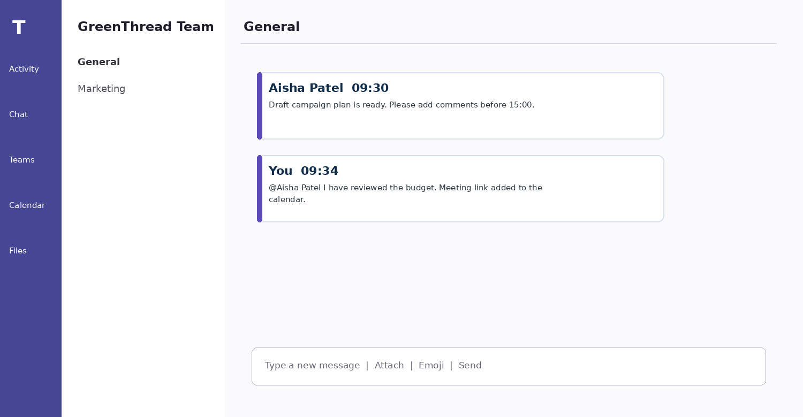
Figure: simulated Microsoft Teams channel message with an @mention
4.2 Online collaboration application: Trello
Trello is an online collaboration tool that provides boards, lists and cards. Lists are stages of a workflow, boards are projects and cards are tasks (Shopify, 2026b). Cards can have description, assignee, due date, checklist, attachment, label and discussion. Kanban style boards are visual in nature. It reflects the status of work: issues for tasks move from To do through In progress and to Done, rather than receiving notifications (Atlassian, 2026).
For GreenThread's online launch, Trello is responsible for product images and copy, payment testing, privacy review, and social posts. Each card also has a single accountable owner and deadline. The planning meeting board can help the team find bottlenecks and determine what needs assistance. You can watch cards, lists, and boards in Trello who will notify someone when a charge is made (Wix, 2026b). It helps non-assignees who need to see tasks. One place where work is shared, creates transparency.
Trello has limits. A board with way too many unstructured cards is an inefficient scan because marking a card Done says nothing about quality (Wix, 2026b) It does not replace a proper content management system, bookkeeping system, or detailed development plan with dependencies. Teams still need to normalise card titles, labelling, ownership, doneness and archiving. Before including sensitive material in descriptions or attachments, check the organization's policies. For larger projects, Trello can be integrated with a calendar, reporting tool or project-management system.
Trello feature test: moving a single card across the workflow lists
The feature you tested or smth moves cards from To do to In progress and Done Prepare a GreenThread website launch board, with each of the three workflow lists → Card: Upload product images, assign assignee + due date → In progress = The card now in #3; A comment/checklist evidence is added to prove this was completed and then dragged down to Done after review (Microsoft, 2026c) Below the board graphic, it displays more audiobooks that indicate what you are doing with cards.
Figure: simulation of Trello with cards moving through a process stream flow
Owners are aided by the board, which helps them keep tabs on work still to be done and run progress sessions of short duration. This is a good way to potentially generate discussions about the lack of product photos, or maybe that approvals are taking too long (Wix, 2026b) before it may just be a card stuck in In progress. Visual state misrepresents progress if the team does not agree on what "Done" means (Atlassian, 2026). Content is entirely simulated for purposes of assessment evidence (Wix, 2026b).
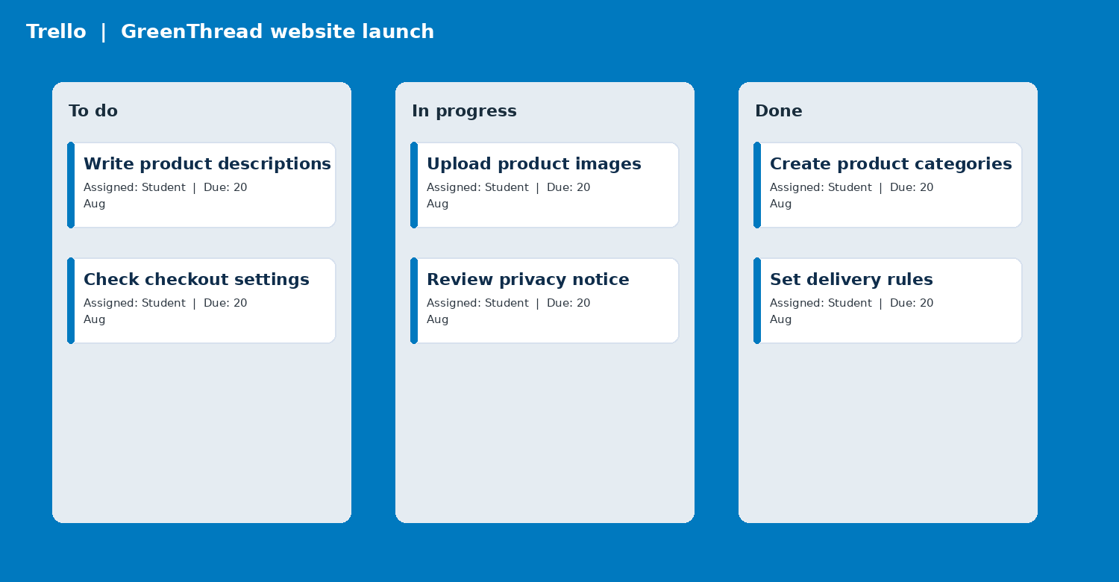
Figure: simulated Trello board showing cards moved through a workflow
The board helps the owner all of them relatednotice unfinished work and facilitates short progress sessions. A card stuck in In progress can prompt a conversation can be assure about missing product photos or approval delays (Wix, 2026b). The team must agree on what “Done” signifies else the visual state therefore needed can be misleading (Atlassian, 2026). The content is totally simulated for assessment evidence (Wix, 2026b).

Implementation, security and improvement considerations
Implementation, security and improvement considerations
Software solutions start with choose an application. Microsoft (2026e) — The presentation of the tools must be clear and controllable GreenThread should avoid purchasing features every time and aim for a basic, decent list to begin with. Just setup your own branded online shop, keep a solid list of products and available stocks, announce your campaign changes, assign tasks rightfully, and send out a simple sales report every week. Requirements should have priority and ownership (Microsoft, 2026e). This prevents the problem of a company paying for multiple overlapping apps, as no one has established the single source of truth typology (Shopify, 2026b).
Simple implementation sequences help. Begin with an imaginary pilot catalogue containing common product codes, pricing, quantities in stock and image/file names. Next, create a test shop with either Shopify (2023a) or Wix and do a sandbox purchase. Third, create the Excel workbook and confirm the stock threshold and lookup table. Fourth, create Teams channels and Trello boards in approved names. Lastly, you have the users to launch one product with a small group, change an image, mark it low stock, ask your colleague for approval and move the task to Done (Microsoft 2026c). The owner should log workflow and change (Microsoft, 2026d) that is delayed, confusing or again to reduce repeat.
The quality of the data is what makes this process effective. Websites, spreadsheets and tasks (Atlassian 2026): Use product codes that are unique And consistent. For price, stock, supplier and product-description fields: Owner (id) +date present on the review of each of these fields (Shopify, 2026b). If the spreadsheet is not up to date, and the website is saying that item is available, you may have a bad experience, or the store already lost the money. Status entries can be limited in Excel, Access must have the proper associated key, and it is hard to forget fields for product order submissions on e-commerce forms because they are required. Although not foolproof, these remedies reduce costly mistakes in reporting as well as customer correspondence.
Nothing can take place without security and privacy being imperative. Utilizing individual accounts, strong passwords, and multi-factor authentication (MFA) wherever possible. It must not save passwords in Word or spreadsheets, nor share an administrator logins (Microsoft, 2026e). Adhere to the principle of least-privilege: a temporary content assistant may need access to edit website pages, but not payment settings; or an external contractor may require only a Trello card without access to the client database. Staff should understand that names of customers, contact details, payment information and private conversations in the team (Microsoft, 2026a) must not appear on screenshots of training and assessment. This includes only imaginary data and is a portfolio simulation of that principle.
Backup and continuity matter. Cloud-based software results in less reliance on local devices, yet organizations cannot neglect their records (Wix, 2023a). GreenThread has to know how its product catalogue, order reports, and key documents can be exported; where they are housed; and who inspects them. Create a retention schedule to delete old campaign documents and attachments. The company needs to cut access, transfer ownership of any shared files and make sure there's no mission critical process dependent on a personal email address (Shopify, 2026b). Those small controls are needed for a growing internet business to gain and master them.
Role-based, brief training is best. Product editors are not database administrators and the only thing they need to be trained on is: image size, product title, price, stock availability text. Excel (Microsoft, 2026d) managers need to understand how formulas work, how to identify errors and how to disable the replacement of locked cells. In Teams, users must differentiate chat from channel; in Trello the user needs to know what Done means for a team. Instead, huge handbooks (Microsoft, 2026c) are less effective than screen grabs, a one-pager on how to do something and a rapid practice task. Feedback from users should complement the advice after the pilot.
The firm must make sure to measure the solution results. Some useful measures are time until a new product is added, % of product records containing complete information, # stock exceptions prior to order acceptance, # jobs performed by the due date, average response time for channel inquiry and staff confidence after training (Microsoft 2026e). Decisions supported not just the report of more (Shopify, 2026a). Have a hand-off checklist that is clearer rather than purchasing an entirely new project-management system to solve jobs often running behind schedule for lack of product photography. The overarching conclusion, more generally, is that tech only enhances operations when combined with strong process design (Shopify, 2026b)
Conclusion
This portfolio demonstrates office software is most valuable when it aids an effective process instead of by popularity. Both can allow you to sell online, but they have different strengths: How tools interact in workplace, communication, customer, data, and project. Word, PowerPoint, Excel and Access generate documents and presentations with clarity and persuasion; contribute to the calculation and analysis of information; store relational data. The IF and VLOOKUP tests showed that an ultra small spreadsheet can be pulled into place to identify stock exceptions and extract regulated reference data, but only if formula ranges and product codes are properly managed.
Microsoft Teams vs Trello: Collaboration Vs Communication Teams enables messaging with context and working together; Trello lets you set up tasks and where they are in the development process. Nothing substitutes clear ownership security settings, data quality and staff training. Next Step (GreenThread): two weeks launch sprint, one online-store process, regulated product list, and Trello board using Teams channels? Before the business expands, practical outcomes should be observed – do they see less duplicate updates, faster stock evaluation, clearer ownership?

References
Atlassian (2026) Watch a card, list or board. Available at: https://support.atlassian.com/trello/docs/watching-cards-lists-and-boards/ (Accessed: 11 August 2026).
Microsoft (2026a) Microsoft Word: collaborate and review documents. Available at: https://www.microsoft.com/microsoft-365/word (Accessed: 11 August 2026).
Microsoft (2026b) Overview of formulas in Excel. Available at: https://support.microsoft.com/en-us/excel/get-started/overview-of-formulas-in-excel (Accessed: 11 August 2026).
Microsoft (2026c) IF function. Available at: https://support.microsoft.com/en-us/excel/functions/if-function (Accessed: 11 August 2026).
Microsoft (2026d) VLOOKUP function. Available at: https://support.microsoft.com/en-us/excel/functions/vlookup-function (Accessed: 11 August 2026).
Microsoft (2026e) Introduction to Microsoft Teams for admins. Available at: https://learn.microsoft.com/en-us/microsoftteams/teams-overview (Accessed: 11 August 2026).
Shopify (2026a) Ecommerce website builder. Available at: https://www.shopify.com/website/builder (Accessed: 11 August 2026).
Shopify (2026b) Build your online store. Available at: https://www.shopify.com/online (Accessed: 11 August 2026).
Wix (2026a) Explore Wix features. Available at: https://www.wix.com/features/main (Accessed: 11 August 2026).
Wix (2026b) Wix Stores: an overview of store features. Available at: https://support.wix.com/en/article/wix-stores-an-overview-of-store-features (Accessed: 11 August 2026).

Appendix A: Formula record
Feature | Formula / action | Purpose
IF | =IF(B2<=C2,"REORDER","OK") | Flags stock at or below a threshold
VLOOKUP | =VLOOKUP(B2,$H$2:$J$4,3,FALSE) | Returns a price for an exact product-code match
Teams | New conversation > @mention > Send | Notifies a relevant colleague in project context
Trello | Drag task card between lists | Updates the visible stage of work

