

Assessment
Supporting Paper

Student name: Flor de Maria Galindo Manuel de Killick
Student ID: 2124309

Module name: Living with Care: The Older Person
Module code: BMHP6009
Lecturer name: Dr Laila Surani

Table of Contents
Topic1………............................................................................................................................3
Introduction…...........................................................................................................................4
Reflection on the disadvantages of group presentation two.....................................................5
Reflection on other group’s perspective…………………..........................................................6
Statistics of older adult using technology.................................................................................7
Technologies support older people in the UK..........................................................................8
Conclusion...............................................................................................................................9
References.............................................................................................................................10

Topic 1
Is the use of technology necessary for the lives of the elderly population in the United Kingdom?

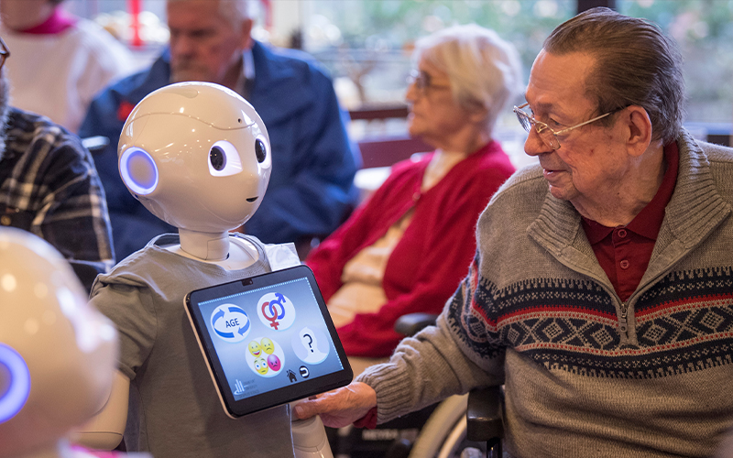 (Roessler, 2024)

Introduction
In this supporting document, I will discuss the disadvantages of technology for older people in Group Presentation Two.
As the population of the world ages, technological advances continue to make it possible to help seniors with daily tasks such as financial planning and social interaction. Innovative technologies provide timely treatments to help older people maintain their health and independence for a prolonged period (Vaportzis, Clausen, and Gow, 2017).
On the other hand, the use of technology may have a negative impact on the lives of older people since it might isolate them from what is going on around them. As a result, they may jeopardise their safety, weaken their cognitive abilities, and damage their memory. Furthermore, older people can become victims of electronic fraud and have their personal information taken, jeopardising their security. However, technological products are being updated to incorporate larger letter sizes, larger buttons, adjustable brightness and contrast for the visually challenged, and greater comfort when using technology (Blanchard, 2017).

Reflection on the disadvantages of group presentation two
In the group presentation, we discussed the disadvantages of using technology in the lives of older adults. For this debate, we presented six arguments. According to the age group distribution statistics of Internet users in the United Kingdom in 2023 (Petrosyan, 2023), some residents do not have access to the Internet and, as a result, will not be able to obtain an education due to a lack of digital literacy. In addition, older adults will be more vulnerable to cybersecurity risks because they may suffer from digital scams, online harassment, and money theft. This is because they have not been informed about the risks and have overconfidence, which can put them at risk for their privacy and security.
Also, privacy concerns are a significant barrier for many older adults who refuse to adopt or use technology. This is because the Internet uses a variety of sensors to collect, evaluate, and distribute personal information, making most seniors wary of banking or shopping online for fear of falling victim to scams or fraudulent activity (Ray et al., 2021). For example, my husband, who is older than me, never uses the Internet to transact or shop because he is concerned about the security of his personal information and money. However, he uses the internet to communicate with friends and family, so technology has both advantages and disadvantages for him. Another reason why many older adults do not use technology in their lives is that they have accessibility issues, for example, a lack of experience in using the Internet since, for them, technology is from the new century. They also have low vision, problems with mobility, and hearing difficulties. Therefore, they do not have access to communicate with other people online.
Likewise, physical limitations are another impediment to the use of technology, such as chronic pain, arthritis, Parkinson's disease, stroke, and dementia, which prevent them from conducting their daily activities. (Aged Care System, Practical Solutions, Technology, 2017). The final negative argument in the debate was the impact of digital technology on brain health, which resulted in device dependency and increased anxiety and stress. Furthermore, older adults who use social media may experience higher levels of social comparison, which can lead to depression. These are the six reasons why some elderly people avoid or are unable to adapt to modern technologies. However, some engineers are developing innovative technology to make it easier for older consumers to access.

Reflection on other group’s perspective
The other group presentation discussed the advantages of the use of technology among the older UK population. The technology supports older people in all their daily activities, and one of them is health monitoring. For example, the NHS app books GP appointments; they can request repeat prescriptions and access their medical history, which can save time and resources. Additionally, technology provides older adults with access to information and education. For example, online classes teach them new skills and keep their minds busy, thus increasing their quality of life.
Technology is important because it allows older adults to connect with the outside world, reducing isolation. For example, video calls and instant messages, regardless of where they are, can help them promote more effective communication with their family members, preventing them from feeling alone. Similarly, mobile technology promotes independence for older adults through fitness apps that encourage them to perform simple exercises to improve their health. Older adults' memory is impaired, but the use of applications can help them remember when it is time to take their medications. As a result, they will feel more relaxed and less anxious about remembering when they should take their medications. Finally, the use of technology quickly and effectively assists older adults who wish to travel alone. For example, the Uber app can take them to their desired destinations without requiring them to rely on their family members; this allows them to manage their own lives. These are the six main reasons why most older adults choose to use technology to improve the quality of their daily lives and live longer.

Statistics of older adult using technology
Around 2 million people aged 75 and over did not use the Internet in 2022. In addition, around 0.7 million people aged 65 to 74 did not use the Internet, bringing the total to 2.7 million people aged 65 and over who have not used the Internet, which is equivalent to one in five people in this age group in 2022. Approximately 500,000 adults over the age of 65 have previously accessed the Internet (Age UK, 2023).

Distribution by age groups of Internet users in the UK in 2023
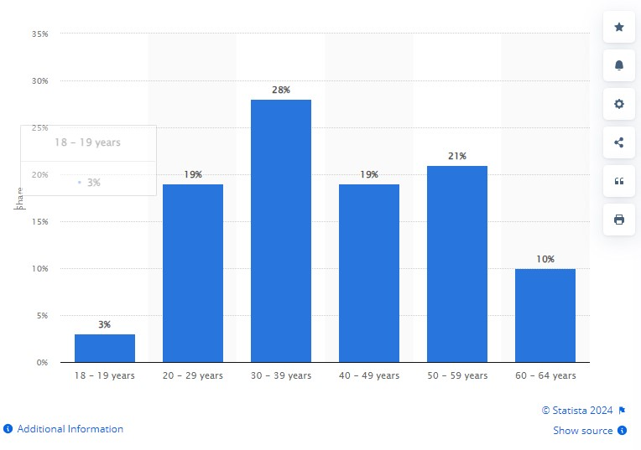

(Petrosyan, 2023)

Technologies support older people in the UK
The National Health Service gives support to older people with long-term health issues to stay well and live independently for longer by using technology such as wearables and monitors (NHS Long Term Plan, 2024). The devices monitor a patient's heart rate, oxygen levels, breaths per minute, skin temperature, and movement 24 hours a day, seven days a week, to determine whether they are stable. Scales and blood pressure monitors are also available (Oxford Health NHS Foundation Trust, 2022). Also, older people can manage their recurring medications, schedule and cancel appointments, and access their medical history with the use of digital tools like the NHS app (National Health Services Digital, 2019).
Age UK is a charitable organisation that offers free computer and IT training to senior citizens in many places to make using the internet simple and pleasurable (Age UK, 2024). The U3A is another charitable organisation that provides in-person and online classes to help seniors acquire skills in crafts, gardening, photography, computer and digital technology, history, literature, and languages (U3A, 2024).

Conclusion
This supporting document helped me reflect on how the use of technology can have both positive and negative effects on the lives of older people. On the one hand, technology has advanced to meet the needs of seniors, allowing them to perform daily tasks with ease while maintaining their independence, which is an important advantage for them. However, many older people are concerned about their privacy and may avoid using technology. Additionally, excessive use of technology can make them feel isolated and disconnected from their environment. However, if they use technology consciously and responsibly, they can improve their quality of life and even increase their life expectancy.

References
Aged Care System, Practical Solutions, Technology (2017) Top 5 Challenges for Seniors Using Technology. Available at: https://carevision.com/top-5-challenges-seniors-using-technology-2/ (Accessed: 28 March 2024).
Blanchard, B. (2017) TECHNOLOGY IMPACTS ON THE SENIOR POPULATION. Available at: https://www.extendedfamilyinc.com/technology-impacts-senior-population/ (Accessed: 27 March 2024).
Oxford Health NHS Foundation Trust, (2022) ‘Smart’ tech to change the way patients are monitored. Available at: https://www.oxfordhealth.nhs.uk/news/smart-tech-to-change-the-way-patients-are-monitored/ (Accessed: 30 March 2024).
Petrosyan, A. (2023) UK internet users 2023, by age group. Available at: https://www.statista.com/statistics/1415144/internet-usage-uk-by-age/ (Accessed: 27 March 2024).
Ray, H., Wolf, F., Kuber, R., and Aviv, A.J. (2021) '“Warn Them” or “Just Block Them”?: Investigating Privacy Concerns Among Older and Working Age Adults', Proceedings on Privacy Enhancing Technologies, 2021(2), pp.27–47. Available at: https://doi.org/10.2478/popets-2021-0016
Vaportzis, E., Giatsi Clausen, M. and Gow, A.J. (2017) 'Older Adults Perceptions of Technology and Barriers to Interacting with Tablet Computers: A Focus Group Study’, Frontiers in Psychology, 8(1687), pp.1–11. Available at: https://doi.org/10.3389/fpsyg.2017.01687

