Student: Manuel Macchiavello
2008315
MBA – MANAGING PERFORMANCE LCMB7013
Lecturer: Tanja Nathan
New Performance
Management for SainCo

Contents
1. Introduction 2
2. Current situation of SainCo 2
3. Performance Management 2
4. Organisational and Employee Concerns 4
5. Traditional organisation in the current global environment 6
6. Employee Engagement and Employee Involvement 8
7. Enhancing Performance Management 10
8. Conclusion 12
9. Recommendations 12
10. Reference 14

1. Introduction
Nowadays, organisations are transforming continuously because the environment is changing as a consequence of different factors such as external and internal forces that redirect the business plan of the organisations. Armstrong (2012) remarks that companies are moving constantly, variations are necessary when the environment change. To be competitive is crucial to adapt all the resources, even the objectives can change periodically. In this sense, a strategy is a process of change, as the organisation efforts to jump from the state it is into a strategically identify potential state, as Torrington et al. (2014) conclude. Sometimes, the changes involve not only the strategy of the company, but the main innovation might also be the culture of the organisation, especially when the business has an old structure like SainCo. Browaeys, Price and Price (2011) say that it is important to understand what the culture of the company is, and it is vital to consider its structure. Organisational culture is a phenomenon that is composed of behaviours and values, in different scales (Redman and Wilkinson, 2013).
In the change process from traditional to modern companies, the first step is understanding that exist a necessity, and it is essential to redesign the business plan because the current business environment have to be in line with the goals of the company. It is also elemental to analyse if the objectives go in the same way with the culture because both have to harmonize. Scullion and Collings (2011) argue that organisation and identity are the results of strategic choices by key decision-makers, and these choices are reflected in the culture of an organisation. In this sense, SainCo is a traditional company with an autocratic management style, the organisation needs to adapt its objectives at the new times but is also important to change its structure. We are going to compare the current model of the company and why it is necessary to change it. Our recommendations are going to be in the short term and in the longer term. In practice, there needs to be a combining of these two methods, a long-term strategy will be established, and short-term strategy incorporated with it, as Rees (2015) clarifies.

2. Current situation of SainCo
The company is a long-established retail organisation which employs 2000 staff members at 10 different locations. The business work under an autocratic management style that is not enough if they want to be more effective, especially with an environment with permanent changes. The style of the company reflects its culture. In this sense, Browaeys, Price and Price (2011) admit that hierarchical culture can work effectively if the objective is efficiency, and the organizational environment is stable and simple. However, the CEO of SainCo wants to modify this because business environment changes constantly, and she understood that it is important to embrace modern Performance Management concepts and practices.

3. Performance Management
What Performance Management is? Why it is important for SainCo? Armstrong (2008) indicates that a performance plan evaluates the essential success factors and the performance levels reached in relation to them. It is elemental to know what the goal of the company are, to identify what are the resources of the organisation, to analyse if the company will achieve its objectives and what will be the best way to succeed it. Performance Management will help the company to know if its goals are going to be achieved. Performance Management is not limited to a specific group, this mechanism can analyse the performance of the employees, a department, or even of whole the organisation. On the other hand, if businesses objectives and individual aspirations are pulling in separate directions, disharmony and dispute will arise and performance is likely to suffer, as Mullins and McLean (2019) suggest. Harmonize aims is a fundamental part when Performance Management is working. In the same line, as we said above, culture play a crucial role because determinate what are the parameters to follow. Browaeys, Price and Price (2011) manifest that business culture is an element of the strategic plan because it affects not only the design of a strategy, but also the way it is implemented in the company. In the same line, Scullion and Collings (2011) determinate that companies that do not have strong Performance Management practices can affect their employees’ pride, satisfaction, intentions to leave, and retention.
Performance Management helps the company to know what are the resources that it has through analysis of its employees. This tool has to manage with careful because might generate different responds with the workers. Armstrong (2012) remarks that employees become stressed when they experience more pressure, or higher level of emotional of physical demands than they can control, and these pressures include achieving performance expectations. In the current times, which several employees are working by remote, electronic performance monitoring (EPM) allows manager to monitor the computer of the workers, is a good choice if the company choose this method as temporary mechanism. However, the big challenge of the managers will be to motivate that employees improve their performance, because they know what their strengths and weaknesses are. Performance Appraisal is a good tool to support the performance of the employees. The interview between manager and employee should be under a cordial atmosphere because employees have to feel comfortable. Good training during the interview is important, techniques such as: clearly describe the aim of the meeting, inspire the employee to talk, listen and prevent confrontation (Kirkpatrick, 2006). In this sense, Performance Appraisal can be inefficient if it is not determinate how the company wants to use it. One of the most important problems is determining what is evaluated whether it be employees' personality traits, the results of the work, or the work manners with his workmates, as Redmon, Mawhinney and Johnson (2013) qualify.
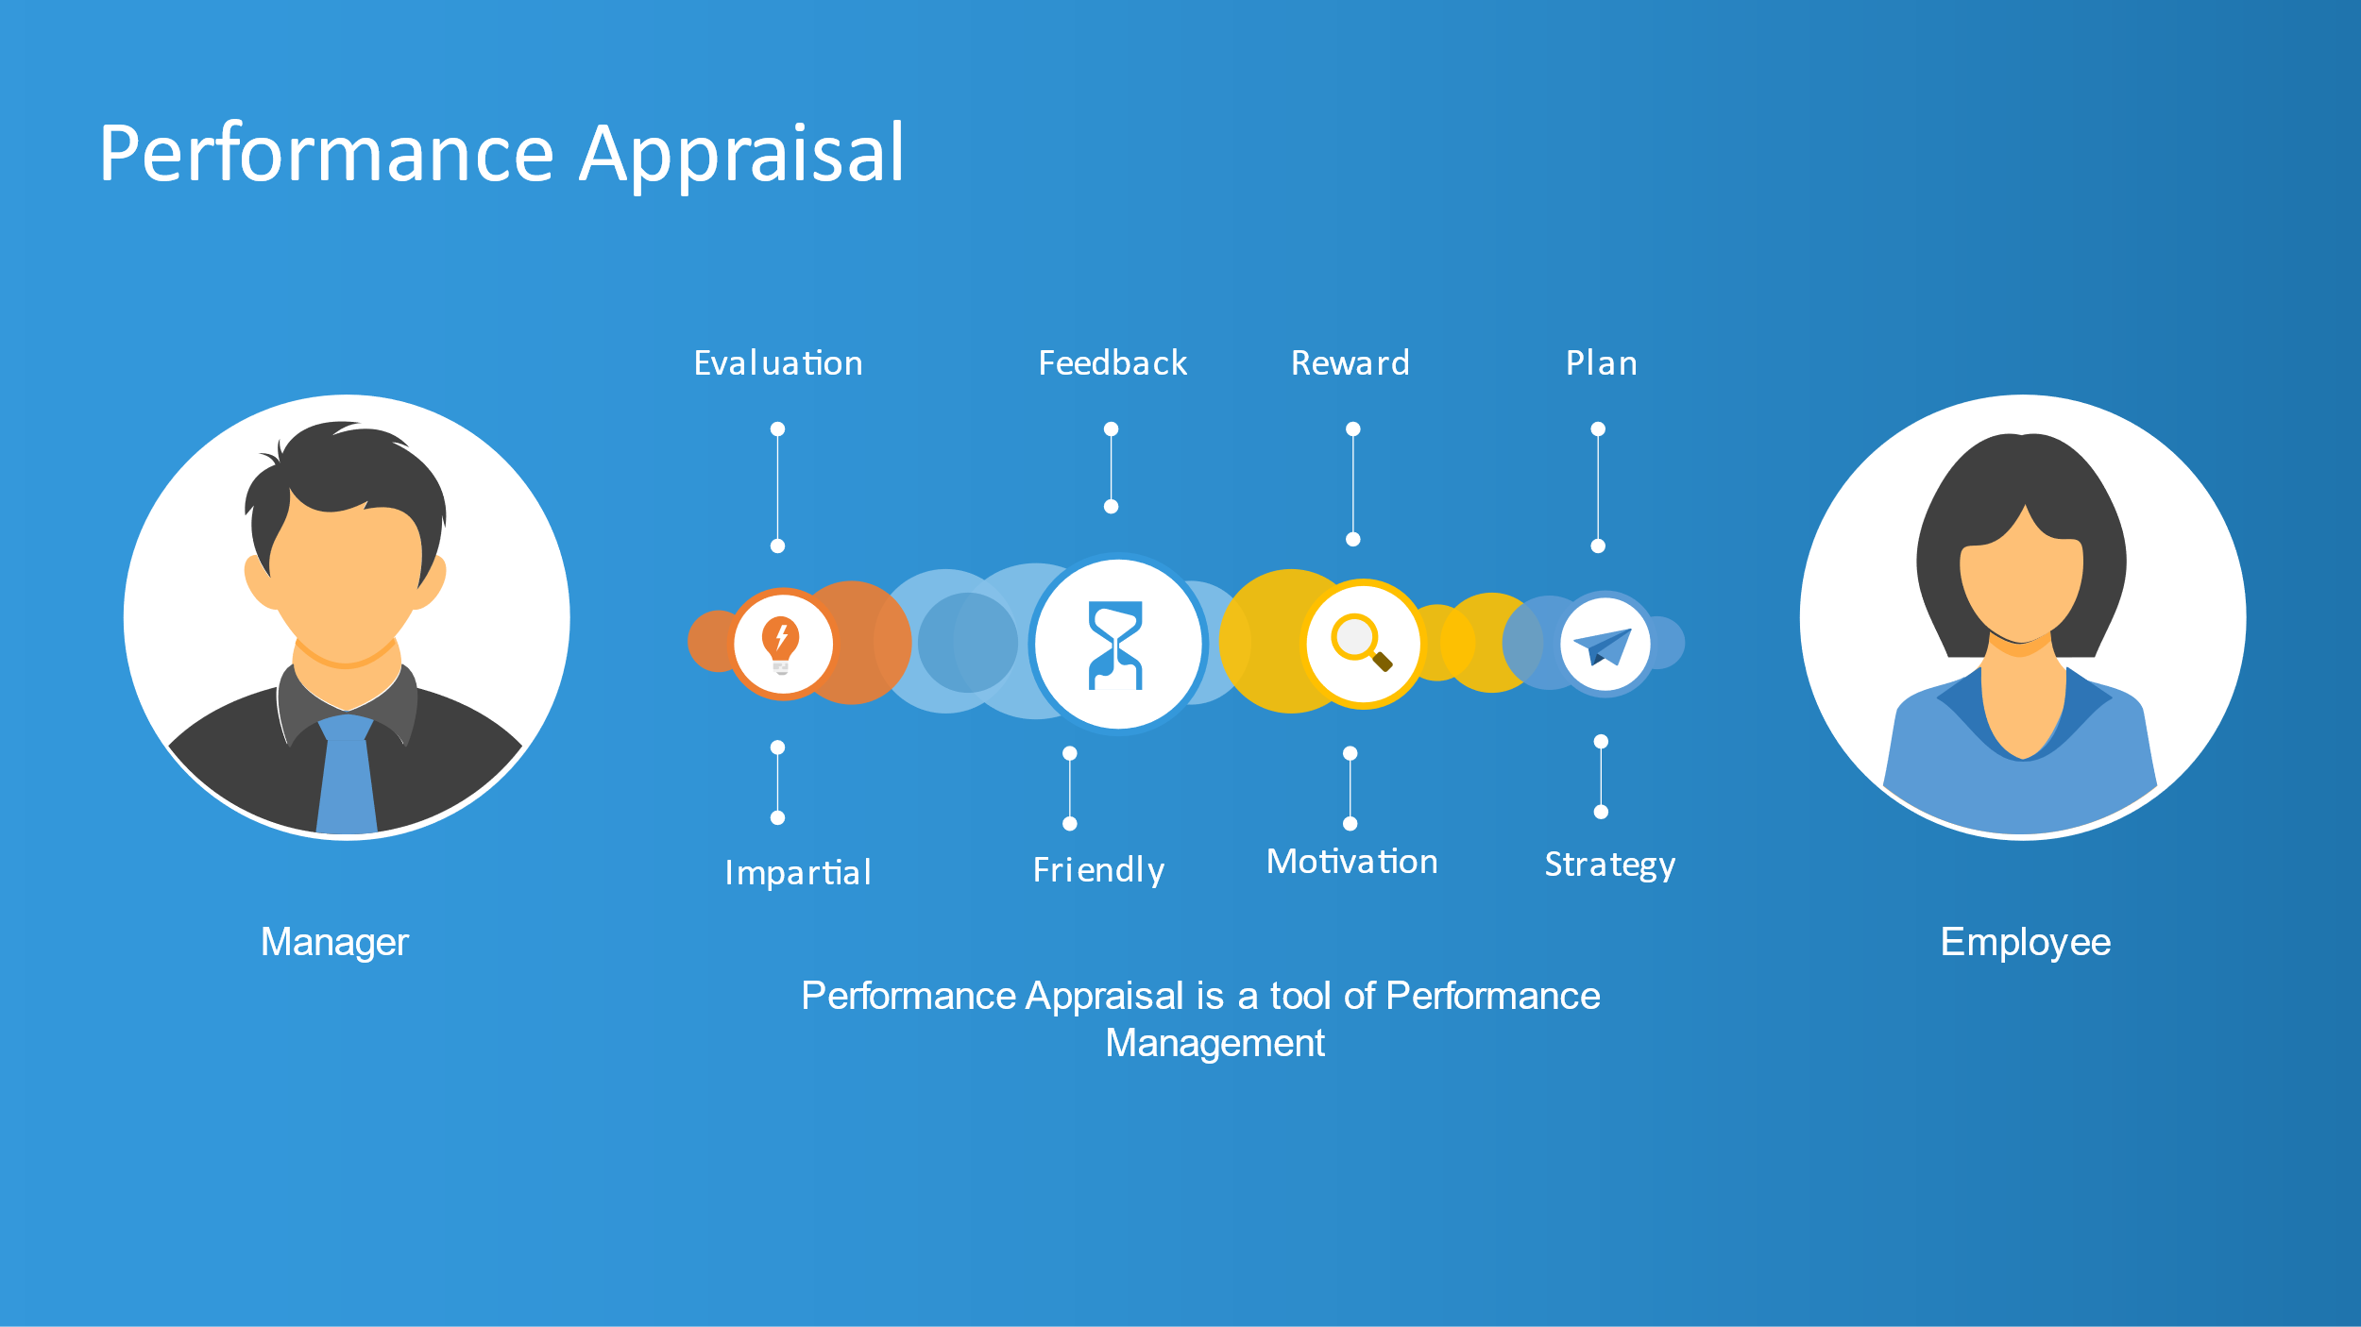

In this sense, it is important to know what the difference is between Performance Management and Performance Appraisal. (Denisi and Murphy, 2017) observe that Performance Appraisal refers to a formal process where the workers of the organisation are evaluated by some judge and Performance Management is a set of activities, policies, and procedures designed to help employees to improve their performance. The organisation has to recognize that Performance Appraisal is a mechanism, and this is part of other tools such as bonuses, permanent feedback, and supervision. Also, training is an important tool to motivate employees, but it is necessary that professionals oversee the training because line managers are not qualified for this work.

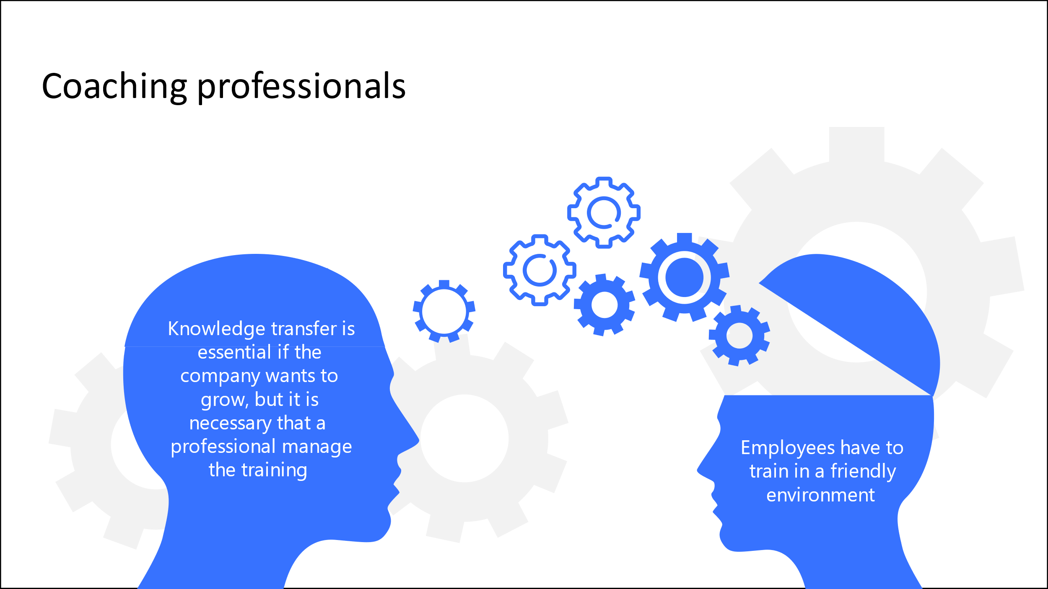

4. Organisational and Employee Concerns
The organisation has to determine what are its objectives, and how they are going to achieve them. All the businesses need to understand that strategic plan is the way to be more effective, because is crucial to have a clear panorama about they want to do. In this sense, Armstrong (2008) indicates that strategic HRM is important because define how the company will achieve its goals through people by means of HR plans and integrated human resource policies and practices. Performance Management is planned by HRM to stablish what will be the methods necessaries to implement. This method helps the company to know what are the resources that they have and what are the capabilities. Thus, the performance of workers represents the competitive advantage of the organisation, and it affects the long-standing growth of the company, as Baykal (2019) manifests. In conclusion, if the organisation has a clear idea about its resources and its goals, the company will have a competitive advantage. Identify the employees who have more skills and who will support to achieve the goals of the company also mean a great step to succeed. In the same line, Tamzini, K. et al. (2017) emphasize the significance of talent and its management in the quest of gaining sustainable competitive advantage and superior organizational performance.
Organisational and employee concerns involve linking the aspirations of the company with the goal of the employees. The importance of Performance Management is also because it builds a connexion between the company and its employees. Torrington et al. (2014) observe that Performance Management systems link organisations goals and employees’ goals, with Performance Appraisal where not always exist objectives. Thus, Performance Appraisal is a tool that company must know how to use it. In a perfect situation there would be many possible advantages of conducting an appraisal, giving a formal chance for managers and workers to examine work in a reflective environment, as Rees (2015) defends. However, a Performance Appraisal a lot of times create tension and dispute because manager do not know how use it. In this sense, employees can be in disagree about their feedback and an appraisal can cause a disadvantage. A good work atmosphere is basic to achieve the goals of the organisation. Yadav (2018) explains that a mentality of happiness at a company permits workers to make the most out of performance and realize their full potential.
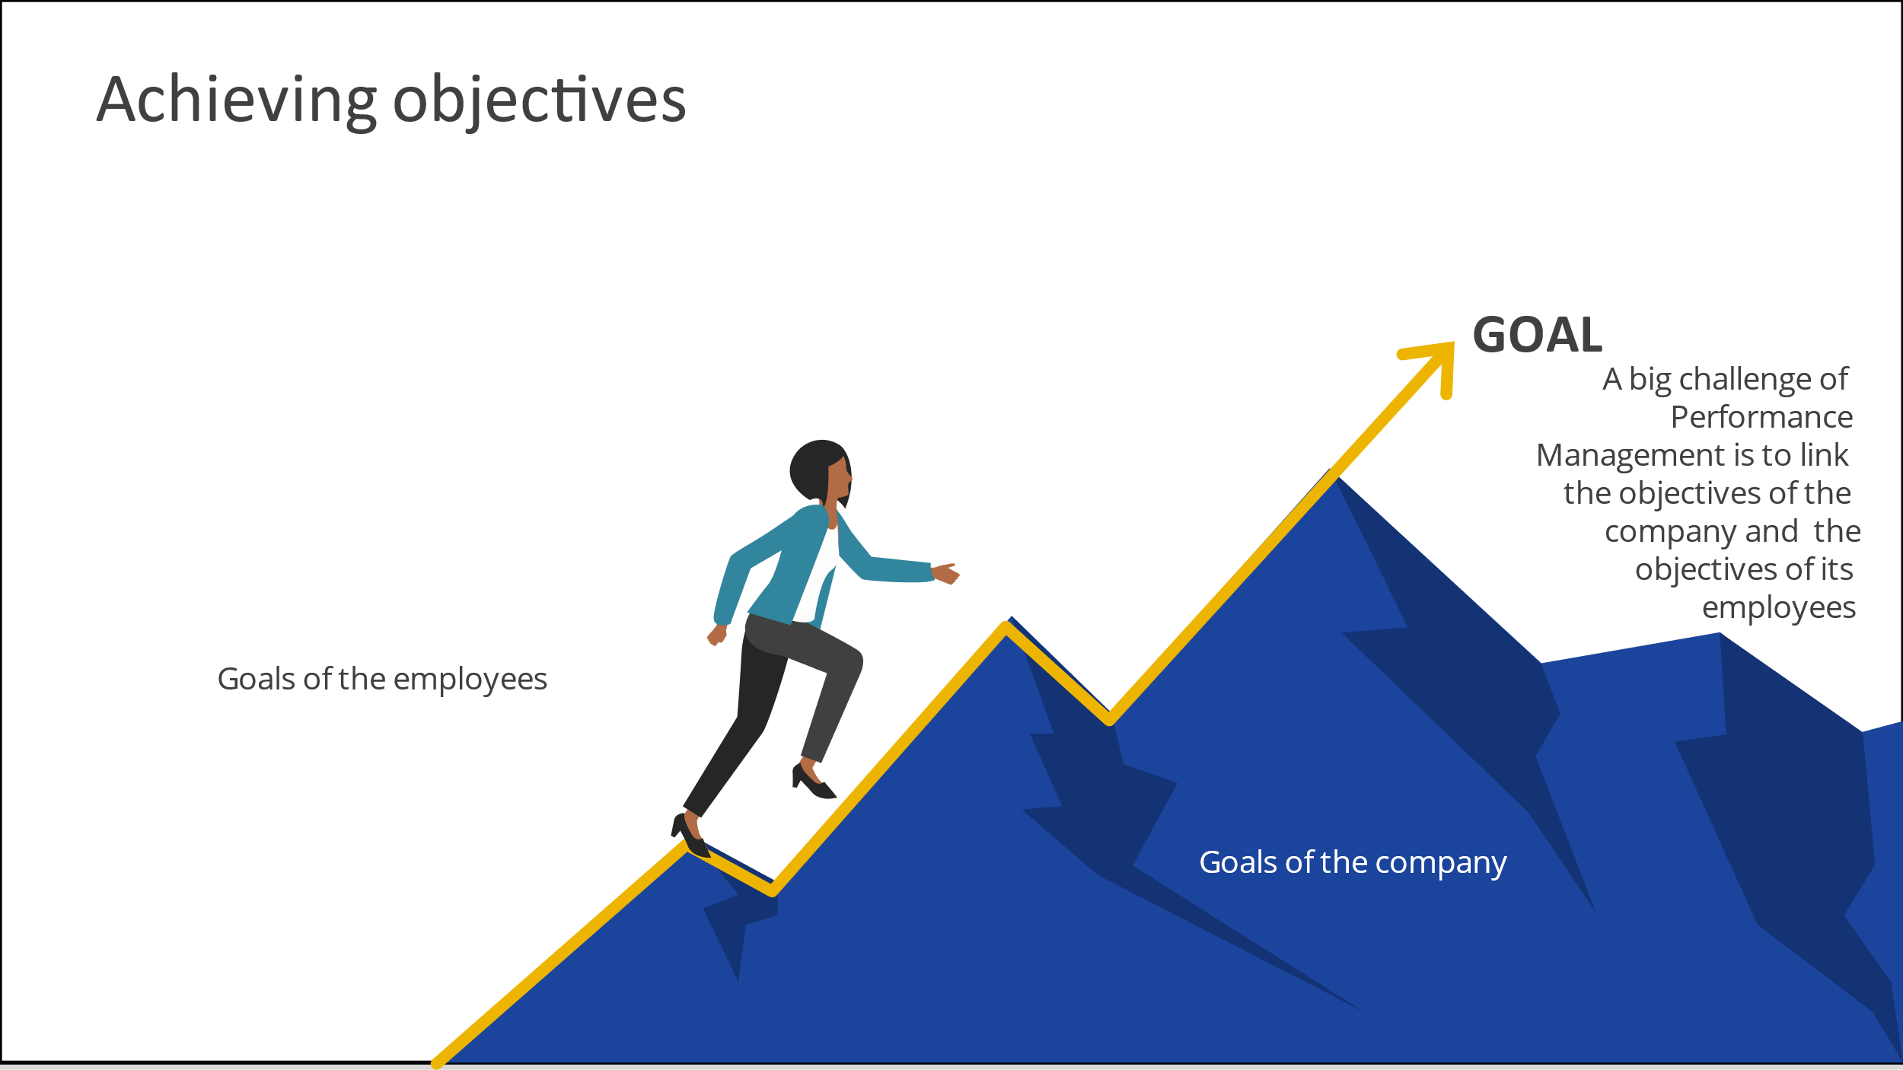

Sainco has different mechanisms to improve its performance and HRM plays a vital role. HRM is crucial for the success of the company because helps the business to develop the skills and potentials of employees, increases the enthusiasm of workforce to work with competence and encourages employees to growth their performance and efforts, as Baykal (2019) argues. Also, HRM has to guide managers to conduct an impartial appraisal because the main idea is to have a good perspective about the company, even though some employees feel a high-stress level, and this can have demotivated them. Torrington et al. (2014) express that a common cause for dismissal is poor performance on the part of a worker, because the law permits dismissals for this justification. This situation can cause an environment stressful at the moment to evaluate through Performance Appraisal. On the other hand, Armstrong (2012) believes that line managers help to achieve the goals of the company because they have a considerable influence over job, encouragement, and coaching with the help of the Performance Management system. The role of the line managers has to be in harmony with HRM perspective. In the same field, Bhattacharya (2017) determines that human capital results the achievement of organisation only if it is effectively utilized and directed to the specific duties in the organizations that need to be performed.
SainCo needs a new Performance Management because wants to understand how change its structure and to be more effective. This is a great step to have a competitive advantage. HR professionals can also analyse internal and external factors because they need to have information about the relationship between the company and its customers. Redmon, Mawhinney and Johnson (2013) interpret that one of the most direct actions of service quality is customer satisfaction with service assessment. SainCo has to consider what the customer feels about the product or service of the company. It is also a way to improve the organisation performance.

5. Traditional organisation in the current global environment
In the present world, the environment is changing constantly and SainCo has to adapt to the new times. The company needs to become competitive because the organisation recognises that it is necessary to embrace modern Performance Management concepts and practices. SainCo has a traditional structure that will limit its growth because companies a lot of times modify their structure looking for an update in the international competitive field. Before developing why is important a modern structure, it is necessary to have knowledge about the current structure of Sainco. In this sense, Brooks (2018) says that traditional structures have two types: multifunctional and multidivisional structures. The first type is also called U-form because the company has a vertical integration, which a person decides each step of the company. In the second structure exist division of roles, each department operate individually. Sainco is an organisation with a traditional structure with a multifunctional style, so all the crucial decisions are taken by an autocratic management style. This structure is still common, however, the current situation has brought about the appearance of new organisational structures or changes of existing forms to keep pace with economic reality, as Browaeys, Price and Price (2011) define.
A modern company is an organisation which achieve adapt to the current situation. Globalization determines the new way of the companies that want to be competitive. The organisations like SainCo need to live a process of changes because innovation begin in the same structure of the business. The transformation can cause conflicts because all change produces different responses of the parts. Mullins and McLean (2019) consider that disputes can be associated to power and politics, hierarchical structure or styles of management, but it can also arise at any level of an organisation and from many different situations or actions. SainCo is a long-established Retail Organisation, which it always had the same style. All the employees have a role and a work routine. The process of change might be traumatic if the management does not how to manage it. According to Yadav (2018), the role of a manager is crucial in the process of change, a transformational boss operates as a catalyst in shaping the workers as per the company needs and culture while in the process enhances the workers as professionals and individuals both. Leaders will be vital when the company start to across the way to achieve a modern structure. Work organisations are not only structures of hierarchical style: they are complex organisms of social relationships, status and power (Mullins and McLean, 2019).
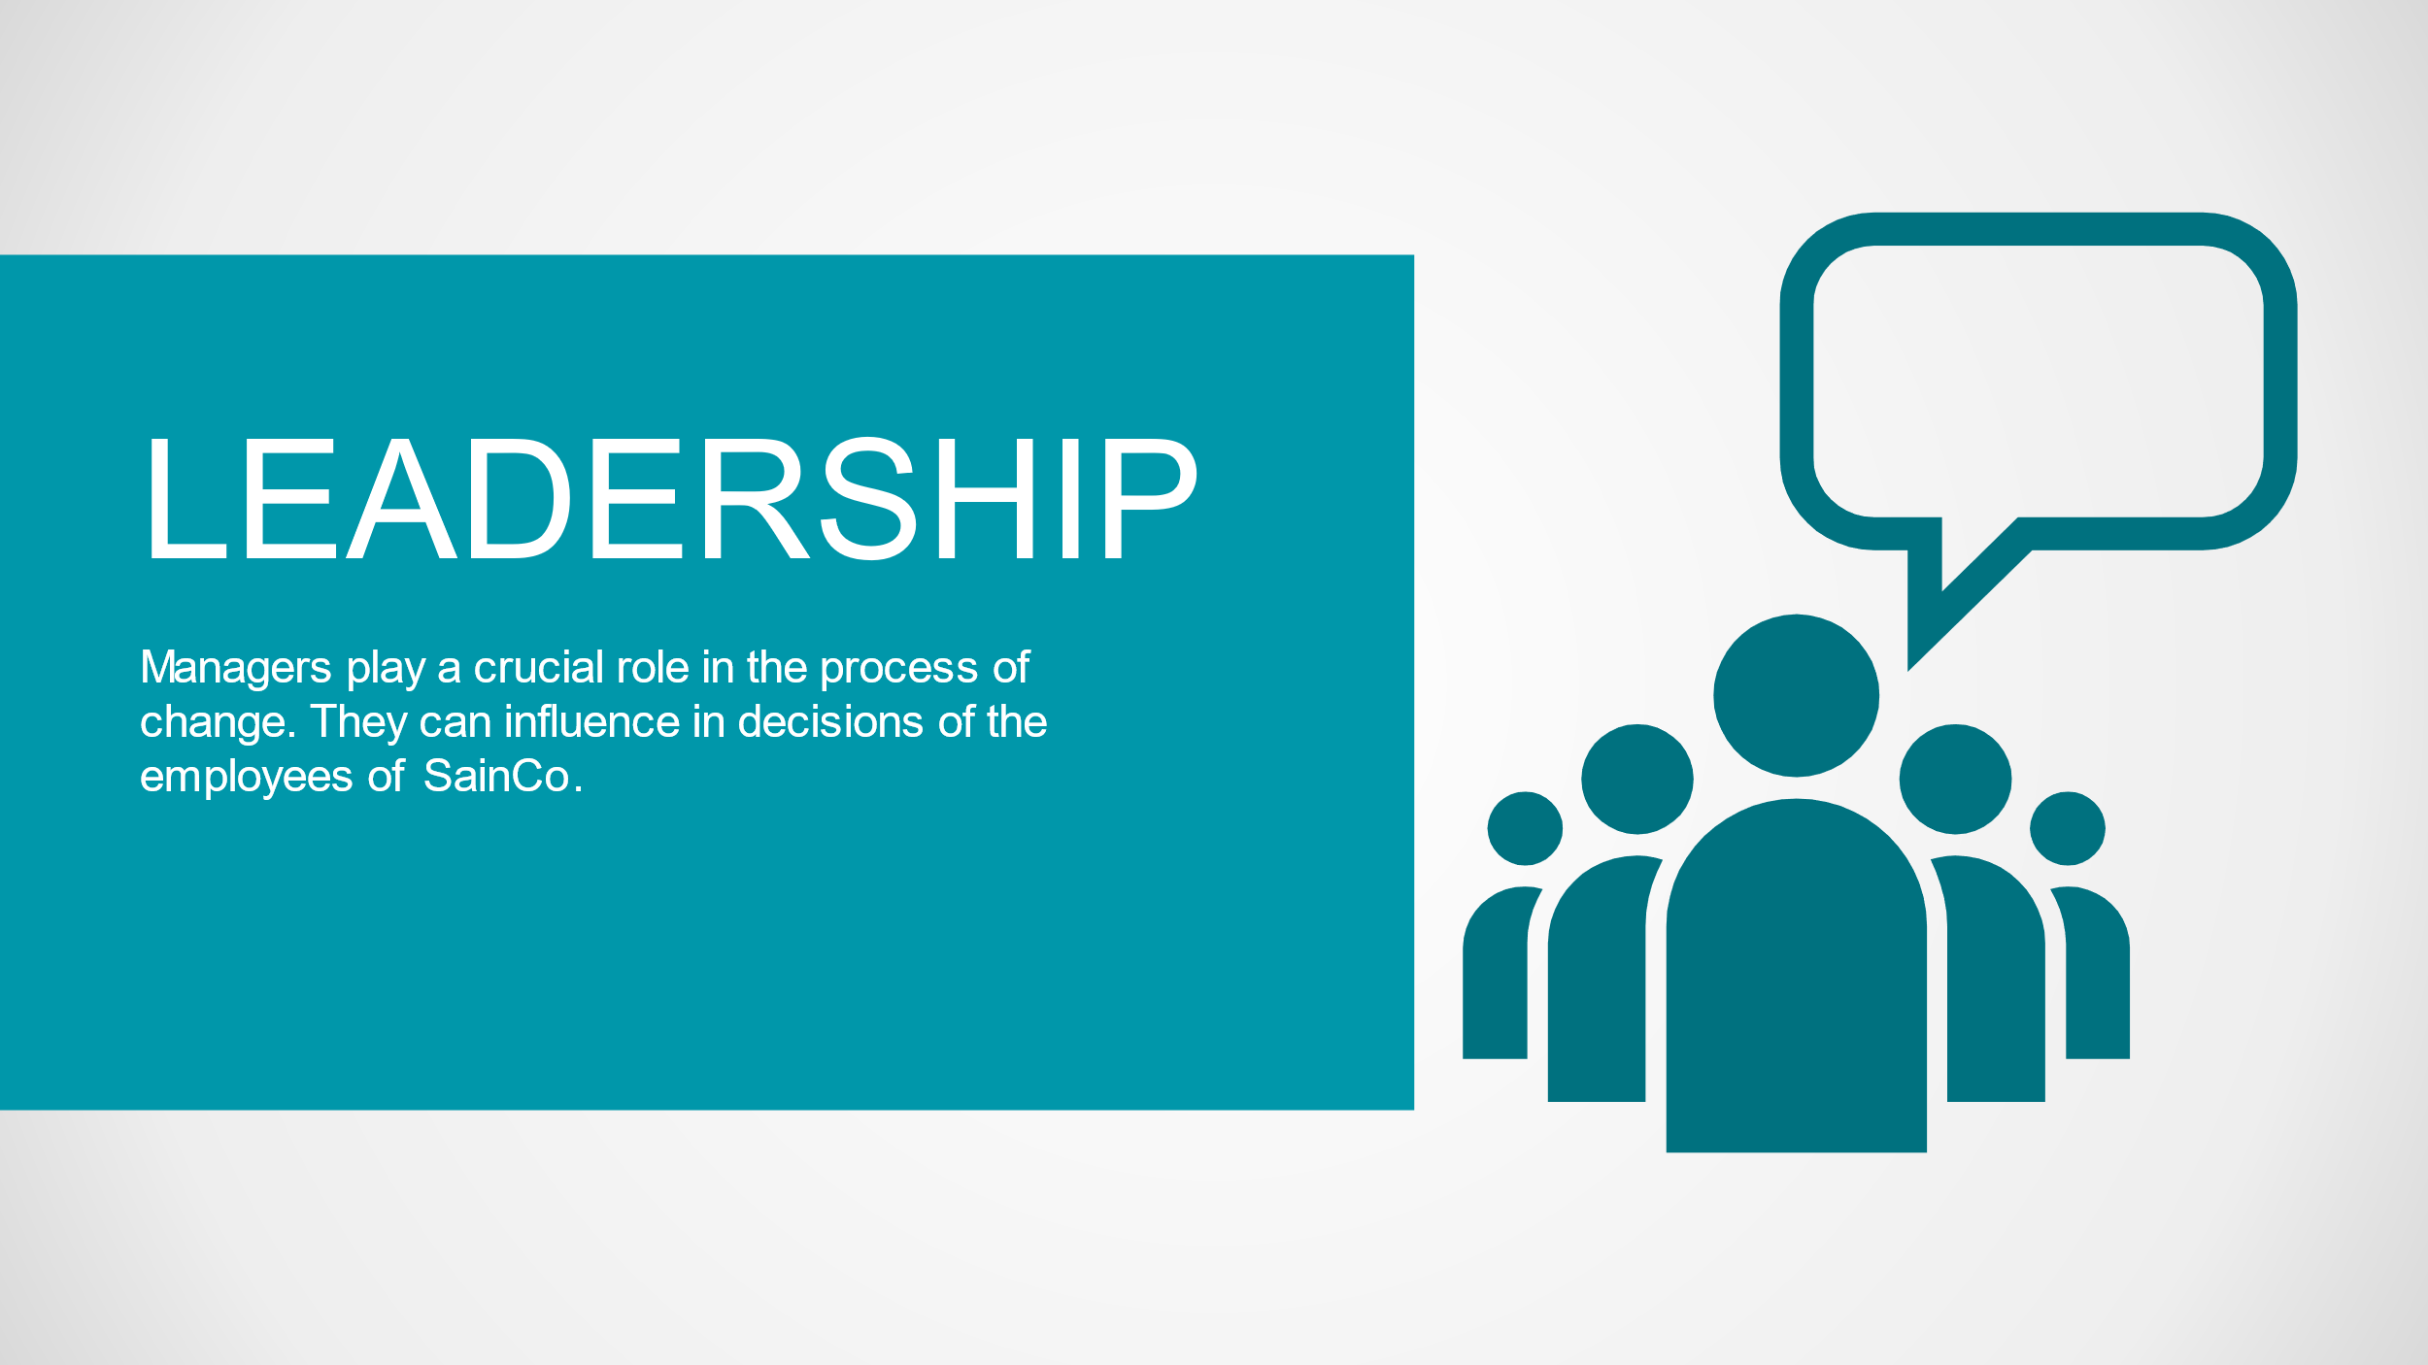

On the other hand, Armstrong (2012) emphasizes that strategic change is involved with broad, long-term, and organization-wide issues involving change, but there is a relationship with its business culture on such matters as development, quality, modernization, and ideals concerning workers and customers, competitive positioning and strategic objectives for achieving and keeping competitive advantage. The culture is intangible part of the company but can or cannot involve with the transformation. The company needs to change its structure because the times are changing, but its culture is the guide that it is not always necessary to change. Culture and structure are two work archetypes, they are two paradigms, but the culture is a range above the structure. The structure is the mode, is the mechanism, is a part of the way to achieve the goal but is the culture of the company that inspires what are the aims. SainCo is in a change process and is crucial that HR professionals can understand what the difference between culture and structure is, because if the company does not have a clear panorama, it will be more difficult the adaptation to a new structure.
A company is not a thing static; the organisation involves adaptation, but this process includes support of different areas of the company, each one plays an important role. According to Browaeys, Price and Price (2011), managing a company involves supervising human resources, these can move to another position, or leave an organisation, or be replaced, but employees must adapt to the culture of the company or at least respect it. Again, we can see the importance of the culture and the necessity to demark it, especially when there is a change process. Thus, modernization practices are inspired by firm-specific factors such as human capital, organizational structure and firm policies, as Cezanne and Saglietto (2019) believe. SainCo require change its structure because the company needs to innovate itself to achieve competitive advantage. In the same line, Donnellan and Rutledge (2019) argue that competitive advantage and disadvantage may shift over time depending on the capability of the company to adapt to environmental changes. The change process of SainCo will mean an opportunity to develop growth methods and to achieve more competitiveness.
Changing a structure of an old company is a big challenge by HR professionals because in the way is possible to find resistance by the employees, but it is crucial to create a good atmosphere, which the organisation does not stop to work during that facet. According to Bhattacharya (2017), it will not be viable to maintain efficiency unless the workforce is in a stress free and happy work environment. Although the change will produce stress and tension in the company, it will be responsibility of managers the method used to provoke less resistance. It is important that the organisation has a work environment and appropriate systems of incentive such as job satisfaction or rewards because progress in performance will achieve through people, as Mullins and McLean (2019) sustain. Environment is essential if the company wants to create commitment with its employees because the organisation that wants to grow recognize the importance of human capital (Cezanne and Saglietto, 2019). Human capital is an essential source by the companies that intend to have competitive advantage. Developing human capital has the capability to improve organisational performance and achieve environmental competitive advantage (Bhattacharya, 2017).

6. Employee Engagement and Employee Involvement
As we said, human capital is a crucial element if SainCo wants to create a company more competitive. In this sense, Performance Appraisal is an instrument used to evaluate what is the performance of the components of the company, but this mechanism also helps to identify what are the asset and sources of the company. Baykal (2019) interprets that to retain an effective workforce in the competitive environment, companies need an effective Human Resource management System. In this sense, Performance Management has to create employee engagement and employee involvement because the company cannot achieve competitive advantage without its employees. Cezanne and Saglietto (2019) admit that Performance Management has to encourage to the employees to develop within the company and validate an employee’s aptness to its objectives. This Performance Appraisal system is called Personal Business Commitments (PBC) and it is used by workers can determine their own goals, and how they can contribute with the objectives of the company. This tool is necessary to employee involvement because build a strong link and motivate them to improve their performance.
If the employees have a workplace with a good atmosphere and they feel that they can participate with the plans of the organisation, and even they feel that the company listens to them, the environment will create an employee engagement, and it will be possible to achieve the goals of the organisation. Performance Appraisal might be a good way to improve the performance of the company, but it is vital to understand that this tool can be redesign by what the company needs. In this sense, Redman and Wilkinson (2013) affirm that the reinvention of Performance Appraisal is more congruent with new business environments. Performance Appraisal is not a static model that the company has to use without change, it can be adapted depending on the context.
Armstrong (2008) argues that engagement and organisational commitment are two important concepts affecting work performance and the attraction of workers. After designing a plan, HR professionals have to develop mechanisms to create employee engagement. Motivation is a big motor that drives each strategy. In this sense, employee involvement is crucial to create a good workplace. Thus, psychological contract is an important instrument because employees also can feel motivation and engagement. This contract is emotional connection, which are based on employees’ perception, as Baykal (2019) defines. Consequently, the company creates a link with its workers because they feel that their performance can contribute with their goals and the goals of the organisation. As we see, the company needs to use all the available tools to build employee engagement. For example, rewards and recognition could have a resultant positive effect on motivation and thus result in higher levels of job performance and satisfaction (Bhattacharya, 2017). SainCo will live a process of changes and Performance Management has to play a fundamental role not only in this facet but also in the whole development of the company. Genuine commitment involves not just knowledge of what the company thinks but an emotional and behavioural response from staff, as Mullins and McLean (2019) determine.
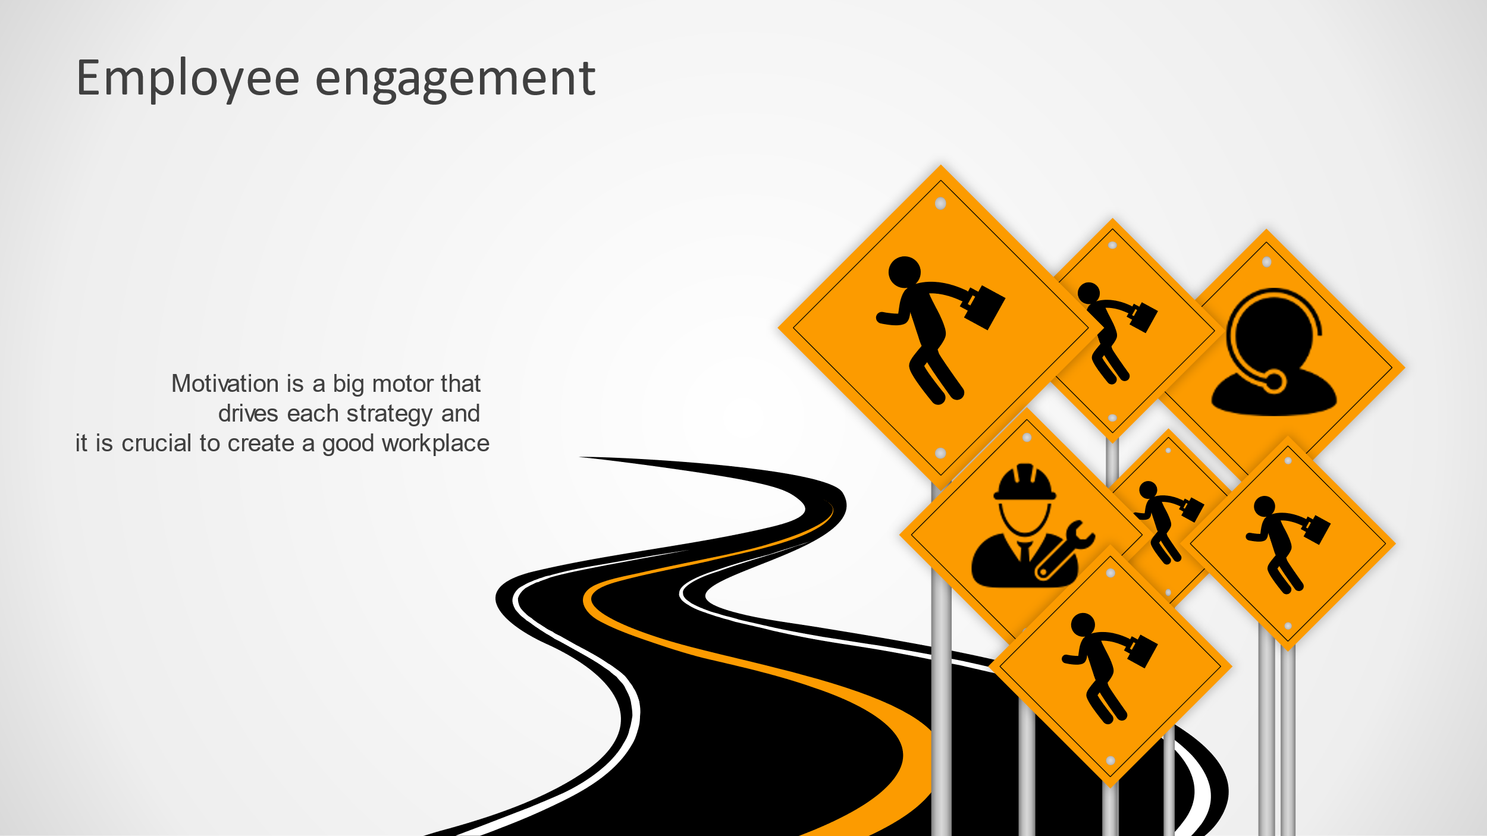

Management and employees, they are the same team with diverse roles but each one has a crucial task. Management and workers cannot divorce, it is not possible to work with different goals. Performance Management means also link objectives between the employees and to produce permanent motivation to improve their performance. SainCo has to understand that creates commitment means staff retention and a high level of work performance, they are basic concepts if the company wants to improve performance and achieve its goals. Encouraging the engagement of the workers is what every organisation wants to do (Armstrong, 2012). Employee engagement generates the opportunity to have a company with a competitive advantage and this is the key to growth. Yadav (2018) believes that the organisation has to design work in such a way that prevents monotony of the workers, it should be such that engages employee on a continuous basis, this is employee engagement.
As we said, the work atmosphere is essential to produce engagement because a healthy workplace support to motivate employees, and a worker who fells motivation can produce more. Armstrong (2012) indicates that work environment can be strategic for improving work engagement through develop a culture which encourages constructive feelings to work, promoting interest and excitement in the jobs people do, reducing stress and recognizing the importance of social interaction. The author explains that a good work environment helps to reduce stress and build strong links between the company and its employees. Clearly, not always is possible to have a work atmosphere without tension because the nature of the tasks sometimes involve pressure, but it is basic to develop a workspace which motivation is the paradigm, which the employees can feel inspiration to improve their performance. Cezanne and Saglietto (2019) remark that a strong job motivation results in more employees’ commitment, more innovation, and more flexibility. It is a chain effect, which all depends on of the environment. In this sense, Performance Management has a permanent challenge not only to keep a motivational work atmosphere, but also has to reinvent constantly ways of motivation.
However, companies have to be careful about how to implement motivational methods because can produce an advantage when it is not use properly. If workers are exhausted by their treatment and are psychologically influenced by discriminatory practices of the organisation, within in an inequitable organisation culture, the company will not achieve its goals through its employees, as Hughes, C. et al. (2015) clarify. Knowledge and develop of impartial practices with a friendly environment are the key to use and take advantage of the main resource of a company, because the employees are the base of growth. Yadav (2018) manifests that organisations design strategies to encourage their workers in a bid to foster commitment and retention rates, to stay competitive. Also, it is crucial measure levels of engagement regularly in order to identify successes (Armstrong, 2008). Engagement can change due to time, tasks or diverse factors, so organisation needs to determinate evaluation periods, which it is possible to analyse if the engagement changes. Armstrong (2008) says that engagement is about what employees do and how they perform in their tasks and what makes them act in aspects that further the achievement of the goals of both the company and themselves. Engagement is motivation, it is to create a strong relationship between the company and its employees, it is sharing the same goals and to grow as a team, it is to achieve excitement to the workers about their tasks and put best efforts.
Finally, the company has to identify and puts attention to the key employees because they also play a crucial role. They are part of the company, but their abilities and knowledge are vital in the company strategy. Cezanne and Saglietto (2019) indicate that the organisation needs to have workers with sufficient knowledge, skills as well as abilities and capabilities, creativity as well as the competency of working independently. The author is emphatic when he says that a key employee can undermine the integrity of the firm, so it is important to keep a specific relationship with them, even it is imperative to encourage them to adhere to the same organisational goals. This does not mean that will be discriminatory treatment with the other employees, but also the organisation has to maintain closer communication with key employees to achieve efficiency. Bhattacharya (2017) concludes that to achieve the determined objective, it is essential to know behaviors related to problems of employees for management. Creating engagement means producing tools that employees can use to improve their performance. Armstrong (2008) believes that this can be increased by explaining to them the objective of the company, communicating to them with a candid method and introducing change after consultation or discussion. Involvement and engagement are part of the same objective, they are fundamental concepts that the company has to know how to use wisely.

7. Enhancing Performance Management
When a company wants to change its structure, and even when an organisation wants to keep growing, HR professionals have to innovate its mechanisms permanently because Performance Management is not a model static that companies can apply in only one way. Environment changes, work atmosphere changes too, and Performance Management has to adapt its tools with the current times. For example, it not the same environment before the Covid-19 and after the pandemic situation, because external and internal forces changed, and the companies had to analyse the situation to make decisions about its goals and how to achieve them. In the same line, the situation in the UK is different because of Brexit. Although can exist organisations that do not have a relationship whit the European Union, Brexit influences a lot of aspects such as the employee market. Sometimes, Performance Management can prevent some environmental changes (Brexit), but it not always there is a possibility to avoid the changes (Covid-19). This is a big challenge for Performance Management. SainCo is not an island in the world, the organisation is part of the global businesses and has to see what happens around to adapt its business. Performance expectations need to be identified and involve the impact from the workers (Torrington et al., 2014).
Performance Management is a process that includes motivating employees because if they are part of the team, and if they feel that the company recognizes their effort and performance, they will improve their tasks and they will contribute more productively. This is a value that all organisations want to have. In this sense, Performance Management has to have constant meetings because feedbacks help to create a strong link. Armstrong (2012) argues that performance review meeting is looking forward to what requirements to be achieved by employees to realize the overall objective of their tasks, to meet new challenges, to make even better use of their skills. Thus, according to Muller (2013), employment chances involve not only hiring and firing topics but also working conditions, training and advancement opportunities, and performance reviews. Performance Management is strategy, it is planification, it is creation because works with different areas of the company and it is responsible for permanent modernization and motivation. Performance Management has to think about how to develop its strategy and how to link it with the employees. Thus, human capital is a concept created by a strategic approach to the management of people, but it is crucial to identify a multidisciplinary view to the study of structural behavior observed in terms of interrelated aspects of the worker, the group, the organisation, and the environment, as Mullins and McLean (2019) describe.
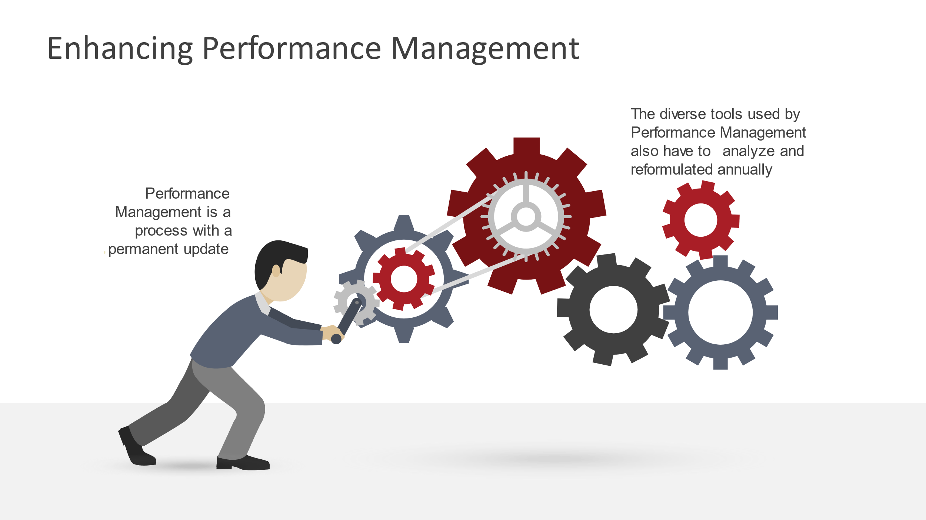

In this sense, Baron and Armstrong (2007) interpret that Human Capital Management has an essential objective to give diagnostic and prognostic data that will inform strategies and procedures created to improve the effectiveness of Performance Management. The authors show us that Human Capital Management is also a tool for Enhancing Performance Management because this mechanism helps to create permanent information about the employees. As we said, if the company wants to growth is fundamental to know what its resources are.

8. Conclusion
Performance Management is by Sainco an aspect crucial if the company wants to grow. Businesses environment changes constantly and it is necessary that the organisation has a clear panorama about what it wants and how is it going to do it. In this sense, Performance Management is an effective instrument when it is used properly. Performance Management has different tools that the company can apply depending on each case. Enhancing Performance Management is a challenge that HR professionals have to look for permanently and it is also the main motor to promote engagement. Armstrong (2008) articulates that there are different tactics for enhancing engagement such as work environment, chances for employee growth and occasions to participate. Employee engagement and employee involvement are two concepts that Performance Management has to develop through its different tools describe lines above. Organisations should encourage such methods that provoke the feelings of happiness regularly as opposed to fewer interventions for happiness at big intervals in the organisations, as Yadav (2018) believes.
However, SainCo has to understand that the change process will produce different reactions because the change situation is a concept that has adhered to diverse responses. According to Mullins and McLean (2019), opposition to change can take many forms and it is often difficult to pinpoint the precise motivations, but forces against change in work organisations include ignoring the needs and expectations of members. Organisation and employees have to be in the same line and Performance Management link them with different mechanisms.

9. Recommendations
In the short term:
-SainCo has to promote meetings with the employees to inform them about future changes. Management has to manage the discussions in a friendly environment, which is crucial to explain with details why the company will change its structure and how each employee can support the transition process.
-SainCo can offer a Bonus Spot to motivate its employees in change moments. These kinds of bonuses are small payments that the company makes to create motivation and commitment.
-Line managers have to promote the plan in the short term because they know the skills and abilities of each employee. They can identify who are the employees with less resistance to the chances.
-Performance Management has to have a list of key employees and has to coordinate with them under a scheme deeper about the details of the changes.

In the long term:
-Business perspective is a process that employees learn in the long term with the different mechanisms used by HR professionals such as seminars. The main reason is to link different areas of the company to show what the strategic goal of the organisation is.
-SainCo has to develop a plan of rewards because recognize the skill of the employee is a great step to create a strong link between the company and the employee. This reward system will reward abilities and engagement through a merit table, in which data will be provided by line managers and customer reviews. A system based only on the decision of the manager can be partial, in this case, SainCo has to manage a metric system where evaluation does not depend on a few managers.
-SainCo has to offer training constantly to show its employee that if they grow the organisation also will grow. As we said, creating engagement is a vital concept for companies.
-SainCo has to have a group of professionals who coach each employee. The professionals are necessary because it not only to support, is to find a way to teach properly. It is important to teach, but it is crucial to know how to teach. Empathy is the main key to be a good coach. Every change always is difficult because it is a new situation and depends on the work environment. A lot of times, the employees respond depends on the manners that are used by the coach.

10. Reference
Armstrong, M., 2008. Strategic human resource management a guide to action 4th ed., London; Philadelphia: Kogan Page.
Armstrong, M., 2012. Armstrong's handbook of management and leadership developing effective people skills for better leadership and management 3rd ed., London; Philadelphia: Kogan Page.
Baron, A. & Armstrong, M., 2007. Human capital management achieving added value through people, London: Kogan Page.
Baykal, Elif, 2019. Handbook of Research on Positive Organizational Behavior for Improved Workplace Performance, Hershey: IGI Global.
Bhattacharya, Anshuman, 2017. Strategic Human Capital Development and Management in Emerging Economies, Hershey: IGI Global.
Brooks, I., 2018. Organisational behaviour individuals, groups and organisation 5th ed., Harlow: Pearson.
Browaeys, M.-J., Price, M.-J. & Price, Roger, 2011. Understanding cross-cultural management 2nd ed., Harlow: Financial Times Prentice Hall.
Cezanne, C. & Saglietto, L., 2019. Global perspectives on human capital-intensive firms, Hershey: IGI Global.
Denisi, Angelo S. and Murphy, Kevin R, 2017. Performance Appraisal and Performance Management: 100 Years of Progress? Journal of applied psychology, 102(3), pp.421–433.
Donnellan, John & Rutledge, Wanda L, 2019. A case for resource‐based view and competitive advantage in banking. Managerial and decision economics, 40(6), pp.728–737.
Hughes, C. et al., 2015. Impact of diversity on organization and career development, Hershey: IGI Global.
Kirkpatrick, Donald L, 2006. Improving Employee Performance Through Appraisal and Coaching 2nd ed., Nashville: AMACOM.
Muller, M., 2013. The manager's guide to HR hiring, firing, performance evaluations, documentation, benefits, and everything else you need to know 2nd ed., New York: AMACOM, American Management Association: Society for Human Resource Management.
Mullins, J.E. & McLean, L.J., 2019. Organisational behaviour in the workplace 12th ed., Harlow: Pearson.
Redman, T. & Wilkinson, A., 2013. Contemporary human resource management: text and cases Fourth., Harlow: Pearson.
Redmon, W.K., Mawhinney, T.C. & Johnson, C.M., 2013. Handbook of Organizational Performance Behavior Analysis and Management, Hoboken: Taylor and Francis.
Rees, W.D., 2015. Skills of management and leadership: managing people in organisations, London: New York, NY: Palgrave Macmillan.
Scullion, H. & Collings, D.G., 2011. Global talent management, New York: Routledge.
Tamzini, K. et al., 2017. Driving Multinational Enterprises Through Effective Global Talent Management, Hershey: IGI Global.
Torrington, D. et al., 2014. Human resource management 9th ed., Harlow, England: Pearson.
Yadav, M., 2018. Harnessing human capital analytics for competitive advantage, Hershey: IGI Global.

