

HE Cert. Professional Skills for Construction, Digital Skills, and Skills of Engineers

ACMA 4013 Skills Development in the Workplace
Reflective Journal
Unit 3 and Unit 4

Student Name: Valentin Mirica
Student ID: 2211628
Module Leader: Divya Chidambaram

Unit 3
Topic: Collaboration
Reflective Journal Contents

Description: Collaboration is the process of working together towards a common goal (Boddy, 2017). It involves individuals or groups sharing knowledge, skills, and resources to achieve a shared objective. Whether in a typical office setting or among members of a virtual team, collaboration takes various forms, including virtual teamwork, co-authoring, and project management (Malak, 2023). It is essential for success in many fields. Collaboration can be internal, external, vertical, or horizontal. Collaboration unleashes creativity, keeps employees engaged, and fosters inventiveness. As humans, we naturally seek connection and community. When working from home, virtual collaboration has become the new norm, facilitated by modern technological solutions (Mori, 2023). The ability of employees to operate as a team with clear and defined goals is crucial for organizational success (Boddy, 2017). It ensures alignment with the bigger vision and a unified direction. For me, collaboration plays an important role in my development and my wellbeing as a human being, because almost every aspect of my day depends on my collaboration with others on different levels and of different importance.
Feelings: When the tasks I have to complete imply collaboration, I always have mixed feelings in the beginning because I have to carefully choose my partners. They must bring in the resources I need, or the skills I lack so that our knowledge and resources do not overlap, because when this happens, competition arises. Collaboration is not easy to be achieved because people with different values, norms and behaviour come to work together. To allow them to work together, they need a common goal, understanding, communication and a leader (Gratton and Erickson, 2024). Many businesses have failed because of poor collaboration. There are theories developed to promote collaboration such as Tuckman theory (Tuckman and Jensen, 2010) about team development or Belbin theory about team roles (Belbin, 2004). They are used nowadays to support collaboration between members of a group and foster good results. According to Tuckman and speaking from my own experience, once members overcome the storming stage, when everyone wants to show off and impose his own values or goals, then, members can achieve great results by working together (Tuckman and Jensen, 2010). For example, Steve Jobs did not found Apple by himself. In the initial stage, he had his friend who helped me to put the foundation of the company and in the later stages, he had an entire team of people that shared his goal and worked towards its achievement (Isaacson, 2014). He was surrounded by employees, he was funded by the government, and he was supported by members of the society who believed in his products and bought them (Isaacson, 2014).
Evaluation:
Collaboration plays a pivotal role in shaping our society, fostering positive outcomes across various domains. The positive impacts of collaboration on the society are collective success, innovation and creativity, improved decision making, trust and cooperation, positive changes (Barker Scott and Manning, 2022). In summary, collaboration fosters growth, development, and progress, ultimately benefiting society as a whole (Barker Scott and Manning, 2022). Collaboration requires members of the society or businesses to share their pool of resources, knowledge and efforts leading to shared achievements. When members and businesses are working together, innovative, and creative solutions arise. Collaboration in the workplace can be both rewarding and challenging. The most known challenges associated with collaboration are misunderstandings, divergent goals, cultural differences, personalities and competition, lack of resources or poor communication, lack of clarity of roles and responsibilities or poor leadership (Morrison-Smith and Ruiz, 2020).
Analysis: When looking at the broaden implications of collaboration, the economic sector, the health care sector, and the society as a whole have been considered by me here. In the economic sector, collaboration significantly increased the supply of options (Menor-Campos et al., 2019). Businesses have come together to share goods and services that allows us all to choose the products and services that are affordable for each of us or meet our individual needs and wants (Menor-Campos et al., 2019). Collaboration also lead to cost savings and improved sustainability. In summary, the collaborative economy transforms markets, benefits consumers, and has the potential to drive economic gains. The healthcare sector is another area that benefited from collaboration because it enhanced patient care, streamlined processes and improved overall outcomes (Bosch and Mansell, 2015). Collaboration helped healthcare professionals to improve patient outcomes. For example, in mental health services, collaboration helped to decrease the number of readmitted patients and find better use for inappropriate out of area placements. Collaboration helped to reduce medical errors, improve quality of care, reduce healthcare costs, and improve communication and decision-making (Bosch and Mansell, 2015). Collaboration also plays a pivotal role in our day-to-day lives, offering a multitude of benefits. For example, a study conducted by the university of Stanford found that individuals are 50% more productive when working in a team, compared to working individually (Density, 2023).
Conclusion: In summary, collaboration is not just about teamwork; it is about leveraging collective intelligence, embracing diversity, and achieving shared goals.
Action Plan: Fostering collaboration, it is very important for the continuous development of us as individuals and for our communities. Collaboration can be fostered by providing people with a clear mission, goals, and expectations. Members also need clear communication channels for effective teamwork. Collaboration is also more effective when members have clear roles and responsibilities.

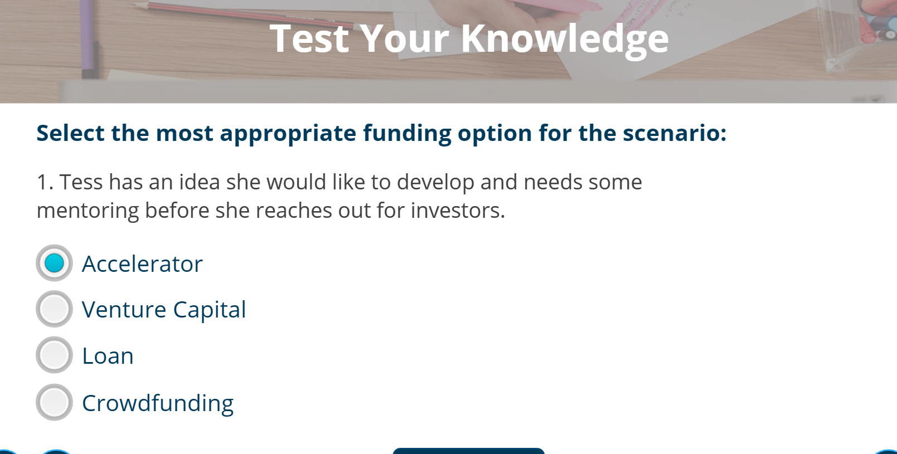


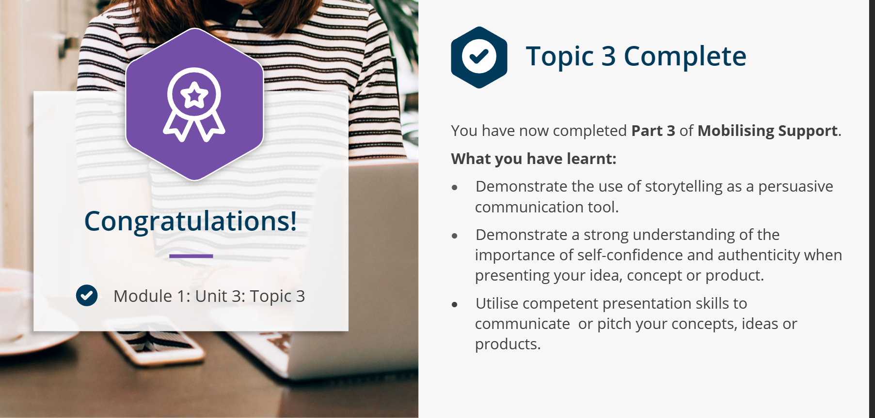
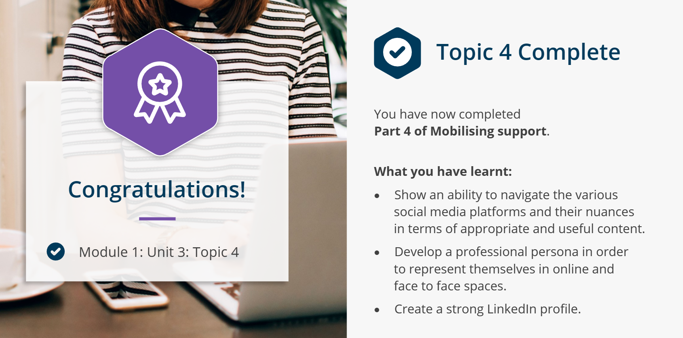

Unit 4
Topic: Personal Evaluation
Reflective Journal Contents

Description: During unit 4, I learned about personal evaluation which is a practice that helps an individual to evaluate his own effectiveness either on a personal or professional plan (Cottrell, 2021). Personal evaluation can help me as an individual to identify my strengths and weaknesses, identify my current situation, identify where I aim to be and identify what I need to do in order to get there (Boddy, 2017). Personal evaluation is used to achieve and measure success and is widely used in academic context to support the development of students and guide them throughout their learning process (Johnson and Chang, 2015). Personal evaluation allows me to improve my performance. Personal evaluation can be done with the aid of reflection and self-assessments tests such as personality tests, SWOT analysis, learning style tests, teamworking assessments (Johnson and Chang, 2015). Personal evaluation is the foundation of the personal development plan that each individual should develop in order to achieve his personal or professional objectives (Cottrell, 2021).

Feelings: Personal evaluation is a very complex and challenging process because many individuals do not know themselves and are anxious to discuss about themselves (Helyer, 2015). In my case, when I first came across personal evaluation, I treated this task in a superficial manner because I did know myself, I did not know what activities to overview, what skills I have or what I want from myself. However, once the individual practices this, personal evaluation is a very rewarding exercise that contributes significantly to the success of the individual (Helyer, 2015). In my case, personal evaluation started to become more effective once I started to use structured assessments and theories that guided me through the process. For example, using Gibbs’ reflective model helps me to take a learning activity and analyze it from start to finish (Gibbs, 1970). I also use the SWOT analysis which not only helps me to identify my strengths and weaknesses but also helps me to identify my opportunities for further development and the challenges that I might face during my development plan (Boddy, 2017).
Evaluation: Using personal evaluation, I became more aware of my abilities, and I created an action plan that allowed me to develop as a student and as an employee (Helyer, 2015). For example, after failing this unit previously, I used personal evaluation to understand what happened and why and I developed an action plan to allow me to perform better during my second attempt. As a result, I passed my first assessment at this unit with an 84% mark. This demonstrated me that when I have a clear objective and I know which abilities to use, I can significantly increase my productivity and success chances. This increased my self esteem and motivated me to continue my academic development. However, there are also drawbacks of personal evaluation. As I mentioned in the beginning, when I first used this exercise, I did not know how to apply it, I did not understand what I was required to identify and how to identify it. In such cases, personal evaluations can lead to inaccurate results, subjectivity, and lack of objectivity (Mackenzie and Correll, 2019). Another drawback of personal evaluation is that is a time-consuming activity that requires constant effort and implication in order to provide the desired results (Mackenzie and Correll, 2019).
Analysis: Personal evaluation is recommended by psychologists to improve our relationships with our children and provide them with a better education by understanding our behaviour, their behaviour, needs and how to fulfill them. Personal evaluation is widely used in higher education to allow the student to understand his skills, his goals and how to achieve that goal by developing the right skills for it (Cottrell, 2021). In my case, as a student, personal evaluation has helped me to increase knowledge about my own self and use that to enhance my productivity. For example, I have used was the VARK questionnaire. This helped me to identify my learning style. Identifying my learning style helped me to learn faster using the methods most suitable for my individual needs. Personal evaluation is mandatory in health care to improve patient care. A nurse is required to submit a continuous development plan that implies self-evaluation in order to receive her pin every three years (NMC, 2021).
Conclusion: Personal evaluation is very important for the development of an individual because it helps him to assess his impact in the academic life, workplace, or family. Personal evaluation allows an individual to take ownership of his actions, use strengths to his benefit and work on his weaknesses. Personal evaluation requires the individual to do a lot of introspection because analysing his own abilities is not an easy task to do and takes time and effort to identify and acknowledge weak areas.
Action Plan: Personal evaluation is more effective when the individual evaluates himself against a certain goal. In such case, the individual has established success criteria and can evaluate his performance against that success criteria to identify weaknesses that must be addressed. Personal evaluation is more effective when structured tools are used to guide the individual through the evaluation process. This will minimise the risk of subjectivity and will improve objectivity. Personal evaluation should be done on a continuous basis and should also be accompanied by SMART goals that can help the individual to address fault areas, because without addressing them, the practice does not bring effective results.
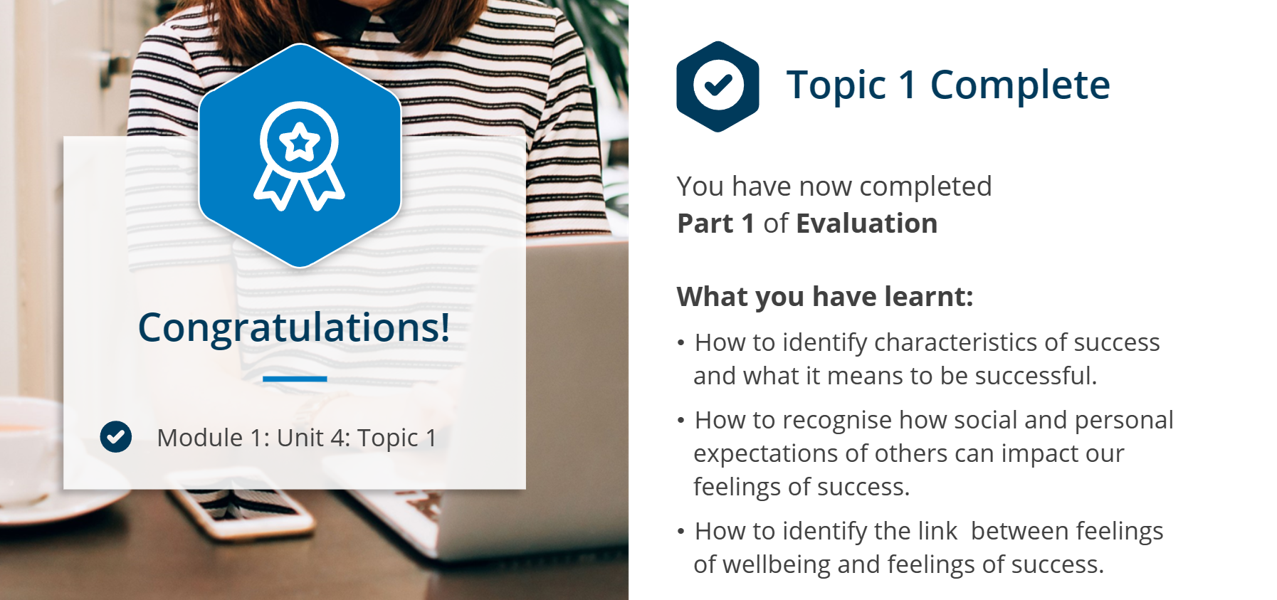
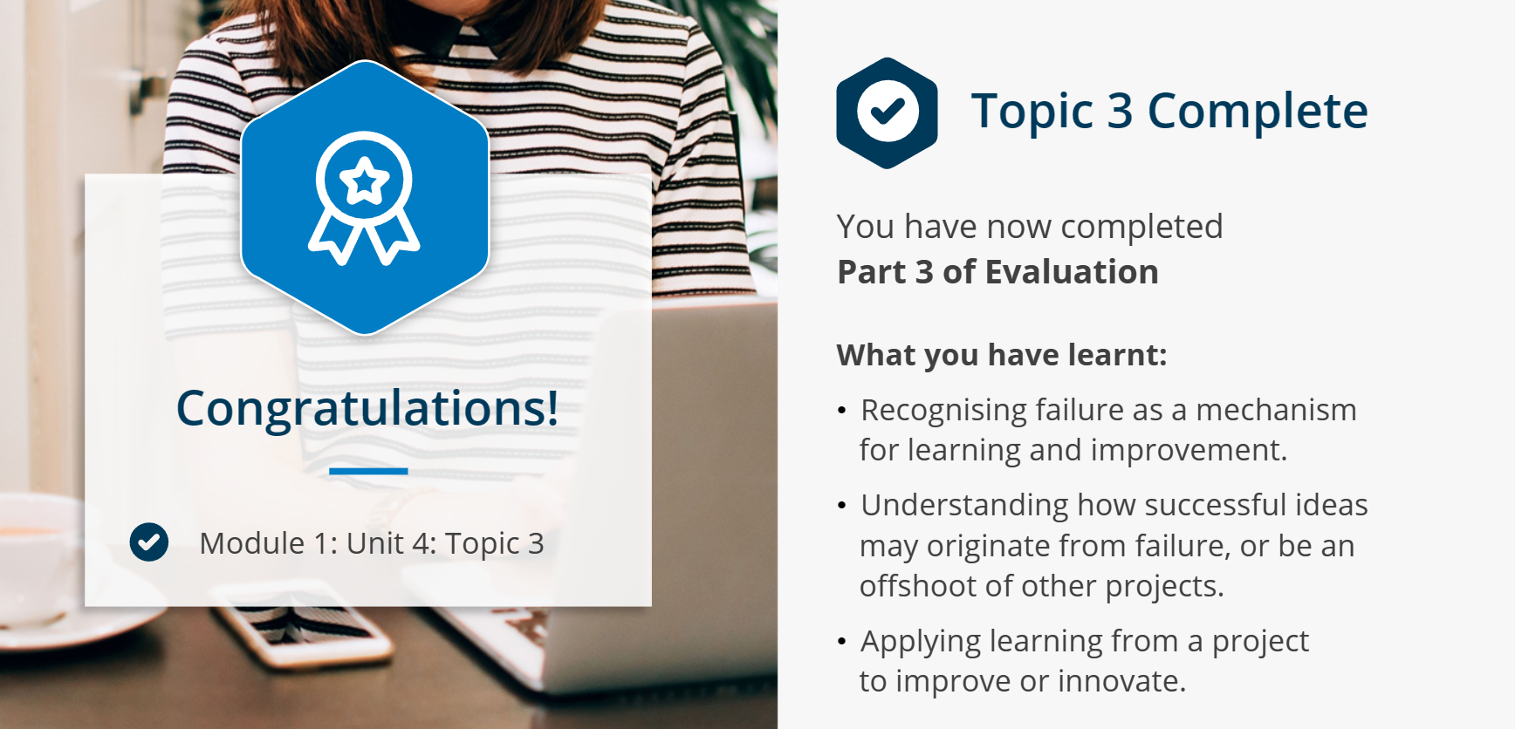
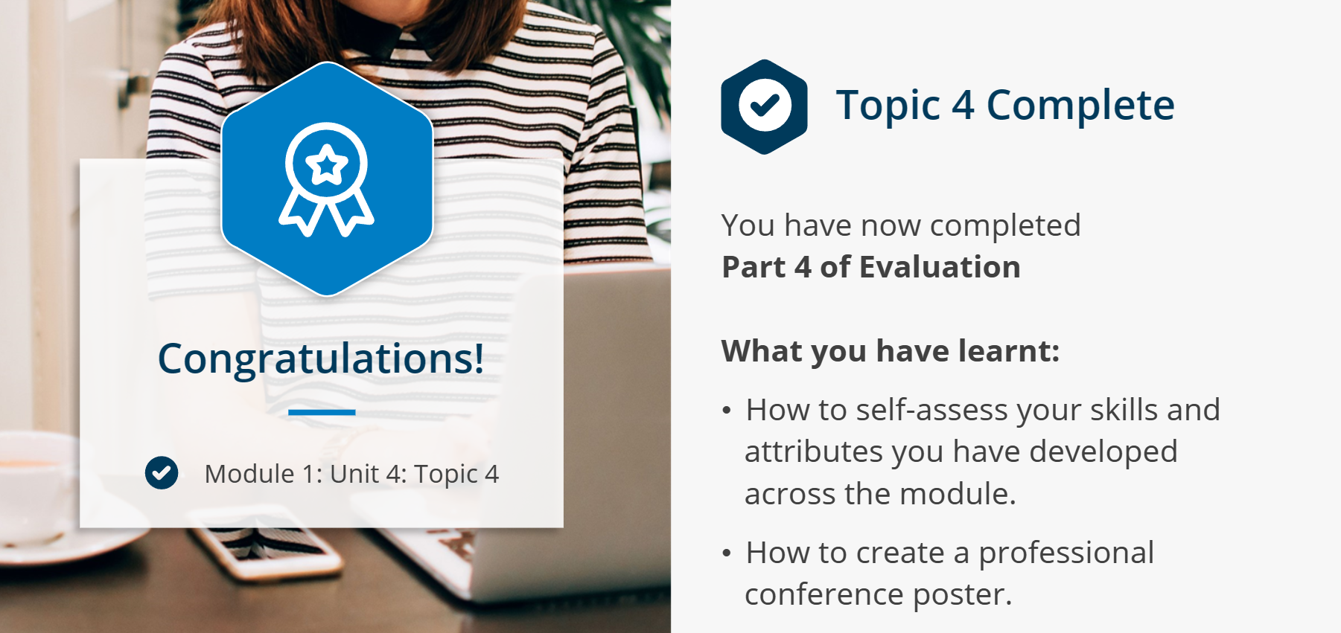

References
- Barker Scott, B.A., and Manning, M.R. (2022) ‘Designing the collaborative organization: A framework for how collaborative work, relationships, and behaviors generate collaborative capacity’, The Journal of Applied Behavioral Science, 60(1), pp. 149–193. doi:10.1177/00218863221106245.
- Belbin, M., (2004). Belbin team roles. Book Belbin Team Roles.
- Boddy, D. (2017). Management. 7th ed. Harlow, England: Pearson.
- Bosch, B. and Mansell, H. (2015) ‘Interprofessional collaboration in Health Care’, Canadian Pharmacists Journal / Revue des Pharmaciens du Canada, 148(4), pp. 176–179. doi:10.1177/1715163515588106.
- Cottrell, S., (2021). Skills for success: Personal development and employability. Bloomsbury Publishing.
- Density (2023) Four benefits to in-person collaboration - and how to nurture it, Workplace Performance Analytics & Optimization. Available at: https://www.density.io/blog/four-benefits-to-in-person-collaboration-and-how-to-nurture-it#:~:text=Collaboration%20matters&text=A%202014%20Stanford%20study%20found,more%20engaged%20with%20their%20work. (Accessed: 10 April 2024).
- Gibbs (1970) Gibbs’ reflective cycle, The University of Edinburgh. Available at: https://www.ed.ac.uk/reflection/reflectors-toolkit/reflecting-on-experience/gibbs-reflective-cycle (Accessed: 16 April 2024).
- Gratton , L. and Erickson, T.J. (2024) Eight ways to build collaborative teams, Harvard Business Review. Available at: https://hbr.org/2007/11/eight-ways-to-build-collaborative-teams (Accessed: 10 April 2024).
- Helyer, R. (2015), "Learning through reflection: the critical role of reflection in work-based learning (WBL)", Journal of Work-Applied Management, Vol. 7 No. 1, pp. 15-27. https://doi.org/10.1108/JWAM-10-2015-003
- Isaacson, W. (2014) The real leadership lessons of Steve Jobs, Harvard Business Review. Available at: https://hbr.org/2012/04/the-real-leadership-lessons-of-steve-jobs (Accessed: 10 April 2024).
- Johnson, R.E. and Chang, C.-H. (Daisy) (2015) ‘Core self-evaluations’, International Encyclopedia of the Social &amp; Behavioral Sciences, pp. 905–910. doi:10.1016/b978-0-08-097086-8.25049-6.
- Mackenzie, L.N. and Correll, S.J. (2019b) Why most performance evaluations are biased, and how to fix them, Harvard Business Review. Available at: https://hbr.org/2019/01/why-most-performance-evaluations-are-biased-and-how-to-fix-them (Accessed: 16 April 2024).
- Malak, H.A. (2023) What is collaboration: Why is it important?, Information Management Simplified. Available at: https://theecmconsultant.com/what-is-collaboration/ (Accessed: 10 April 2024).
- Menor-Campos, A. et al. (2019) ‘Effects of collaborative economy: A reflection’, Social Sciences, 8(5), p. 142. doi:10.3390/socsci8050142.
- Mori, V.Y. (2023) Unleashing creativity with virtual collaboration, LinkedIn. Available at: https://www.linkedin.com/pulse/unleashing-creativity-virtual-collaboration-yehudit-mori-8mzrf/ (Accessed: 10 April 2024).
- Morrison-Smith, S. and Ruiz, J. (2020) ‘Challenges and barriers in virtual teams: A literature review’, SN Applied Sciences, 2(6). doi:10.1007/s42452-020-2801-5.
- NMC (2021) Continuing professional development, The Nursing and Midwifery Council. Available at: https://www.nmc.org.uk/revalidation/requirements/cpd/ (Accessed: 16 April 2024).
- Tuckman, B.W. and Jensen, M.A.C., (2010). Stages of small-group development Revisited1. Group Facilitation, (10), p.43.

