Table of Contents
1.0 Introduction 2
2.0 Introduction of sustainability, the core aspects, and how it fits within the hotel industry 2
3.0 The Positive and Negative Impacts of Sustainability on The Hotel Industry 5
4.0 Sustainable Tourism and its Impact on the Environment 11
5.0 Conclusion 13
References 14

1.0 Introduction
Sustainability has evolved into a key factor in the operations of modern companies, with businesses worldwide, on the other hand, gradually but persistently realizing the significance of environmental, social, and economic responsibility (Žalėnienė and Pereira, 2021). The hotel sector, given the huge amount of resources it spends and the reach it has, is not so different. This report critically evaluates the effect of sustainability on the hotel industry, paying attention to the positive and negative impacts and also how the industry has adapted to these challenges.

2.0 Introduction of sustainability, the core aspects, and how it fits within the hotel industry
Sustainability is a concept that comprises a wide range of factors to guarantee the longevity and preservation of the earth and its inhabitants (Thiele, 2024). According to Morioka and Carvalho, (2016), the core aspects of sustainability are environmental sustainability, social sustainability, and economic sustainability. There is a connection between the various pillars and they are important for achieving a sustainable outcome.

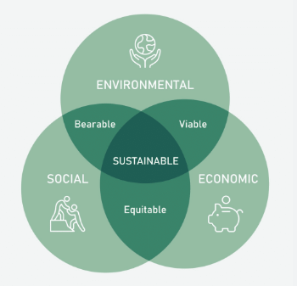
Aspects of sustainability (Barrier, 2017)
Environmental sustainability concerns itself with the conservation and maintenance of natural resources. Thereby it intends to make sure that the rate of depletion is not above the rate of rejuvenation. This includes the utilization of renewable resources optimally and ensuring that the emission rates for pollution are low (Medeiros, Ribeiro and Cortimiglia, 2014). Talan, Tyagi and Surampalli (2020) highlight that social sustainability pertains to the business' impact on people which includes adherence to universal human rights and fulfillment of basic needs including healthcare, education, and public transport. Economic sustainability seeks to keep businesses resilient and provide them with a way to meet all their needs while allowing local communities and ecosystems to benefit from their success (Barrier, 2017). Adams et al. (2016) point out that achieving sustainability requires a fundamental mindset shift, values, and practices, alongside a commitment to addressing global challenges through collaboration and innovative solutions. Žalėnienė and Pereira (2021) further state that it involves a broad perspective and attention to the interconnectedness among ecological, economic, and social concerns and making decisions that may be tough for many people to accept at times. According to Bansal and DesJardine (2014), sustainability is an integral part of business strategies that sustain long-term success. It does so by driving social and environmental change and thus creates a positive impact on the organization as a whole. Companies that score higher on environmental, social, and governance (ESG) metrics tend to exceed market expectations both in the mid-term and the long term. Implementation of sustainability may result in long-term gains – such as financial improvement and business development, as well as increased employee loyalty (Thiele, 2024).
Due to the environmental effects of the hotel industry, approximately 1% of worldwide carbon emissions are generated (PBE, 2023). According to Jones, Hillier and Comfort (2014), sustainability is a necessary concept for the hotel industry to reduce its environmental impact and carbon footprint, meet guests' expectations, and guarantee its long-term development. Sustainable practices in hotels can result in cost savings via energy and water conservation, waste management, and guests' involvement and education as stated by Han et al. (2020). The hotel sector is one of the biggest consumers of energy, water, and other resources. Thereby, it contributes much to environmental degradation and resource depletion. Therefore, the hotel industry implementing sustainable practices would reduce its environmental footprint improve the efficiency of resource use, and consequently boost society and economy Abdou et al. (2020). Legrand, Chen and Laeis (2022) opine that sustainability in the hotel sector can be achieved in multiple ways including cutting energy and water consumption, practicing waste reduction and recycling, sourcing sustainable food and materials, as well as contributing to the community and social responsibility. Mbasera et al. (2016) in alignment highlight that these practices are among the major players resulting in the environmental, social, and economic sustainability of the industry. Reducing environmental impact in the hotel industry means adopting sustainable practices that prevent wastage, minimize resource use, and protect the environment.
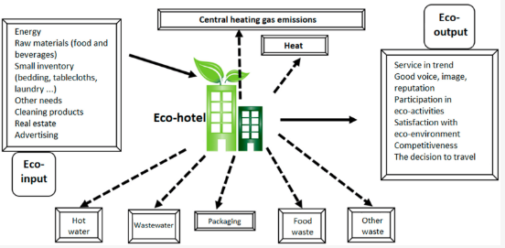
Pollution from business activities and processes in the hotel (Duric and Potočnik Topler, 2021)
Hotels can reduce energy consumption by installing energy-efficient lights and appliances, using renewable energy sources, and enacting policies that may promote energy conservation (MacAskill, Becken and Coghlan, 2023). Likewise, hotels can save water through the use of water-efficient fixtures, encouraging water use conservation while rainwater harvesting systems can be adopted as stated by Scarfiello (2016). Hotels can boost waste prevention and reuse by initiating waste sorting and recycling programs, using reusable and degradable products, as well as avoiding excess packaging waste.
Economic sustainability for the hotel industry consists of prolonging financial performance and growing economy while maximizing cost and optimizing resources (Pamfilie et al., 2018). For example, hotels can save energy and water by opting for efficient lighting and appliances which in the long term will lead to cost reduction. Also, Naydenov (2018) stated that hotels can boost their economic sustainability further by voting for sustainable and locally produced food and materials which will support the local economies and promote sustainable agriculture and forestry practices. In the hotel industry, social sustainability means working on the issues of social equality, justice, and community engagement in strategic decision-making as posited by Legrand, Chen and Laeis (2022). For example, hotels can engage in community development activities including supporting schools, hospitals, and community groups. Moreover, hotels can support social sustainability by following standard labor practices, which include decent wages, health insurance coverage, skill training and hiring people of different cultural backgrounds within the workforce (Santos, 2023).

3.0 The Positive and Negative Impacts of Sustainability on The Hotel Industry
Sustainability practices have had both the positive and the negative parts for the hotel industry.
Positive impact
The hotel sector has incorporated sustainability as a business mandate, recognizing the ripple effects on the environment, the economy, and society. Through the utilization of sustainable techniques, hotels are not only helping in the protection of the environment, but they are also able to improve their brand image, operational efficiency, and overall profitability (Santos et al., 2020).
According to Nogueira, Gomes and Lopes (2022) the Triple Bottom Line (TBL) theory focuses on the complex relationship between the economic, social, and environmental effects of making sustainable development possible. Hotels that incorporate eco-friendly practices, like energy and water conservation, waste minimization, and usage of renewable sources of power, can drastically cut their carbon footprint (Nguyen, 2017). This corresponds to the environmental dimension of the TBL theory and has the role of natural resource protection. The hotel chain of Marriott International has implemented different sustainability actions. Among these are the implementation of energy and water conservation methods, waste reduction programs, renewable energy generation, and eco-friendly sourcing strategies (Marriott, 2019). Having a science-based reduction target for the emissions, installing EV chargers, replacing single-use toiletry bottles with larger pump-topped bottles, launching a food waste reduction campaign, acquiring 100% of eggs from cage-free sources, and responsibly sourcing 95% of animal proteins, cleaning products, and room amenities Marriott shows its environmental conservation commitment (Fox, 2021).

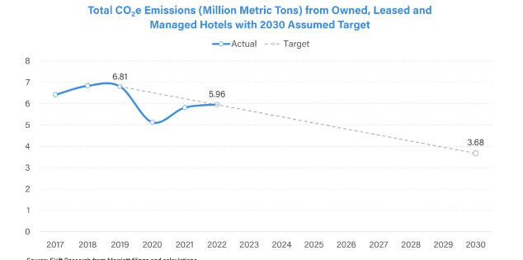
Marriott International’s carbon emissions data (Geerts, 2023)
The revenues of Marriot International have shown remarkable growth when it has taken sustainability initiatives strongly and it has caused an impact on its financial performance significantly (Eschenbrenner et al., 2023). Such initiatives have yielded expenditure reductions with a manufacturing cost optimization of about 15% which in turn has led to a sales revenue growth in the organization. Additionally, the brand has started to bring in more nature-conscious guests further boosting the hotel’s revenue. That is just one of the many purposes they have served, though, not only do they help the company to take some revenue, but are part of the hotel's purpose and revenue stream, linking with the company's long-term sustainability goals (Jenns, 2023).
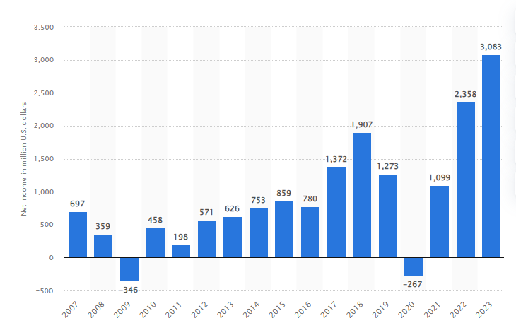
Net income of Marriott International worldwide from 2007 to 2023
According to Farmaki (2019) through addressing environmental concerns, hotels can position themselves as responsible institutions that contribute to the success of the environment in the long run. The Stakeholder Theory highlights the importance of taking into account the interests of all stakeholders – customers, workers, residents, and so on. With the rise of consumer consciousness and preference for eco-friendly activities, hotels that embrace sustainability can have an edge over others and generate a competitive advantage (Freudenreich et al., 2020).
A study by Sun et al. (2018) highlights that hotels' green initiatives bring about customer satisfaction and loyalty as well as environmentally conscious consumers. Shanti and Joshi (2022) posit that through their promotion of sustainable practices, hotels can attract and retain customers who are environmentally conscious thereby enhancing their brand reputation and customer loyalty. This aligns with the natural resource-based view (NRBV) theory which states that businesses can acquire a competitive advantage by efficient management of natural resources and effective waste reduction (Yunus and Michalisin 2016). Hotels that adopt such sustainable practices as energy-efficient technologies and waste management systems can decrease operating costs and contribute to the improvement of long-term profitability (Prakash et al., 2023). The implementation of sustainable practices could result in substantial cost reduction for hotels due to increased productivity in their operational efficiency as pointed out by Hussain, Al-Aomar, and Melhem (2019). The natural resource-based view theory highlights that environmental strategies should be applied to create competitive advantages and sustainable development (Brulhart, Gherra and Marais, 2017). Hilton Hotels & Resorts has opted for sustainable practices to decrease its environmental impacts and improve operational performance. The initiatives adopted by the firm includes a LightStay program which concentrates on energy and water conservation, waste reduction, and eco-friendly operations (Hilton, 2022). By implementing these initiatives, Hilton has accumulated $1 billion in operational savings since 2009 thus far.
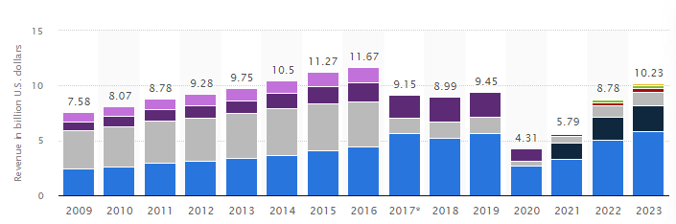
Revenue of Hilton Worldwide Holdings from 2009 to 2023
Other eco-friendly projects of Hilton include recycling cardboard every month, cutting down on energy usage through the use of energy-saving lamps, desk lamps, and natural sunlight. Moreover, Hilton has undertaken to establish science-based emission reduction targets and achieve net-zero value chain greenhouse gas emissions by no later than 2050 (Hilton, 2023). This aligns with the Circular Economy Model which emphasizes the importance of closed-loop systems that decrease waste and promote materials reuse and recycling as stated by Kara et al. (2022). Hotels that embrace circular economy practices or principles, such as recycling programs and the use of sustainable materials can at the same time save costs from resource efficiency while reducing environmental impact (Julião et al., 2019).
However, compared to industry leaders like Marriott and Hilton, which have invested heavily in large-scale sustainability projects, smaller independent hotels may lack in terms of resources that will make it possible to implement comprehensive initiatives (Myung et al., 2014). Quality and environmental management can enhance competitive advantage as opined by Molina-Azorín (2015). Yusof (2017) further states that green practices can significantly impact customer satisfaction and loyalty. The Hilton's we care! program has shown success in reducing energy and water use and CO2 emissions. For hotel groups like Wyndham Hotels & Resorts, a more de-centralized approach has been adopted, and each property has the autonomy to determine their sustainability strategies based on local contexts (Beach, 2023). This proves that hotels apply different approaches to ensure the inclusion of sustainability in their operations.

Negative impact
Though the process of pursuing sustainability in the hotel industry provides a lot of positive effects, there are some downsides also. The implementation of sustainable initiatives in the hotel industry can bring about high initial investment costs incurred to employ eco-friendly practices as noted by Tiwari, Dambhare and Tripathi (2020). The Neoclassical Economic Theory highlights the rational use of resources to increase production (Saunders, 2014). From this perspective, the initial expenses for the installation of energy-efficient systems, water conservation technologies, and waste management infrastructure can be an obstacle, in particular, for those hotels that are smaller or operate in developing economies that lack financial resources. According to a study done by Hsiao et al. (2014), the introduction of an environmental certification scheme in hotels involves huge inputs in infrastructural setup, training, and monitoring systems. Although these investments may have a long-term outcome, the immediate fiscal pressure might present a challenge that can slow down the uptake of sustainable practices (Verma and Chandra, 2018).
Sustainability regulations and reporting requirements are rapidly becoming more complex which means that hotels have to deal with more administrative and operational challenges (Yunus and Michalisin 2016). The institutional theory views organizations as following social norms and rules which may result in mandatory sustainability reporting and compliance measures (Vigneau, Humphreys, and Moon, 2015). The Global Reporting Initiative (GRI) has made guidelines for the hospitality industry, and hotels are required to disclose their environmental, social, and economic performance. This is a demand since it can be difficult and costly, especially for hotels that have smaller sizes and few resources (Koseoglu et al., 2021).
Sometimes the implementation of sustainable practices calls for a cultural shift within the organization, which many employees and stakeholders refuse to do as they are used to traditional methods (Larsson and Larsson, 2020). According to Will (2015), the Change Management Theory emphasizes effective communication, training, and incentives as being useful to overcome resistance and speedy organizational change. When it comes to hotels, resistance to transformation might be caused by the lack or misunderstanding of the advantages of sustainability, fears of interruptions of operations, or cast-out of sustainable practices' views (Consultants, 2023). Overcoming these challenges may be difficult and needs considerable action in the form of educational and training programs as well as incentives.
The sustainability initiatives oftentimes could conflict with other business priorities, for instance, guest satisfaction, profitability, and operational efficiency as stated by Chladek (2019). The Stakeholder Theory focuses on sensing the dilemma of the needs of different stakeholders, comprising shareholders, employees, customers, and the environment (Hatami and Firoozi, 2019). Gerhardsson, Laike and Johansson (2021) argue that while switching to energy-efficient lighting systems is a desirable step towards environmental sustainability, it could impact the guests’ enjoyment and preferences if the lighting quality is considered poor. On the other hand, Chechi (2023) highlights that sourcing local and organic produce for an in-house hotel restaurant may adhere to sustainability goals but it is likely to hike operational costs and may even end up in a clash with the profitability policy.
According to Adams et al. (2016), the Natural Step Framework provides a systematic approach to sustainability by focusing on four system conditions: contributions to systematic increases in substances of the crust of the Earth, contributions to systematic increases in substances made by society, minimizing the physical degradation of nature and meeting the needs of people everywhere. Additionally, the Circular Economy Model stresses the need for hotels to practice closed-loop systems that minimize waste and advocate for reusing and recycling resources to cut down on their environmental impact and eventually achieve cost savings through resource efficiency (Moreno, Braithwaite and Cooper, 2014).

4.0 Sustainable Tourism and its Impact on the Environment
Sustainable tourism revolves around generating the least amount of negative environmental impacts of travel and tourism activities by optimizing the positive outcomes for local communities while keeping the natural resources safe (Budeanu et al., 2016).
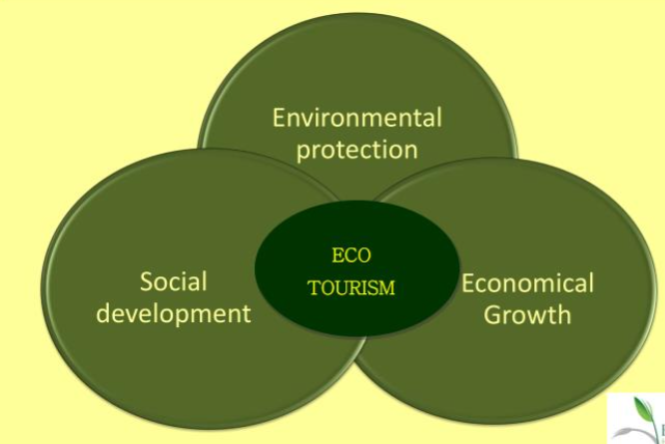
Sustainable Development Model (Nolen, 2012)
According to Hall, Gössling, and Scott (2015), the conservancy and preservation of natural resources is one of the core elements of sustainable tourism. Koščak and O’Rourke (2023) posit that responsible tourism activities play a significant role when it comes to preserving notable ecosystems and environmentally critical biodiversity. It also contributes to the sustainable development of tourism destinations for the long-term period. The Triple Bottom Line (TBL) theory enables assessing the sustainability of tourism approaches by emphasizing the interdependence of the economy, the environment, and society (Wu et al., 2019). According to Telfer and Sharpley (2015), traditional tourism systems focus on economic development rather than considering all the environmental and social consequences associated with mass tourism. In contrast, Hall, Gössling and Scott (2015) argues that sustainable tourism aspires to be an equilibrium among these pillars where economic benefits are attained yet the environment is protected and cultural recognition is promoted.
Khuntia and Mishra (2014) state that the overuse of natural resources is one of the major environmental consequences of unsustainable tourism and this may refer to water, energy, and land. According to the Natural Resource-Based View (NRBV) theory adaptation to environmental factors such as an efficient use of natural resources and waste minimization can lead to a competitive advantage for companies (Makhloufi et al., 2022). Shakya and Shrestha (2019) highlight that sustainable tourism refers to the implementation of water-saving measures, embracing renewable energy sources, as well as the popularization of environment-friendly modes of transport. For example, the Bali Sustainable Villas initiative encourages luxury resorts to adopt sustainable practices like rainwater harvesting, solar power, and waste management systems (Carissa, 2022). Their operations align with the natural resource-based (NRBV) theory allowing these resorts to stand out from the competition as a result of their environmentally conscious and responsible approach.
Another significant environmental impact of unsustainable tourism is the degradation of the ecosystems and loss of biodiversity as highlighted by Gazta (2018). According to Notte et al. (2017), the Ecosystem Services Framework recognizes that natural systems deliver some essential functions like climate regulation, water purification, and habitat provision. Sustainable tourism approaches target the maintenance and preservation of these ecosystem services which will ensure the preservation and long-term viability of the natural environment (Drius et al., 2019). An example the Galapagos Islands which is a UNESCO World Heritage Site have put in place regulations that limit the number of visitors and also enforce sustainable tourism practices to protect the ecosystem and indigenous species (Centre, 2019). In line with the Ecosystem Services Framework, the Galapagos Islands sustainable tourism initiatives ensure that the exponential economic growth due to tourism does not come at the cost of environmental damage that cannot be reversed.
The Circular Economy Model aligns with sustainable tourism by maximizing closed-loop systems that minimize waste and make efficient use of resource efficiency (Fernandes et al., 2020). This model recommends that the tourism industry have practices like recycling, composting, and the use of sustainable materials in construction and operations. The Bucuti & Tara Beach Resort in Aruba has included a comprehensive sustainability program in its water recycling, renewable energy sources, and complete single-use plastics elimination (One Planet network, 2023). In line with the principles of Circular Economy, the resort can minimize its ecological footprint and become a shining example of the practice of sustainable tourism. According to Pan et al. (2018), while sustainable tourism has advanced in environmental damage control, to be able to recognize constraints in the implementation of these initiatives is essential. This could be characterized by sites or enterprises considering only quick economic impacts while ignoring long-term environmental sustainability (DiSegni, Huly and Akron, 2015).
For these obstacles to be conquered, Roxas, River, and Gutierrez (2020) argue that there is a need for collaboration with all the key stakeholders such as the governments, tourist companies, local communities, and tourists themselves. The Stakeholder Theory emphasizes the need to consider the interest of all parties involved in a business in decision-making as posited by Gooyert et al. (2017). In this regard, local communities can be engaged in sustainable tourism projects and tourists can be trained in environmental education, which enable the tourism industry to bring about a shared responsibility for preserving the environment.

5.0 Conclusion
Sustainability has profoundly shaped the hotel industry, having both positive and negative implications. The main drivers for many hotels to put sustainability first and being environmentally and socially responsible are cost savings, improved brand reputation, and increased employee engagement. However, capital costs, disruptions in operation, and conflicts with guests’ requirements are the most significant problems that hotel operators have to deal with. As the industry develops, the integration of environmental, social, and economic sustainability which are essential for long-term success will be the key. Cooperation between hoteliers, industry groupings, decision-makers, and consumers will be necessary for bringing about the required change. By incorporating sustainability as a core business strategy, the hotel industry could reduce its environmental impact, increase its competitiveness, and maximize its potential to benefit its stakeholders and society as a whole.

References
Thiele, L.P., 2024. Sustainability. John Wiley & Sons.
Morioka, S.N. and de Carvalho, M.M., 2016. A systematic literature review towards a conceptual framework for integrating sustainability performance into business. Journal of cleaner production, 136, pp.134-146.
De Medeiros, J.F., Ribeiro, J.L.D. and Cortimiglia, M.N., 2014. Success factors for environmentally sustainable product innovation: a systematic literature review. Journal of cleaner production, 65, pp.76-86.
Talan, A., Tyagi, R.D. and Surampalli, R.Y., 2020. Social dimensions of sustainability. Sustainability: Fundamentals and Applications, pp.183-206.
Barrier, E.B., 2017. The concept of sustainable economic development. In The economics of sustainability (pp. 87-96). Routledge.
Adams, R., Jeanrenaud, S., Bessant, J., Denyer, D. and Overy, P., 2016. Sustainability‐oriented innovation: A systematic review. International Journal of Management Reviews, 18(2), pp.180-205.
Žalėnienė, I. and Pereira, P., 2021. Higher education for sustainability: A global perspective. Geography and Sustainability, 2(2), pp.99-106.
Bansal, P. and DesJardine, M.R., 2014. Business sustainability: It is about time. Strategic organization, 12(1), pp.70-78.
Jones, P., Hillier, D. and Comfort, D., 2014. Sustainability in the global hotel industry. International Journal of Contemporary Hospitality Management, 26(1), pp.5-17.
Han, H., Lee, J.S., Trang, H.L.T. and Kim, W., 2018. Water conservation and waste reduction management for increasing guest loyalty and green hotel practices. International Journal of Hospitality Management, 75, pp.58-66.
Abdou, A.H., Hassan, T.H. and El Dief, M.M., 2020. A description of green hotel practices and their role in achieving sustainable development. Sustainability, 12(22), p.9624.
Legrand, W., Chen, J.S. and Laeis, G.C., 2022. Sustainability in the hospitality industry: Principles of sustainable operations. Routledge.
Mbasera, M., Du Plessis, E., Saayman, M. and Kruger, M., 2016. Environmentally-friendly practices in hotels. Acta Commercii, 16(1), pp.1-8.
MacAskill, S., Becken, S. and Coghlan, A., 2023. Engaging hotel guests to reduce energy and water consumption: A quantitative review of guest impact on resource use in tourist accommodation. Cleaner and Responsible Consumption, p.100156.
Scarfiello, R., 2016. Assessment of water use and re-use in hospitality businesses (Doctoral dissertation, Master’s dissertation submitted in the framework of Erasmus+ exchange semester at University of Gent, Faculty of Bioscience Engineering Home University: Faculty of Civil Engineering,(Italy).
Pamfilie, R., Firoiu, D., Croitoru, A.G. and Ionescu, G.H.I., 2018. Circular economy–A new direction for the sustainability of the hotel industry in Romania. Amfiteatru Economic, 20(48), pp.388-404.
Naydenov, K., 2018. Circular tourism as a key for eco-innovations in circular economy based on sustainable development. Proceeding of the 18th International Multidisciplinary Scientific GeoConference SGEM, Albena, Bulgaria, 30, pp.18-132.
Legrand, W., Chen, J.S. and Laeis, G.C., 2022. Sustainability in the hospitality industry: Principles of sustainable operations. Routledge.
dos Santos, R.A., Méxas, M.P., Meirino, M.J., Sampaio, M.C. and Costa, H.G., 2020. Criteria for assessing a sustainable hotel business. Journal of Cleaner Production, 262, p.121347.
Nogueira, E., Gomes, S. and Lopes, J.M., 2022. The key to sustainable economic development: A triple bottom line approach. Resources, 11(5), p.46.
Nguyen, T.P.T., 2017. The relationship between eco-friendly practices and attitudes toward green hotels for domestic tourists. VNU JOURNAL OF ECONOMICS AND BUSINESS, 33(2).
Farmaki, A., 2019. Corporate social responsibility in hotels: a stakeholder approach. International Journal of Contemporary Hospitality Management, 31(6), pp.2297-2320.
Freudenreich, B., Lüdeke-Freund, F. and Schaltegger, S., 2020. A stakeholder theory perspective on business models: Value creation for sustainability. Journal of business ethics, 166(1), pp.3-18.
Sun, H., Samad, S., Rehman, S.U. and Usman, M., 2022. Clean and green: the relevance of hotels' website quality and environmental management initiatives for green customer loyalty. British Food Journal, 124(12), pp.4266-4285.
Shanti, J. and Joshi, G., 2022. Examining the impact of environmentally sustainable practices on hotel brand equity: a case of Bangalore hotels. Environment, Development and Sustainability, 24(4), pp.5764-5782.
Yunus, E.N. and Michalisin, M.D., 2016. Sustained competitive advantage through green supply chain management practices: a natural-resource-based view approach. International Journal of Services and Operations Management, 25(2), pp.135-154.
Prakash, S., Sharma, V.P., Singh, R. and Vijayvargy, L., 2023. Adopting green and sustainable practices in the hotel industry operations-an analysis of critical performance indicators for improved environmental quality. Management of Environmental Quality: An International Journal, 34(4), pp.1057-1076.
Hussain, M., Al-Aomar, R. and Melhem, H., 2019. Assessment of lean-green practices on the sustainable performance of hotel supply chains. International Journal of Contemporary Hospitality Management, 31(6), pp.2448-2467.
Brulhart, F., Gherra, S. and Marais, M., 2017. Are environmental strategies profitable for companies? The key role of natural competences from a resource-based view. Management Decision, 55(10), pp.2126-2148.
Kara, S., Hauschild, M., Sutherland, J. and McAloone, T., 2022. Closed-loop systems to circular economy: A pathway to environmental sustainability?. CIRP Annals, 71(2), pp.505-528.
Julião, J., Gaspar, M., Tjahjono, B. and Rocha, S., 2019. Exploring circular economy in the hospitality industry. In Innovation, engineering and entrepreneurship (pp. 953-960). Springer International Publishing.
Tiwari, S., Dambhare, A. and Tripathi, R., 2020. Eco-friendly practices in star category hotels of Lucknow: An exploratory study. AVAHAN: A Journal on Hospitality and Tourism, 8(1), pp.9-16.
Saunders, H.D., 2014. Toward a neoclassical theory of sustainable consumption: Eight golden age propositions. Ecological Economics, 105, pp.220-232.
Hsiao, T.Y., Chuang, C.M., Kuo, N.W. and Yu, S.M.F., 2014. Establishing attributes of an environmental management system for green hotel evaluation. International Journal of Hospitality Management, 36, pp.197-208.
Verma, V.K. and Chandra, B., 2018. Intention to implement green hotel practices: evidence from Indian hotel industry. International Journal of Management Practice, 11(1), pp.24-41.
Vigneau, L., Humphreys, M. and Moon, J., 2015. How do firms comply with international sustainability standards? Processes and consequences of adopting the global reporting initiative. Journal of business ethics, 131, pp.469-486.
Koseoglu, M.A., Uyar, A., Kilic, M., Kuzey, C. and Karaman, A.S., 2021. Exploring the connections among CSR performance, reporting, and external assurance: Evidence from the hospitality and tourism industry. International Journal of Hospitality Management, 94, p.102819.
Beach, D. (2023). Wyndham ® Deerfield Beach Resort. [online] Available at: https://d1io3yog0oux5.cloudfront.net/_7718a3995eaa4232a6ed41a2042f510d/wyndhamhotels/db/2300/20907/document/2023ESGReport_16104225137.pdf [Accessed 6 Apr. 2024].
Duric, Z. and Potočnik Topler, J. (2021). The Role of Performance and Environmental Sustainability Indicators in Hotel Competitiveness. Sustainability, [online] 13(12), p.6574. doi:https://doi.org/10.3390/su13126574.
Eschenbrenner, B., Zlatic, A., Bechtel, M., Collins, B. and Straley, C. (2023). Marriott International: A Managerial Strategic Audit Marriott International: A Managerial Strategic Audit. [online] Available at: https://digitalcommons.unl.edu/cgi/viewcontent.cgi?article=1647&context=honorstheses.
Fox, J.T. (2021). Marriott announces new environmental initiatives. [online] Hotel Management. Available at: https://www.hotelmanagement.net/operate/marriott-announces-new-environmental-initiatives.
Geerts, W. (2023). Marriott on Track For Emissions Goal – but Trending in Wrong Direction. [online] Skift. Available at: https://skift.com/2023/09/14/marriott-on-track-for-emissions-goal-but-trending-in-wrong-direction/.
Hilton (2022). Hilton 2022 Environmental, Social and Governance Report. [online] Available at: https://esg.hilton.com/wp-content/uploads/sites/4/2023/04/Hilton-2022-Environmental-Social-and-Governance-Report.pdf.
Hilton (2023). Environmental Impact. [online] Hilton. Available at: https://esg.hilton.com/environment/.
Jenns, C. (2023). Marriott International publishes 2023 sustainability report. [online] Hotel Management Network. Available at: https://www.hotelmanagement-network.com/news/marriott-international-2023-sustainability-report/.
Marriott (2019). csr-marriott. [online] csr-marriott. Available at: https://serve360.marriott.com/.
Plan Be Eco (2023). How to calculate the carbon footprint in the hotel industry. [online] Plan Be Eco. Available at: https://planbe.eco/blog/how-to-calculate-the-carbon-footprint-in-the-hotel-industry/#:~:text=Hotels%20contribute%20about%201%20percent.
Santos, E. (2023). From Neglect to Progress: Assessing Social Sustainability and Decent Work in the Tourism Sector. Sustainability, 15(13), pp.10329–10329. doi:https://doi.org/10.3390/su151310329.

