Name – Faiza Tahir
Student number – 2333852
Module: LCHS4003 – Introduction to Health and Social Care
Community Mental Health Services in the UK
Dr Helen Parsons
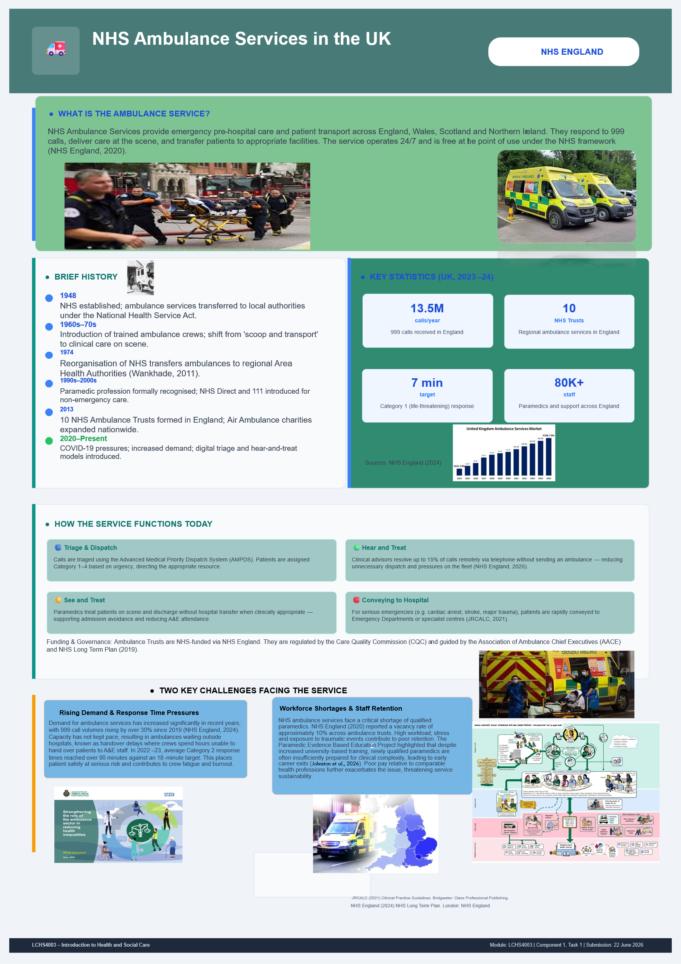
Community Mental Health Services in the UK
About the service
Community mental health services (CMHS) play a crucial role in the health and social care framework of the UK, delivering assessment, crisis intervention and ongoing support for people with mental health difficulties in their homes and communities (Kaehne et al., 2017). This essay examines the background and historical context of CMHS, critically assesses the current practice of CMHS and considers the role of such services in improving the quality of life of their users.

Main Body

History of the service
Historically, mental health care in the UK was provided within large psychiatric hospitals and asylums. People with mental illnesses were removed from society and often deprived of freedom and social isolation, leading to stigma and loss of personal independence (Houston, 2020). The negative impacts of institutionalisation became more and more evident, raising issues of quality of life and human rights.
In the 1980s and 1990s, the trend towards community-based care continued to grow as a result of evolving policy attitudes. The NHS and Community Care Act 1990 marked a turning point, as it established the idea of assessing people's needs and providing support in their community (Huckfield, 2022). The Care in the Community initiative was designed to phase out large psychiatric hospitals and create alternative community services, with a shift in philosophy towards recovery-based approaches that move away from the model of social inclusion and independence.
Comprehensive legislation has influenced the development of CMHS. Assessment, treatment and detention is made under the Mental Health Act 1983 (as amended by Mental Health Act 2007). Local authorities have a duty under the Care Act 2014 to promote the well-being of individual children and young people, including their emotional and mental health. Parity of esteem for physical and mental health was established in law in the Health and Social Care Act 2012. The NHS Long Term Plan (2019) pledged to increase funding for mental health services and to set up community access to mental health services that are available around the clock (NHS England, 2019).

Function of the service
Community mental health services work in collaboration between NHS mental health trusts, local authorities and voluntary sector organisations (Newbigging et al., 2020). Other members of multi-disciplinary teams are psychiatrists, mental health nurses, psychologists, social workers, occupational therapists and support workers. Referrals are made through GP referral, through NHS 111, crisis teams and through hospital discharge pathways. Services include mental health assessment, medication management, counselling, psychological therapies, crisis intervention and care planning.
Effective service delivery is dependent upon partnership working. NHS services, GPs and voluntary organisations work together in Neighbourhood Mental Health Teams. Good communication between professionals, services and service users is a key priority and accurate record-keeping will enable that information to be current and shared with those involved in the individual's care.

Challenges
The provision of CMHS has a significant impact on the quality of life of service users, as they can live in their own home and/or community, are able to be independent and autonomous (Guadie et al., 2025). Family, friends and the local community play an important role in service users' mental wellbeing and recovery and are essential to their relationships. Families and carers receive information, crisis planning and practical support, which helps to lighten their care load.
While there are many opportunities for CMHS, they also encounter many obstacles. There has been a significant increase in demand, with 453,930 new referrals to secondary mental health services each month in 2024/25 (NHS England Digital, 2025). There are significant worryingly high vacancy rates for mental health nursing staff, 14.3% versus 7.8% nationally (Care Quality Commission, 2025). There is uneven geographical distribution of support. Some services may have inadequate resources, and not all people can receive timely services when they are in crisis (Nila et al., 2025).

Conclusion
The transformation of community mental health services from institutional care to a model based in the community, with a focus on recovery and independence, and social inclusion. However, challenges including rising demand, workforce shortages, funding constraints and geographical disparities must be addressed through continued investment and workforce development to meet future mental health needs.
References for Poster –
Fraser, A., Hickman, B., Regal, B., Haggar, T., Boaz, A. and Policy, P., 2025. Community First Responders and the ambulance service.
England, N.H.S., 2020. Ambulance quality indicators [online]
JRCALC (2021) Clinical Practice Guidelines. Bridgwater: Class Professional Publishing
NHS England (2024) NHS Long Term Plan. London: NHS England.
Johnston, S., Waite, P., Violato, M., Black, S. and Wild, J., 2026. Supporting Health, Improving Employee Life and Duty (SHIELD): Protocol for a cluster randomised controlled feasibility trial of dedicated time at work for Emergency Medical Service worker mental health.

References for essay
Guadie, B.A., Belete, M.B., Beyene, M.M., Melese, A.K., Tessema, T.Y. and Workineh, Y. (2025) 'The experience of living with human immunodeficiency virus among adolescents', PLOS ONE, 20(1), p. e0308347.
Houston, R.A., 2020. Asylums: the historical perspective before, during, and after. The Lancet Psychiatry, 7(4), pp.354-362.
Huckfield, L., 2022. New Labour, co-ops and social enterprise. In How Blair killed the co-ops (pp. 93-145). Manchester University Press.
Kaehne, A., Birrell, D., Miller, R. and Petch, A., 2017. Bringing integration home: Policy on health and social care integration in the four nations of the UK. Journal of Integrated Care, 25(2), pp.84-98.
Newbigging, K., Rees, J., Ince, R., Mohan, J., Joseph, D., Ashman, M., Norden, B., Dare, C., Bourke, S. and Costello, B., 2020. The contribution of the voluntary sector to mental health crisis care: a mixed-methods study. Health Services and Delivery Research, 8(29), pp.1-200.
Nila, F.H., Villeneuve, M., Subramaniam, P. and Chang, K.Y.J., 2025. Service Continuity Support Initiatives of Community‐Based Healthcare and Social Care Organisations in Emergencies: A Systematic Review. Health & Social Care in the Community, 2025(1), p.8870937.

