Chloe Burgess (1600608)
SBUS5105 – Data Handling and Business Intelligence
Abstract
This document will give an insight to data preparation and the importance of it in Business Intelligence using a BI survey where 2,800 BI professionals rate the importance of several BI trends, with data preparation being one of the highest. However, there will always be some disadvantages to any method, therefore implications will also be identified and discussed with possible solutions.

The Importance of Data Preparation in Business Intelligence
Introduction
Data preparation is the third step of the six-step CRISP-DM Data Mining Process which was proposed in the mid-1990s by a European consortium of companies to serve as a non-proprietary standard methodology for data mining (Sharda, et al., 2014). According to BARC & Company (2017) the goal of data preparation is to support business analysts and data scienists by preparing different kinds of data for analytical purposes. They also went on to explain that data preparation is a sub-domain of data integration that can be completed with dedicated tools such as Microsoft Excel or Weka.
The first step of data preparation is to collect all the relevant data from identified sources from the business task that has been addressed in data understanding of the CRISP-DM process. Secondly, the data is cleaned; this is when the values in the data set are identified and dealt with as most data sets will contain noisy data which will need to be extracted otherwise it can lead to inaccurate results and poor decision-making for any company. The third step is where the data is transformed for better processing, for example; using excel you can give a column or a row of data a categorical or nominal value to help interpret the data even further. Then finally, the data sets are reduced as too much data can be a problem as not all of it will be relevant; therefore, the skewed data needs to be extracted for it to balance (Sharda, et al., 2014).
The Importance of Data Preparation
According to Survey (2017), new trends have emerged that have made an enormous influence on how organisations work, interact, collaborate, communicate and protect themselves. IT ‘meta-trends’ influence organisations’ strategies, operations and investments through a wide variety of technological drivers such as artificial intelligence, agility and cloud. These meta-trends can be considered as the main drivers behind many important trends related to the use of software and technology for BI/analytics and data management or to the way technology is used within companies.
To gain useful BI, it is important to focus upon data preparation before visualising it. As a neat and prepared dataset results in accurate, meaningful and clean data visualisation, that enhances overall BI (Insights, 2016).
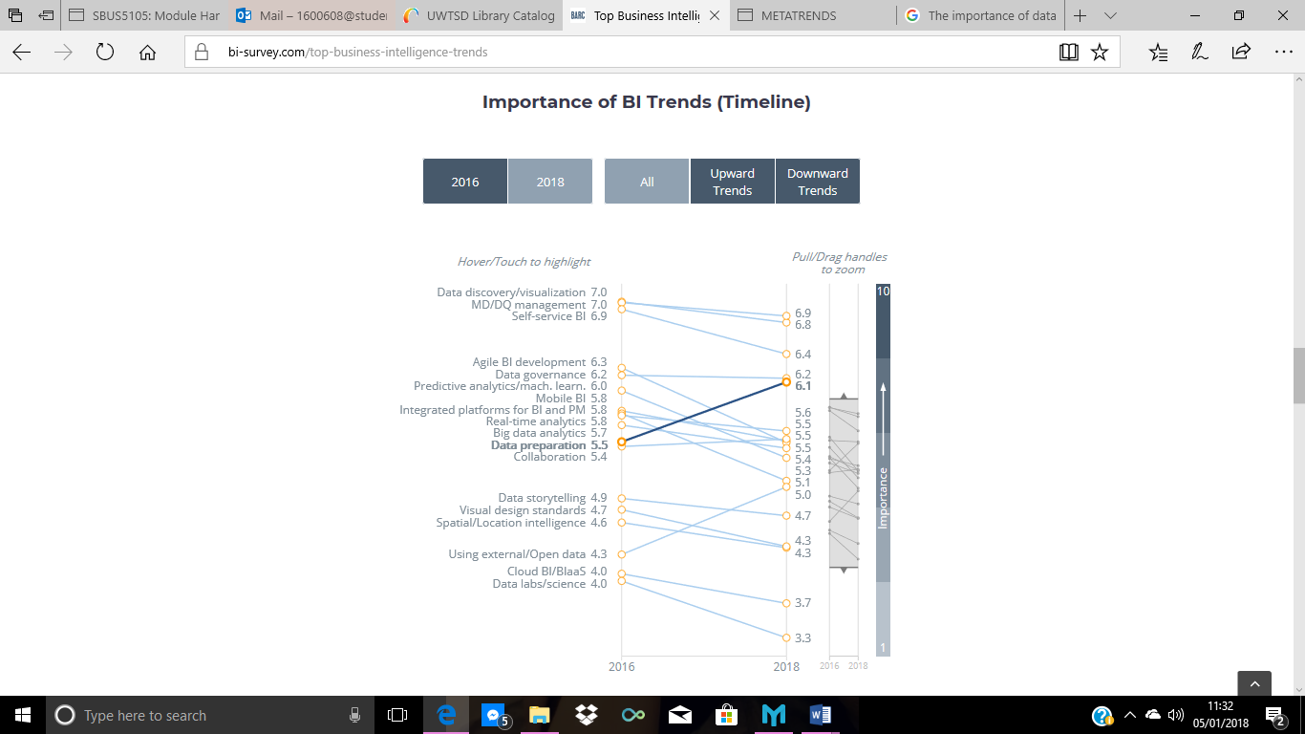
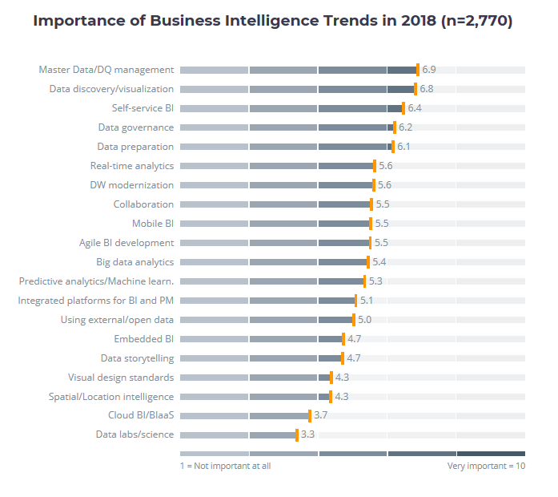
BARC’s BI Trend Monitor 2018 focuses on the business intelligence and data management trends currently driving the BI market from user perspectives. To obtain useful data for this monitor, 2,800 users, consultants and vendors were asked for their views on the most important BI trends and the following results were given: Figure A: Figure B:
Looking at the results in figure A, data preparation has been given a rating of 6.1 for their importance in 2018 which is ranked as very important using the coloured bar along the bottom. Comparing figure A to figure B you can see that the importance of data preparation has increased by 0.6 percent over the two years with it being one of the three trends that increased in importance as if you look at figure C below, most trends were downward.
Figure C:
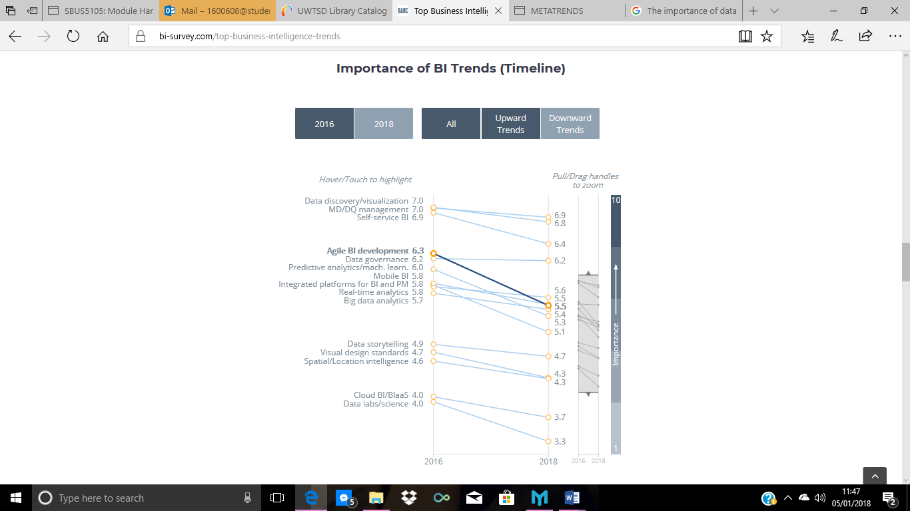

Further backing up the importance of data preparation Sukhadeve (2016) specified that data preparation is an essential step to generate insights. It is one of the most time-consuming yet crucial process in the data mining process. It is the method of collecting, cleaning, processing and consolodating data for analytics. It enriches the data, transforms it and improves the accuracy of the outcome.
Implications with Data Preparation
Many problems have been identified with data preparation first-hand and academically, it is believed that this step of the CRISP-DM process accounts for roughly 80% of the total time spent on the project (Sharda, et al., 2014) as like previously stated data sets will contain noisy data that will need to be extracted and cleansed and depending on the size, it can be a lengthy process.
Weldon (2016) also stated that the challenges with data preparation are growing as data is increasingly created in an increasingly mobile and fast-changing environment. In response, self-service analytical tools which ranked as the third most important trend in business intelligence work (see figure A) are becoming more popular to use with data preparation. Self-service business intelligence offers an environment in which information workers can create and access specific BI reports, queries and analytics without IT involvement. This also extends the scope of BI applications to address a wider range of business needs and problems (Imhoff, 2017).
Two other problems associated with data preparation is having a high level of categorical variables as a this can lead to many problems as there would be a few important factors to look out for. This is also a problem because some algorithms do not support large variables and even if it is supported it is likely to require a lot of space, memory and time. This can be fixed by reducing the number of variables by eliminating inappropriate data. The second problem being missing values which means you are likely to be missing out on very important information; data could be missing because it has been lost, erased, withheld or never found out. This missing data must be represented in a systematic way, for example, a blank space instead of text or numbers as all classical algorithms and some data mining algorithms require defined values. Another solution to missing values would be to extract the columns or rows with these depending on the quantity, if a large quantity it would be a better solution to correct the error to obtain the other information (Fahrnkopf, 2015).
Conclusion
It is evident that data preparation has a high level of importance when it comes to a companies’ BI and that it is an upcoming trend for business intelligence in 2018 as statistics suggest. It is also seen as one of the most important steps in the CRISP-DM Data Mining Process as it plays a major part in business decision-making and accounts for 80% of the data mining task, therefore it should not be overseen otherwise it will lead to inaccurate results from the information obtained. This also supports the implications that comes with data preparation as it is so time-consuming and requires the most attention, therefore it is important that the main steps of data preparation are covered.
It has also been suggested that self-service BI can be used as an analytical tool to support data preparation when it comes to making decisions based on judgement by accessing business intelligence reports, queries and analytics. The best benefit from this for companies is that is doesn’t require employees to have specialised IT skills.
Keywords: Data Preparation, CRISP-DM Data Mining Process, Data Understanding, Meta-trend & Self-service analytics

References
BARC & Company, A. G. G., 2017. BI Survey. [Online]
Available at: https://bi-survey.com/data-preparation-survey/
[Accessed 02 January 2018].
DeZyre, 2016. Why data preparation is an important part of data science?. [Online]
Available at: https://www.dezyre.com/article/why-data-preparation-is-an-important-part-of-data-science/242
[Accessed 05 January 2018].
Fahrnkopf, K., 2015. Two Frequent Challenges in Data Preparation. [Online]
Available at: https://info.salford-systems.com/two-frequent-challenges-in-data-preparation
[Accessed 05 January 2018].
Imhoff, C., 2017. Self-Service Business Intelligence: Empowering Users to Generate Insights. [Online]
Available at: https://www.tableau.com/learn/whitepapers/tdwi-self-service-business-intelligence
[Accessed 05 January 2018].
Insights, V., 2016. Data Preparation & it's importance. [Online]
Available at: https://visualrsoftware.com/data-preparation-applications/
[Accessed 05 January 2018].
Sharda, R., Delen, D. & Turban, E., 2014. Business Intelligence and Analytics; Systems for Decision Support. 10th ed. England: Pearson.
Sukhadeve, A., 2016. Why data preparation should not be overlooked. [Online]
Available at: https://www.datasciencecentral.com/profiles/blogs/why-data-preparation-should-not-be-overlooked
[Accessed 05 January 2018].
Survey, B., 2017. Top Business Intelligence Trends 2018:. [Online]
Available at: https://bi-survey.com/top-business-intelligence-trends
[Accessed 05 January 2018].
Weldon, D., 2016. HDM. [Online]
Available at: https://www.healthdatamanagement.com/news/why-data-preparation-is-a-key-in-enabling-self-service-analytics
[Accessed 05 January 2018].

Business Intelligence

