

Assessment Component 2
Written Essay

Student name: Alia Ashrafi
Student ID: 1916229

Module name: Children, Young People and Families
Module code: (BMHP5004_LON)
Lecturer name: Bianca Sanfilippo
Word count: 2360

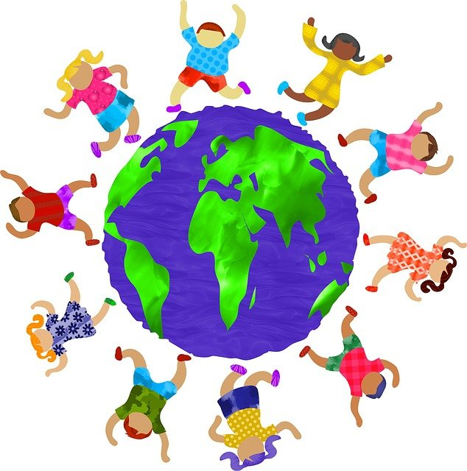

Introduction
When sociologists argue that "childhood is socially constructed," they imply that our conceptions of childhood are shaped by society rather than the biological age of a "child." (Thompson, 2015) Children and childhood have been studied using various methods, including scientific, practical, and social constructionist approaches. Social constructionism aims to learn how children and childhood knowledge are created, by whom, why, and most importantly, for what purpose. Social constructionism provides new perspectives on children and childhood. Childhood's social construction is based on various ideas in different cultures, communities, and historical periods. It also highlights the variety of settings and situations in which children grow up. (Norozi, 2016)

The objective of this essay is to explore the importance of social childhood construction. It gives an outline of the developments in children from the past to the present. It also discusses the family as a socially created notion and results within families in the United Kingdom. The article examines the elements that have contributed to improving the lives of children and decreasing disparities from historical to contemporary periods and why these factors enhanced the lives of children. It discusses existing initiatives in the United Kingdom to assist vulnerable children and decrease disparities between children from advantaged and disadvantaged backgrounds.

Definitions
Childhood: According to the dictionary, childhood is the condition of being a child or young. (merriam-webster.com, 2021)
Medical definition of childhood (1) The period of a boy or girl's life from birth until he or she reaches the age of maturity. (2) The more limited temporal span from infancy until the beginning of puberty (Jay W. Marks, 2021)
Childhood is split into three stages/parts: The three aspects of child development include early childhood, middle childhood, and adolescence. Each stage is structured around the central development tasks for that period. Early childhood (generally defined as birth to the eighth year) is rapid physical, cognitive, socio-emotional, and linguistic development. Middle childhood (generally defined as ages 6 to 12) is when children acquire the fundamental skills for developing good social connections and responsibilities that will educate them for adolescent years. And the period of adolescence, at this point, the children had matured into young adults. They'll start thinking critically, questioning everyone, and learning about their bodies. They begin to assume adult duties while still minors, such as driving a vehicle or working. (ODPHP, 2021)
There are two perspectives on childhood: biological and social.
Childhood Biologically: In biology, youth refers to a child's development until they reach puberty. The child has matured into an adult form at this stage. While some regions of the body, like the brain, may not be finished growing until childhood is gone. It's understandable to separate the two. Our teenage years are very different from those of our childhood.
Childhood in a Social Setting: Many people see teenagers as children until they attain legal maturity. This varies by country, although most cultures set the age limit at 18. While children have physiologically grown, they are still coping with the changes and are too immature to manage adult life. This is also a comprehensible definition. Our adolescent years, like our childhood, may impact us, and many people feel that adolescents should be safeguarded as well. (Kirkpatrick, 2021)

Childhood experience, Family Relationships and Family Life
This is well known; one's upbringing influences adulthood. Those reared in loving families are more likely to succeed than those raised in homes with poverty and violence. A kid with a supportive family, for example, will have a higher chance of academic and life success. Parents who do not support or severely criticise their children, on the other hand, may raise children who are unsure or indifferent about their careers. There are exceptions to this norm from time to time. A child may grow up in poverty yet eventually rise beyond it. A child who has been helped, on the other hand, may fail.
Children whose parents enable them to make decisions are more likely to succeed. A kid should be protected, but parent involvement, in which a parent supervises everything a child does, may make a youngster too reliant on others. Children who are not monitored at all, on the other hand, may grow up without taking on any obligations. (Kirkpatrick, 2021)
Researchers have found that good childhood experiences are equally as essential as bad ones and may even help mitigate traumatic occurrences. (Christina Bethell, 2019)

A Comparative Approach to Childhood Social Construction
A comparative approach – that is, looking at how children are viewed and treated in periods and locations other than their own – is a valuable method to demonstrate the social construction of childhood. Two well-known instances of how childhood differs in different nations are:
Child Labor - In certain cultures, children are seen as an "economic asset" and are expected to work for a wage. In LDCs, children are often viewed as a source of cheap (free) labour on the farm, in the house, or in sweatshops where the pay may supplement the family's income. (Thompson, 2015)
In the UK, Children may only begin full-time employment after achieving the minimum school-age requirement; they can work up to 40 hours per week. (Gov.UK, 2021)
Since a few past centuries, children all across the globe have learned how to produce crops, gather water and firewood, assist at home, and herd animals alongside their parents. Children continued to labour with grownups in mines and factories as Europe became more industrialised. However, 'child labour in nineteenth-century Europe was fundamentally different from that which had gone before it,' growing increasingly hazardous and requiring machinery, chemicals, inadequate ventilation, and long shifts, which were considered by some to be detrimental to the wellbeing of young people. (Evans, 2012)
Forced Marriage - In certain countries, young adolescent girls are forced into arranged marriages against their will, forcing them to assume the responsibilities of a housewife and mother at a young age. In India and Ethiopia, for example, this is well-documented. (Thompson, 2015)
In the United Kingdom, it is prohibited. It's not the same as being married in a planned marriage. People in arranged marriages always have the option of getting married or not. Nobody has the authority to make someone do anything they do not want to do. (NSPCC, 2021)

Childhood Events Over Time
During the Victorian Era in the 1800s, the contemporary perspective of children became popular. Children's innocence was not a new concept before, but children's media and tales became more widely known. During the Enlightenment of the 18th century and the Romantic era, the modern idea of childhood with autonomy and objectives started to develop. According to certain historians, childhood as a separate stage of life did not emerge until the 16th century. Childhood, as per Aries (1982), has gone through a social construction process.
Throughout history, people's perceptions of childhood have changed dramatically. Children were formerly thought to be adults trapped in tiny bodies. Many had employment and were treated as though they were adults who understood how things worked. When compared to how children are handled now, it's a stark difference. Children are nowadays portrayed as innocent and in need of entertainment that develops their creativity. Children learn in different ways than adults do, and they should be treated as such.

Theories
Urie Bronfenbrenner is a co-founder of the national Head Start programme and one of the world's foremost experts in developmental psychology, raising children, and human ecology. The ecological systems theory of Bronfenbrenner sees child development as a complex system of connections influenced by many layers of the surrounding environment, ranging from close home and school settings to broad societal values, laws, and traditions.
To examine a kid's development, we must include her local surroundings and how the broader environment interacts with the child. Bronfenbrenner classified people's settings into five categories: microsystems, mesosystems, exosystems, macrosystems, and chronosystems. The ecological systems theory's microsystem is the most influential level. This refers to the developing child's most immediate environmental contexts, such as home and school. The ecological systems theory of Bronfenbrenner has consequences for educational practice. (Guy-Evans, 2020)

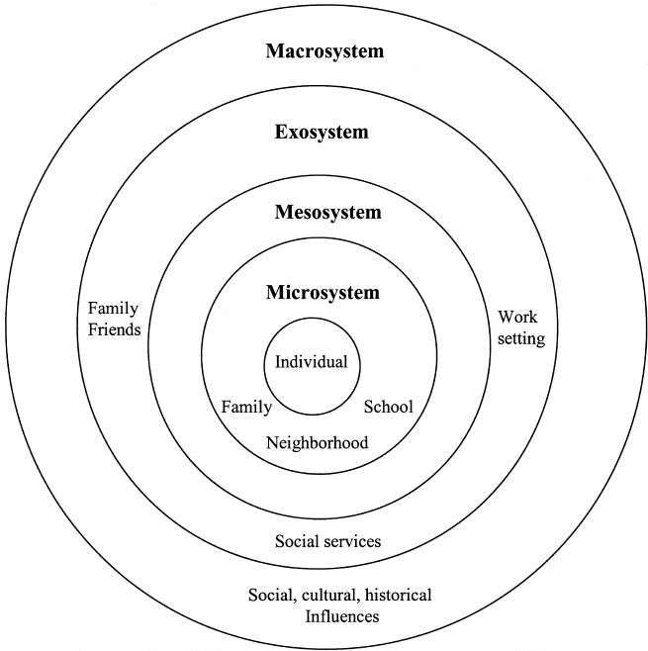
The microsystem is the first level of Bronfenbrenner's theory. It includes parents, siblings, teachers, and school classmates who directly interact with the kid in their local surroundings. In a microsystem, relationships are bidirectional, which means that the kid may be affected by others in their surroundings while simultaneously having the ability to change the beliefs and behaviours of others. Microsystems: Interactions between different microsystems, such as those between a child's parents and teachers or classmates and siblings, are referred to as the mesosystem. According to the ecological systems theory, if a child has a good connection with their teachers and parents, this should positively impact their development; if they don't get along, this could negatively affect them. The exosystem is a component of Urie Bronfenbrenner's ecological systems theory, which he created in the 1970s. Other formal and informal social structures are included, which do not contain the kid directly but indirectly impact them by affecting one of the microsystems.
Neighbourhoods, parent's jobs, parent's friends, and the media are all examples of ecosystems. These are settings where the kid is not engaged and is not part of their experience, but which nevertheless impacts them. If one of the parents had a disagreement with their employer at work, ecosystems might affect the child's development. As a consequence of anything that occurred at work, the parent may return home and have a bad temper with the kid, negatively impacting growth. The macrosystem is a component of Bronfenbrenner's ecological systems theory that focuses on how socioeconomic position, wealth, poverty, and ethnicity influence a child's development.
Therefore, individuals' ideas and perceptions of life events may be influenced by the society entangled. The macrosystem is distinct from the preceding ecosystems. It does not relate to the particular surroundings of a single developing kid but rather to the previously formed society and culture in which the child is growing.
This may also include factors such as financial position, ethnicity, geographic region, and cultural beliefs. A kid growing up in a third-world nation, for example, would develop differently from a youngster growing up in a wealthy one. The chronosystem is Bronfenbrenner's fifth and final stage of ecological systems theory.
This system includes all environmental changes that occur during life and affect development, such as significant life transitions and historical events. Examples are simple life changes, such as beginning school, and non-normative life transitions, such as parents divorcing or needing to move to a new home. (Guy-Evans, 2020)
Vulnerability
There is little consensus on what constitutes childhood vulnerability. Individual traits, the influence of other people's actions or inaction, and the physical and social surroundings may all make a kid susceptible to hazards and bad results. • any harm the child has experienced or may be at risk of experiencing – these can include a specific set of childhood experiences known as "adverse childhood experiences" • the ability of the child's carers and wider family environment to meet the child's needs, or indeed to cause harm – these might include:
• the lack of supporting connections in a child's life; • the broader community and societal circumstances outside the family, such as crime, the built environment, community cohesiveness, and resilience. This is not a comprehensive list, and children may be exposed to one or more of these variables with varying degrees of repercussions throughout their lifetimes, even into adulthood. The term "vulnerable children" is used in this study to refer to any kid who is at risk. Children who are at a higher risk of suffering bodily or mental damage and experiencing because of one or more circumstances in their life have had bad results. Adverse childhood experiences may also be a factor for particular susceptible youngsters. These are a few of a specific set of early events that have been linked to poor long-term consequences. (Gov.UK, 2021)
Safeguarding
Child protection and child safety are two terms that are often used interchangeably.
Regardless of age, handicap, gender reassignment, ethnicity, religion or belief, sex, or sexual orientation, every kid has the right to equal protection from danger.
Children are protected from adults and other children who may be dangerous if appropriate safeguarding rules and procedures are established and followed. Voluntary and community organisations, religious groups, private sector providers, schools, hospitals, and sports clubs are included.
The activity of promoting the wellbeing of children and protecting them from danger is known as safeguarding. Protecting children from abuse and maltreatment; preventing damage to children's health or development; ensuring that children grow up with safe and effective care; and taking action to ensure that all children and young people have the most significant possible results. The safeguarding procedure includes child protection. It focuses on safeguarding specific children recognised as suffering or at risk of experiencing severe harm. This contains child protection protocols, which specify how to react to child safety issues. (NSPCC, 2021)

Recommendation and Conclusion
Everyone's definition of childhood is different, yet we all agree that it is a formative development time. Although it is linked with immaturity, it may also be a period of wonder and curiosity. Childhood is also connected with innocence. We can better nurture children and build a brighter future for all of us if we learn more about them. Know how to raise your kid if you're a parent. If you're an adult, consider how you might assist a troubled kid in your community. We can make a difference if we work together. Significant differences in the conceptions of childhood, adolescence, and youth have been emphasised in this study, both across and within cultures. Such models have an impact on young people's lives because they influence the content and process of learning and development, whether they are expected to go to school or work, their level of social and economic responsibility within the family, when they marry and have children, and how much personal autonomy they have over these decisions. Building on the strengths of the social constructivist childhood model, it is critical to investigate the numerous and diverse variables that influence children's development (biological, socio-cultural, economic and political), which impact the lives of young people in certain situations. To accomplish so, a multidisciplinary strategy is required to advancing our knowledge of young people's autonomy.

References
Christina Bethell, P., 2019. www.contemporarypediatrics.com. [Online]
Available at: https://www.contemporarypediatrics.com/view/positive-childhood-experiences-may-have-greater-impact-bad
[Accessed 03 sept 2021].
Evans, R., 2012. Understanding young people’s right to decide, London: IPPF.
Gov.UK, 2021. https://assets.publishing.service.gov.uk. [Online]
Available at: https://assets.publishing.service.gov.uk/government/uploads/system/uploads/attachment_data/file/913974/Understanding_and_quantifying_vulnerability_in_childhood.pdf
[Accessed 03 sept 2021].
Gov.UK, 2021. www.gov.uk. [Online]
Available at: https://www.gov.uk/child-employment
[Accessed 03 sept 2021].
Guy-Evans, O., 2020. www.simplypsychology.org. [Online]
Available at: https://www.simplypsychology.org/Bronfenbrenner.html
[Accessed 03 sept 2021].
Jay W. Marks, M., 2021. www.medicinenet.com. [Online]
Available at: https://www.medicinenet.com/childhood/definition.htm
[Accessed 03 SEPT 2021].
Kirkpatrick, N., 2021. www.betterhelp.com. [Online]
Available at: https://www.betterhelp.com/advice/childhood/the-best-childhood-synonym-how-to-define-the-meaning-of-childhood/
[Accessed 03 Sept 2021].
merriam-webster.com, 2021. www.merriam-webster.com. [Online]
Available at: https://www.merriam-webster.com/dictionary/childhood#:~:text=1%20%3A%20the%20state%20or%20period,in%20the%20development%20of%20something
[Accessed 03 sept 2021].
Norozi, S. A., 2016. Childhood as a Social Construction. Journal of Educational and Social Research, 6(2).
NSPCC, 2021. https://learning.nspcc.org.uk. [Online]
Available at: https://learning.nspcc.org.uk/safeguarding-child-protection
[Accessed 03 sept 2021].
NSPCC, 2021. www.childline.org.uk. [Online]
Available at: https://www.childline.org.uk/info-advice/bullying-abuse-safety/crime-law/forced-marriage/
[Accessed 03 sept 2021].
ODPHP, 2021. www.healthypeople.gov. [Online]
Available at: https://www.healthypeople.gov/2020/topics-objectives/topic/early-and-middle-childhood#1
[Accessed 03 sept 2021].
Thompson, K., 2015. https://revisesociology.com. [Online]
Available at: https://revisesociology.com/2015/05/06/social-construction-of-childhood/
[Accessed 02 SEPT 2021].

