

MSc INDUSTRY 4.0 ADVANCED MANUFACTURING
RESEARCH METHODS AND PROFESSIONAL DEVELOPMENT
‘Can an Aircraft Interior Cabin OEM effectively engage with and analyse the end consumer on a large scale to find innovative ‘hidden gems’ and take the possibilities for air travel experience to ‘new heights’?’.

STUDENT – GARY ARRELL

SUPERVISOR – GRAHAM HOWE

DATE – 3rd MAY 2022

CONTENTS

Background information and Introduction Pages 3-6

Big Business Page 6

Proposal Aim Explained Pages 6-8

This has worked before!! Pages 8-10

Method Pages 10-11

Limiting Factors and Risks Page 11

Conclusion Pages 11-12

Bibliography and references Page 13

Background Information and Introduction.
In the world of today almost every aspect of ‘life’ as we know it is measured upon one’s personal experience and how one ‘feels’ whilst engaging in the multitude of activities and essential undertakings which pave the way for our own individual journeys through each and every day.
‘Comfort’, ‘Entertainment’, ‘Service’ and even ‘Security’ are some of the words which are of key focus when evaluating any user experience. This could be something as seemingly insignificant as the lighting in a small café we choose to dine in for a quick bite to eat or something as obviously significant as the comfort provided by the seating in the vehicles we spend hours upon hours of our lives driving or travelling in from one destination to another. In any case, there are many different aspects in any single consumer experience which need careful analysis and consideration in order to optimise said experience for the better. Travelling for, which can be in a lot of cases, a substantial length of time tends to be a daunting proposition for many individuals. This is never more prevalent than when travelling through the air tens of thousands of feet above the earth’s surface for a number hours in a vehicle which the vast majority of the global population know very little about, all whilst at the mercy of the individuals piloting this vehicle who are also an unknown entity to those travelling under their expertise and care. Air travel can instil a feeling of uncertainty in many people and this fact alone magnifies the importance of making the entire experience as pleasant and comfortable for the customer as possible.

"I've learned that people will forget what you said, people will forget what you did, but people will never forget how you made them feel." – Maya Angelou [1]

In a previous working role I spent a number of years as part of the design team at ‘Thompson Aero Seating’ in Northern Ireland working on their Innovative Vantage, Vantage Solo and Vantage XL aircraft seating product range for business class cabins. The main objective of this product range was to maximise every inch of cabin space and improve customer experience by facilitating the ability to lie in ‘full-flat bed mode’ during the flight. [7] This approach to maximising customer experience and optimising how cabin space is utilised was welcomed with open arms by multiple airlines. This includes giants of air travel across the globe such as Delta Airlines, Air France, Singapore Airlines, LATAM (Latin-American Airlines) and Lufthansa to name a few. In my present working role I am involved in the design of Aircraft Interior Furniture for ‘Safran Seats’ based in the United Kingdom. I am currently part of a design team working on a first class cabin suite for a fleet of Japanese Airlines, Airbus A350-1000 Aircraft. From my own experiences working in the world of Aircraft Interiors development, it is clear to me that there is a constant and continuous open innovation and co-creation mentality between airlines, aircraft manufacturers and other ‘original equipment manufacturers’ (OEMs) such as ‘Thompson Aero Seating’ and ‘Safran Seats’, when working together on various different projects. The reason for this is the insatiable desire within these organisations to continue to Innovate in order to improve global air travel and, within that, to maximise the positive aspects of this experience for the end consumers I.E the individuals travelling on their airlines whilst utilising the products they manufacture. All of this is, of course, done with the primary aim to surpass their competitors and improve their products’ popularity, and ultimately overall organisational profitability.
This research activity will aim to identify something entirely new and innovative which has not yet been considered by Aircraft Interior OEMs. It aims to find something that will improve the consumer experience whilst travelling with airlines who opt to use them as the supplier of choice for their interior Cabin furniture. It will aim to look at the terms ‘open innovation’ and ‘co creation’ in a new light in this area by initiating an aggressive campaign with new and unprecedented levels of consumer engagement and consumer data analytics, in the hope of finding a ‘hidden gem’ which sparks a never before seen and exciting innovation in the world of aircraft interior manufacturing. As I am working for this company and as they are a globally recognised enterprise in the world of Aircraft Interiors, this research proposal is written with the aim to be undertaken by ‘Safran Seats’ UK. There have been studies carried out in the past on the importance of the various elements of the ‘in flight’ experience for the consumer, or passenger as it is in this case. These studies were done on a much smaller scale than that of which I intend to try and implement for this particular research exercise. In one such study this started with retrospective interviews and brainstorming sessions. More than 10 graduate students and professors from the Florida Institute of Technology were asked to recall and brainstorm on all their inflight activities. A total of 23 activities were elicited from these interviews and brainstorming sessions. To study satisfaction rate from performing these activities, as well as the importance of these activities in flight situations, a 26-question survey was designed and setup online, with a total of 93 respondents. There was no limitation for the respondents’ demography. The only requirement for the survey was that the respondents had flown at least one long haul flight, i.e. more than 6 hours. Diversity of demographics was taken into account. Out of the 93 respondents, 53.3% were male and 46.7% female. Also, different age groups took part in the study ranging from 20 years old to 83 years old. Respondents were asked to rate their perception of “how important” different activities during flying were to them. In the next question they were also asked to rate “how satisfied” they were while performing those inflight activities. The answers for both questions ranged from 1 to 5 which in the first question was equivalent to “not at all important” to “extremely important” and for the latter one from “not at all satisfied” to “extremely satisfied.” [8] The results of this study were documented and are outlined in ‘figure 1’ and ‘figure 2’ respectively as shown below.

Figure 1
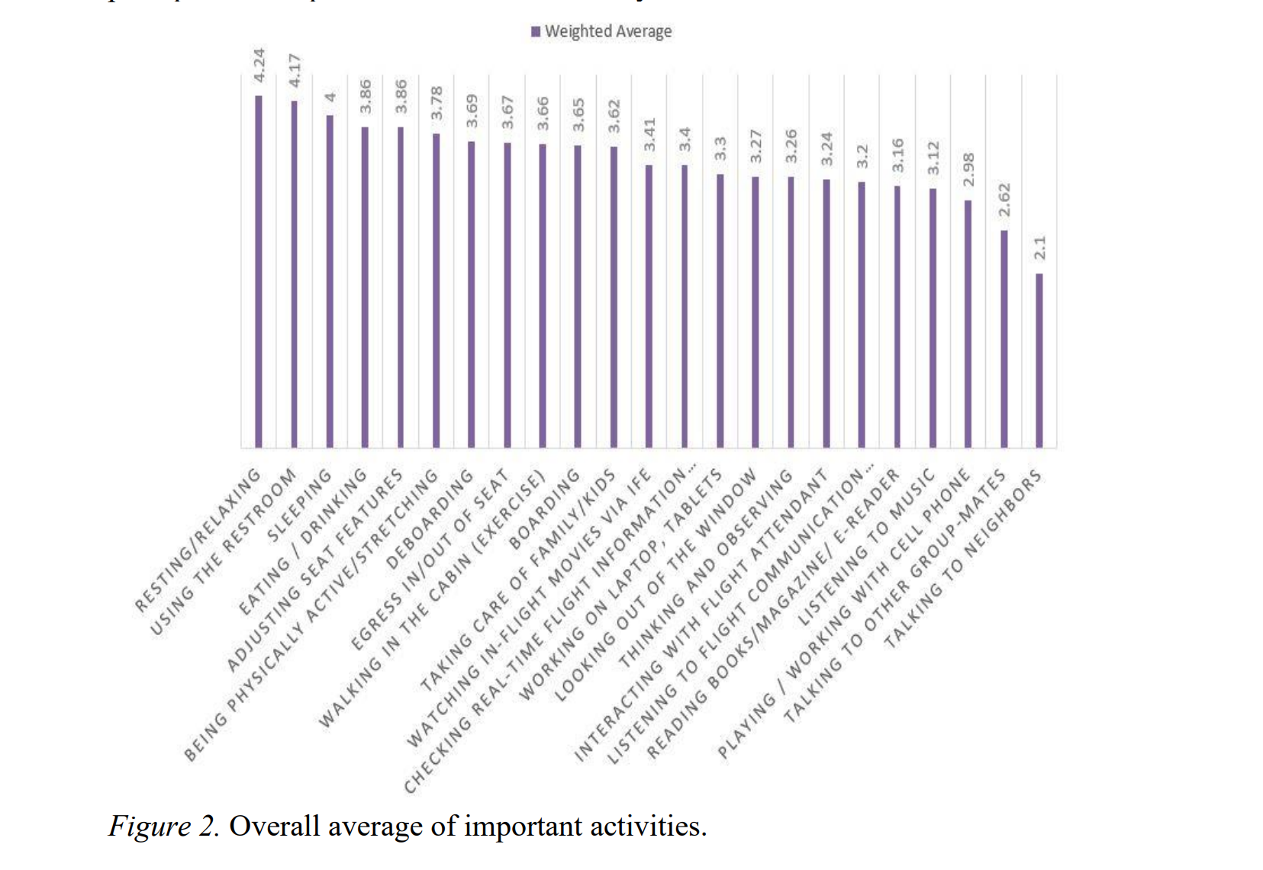
Figure 2
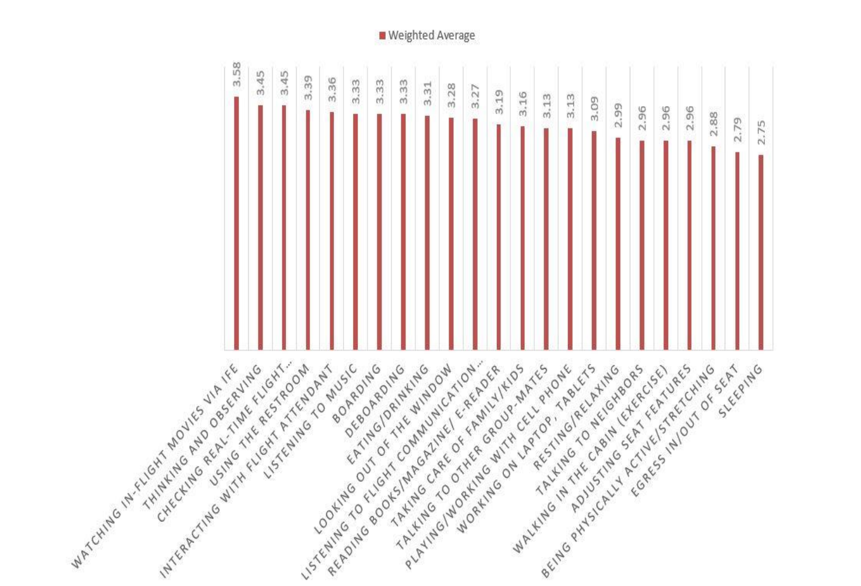

The research activity I am proposing Is not entirely similar to this as it is not a satisfaction survey of innovations and services which already exist, but rather a means of finding a new innovation or in-flight service which could in turn improve and widen the possibilities of the passenger’s experience in one of the areas highlighted within this particular, previously undertaken study. I therefore feel it feasible to include this information as perhaps an indicator of potential areas of investigation or topics of debate to be initiated with the consumer for this new research activity.

Big Business
According to the Boeing Commercial Market outlook and Airbus Market forecast, 2019, it is anticipated that in the next decade the overall global demand for air travel will increase significantly. It is estimated that around 200 million people worldwide are expected to enter the ‘middle class’, thus facilitating the growth of the market for aircraft interior cabins manufacture.
The Global Aircraft Cabin Interior Market Size was USD 27.06 billion in the year 2019, exhibiting a CAGR of 11.8% during the forecast period [2020-2027] [2]
In North America alone the market size was 9.08 billion in 2019. This was then unfortunately adversely affected by the Coronavirus Pandemic but is forecast to make a steady recovery and to have progressed substantially by the year 2027. [2] This is outlined in ‘figure 3’ below.

Figure 3
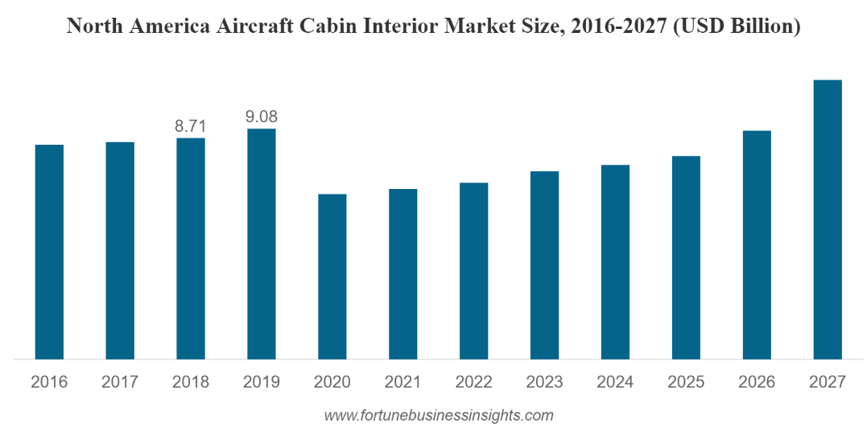

The reason for highlighting these figures is to give an idea of the current size of the market and the potential for growth in order to underline the paramount importance for rival OEMS to constantly endeavour to find Innovative ideas which sets them apart from their competitors and thus increase their potential share of the profits in this very substantial market place. This is simply some information to draw emphasis to the fact that Aircraft interior Cabin manufacturing sector is ‘Big Business’ before I proceed to outline this research proposal in greater depth.

Proposal Aim Explained
The aim of this proposal is quite simply to answer the question denoted in the title of this article:
‘Can an Aircraft Interior Cabin OEM effectively engage with the end consumer on a large scale to find innovative ‘hidden gems’ and take the possibilities for air travel experience to ‘new heights’?
Is it really possible and feasible that an OEM such as Safran Seats can engage with the consumer with an approach so focussed upon ‘open innovation’ and ‘co creation’ that a new, predominantly consumer driven, innovative idea can be implemented in a future aircraft cabin interior design?
I feel that it is important to give clarity on precisely what we are, but also what we are not, trying to achieve with this research activity. I recently watched a very interesting and informative video on innovative materials and methodologies within the aircraft interiors manufacturing sector. In this video five experts in their fields collaborated in order to discuss and document some of the current ongoing innovations and improvements within their own areas of expertise. For example, Samantha Bunyan from ‘Cecence’ explained some of the new composite material processes and methodologies being explored to reduce weight primarily on panels for the ‘seat back’ on aircraft seating and Roland Gerhards from ‘ZAL Centre of applied aeronautical research’ spoke about trialling hydrogen fuel alternatives and how material science and selection could help reduce noise by mitigating vibration etc. [5]These are all areas of study which are ongoing worldwide by various experts who are best qualified to do so with creating a ‘greener’ environment at the epicentre of all new ideas and innovations. The aim of this research is not to delve into things to this depth or level of understanding but more to ‘open up the floor’ to a large number of consumers and see if their input can spark a new idea which will then be pursued by the relevant experts within the industry taking all of the aforementioned factors into consideration.
Is there something that all the experts in their respective fields are missing due to focussing on optimising the technology, services and processes which already exist?
Can a great new idea be sparked by gathering data from relevant sources and asking a large number of consumers to share their ideas?
What does the consumer think would set one Aircraft Interior OEM above all the rest?
Is there a ‘hidden gem’ to be added to the consumer’s in flight experience?
I have often given these questions a lot of thought. Having several young children myself I find myself drawn to the ‘parent and baby’ situation on a lot of airlines/aircraft whereby the parent is either expected to pay for a seat or have their child sit on their lap for the duration of the flight, which In many cases can be for quite a number of hours. Is there something in that which would spark an Aircraft interior OEM marketing campaign to focus on a parent and child friendly in flight experience? Is there a way of integrating designated areas on aircraft for this? Is there value in doing so?
Another idea I have often thought of is what if other services were offered in business class and first class cabins. A relaxing head massage to relieve stress of an extremely busy individual flying from one side of the world to the other for a business meeting? Or perhaps the option for some simple beauty treatments during long haul flights for individuals on a tight schedule who won’t have the time to do so when they land? Are these things an Interior Cabin OEM could facilitate in their furniture design and something they could pioneer? Could cabin crew be upskilled to enable them to provide certain services? Is there much, much more opportunity for in-flight service to drastically improve the overall in-flight experience for the consumer?
These seem like fairly far-fetched ideas and there may be too many limiting factors to ever deem any of them feasible. But my point is that this is just one person ‘thinking out loud’. What ideas could be generated from a mass analysis of the thoughts of thousands or even millions of consumers who fly, in many cases, on a much more regular basis than myself? Is there something simple that could transform the in-flight experience that many people are aware of and the issue has just never been ‘brought to the table’ or to the attention of those with the necessary capabilities to address it?
The fact of the matter is that I don’t know the answer to this and I don’t think anyone can honestly and definitively say they do either until this option is explored by carrying out the research on this scale.
In actual fact, all be it not within the Aircraft Interiors Sector, this approach has been adopted before by a large enterprise and the results of the research identified issues and ideas which lead to a massive company campaign with a very successful and lucrative outcome. This research model is similar to the one I am proposing and is, in fact, where my research project idea originates from.

This has worked before!!
Before I explain how this approach to research has been successfully implemented in the past I feel it is important to outline the definition of two particular ideologies.
Co Creation.
Co-creation, or co-creativity, is the practice of collaborating directly as peers in the design and development of an innovation with a traditionally external group such as: fans, customers, suppliers or employees (outside of their job scope). Simply put – it’s when an organization brings in a group that they do not normally collaborate with, and they work effectively together to create something awesome! [9].This is an ideology which is already very prominent within aircraft interiors manufacture with various suppliers etc. working together to create various aspects of the the finished product in many cases. The question this research aims to get an answer to is whether or not there can be a co creation with heavy consumer involvement in this industry? And if so, to what extent? What new innovation can consumer input possibly spark amongst the experts within this industry?
Netnography
Netnography is a specific approach to conducting ethnography on the internet. It is a qualitative, interpretive research methodology that adapts traditional ethnographic techniques to the study of social media. Netnography adds specific practices that include locating communities and topics, narrowing data, handling large digital datasets, analysing digitally contextualized data, and navigating difficult online ethical matters and research procedures. The nature of researcher immersion and ethnographic (or “netnographic”) participation is also treated rigorously within netnography. The new approach has gained wide acceptance within business research and is spreading to other fields. [6] .

Nivea Black and White Campaign
Nivea is the best-known brand of the multinational skin care corporation Beiersdorf based in Hamburg, Germany. The company is a worldwide research and development leader in the area of skin care. Innovation efforts at Nivea have long been predominantly technology-driven harnessing superior internal R&D capabilities. Even though open innovation is not a new concept to Nivea consumers had not been incorporated as co-creation partners in open innovation activities until recently. In the last few years Nivea has recognized consumers as valuable sources of innovation. In order to integrate the consumers’ voice beyond traditional market research techniques like concept tests or focus groups, the Nivea Deodorant and Antiperspirant Division instituted a holistic co-creation approach with users in the fuzzy front end of innovation. They embraced consumers in two ways. Firstly, they analysed social media and online communities using the netnography as their go to method for qualitative research. Secondly, they performed an online co creation study for the selection and enrichment of ideas.
A team of researchers and designers started the netnography on ‘Deodorant and Antiperspirant Staining’ with a creative session to uncover potential search fields, topics and analogue markets. Additionally, an initial set of keywords and phrases was conceived which was continuously developed and refined in the course of the subsequent identification and selection of social media sources. Starting out with a broad search, more than 200 social media sites in three languages were screened covering all kinds of online ‘consumer tribes’. In addition to general search engines and specific search tools designed to explore social media and user-generated content the search also utilized an extensive internal database containing communities, forums, blogs, advice portals, UGC platforms, question & answer sites and social networks. Apart from social media sites on cosmetics, health, beauty, lifestyle, fashion, sports and do-it-yourself, relevant consumer statements were also identified in conversations revolving around bodybuilding or wedding preparations, in which users have extreme needs and take enormous efforts when they prepare themselves for a competition or the day of their wedding. Applying qualitative as well as quantitative selection criteria, e.g. the size and activity of communities or the quality of the conversations, the most relevant and insightful communities were observed and analysed in-depth. In a next step threads of consumer conversations were retrieved from the social media sites and observed. Using software for qualitative data analysis the content was then systematically analysed and clustered into different topics. [3]
Without going into a great deal more detail and in order to not lose focus on the research proposal at hand we summarise as follows:
Nivea’s Co creation campaign, powered by the use of netnography and a keen desire to create a consumer driven innovation, identified the requirement to address the problems associated with the different types of stains caused by their previous products. This then lead to the innovation of Nivea Black and white. This is a successful, innovative product known world-wide which needs no further explanation and the financial gain for the company as a whole entirely justified the methodology used throughout the entire campaign. I would like to draw attention to the fact that at the beginning of this campaign, Nivea as a business did not know if investigation of and engagement with the consumer on such a large scale would find an innovative ‘hidden gem’ which would justify the efforts of the campaign. Needless to say the campaign was a massive and resounding success and it is for this reason that I would like to see If the same methodology applied in a different industry, aircraft interiors design in this case, could produce a result or innovation of similar notable significance. With that said and at the forefront of our minds, I now proceed to outline the intended method for this particular research proposal. I encourage you to draw parallels and ponder the idea of what way this applied methodology could be of benefit to the industry being addressed in this instance.
“Make the customer the hero of your story.” – Ann Handley [4]
Method
In the first instance a number of subject matter experts will need to meet and collate ideas of potential search fields and what forms of social media and online resources will be appropriate to begin using netnography to collect and analyse already pre-existing and continuously expanding sets of data. A number of keywords relating to the subject will need to be identified and included in these extensive online searches. Travel forums, user reviews detailing in-flight experiences and anything in relation to air travel will be a good place to start. Personal social media sites will also be a good place to search key or ‘buzz’ words relating to the topic of aircraft interior cabin improvement ideas and overall in-flight experience improvement topics. In order to successfully get such a large scale research campaign underway the company pioneering the research (in this case Safran Seats is the company the proposal is aimed toward) will need to employ the services of an enterprise with the relevant expertise to search for and collate the online data being mentioned as a starting point. There are many of these big data analytics companies now in the world of today and they are not hard to find. A list of just some which exist are below and judging by consumer reviews each one would serve as a highly capable partner for data mining and the analysis and interpretation of large sets of said data.
SAP
Accenture Analytics
Tableau
Qlik
Fractal Analytics
Manthan
Oracle
Alteryx
Tiger Analytics
Mu Sigma Analytics
Once this initial set of data has been gathered it will then need analysed using the software provided by one of these companies with the relevant expertise to do so. The aim of this will be to spot any recurring topics, ideas or issues which could identify a trend which sparks the idea for a brand new innovation. There may even be something a lot more obvious than a ‘trend’ identified using ‘buzz’ words in that a great idea could have been blatantly and definitively mentioned on a number of occasions but has just not yet been brought to the attention of those who truly understand its’ value. This is the precise reason for carrying out this research, for the chance to find a ‘hidden gem’ which is currently being overlooked, or to spot a trend in consumer feedback which highlights an area requiring attention which could in turn lead to the beginning of a brand new innovation which could potentially set this aircraft interior cabin manufacturer one step ahead of its competitors.
In parallel to big data analytics using netnography, an aggressive consumer engagement campaign should commence. Specific questions will be put out to consumer focal groups and online in a multitude of different platforms giving the consumers a voice in order to try and find that one special innovation or idea that just hasn’t yet been thought of!
I have considered alternative ways to approach this research proposal. However, as this is a unique methodology and is based on that used in another companies research model, I have concluded that using netnography and a co-creative, open innovation orientated approach to extracting information and data from the relevant consumer focal groups is the best, and perhaps only way to approach this.

Limiting Factors and Risks
There are a few things which need to be considered when planning to implement this research activity. As with any project the cost must be taken into account. Employing a data analytics specialist for a project of this magnitude will be expensive. Is this a justified expense or a risk too far for something which has no certain, positive outcome and reward?
Is there enough data in relevant subject areas online to perform searches of this nature and obtain enough information to analyse effectively? Is there enough interest in the subject area online to gather and collate enough useful data to support the research proposal?
Are consumers interested in the subject area enough to participate in online research workshops and take the time to put forward ideas for Aircraft Cabin interior OEMs analysis?
Conclusion
Aircraft interior Cabin manufacture is big business with huge potential for profit as detailed at the beginning of this proposal. There are multiple global players in the industry continuously trying to out-do one another to find a new innovation which sets them apart from their competitors.
Netnography, co creation and a consumer orientated open innovation approach to research has worked before in finding extremely successful new innovations for businesses in other sectors. The aim of this research proposal is to convince the aircraft interior OEM that this is a project worth under taking, I believe it is. It is not a project with a guaranteed positive outcome and could become more of a ‘lessons learnt’ exercise if the desired results are not yielded from the research in order to carry forward and implement a new innovation. But this is a new approach and with anything new there will always be a risk of it not providing the desired results. This research would need to be carried out as per the method outlined for us to truly know: ‘Can an Aircraft Interior Cabin OEM effectively engage with and analyse the end consumer on a large scale to find innovative ‘hidden gems’ and take the possibilities for air travel experience to ‘new heights’?’
“Innovation needs to be part of your culture. Customers are transforming faster than we are, and if we don’t catch up, we’re in trouble.” – Ian Schafer [1]

Bibliography and References

[1] 101 Of The Best Customer Experience Quotes (forbes.com)

[2] Aircraft Cabin Interior Market Size, Share | Forecast [2020-2027] (fortunebusinessinsights.com)

[3] Bilgram, V., Bartl, M. and Biel, S., 2011. Getting closer to the consumer–how Nivea co-creates new products. Marketing Review St. Gallen, 28(1), pp.34-40.

[4] Favre, C.C., 2017. The Small2Mighty tourism academy: Growing business to grow women as a transformative strategy for emerging destinations. Worldwide Hospitality and Tourism Themes.

[5]Innovative materials and methodologies - Aircraft Interiors Expo (aerocontact.com)

[6] Kozinets, R.V., 2015. Netnography: redefined. Sage

[7] Thompson Aero | Intelligent Design

[8] Torkashvand, G., Stephane, L. and Vink, P., 2019. Aircraft interior design and satisfaction for different activities; a new approach toward understanding passenger experience. International Journal of Aviation, Aeronautics, and Aerospace, 6(2), p.5.

[9] What is co-creation? | Chaordix

