
communication in the workplace
Assessment 2

June 25, 2021
University of Wales Trinity Saint David

Samina Ibrahim 2021565
UWTSD
25th June 2021
Word count: 2154 (excluding executive summary, references and appendices)

Executive Summary

The primary goal of this report is looking at the different models of teamwork theories such as Meredith Belbin and Bruce Tuckman. These theories help teamwork in the any organisation and here it will be linked to the case study ABC technology.
Alongside this, it will then go on to the different communication models. The Shanonn and Weaver communication model, the Schramm Model and the The Source-Message-Channel-Receiver (SMCR) communication framework by David Berlo. These models will be found in the appendices. Furthermore, the report will examine effective virtual communication and why team work is vital in any organisation.
Lastly, recommendations and references will be provided.

Table of Contents
Executive Summary 1
Terms of Reference 3
Procedure 3
Introduction 3
Findings 4
Conclusion 7
Recommendations 7
Bibliography/References 8
Appendices 10
Acknowledgements 13

Terms of Reference

This report has been requested by Melanie Squire, Lecturer at University of Wales Trinity Saint David, June 2021.
This report will cover the understanding of the skills and communication on how all employees of the teams can participate in a workshop to learn and ensure effective teamwork skills are in order to encourage and ensure greater communication and teamwork in the two groups, which have been stated in the case study of ABC technology.
Theories such as Tuckman and Belbin will also be taken into account within this report as they both demonstrate how to improve teamwork within an organisation.
In addition, an explanation and the importance of two-way communication relevant to the case study scenario using the theoretical communication models taught on the course to illustrate the compelling points.
Lastly, looking at why effective virtual communication and team working is important and why effective communication is important for the continued success of the organisation, specific to the case study of ABC Technology.

Procedure
In order to write this report, reflective journals, and academic books, journals from the University library, websites, and Internet searches will be used to complete this assignment. The information collected will then be established in the references.

Introduction
This report will give an insight to ABC Technology, including the relevant teamwork theories of Tuckman and Belbin and how they can be used to focus on improving teamwork in the company described in the case. As well we theories, the report will also focus on communication, conflict management and specifically on the communication theories by Berlo, Shannon and Weaver and Schramm. The report will also focus on demonstrating the significance of two-way communication and why verbal and nonverbal communications are critical in the study case of ABC Technology.

Findings
Area 1
Tuckman's model emphasizes on how a team approaches an activity, from the creation of the team to the execution of the task. Tuckman's theory is especially applicable to performance relationship challenges because the stages relate to the accomplishment of the project initiated by a team. Here, stages are described by Bruce Tuckman's Forming, Storming, Norming, and Performing model. When you understand Tuckman's model, you'll be able to assist your team in becoming more successful – quicker. These phases are all appropriate and unavoidable for a team to grow, face obstacles, deal with problems, seek solutions, plan work, and produce results. For every stage has a distinct focus, corresponding to a distinct set of ideas, perceptions, and group activities. Making people mindful of the stages and why things turn out the way they do. Obtaining a method for knowing and assessing the reasons of change in the team's behaviour can assist the team in optimising its methodology and performance. This is particularly evident when the Tuckman analysis is used as a starting point for discussion rather than a stabilised prognosis.
The Forming stage, the group is created, and everyone performs admirably. There is a pleasant and courteous atmosphere. Since functions and tasks are not yet clearly established, the team leader must provide strong leadership. The Storming stage starts growing limitations which are challenged, resulting in conflicts. Also widely known is dissatisfaction with the lack of progress. Here, the coordinator requires direction.
Team members begin to work out their dissimilarities, recognise the strong points of their colleagues, and honour the leader's jurisdiction. When new tasks arise, actions from the storming and norming stages may coincide for some time. At the performing stage, dedication falls in line with pride in the team's progress. Team attitude makes team roles more dynamic, and the team leader can assign more tasks. Risks can be mitigated or solved as they arise. Lastly, at the adjourning, once all phases are finished, it is critical to recognise the team's accomplishments. After lengthy stretches of intensive teamwork, letting go of the group structure can raise doubts for teams and individuals.
Dr Meredith Belbin studied team-work for many years, and he famously observed that people in teams tend to assume different "team roles." He defined a team role as "a tendency to behave, contribute and interrelate with others in a particular way" and named nine such team roles that underlie team success. (Mindtools, 2021)
Belbin proposes that by recognising your role within a specific team, you can grow your skills and knowledge base your flaws as a group member, thereby improving your contribution to the organization. The Belbin model is frequently used by team organizations and community research scholars to actually build more organized teams. According to Belbin's team role theory, when a team is more balanced in terms of the spread of naturally occurring team roles, it tends to be high performing. (Senaratne and Gunawardane,2013 P. 15) This is can help improve teamwork within ABC technology.

Belbin recognised nine Team Roles which are, Resource Investigator, Team worker and Co-ordinator (the Social roles); Plant, Monitor Evaluator and Specialist (the Thinking roles), and Shaper, Implementer and Completer Finisher (the Action or Task roles). The model's goal is not merely to classify people into discrete roles, but to provide a framework for improving performance level.
This can be accomplished by finding flaws, emigrating the responsibilities of individuals who have copy responsibilities, or utilising complementary roles to enhance team's success. The results can then be used to ensure that every team has the right mix of roles and competencies. The framework can be used at a 'team building day,' where teammates are classified into profiles while performing a fun task. The ABC case study can reflect on having effective teamwork as an excellent way to get results. There is something very effective about attaching a group of individuals to be on the same page, and all collaborating for one ultimate goal.

Area 2
Following on, the importance of two ways communication in the case study of ABC Technology can be efficient in communication as it’s important because it allows for feedback to help improve a situation.
The Source-Message-Channel-Receiver (SMCR) communication framework was designed by David Berlo in 1960. Berlo's style is different in that it presents a comprehensive account of the core components in each step that will impact how well the message is communicated. The first element of Sender is the message's creator or the person who sends the message, A Message is the element that the sender sends to the receiver. It may be in the form of voice, audio, text, video, or another form of media. The medium through which the message is transmitted is referred to as the channel. Technical machines, such as telephones and the internet, can be used as channels in mass communication and other forms of communication. However, the five senses of a human being serve as a channel for information exchange, and the viability of the channel is affected. Lastly, the person who receives the message sent during the process is referred to as the receiver. This model believes that the thinking pattern and all other factors mentioned above must be in sync to that of the sender for the communication to be effective. (Businesstopia in communication ,2018)
The Shannon and Weaver Model of Communication is a mathematical communication theory. The model by Shannon-Weaver was created specifically to foster effective communication between sender and receiver. They also discover "Noise" factors that affect the communication process. Initially, the model was designed to improve technical communication. Subsequently, it became widely used in the field of communication.
As a result, the sender encodes the message and sends it to the sender via a channel. There is physical noise passing through that channel, which can interact with message reception. The receiver decodes the message after it has passed through the channel in attempt to comprehend it. Each of those concepts are defined as follows by Reuben and Stewart (2006)
The Schramm Communication Model is a cyclical communication model that includes all basic communication principles. The Schramm Communication Model provides a traditional approach and clarification to communication. It can be used to assess how two people communicate when they share information, thoughts, or behaviours. Characteristics of effective communication, without knowledge cannot circulate among two people. This could also assist ABC technology team in connecting and communicating in order to prevent future problems. The Schramm model is considered the theories of domain of perception, a similarity between the two communicators that facilitates communication. This makes this quite unique.

Why effective teamwork is important.
In simple terms defining effective communication can be referring to the process of sharing ideas, thoughts, knowledge, and information in order to achieve the goal or desire in the best of ways. In a nutshell, it is the recipient's demonstration of views in a way that the receiver can understand. Companies can miss important opportunities to grow and expand their business when there is poor communication in the workplace. (Gutierez, A 2014 pg 5)
Teamwork can be likened to two compounds, almost essential to modern life. It’s the glue which keeps a team together, a bond which promotes strength, unity, reliability and support (The Happy-Manager, 2021)
Teamwork, when handled correctly, maximises strengths and brings out the best in each group members. These specific, possibly one-of-a-kind independent attributes are then supplemented by the qualities of others or the team as a whole. UK entrepreneur, Richard Branson, mentions, what matters is working with a few close friends, people you respect, knowing that if times did turn bad these people would hold together. (The Happy-Manager, 2021)
Albert Einstein is credited with inventing the theory of relativity, but the reality of the situation seems to be that he refined his idea through discussions with friends and co workers. This is most often the case. “Every genius has a team,” Murphy says. “When people build on each other's skills and knowledge, they can create practical and useful solutions.” (Middleton, 2019)

Why effective virtual communication and team working is important?
Within a virtual team, effective communication is essential. Communication that is direct and clear will not only help you avoid confusions, but it will also boost your successfulness. Different communication challenges are presented by methods such as Skype, Microsoft Teams, Slack, Zoom, and other virtual meeting channels.
The global virtual team is intended to provide an organisation with flexibility and adaptability, whilst reducing overheads and costs through improved resource utilisation (Jarvenpaa and Leidner, 1999) while the global virtual team's intentions are admirable, the teams also include a higher dimension than co-located teams. It is not enough to simply deliver a message; it must also serve the sender's purpose. Bear this in mind; let us look at the factors that contribute to effective communication. Firstly, the message that the sender wishes to convey must be simple, easy to understand, and systematically framed. The most crucial skill in a person is that they must be a good, alert and patient listener. Communicating effectively is always a two-way street. A person must both receive and give feedback in order to understand the other person's point of view.
Digital transformation in personal and professional lives has found the change to working remotely relatively easy for many workers. Smoother and more widely available Wi-Fi, as well as simple cloud systems, enables virtual team tools like Slack to bring 'The Office' almost anywhere and you take your laptop. (Shields, 2018)
In the case study dispersed teams are more likely to have members from different cultures, backgrounds, and experiences (Hill, Bartol, Vol. 60, No. 1)
Virtual teams depend on having appropriate communication technology to connect and support the members in ways that develop trust. (Business Horizons Volume 60, Issue 1, 2017, Pg 25) Common scenarios reflect technological issues that might gradually improve face-to-face teams but may deliver virtual teams to a halt. The team cannot be effective if it is unable to obtain the information it requir

Conclusion
In conclusion, ABC technology has stated that communication had broken down, due to conflict with the two teams. As per the report, theories have referred to individuals and groups. Belbin works on the theory focusing on individuals and Tuckman focusing on groups. Both these are crucial to a team’s life cycle.
The report also shows different communication models and how each of them is effective in their own way. Theoretical framework and the theories explain the manner in which to communicate.
Effective teamwork has also been a relevant part in this report, as with this collaboration brings out the paramount in team members by maximising their character strengths.

Recommendations
There are many things that should be taken into account from the findings of this report. One of these can be providing regular team rewards. This can be praised for training valuable skills and abilities. Also team building plays an important factor, this can help employees to learn from one another and gain new skills. Teamwork improves problem-solving, developing strategies, and decision-making strengths. Furthermore, communication is key, as it’s not only about assisting and meeting needs, but it also assists in connecting with the other people.

Bibliography/References

- Anttiroiko, A.-V. & Savolainen, R. (2011). Towards Library 2.0: The adoption of Web 2.0 technologies in public libraries. Libri: International Journal of Libraries & Information Services, 61(2), 87-99.
- Belbin, R. M. (2004). Management teams: Why they succeed or fail, Oxford: Butterworth-Heinemann publications, (2004 – Republication of 1981) [Google Scholar]
- Belbin, R. M. (2004). Management teams: Why they succeed or fail, Oxford: Butterworth-Heinemann publications, (2004 – Republication of 1981) [Google Scholar]
- Belbin, (2021) Belbin Team Roles Available at: https://www.belbin.com/about/belbin-team-roles (Accessed : 16th June 2021)
- Business Horizons Volume 60, Issue 1, January–February 2017, Pages 25-34

- Business Topia (2018) Berlo communication model Available at (https://www.businesstopia.net/communication/berlo-model-communication. Accessed on: 20th June 2021
- CommunicationTheory.org (2010). Shannon and Weaver Model of Communication. Communication Theory. Available at: http://communicationtheory.org/shannon-and-weaver-model-of-communication/ Accessed on: 21st June 2021

- Effective Communication in the Workplace

- Hill, S N, Bartol, K, 2018 Vol. 60, No. 1 Five ways to improve communications in Virtual Teams
- Jarvenpaa SL, Leidner LE (1999) Communication and trust in global virtual teams. 10(6):791–815

- Gutierez,A, (2014 )Learn How to Communicate Effectively and Avoid Common Barriers to Effective Communication Available at : https://www.mindtools.com/pages/article/newLDR_83.htm . Accessed on 21st June 2021

- Reuben, B. D., & Steward, L. P. (2006). Communication of human Behavior (5th ed). Boston: Pearson
- Sheilds, T (2018), Why are virtual teams important? Available at : https://blog.logicearth.com/why-are-virtual-teams-important. Accessed on: 22nd June 2021

- Senaratne, & Gunawardane, S (2012) Application of team role theory to construction design teams

- Strategies for building effective virtual teams: Trust is key Business Horizons (2017) Volume 60, Issue 1

Appendices

Include related support information eg. Charts, questionnaires etc.

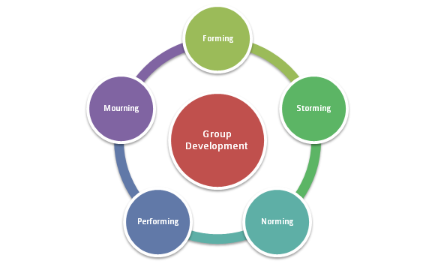 http://www.mspguide.org/tool/tuckman-forming-norming-storming-performing
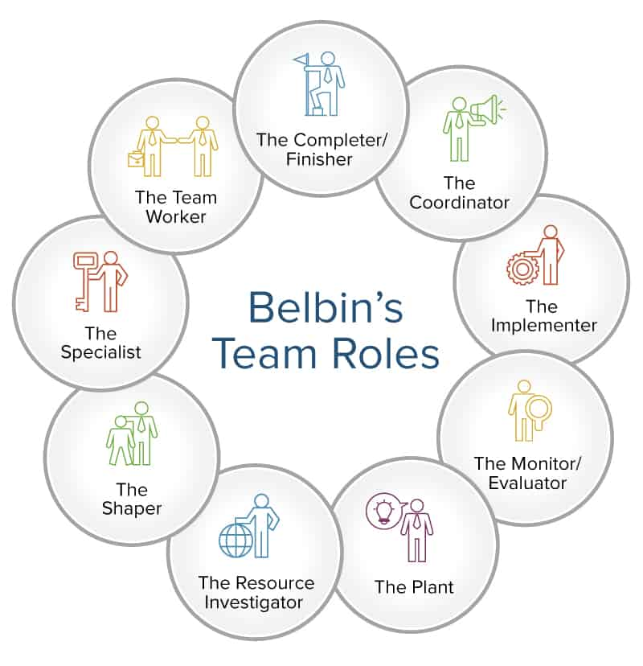
https://www.smartsheet.com/how-to-use-team-roles-to-boost-performance

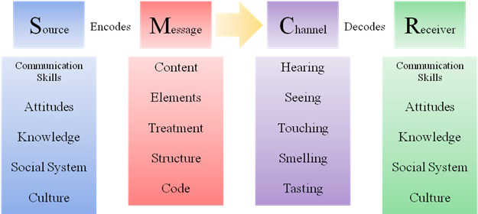

http://jayaseelansr.blogspot.com/2017/07/david-berlos-model-of-communication.html

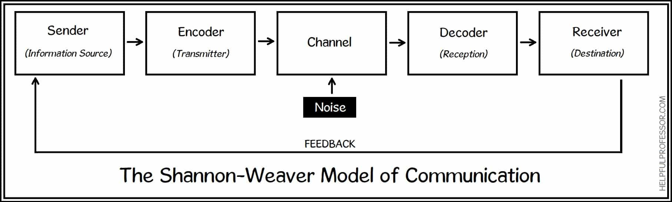
https://helpfulprofessor.com/shannon-weaver-model/

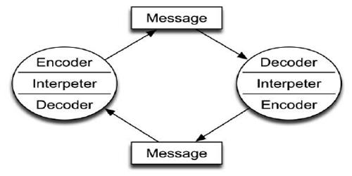

https://qsstudy.com/business-studies/schramms-model-communication

Acknowledgements

A big thank you to lecturer Melanie Squires who has taught our group now for two semesters. This has been a real delight. Alongside this to the fellow students in the class who have always helped where they can.
Also, having a lesson on how to use the University’s library recently has really helped. This has refreshed the mind and we have been able to pick up some more ways to research and explore further avenues.

