DS 1 Template – Leticia E Mota ID2544839

Screenshot/Photo 1
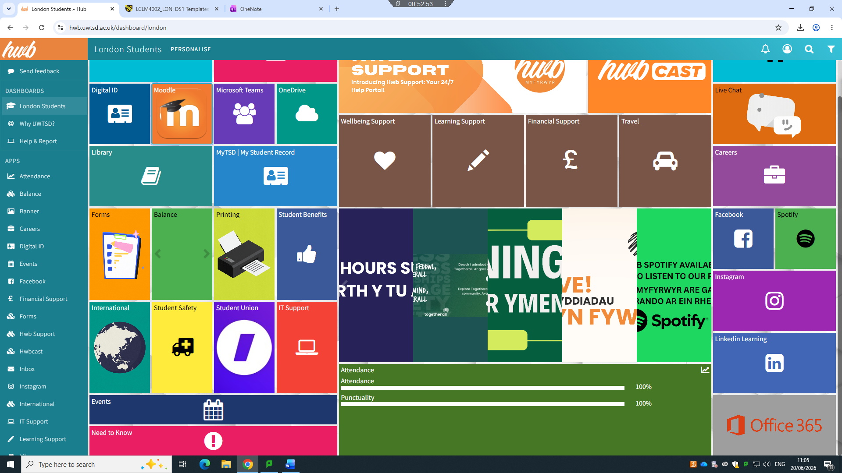
This is the main page of the University App.

Screenshot/Photo 2
[Insert Photo/Screenshot below]
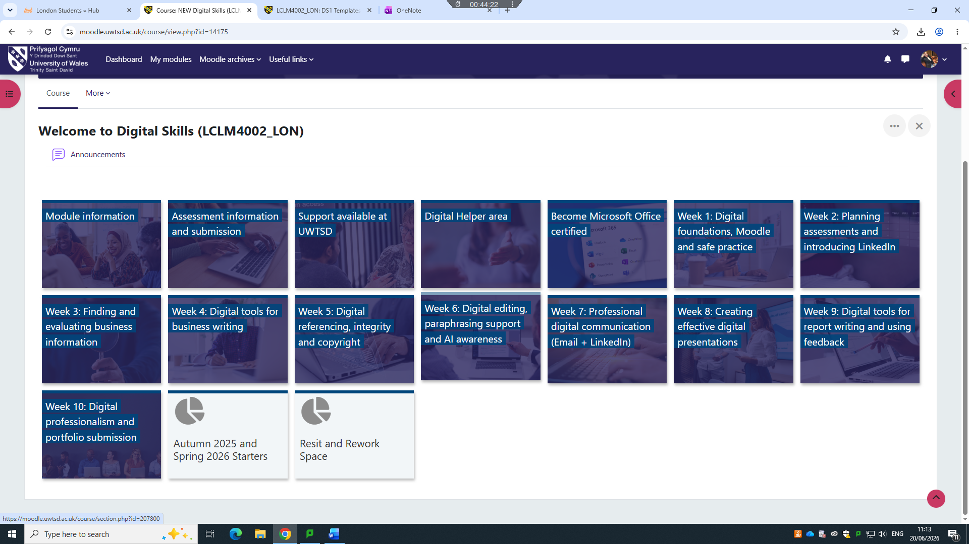
Here is the my Digital skills Moodle.

Screenshot/Photo 3
[Insert Photo/Screenshot below]
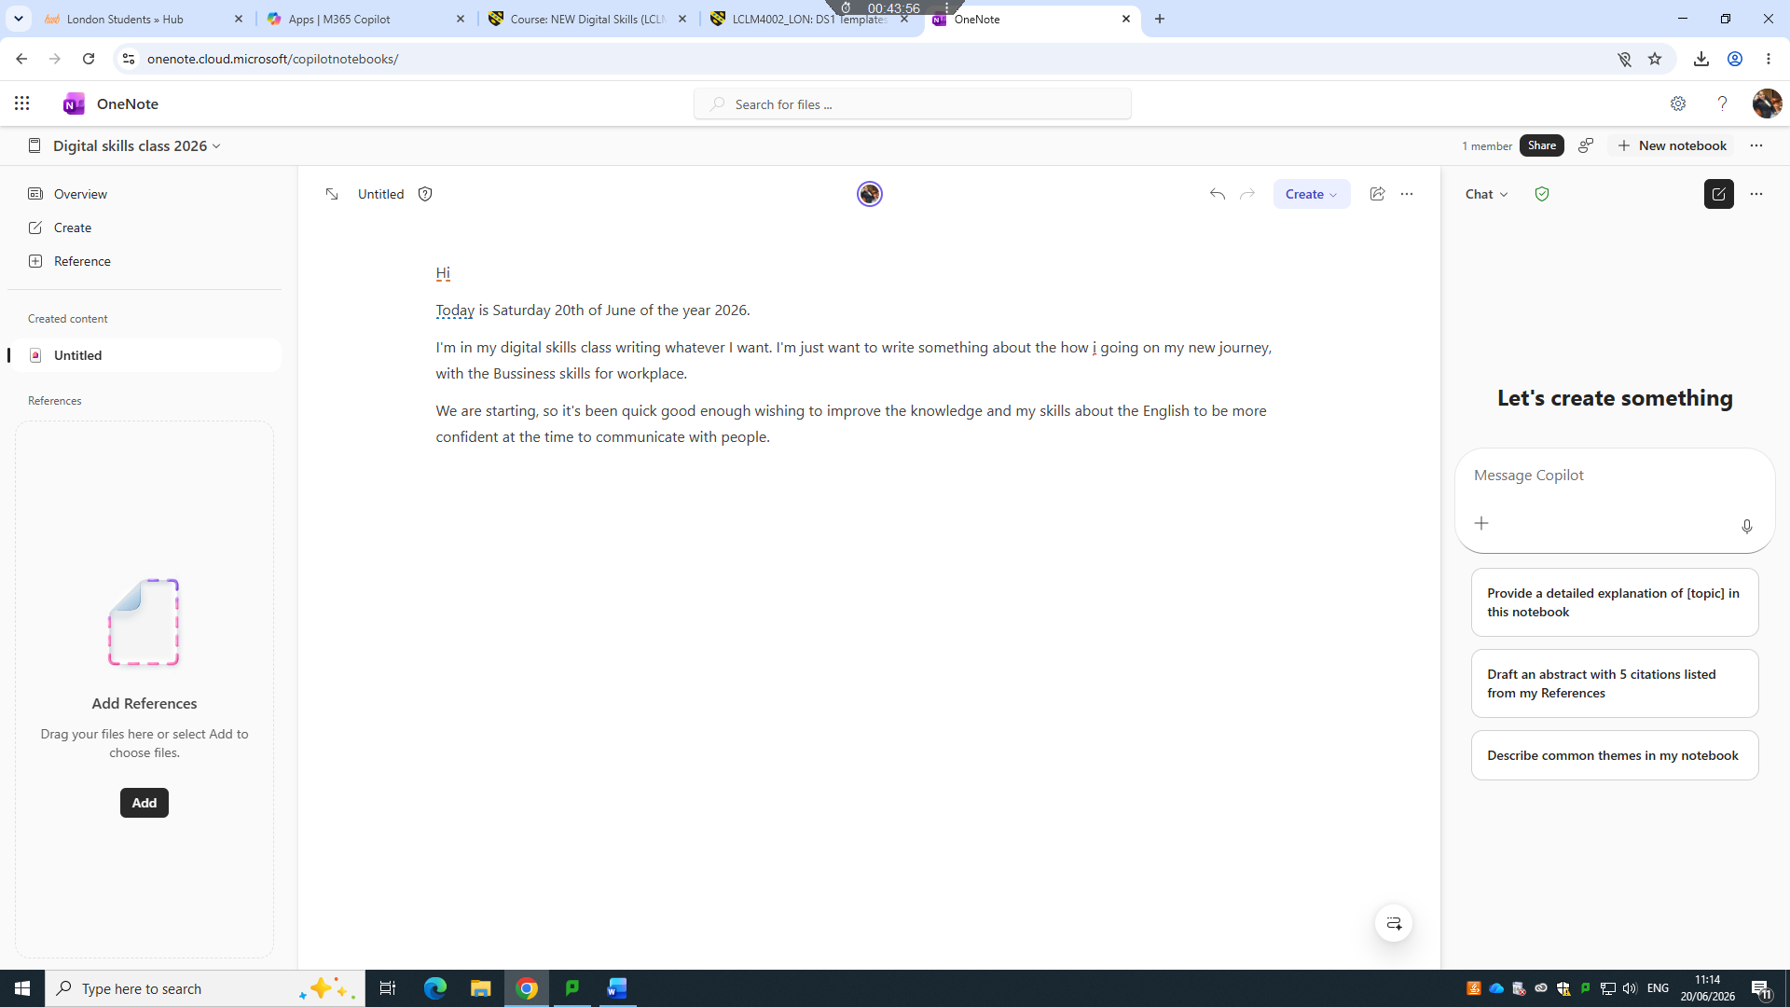
[Today I wrote a short text using Onenote in class ]

Screenshot/Photo 4
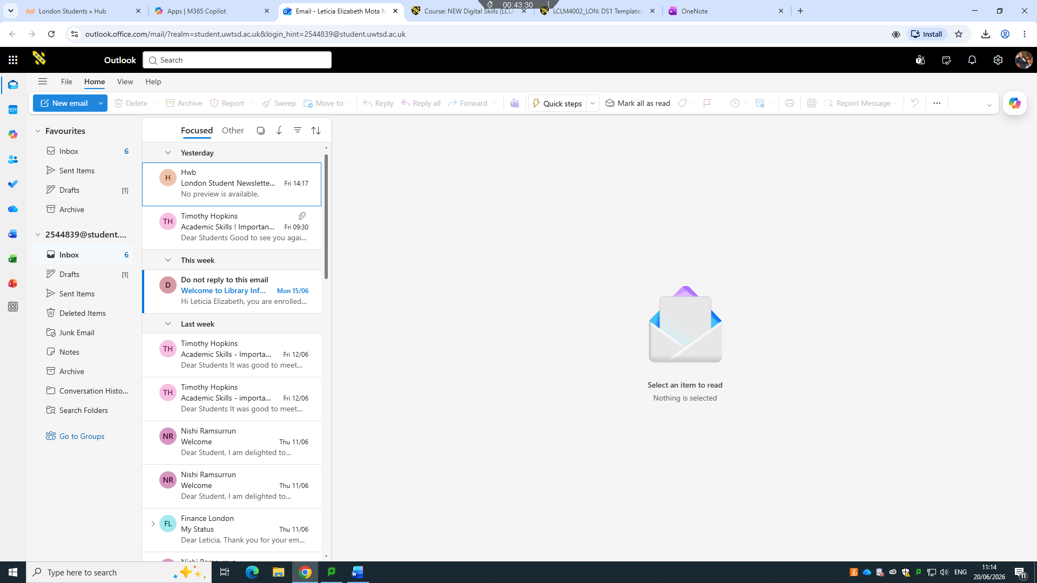
I was using my student email seen if I had news messages.

Screenshot/Photo 5
[Insert Photo/Screenshot below]
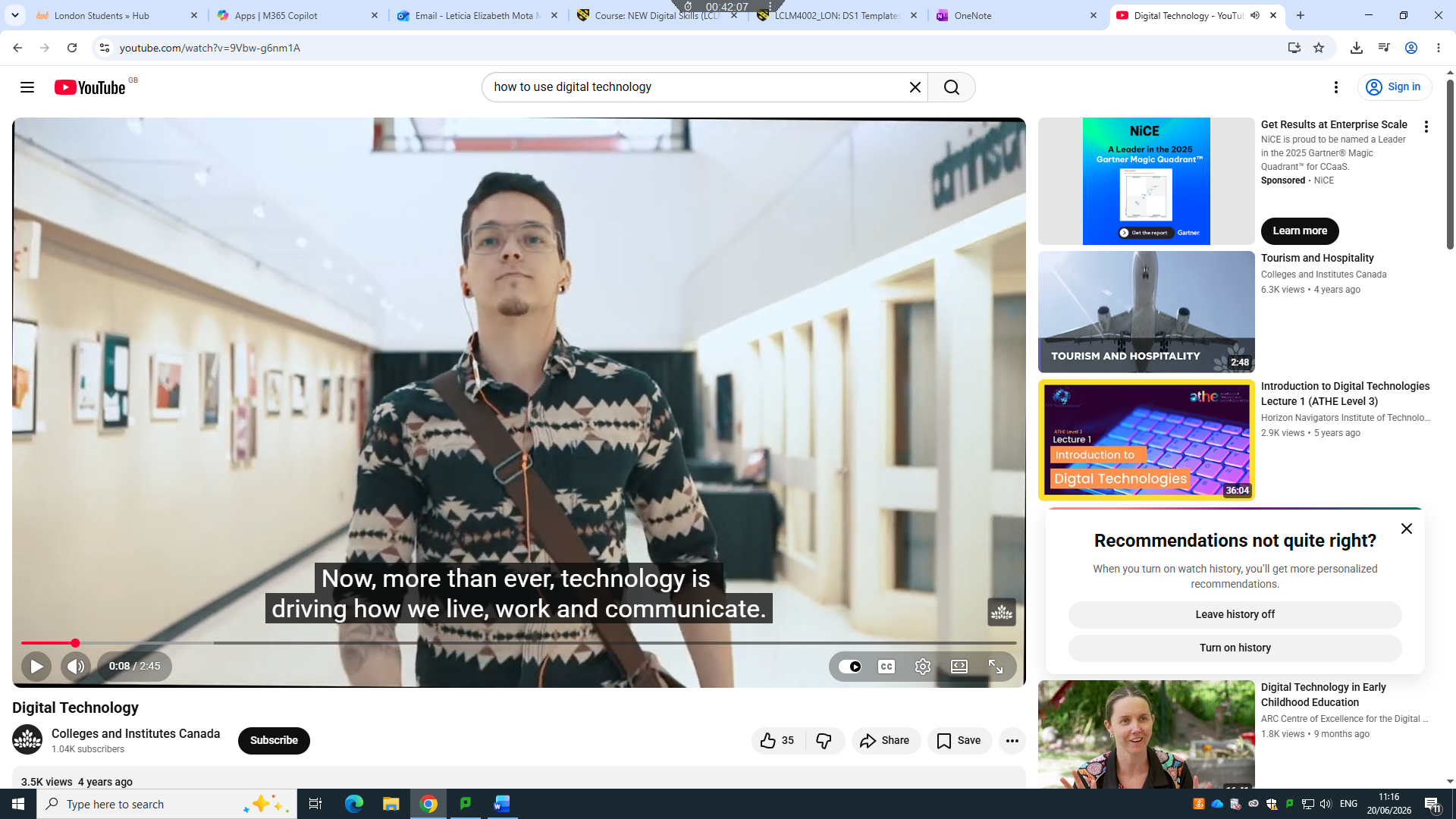
On YouTube I was watching a video about to learn the digital technology.

My Short Reflection
- Write 5–8 simple sentences about your digital life.
- You can use the sentence starters below if helpful.
In my diary time I regularly use the technology to be connected with friends and family.
Using social media to search new places to travel.
I often use the new technology to buy online.
I use YouTube to listen to music with my son.
I use my emails to recover password that I forget and to receive it from my employed

I used social media always because is a easy way to knows and search everything ,
My wishing to this course is get it with a really good credit and do al the works as better as I can, improve my English and my personal development. I’m nervous

