Table of Contents
Introduction 2
Effectiveness of the use of modern technologies within the workplace 2
More Text and Google hangout than face to face communication 2
Workplace technology patronizing personal lives 2
Technology enables the voice to be heard 2
Explore social media as a tool for marketing, information gathering and communication within the workplace 2
Creating own professional online presence to illustrate and evidence this research 2
Conclusion 2

Introduction
This is an era of globalization; people around the world keep connected with each other via digitalization. That is why; the communication and interaction can happen globally with the help of digitalization. They eminence of digitalization is beyond description. Now days this world has become a borderless market by the blessing of digitalization. People live is Australia can easily sell their products towards the people live in Asia within a second. All sorts of thing can be possible with the blessing of globalization and digitalization. The most essential part of an organization is their improvement of technology, the technological improvement is mandatory to get the best use of digitalization. Here in this report will describe regarding one of the leading multinational named Unilever. Unilever is the parent company under this organization there are so mane subsidiary organization. Those are also having individual identity and brand value a swell. However, to maintain all of these sub brand properly. Along with that, Unilever has the operation towards all over the world. That is why, maintaining all these aspects is not an easy task, for the proper operation Unilever needs to have a proper communication towards all the subsidiary brands around the word, that this why, they need to practice a proper digitalization to have a proper operation along with utilization as well.

Effectiveness of the use of modern technologies within the workplace
The essentiality of knowing the environment of workplace is regarding achieving success of the organization is beyond description. That is why, the eminence of conducting proper process of operation, workplace, and norms are mandatory to lead the organization towards the right direction. Along with that, they also need to generate proper outcome towards their organization into the work place. The work of the organization can do effectively and efficiently as well with the help of proper digitalization. As Unilever is the leading organization that is why the effectiveness of modern technology towards Unilever is the most eminence regarding their proper communication and maintenance, here are the descriptions below

Deploying an intranet
The operation of Unilever have more than hundreds countries. That is why, towards their operational department they need to have a proper integration along with that, they also need to have a proper interaction so that all the employees of the Unilever, get opportunities to express their ideas and thoughts towards their seniors. In addition, they will get scope to express their creativities and innovativeness and generate their ideas properly (CIO, 2009).
People Connect
The development of IT sector of Unilever is also mandatory, because with the development they will able to use the policy regarding proper communication towards their social media for instance, facebook, twitter, instagram and so on. Customers can connect with their customers directly via social media. Customers also get scope and opportunities to express their feedback regarding their products, the usage of the products, if they face any obstacles or problem regarding the use of the cosmetics of Unilever, they will able to get proper solutions regarding that. Unilever also get opportunities to rectify their products and prepare their products as per the preferences of their customers (CIO, 2009).
Deploying the tools
Unilever also needs to deploy their tools as per the demand of the customers along with that, the proper integration regarding their demand towards the work place. An enterprise search engine tools are essential so that all the information regarding organization employees can easily gain. Whereas the return and indexes is, web two contents. In terms of security approaches there also essential to having the development of web, where the testing purpose is call the perpetual beta. In that time, they access all sorts of default data (CIO, 2009).
Take away
The proper adaption and activities regarding Unilever is maintaining the connection of the employees towards their customers in the organization. Where the entire aspects is the process of understanding the people along with that the connection device of geographical workgroup with people along with that, they expand together with a very short period. The eminence of knowing the benefit of wed 2.0 along with their ultimate metric (CIO, 2009).

Explore social media as a tool for marketing, information gathering and communication within the workplace
People around the world now a day are able to know regarding their organization within few seconds with the help of social media. With the help of social media, customers use their opinion and thoughts very easily in the social media along with that able to share their feedback as well. Regarding the feedback of people, others also get to know regarding the particular products and feel curious to purchase. This is also beneficial for the organization as well, because after getting positive feedback organization will know regarding their products and will try to sustaining the quality. Whereas, after getting negative feedback Unilever will get to know about their lacking and come up with new ideas and thoughts regarding the change of their products as well. here are some tools of Unilever they have used in social media are describing below
Marketing towards facebook
Unilever have a worldwide operation around the world. Unilever has facebook page regarding country based where they will provide a platform towards their customers so that they able to share their valuable ideas, thoughts, feedback and so on. Along with that, the official page of Unilever they create a direct communication with their target customers. They also will able to know their target customers if they are coming up with new products or flavors. Customers also getting a direct platform to share their benefits or problems after using the products of Unilever, by that others will also get inspire or aware regarding purchase that particular products as well. That is how, Unilever create platform in social media to create a direct interaction with their customers with the help of their verified facebook page (Decoyer, 2014).
Hash tag marketing
Unilever come up with variety of contest one of them is Hashtag, via this contest they able to know the positive sentiments of their customers. Regarding the positive sentiment Olympics sentiment had the highest percentages.

Instagram marketing
Unilever has an official page in instagram where they able to provide advertisement regarding their customers. They also able to provide post regarding their products towards instagram account along with that the people who operate intagram also able to know regarding the new or upcoming products of Unilever as they also provide advertisements towards instagram as well. as people also can follow the instagram page of Unilever to get themselves updated with the news of the products of Unilever along with that they also easily recall the products name iin terms of purchasing (Jeff & Drucker, 2012).
Display ad
Display ad comes towards the web page, for instance the side of the web page, or the bottom of the webpage, sometimes display ads come towards the top of the webpage as well. Unilever used to provide display ads towards their customers. Unilever is the parent company, under Unilever there are so many subsidiary companies belong. Unilever is also very flexible like, after continuously doing market research they always try to come up with new ideas and perceptions regarding that, they used to conduct with huge promotional activities, with the help of promotional activities people easily get to know about their products along with that, the can purchase their products as well (Decoyer, 2014).
Search ad
In terms of searching something into the website, there are various link come towards the webpage and there is written ad in a short form, after clicking the link people get to know about the full information regarding the products towards that link, Unilever sometimes use search ad to let people know about the products (Decoyer, 2014).
Video ad
Regarding watching various videos, in the beginning of the video, or middle of the video along with that, sometimes end of the video various sorts of ads conducts that ads are known as video advertisement. When Unilever comes up with new products, they trend to use video ads regarding their new products in the most viewed video as that it reached to many viewers (Decoyer, 2014).

YouTube
Unilever have an official site or YouTube channel. Unilever has a huge sub brands under their parent brand. The subscribers of Unilever into YouTube are huge, they post regarding their new advertisements, or their campaign along with that they are often conducted with lots of CSR activities those sorts of thing they posted into their YouTube channel. They have a huge line extension that is why in their YouTube channel they have all the products of their portfolio separately. In YouTube, people get to know regarding any sorts of initiates of Unilever by subscribing their channel properly. People also able to comment regarding the videos towards the command sections below along with that they provide their valuable feedback regarding their products with the help of their feedbacks Unilever able to take essential steps regarding the demand of market (Decoyer, 2014).

Creating own professional online presence to illustrate and evidence this research

Face book
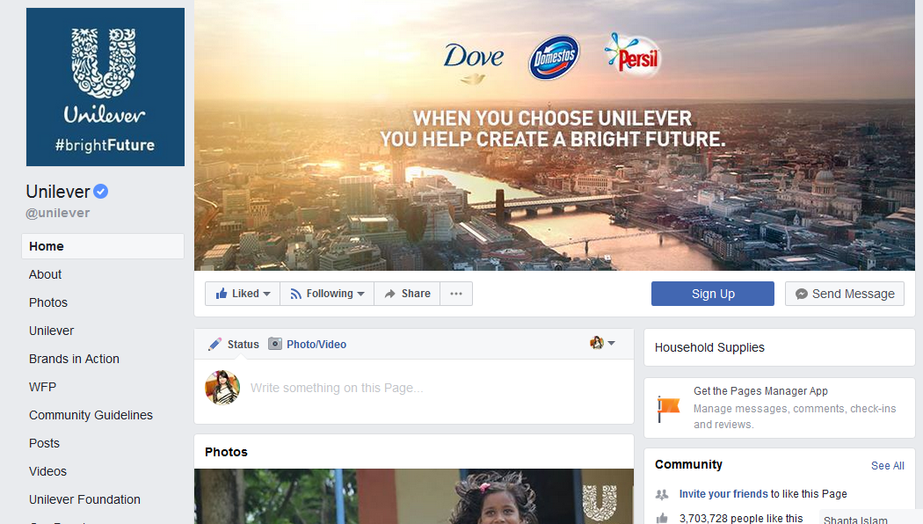
This is the official page of Unilever, where millions of people can connect easily. The official page of Unilever varies from country to country. They have pages regarding country wise. The page posted above is the page of Unilever USA. Here in this page people easily able to share their feedback towards the products along with that Unilever also able to post regarding their new products where people can easily gather the ideas and knowledge regarding their new products. In the facebook page Unilever try to create social connection with their customers for instance, in various occasion like, Christmas, new year, mother’s day, Unilever wish towards their billion of customers via their facebook page (Thomas, 2013).

YouTube

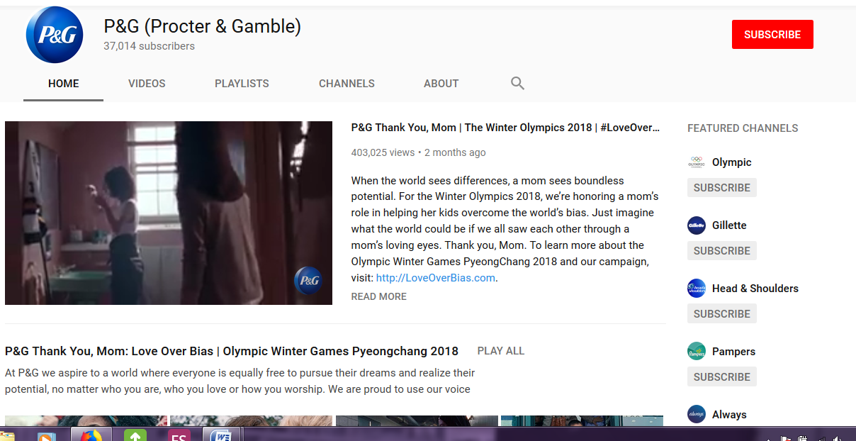
Here we can see, in the right side of their YouTube official channel Unilever also have separate channel regarding their subsidiary companies. Here views can easily get to know the sub brands of Unilever along with that, they can easily visit those sites as well. Unilever trend come up with many promotional activities. With the help of their YouTube channel, they get the scope and possibilities regarding sharing their new advertisements towards the customers or customers also able to provide comments in their comment section below that is how they able to create a positive correlation with their customers (Thomas, 2013).
Instagram
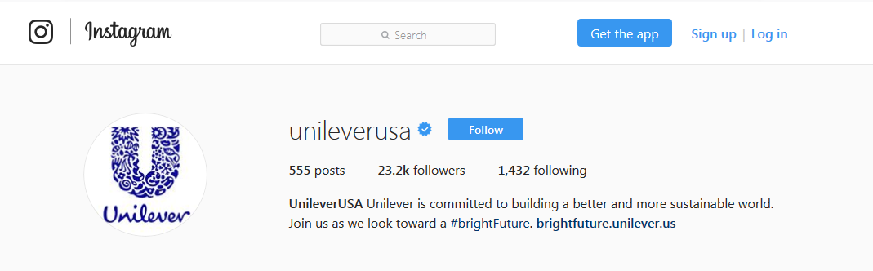
This is the official instagram page of Unilever, here in this page they share various sorts of their products ads, Champaign, with their customers occasionally. People follow the official page of Unilever to get their updated news and information along with that to create a positive correlation as well (Thomas, 2013).

Conclusion
To conclude, we can say that, the eminence and essentiality of digitalization is beyond description in this new era of globalization. Especially one of the leading multinational organizations named Unilever, the practice of digitalization of Unilever is beyond description as they have an operation all around the world. The line extension of Unilever is also huge, the popularity of their sub brands are also huge because Unilever trend to provide quality to their entire subsidiary brads. With the blessing of updated technology and digitalization Unilever trend to connect with all of their sub brands with all the branches around the world.

Reference
CIO (2009),” How Procter & Gamble Got Employees to Use Social Networking at Work” available at: https://www.cio.com/article/2425347/consumer-technology/how-procter---gamble-got-employees-to-use-social-networking-at-work.html. Accessed on: 30th December
Blythe, Jim and Zimmerman, Alan S. (2005) Business-to-business Marketing Management: A Global Perspective, Cengage Learning EMEA
Inman, P. & Traynor, I. (2013). UK economy: a miraculous recovery – or a blip in a longer-term decline?. Retrieved from The Guardian http://www.theguardian.com/business/2013/sep/08/uk-economy-recovery-decline [accessed 22nd October 2016]
Kleinman, Z. (2013, March 30). Counting data cost on mobile phones. Retrieved from BBC News: http://www.bbc.co.uk/news/technology-21959032 [ accessed 22nd October 2016]
mintel,(2017), “4 key takeaways from International Hotel Investment Forum 2016”available at
<http://www.mintel.com/blog/travel-and-tourism-market-news/4-key-takeaways-from international-hotel-investment-forum- accessed on 21.11.2016. >
Blanchard, Olivier (2011). Macroeconomics Updated (5th ed.). Englewood Cliffs: Prentice Hall.
Dwivedi, D.N. (2001). Macroeconomics: theory and policy. New Delhi: Tata McGraw-Hill.
Levi, Maurice (2014). The Macroeconomic Environment of Business (Core Concepts and Curious Connections). New Jersey: World Scientific Publishing. ISBN 978-981-4304-34-4.
Lelin, G., & Thomas, K. (2013). Our strong present – Lessons from United Kingdom’s Innovation System. London: Nestle.
Stuart, P., Dan Oratori, Q., Doulton, H., Croos, K., & Decoyer, C. (2014). The Past of Innovation Management: The previous 100 Years. Prism, 2: 33–38.
Jeff & Drucker. (2012). Flying Beyond: Invention for the Few more Millions – The Uplifting of the Modern Higher Class and They way to Capitalize On It. Brisbane: Peter & Drucker.
Peter & Drucker. (2012). Flying Beyond: Invention for the Few more Millions – The Uplifting of the Modern Higher Class and They way to Capitalize On It. Brisbane: Peter & Drucker.

