

Name: Rita Zambito
Student number: 2245801
Module Code: ACCA6026_BIRM
Module Title: Data Warehousing & Data Mining
Lecturer Name: Dr. Mobolanle Bello
Assignment Title: Data Mining
Date of submission: 14/11/2025
IICL, Birmingham
Table of Contents
1.1 Purpose and Practice of Data Mining 2
1.2 Dataset Description and Data Exploration 3
1.3 Data Pre-processing and Post-processing 7
1.4 Analysis Methods and Results 9
1.5 Recommendations for Improving Student Performance 20
1.6 Reflection 21
Conclusion 22
References 22

Introduction
Understanding the factors that influence student achievement is a key challenge in education. Analysing such factors can help institutions design more effective strategies to support learning and improve academic success.
For this research, datasets from Portuguese secondary schools were used to examine how demographic, social, and academic variables influence students’ final grades. The main goal of the analysis is to identify which factors have the greatest impact on performance and to reveal patterns among groups of learners with similar characteristics. Data mining techniques were applied using Tableau for data cleaning, visualisation, and analysis. The report proceeds from data exploration to analytical results, interpretation, and educational recommendations.

Purpose and Practice of Data Mining
Data mining is the process of extracting meaningful patterns and knowledge from large datasets using statistical, computational, and machine learning methods [1]. Its purpose is to transform raw data into useful information that supports decision-making and prediction [1]. The practice involves several stages, including data collection, cleaning, transformation, modelling, and evaluation, aimed at discovering hidden relationships and trends that are not immediately visible through traditional analysis [1].
The main techniques of data mining include classification, used to assign items to predefined categories [2]; clustering, which groups similar data points without predefined labels [3]; association rule mining, which detects relationships between variables [4]; and regression, used to predict numerical outcomes [5]. These techniques are often supported by algorithms such as decision trees, neural networks, and k-means clustering [6], and visualised through analytical tools like Weka or Tableau. Together, they enable researchers to recognise correlations, patterns, and anomalies within complex datasets [7].
In the educational field, the purpose of data mining is to gain insight into the factors that influence students’ academic results and to predict their performance using real-world educational data [8]. Understanding these patterns supports schools and teachers in developing targeted strategies, improving resource allocation, and ultimately enhancing student achievement [8]. In the following sections, it will be demonstrated how applying these techniques to a real educational dataset can reveal key factors influencing student performance and support the prediction of academic outcomes.

Dataset Description and Data Exploration
The dataset used in this study originates from the UCI Machine Learning Repository and contains real educational data collected from two Portuguese secondary schools, Gabriel Pereira and Mousinho da Silveira [9]. The purpose of the dataset is to analyse student academic performance and identify social, demographic, and behavioural factors that influence their final grades.
The data is provided in two main CSV files: student-mat.csv for Mathematics students and student-por.csv for Portuguese language students. A supplementary text file (student.txt) explains the structure and meaning of each attribute, including data types and potential values. The two datasets share the same structure and were designed to allow separate or combined analyses.
Each dataset includes 33 attributes and information from 395 students in Mathematics and 649 in Portuguese. Some students appear in both datasets, representing those enrolled in both subjects. The attributes cover various aspects such as demographics (age, gender, family size), social background (parents’ education and occupation), and lifestyle factors (study time, absences, alcohol consumption). The target variable used for prediction is the final grade (G3), while G1 and G2 represent grades from previous periods.
The attributes include a mix of categorical (e.g., school, sex, address), numerical (e.g., age, absences, grades), and binary (e.g., school support, family support) variables. The dataset is complete, with no missing values or duplicates. It required minor cleaning to correct misaligned data columns in Excel before being imported into Tableau for analysis [10].
Initial data familiarisation was then conducted through descriptive statistics and visual inspection of grade distributions and relationships between key variables. This phase aimed to understand general patterns before performing predictive and clustering analyses.
Math Students Exploration
Figures 1–3 show the exploration of the Mathematics dataset. The histogram indicates that most students scored between 8 and 12, suggesting an overall moderate performance. The boxplot reveals that longer study times generally correspond to higher final grades. The scatter plot between absences and final grades shows that most students have relatively few absences, concentrated on the left side of the scale, while those on the right, with higher absence levels, tend to achieve noticeably lower G3 scores.
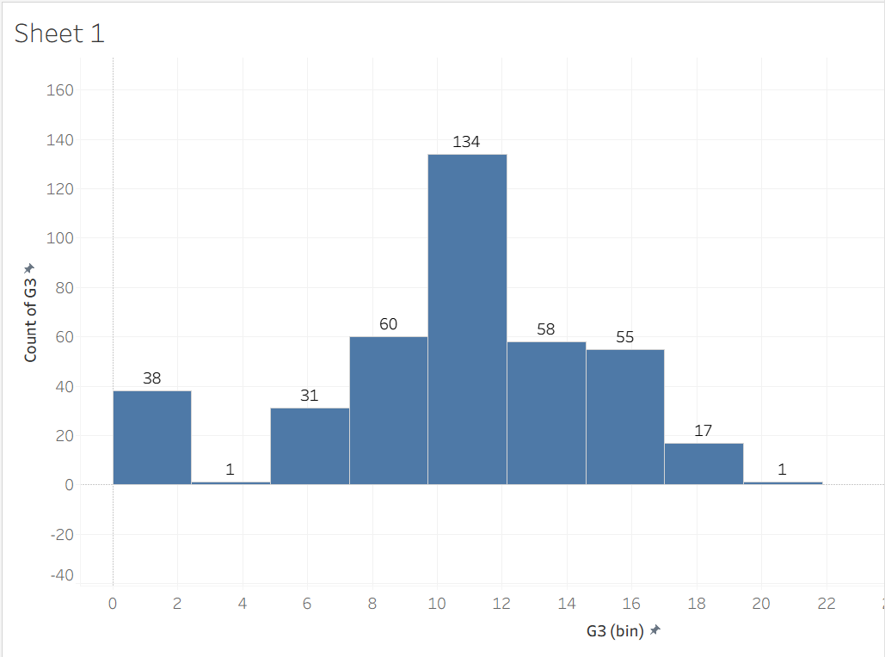
Figure 1. Histogram showing the distribution of final grades (G3) among Mathematics students.

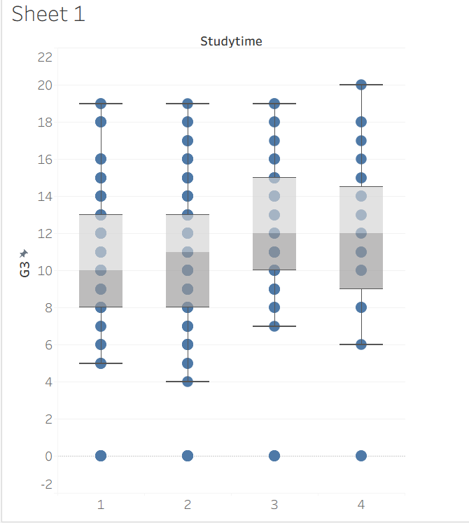
Figure 2. Boxplot showing the relationship between study time and final grades (G3).

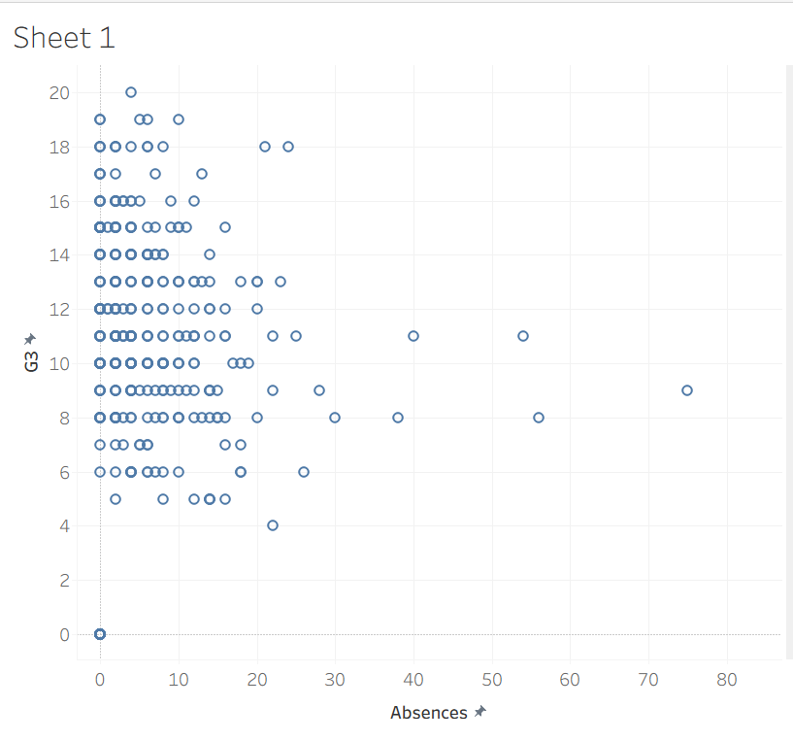
Figure 3. Scatter plot showing the relationship between absences and final grades (G3)

Portuguese Students Exploration
Figures 4–6 display similar analyses for Portuguese students. The grade distribution is slightly higher, with more students achieving above-average scores. The boxplot again highlights a positive relationship between study time and performance, while the scatter plot confirms that increased absences correspond to lower grades.
Together, these initial findings provided a foundational understanding of the dataset and guided the next phase of data pre-processing and modelling.
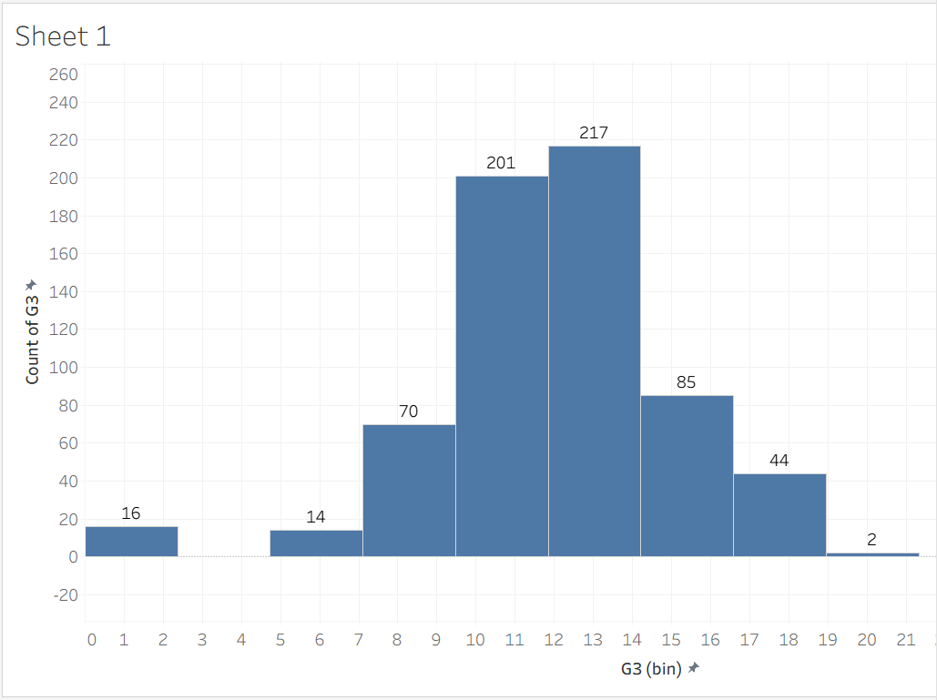
Figure 4. Histogram showing the distribution of final grades (G3) among Portuguese students.

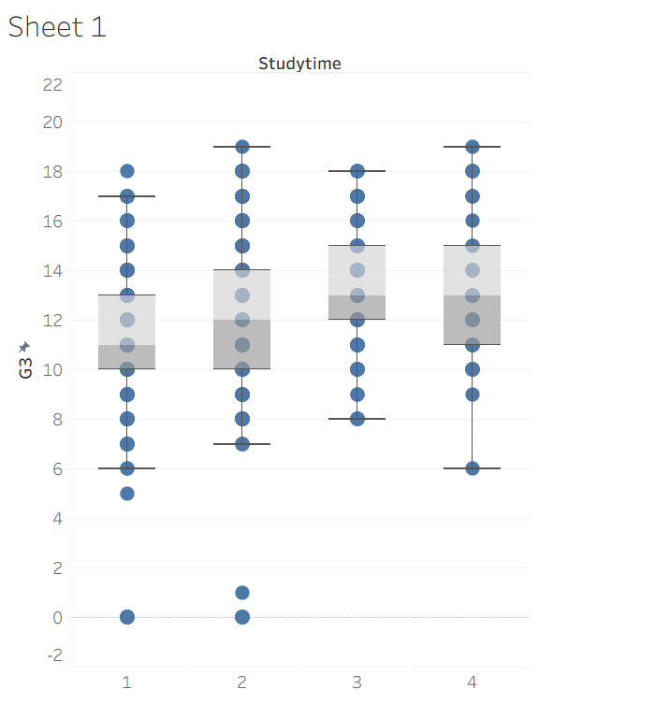
Figure 5. Boxplot showing the relationship between study time and final grades (G3).

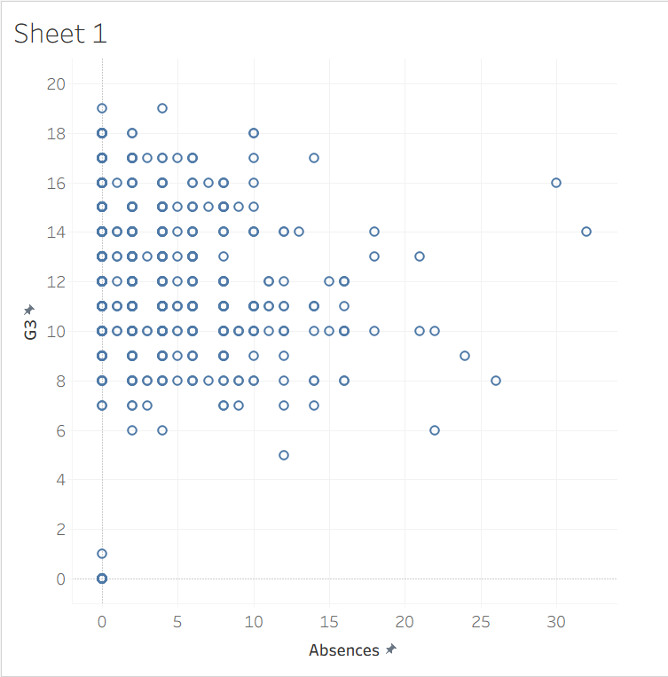
Figure 6. Scatter plot showing the relationship between absences and final grades (G3).

Data Pre-processing and Post-processing
Primary Pre-processing
Before any analysis could be carried out, the original CSV files from the UCI Machine Learning Repository required minor structural cleaning [11]. When opened in Excel, the data appeared misaligned, with some columns and values shifted due to delimiter inconsistencies. These issues were corrected by realigning the data into proper columns and ensuring that each variable corresponded to its correct attribute header. The corrected version was saved as an Excel file to preserve the formatting and facilitate accurate import into Tableau. During this stage, the integrity of the dataset was verified by checking that all rows contained complete information and that the total number of instances and attributes matched the documentation [11]. The dataset was confirmed to contain 395 student records and 33 attributes.
Secondary Pre-processing
After structural correction, a brief review was performed to verify variable types and consistency across the dataset [11]. Categorical attributes such as “school”, “sex”, and “address” were checked to ensure uniform entries, while numerical variables such as “age”, “absences”, and “grades” were confirmed to contain valid numerical values. Some binary attributes were represented as “yes/no” fields and required no additional conversion. However, care was taken to verify that all binary categories were consistent, for example avoiding variations such as “Y/N”. The Math and Portuguese datasets were kept separate to maintain the distinction between the two subjects and to allow independent exploration. No missing values or duplicate records were identified. These checks confirmed that the dataset was clean, balanced, and ready for import into Tableau.
Data Preparation for Tableau
The pre-processed datasets were imported individually into Tableau for analysis and visualisation [10]. Once loaded, automatic data aggregation was disabled to allow individual-level analysis rather than summarised results. Several data types were adjusted to ensure correct interpretation during visualisation, particularly converting relevant fields from measure to dimension where categorical grouping, such as boxplots, required separate visual elements. This step ensured that Tableau handled the data correctly when generating graphs and predictive models.
The workspace in Tableau was organised to support two parallel analyses, one for Mathematics and one for Portuguese students. Calculated fields were created when necessary to support statistical exploration, such as generating predicted values and comparing them with actual results. Data relationships between key variables (study time, absences, health, alcohol consumption, and final grades) were then visualised through a range of charts, including histograms, boxplots, scatter plots, regression outputs, and cluster diagrams. These visualisations provided both descriptive and predictive insights, forming the analytical core of the report.
Post-processing
After generating the predictive and clustering outputs, the results were reviewed and exported for reporting [12]. Post-processing in this context involved interpreting the visual patterns and ensuring that all graphs accurately represented the findings [12]. Screenshots from Tableau were carefully selected and labelled according to their analytical purpose, for example, Figures 1–6 showing exploratory visualisations, and Figures 7–18 representing regression and clustering results. Each figure was saved with consistent formatting to maintain clarity and visual coherence throughout the report.
Interpretation played a key role at this stage. The predictive models highlighted relationships such as the negative association between failures and final grades, and the positive impact of study time on student performance. Similarly, the cluster analyses helped to identify groups of students sharing similar characteristics in terms of study habits, health, or alcohol consumption. These results were not altered after export but were examined to support accurate commentary in the analysis section.
Finally, the post-processing stage included organising and integrating all visual evidence into the report structure. Each visualisation was matched with written interpretation, ensuring that every output was clearly linked to its analytical context. This process completed the data mining cycle, from initial data cleaning and preparation, through analysis and interpretation, to presentation of meaningful insights on student performance.

Analysis Methods and Results
Prediction is the process of estimating an outcome variable based on patterns found in existing data [13]. In this study, prediction was used to estimate students’ final grades (G3) according to variables such as mid-term grades, failures, and travel time.
Clustering is a technique used to group data points that share similar characteristics, without predefined categories [14]. In this context, clustering helped identify groups of students with similar behaviours, study habits, or lifestyle factors that influence academic performance.
Regression analysis was chosen for prediction because it provides a clear and interpretable way to understand how individual variables influence the final grade [15]. Tableau’s built-in linear regression function was applied to visualise trends and calculate predicted G3 values directly on scatter plots.
For clustering, Tableau’s automatic grouping algorithm was used. It applies distance-based similarity to divide the data into clusters without requiring prior labels. This method was appropriate for educational data containing mixed numeric and categorical attributes, allowing meaningful groups to emerge visually.
All models were created in Tableau using the cleaned datasets for Mathematics and Portuguese students. Prediction graphs were produced to explore how individual variables affect G3, while clustering analyses were performed to detect patterns among learners.
Mathematics Dataset
Prediction Models:

- G3 – Failures
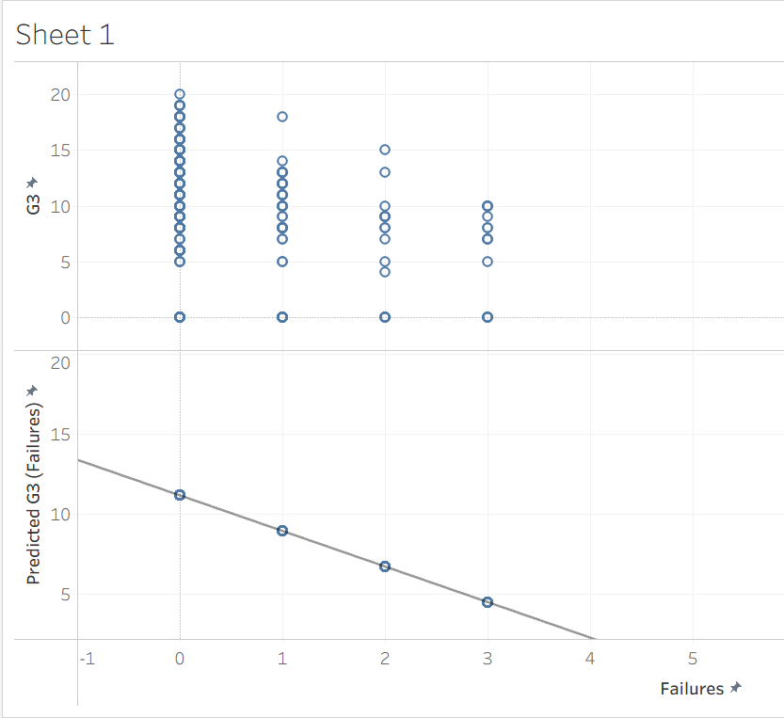
Figure 7. Comparison between actual and predicted final grades (G3) using Failures as predictor.

Predicted grades decrease steadily as the number of past failures increases. Students with no previous failures achieve around G3 = 15, while those with three or more drop below 6. The clear negative trend confirms that repeated failure strongly predicts poor performance. A few exceptions achieve good results despite previous setbacks, possibly through renewed effort or tutoring. Identifying such students early can help provide support and prevent further decline.
- G3 – G2
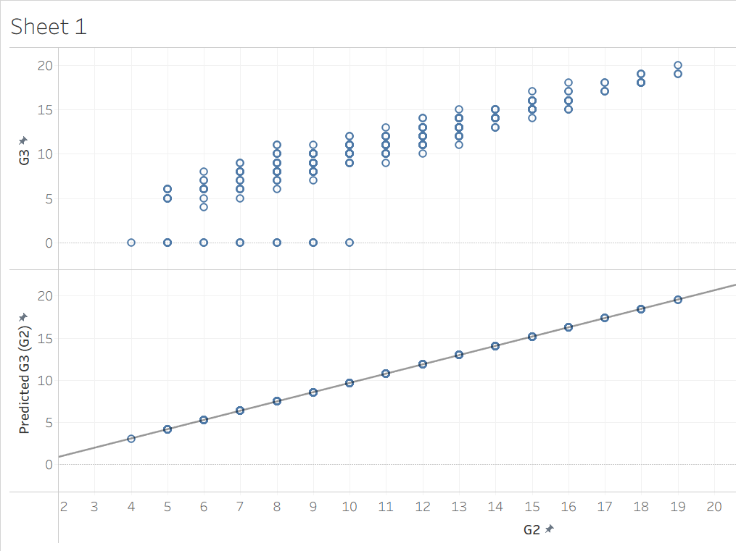
Figure 8. Comparison between actual and predicted final grades (G3) using G2 as predictor.
A strong positive correlation appears between mid-term and final grades. Students scoring 15–20 in G2 usually achieve above 15 in G3, while those under 10 rarely exceed 8. Some fall below expectations, suggesting reduced engagement later in the course. Monitoring G2 performance enables teachers to detect problems early and offer timely feedback.
- G3 – Traveltime
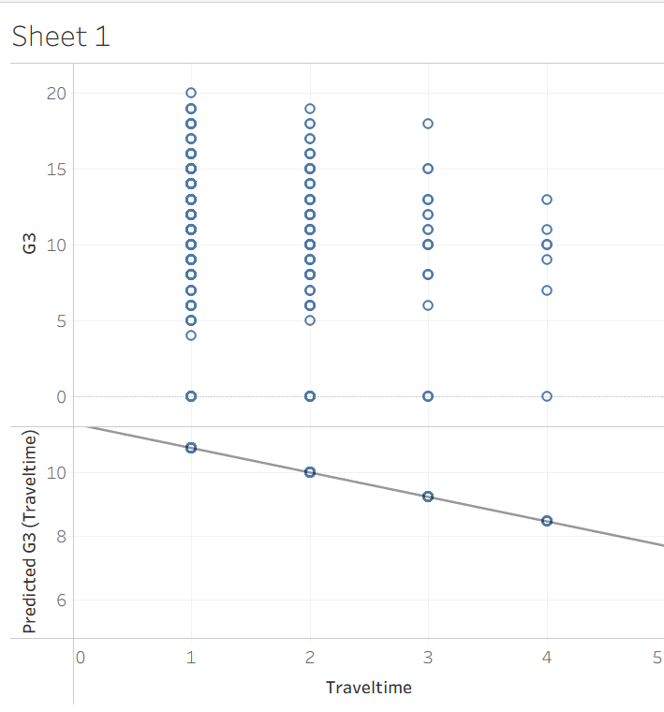
Figure 9. Comparison between actual and predicted final grades (G3) using Traveltime as predictor.

Predicted grades decrease as travel time increases. Long commutes may limit study opportunities, though some students perform well despite distance. Providing flexible learning schedules could reduce these disadvantages.

Clustering Analysis:

- Study time – G3
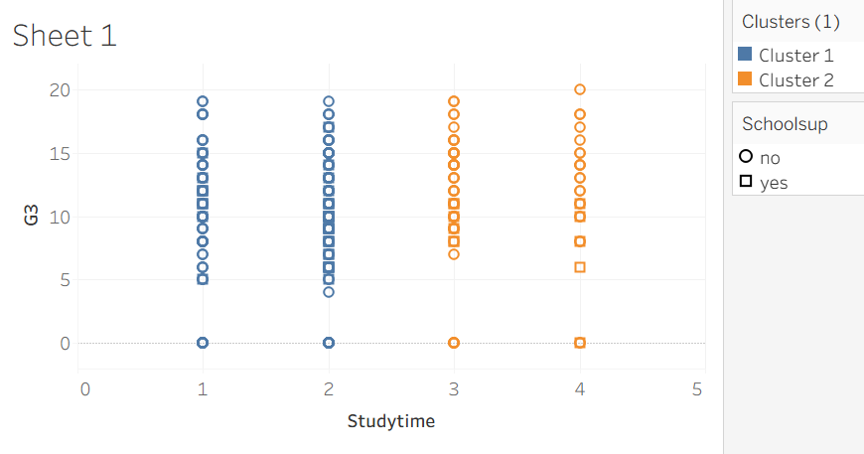
Figure 10. Cluster analysis showing the relationship between study time, school support, and final grades (G3).

Cluster 1 (blue): 303 students – Avg G3 = 10.1; Study time = 1.65.
Cluster 2 (orange): 92 students – Avg G3 = 11.4; Study time = 3.29.
Students who study longer and receive school support perform better overall. Promoting structured support and consistent study habits could help raise general achievement.
- Health – G3
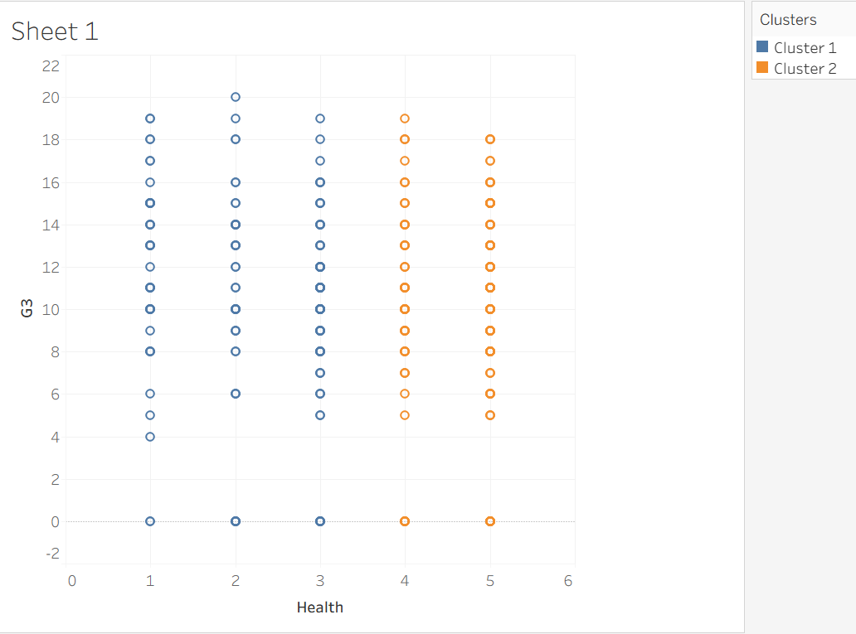
Figure 11. Cluster analysis showing the relationship between students’ health status and final grades (G3).

Cluster 1 (blue): 183 students – Avg G3 = 10.54; Health = 2.24.
Cluster 2 (orange): 212 students – Avg G3 = 10.31; Health = 4.69.
No clear link is found between health and results, though improved wellbeing may still enhance motivation and attendance.
- Alcohol (Dalc) – G3
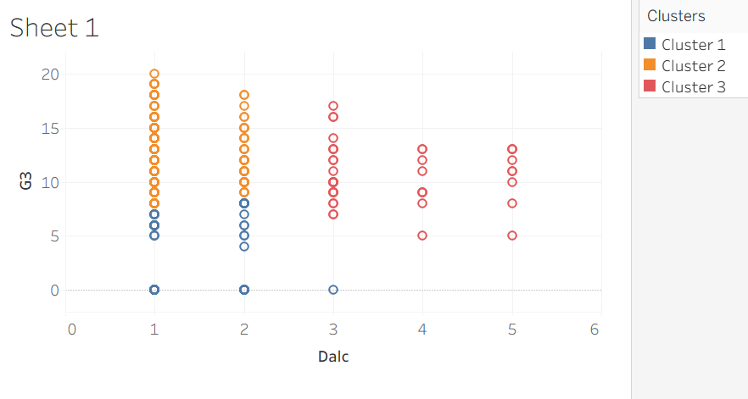
Figure 12. Cluster analysis showing the relationship between students’ alcohol consumption (Dalc) and final grades (G3).

Cluster 1 (blue): 76 students – Avg Dalc = 1.38; G3 = 3.26.
Cluster 2 (orange): 276 students – Avg Dalc = 1.17; G3 = 12.35.
Cluster 3 (green): 43 students – Avg Dalc = 3.63; G3 = 10.65.
Low alcohol use aligns with higher results, while heavy drinkers show weaker outcomes. Awareness campaigns could reinforce responsible habits.
Portuguese Dataset
Prediction Models:

- G3 – Failures
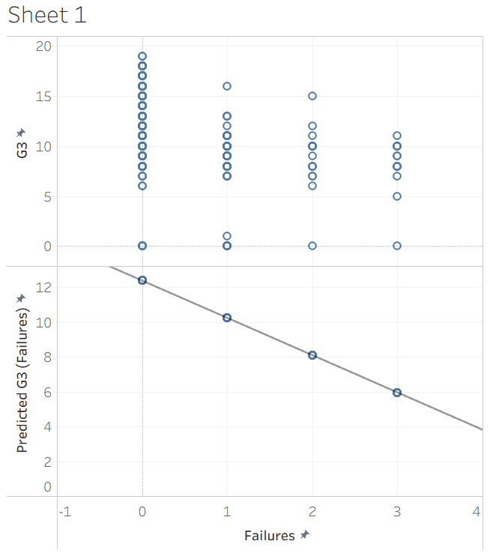
Figure 13. Comparison between actual and predicted final grades (G3) using Failures as predictor.
Predicted grades drop sharply as failures increase. Students with no previous failures reach around G3 = 15, while those with several fall below 6. The pattern confirms that repeated failure is a consistent indicator of poor academic achievement. A few students recover after early setbacks, suggesting improvement through extra effort or support.
- G3 – G2
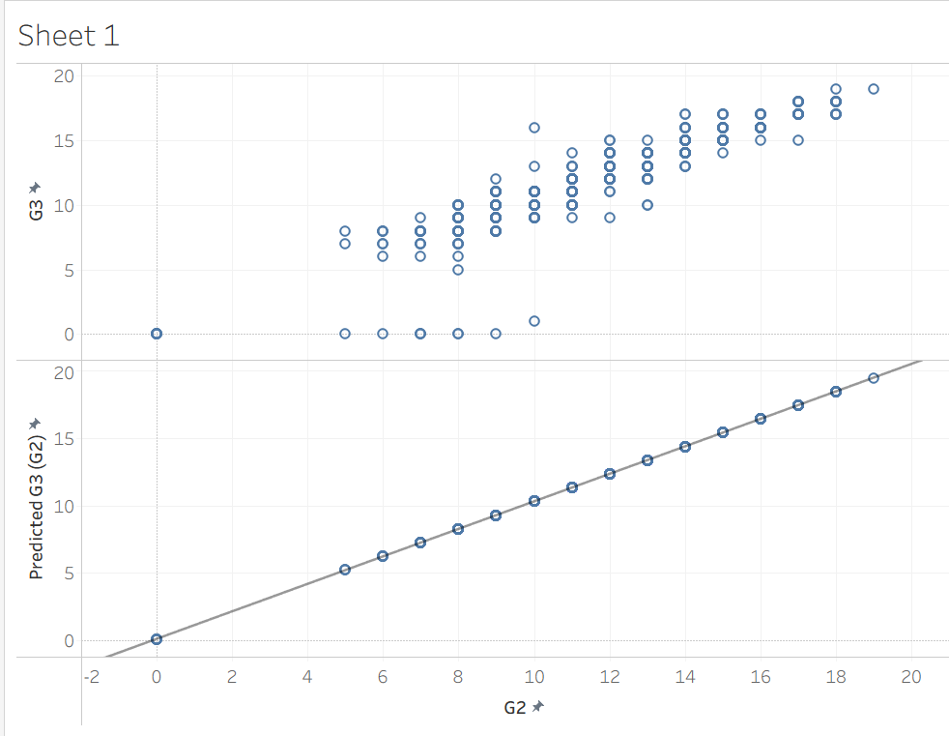
Figure 14. Comparison between actual and predicted final grades (G3) using G2 as predictor.
A clear positive relationship appears between mid-term and final results. Students with G2 above 15 typically finish with G3 values above 14, while those below 10 rarely exceed 8. Tracking G2 trends helps identify declining performance and enables early intervention.
- G3 – Traveltime
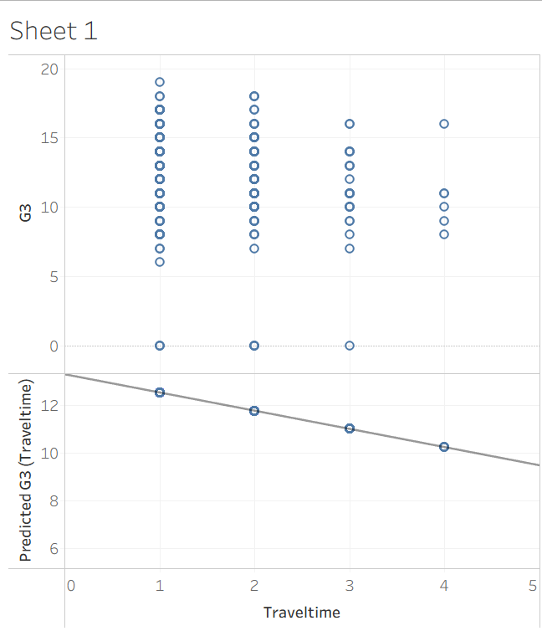
Figure 15. Comparison between actual and predicted final grades (G3) using Traveltime as predictor.
Grades gradually decrease with longer travel time. Students living closer to school achieve higher results, while long-distance commuters tend to perform slightly worse. Flexible schedules or after-class support could help balance this disadvantage.

Clustering Analysis:

- Study time – G3
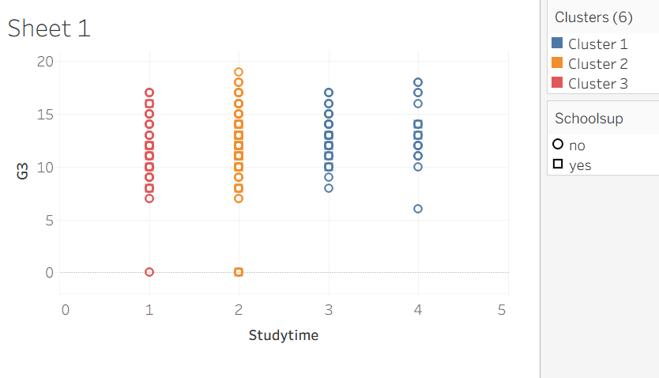
Figure 16. Cluster analysis showing the relationship between study time, school support, and final grades (G3) among Portuguese students.

Cluster 1 (blue): 297 students – Avg G3 = 12.41; Study time = 2.0.
Cluster 2 (orange): 132 students – Avg G3 = 13.18; Study time = 3.27.
Cluster 3 (red): 220 students – Avg G3 = 10.46; Study time = 1.04.
Cluster 2 combines the longest study time and highest grades, while Cluster 3 groups low-study, low-achieving students. Encouraging structured study routines and personalised support could improve lower-performing groups.
- Health – G3
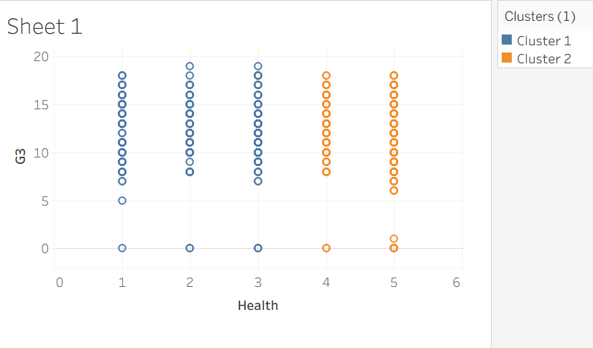
Figure 17. Cluster analysis showing the relationship between students’ health status and final grades (G3) among Portuguese students.

Cluster 1 (blue): 292 students – Avg G3 = 12.13; Health = 2.12.
Cluster 2 (orange): 357 students – Avg G3 = 11.72; Health = 4.70.
No clear connection is observed between self-reported health and grades, although good wellbeing can indirectly support concentration and attendance.
- Alcohol (Dalc) – G3
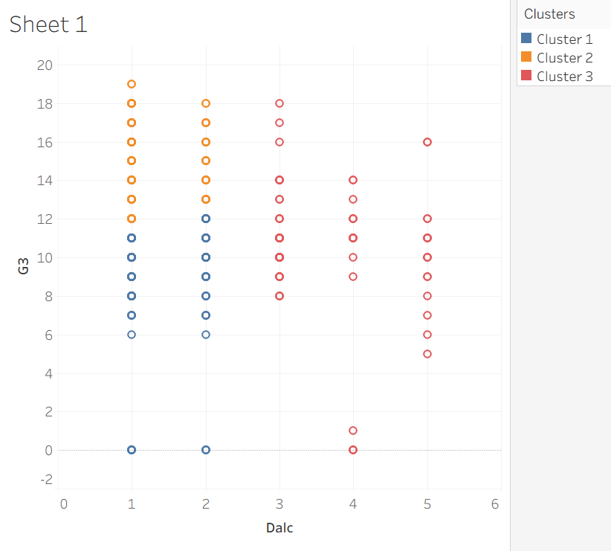
Figure 18. Cluster analysis showing the relationship between students’ alcohol consumption (Dalc) and final grades (G3).

Cluster 1 (blue): 261 students – Avg Dalc = 1.31; G3 = 9.50.
Cluster 2 (orange): 311 students – Avg Dalc = 1.13; G3 = 14.28.
Cluster 3 (red): 77 students – Avg Dalc = 3.66; G3 = 10.46.
Minimal alcohol use corresponds with better academic performance. Promoting awareness of healthy lifestyles could help sustain positive learning outcomes.

Recommendations for Improving Student Performance
The analysis of both Mathematics and Portuguese students revealed several key insights into the factors influencing academic performance. Study time, previous good grades, and access to school support were consistently associated with higher final results, while longer travel time, frequent absences, excessive alcohol consumption, and multiple past failures were linked to lower performance. Health and lifestyle factors also appeared to play a role, indicating that well-being contributes to overall achievement.
Based on these findings, schools should prioritise interventions that encourage consistent study habits and attendance. Increasing the availability of academic support sessions, particularly for students identified through predictive analysis as being at risk of low achievement, could lead to measurable improvement in results. Teachers may also use data-driven insights to personalise feedback and allocate extra support to students showing early signs of academic difficulty. In addition, the findings suggest that health and lifestyle education, including awareness campaigns on balanced routines and responsible behaviour, may indirectly improve learning outcomes by enhancing students’ focus and motivation.
Beyond these immediate strategies, this analytical approach could be extended across different subjects and schools to strengthen evidence-based planning. The use of predictive and clustering methods allows early identification of underperforming students and ensures that resources are allocated where they can have the greatest impact [16]. Embedding such analytical methods into regular school evaluation would encourage data-driven educational strategies and continuous improvement across the educational environment [16].

Reflection
The data mining process proved to be both effective and insightful, successfully transforming a raw educational dataset into meaningful analytical outcomes. The overall workflow, from data cleaning and preparation to visualisation and interpretation, was executed efficiently, and Tableau demonstrated strong capabilities for handling structured data and presenting findings through clear visual formats. The analysis met its primary goal of applying predictive and clustering techniques to educational data in a coherent and interpretable way.
One of the main strengths of the approach was its structured methodology. Each stage of pre-processing, analysis, and post-processing followed a logical progression, ensuring data consistency and interpretative accuracy. Tableau’s interactive features allowed patterns to be identified quickly and supported analytical reasoning through visual exploration [17]. However, the platform also had some constraints, particularly in terms of algorithmic flexibility and the depth of statistical validation available compared with dedicated data science tools [17].
Efficiency could be further enhanced by automating some parts of the process, such as data cleaning or validation, and by integrating Python or R for more sophisticated modelling. For future work, expanding the dataset to include more schools or academic years would improve the robustness and generalisability of results. Overall, this reflection highlights the value of combining visual analytics with predictive modelling in education, providing a foundation for continuous methodological improvement and more evidence-based decision-making.

Conclusion
This report demonstrates how data mining can be effectively applied beyond business or technical fields, offering valuable insights for the education sector. By translating complex student data into clear evidence, it highlights how analytical approaches can support fairer, more informed decisions that directly benefit students and teachers alike.
The study shows that using data ethically and intelligently has the potential to enhance educational practices, promote equal opportunities, and strengthen institutional understanding of student needs. More broadly, it reflects how data-driven thinking can contribute to social progress, improving not only individual outcomes but also the collective quality of education systems.

References
[1] J. Han, J. Pei, and H. Tong, Data Mining: Concepts and Techniques, 4th ed. San Francisco, CA, USA: Morgan Kaufmann, 2022.
[2] S. H. Haji, A. M. Abdulazeez, D. Q. Zeebaree, F. Y. Ahmed, and D. A. Zebari, “The impact of different data mining classification techniques in different datasets,” in Proc. IEEE Symp. Ind. Electron. Appl. (ISIEA), Jul. 2021, pp. 1–6.
[3] G. J. Oyewole and G. A. Thopil, “Data clustering: application and trends,” Artif. Intell. Rev., vol. 56, no. 7, pp. 6439–6475, 2023.
[4] F. Bao, L. Mao, Y. Zhu, C. Xiao, and C. Xu, “An improved evaluation methodology for mining association rules,” Axioms, vol. 11, no. 1, p. 17, 2021.
[5] M. V. Sebt, Y. Sadati-Keneti, M. Rahbari, Z. Gholipour, and H. Mehri, “Regression method in data mining: A systematic literature review,” Arch. Comput. Methods Eng., vol. 31, no. 6, pp. 3515–3534, 2024.
[6] V. Levkivskyi, N. Lobanchykova, and D. Marchuk, “Research of algorithms of data mining,” in E3S Web Conf., vol. 166, p. 05007, 2020.
[7] D. Papakyriakou and I. S. Barbounakis, “Data mining methods: A review,” Int. J. Comput. Appl., vol. 183, no. 48, pp. 5–19, 2022.
[8] N. D. Lynn and A. W. R. Emanuel, “Using data mining techniques to predict students’ performance: A review,” in IOP Conf. Ser.: Mater. Sci. Eng., vol. 1096, no. 1, p. 012083, Mar. 2021.
[9] P. Cortez and A. Silva, “Using data mining to predict secondary school student performance,” UCI Machine Learning Repository, 2008. [Online]. Available: https://archive.ics.uci.edu/ml/datasets/student+performance [Accessed: Nov. 13, 2025].
[10] Tableau Software, “Tableau user guide,” Tableau, 2023. [Online]. Available: https://www.tableau.com/lear. [Accessed: Nov. 13, 2025].
[11] V. Çetin and O. Yıldız, “A comprehensive review on data preprocessing techniques in data analysis,” Pamukkale Univ. J. Eng. Sci., vol. 28, no. 2, pp. 299–312, 2022.
[12] D. Pessach and E. Shmueli, “Algorithmic fairness,” in Machine Learning for Data Science Handbook: Data Mining and Knowledge Discovery Handbook, Cham, Switzerland: Springer Int. Publ., 2023, pp. 867–886.
[13] N. Tomasevic, N. Gvozdenovic, and S. Vranes, “An overview and comparison of supervised data mining techniques for student exam performance prediction,” Comput. Educ., vol. 143, p. 103676, 2020.
[14] A. Ghosal, A. Nandy, A. K. Das, S. Goswami, and M. Panday, “A short review on different clustering techniques and their applications,” in Emerging Technology in Modelling and Graphics, 2020, pp. 69–83.
[15] S. Khan, “Study factors for student performance applying data mining regression model approach,” Int. J. Comput. Sci. Netw. Secur., vol. 21, no. 2, pp. 188–192, 2021.
[16] S. A. Alwarthan, N. Aslam, and I. U. Khan, “Predicting student academic performance at higher education using data mining: A systematic review,” Appl. Comput. Intell. Soft Comput., vol. 2022, p. 8924028, 2022.
[17] A. Lavanya, S. Sindhuja, L. Gaurav, and W. Ali, “A comprehensive review of data visualization tools: features, strengths, and weaknesses,” Int. J. Comput. Eng. Res. Trends, vol. 10, no. 1, pp. 10–20, 2023.

