RUNNING HEAD: EPORTFOLIO

Learning In The Digital Era
Eportfolio

Fanica Mazilu

Task one
Mindfulness in psychology – a breath of fresh air?
The article selected for a summary of mindfulness in psychology – a breath of fresh air? By Edo Shonin, William Van Gordon and Mark D. Griffith, The article discusses mindfulness, an ancient Buddhist practice that has gained popularity in psychology. Mindfulness is the awareness that arises through paying attention, on purpose, in the present moment, and non-judgmentally. It involves training one's attention to focus on the present moment and accept thoughts, feelings, and physical sensations without judgment or reaction (Feldman and Kuyken, 2019). The authors discuss several studies that have shown the effectiveness of mindfulness in treating psychological disorders such as depression, anxiety, and stress. Mindfulness-based interventions were found to be as effective as cognitive-behavioural therapy in treating anxiety disorders. Mindfulness-based cognitive therapy also effectively reduces the risk of relapse in patients with recurrent depression.
The article also highlights the positive impact of mindfulness on physical health, such as reducing chronic pain and improving immune function and cardiovascular health. However, the authors caution that there are potential risks associated with the practice, such as increased anxiety, feelings of disorientation, or even psychosis. Mindfulness has also been found to have a positive impact on physical health. Research has shown that mindfulness can reduce symptoms of chronic pain and improve immune function (Wielgosz et al., 2019). In addition, mindfulness-based interventions have been shown to reduce blood pressure and improve cardiovascular health (Tomilson et al., 2018). The authors also express concern about the mainstreaming of mindfulness, which may lead to the commercialisation of the practice, with mindfulness becoming more of a product than a practice rooted in spiritual tradition. Nevertheless, the article suggests that mindfulness is a promising area of research in psychology and has demonstrated efficacy in treating a range of psychological and physical conditions. However, it is important to approach mindfulness with caution and ensure that it is practiced in a way that is safe and respectful of its spiritual roots.

Task two
Video presentation link:
https://uowtsd-my.sharepoint.com/:v:/g/personal/2005521_student_uwtsd_ac_uk/EeGSKqVWIblPi5VQ8Xun9dUB8Xf2pezNRbChwrzE5fkdmw?e=QKB9Py

Task three – part 1
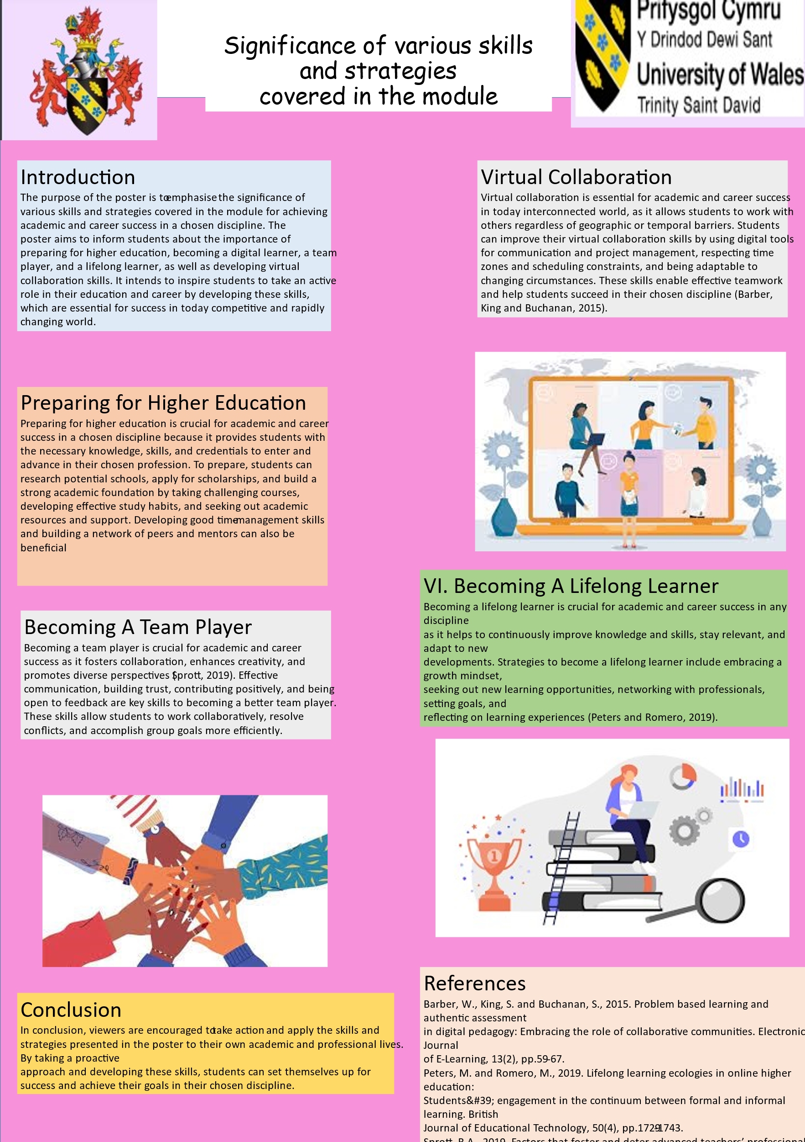

Task three – part 2
Throughout this project, I had the opportunity to work collaboratively with my team members to create an academic poster highlighting the importance of the topics covered in this module for academic and career success in psychology or counselling. The process of working in a team was both challenging and rewarding, as it required us to communicate effectively, share ideas, and work towards a common goal. Personally, I contributed to this poster by conducting research, sharing my insights, and collaborating with my team members to develop the poster's content and design. Through this process, I gained a deeper understanding of the topics covered in this module and their relevance to my chosen discipline. Furthermore, I learned how to work efficiently in a team, manage conflicting ideas, and resolve problems effectively. This poster has been an enriching experience that has taught me valuable skills that I can apply in both my academic and professional life. I look forward to continuing to develop these skills and working collaboratively with others in the future.

References
Feldman, C. and Kuyken, W., 2019. Mindfulness: Ancient wisdom meets modern psychology. Guilford Publications.
Grzanka, P.R., Santos, C.E. and Moradi, B., 2017. Intersectionality research in counseling psychology. Journal of counseling psychology, 64(5), p.453.
Shin, R.Q., Welch, J.C., Kaya, A.E., Yeung, J.G., Obana, C., Sharma, R., Vernay, C.N. and Yee, S., 2017. The intersectionality framework and identity intersections in the Journal of Counseling Psychology and The Counseling Psychologist: A content analysis. Journal of Counseling Psychology, 64(5), p.458.
Sommers-Flanagan, J. and Sommers-Flanagan, R., 2018. Counseling and psychotherapy theories in context and practice: Skills, strategies, and techniques. John Wiley & Sons.
Tomlinson, E.R., Yousaf, O., Vittersø, A.D. and Jones, L., 2018. Dispositional mindfulness and psychological health: A systematic review. Mindfulness, 9, pp.23-43.
Wielgosz, J., Goldberg, S.B., Kral, T.R., Dunne, J.D. and Davidson, R.J., 2019. Mindfulness meditation and psychopathology. Annual review of clinical psychology, 15, pp.285-316.

