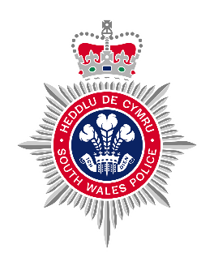
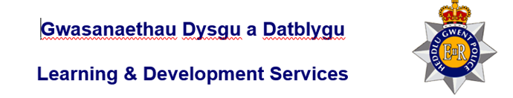

Criminal Damage Role play
Scenario 9 – location to be specified by SWP/Gwent Trainer (vehicle)

Scenario Requirements

- Two role actors, appropriately dressed – (as instructed by course trainers)
- Two officers appropriately dressed – (as instructed by course trainers)
- Control room operator.
- Assessor to be in full possession of relevant definition regarding the offence being assessed as well as the relevant assessment criteria sheet that must be completed by the assessor during the observations.
- One car
- Empty wine bottle.
- Vehicle

Safety Brief
- Safe working environment, risk assessment to be completed of the venue.
- Assessor to have given full briefing to Role actor/s and Officers/s being assessed prior to the role play.
- If officer is to detain / arrest role actor then this will be done by the officer taking hold of the role actors arm and informing them that they are being detained / arrested.
- For GWP, no handcuffs are to be used if the officer wishes to use handcuffs then they should inform the subject that they are handcuffed. Subject should place hands to the rear when informed.
- For SWP, handcuffs can be used in accordance with the Officer’s PST training.
- NO actual UDT strikes, takedowns or ground restraints are to be used.
- If there are any safety issues identified then the identifying officer should immediately call “CHECKMATE” to the role play and report their findings to the assessor.
If there are no safety issues the role play will run its course and the assessor will call “END EX” once they are happy the role play has concluded.

Trainer briefing to student(s)
You are on independent uniformed foot patrol (location as directed by the course trainer) when you are updated via your control room as to a 999 call from a person who has attended the Police Station. The caller states that they are a taxi driver and they have a person with them who has damaged their vehicle.
You are tasked with attending the Station and speaking with the reporting person. It is the time of day and day of the week.

The following details can be passed on to the student if they ask for further information-

- There is no further information to hand regarding the incident, the caller has hung up.
- No back up available currently due to other commitments.
- If you require any radio checks and have a radio available, use your radio to gather any further information required, the course trainer will designate someone to act as the controller.
- Deal with the incident as you see fit.
- Consider the following-

- Officer Safety
- Communication Skills
- Relevant Offences
- Legislation
- NDM

Role Actor 1 script - victim
You are a taxi driver for ABC Taxis, you have picked up the suspect for a fare. During the journey you have noticed that the person has got a bottle of wine out of a bag and started to drink it in the back of the Taxi. You have asked them not to do this and pointed out a “no food/drink” sign in the back of the taxi. The person has refused to put the bottle away and has become aggressive. They have then poured the whole bottle of wine over the back of the taxi.
You have locked the person into the rear of the vehicle and driven straight to the police station.
Upon the arrival of officers you will explain to them what has happened and state “I WANT THEM TO PAY FOR THE PROFFESSIONAL CLEAN OF THE TAXI, I CAN’T USE IT IN THIS STATE”
Role actor to provide own details: PNC no trace.

Role Actor 2 script - suspect
You have been out drinking with your friends, but you have become separated from them and you have decided to make your way home. You have stopped and purchased a bottle of wine before getting into a taxi. During the journey you have opened the wine and started drinking.
The driver has asked you to stop and pointed out a sign saying “no food/drink” in the taxi. You have become irate and argued with the driver, you have lost your temper and poured the contents of the bottle all over the back of the taxi.
The taxi driver has then driven you to the police station.
Upon arrival of officers, you will start shouting and ask to be let out of the car.
You will state to officers
“THEY MADE ME DO IT, THEIR DRIVING WAS SO BAD I SPILT MY WINE”
When cautioned you will state “BUT THEY CAN WASH IT OFF, WHAT’S THE PROBLEM?”
You will be argumentative and very condescending towards both the driver and the officers. You will repeatedly tell them that you have more money than them and that your brother is a solicitor and knows the chief of police.
You will refuse to provide details.

Overall outcome of scenario

- Suspect to be arrested on suspicion of Criminal Damage Section 1 Criminal damage act 1971
- Correct use of arrest and search powers if completed are to be shown by the student.
- NDM should be followed.
- Police Personal procedures- radio procedures and recording of incident in PNB should be carried out in line with force policy.
- Any exhibits should be seized safety and documented.
- Officer should complete any relevant documentation (use of force form, DASH)
- Legislation- Criminal Damage Act section 1.

Criminal Damage S1 (1) Criminal Damage Act 1971
A person who without lawful excuse destroys or damages property belonging to another, intending to destroy or damage and such property or being reckless as to whether any such property would be destroyed or damaged shall be guilty of an offence.

