


HNC Mechanical Engineering

Individual Project

SGDM5024

Lecturer: John Williams

Project Report & Presentation

Karl Phillips
30/04/2020

Summary
This report follows the progress of an apprentice’s project in making some improvements to a machine’s performance, as it has many issues that cause downtime. But it starts by researching ways to increase productivity in the workplace and what OEE means. There are many ways to increase productivity at work, including holding standing meetings, avoiding multitasking, taking regular scheduled breaks and minimising interruptions when working. OEE stands for Overall Equipment Effectiveness and it is a diagnostic tool that helps to measure and potentially improve a machines performance. There are three main loss categories when measuring a machines efficiency, Availability, Performance, and Quantity losses. If these areas are improved, the efficiency will improve. To calculate the OEE of a machine, the three main loss categories are multiplied together as a percentage giving an overall percentage. In a perfect world a machine would have 100% efficiency meaning no losses anywhere. The world standard average OEE is 88%, as there will almost certainly be some losses occurring within the process with breakdowns etc.
The project was based on the PLA machine that is situated on line 2 within Marelli Llanelli site and it assembles radiators for Jaguar Land Rover (JLR). It was being monitored for its downtime by the line coordinator and the highest problems were to be looked at for improvement. If improved it will increase the machines OEE and its productivity by reducing unnecessary stoppages. The two problems with the highest downtime were a tag on all four corners not fully folding into the correct position, so a second operator was needed to manually fold over the tags fully. The second problem was an assembly component (side casing), falling off occasionally during the assembly process and sometimes causing damage to parts. This would increase machine downtime and the scrap levels.
Prior to starting the project, a project proposal was created for approval. This stated the where the improvements needed to be made and the cost the company would save in doing so. If successful, the company would save in excess of £100,000 annually. A Product Design Specification (PDS) was then created, highlighting the specification criteria that must be met in order to carry out the project. Then a timing plan was drawn up, showing the timescales that each activity within the project would take. Although this was subject to change if any problems were met while carrying out tasks on the plan. There were three solutions looked at for each of the project improvements, so a criteria analysis chart and graph were created to show the best option of the three that was to be implemented. For the side casing issue, it was decided that duplicates of the originals were to be added to the outer edges of the compression tooling. The tag benders were to have an adjustable plate added to the original tag benders, this would increase the folding of the tags. Rough sketches were drawn up for both the improvements and technical drawings were created from them, so the designs could be implemented. Materials was booked out from the stores for the modification components and various machines were used to manufacture them, such as surface grinders, a band saw, and a milling machine. Some hand tools were also used such as a hacksaw and file. When the components were complete, modifications were also made to parts of the machine so the components could be fitted onto it. When the machine had the modifications fitted to it, there was a trial carried out to check if there were any improvements.
The project was quite successful overall. The tag benders were 100% successful and removed the second operator that was needed. When comparing the machine breakdowns chart before and after the modification were implemented, the side casing problem did reduce from 16% of the machine’s downtime to only 0.7%. This wasn’t 100% successful but a great improvement. In actual time this meant that downtime went from an average of two and a quarter hour’s per week, to under four minutes per week after the modifications were in place. The budget set out on the PDS was £3,000 and on completion of the project it came in under that value. Almost all the materials used except for a few bolts cost almost £118. The man hours worked over the course of the project accumulated to 74 hours. There were energy costs to consider too but they would be minimal as it took under 16 hours to manufacture the components with machinery. With everything added together this would still be under £3,000.
There may have been another source responsible for the remaining downtime for the side casing issue. The machine would have to be monitored until this problem occurs, but this isn’t possible as there are many other problems to deal with that have a higher priority. If the problem still remains to some extent however, higher tension springs could possibly be used to resolve it. However, higher tension springs could potentially cause damage elsewhere.

Table of Contents
1. Summary i
2. Acknowledgements 1
3. Introduction 2
4. Literature Review & Background Research 3
4.1 Increasing Productivity 3
4.2 Overall Equipment Efficiency (O.E.E.) 4
5. The Machine Problems 5
6. Project Design Specification (P.D.S.) 8
7. Project Planning 9
8. Project Solutions 10
8.1 Side Casing Holder 10
8.2 Tag Bending Modification 10
9. Design & Implementation 11
10. Analysis, Results & Evaluation 14
11. Conclusion 16
12. Recommendations 17
13. Bibliography & Citations 18
13.1 Bibliography 18
13.2 Citations 19
14. Appendices 20
14.1 Appendix1 – Core Build 5 Breakdowns Chart (July – September 2019) 20
14.2 Appendix 2 – Project Proposal 21
14.3 Appendix 3 – Product Design Specification (PDS) 22
14.4 Appendix 4 – Initial Timing Plan 26
14.5 Appendix 5 – Other Side Casing Holder Methods 27
14.6 Appendix 6 – Criteria Analysis for Side Casing Clip Modification 28
14.7 Appendix 7 – Criteria Analysis for PLA Tag Bender Modification 29
14.8 Appendix 8 – Technical Drawing of R/H Side Casing Holder 30
14.9 Appendix 9 – Technical Drawing of L/H Side Casing Holder 31
14.10 Appendix 10 – Technical Drawing of Tubeplate Tag Bender Plate 32
14.11 Appendix 11 - Manufacturing of the Tubeplate Tag Bender Plates 33
14.12 Appendix 12 – The Manufacturing of the Side Casing Holders 34
14.13 Appendix 13 – Making Modifications to the Machine 35
14.14 Appendix 14 – Core Build 5 Breakdowns Chart After Modifications 36
14.15 Appendix 15 - Timing Plan After Completion with Time Taken 37

Table of figures
Figure 1 - Labelled Section of a Typical Radiator 7
Figure 2 - Labelled PLA Core Build Area of Machine 7
Figure 3 - Compression Arm Movement 8
Figure 4 - Tag Bender Locations 9
Figure 5 - Tags Not Fully Folded 9
Figure 6 - Tags for Securing Side Casing 9
Figure 7 - Manually Fully Folded 9
Figure 8 - Initial Timing Plan Activities 11
Figure 9 - Existing Side Casing Brackets 12
Figure 10 - Rough Sketch of Side Casing Holder 13
Figure 11 - Sketch of Original Tag Bender 13
Figure 12 - Sketch of Original Tag Bender 13
Figure 13 – Rough Sketch of Tag Bending Plates 14
Figure 14 - Engineering Stores Requisition 14
Figure 15 – Tag Bender Fitted 15
Figure 16 - Side Casing Holder Modification Fitted to the Machine 15
Figure 17 - Tag Bender Modification Being Fitted to the Machine 15
Figure 18 - Complete Core with Correct Tag Folding After Modification 16
Figure 19 - Comparison of Downtime Percentage 16
Figure 20 - Breakdown of Material Cost 17
Figure 21 - Timing Plan Comparison (Before & After) 17

Acknowledgements

The following people helped and supported the progress of this project, and I would like to thank them for their input throughout.
Steve Webber - Line 2 Coordinator – Contributed by supplying the machine downtime data for analysis, on whether the project was successful or not.
Dave James - Maintenance Manager – Provided the task of finding a solution to the problems with the P.L.A. machine. He also offered any additional support if it was needed.
Neil Jones – Line 1 Senior Engineer – Gave advice and manual support where needed from his line Technicians.
Jeff Harries – Technician – Helped with the brainstorming for the possible solutions to the problems and helped with the manufacture of the modification components.
Tom Blizzard – Technician – Helped with the solution brainstorming.
Viv Rees - Engineering Stores Administrator – Supplied me with the stores expense reports for the cost of the materials used.

Introduction

Marelli CK holding Ltd formally Calsonic Kansei, is a worldwide manufacturing company that supplies components for various vehicle suppliers within the automotive industry, such as Nissan, Peugeot, Jaguar Land Rover, and Rolls Royce. The Llanelli plant supplies heat exchange products such as radiators, oil coolers and condensers. When a new machine is brought into the factory environment and is used in production to produce high volumes, there can be minor issues (teething problems), on some occasions. One of the machines that was purchased from Japan and builds the PLA radiator for Jaguar Land Rover (J.L.R.), has some minor issues that have a major effect on productivity and also increases company costs.
The problems causing the highest downtime were to be dealt with first. One of the issues is a component (a side casing) used to assemble the radiator, falls off occasionally while the machine is carrying out the assembly process. The repercussion of this is having to reset the machine every time this happens, wasting valuable time and reducing productivity. The casing sometimes gets damaged when it jams in between the compression tooling and the machine bed, so scrap volumes also increase.
Another small but high costing problem with the machine is a couple of tags on all four corners of the radiator core that should secure another component in place, don’t fully fold over when the machine assembles the radiator. This causes issues when brazing (lack of bonding). Because of this problem, two operators have to run the machine to try to reduce the machine downtime. One of the operators assembles the radiator cores and the other has to finish off bending over the tags manually. This increases the volumes produced but it isn’t cost effective. The both issues reduce the Overall Equipment Efficiency (O.E.E) of the machine. If the project is a success, other high-volume running machines with similar problems could be looked at and improved the same way.
An apprentice has been tasked with trying to resolve the problems or at least improve them, and has been given the option of any support needed from other employees within the department, such as technicians, engineers etc. Although there has been no time scale set, the quicker the improvement modifications are put in place, the sooner the increased productivity and company cost reductions will come into effect.

Literature Review & Background Research

Increasing Productivity
There are many ways to improve productivity at work, both by the employer and the employee. Some of them can be seen below:
- Hold Standing Meetings – If a meeting must be held, a standing meeting is a good way to increase productivity. A meeting where everyone stands in a group can decrease territoriality, improve performance, and increase stimulation within the group.
- Take regular breaks – It does sound counterintuitive, but taking a break when there is a scheduled one can increase concentration. INC, 2018 states “Some research has shown that taking short breaks during long tasks helps you to maintain a constant level of performance; while working at a task without breaks leads to a steady decline in performance”.
- Quit Multitasking – Multitasking can seem a good way to increase productivity, but the opposite may be in fact true. When carrying out several tasks together, the results can be a loss of time and productivity. If possible, prioritising and giving full concentration to a single project before starting the next task, will increase productivity and possibly a better job will be done also.
- Turn off notifications or lose the phone completely – When in work, your mobile phone should only be used on breaks. If the phone must be kept with you, turn off the notifications. Being able to resist a Facebook, Snapchat, Instagram or message notification in this day and age is not easy. Taking this option away will let you give full concentration to the job at hand.
- Have something nice to look at – It may sound unlikely, but INC, 2018 states “some research shows outfitting an office with aesthetically pleasing elements--like plants--can increase productivity by up to 15 percent”. Some examples can be having pictures, flowers, or something else that makes you feel happy.
- Minimise interruptions (where possible) – Try to keep work time to actually do work. When a colleague pops in for a quick chat, this can reduce productivity. Try to think smarter not harder. Sometimes taking a step back to think about ways to improve the efficiency and use of your workspace can increase productivity. Rearranging items/components used more often to within your reach will reduce the energy used, and increase speed if it is a repetitive job.

Overall Equipment Efficiency (O.E.E.)
OEE is a diagnostic toll and is a proven way to monitor and improve process efficiency. It is a Key Performance Indicator (KPI), that measures the effectiveness and any deviations from machine performance. OEE can be used in Total Productive Maintenance (TPM) and in Lean Programs. OEE represents the percentage of good production time on the selected equipment. The goal of OEE is to reduce the big six losses that are grouped into three main categories:
- Availability Loss – Equipment Breakdowns, Machine Changeovers.
- Performance Loss – Minor stoppages (less than 10 minutes), Reduced Speed.
- Quantity Loss – Start-up Scrap, Product Scrap/Rework.
The formula for calculating the machine OEE is: $OEE=Availabilty(\%) x Performance(\%) x Quantity(\%)$
For example: $OEE=88\% x 86\% x 83\%=63\%$
OEE should be used as an improvement KPI, not as the company’s final goal. OEE should be continuously measured and improved where actions are needed. OEE.com, 2020 states that “Overall Equipment Efficiency (OEE) is the gold standard for measuring manufacturing productivity. Simply put – it identifies the percentage of manufacturing time that is truly productive. An OEE score of 100% means you are manufacturing only Good Parts, as fast as possible, with no Stop Time. In the language of OEE that means 100% Quality (only Good Parts), 100% Performance (as fast as possible), and 100% Availability (no Stop Time)”. The world standard average OEE of a machine is around 88%, as there will almost certainly be losses occurring somewhere.

The Machine Problems

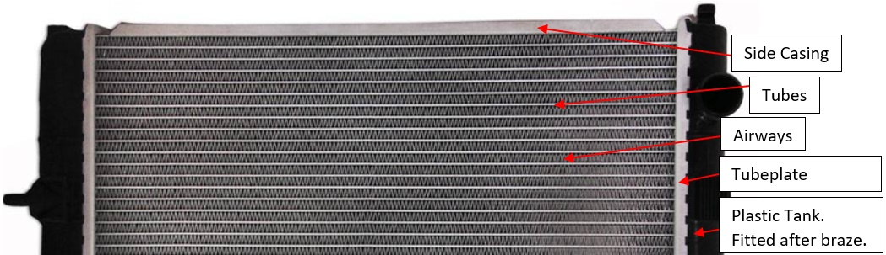
The P.L.A. core build machine (Figure 2) had various issues that increased the costs for the company, and reduced the productivity on assembling the radiator cores. Part of a typical radiator core and its components can be seen on Figure 1. The line coordinator Steve Webber recorded problems that caused the machine downtime with a ‘machine breakdowns chart’ (appendix 1). This information was passed on to Dave James the maintenance manager, who then tasked an apprentice to try to solve the problem causing the most issues. One of these issues was the side casing falling off when the compression arm was retracting during the assembly process, reducing the machines O.E.E. The machine needed resetting when this fault occurred. Figure 2 illustrates some of the basic components affected in the project.

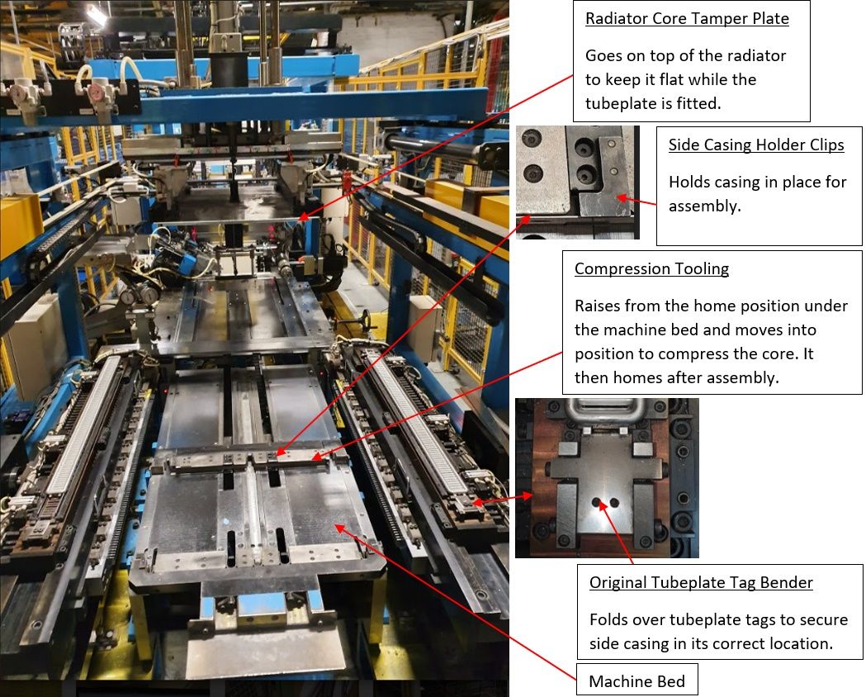
Figure 1 - Labelled Section of a Typical Radiator

Figure 2 - Labelled PLA Core Build Area of Machine
Figure 3 explains how the side casing may fall off while assembling a core (Note: The compression arm moves extremely quickly in both directions during the assembly process).
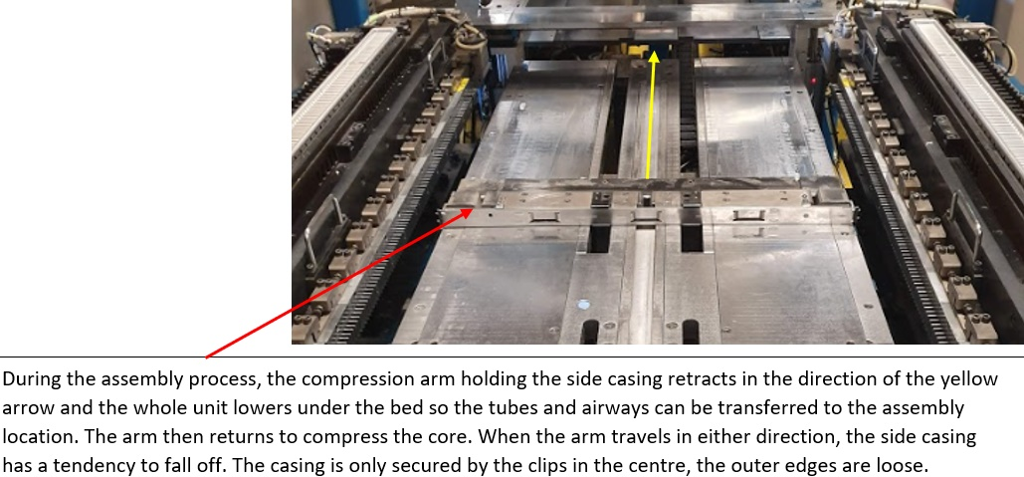

Figure 3 - Compression Arm Movement

There was another issue that was not on the breakdowns chart and has been causing a problem since the machine has been in service. There are a couple of tags that fold over during assembly and are used to hold the side casings central and tight to the tubeplate (Figure 6). They are situated on all four corners of the radiator core (Figure 4). However, the machine wasn’t fully folding over the tags during the assembly process, as seen in Figure 5. This caused problems when the radiator was sent down the furnace as the corners didn’t fully braze in the correct position and caused lack of bonding (not bonded to one another). To combat this, a second operator was needed to manually fully bend over the tags to the correct position as seen in Figure 7. The operator would use a pein hammer to tap them down flat, while the first operator continued to use the machine to assemble cores.
The cost incurred from the both problems is quite significant. The side casing problem had an average of just over two and a quarter hours downtime a week. Within that downtime, two operators were being paid for non-productive tasks. There was also scrap accumulated from the wasted cores and possibly damaged side casings. When casings are jammed between the bed, maintenance get called to solve the issue, this is one of the many knock-on effects the problem causes and another additional cost to the company. The company was paying the extra operator that was needed to fully fold the tubeplate tags over, a full wage to do what the machine should be doing. If the both problems were to be resolved the company would save an accumulated sum of over £100,000 annually.
Dave James tasked the apprentice to come up with a solution for this problem also, as it was related to the same area of the machine and would save the company money and labour for that particular machine. A project proposal was then created and approved (see appendix 2).
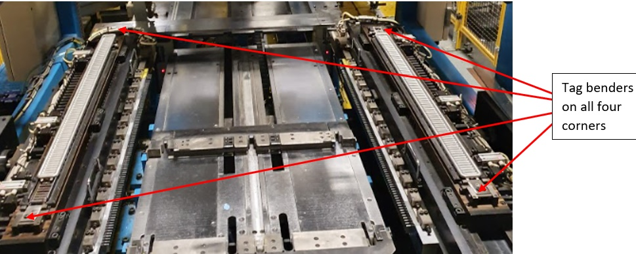
Figure 4 - Tag Bender Locations

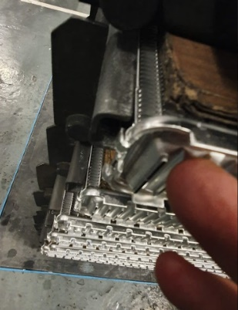
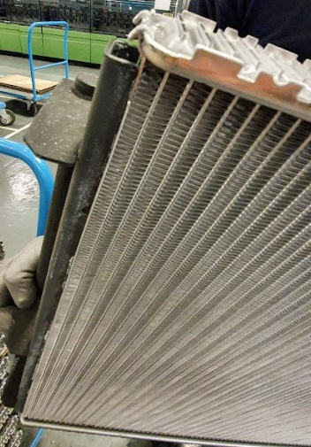
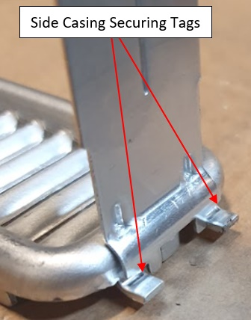
Figure 5 - Tags Not Fully Folded
Figure 6 - Tags for Securing Side Casing
Figure 7 - Manually Fully Folded

Project Design Specification (P.D.S.)
Prior to starting the project, a meeting was held with the line 2 Senior Engineer, his Technicians and the Apprentice. This was when the Project Design Specification (P.D.S.) was produced (appendix 3), stating what specification criteria was to be met when carrying out the project.
It was highlighted in the meeting that if the project was to be a success, the machine would fully bend the tags into the correct position on all four corners without damaging the radiator core in any way and keeping within the manufacturer’s specification. There would then be no need for an extra operator to manually fold over the tags. If there was any reduction in the downtime caused by the side casing falling off, more production time would be gained and scrap levels would also decrease. When the machine is reset to its home position, any components in the assembly area are scrapped, which is most of the radiator core. Improving this would save the company money and increase productivity.

Project Planning
After the approval of the P.D.S. a timing plan was created with time scales for various activities to be carried out (see appendix 4). A cropped image of the project activities that were initially set out can be seen on Figure 8 below.
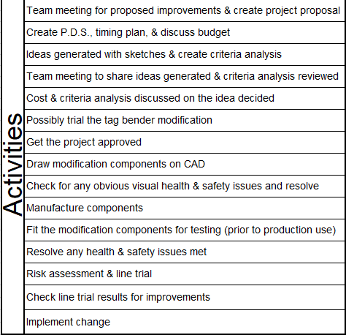
.

Figure 8 - Initial Timing Plan Activities

When activities were delayed, other tasks were either started early to take up any slack in the project, or they’d be knocked back a week or so if it was not possible to start an activity. There was no specific time put on completing the project. If the project were to be completed longer than the nineteen weeks specified on the initial timing plan, it wouldn’t be too much of an issue. Production must be considered while carrying out the project as the volumes for the PLA are high, so keeping the machine running as often as possible was the priority.

Project Solutions

Side Casing Holder
When considering ideas for the side casing holder, there were three possible solutions considered:
- Spring steel clips – Shaped spring steel plates were going to be screwed to either end of the compression tooling to help secure the side casing in place. This design was the cheapest and quickest to implement out of all the designs. But as it was spring steel, the clips would possibly fail when used continuously.
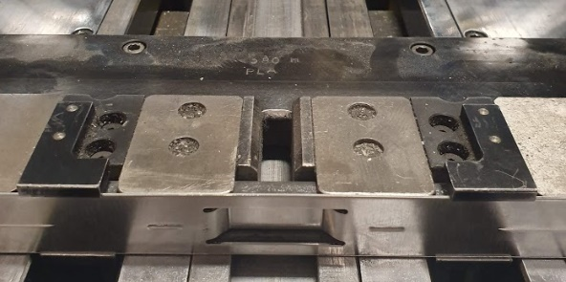
- Duplicate existing brackets – Duplicates of the existing brackets (Figure 9) would be manufactured and fitted to either end of the compression tooling. Drawing up and manufacturing new brackets would be quite time consuming. Although it’s a more expensive alternative to the spring steel idea, they would stand the test of time. The ones already in place are still doing their job sufficiently.
Figure 9 - Existing Side Casing Brackets

- Redesigning the system with new clips – When looking at other side casing securing methods used on other machines that DO actually work (see appendix 5), it would mean a complete overhaul of the existing tooling. Although this design would be successful, it would take a great deal of time to draw up and manufacture the parts. Then would also be the downtime needed to fit them to the machine. It would be the more expensive of the three designs.
Looking at the criteria analysis on appendix 6, design B the ‘duplicating of the existing brackets’ (design B) is the best of the three when considering all the criteria requirements.

Tag Bending Modification
The tag bending modification also had three possible solutions for consideration:
- Duplicate the original design but slightly bigger - A thicker and longer version of the original tag benders were going to be drawn up and manufactured. This design would be an improvement on the original and a possible success. But there would likely be trial and error with the length and thickness of the plates, and they would need removing for more material to be taken off them (grinding).
- Adding longer stroke cylinders – By adding longer stroke cylinders to the existing process, the plates could bend the tags further and maybe complete the full folding stroke needed. The downtime of the machine needed to carry out this modification would be extremely high, so would the cost with parts and the labour involved too.
- Add plates to the existing plates – If a plate was added to the existing tubeplate tag benders, it would increase the thickness and length (if needed), to complete the full bending of the tags. The cost to create a drawing and to manufacture a plate would be moderately low, as the plate would be a fairly basic design. The machine downtime to fit the modified component would be about the same as ‘design A’ but they wouldn’t need removing for further modifications to be made.
The criteria analysis for the tag bender designs can be seen on appendix 7, the design that came out on top was to ‘add plates to the existing ones’ (design C).

Design & Implementation
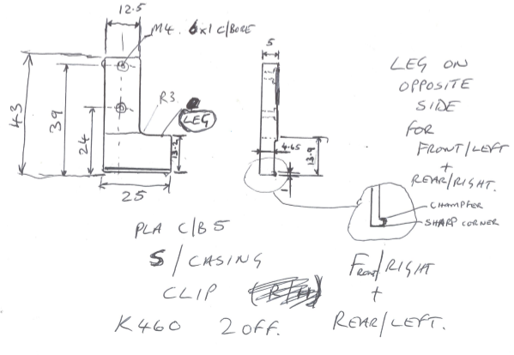
The final idea used for the side casing holder was to manufacture and add the same ‘L shaped’ component as the original ones but on either end of the tooling to secure the casing fully along its length. The existing holders were removed from the machine when it was not running (break), they were measured to be duplicated. A rough sketch can be seen on Figure 10, and from this sketch a technical drawing was created using Autodesk inventor (appendix 8 & 9).

Figure 10 - Rough Sketch of Side Casing Holder

The design of the tubeplate tag benders needed to be simple and attach to the original ones. To make the brackets versatile it was decided between the apprentice and Jeff Harris (Technician) that there should be elongated slots on either side of the plates. This would allow for any adjustments if needed, when building trial cores. Another addition was to put a countersunk hole in the centre of the bracket, so when they were in the correct position they could be drilled while in situ, then removed and the hole on the original bracket would be tapped. The modification bracket would then be secured in its correct position with three bolts.
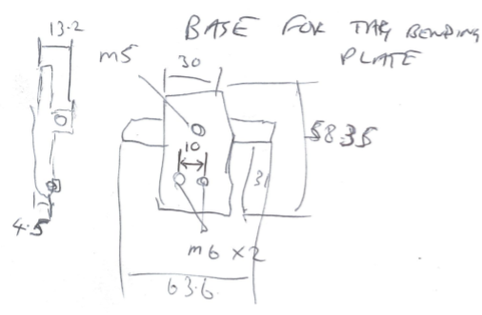
One of the existing tag benders was removed for measuring and to be checked for bolt clearance. A rough sketch was created, adding the holes that would be on the original tag benders (Figure 11). Although, the ‘M5’ hole wasn’t dimensioned on the drawing as it was to be added when the new plate was in its correct position. This sketch was used to get the dimensions for the plates that would be added. It was also used by Jeff to drill and tap the bottom two ‘M6’ holes on all four corners of the original tag benders (Figure 4).

Figure 11 – Rough Sketch of Original Tag Bender

Figure 12 - Sketch of Original Tag Bender
A rough sketch was also created for the plates as seen on Figure 13. A technical drawing was then created off this drawing for the new plates (appendix 10).
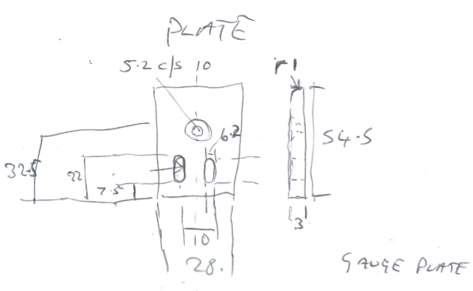

Figure 13 – Rough Sketch of Tag Bending Plates

The material for the both modifications was booked out from the stores using a requisition (Figure 14). Some of the manufacturing process that were carried out are illustrated on appendix 11, 12 and 13.
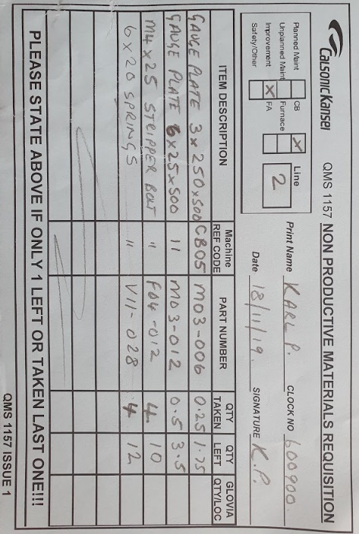
Figure 14 - Engineering Stores Requisition

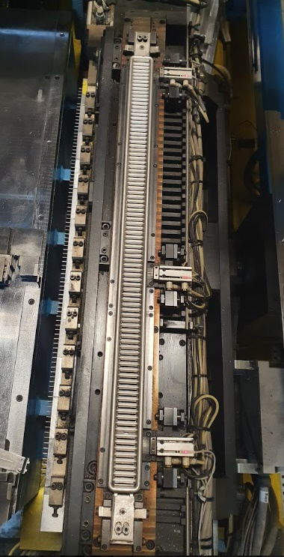
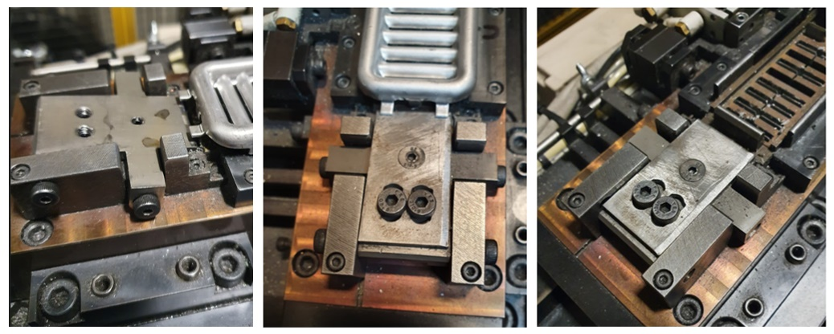
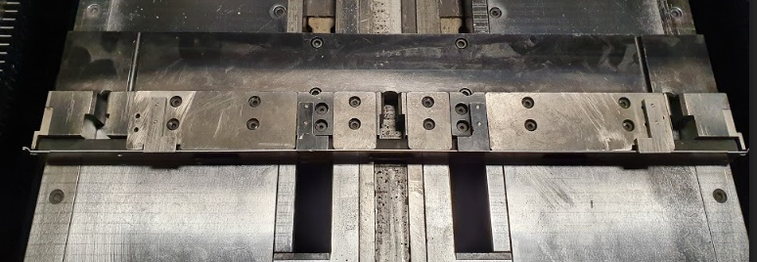
When the parts and machine modifications were complete, they were fitted to the machine for a trial. The side casing holders held the casing instantly. However, the tag benders needed tweaking. When they were in the right place, a 4mm drill spotted through the centre hole of the plates on all four corners. The plates were then removed and the original plate was threaded using an M5 tap while they were on the machine. Images of the modifications fitted to the machine can be seen on Figure 15, Figure 16 and Figure 17 below.
Figure 17 - Tag Bender Modification Being Fitted to the Machine
Figure 16 - Side Casing Holder Modification Fitted to the Machine

Figure 15 – Tag Bender Fitted

Analysis, Results & Evaluation
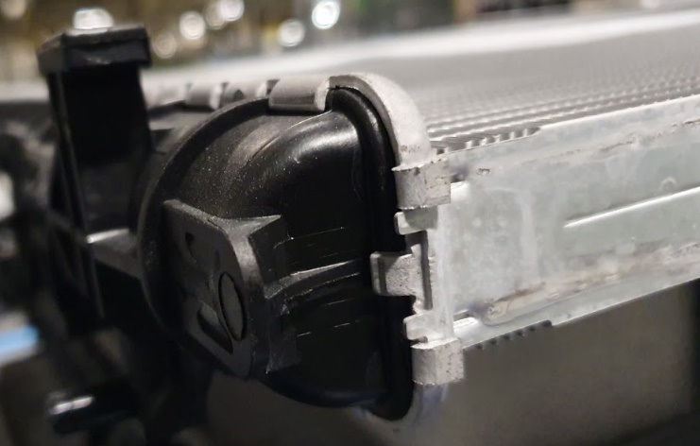
There was some degree of success with the both modifications added to the machine. The tubeplate tag benders fully folded over the tags on all four corners without damaging the core in any way. They were also within the specifications required by JLR for their product. There was now no need for the extra operator to manually bend the tags so it was a complete success. One of the corners of a brazed completed core after the modification was implemented, can be seen on Figure 18 below. The tags are perfectly flat without damaging the core in any way.

Figure 18 - Complete Core with Correct Tag Folding After Modification

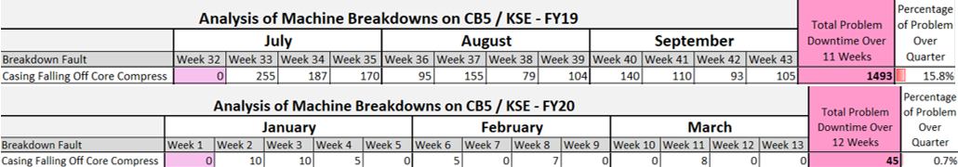
In the case of the extra side casing holders, there was still some downtime against it but it had greatly reduced compared to before the project. The updated breakdowns sheet can be seen on appendix 14. Figure 19 below shows a comparison of the downtime problem before and after the modification. Week 32 and week 1 are shutdown weeks so there was no production. The machine downtime has dropped from just under 16% prior to the modification, to less than 1% after. That’s increased production time by more than 24 hours over a twelve-week period, rather than the eleven-week period in FY19. The average downtime has dropped from just over two and a half hours per week, to just under four minutes per week.
Figure 19 - Comparison of Downtime Percentage
The total budget limit on the PDS was £3,000. The total cost for the both modifications came way under the budget as the materials used, were minimal and of little cost. Most of the materials used except the bolts came to almost £118 and a breakdown of that can be seen on an extract of the stores expense report (Figure 20). A majority of the expense went into the man hours of work that was put into manufacturing and the fitting of the components. It took a total of 74 hours to complete the project over 19 weeks, this can be seen on the completed timing plan in appendix 15. With the man hours and the material cost accumulated together it would be under £3,000 in total. However, there are the energy costs to consider but they would be minimal as it only took less than 16 hours of using machinery to manufacture the components.
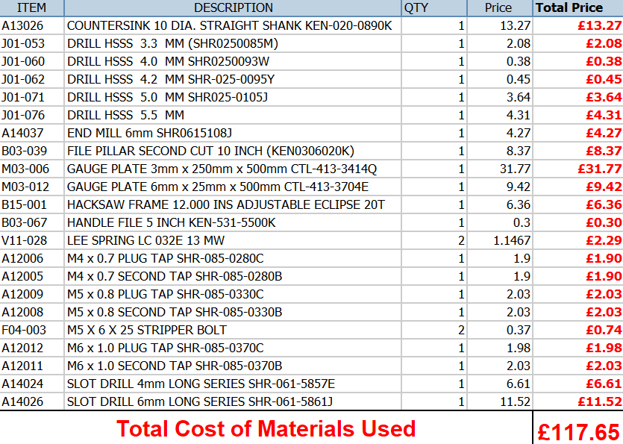

Figure 20 - Breakdown of Material Cost

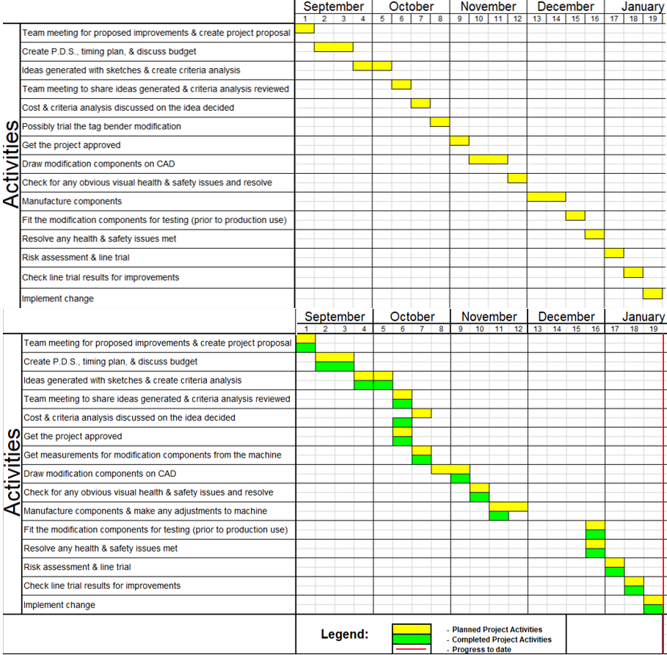
There were many differences in the updated timing plane to the original as can be seen on Figure 21. The trial of the tag bender modification was removed from the timing plan. This was because production volumes were high at that time and access to the machine was limited. It was decided to just go ahead with the modification anyway, as it could be adjusted when it was fitted anyway. Some of the other activities were condensed into one week. This was made possible by everyone attending the same extended meeting. This in turn brought other activities forward, saving us some time knowing that the Christmas shutdown would more or less stop tasks proceeding.

Figure 21 - Timing Plan Comparison (Before & After)

Conclusion
Although many obstacles were met during the project process and the timing plan was changed at different stages, the project was still completed within the time scale.
The tag bending modification was a complete success so no further action was needed. As for the side casing holders, there has been a great deal of success in this modification. But as the downtime was now so low, it was hard to see if the issue with the holders still remained.

Recommendations
With the modifications having a high level of success, the same additions could be added to any other low volume running machines that have the same setup as core build 5. If the company were to purchase another machine off the Japanese company that supplied this machine, the information that has been gained from carrying out these modifications would be passed onto them for future machine improvements.
If it is found that the side casing holder modification was still the cause of the minimal downtime still present, higher tension springs could be used on the holders to secure the casing better. But there is a fine line on how much tension the casing holder can have, as it may damage the end airway when approaching the core for the assembly part of the process.

Bibliography & Citations

Bibliography
360, E., 2020. Tolerances for fasteners. [Online]
Available at: https://standards.globalspec.com/std/94857/BS%206322-2
[Accessed 1st February 2020].
3btraining, 2020. Understanding Abrasive Wheel Markings. [Online]
Available at: https://www.3btraining.com/construction-2/understanding-abrasive-wheel-markings/
[Accessed 1st February 2020].
bsi., 2020. Cylindrical helical springs made of round wire. Quality specifications for cold coiled compression springs. [Online]
Available at: https://shop.bsigroup.com/ProductDetail/?pid=000000000030202169
[Accessed 1st February 2020].
bsi., 2020. UK's national standard for engineering drawings revised. [Online]
Available at: https://www.bsigroup.com/en-GB/about-bsi/media-centre/press-releases/2017/february/UKs-national-standard-for-engineering-drawings-revised/
[Accessed 1st February 2020].
INC, J. R., 2018. 15 Ways to Increase Producitivity at Work. [Online]
Available at: https://www.inc.com/john-rampton/15-ways-to-increase-productivity-at-work.html
[Accessed 30th January 2020].
Klipfolio, 2020. KPI Examples and Templates. [Online]
Available at: https://www.klipfolio.com/resources/kpi-examples
[Accessed 15th April 2020].
Lab, L., 2018. What is OEE - Overall Equipment Effectiveness. [Online]
Available at: https://www.youtube.com/watch?v=-lm1TJ3CiQo
[Accessed 10th April 2020].
Lab, L., 2019. OEE Calculation - Overall Equipment Effectiveness. [Online]
Available at: https://www.youtube.com/watch?v=eLQqaSGjlrw
[Accessed 10th April 2020].
MachneBuilding.net, 2020. BS EN 13128 the milling machine safety standard. [Online]
Available at: http://www.machinebuilding.net/ta/t0238.htm
[Accessed 1st February 2020].
Mulder, P., 2016. Total Productive Maintenance (TPM). [Online]
Available at: https://www.toolshero.com/quality-management/tpm-total-productive-maintenance/
[Accessed 15th April 2020].
OEE.com, 2020. What is Overall Equipment Effectiveness?. [Online]
Available at: https://www.oee.com/
[Accessed 10th April 2020].
Operations, B., 2015. Five critical sccess factors for implementing lean programs. [Online]
Available at: https://better-operations.com/2015/11/23/5-critical-success-factors-for-implementing-lean-programs/
[Accessed 15th April 2020].
Standards, E., 2020. BS EN ISO 4957:2018 Tool steels. [Online]
Available at: https://www.en-standard.eu/bs-en-iso-4957-2018-tool-steels/
[Accessed 1st February 2020].
Store, T., 2020. Test conditions for surface grinding machines. [Online]
Available at: https://www.techstreet.com/standards/bs-iso-4703-2001?product_id=1122319
[Accessed 1st February 2020].
WheelZine, 2020. How to Fix a Leaking Car Radiator Properly All By Yourself. [Online]
Available at: https://wheelzine.com/radiator-leak-repair
[Accessed 15th April 2020].

Citations

INC, J. R., 2018. 15 Ways to Increase Producitivity at Work. [Online]
Available at: https://www.inc.com/john-rampton/15-ways-to-increase-productivity-at-work.html
[Accessed 30th January 2020].
OEE.com, 2020. What is Overall Equipment Effectiveness?. [Online]
Available at: https://www.oee.com/
[Accessed 10th April 2020].

Appendices

Appendix1 – Core Build 5 Breakdowns Chart (July – September 2019)
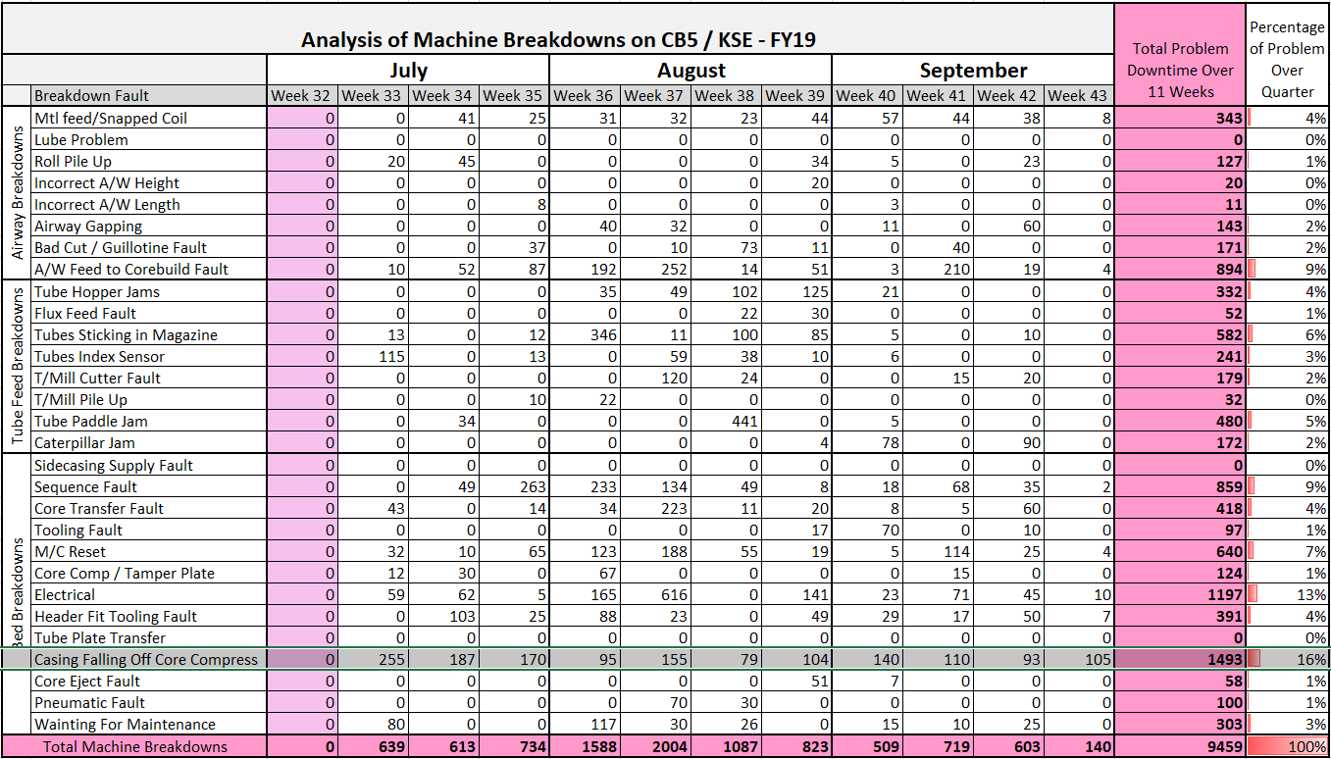


Appendix 2 – Project Proposal

Appendix 3 – Product Design Specification (PDS)
Product Design Specification for PLA core build 5 Modifications
Design brief
The machine that assembles a radiator for Jaguar Land Rover has a couple of issues that reduce productivity and increase the running costs of using the machine.
One of the issues is when the compression arm goes back into the machine ready to receive the next core, the side casing that is held by the clips on the compression arm, comes off occasionally while retracting. This can sometimes jam in the machine or the operator has to lean in and replace the side casing onto its holder. The machine then needs to be reset before continuing.
The second issue is when the radiator core is finishing the full assembly, a couple of tags on the tubeplates that are folded over to secure the tubeplate to the side casing and keeping them central and together in all four corners don’t fully fold over. Another operator has to remove the completed core from the machine and manually tap the four tags fully flat, using a pein hammer.
Modifications must be added to the machine to eliminate the problems. The correct assembly of the radiator core must not be affected in any way.

- Performance
  - When the machine fully compresses the side casing holders must not damage the radiator in any way.
  - The side casing must secure on the compression arm when it is fitted by the operator.
  - The casing must stay secure when travelling in either direction.
  - The side casing must never rub on the bed of the machine.
  - The tubeplate tag bender must fully fold over the tag.
  - The tag must be central to the side casing when folded.
  - When the tag is folded over there must not be any damage to the assembled core.

- Environment
  - There won’t be much variation in the temperatures where the machine is used but corrosion must be considered.
  - There will be evaporated oil present on the radiator components being assembled.
  - Rich Flux may also be present in the assembly components used.

- Product life span
  - The machine will be used for at least 15 years. Two years of high volumes, with the volumes forecasted to drop for the remainder.

- Life in service
  - The machine that gets modified will be running around 400 hours a month for the next 2 years, then on a possible reduced rate of 100 hours a month.

- Shelf Life
N/A

- Target costs
  - The full target cost should be under £3000.

- Quantity
  - The side casing clip will have a quantity of 1 left hand and 1 right hand (2 off in total).
  - There will be 4 off tag benders needed in total (one for each corner).

- Maintenance
  - Modified components will be monitored for wear when used by the operator as part of their pre-work checks.
  - Checks of the modified components will be added to the maintenance Preventative Maintenance (P.M.) of the machine, on a three-monthly basis.
  - No special tools should be required for maintenance.

- Marketing
N/A

- Packaging
N/A

- Size and Weight restrictions
  - Modifications must not impede the assembly of the radiator core in any way.

- Shipping
N/A

- Manufacturing Processes
  - All material used will be cut internally (Marelli CK Holdings), using a band saw.
  - Any modification components manufactured will be milled and drilled using manual or CNC milling machines, then grinded with a surface grinder to correct dimensions if necessary. All processes completed internally.
  - If there is to be any processes to be carried out when the modification components are fitted to the machine such as tapping or drilling holes, hand tools will be used (cordless hand drill, tap wrench, taps etc).

  - Materials to be bought in from the following suppliers:
- Gauge Plate – Cromwell Tools
- Springs – Lee Spring
- Drill bits – Cromwell Tools
- All fittings (Stripper and various bolts etc) – Eriks Industrial Services Ltd

- Aesthetics
  - The form can follow function.
  - Modification components must have no sharp edges.

- Ergonomics
  - The modified parts must be safe enough for the operator to use.

  - When checking the components used for the modification during preventative maintenance, it should be as easy as possible to check for wear on springs etc.

- Customer Requirements
  - Must assemble PLA radiators to the required specification set by Jaguar Land Rover (JLR).

- Competition
N/A

- Quality and Reliability
  - Any materials used must be strong and reliable enough to carry out what is intended of them.
  - Materials used should be as maintenance free as possible.

- Standards and Specifications
  - Standards to adhere to:
- BS 8888 – Technical drawings
- BS EN ISO 4957 – Gauge Plate 0.1 Tool steel
- BS EN 15800 – Springs
- BS EN 13128 – Milling machines
- BS ISO 4703: 2001 – Surface grinding machines
- BS EN 12413 and BS ISO 525 – Abrasive wheel
- BS 6322(2) & BS 4320 - Nuts and washers

- Company Constraints
  - None – except those outlined in Manufacturing and Processes.

- Processes
  - All components to be of a metric form.

- Safety
  - The machine must be used by a competent person (Trained).
  - Modified components must be safe to use with no sharp edges present.
  - There must be no pinching points on the modifications made.
  - Radiator assembly components must be easy to fit with the new modifications in place.

- Testing
  - Modifications will be tested for ease of use prior to an operator using them.
  - When being tested by an operator they will be briefed and the testing will be monitored.

- Legal
  - Possible litigation lies in the user injuring themselves by having access to moving parts during the assembly operation. (Training must be given to try to avoid this).

- Installation
  - No special tools will be required when installing modification components.

- Documentation
  - The modifications will be added to the existing Standard Operating Sheet (S.O.S.).

- Disposal
  - The materials used will be fully recyclable.

Appendix 4 – Initial Timing Plan

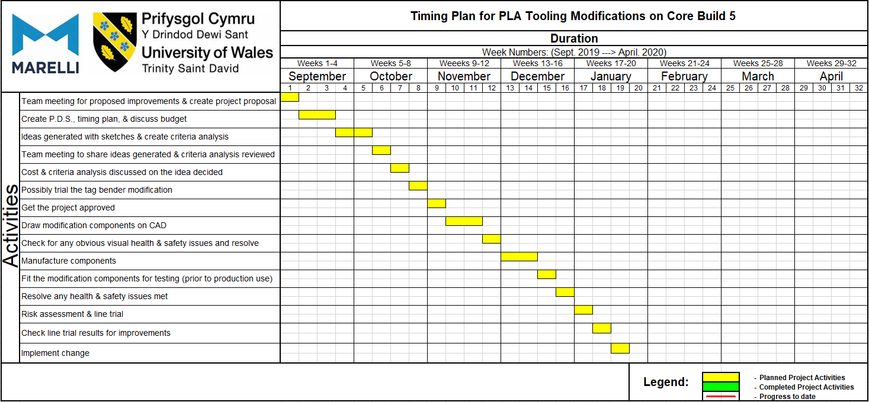

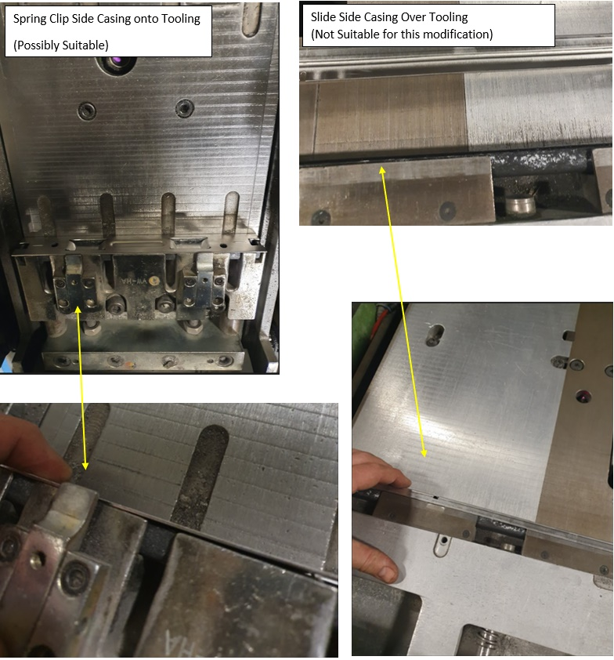
Appendix 5 – Other Side Casing Holder Methods

Appendix 6 – Criteria Analysis for Side Casing Clip Modification
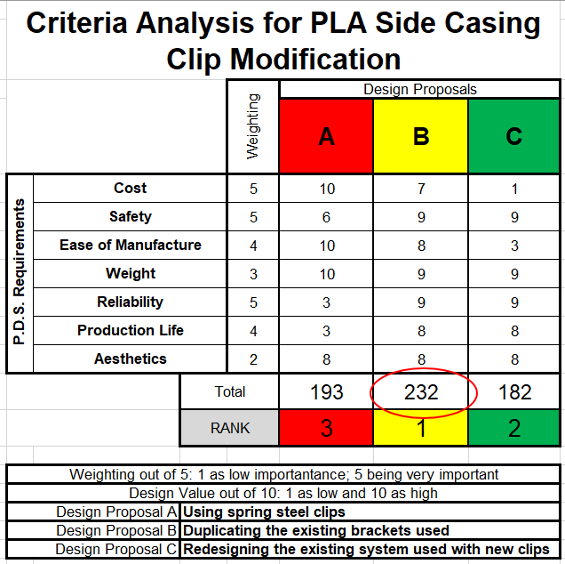

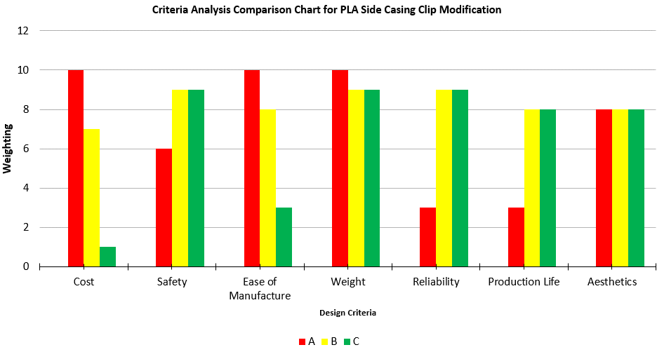

Appendix 7 – Criteria Analysis for PLA Tag Bender Modification

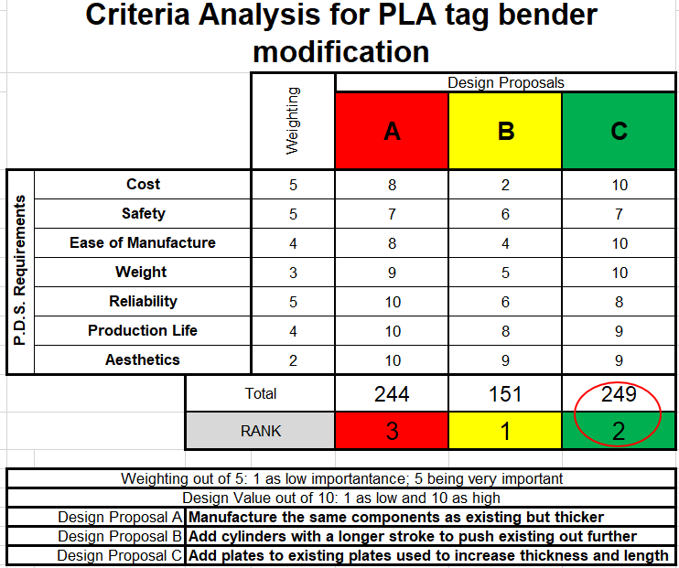

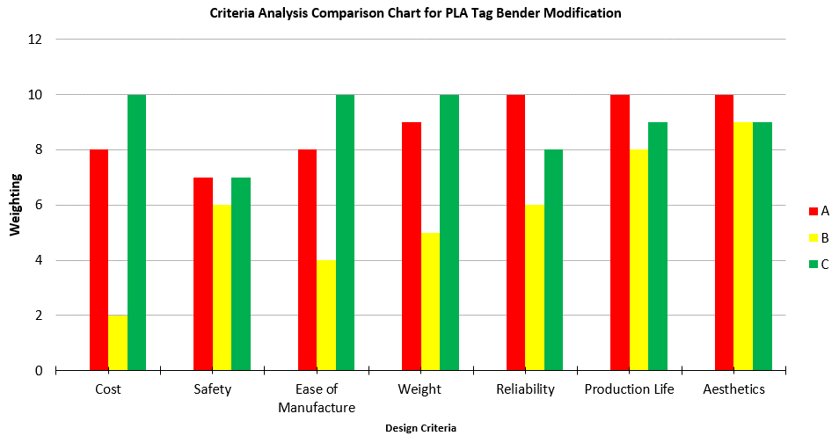

Appendix 8 – Technical Drawing of R/H Side Casing Holder
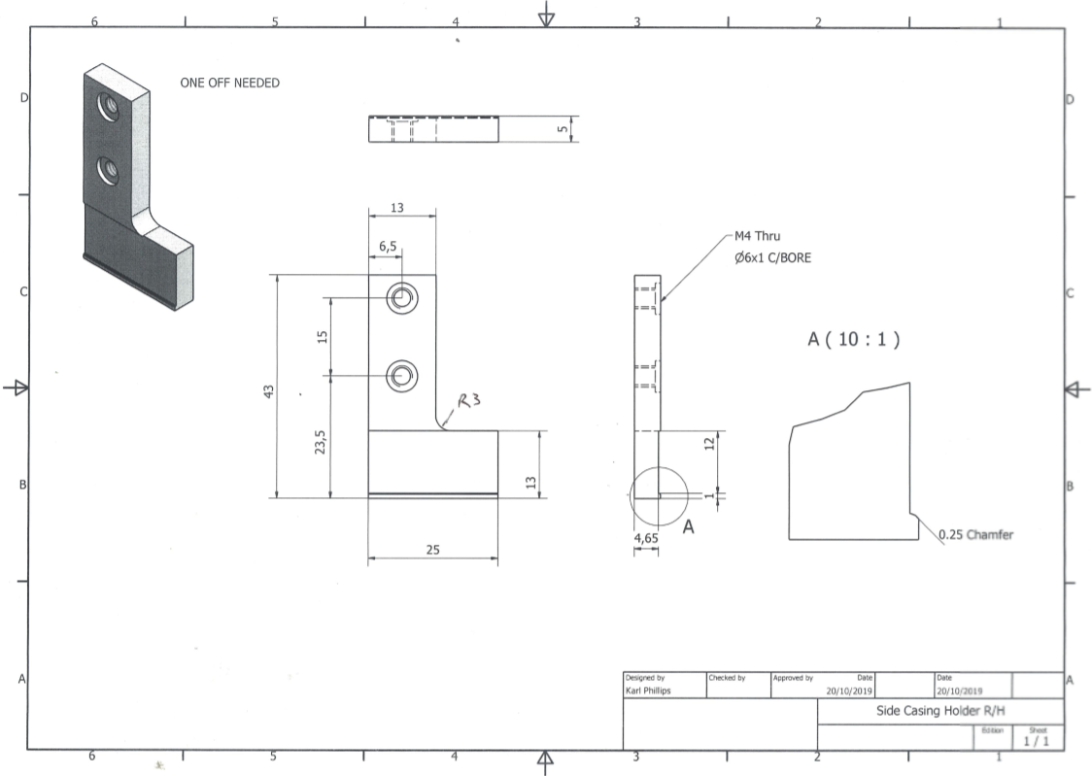
K460

Appendix 9 – Technical Drawing of L/H Side Casing Holder
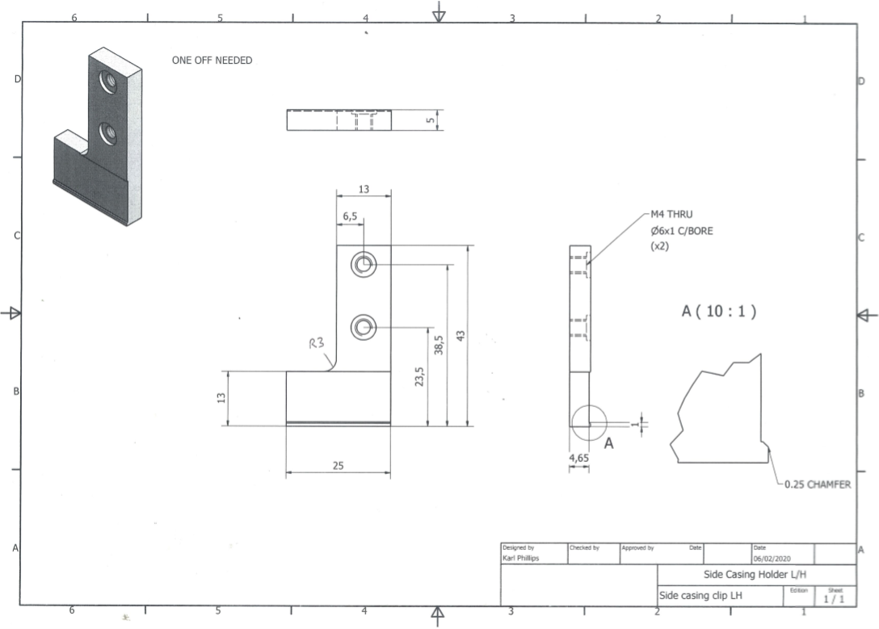
K460

Appendix 10 – Technical Drawing of Tubeplate Tag Bender Plate
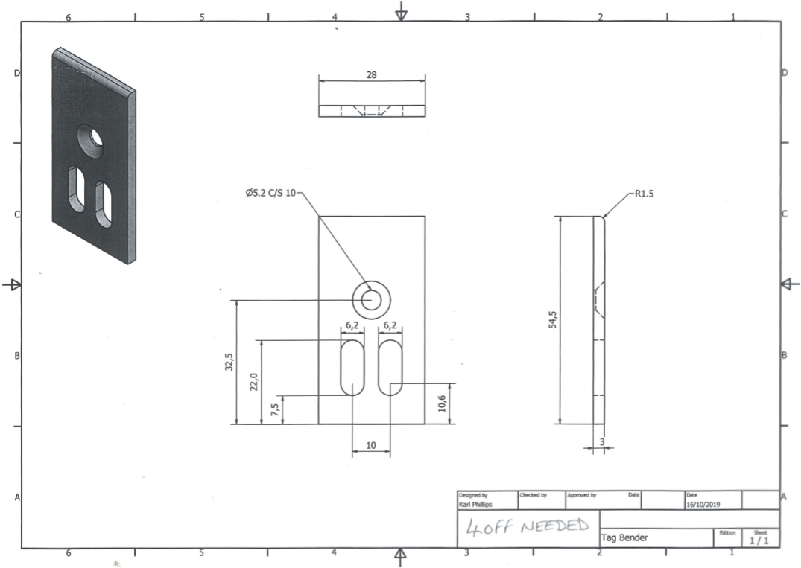
Gauge Plate

Appendix 11 - Manufacturing of the Tubeplate Tag Bender Plates
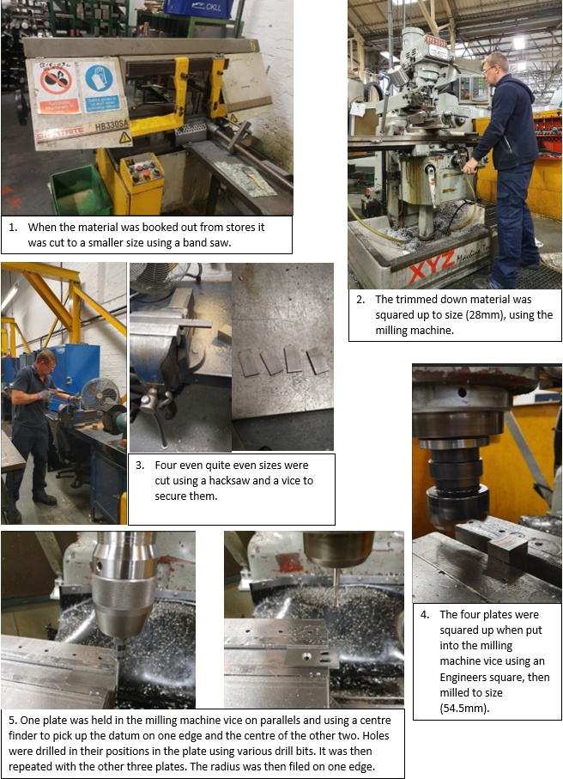

Appendix 12 – The Manufacturing of the Side Casing Holders
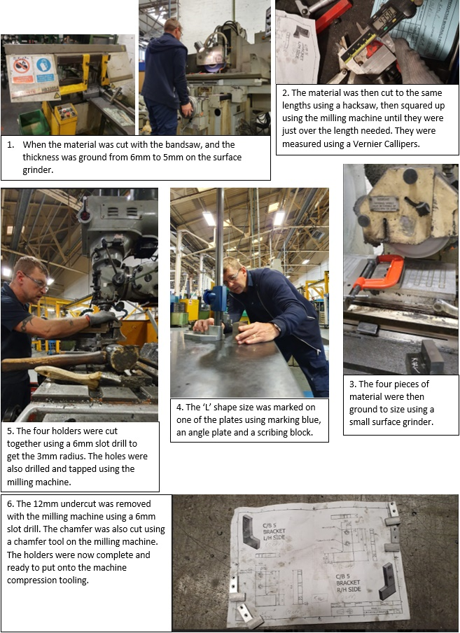

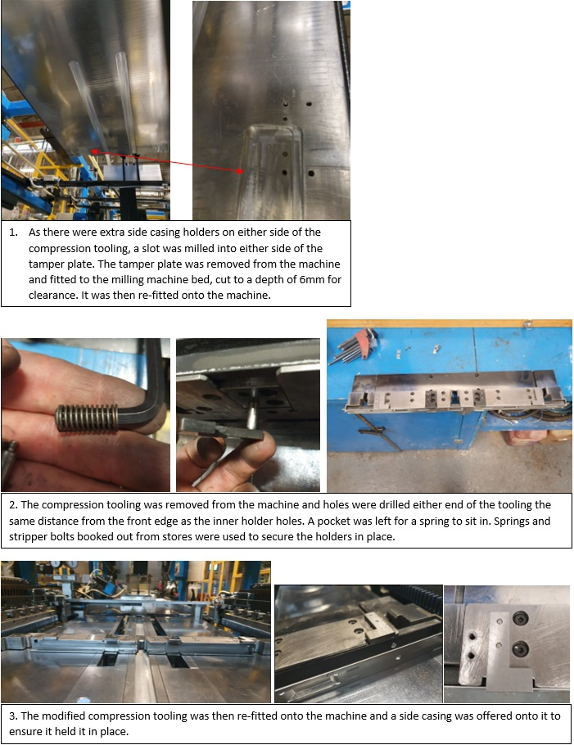
Appendix 13 – Making Modifications to the Machine

Appendix 14 – Core Build 5 Breakdowns Chart After Modifications
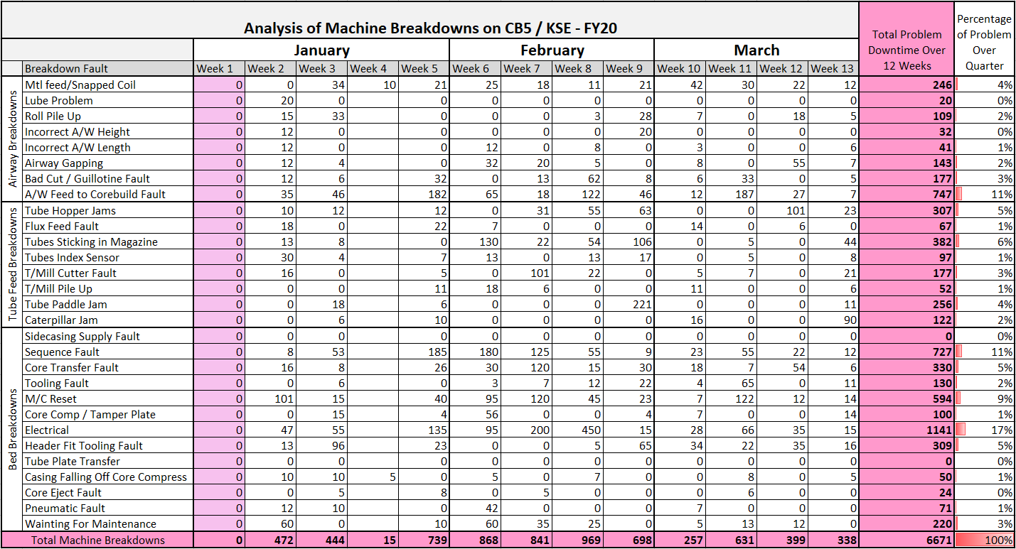

Appendix 15 - Timing Plan After Completion with Time Taken


