HNC: Process Operations Engineering
Subject: Environmental Protection and Substainable Manufacturing Systems

Assignment 1: Research Report

Stundent Number: 1708067
Student Name: Charlie Perkins
Email: 141612@pembrokeshire.ac.uk
Lecturer Name: Kadi Berry
Hand In Date: 26/04/2023
Abstract
The following report explores the infrastructure of the Fluid Catalytic Cracking Unit ‘FCCU’ and the associated equipment within the process, illustrating the implications on the conservation of energy within the Power Recovery Train ‘PRT’. Analysing methods used to reduce energy losses, while identifying improvements to the system to increase energy recovery made by the process during operation, identifying how local/global rules and regulations have been met. Furthermore, the segregation and recycling of the Wastewater Treatment Plant ‘WWTP’ has been explained, identifying how the wastewater is cleaned and pumped back into the haven meeting environmental standards.

Contents

Table of Figures 4
Introduction 5
Task 1) 6
Refinery Process - Fluid Catalytic Cracking Unit (FCCU) 6
FCCU Process Systems and Equipment 7
7
FCCU - Power Recovery Train (PRT) Infrastructure 8
PRT Associated Equipment, with their Implications on Energy Conservation 11
PRT - Expander 11
PRT - Air Blower 14
PRT – Steam Turbine 15
PRT – Motor Generator 15
PRT Mechanical Protection and Safety Systems, used to Reduce Energy Losses 16
PRT Improvements to Aid in Energy Recovery, Meeting Local and Global Standards 16
Task 2) 18
Segregation and Recycling of Waste Products on the Wastewater Treatment Plant ‘WWTP’ 18
References 24

Table of Figures

Figure 1 FCCU Structure (13/03/23) 7
Figure 2 PRT Structure (13/03/23) 8
Figure 3 Multi-Stage Axial Compressor - Air Blower (13/03/23) 9
Figure 4 Lube Oil Skid (11/04/23) 10
Figure 5 Steam Turbine (11/04/23) 10
Figure 6 Turbo Expander (11/04/23) 11
Figure 7 Turbo Expander Flue Gas Flow (11/04/23) 12
Figure 8 Stator Vanes within a Fan Blade (24/04/23) 14
Figure 9 Primary Diversion Box (18/03/23) 19
Figure 10 API Separators (18/03/23) 20
Figure 11 Inline Mixer, with Polyelectrolyte Added (18/03/23) 21
Figure 12 Jet Aeration Systems (23/03/23) 22
Figure 13 Dissolved Air Flotation ‘DAF’ Units (21/03/23) 22
Figure 15 Air Blowers and Pumps (23/03/22) 23
Figure 14 Wastewater Parameters, before Pumped to Haven (23/03/23) 23

Introduction
This report explores the infrastructure of a process and associated equipment within Valero Pembroke, explaining their implications on the conservation of energy and analysing methods used to reduce energy losses. Suggesting on improvements to be made to the process in energy recovery, while meeting local/global rules and regulations. Lastly, explaining how segregation and recycling of the wastewater is achieved at the refinery.

Task 1)

Refinery Process - Fluid Catalytic Cracking Unit (FCCU)
The purpose of the ‘FCCU’ is to split long chain hydrocarbons and cyclic hydrocarbons into smaller and more valuable products. The max feed rate for the FCCU is 606 m3/hr.
The feedstock used is a mix of Vacuum Gas Oil ‘VGO’, taken from the Vacuum Distillation Unit ‘VDU’ and atmospheric residue from the Crude Distillation Unit ‘CDU’. (A. Kayode Coker, 2022).
These feedstocks when cracked produce:
- Liquid Petroleum Gas (LPG) - LPG and Olefin feed stock for the Alkylation Unit.
- Naphtha - Gasoline component.
- Light Cycle Gasoil (LCGO) - Diesel Hydrotreater feedstock, also used for fuel oil.
- Heavy Cycle Gasoil (HCGO) - Carbon black feedstock, also used for fuel oil blending.
- By-product fuel gases (Hydrogen ‘H2’, Methane ‘C1’ and Ethane ‘C2’).
- By-product coke burnt on the catalyst in the Regenerator.

FCCU Process Systems and Equipment
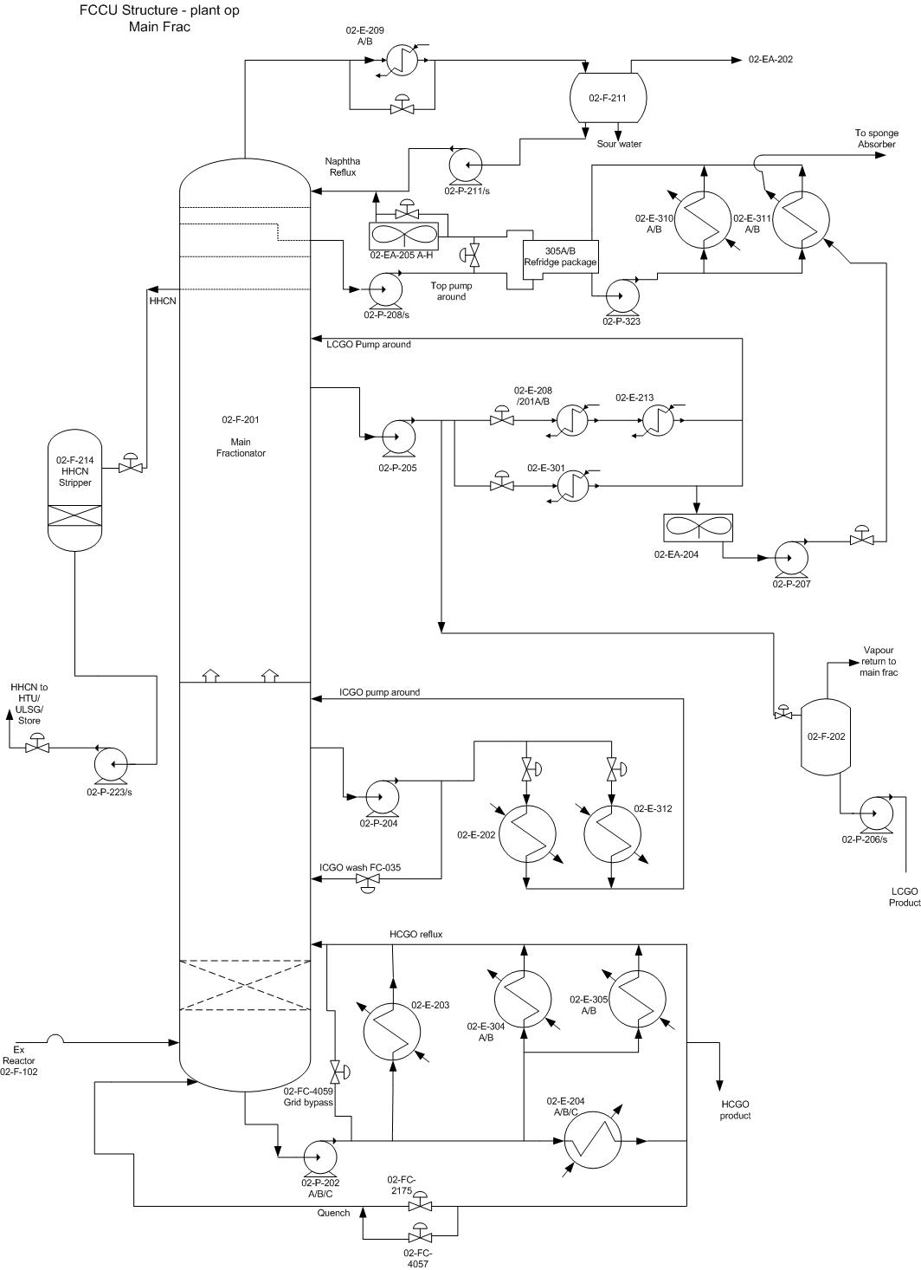
Figure 1 FCCU Structure (13/03/23)

FCCU - Power Recovery Train (PRT) Infrastructure

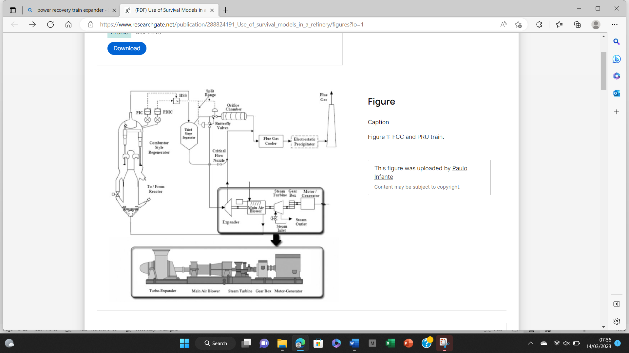
The Power Recovery Train ‘PRT’ is a process used to recover large amounts of energy from the hot flue gasses (695°C), that surface from the regenerator, which is used to restore the catalysts cracking ability by removing coke. The ‘PRT’ has an expander that is linked by shafts used to transfer energy to a chain of equipment. These being an air blower, steam turbine gearbox and motor generator. (Robert A. Meyers, 2016).
Figure 2 PRT Structure (13/03/23)

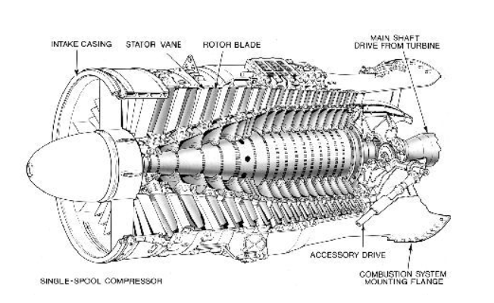
The energy is recovered from the flue gas stream when it expands to a lower pressure and temperature state across a single stage expander. From this the energy can be used to drive a multi-stage axial compressor, known as the air blower. Prior to the air blower the air must pass through coalescer pads and filters used to remove particulates, the blower blades are also cleaned regularly to ensure efficiency. (R. Ramzy, 2020).
Figure 3 Multi-Stage Axial Compressor - Air Blower (13/03/23)

The steam turbine is used during start-up of the process; however, it can be used to set the ‘PRT’ speed when the motor generator is overloaded, and insufficient energy is accessible from the expander. (Amir Ayad, 2021).

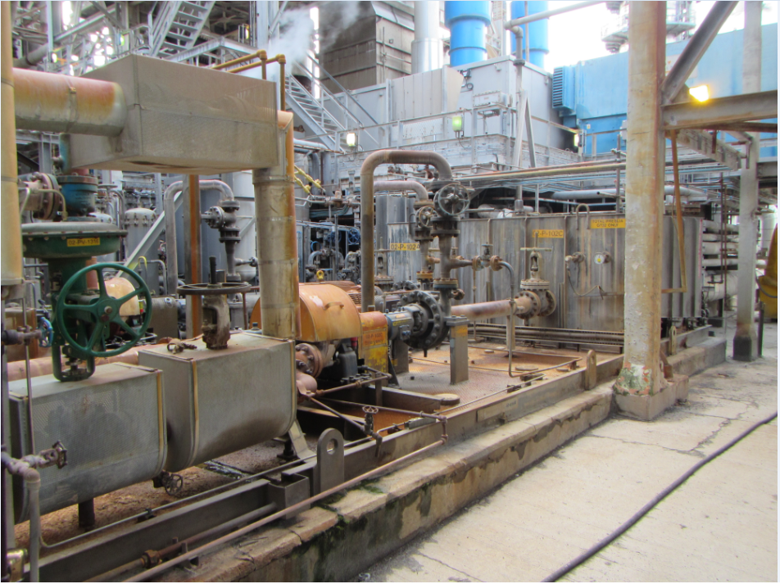
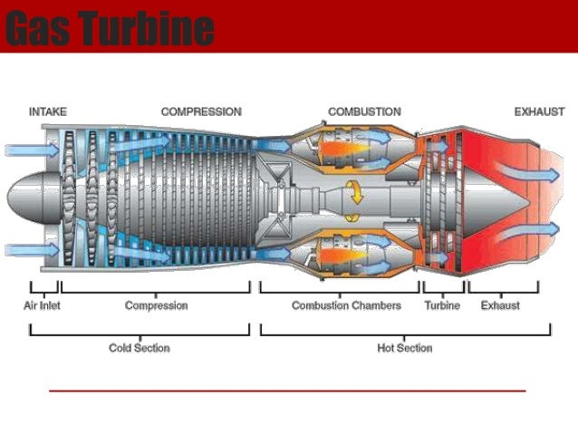
The motor generator operates as two applications, a driver to assist the expander prior to use of the steam turbine, or as an electrical generator. Due to the ‘PRT’ using a series of components that require lube oil, an independent facility is used to provide a lube oil feed to bearings and internals within the gearbox, air blower and steam turbine. (B. Lang and L. Edwards, 2018).
Figure 4 Lube Oil Skid (11/04/23)

Figure 5 Steam Turbine (11/04/23)

PRT Associated Equipment, with their Implications on Energy Conservation

PRT - Expander

The flue gas leaves the regenerator and enters the suction line of the expander, with the flow rate controlled by a butterfly valve. The line is continuously purged by medium pressure ‘MP’ steam controlled via orifice plates, this prevents catalyst and hot flue gas from damaging gland packing of the valve causing it to seize, also preventing the shafts from overheating and cracking allowing leaks to become present. The train from the expander through to the high-speed shaft of the gearbox runs at a nominal normal operating speed of 3900 rpm. The output shaft of the gearbox and the motor generator operate at approximately 1500 rpm. (Silvia Madeira, 2013).
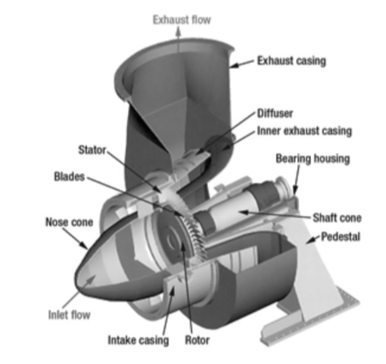
Figure 6 Turbo Expander (11/04/23)

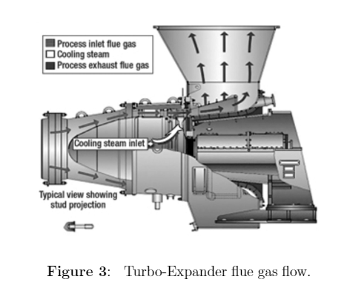
Figure 7 Turbo Expander Flue Gas Flow (11/04/23)

At the expander suction there are various instruments to monitor and analyse the flue gas:
Gas chromatography is used to take samples and measure the following components:
- Carbon Monoxide
- Carbon Dioxide
- Nitrogen
- Oxygen Sulphur Dioxide
- Water
The above samples are taken to ensure compliance with the Environmental Protection Act 1990 and the Clean Air Act 1993. (Rosie Anderson, 2023).
Furthermore, a temperature indicator is used to sound a high and low alarm, which states the temperature of the expander discharge, with a torque indicator used to indicate the horsepower, torque and speed on the output drive shaft of the expander. This ensures that efficient operating settings are put in place, so maximum output can be achieved, preventing energy losses seen by over working induvial parts of the ‘PRT’.

As the expander is exposed to high temperatures, it is vital that cooling is in place, this is carried out through three different operations:

- Normal Cooling – Constant cooling steam supplied when the ‘PRT’ is in operation.

- Windmilling - Cooling supplied when the ‘PRT’ is running with power supplied from the steam turbine/motor generator and the expander inlet valve is throttled or closed.

- Afterburn control – Steam supplied without flow restriction used for emergency cooling, this will start in the condition of the expander reaching unsafe high temperatures.

During operation the expander can undergo a build-up of catalyst on the blades, when this occurs the temperature can be reduced while pressurised walnuts are fed into the expander inlet. Allowing catalyst to break up and be collected within the regenerator, while cleaning the blades ensuring efficiency. This method of cleaning prevents an energy loss as the catalyst is regenerated, it’s also environmentally friendly as the walnuts are a sustainable material source. (Nabil Abu-Khader, 2022).

PRT - Air Blower

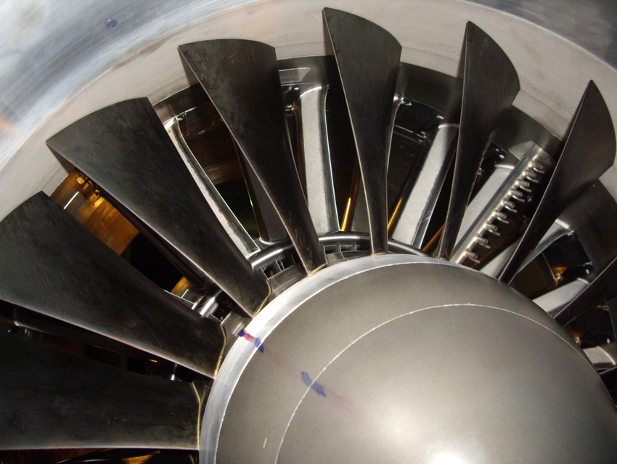
The air blower is a 15-stage axial compressor, used to provide continuous compressed air to the regenerator for catalyst regeneration. The compressor is driven by the expander output shaft. Prior to the entry of the air blower the air is filtered and measured. Within the air blower, rotor blades are used to increase the velocity of the air, with stator vanes positioned so that the pressure can be increased, these vanes are controlled by hydraulics. (S. Can Gülen, 2019).
Figure 8 Stator Vanes within a Fan Blade (24/04/23)

The flow rate through the blower is around 310,000 Sm³/hr. The compressed air is discharged through the top half of the casing. The blower can be driven from either end, this is achieved as the motor generator and steam turbine can drive the blower from the inlet, with the expander driving from the outlet. (James G. Stallcup, 2020). The motor generator and steam turbine drive the blower until a high temperature flue gas begins to flow from the separator to the expander. Once the expander takes over, the turbine begins the windmilling mode, with the motor generator either driving the shaft or generating electricity to the refinery grid, dependent on the speed of the ‘PRT’. This allows cost savings to be seen as the power generated would be distributed back into the refinery.

PRT – Steam Turbine
The High Pressure ‘HP’ steam powered turbine is a three-stage multi-valve condensing turbine, its used to allow the power expander train to get up to speed when insufficient hot flue gas is available to drive the air blower at the required speed and power during the commissioning and startup of the ‘FCCU’. The Valve controlling the ‘HP’ steam can be operated either locally or via the control panel. When the ‘PRT’ is in operation, the ‘HP’ steam is kept hot by connecting a small flow to the ‘MP’ steam systems through restriction orifice plates.
In the event of oil pressure falling below the setpoint within the turbine, the solenoid valves will de-energise activating the trip/throttle valves to close preventing steam from powering the turbine. Furthermore, if an unsafe speed is achieved (low or high) local and panel alarms will be sounded and the ‘PRT’ will initiate its shutdown preventing wasted energy being output. (Kyle Pennell, 2023)
If any steam leaks are within the turbine they are routed through the shell of the condenser and piped back into the system, aiding in energy recovery.

PRT – Motor Generator
The motor generator ‘Mogen’ operates as a drive motor or electric generator dependent on the load on the ‘PRT’. The motor will take over effect if the speed of the ‘PRT’ drops below 1500 rpm (designed speed for electricity to be generated for the plant grid). This set-up allows energy recovery to be continuous, preventing frequent start-ups and shutdowns, leading to high emission outgoings. That could see the Environmental, Health and Safety ‘EHS’ group enforcing fines and demanding a refinery shutdown action. (Tek Sutikno, 2010).
The operation of the ‘Mogen’ is monitored by local and control panel readings, locally it can be determined by a zero centre (indicator pin), the control panel will be shown on a computer software known as ‘DeltaV’. As stated above its operation is either as a drive motor or electric generator.
If the ‘Mogen’ operating speed differs 10%, a switch will be energized linked to the drive motor or electric generator switching the operation. If the speed drops or rises above the shutdown low/high alarms, solenoids are energized and the circuit breaker to/from the plant grid is disconnected, shutting down the unit.

PRT Mechanical Protection and Safety Systems, used to Reduce Energy Losses

- Train bearings are pressure lubricated and temperature monitored both locally and in the control room. The lubrication creates a barrier between rolling contact and sliding surfaces, preventing bearings becoming seized and energy losses present.
- Throughout the ‘PRT’ pressure, flow, temperature, vibration and speed sensors are installed. These sensors allow inefficiencies to be identified and unsafe operational levels to be stopped. Common failures found are bearing, piping, casing, rotor, misalignment, corrosion and loose connections.
- The sensors all have high alarms and trips fitted to ensure that if their limits are reached the ‘PRT’ can be brought back to a safe level, via an emergency shutdown.
The above systems ensure that regulations such as the Health and Safety at Work Act 1974, Provision and Use of Work Equipment regulations 1998 and Control of Substances Hazardous to Health regulation 2002 are met, not putting employees at risk. (Richard Brookes, 2019).

PRT Improvements to Aid in Energy Recovery, Meeting Local and Global Standards
As the ‘PRT’ is a large heavy-duty machine that operates under high temperatures, it requires the use of strong, hard waring, heavy materials with a high resistance to heat, such as titanium and tungsten. Due to the scale of the machine and heavy materials used a high amount of efficiency is lost, along with a poor amount of energy recovery. An improvement that could be made to this system would be a re-design with more advanced metals used such as Carbon steel or beryllium. To allow the ‘PRT’ to be downsized and made lighter, improving its efficiency and energy recovery.
Furthermore, another improvement would be to put in place a planned preventative maintenance ‘PPM’ task that ensures filter maintenance is carried out. Ensuring filters are cleaned and replaced when required, this ‘PPM’ would allow build-up of dust and coke to be removed. Enhancing the extraction of dust and coke from within the catalyst, improving the energy recovery as a more efficient catalyst regeneration can be accomplished. This will also ensure that the stator vanes and fan blades remain clean as the catalyst will be cleaner preventing a build-up on the blades, which will downgrade the streamline and power output of the expander.
Lastly, a major improvement to the ‘PRT’ would be to add a 4th stage separator to further clean the catalyst as the separators prevent dust and coke entering the regenerator, contaminating the catalyst when it is sent back through the ‘FCCU’.

Task 2)

Segregation and Recycling of Waste Products on the Wastewater Treatment Plant ‘WWTP’
The ‘WWTP’ is a process used to clean contaminated water that is produced within the refinery (3 million gallons of water per day). The contaminated water is treated to ensure that when it is discharged into the haven it meets standards, set by the Environment Agency ‘EA’. (British Water, 2020).
There are five main wastewater streams on site, these are:
- Ballast Water, discharged from Ocean tankers loading refinery products.
- Process Water, used within refinery processes, highly contaminated with Phenols Ammonia, Sulphides and oils.
- Surface Water, rainwater collected within storm drains and reservoirs.
- Product Tankage, water accumulated within tanks storing product.
- Sanitary Systems, waste from on-site sewerage.
The ‘WWTP’ is operated based on the following accumulated data:
- Flow 568 m³/hr
- Suspended Solids 200 ppm
- Oil 300 ppm, Biological Oxygen Demand B.O.D.5 150 ppm
- Total Dissolved Solids 6000 ppm
From the above data the ‘EA’, requires the wastewater produced by the refinery to be discharged into the haven under the following conditions:

  - Temperature 35⁰C
  - Suspended Solids 85 ppm
  - pH 6 – 9
  - COD 270 ppm
  - Sulphides 1 ppm
  - Ammonia 20 ppm
  - Phenols 3 ppm
  - Cyanide 250 ug/l
  - Copper, [Cu] 80 ug/l
  - Nickel, [Ni] 85 ug/l
  - Zinc, [Zn] 560 ug/l
  - Oil 17 ppm

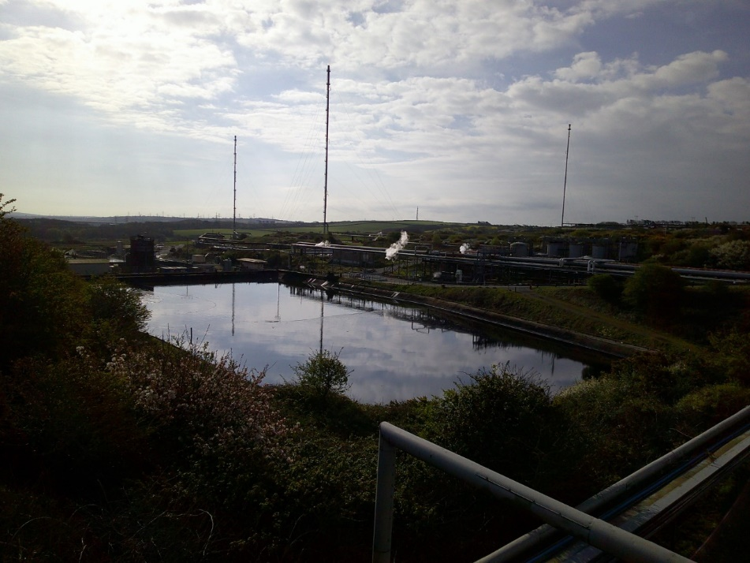
The five main wastewater streams are fed to and accumulated in the Primary Diversion Box (PDB), this supplies the wastewater to the ‘WWTP’, which operates under a gravity fed system that is assisted by hydraulic pumps used to redirect the influent/effluent as required.
Figure 9 Primary Diversion Box (18/03/23)

If the pH is above the range required for the process to begin, 96% Sulphuric Acid is injected into the ‘PDB’ allowing the pH to be lowered.
After the ‘PDB’ the wastewater passes through API separators used to separate solids and oil from the main influent. The main influent is then sent through two API forebays. (American Water Chemicals, 2023).
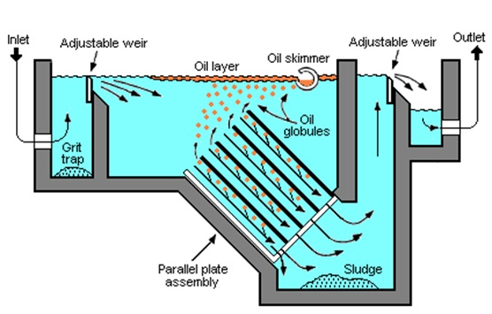
Figure 10 API Separators (18/03/23)

Once the wastewater passes over the weir and through the outlet, it flows through the Secondary Diversion Box ‘SDB’. Polyelectrolyte is then dosed into the effluent by an automated pump, which uses water to dilute the solution before it is sent to the in-line mixer. (S. Srinu Naik, 2018).
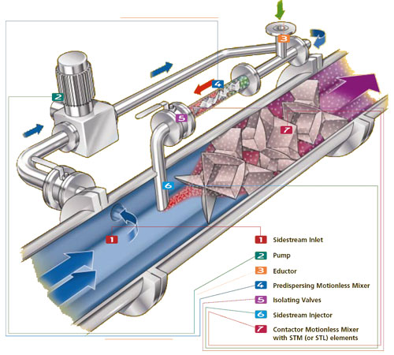
After the mixer the wastewater is fed to the Dissolved Air Flotation ‘DAF’ Units, these operate by introducing air saturated water and flocculated effluent through the centre of the flotation zone. This allows Solids and oil particles to attach onto air bubbles and rise to the surface of the tanks, to be collected by a rotating skimmer blade and pushed into the trough. Heavier particles settle to the base of the tank for collection by a floor scraper. (Donald B. Aulenbach, 2021).
Figure 11 Inline Mixer, with Polyelectrolyte Added (18/03/23)

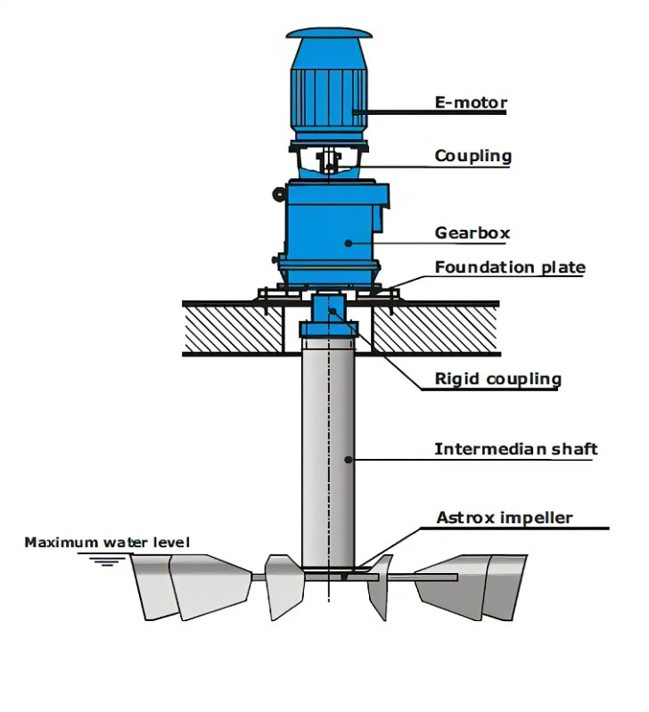
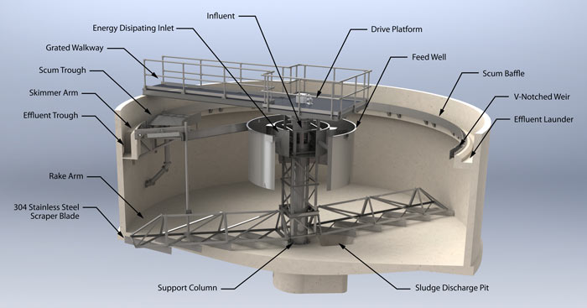
From the DAF units the wastewater is fed into a neutralisation sump and equalisation basin where 75% concentrated Phosphoric Acid is added acting as a nutrient feed for the biological cleansing process, controlling the Phosphate level in the final effluent. (Lawrence K Wang, 2012). Before the wastewater can enter the biological process, it must be heated within the heat sump, this is achieved by injecting steam into the wastewater. This brings the influent between 27 ˚C and 35 ˚C, the temperature suits the microorganism’s increasing activity. (Moe Toghraei, 2022).
Figure 12 Jet Aeration Systems (23/03/23)

Figure 13 Dissolved Air Flotation ‘DAF’ Units (21/03/23)

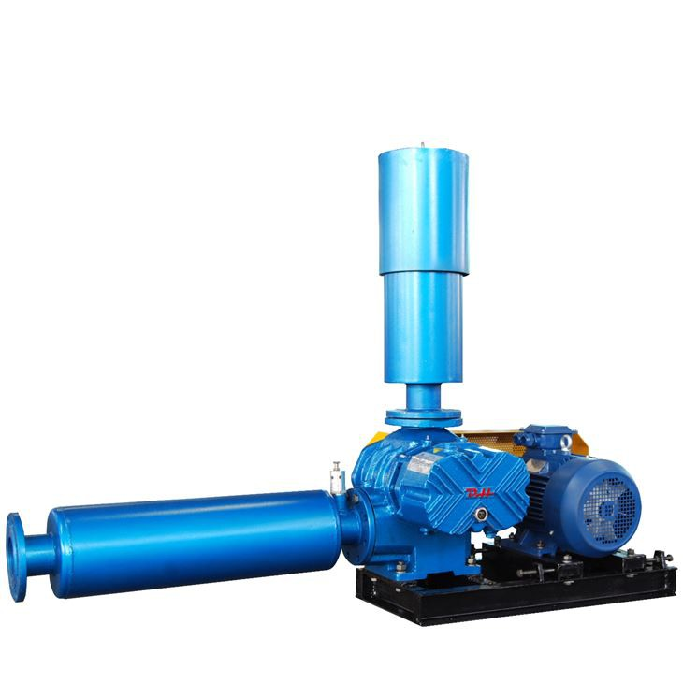
Figure 15 Air Blowers and Pumps (23/03/22)

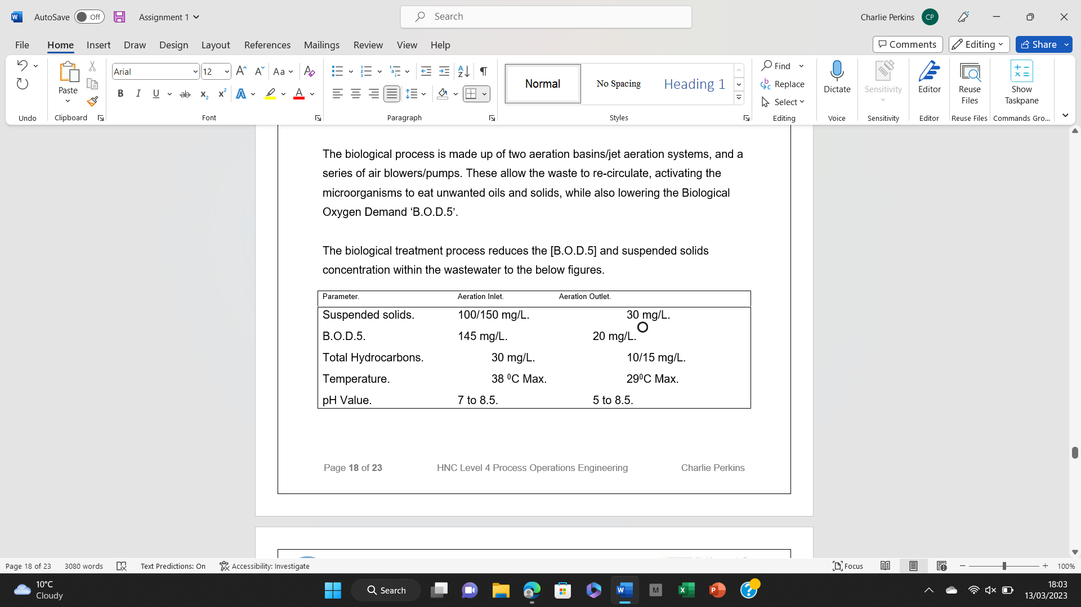
The biological process is made up of two aeration basins/jet aeration systems, and a series of 55kW air blowers and 30kW pumps. These allow the waste to re-circulate, activating the microorganisms to eat unwanted oils and solids, while also lowering the Biological Oxygen Demand ‘B.O.D.5’, figures can be seen below. (Mritunjay Chaubey, 2021).
Figure 14 Wastewater Parameters, before Pumped to Haven (23/03/23)

Samples are taken from these basins ensuring that the wastewater meets ‘EA’ standards. Once complete the wastewater can be pumped into the haven providing a record of the flow and volume is taken. If the wastewater is not to standard it is sent back through the biological process, if this again fails the process is started again with the wastewater directed back towards the ‘PDB’.

References
A. Kayode Coker, 2022. Petroleum Refining Design and Applications Handbook. First ed. New York: Wiley.
American Water Chemicals, 2023. AWC - American Water Chemicals, Inc.. [Online]
Available at: https://www.membranechemicals.com/about-us/
[Accessed 12 03 2023].
Amir Ayad, 2021. Steam Turbines, California: SCRIBD.
B. Lang and L. Edwards, 2018. Cracking & Olefins FCCU Recovery, Texas: Valero.
British Water, 2020. A Guide for Users of Wastewater Treatment Plants. First ed. London: Environment Agency.
Donald B. Aulenbach, 2021. Environmental Flotation Engineering. First ed. New York: Springer International Publishing.
James G. Stallcup, 2020. Stallcup's Generator, Transformer, Motor & Compressor. Third ed. California : Builder's Book Inc..
Kyle Pennell, 2023. Power Recovery Turbines for Large Radial Engines. [Online]
Available at: https://www.brighthubengineering.com/
[Accessed 28 03 2023].
Lawrence K Wang, 2012. Handbook Of Environment And Waste Management: Air And Water Pollution Control. First ed. London: World Scientific Publishing Company.
Moe Toghraei, 2022. Rules of Thumb for Water and Wastewater Engineers. First ed. New York: Wiley.
Mritunjay Chaubey, 2021. Wastewater Treatment Technologies. First ed. Oxford: Wiley.
Nabil Abu-Khader, 2022. Power Recovery Train Controls. [Online]
Available at: https://www.turbomachinerymag.com/view/power-recovery-train-controls
[Accessed 24 03 2023].
R. Ramzy, 2020. Axial Flow Compressors 101: The Essential Overview. [Online]
Available at: https://www.linquip.com/blog/axial-flow-compressors/
[Accessed 12 03 2023].
Richard Brookes, 2019. Supporting HSE improvement. [Online]
Available at: https://www.hse-network.com/health-and-safety-at-work-act-1974-explained/
[Accessed 22 03 2023].
Robert A. Meyers, 2016. Handbook of Petroleum Refining Processes. Fourth ed. New York: McGraw Hill LLC.
Rosie Anderson, 2023. What is the Environmental Protection Act 1990?, London: DeltaNet International.
S. Can Gülen, 2019. Gas Turbines for Electric Power Generation. First ed. Cambridge : Cambridge University Press.
S. Srinu Naik, 2018. Innovative Technologies for the Treatment of Industrial Wastewater. First ed. Florida : Apple Academic Press.
Silvia Madeira, 2013. Use of Survival Models in a Refinery. REVSTAT – Statistical, 11(1), p. 45–65.
Tek Sutikno, 2010. Installing a power recovery system on FCC or RFCC units. [Online]
Available at: https://www.digitalrefining.com/article/1000462/installing-a-power-recovery-system-on-fcc-or-rfcc-units
[Accessed 28 03 2023].

