an exploration into how artists use colour and light, to provoke sensation
Nicole Soutar

submitted in partial fulfillment of the requirements for the degree of BA (hons) university of wales trinity saint david, swansea

December 12, 2018
Contents

List of Figures ….…………………………………………………………………..…..…. 2
Summary ………...…………………………………………………………………......…. 3
Introduction ………………………………………………………………………….....….. 4
Chapter 1: Colour and Light as Sensation ……………………………………..…..….. 5
Chapter 2: Colour and Light within Immersive Experience …………………………... 17
Conclusion ………………………………………………………………………………… 26
Bibliography ………………………………………………………………………………. 28

Word count: 5,509
List of Figures
Figure 1 – J.M.W Turner, The Fighting Temeraire, tugged to her last berth to be broken up (1839). Oil painting on canvas ……………………………………….……… 6
Figure 2 – J.M.W Turner, Snow Storm, Steam Boat off a Harbour’s Mouth (1836) Oil painting on canvas ………………………………………………………………..………. 7
Figure 3 – Claude Monet, Impression, Sunrise (1872) Oil painting on canvas ........ 10
Figure 4 – Claude Monet, Waterlilies (1916-19) Oil painting on canvas …………... 12
Figure 5 – Claude Monet, Nymphea’s (1890-1926) Oil paintings on canvas ……... 14
Figure 6 – Paul Cezanne, Mont Sainte-Victorie (1885-87) Oil painting on Canvas .15
Figure 7 – Hella Jongerius, Colour Catchers (2017) Paper sculptures ………….… 18
Figure 8 – Olafur Eliasson, The Weather Project (2003) Light and fog installation ..22
Figure 9 – Olafur Eliasson, Beauty, (1993). Light and mist installation ………….… 23

Summary
A discussion and exploration into the way in which painters and contemporary artists, use colour and light within their work, in order to create an embodying experience for the audience and emit sensation. With research and analysis into the works of J.M.W Turner, Claude Monet and Paul Cezanne, as well as a comparison to these with contemporary artists Hella Jongerius and Olafur Eliasson.

Introduction
This dissertation has been constructed to discuss how artists employ colour and light to create immersive artwork that embodies the audience. The dissertation also explores how colour and light are used to translate a sensation of feeling and emotion to the viewer.
The first chapter of this dissertation discusses 19th century painter J.M.W Turner, with comparison to Impressionist painters Claude Monet and Paul Cezanne. The chapter explores how Turner, Monet and Cezanne use colour and light to breathe emotion and sensation into their artworks, creating an immersive experience for the audience.
The second chapter examines contemporary artists Hella Jongerius and Olafur Eliasson, their use of colour and light within installation, and how artists explored in chapter one may have influenced their work. Within this chapter, Hella Jongerius’ experimentation and use of colour and light is examined, with reference to writer and scientist, Johanne Goethe and his research into colour.
Olafur Eliasson’s immersive installations are discussed to illustrate how the creation of contemporary art has transformed and adapted, whilst maintaining the same desire to create artworks with an immersive audience experience. Additionally, the Philosopher Maurice Merleau-Ponty is examined, particularly his ideas surrounding embodiment and consciousness and how this has influenced Eliasson’s work.

Chapter 1: Colour and Light as Sensation
Joseph Mallord William Turner (23 April 1775 - 19 December 1851) was a 19th century painter, who created his works on the scene, actively responding to changes in the light and weather (Wilkinson, 1975, p.14). This is reflected within his paintings where energy and movement create a mood that is often felt by the audience, an immersive feeling that creates the sense of what it was like to be there.
Turner’s early work consisted of some engraving and watercolours. During this period, Turner was still developing his use of colour. The use of grey washes dulled down his paintings, losing the vibrancy of the colours. This technique changed in the 1820’s as Turner discovered ‘a new freedom of colouring’ with his first oil painting, ‘The Bay of Baiae’ painted in 1823 (Wilkinson, 1975, p.9). Turner developed his use of colour further in 1826, when he began using blue paper for his composition studies. He would take these out with him to use on the scene. The blue paper was effective in depicting moonlight and mist, and the colour blue is also the colour of distance, perfect for use within landscape paintings (Wilkinson, 1975, p.14).
Later, between 1820 and 1830, he created a series of unfinished watercolour paintings which came to be known as ‘colour beginnings’. The drawings, found by Finberg, were in parcels marked with various titles such as ‘Colour effects, Valueless, Colour on white’ and ‘Beginnings’. It is thought that these paintings were ideas, observations and experimentation with colours and an exploration of light and shadow (Wilkinson, 1975, p.99 – 101).
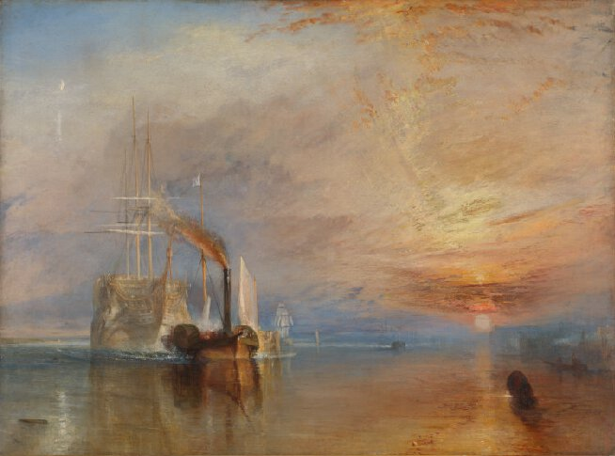
These sketches were followed by colour sketches, depicting the event of the Houses of Parliament burning down on the evening of 16 October in 1834, when Turner was in London (Wilkinson, 1975, p.78). The paintings are expressive, translated through his use of pigment and how it was handled. It’s possible that Turner may have painted these sketches on the scene, capturing the chaos and effectively illustrating the burning fire with the use of bright reds and oranges, surrounded by muted, cold blues that create luminosity in the flames. This is where Turner began using an array of vibrant colours to capture the scene he was in, and as Reynolds writes; ‘he was more and more liberated in his attitude to colour of the highest pitch’ (Wilkinson, 1975, p.78).
Figure 1: The Fighting Temeraire

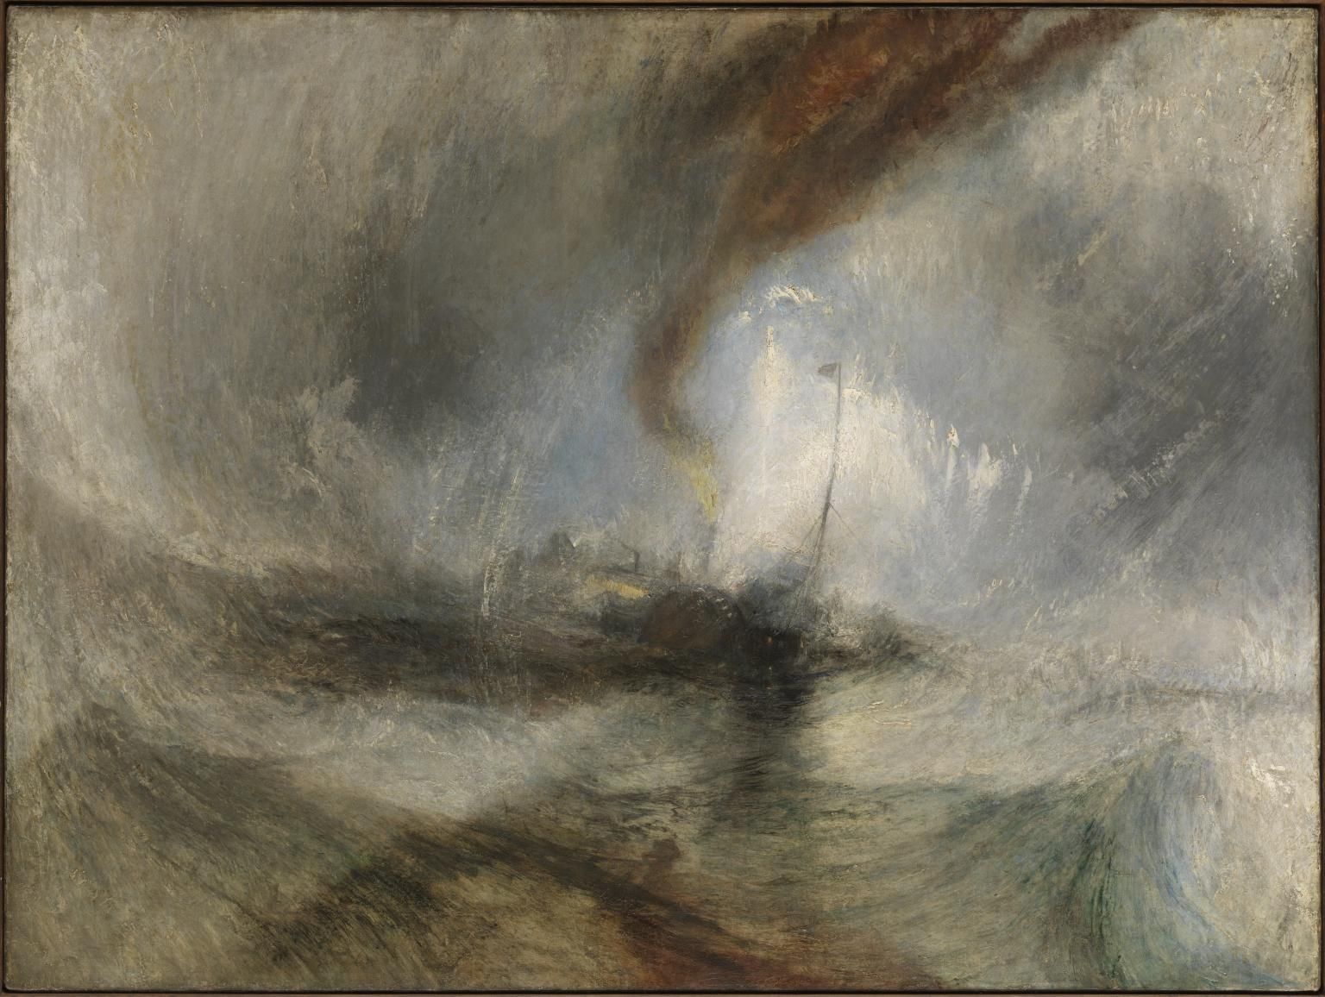
Two paintings in particular where mood has been created and also contrasted, is ‘The Fighting Temeraire, 1839’ (Figure 1) and ‘Snow storm – Steam Boat off a Harbours Mouth, 1836’ (Figure 2). The Temeraire was a fighting ship built in 1798 and fought in the battle of Trafalgar. It was broken up by 1838, a fate which inspired Turner in creating the painting (Egerton, 1995, p.9). Within ‘The Fighting Temeraire’, the boat is depicted at dawn, with the sun making it’s first appearance on the horizon. The use of orange and yellow perfectly illustrates sunrise, and his use of white and horizontal brushstrokes of light breaking through the clouds, gives a realistic representation of how light behaves at this time of day. The painting projects the feeling of a new day and is quite joyous in its emotion. There is a positive, elated mood combined with a sense of gratitude to nature. The bright luminosity of the sun with the glow of the surrounding colours draw the viewers eyes toward this part of the painting, almost as though seeing it through the eyes of the ship, heading toward what feels like a better place. All of this is created through Turner’s use of colour, and the attention he pays to how colour and light react together.
Figure 2: Snow Storm, Steam Boat off a Harbour's Mouth

This is harshly contrasted with the painting ‘Snow Storm, Steam-Boat off a Harbour’s Mouth’ (Figure 2), which depicts a boat in the midst of a storm (Egerton, 1995, p.100). The colours are much darker in this piece and the use of deep greys and muddy browns that surround the edges of the painting create a gloomy, dark atmosphere with very little light. The effect of the ‘eye of the storm’ is created, with the dark colours slowly moving in on the boat, swallowing it.
The mood of this piece is much more negative and emits the feeling of fear and worry. The brushstrokes head in different directions and are erratic, creating the feeling of panic and movement. The effect of fast movement is also achieved in the way the boat is painted out of focus. The blurriness of the boat gives it the effect of being tossed over the sea and leaves the viewer barely able to make out the figure, as it disappears into the storm.
These two pieces are incredibly contrasted with one another. The changes and contrast in the colours used and amount of light depicted create a contrast in the mood and atmosphere. It’s very clear to see how these two paintings are depicting not only different times of the day (dawn and night) but also differing weather conditions (calm and stormy), and how this completely changes the dynamic, look and feel of the painting as well as the way in which the audience responds to it.
The way he’s painted this piece is very abstract, he hasn’t painted definitive lines, clear objects, or subject matter, but instead has painted the feeling, the sense of actually being there, and is relaying this back to the audience. The viewer sees what is only sensory, it isn’t something objective, and it doesn’t necessarily very clearly tell the audience what it is, but the mood and atmosphere are conveyed in a way that touches the viewer, and instantly connects them with the place, time and feel of what he’s depicting. This is incredibly interesting, as Turner was painting long before Abstract art was popularised, and at a time where the style of Neo-Classical paintings, were very literal in what they depicted (Smith, 1995, p.9).
Writer, poet and scientist, Johann Wolfgang von Goethe (28 August 1749 – 22 March 1832) wrote about the importance of our senses, when engaging with the world and art (Boyle, 2018). He quotes; “everything should, as far as possible, be placed before the senses.” (Stair, 2000, p.52) Goethe believed that it was all of our senses, working together, that truly meant we were experiencing nature and the world. These senses are translated through the use of painting by Turner, and the artists that would follow. Goethe investigated into the use of colour by artists, and began writing his own colour theory, which Turner also interpreted himself and practiced within his own work (Dixon, C. 2008, p.19).
Turner could have had influence on Impressionists such as Claude Monet (14 November 1840 – 5 December 1926) and Paul Cezanne (19 January 1839 – 22 October 1906), who were painters of a later period (Dixon, 2008, p.246). Theodore Duret argued that an impressionist was a painter who ‘…pursued transient atmospheric effects…’ (Smith, 1995, p.9). The impressionists did not conform to painting historical and mythological subject matter and the style of drawing ‘correctly’ as seen throughout the Renaissance, and instead, much like Turner, spent time painting and laying down first impressions of a scene in the open air, capturing the atmosphere and mood of a place instantly by laying down colours (Smith, 1995, p.9). This technique was known as painting ‘en plein air’. Meaning to paint outside in the open. This allowed both Turner and the impressionists to accurately paint and express these transient atmospheric effects to the viewer (Dixon, 2008, p.31).
Monet even painted up a number of Canvases, as many as five, all varying in tones, so that as and when the atmosphere or environment of a scene changed, so did the canvas he was working on (Smith, 1995, p.98). This captured the true sense of the place through what the light and colours were emitting.
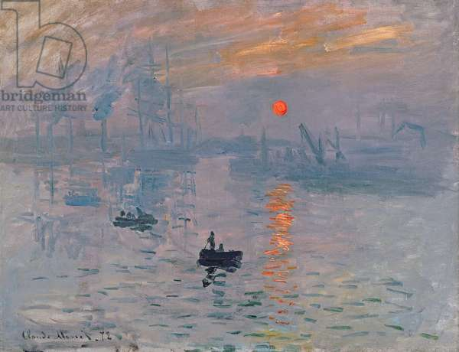
Figure 3: Impression, Sunrise
Monet’s career began with his first impressionist painting ‘Impression, Sunrise, 1872’ (Figure 3). It was a pinnacle point in the beginning of impressionism. Paintings at the time of Monet were still created within studios and ignored the true nature of the outside world. Monet, like Turner, instead painted to ‘capture the shifting moods of landscape’, (Pattison, 2003) by going out into the world and painting an impression of it, conveying the atmosphere, mood and sensation.
At the time, the painting was not well received by critics, and was seen as more of a sketch than a final piece, which critics found was an insult to other painters (Pattison, 2003). But they didn’t see or understand what Monet was doing. He was conveying nature, it’s textures, colours, moods and light, to embody the viewer in the experience he had while being there, painting the scene.
Monet creates distance in the way he fades out subjects in the background, and creates silhouettes with subjects in the foreground. A quiet, still mood is created with the calmness of the water and the muted, cool colours, that give the impression of a brisk, misty morning. The centre of the painting feels warm, with the intense orange glow of the sun reflecting on the water and within the clouds, breaking through the cold, as it starts to warm up the scene.
Another interesting technique of Monet’s is the way he applies colour. At the beginning of painting, Monet lays down the dominant values of a scene, that is worked into with gradations and contrasting colours (Smith, 1995, p.93). Here, Monet is merely painting the sensations of colour and light, without drawing a definite outline. He applies patches of colour as and when he sees them before him, he quotes;
‘when you go out to paint, try to forget what objects you have before you… merely think, here is a little square of blue, here an oblong of pink, here a streak of yellow, and paint it just as it looks to you, the exact colour and shape, until it gives your own naïve impression of the scene before you’ (Smith, 1995, p.27).

Monet worked very quickly when out, capturing the very first impression a scene made on him. He then reworked the canvas later in the studio, as Turner did, where changes were made to better adapt to the indoor light of a gallery. The changes in light within our environment also effects how the painting is viewed after. Once brought indoors under different light, it changes the appearance and effects of the painting and colours, which could have a massive impact on the overall mood the painter is trying to communicate. Both Monet and Turner thought carefully about this and is also practiced by other impressionists such as Paul Cezanne (Smith, 1995, p.26).
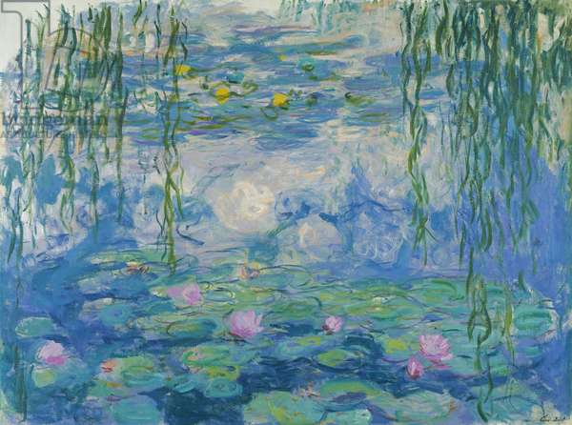
Figure 4: Waterlilies
Monet became best known for his later works created at his self-made garden in Giverny, and more specifically, his series on the lily pond, which began in 1902, and captures the reflections made on the surface of the water (Temkin and Lawrence, 2009, p.5). In Figure 4, ‘Water Lilies, 1916’, Monet has captured the reflection of the clouds within the sky above, painted softly beneath the vibrant lily pads that sit on top, as they mimic each other’s shape. Wispy brushstrokes of green delicately illustrate the willow trees that hang just above the water’s surface, and in front of the viewer, creating perspective and the sense of peering through. The changes in textures, colours and the layers that are built up create depth in the painting.
Monet is also similar to Turner, in that he paints these lily pond paintings quite abstractly, some clearer than others, and some an embodiment of the feeling of being there. During this time, Monet was diagnosed with cataracts, and struggled to see very well. Seeing colour became more difficult, but he could still see the contrast and distinction between light and dark, which is reflected in his paintings. Deep, dark areas are often married with bright luminosity (Gordan and Forge, 1980, p.282).
However, Monet could see colour much more clearly when he stood back from his paintings, and thus, began painting on large canvases. Originally, these larger paintings ranged between 73cm and 107cm wide. He then went on to implement the idea of creating paintings that were up to two metres in height, and six metres wide. These paintings were the beginning of the ‘enveloping painted environment he had dreamed of for so long’ (Gordan and Forge, 1980, p.225). Curator, Paul Hayes Tucker quotes;
‘He took up the largest project of his entire career, attempting to realise the idea of creating paintings that would surround the walls in a single room, to immerse the viewers in the beauties and glories of his garden’ (Pattison, 2003).

The scale of these works is very important when conveying the atmosphere and mood to the audience. The large, floor to ceiling paintings swallow the audience and immerse them in the world Monet has created. It is recalled that he once said; “he would like the visitor to feel as if he had been immersed in an aquarium of flowers – constantly surrounded by painting, one had to dive in something fluid and boundless.” (Pattison, 2003) His ambition was to envelope the viewer in his world, and as Temkin and Lawrence quotes, creates an ‘environment that in today’s parlance, would be called an installation’ (Temkin and Lawrence, 2009, p.9). Monet was trying to create the same immersive effect at this time, that contemporary installation artists create today. These later paintings by Monet became a reference point for contemporary artists (Temkin and Lawrence, 2009, p.42).
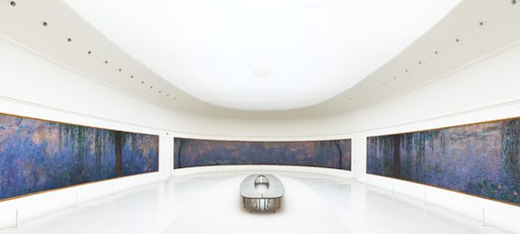
Figure 5: Nymphea's
A visitor seeing these large panels in person at the ‘Musée de l'Orangerie’ (Figure 5) quotes; “when I walked into the room, it was like everything was on top of me, my head went one way and my body the other – I think a print could never produce what this has made me feel, a print doesn’t give me emotion, this has.” (Pattison, 2003)
Monet attempts to place the viewer in the scene as best he can, when limited to two dimensions. It is also this limitation that encourages artists like Monet and Turner, to paint in the way they do, and to portray the atmosphere and mood in such a sensational way.
As mentioned previously, another impressionist artist who applies colour in the same way as Monet is Paul Cezanne. Cezanne paints patches of flat colour, painting the colours within the scene he saw before him, without the use of line (Smith, 1995, p.154). This is because like Monet, Cezanne believed that line did not belong in a painting, as nature is not composed of lines, but of colours, and quotes; “to paint is to record sensations of colour.” (Smith, 1995, p.155)
Cezanne paid particular attention to the colours he placed next to each other, knowing that different colours side by side effected the intensity, saturation and hue of the other, and tended to place complementary colours next to each other. In doing so, the colours appear more intense and better represent the brightness of outdoor natural light. Although natural light couldn’t be reproduced through painting, this was as close as Cezanne could get (Smith, 1995, p.156-157).
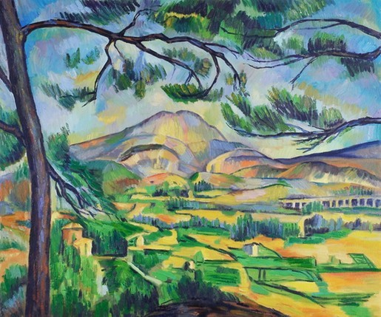
Like both Monet and Turner, Cezanne also pays attention to how a painting can be affected by the indoor light of a gallery or studio space. As well as the light, he also understood how colours surrounding a painting could have an effect on the way the colours are perceived, and painted his studio walls light grey, to avoid interference with the harmonies of colour created in his paintings. He also often avoided the use of frames, as he thought they were distracting and also changed the overall appearance of the colours and painting (Smith, 1995, p.160).
Figure 6: Mont Sainte-Victorie
In this piece ‘Mont Sainte-Victorie 1879’ (Figure 6), the main composition of the painting is made up by two sets of complementary colours, orange and blue, and green and red, with tones of each in between. This creates a harmonious painting with great saturation. His numerous brush strokes create a tactile, textured surface that imitates nature. The tree overhanging in the foreground create perspective and the feeling of distance, but also puts the viewer within the landscape, immersing them (Alexander, 2005, p.97).
The bold colours in Cezanne’s pieces give them the feeling of positivity and the sense of appreciation for the landscapes he was surrounded in, which in turn, is passed on to the viewer. It is the audience that plays an important role in Cezanne’s work, who in the last century, has commented ‘nature is on the inside’, expressing the idea of provoking an ‘echo’ inside us, of what we see externally (Ullrich, 1999, p.46). These are similar ideas to that of the 18th Century French philosopher and phenomenologist, Maurice Merleau-Ponty (14 March 1908 – 4 May 1961) who wrote about both the mind and body, working together when experiencing the world, he quotes; “the world is not what I think, but what I live.” (Ullrich, 1999, p.46) And much like Goethe, believes we experience with the ‘totality’ of our body, sensing with all of our sense operations.
All three of the artists that have been discussed so far, try to fully embody a scene, and immerse the viewer in it. It’s a form of communication, from one human being to another. These artists have attempted to bring the audience into their paintings, and immerse them in an experience, a sensation, not just a physical scene. A subjective intimate experience is created with the work rather than an objective one, that is felt with all of the senses. These are ideas that both Merleau-Ponty and Goethe have written about.
Chapter 2: Colour and Light within Immersive Experience
The creation of immersive art, where the artist is creating an experience through painting, rather than just depicting a story, is an idea that has fuelled the minds of contemporary artists today, such as Hella Jongerius and Olafur Eliasson.
Merleau-Ponty makes emphasis on our being within the world, rather than on it. The world surrounds and embodies us not just physically, but within our consciousness. We experience with all our senses and both mind and body (Ullrich, 1999, p.46). These contemporary artists, who are creating immersive installations, have brought these two together, so that we experience their art both consciously and physically.
Hella Jongerius, a designer and contemporary artist, has created a body of work on colour research, which has gone into the curation of an exhibition, entitled ‘Breathing Colour’. The exhibition, held at the Design Museum, London, features a variety of paintings, textile pieces and sculptures that explore the ‘endless possibilities of colour’, when subject to changes in light, texture and shape (Dawood, 2017).
Jongerius has a passion for colour, and places importance on design and textile industries maintaining and using more dynamic, pigmented colours. Jongerius has researched and created an array of colours that are high in vibrancy, richness and saturation. She argues; “the processes of industrialisation have narrowed our experiences of colour.” (Jongerius, 2017, p.1) Jongerius aims to create colour, from colour only, in contrast to how industry mixes and creates colour today, by darkening colours with black (Carbon), rather than maintaining their bold hue by using a colour complementary to it, this dirties the colour, and takes away it’s vibrancy (Dawood, 2017).
Maintaining this way of producing colour is important to Jongerius and the work she creates, as she views colour as dynamic, she says; “As designers, we can only buy what the paint industry makes – I would like to buy colours that breath and react with light and which are not stable – tactility is very important.” (Dawood, 2017) Industry has developed coatings that fail to change under the influence of changing light, it leaves them static (Schouwenberg, 2010, p. 270). Colours should change in response to light and texture, themes that she has explored throughout her latest exhibition (Dawood, 2017).
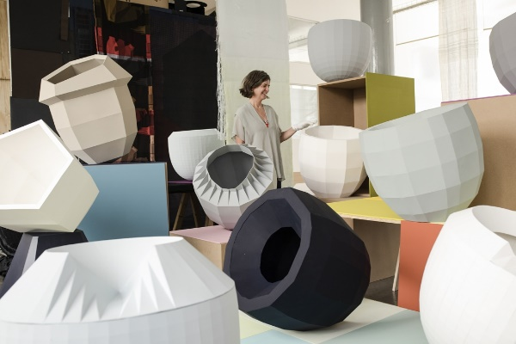
Within Jongerius’ exhibition, ‘Breathing Colour’, she has focused on the effect light has on colour, and how the dynamic, changing nature of daylight, creates and breaths variations of tones and hues upon objects, as well as other factors such as shape and texture, that allow the light to refract or cast shadow (Jongerius, 2017, p.17).
Figure 7: Colour Catchers

A prime example of Jongerius’ playful investigation into how colour operates, are her pieces entitled ‘Colour Catchers’ (Figure 7). The colour catchers are bowl like sculptures created from straight folds, that are an ‘abstraction’ of the everyday objects that inhibit Jongerius’ life (Jongerius, 2017, p.17). An array of colours and tones is created through the structured, folding of the surface, each flattened side emitting a different effect, as shadows are cast and light hits it in different areas. The folding serves an important purpose, separating and dividing the object, so that light reflects off the surfaces in a way that can be clearly seen and studied. To study the changes in colour as a result of light, would be more difficult on something rounded and smooth, as it’s harder to tell where one tone ends, and another begins.
The colours play with the viewer’s eyes, some pieces are entirely grey, but under the bright lighting and the coloured platforms they sit on, they can appear blue, red or pink (Dawood, 2017). The pieces are dynamic, and ever changing as daylight is, showing how ‘colours are inherently unstable’ (Jongerius, 2017, p.18), similar to that of the impressionists, who laid down flat patches of colour, that changed according to the light and mood.
Jongerius’ exploration into colour and how it changes with light has strong similarities with Goethe’s work on colour. Goethe wrote about how light and dark are needed in the creation of new colours and tones of colours, and also experimented with these elements (Stair, 2000, p.54). Hella Jongerius shows her process of experimentation with varying light conditions, to produce a more extensive range of colours. Turner and the Impressionists also did this in painting the same scene under different lighting and weather conditions, to fully understand the dynamic sensation of nature.
As well as an exploration into colour, the exhibition creates an audience experience. The exhibition is separated into three sections, morning, noon and evening. Within Morning, we see hanging beads and textiles that are translucent and semi-translucent, a multi-coloured glimmer refracts off them as the light passes through and fluctuates, showing how a broad spectrum of colour can be generated through the use of light (Dawood, 2017). Within Evening, the viewer is subjected to shadows and the role they play, and the colour black is explored through hanging tapestries, in which the shades of black are created, without the use of black materials, questioning our definition of what black is, and changing our perception of the colour (Dawood, 2017).
As well as physical art pieces, sounds also play, adding to the atmosphere created (Dawood, 2017). Throughout these spaces, Jongerius is capturing the mood and diversity of these different times of day, that all, not just look different, but feel different, and even sound different. This is incredibly alike to that of J.M.W Turner, who captured the very essence of the break of morning, and understood how to paint it, believing that, ‘every colour was an individualised combination of lightness and darkness’ (Jongerius, 2017, p.11) and Monet, whose vibrant use of colour and attention to light, created paintings that the viewer could become immersed in.
She is exhibiting our surroundings through physical form and changes the viewer’s perception of colour and how they see it. Alex Newson, Curator at The Design Museum, quotes;
‘My favourite thing in the exhibition isn’t in the exhibition at all – it’s what happens when you leave. It’s seeing that complex variety of colours within objects for the first time’ (Dawood, 2017).

The audience is just as important when creating an artwork. Goethe quotes; “perception itself becomes a craft.” (Stair, 2000, p.54) The audience’s perception changes the artwork as the artwork creates an individual, personal response. The artwork becomes the result of the individual’s perception of it.
Her experimentation and use of colour within her pieces of work, elevates the exhibition as a whole. The colours are bold and vibrant, and she plays with contrasts in shadow and light which move the room, so that it really ‘breathes’ colour.
Olafur Eliasson, a Dutch installation artist, has created works that solely serve the purpose to generate an audience experience. Eliasson explores the themes of natural phenomena and our relationship with it (May, 2003, p.11). He has created a body of work that was exhibited at the Tate Turbine hall in 2003, entitled ‘The Weather Project’ in which he has used elements of nature (water, light, temperature, pressure) to recreate different weather conditions, through installation.
Eliasson, who has been influenced by the phenomenology of philosopher’s like Merleau-Ponty (O’Donovan, 2008, p.25), discusses ideas on how we are embodied in the world around us, Eliasson shares similar views, he quotes; “Right between thinking and doing is experience.” (TED, 2009) Experience is what we feel and what embodies us and is something Eliasson tries to provoke with his art work. He ‘emphasises the activity of the perceiving subject in community with other subjects’ (O’Donovan, 2008, p.25).
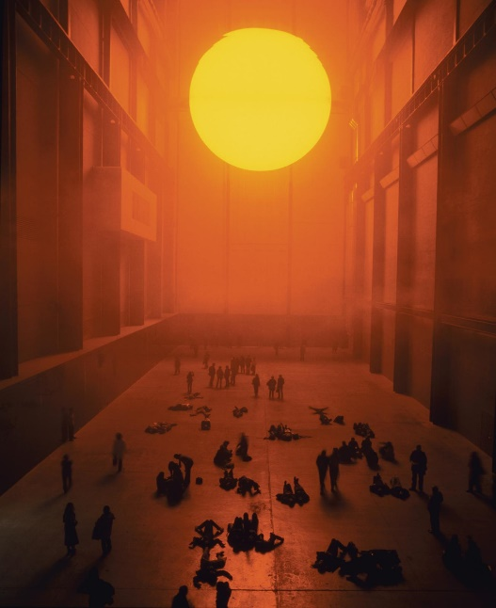
Figure 8: The Weather Project
Eliasson’s installation ‘The weather project, 2003’ (Figure 8), which was installed in the Turbine Hall at the Tate Modern (May, 2003 p.13), is a captivating, embodying piece. He has used a semi-circle of yellow light, that is reflected on a mirrored ceiling to create the effect of the sun. Pumping mist into the space creates a cloudy haze that floats almost 20ft above (Creative Review, 2003). The use of space within this piece is just as important as the light. The huge space of the turbine hall with its high ceiling, creates the feeling of insignificance, as the small, inferior viewer stands in front of the immense ball of light that hangs above them, and shadows darken the room below. Colours other than yellow and black become invisible due to the use of mono-frequency lights, and creates a duotone landscape and high contrast, adding to the atmosphere of the space (Creative Review, 2003). The vibrant golden colour and light emitted from the ‘sun’ is similar to that of the colour’s in Turners painting, ‘The Fighting Temeraire’, and Monet’s early painting, ‘Impression: Sunrise’. This warm, intense colour in combination with the sun like shape, create the feeling of intense heat. The atmosphere is like that of a blazing sun rising over a desert.
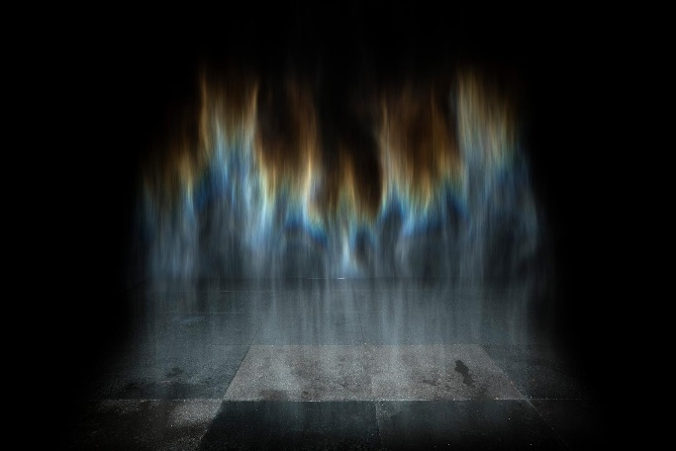
The audience can be seen interacting and responding to the piece, some stand and look up in awe, while others lie relaxed on the ground, looking up at the mirrored ceiling above, and the golden light that bounces off of it. He has recreated natural elements within an unnatural setting, in his ‘aims to make the viewer reflect upon their relationship to and perception of the physical world’ (Creative Review, 2003).
Figure 9: Beauty

Although this installation is immersive, and provokes a feeling within the viewer, it still can’t be fully interacted with, touched and walked through, like his 1993 installation ‘Beauty’ (May, 2003, p.19). This body of work (as seen in Figure 9) not only immerses the viewer in a mood and experience but allows the viewer to fully interact with it. The piece creates a rainbow-like phenomenon, created through mist that falls from the ceiling of a darkened room. The mist is spot lighted in a way that captures and reveals the spectrum of colours that dance within it. He has taken an element of nature from outside, and brought it into an enclosed space, so that it can be experienced up close. This changes the dynamic of a natural phenomenon, which ‘encourages the viewer to explore the boundaries of their own perception and subjectivity’ (May, 2003, p.13). The light is dragged to the floor with the falling damp mist, creating changes and contrasts in light and shadow.
Eliasson has entitled the piece ‘Beauty’, which by definition, refers to ‘a shape colour or form, that pleases the aesthetic senses’ (Oxford Dictionaries, 2018). ‘Aesthesis’, the Greek word that derives from the word Aesthetic, refers to sense perception and the ‘totality of human perception or sensation as a rich and embodied way of being in the world’ (Ullrich, 1999, p.44). This relates to what Olafur Eliasson, and the artists I have looked at previously, have done through the creation of their work. They create an aesthetic, that embodies the viewer and translates a sensation.
The installation is ethereal and mesmerising, it makes the viewer want to step inside to fully experience it, and they can. The look and effect of water that’s created in combination with the colours that flicker and move, is somewhat similar to that of the effect that Monet was trying to create with his Water Lily murals, enveloping the viewer in the ethereal reflection and movement of water, immersing them in ‘an aquarium of flowers’ (Pattison, 2003). This piece takes it a step further and allows the viewer to become fully immersed in it and experience it physically. This elevates the piece from what is experienced through feeling and atmosphere, and what can be experienced through touch and physical interaction, pushing the boundaries of what art can do. It also translates the ideas discussed by both Goethe and Merleau-Ponty, where cognitive thought (the mind) comes together with physical interaction (the body) bringing ‘mind and matter back together again’ (Stair, 2000, p.53) to allow the viewer to experience the work, in the same way we experience nature and the world, with the use of all of our senses.

Conclusion
This dissertation has discussed and explored how traditional painters, used colour and light in depicting the world around them, to embody the viewer in an experience.
Turner and the Impressionists (Claude Monet and Paul Cezanne), all used colour and light to express the scene they were painting and fully capture it, not only visually, but sensually. These artists have also been referenced to philosopher Merleau-Ponty and writer Johanne Goethe, and their ideas on how we experience the world and are embodied in it. The two talk about how we experience the world with all of our senses, and with the totality of our body, showing how these artists have experienced the world around them, and captured the very sensation of that moment, to enable them to communicate it effectively to the viewer, so that they can experience it too.
The dissertation has also explored how contemporary artists Hella Jongerius and Olafur Eliasson use colour and light in this same way. But they are able to take their art a step further, with the aid of modern-day technology. The use of such modern methods helps to create a stronger sensation of immersion than what can be experienced through a two-dimensional painting, it is something that can be moved within, walked through, touched and interacted with.
All of these artists create a sensation and feeling within their work that can be felt by the viewer, to which each artist, in some way, influenced the next. A key example of this is Monet’s enveloping Water Lily murals, an idea of an installation that surrounds the viewer and embodies them in the artwork. A body of work that went on to influence the likes of Olafur Eliasson and other contemporary artists, in recreating an event, emotion or natural phenomenon within a space, in a way that the audience can experience it, with all their senses.
Turner and the Impressionists painted on the scene to capture the true essence of a place, whereas the likes of Hella Jongerius and Olafur Eliasson, bring that essence into a gallery space, to be experienced first-hand.

Bibliography
Alexander, S. (2005) Beyond ‘Cezanne’s Doubt’. Journal of Visual Art Practice, 4(2), pp. 97-109. Available at: https://web-a-ebscohost-com.ezproxy.uwtsd.ac.uk/ehost/detail/detail?vid=5&sid=5faecc0d-b37b-4ac0-8ee6-8735e06fcc90%40sessionmgr4009&bdata=JnNpdGU9ZWhvc3QtbGl2ZQ%3d%3d#AN=505102061&db=asu [Accessed 21/11/2018]
Anonymous (2018) Dictionary definition: Beauty. Available at: https://en.oxforddictionaries.com/definition/beauty [Accessed 7/12/2018]
Breathing Colour. Hella Jongerius. The Design Museum. (2017) Exhibition Catalogue [Accessed 28/11/2018]
Dawood, S. (2017) Breathing Colour: The Design Museum's latest show on the work of Hella Jongerius. Design Week (Online) Available at: https://search-proquest-com.ezproxy.uwtsd.ac.uk/artshumanities/docview/1914375562/fulltext/3830F01F7573404CPQ/4?accountid=130472
Dixon, C. Radford, R. and Ward, L. (2008) Turner to Monet: The triumph of landscape painting. Australia, Publishing Department of the National Gallery of Australia.
Egerton, J. (1995) Turner, The Fighting Temeraire. Great Britain: National Gallery Publications Limited.
Gordon, R. and Forge, A. (1980) Monet. New York: Abradale Press/Abrams
May, S. (2003) The Weather Project. London: Tate Publishing.
O’Donovan, L. (2008) Walking Through the Rainbow. America, 198(19), pp. 25-27. Available at: https://web-a-ebscohost-com.ezproxy.uwtsd.ac.uk/ehost/detail/detail?vid=3&sid=9ff084dc-c7a1-4e1a-9355-b92b2d088243%40sessionmgr4009&bdata=JnNpdGU9ZWhvc3QtbGl2ZQ%3d%3d#AN=32469779&db=asu [Accessed 01/12/2018]
Pattison, N. (2003) BBC Fine Art Collection 1 of 7, Mad About Monet. [Online] Available at: https://www.youtube.com/watch?v=0vWWBIhItE4&t=1222s [Accessed 14/11/2018]
Schouwenberg, L. (2010) Hella Jongerius, Misfit. London: Phaidon Press.
Smith, P. (1995) Impressionism, Beneath the Surface. New York: Harry N. Abrams, Incorporated.
TED (2009) Olafur Eliasson: Playing with Space and Light. [online video] Available at: https://www.youtube.com/watch?v=WCGuG0uT6ks&t=571s
Temkin, A. and Lawrence, N. (2009) Claude Monet, Water Lilies. New York: Museum of Modern Art.
The Weather Project. Creative Review, 23(12) pp. 81. Available at: https://web-b-ebscohost-com.ezproxy.uwtsd.ac.uk/ehost/detail/detail?vid=7&sid=ae6adfdd-06f4-4f3e-b625-e440b79a70d9%40pdc-v-sessmgr01&bdata=JnNpdGU9ZWhvc3QtbGl2ZQ%3d%3d#AN=11604095&db=asu
Ullrich, P. (1999) Beyond Touch, The Body as Perceptual Tool. Fibrearts, 26(1), pp. 43-48. Available at: https://web-a-ebscohost-com.ezproxy.uwtsd.ac.uk/ehost/detail/detail?vid=3&sid=5faecc0d-b37b-4ac0-8ee6-8735e06fcc90%40sessionmgr4009&bdata=JnNpdGU9ZWhvc3QtbGl2ZQ%3d%3d#AN=505823392&db=asu [Accessed 21/11/2018]
Wilkinson, G. (1975) Turner’s Colour Sketches. London: Barrie & Jenkins Ltd.

Figures:
Figure 1: Turner, J.M.W. (1839) The Fighting Temeraire, tugged to her last berth to be broken up. Oil paint on canvas. Available at: https://www.nationalgallery.org.uk/paintings/joseph-mallord-william-turner-the-fighting-temeraire [Accessed 02/11/2018]
Figure 2: Turner, J.M.W. (1836) Snow Storm, Steam Boat off a Harbour’s Mouth. Oil paint on canvas. Available at: https://www.tate.org.uk/art/artworks/turner-snow-storm-steam-boat-off-a-harbours-mouth-n00530 [Accessed 02/11/2018]
Figure 3: Monet, C. (1872) Impression: Sunrise. Oil on Canvas. Available at: https://www.bridgemanimages.com/en-GB/search?filter_text=claude+monet&filter_group=all&filter_region=GBR
Figure 4: Monet, C. (1916-19) Waterlilies. Oil on canvas Available at: https://www.bridgemanimages.com/en-GB/search?filter_text=claude+monet&filter_group=all&filter_region=GBR [Accessed 28/11/2018]
Figure 5: Monet, C. (1890-1926) Nymphea’s. Oil on Canvas. Available at: https://www.flickr.com/photos/mbell1975/6043261269
Figure 6: Cezanne, P. (1885-87) Mont Sainte-Victorie. Oil on Canvas. Available at: http://www.paulcezanne.org/mont-sainte-victoire-1885.jsp [Accessed 21/11/2018]
Figure 7: Jongerius, H. (2017) Colour Catchers. Photograph of paper sculptures. Available at: https://www.creativeboom.com/inspiration/breathing-colour-hella-jongerius-explores-our-connections-to-colour-at-design-museum/ [Accessed 24/11/2018]
Figure 8: Eliasson, O. (2003) The Weather Project. Photograph of installation. Available at: https://www.tate.org.uk/context-comment/articles/the-weather-project [Accessed 26/11/2018]
Figure 9: Elliason, O. (1993) Beauty. Photograph of installation. Available at: https://olafureliasson.net/archive/artwork/WEK101824/beauty [Accessed 28/11/2018]

